Study Of the Physical Properties, Crystal Structure, Chemical Composition and Application of Mixture of Ninivite Silica Rocks with Iraqi Fuller’s Earth

Regab Awad Buker

Department of Chemistry, College of Education

University of Mosul-Iraq

(Received on 5/6/2006) (Accepted for publication on 24/4/2007)

Abstract
X-ray powder diffraction, x-ray fluorescence, infrared spectroscopy, thermogravimetric, differential thermal analysis, and chemical analysis were performed to study the physical properties, crystal structure and chemical composition of silica rich Ninivite silica rocks and Iraqi natural Fuller’s earth.
The results were compared with that obtained from mixing the two samples in a ratio 1:1. These samples have been used as adsorbents in fractionating columns to fractionate Qaiyarah Heavy Crude (QHC) Oils into their simple components.

الخلاصة

تم دراسة الخواص الفيزيائية والتركيب البلوري والتكوين الكيميائي لنماذج من صخور نينفايت الغنية بالسيليكا وأطيان فلر المعدنية المحلية باستخدام تقنيات حيود الاشعة السينية وفلورة الاشعة السينية وأطياف الاشعة تحت الحمراء والتحاليل الحرارية الوزنية والتفاضلية والتحليل الكيميائي. وتم مقارنة النتائج المستحصلة مع خليط من النموذجين بنسبة 1:1 كما تم دراسة كفاءة تلك النماذج الثلاثة في فصل مكونات نفط القيارة الثقيل المعقد الى مكونات ابسط ذات فائدة باستخدامهم كمادة تسهل عملية الادمصاص في عمود الفصل الكروموتوغرافي.

Introduction
Iraqi heavy crude oil is one of large number of materials occurred naturally and compose mainly of different components . Classical physical methods, like fractional distillation or crystallization are not efficient in separation of those materials into their simple components. It is therefore, the problem of the workers to maintain a reliable technique to separate these complex mixtures into groups of more valuable substances. Liquid chromotographic adsorption over silica gel^{(1,2)},however, was reported as a promising physical method for separation of mixture of the substances that are less polar and difficult to crystallize. In general, the idea of such technique is based on differences in the partition equilibria of the mixture components between the stationary phase (the adsorbent) and the mobile liquid phase⁽³⁾.
Fortunately, it is of great interest that silica gel occurred
naturally in large masses in our country. Numerous occurrences of silica-rich rocks named Ninivite⁽⁴⁾have been described for the first time from the Miocene northern Iraq. Ninivite silica rocks are considered of great
industrial importance⁽⁵⁾, due to their a high silica content, low bulk density, and high porosity. As a result of the above physical properties, such rocks and the associated numerous occurrences of Natural Iraqi Fuller’s earth⁽⁶⁾were employed and investigated in fractionation processes as adsorbent materials by many worker⁽⁷⁻¹¹⁾.
In order to continue researching for our raw materials and investigating the benefit use of Ninivite silica rocks, recently, Buker and Taher⁽¹²⁾ reported that such materials have been adoped with chromium oxides and used as adsorbents to separate Iraqi virgin olive oil into its simple components.
Accordingly, the present study is undertaken to extend the investigation via the preparation of qualified adsorbent catalysts by mixing Ninivite silica with Iraqi Fuller’s earth in a ratio of 1:1, and employing such catalysts in heavy crude oils fractionation processes.

Experimental
- Source and preparation of silica and Fuller’s earth samples:
Ninivite silica rocks and olive clay samples were used as a natural silica gel rich sample and natural Fuller’s earth sample respectively. All samples were obtained from area around Mosul city/Iraq and have (80-120mesh) chromatographic grade ready for chromatographic fractionation. The third sample was prepared by mixing the above two samples in a ratio of 1:1

which was well mixed , heated in an oven at 360ْC according to the thermal analysis program and then converted to (80-120mesh)grade.

- Chemical and Physicochemical:
Chemical composition of the collected and prepared samples were obtained by x-ray fluorescence and instrumental chemical analysis techniques. Stoch solution for the later analysis was obtained by sodium fusion technique⁽¹³⁾ followed by dissolving the content in 6M HCl. Moreover, physicochemical properties were also determined like pH, which was 6.6 (solid : distilled water 1:1w/v), density, porosity, and specific surface area, which was determined by ethylene glycole method⁽¹⁴⁾.
- Thermal analysis:
Thermogravimetric (TG) and Differential Thermal Analysis (DTA) were recorded between 25 and 450 C on TG and DTA analyzers constructed and built in our university. The heating rate was of 5 C min⁻¹ and $α$-Al₂O₃ was used as standard reference.
0
0

Infrared spectra
Absorption spectra of natural and prepared samples were recorded on Pye-Unicam 1100 infrared spectrophotometer using KBr disk. Meanwhile, the spectra of the eluted fractions in the study was obtained using NaCl cell⁽¹⁵⁾.

- X-ray powder diffraction and fluorescence:
$$α$$
x-ray powder diffraction studies were carried out using CuK radiation, and diffraction patterns were recorded using phillips x-ray powder diffractometer fitted with a vertical goniometer. The phase contributing to the x-ray diffraction patterns were identified by reference to the joint committee on Powder Diffraction Standers Powder Diffraction File (P.D.F). Meanwhile, x-ray fluorescence data were obtained using Phillips Pw 1450/10 Fluorescence Analyzer.
- Application:
Three chromatographic columns, containing Ninivite silica gel, Natural Fuller’s earth and the mixed sample were employed in the fractionation processes. These samples were of (80-120mesh) and activated by heating in an oven at 450 C for two hours and employed for fractionation. A known weight of purified Gaiyarah petrolene(QP)⁽¹⁰⁾ was fractionated into four fractions using four eluant solvents increased gradually in their polarities. These solvents are n-heptane, toluene, chloroform, and ethanol respectively. The overall processes mentioned above were
0

employed to evaluate the adsorption capacity of the three samples under investigation.

Results and Discussion

Chemical composition
The analysis of natural semi-pure Ninivite silica rock, Fuller’s earth and the prepared mixed samples are determined by x-ray fluorescence and instrumental chemical analysis methods, like atomic absorption spectra and flame photometry, and shown in Table (1) . It seems that natural samples compose of different
oxides most of them related to mineral rocks and clays suggested to be used as adsorbent catalysts like

silica, alumina, iron oxide, calcium, magnesium and potassium oxides⁽¹⁴⁾.
Moreover, the observed results reflect a notable differences in chemical composition of the Ninivite and Fuller’s samples. There is a big differences in silica, alumina, iron oxide and calcium oxide content. Such results indeed affect in adsorption behaviour of the two samples, and mixing them to prepared a new sample was suggested through the chemical composition of the third column in Table (1).

Table(1): X-ray Fluorescence and Instrumental Chemical Analysis of Silica and Fuller’s Samples
Oxides % | Ninivite Silica Rocks | Natural Fuller’s Earth | Mixed Sample
SiO₂ | 85.06 | 41.42 | 63.20
Al₂O₃ | 0.30 | 7.21 | 3.71
Fe₂O₃ | 0.12 | 29.03 | 14.59
MgO | 0.12 | 0.79 | 0.42
CaO | 3.86 | 10.31 | 7.06
Na₂O | 1.37 | 0.49 | 0.93
K₂O | 1.20 | 5.12 | 3.10
SO₃ | 3.46 | 2.43 | 3.04
L.O.I* | 4.51 | 3.20 | 3.85
* Lost on ignition

Physical properties
Table (2) shows the physical properties (e.g. density, porosity, water adsorption, and surface area, which have been determined following the methods describe in the literature) of the three samples under investigation. The capillary action was also measured and the rising of water level observed as mentioned with time is taken as the measurement of the capillary action. The results of the three samples are presented in Figure (1). In general, it seems that the physical properties of silica rocks are more advantages than the clays in term of an adsorption system except for the water adsorption.
Such exception reflect the fact that clay samples contain so many fractures on their surfaces and hence increasing the percentage amounts of water adsorption. In conclusion, it is obvious that mixing the two samples might alter its whole physical properties in the direction of adsorption application

Table (2): Physical Properties of Ninivite and Fuller’s Sample
Sample | Density g/cm³ | Porosity % | Water Absorption % | Surface Area m²/g
Ninivite silica rock | 0.70 | 73.0 | 91.0 | 426.10
Fuller’s earth | 2.94 | 38.5 | 137.3 | 129.03
Mixed sample | 1.72 | 54.2 | 110.0 | 240.12

Structural investigation
It is well known that careful x-ray diffraction studies reveals the presence of mixed layer structures and frequently indicate the nature and the relative abundance of the units that are mixed.
Accordingly, x-ray powder diffraction for Ninivite silica rocks and mineral clay samples were carried out and reported recently^{(7,11)}. It was mentioned that silica sample pattern⁽⁷⁾contains reflection typical of quartz in addition to other secondary minerals like alunite, illite, and gypsum. The amorphous silica defined on x-ray diffraction chart as a broad hump between 2 $θ$ (16and28) .
Meanwhile, it was reported that x-ray powder diffraction of natural clay sample⁽¹¹⁾reflect the presence of feldspar mineral in addition to quartz, hemetite, kaolinite, illite, chlorite, calcite, and dolomite. Figure(2) shown

the mixed sample pattern which
contains reflections related to quartz, feldspar, alunite, kaolinite, palygroskite, montmonrilinite, calcite, and gypsum minerals. The amorphous silica also defined as a broad hump between 2$θ$(16 and 28). Such mixed unites of the investigated sample are presented in Table(3) via their interplanar spacings⁽¹⁶⁾.
It is obvious that rocks and clays are porous in character and should held water molecules as a hydration and geometrical water. Therefore, and in order to obtain a highly activate adsorption catalyst, such materials should be treated thermally. Accordingly, DTA and TG technique were employed to study the hydration

phenomenon^{(11,12)}. Figure (3) represent the DTA curve of the mixed sample and it is noted that three DTA endothermic peaks were found corresponding to removal of the the three classes of water molecules; hydroscopic, zeollitic or coordination water molecules, and finally the structural hydroxyl groups. To interpret such foundation, TG of the prepared sample was performed and represented in Figure(4). It is clear that losses of 4.5%,5.7%, and 7.2% from the original weight were observed which represent the dehydration of physical, interlayer adsorbed and structural water molecules respectively^{(11,12)} .

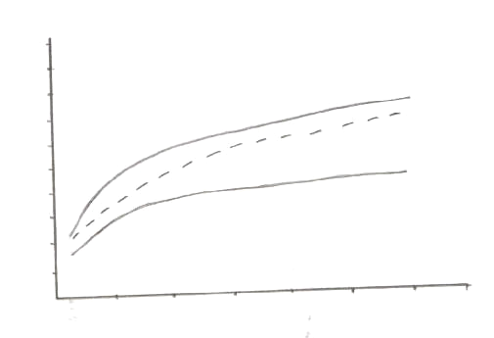
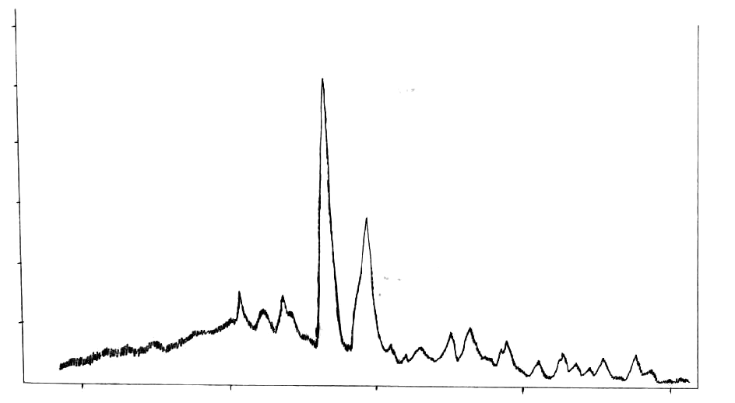
1
2
3
4
5
6
7
8
2
4
12
14
16
8
10
6
Time (Sec)
Figure (1): Capillary Action Curves of (a) Ninivite, (b) Fuller’s, and (c) Mixed Samples
Height (cm)
(a)
(c)
(b)
Intensity
Angle, 2
10
20
30
40
50
Figure (2): Powder X-ray Diffraction Pattern of Mixed Sample

Table (3): Interplanar Spacings for Contributing Phases in Mixed Sample
Crystalline Phase | hkl | 2$θ$ | d values in A⁰
Quartz | 100 | 20.7 | 4.28
Quartz | 101 | 26.5 | 3.36
Quartz | 110 | 36.2 | 2.48
Feldspar | 002 | 29.5 | 3.18
Feldspar | 222 | 33.0 | 2.90
Feldspar | 241 | 34.9 | 2.71
Feldspar | 401 | 42.7 | 2.11
Feldspar | 113 | 42.2 | 2.09
Feldspar | 245 | 44.4 | 2.03
Feldspar | 422 | 47.5 | 1.91
Alunite | 113 | 38.6 | 2.33
Kaolinite | 020 | 20.1 | 4.41
Kaolinite | 022 | 24.3 | 3.74
Kaolinite | 202 | 38.2 | 2.35
Kaolinite | 221 | 45.8 | 1.98
Palygroskite | 201 | 22.2 | 3.99
Montmorolinite | 020 | 19.8 | 4.31
Calcite | 102 | 23.7 | 3.84
Calcite | 132 | 30.7 | 3.02
Calcite | 116 | 48.6 | 1.88
Gypsum | 211 | 40.8 | 2.21
Gypsum | 202 | 43.3 | 2.08

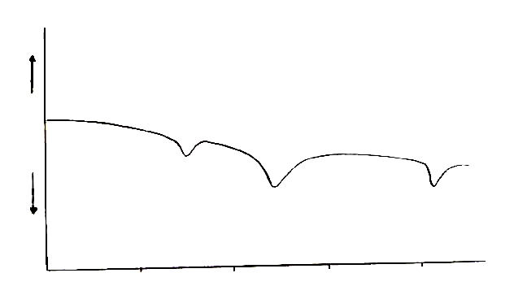
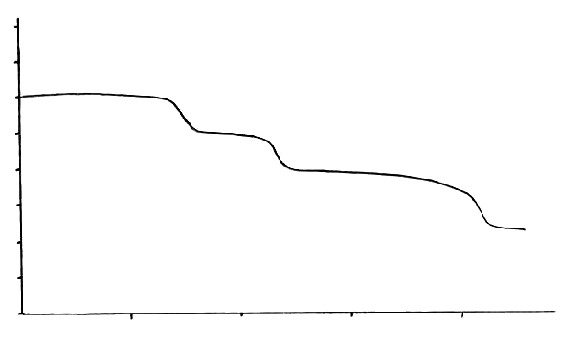
Endo.
Exo.
T
100
200
300
400
Temperature C
Figure (3): Differential Thermal Analysis Curve of Mixed Sample
100
200
300
400
Temperature C
Figure (4): Thermogravimetric Curve of Mixed Sample
0.7
0.8
0.9
1.0
1.1
w(g)
0
0

Finally, it is of interest to investigate both, the mineralogy and the migration and elimination of the above mentioned water molecules, by infrared absorption technique. Therefore, a range 400-4000cm⁻¹ in frequency was applied and the spectra reveal several absorption bands including those between 1000-1120, 490-525,465-485, and 1437-1450 cm⁻¹ which are attributed to the Si-O, Fe-O, Al-O, and CO₃²⁻ stretching vibrations respectively⁽¹⁵⁾.
Moreover, the spectra shows an absorption bands at 1635cm⁻¹ and in the range 3400-3600cm⁻¹ which are related to the structural (-OH) group⁽¹¹⁾ such bands show a significance variation in the position and sharpness of the vibration upon heating the sample in the range of 120-500 C which is related to the dehydration phenomena.
0

Adsorption activity
Obviously, it is difficult to state so many articles dealing with the adsorption and desorption catalysts reported till now. However, and in

general the materials which are suitable for the separation of majority of substances or for the separation of complex mixture into groups of compounds are said to be a good adsorbents and evaluated to be applied in fractionation processes.
Therefore, and referring to the above physical and chemical characteristics noted for the prepared sample in this study, three fractionating columns were packed with chromatographic grade (80-120mesh) activated rock and clay samples. They employed in fractionation of QP into its simple components using four eluants increased gradually in their polarities and the observed results are shown in Table (4). Results in the above table revealed the percentages of the fractions eluted. In general, adsorption of petrolene materials occurred strongly on rocks and clays minerals. Desorption also occurred on the same strength on using polar eluants.

Table(4):Chromatographic Fractions of QP* Using Different Adsorbents.
Solvent | Adsorption Coefficient | Ninivite Silica Rocks (%) | Natural Iraqi Fuller’s Earth(%) | Mixed Sample (%)
Heptane | 0.2 | 35.01 | 47.46 | 34.52
Toluene | 2.4 | 20.85 | 17.66 | 23.90
Chloroform | 4.1 | 25.07 | 20.88 | 24.07
Ethanol | 6.3 | 14.03 | 8.16 | 15.63
Loss | _______ | 5.04 | 5.84 | 1.88
* Average QP composition: 38% straight chain aliphatic, 27% branched aliphatic, 18%naphthenic, and 17%aromatic compounds⁽¹⁰⁾.

The chemical characteristics nature of the eluted fractions might be determined by referring to previous studies and relying on their infrared data^{(10,15,17)} ,Figure(5). The eluted fraction on using n-heptane, which is the lower polar solvent, seems to be mainly saturated paraffin hydrocarbons and compose mainly of straight aliphatic hydrocarbons. This via the absorption bands at 2930cm⁻¹ and 1460cm⁻¹ which are attributed to the stretching and bending vibrations of methylene groups⁽¹⁷⁾.
Interference of branched aliphatic and naphthenic compounds was happened in this fraction through the presence of absorption bands at 2858,1378, and 2842cm⁻¹ which are related to –CH₃ and naphthenic-CH₂ groups respectively⁽¹⁷⁾.

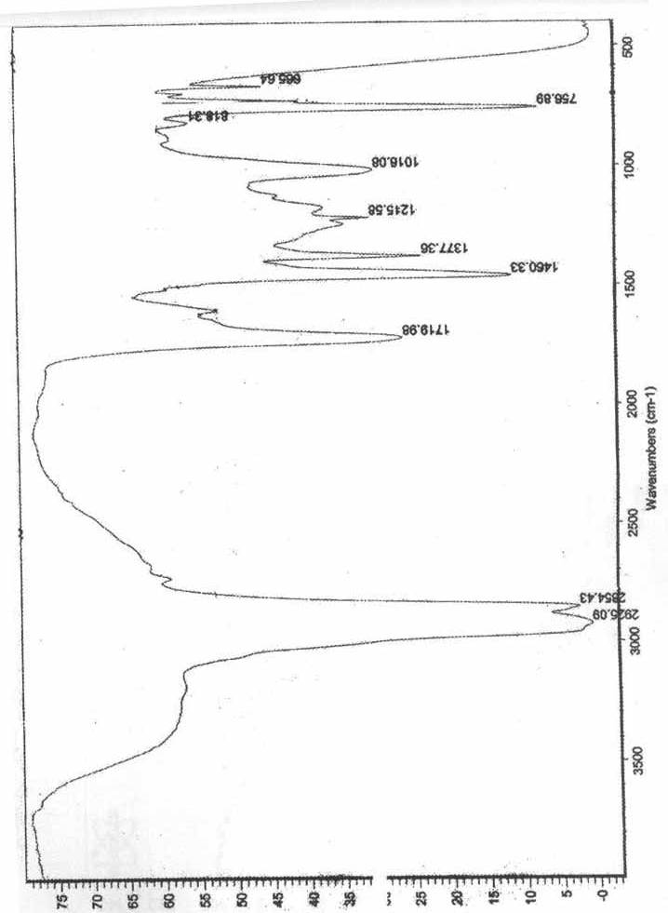
Figure (5): Infrared of the eluted sample

……

On studying the toluene fraction it was suggested that such fraction contains mostly of branched aliphatic compounds in addition to naphthenic once and little amounts of aromatics ( C C stretching bands at 1612cm⁻¹).

This aromatic appeared secondly in chloroform fraction which contains mainly of naphthenic hydrocarbons. Meanwhile, it was noted that ethanol fraction contains aromatic hydrocarbons accompanied with traces of naphthenics. The whole

interference occurred can be seen in Table (5) which represents the infrared data of the three samples investigated. The results reflect the fact that using mixed sample as adsorbent seems to be more active and selective in this field of studies.

Table(5): Infrared Spectroscopic Data for Eluted Fractions.
Solvent |  | $ϑ$C-H:CH₃ | $δ$C-H:CH₃ | $ϑ$C-H:CH₂ | $δ$C-H:CH₂ | CH₂:naph. | C$\underline{\text{.}\text{.}\text{.}\text{.}\text{.}\text{.}\text{.}}$Carom.
Heptane | I* | 2930(s) | 1460(s) | 2857(m) | 1377(m) | 2842(w) | -
Heptane | II | ~2930(s) | ~1460(s) | 2857(m) | ~1377(m) | ~2842(w) | -
Heptane | III | ~2930(s) | ~1460(s) | 2857(m) | ~1377(m) | ~2842(w) | -
Toluene | I | (m) | (m) | (s) | (s) | (m) | 1612(w)
Toluene | II | (m) | (m) | (s) | (s) | (m) | ~1612(w)
Toluene | III | (m) | (m) | (s) | (s) | (m) | ~1612(w)
Chloroform | I | (bm) | (bm) | (m) | (m) | (s) | (m)
Chloroform | II | (bm) | (bm) | (m) | (m) | (s) | (m)
Chloroform | III | (w) | (w) | (m) | (m) | (s) | (m)
Ethanol | I | (w) | (w) | (m) | (m) | (m) | (s)
Ethanol | II | (w) | (w) | (m) | (m) | (m) | (s)
Ethanol | III | (w) | (w) | (m) | (m) | (m) | (s)
* I:Ninivite Silica, II: Fuller’s, III: Mixed Sample.
m: medium s: strong w: weak bm: broad medium

References

- R.A. Chalmers, “Laboratory Handbook of Chromatographic Methods”, Buttler and Tanner Ltd., London,1970.
- A.Yamada,Y.Ezaki, and A. Nomura, J. Chromatog.,1995, 705(2),345.
- O. Mikes, “Chromatograhphic and Allied Methods”, John Wiley and Sons, New York,1979.
- S.Z. Jassim and S.Q. Al-Naqib, J.Iraqi Geol. Soc., 1989,22,112.
- K.J.Aswad, M.A.Amine, and S.Q.Al-Naqib, Dirasat, 1995, 22B,1541.
- K.M.Banat, “Basic of Minerals Clays”, Baghdad Univ. Press,1980.
- R.A.Buker and N.H.Taher, Dirasat, 2000, 27B(2), 244.
- R.A.Buker, National J. Chem., 2004,12,9.
- R.A.Buker, J.Chem.Soc. Iraq, 1993,18(2),79.
- O.M. Ramadhan, J.Fuel Sci. Tech.Int., 1992,10,221.
- R.A.Buker and S.A.M. Al-Mallah, To be Published in J.Edu. and Sci.,2006.
- R.A. Buker and N.H. Taher, Dirasat, 2006,33B(2).

- M. Ozacar, A. Alpand, and A.Aydin, J. Therm. Anal.., 2000, 59(3), 869.
- K. Carrado, S.E. Yuchs, and K. Song, “Heterogeneous Catalyst Based on Clays”, Pergamon Press Ltd., Britain,1996.
- K.Nakamoto, “IR and Ramman Spectra of Inorganic Compounds”, 5th. Ed., John Wiley & Sons., New York,1997.
- N. Johnson. “x-ray Diffraction for Geological Applications”, Shimatlza Group Company,2000.
- R.M. Silverstein, G.C.Baslar, and T.C. Morill, “Spectrometric Identification of Organic Compounds” 4th. Ed., John Wiley and Sons, Inc., New York,1981.

