Spectrophotometric Determination of Cobalt (II) Using
4-(6- Nitro-2-benzothiazolylazo) resorcinol

Nassir A. Nassir
college of Sciences, University of Kufa

(NJC)

(Received on 15/11/2006) (Accepted for publication on 27/5/2007)

Abstract
A sensitive and selective spectrophotometric method is proposed for the rapid determination of cobalt (II) using 4- (6- nitro-2- benzothiazolylazo) resorcinol (6-NO₂BTAR).The reaction between 6-NO₂BTAR and Cobalt (II) is instantaneous at pH 6.0 and the absorbance remains stable for over 24h. The method allows the determination of cobalt over the range (1-8) μg/ml with molar absorptivity of (4857.1) L.mol⁻¹.cm⁻¹ and features a detection limit of (0.2) μg/ml at 458 nm. The precision (R.S.D%<1%) and the accuracy obtained were satisfactory. The proposed method has been successfully applied to the determination of cobalt in filling.

الخلاصة
استخدم الكاشف العضوي 4- (6-نايترو-2-بنزوثيازوليل) ريسورسينول (6NO₂BTAR) في تقدير كميات مايكروغرامية من ايون الكوبلت (II) بطريقة تحليلية طيفية سهلة وسريعة وحساسة الطول ألموجي للامتصاص الأعظم للمعقد المتكون من تفاعل الكاشف 6NO₂BTAR مع ايون الكوبلت (II) هو 458 نانومتر عند pH=0.6 وبنسبة 2:1 من الايون الفلزي إلى الكاشف. مدى التراكيز التي تطاوع قانون بير تقع ضمن (8-1) مايكروغرام كوبلت (II) /مليلتر وبلغت قيمة الامتصاص المولاري 4857.1 لتر. مول⁻¹.سم⁻¹ وقيمة حد الكشف ( 0.2) مايكروغرام / مليلتر . وحدد دقة وضبط الطريقة التحليلية المتبعة باستخدام محلول قياسي من ايون الكوبلت (II) فكانت قيمة R.S.D%، Erel% , %Re هي 0.34%، 1.32-% ،98.68% على التوالي. كذلك تم تحديد التراكيز لعدد من الايونات الموجبة والجذور السالبة التي تتداخل عند تقدير ايون الكوبلت (II) باستخدام هذا الكاشف. طبقت الطريقة التحليلية لتقدير الكوبلت في حشوة الاسنان.

Introduction
Cobalt is an important element, not only for industry but also for biological systems. In rapidly expanding analytical fields such as environmental, biological and material monitoring of trace metals, there is an increasing need to develop simple, sensitive and selective analytical techniques that do not use expensive or complicated test equipment. Many sensitive techniques, such as spectrofluorimetry, X-ray fluorescence, spectrometry, neutron activation analysis, atomic absorption spectrometry and chemiluminescence have been widely applied to the determination of cobalt ⁽¹⁻⁷⁾.
However, the spectrophotometric method still has the advantages of being simple and not requiring expensive or complicated test equipment. For this reason, a wide variety of spectrophotometric methods for the determination of cobalt have been developed. The main chromogenic reagents are pyridylazo reagents, thiazolylazo reagents, benzothiazalylazo reagents, 8-aminoquinoline derivatives, porphyrins, nitroso dyes etc ⁽⁸⁻¹⁸⁾ . Each chromogenic system has its advantages and disadvantages with respect to sensitivity, selectivity and rapidity.
Eskandari et al., ⁽¹⁹⁾ proposed a simulataneous determination of copper (II) and cobalt (II) by first and second derivative by 1-(2-pyridylazo)-2-naphthol in tween 80 micellar solutions. Study on the solid phase extraction and spectrophotometric determination of cobalt with 2-(2-Quinolyazo)-5-diethylaminoaniline was achieved⁽²⁰⁾ at 625 nm. Beer’s law is obeyed in the range of (0.01-0.6) μg.ml⁻¹ with molar absorptivity of 1.43× 10⁵ L. mol⁻¹. cm⁻¹.
In this paper, the result presented indicate that 4-(6-Nitro benzothiazolylazo) resorcinol, which prepared by Azhar ⁽²¹⁾ is a sensitive and selective reagent for the rapid and accurate determination of cobalt (II).

Experimental
Apparatus
A Shimadzu 1650 UV- Visible scanning spectrophotometer equipped with 10 mm quartz cells was used to record absorption spectra. An Apel 303S visible spectrophotometer was utilized to measure the absorbance of the solutions. A WTW model ph meter was used for measuring and adjusting pHs of the solutions.

Reagents
All chemicals were used of analytical grade unless stated otherwise. All solutions were prepared with distilled water.
- Standard cobalt (II) solution. A solution of cobalt (II) (1000 μg.ml⁻¹) was prepared by dissolving (0.4038)g of cobalt chloride hexa hydrate ( Merck) in (100) ml of the water. Working solutions were prepared freshly by appropriate dilution of the stock solution.

-4-(6-Nitro-2-benzothiazolylazo)resorcinol(6-NO₂BTAR)(3×10⁻⁴ M). prepared by dissolving (0.0095)g of 6-NO₂BTAR in (100)ml of absolute ethanol (Hopkin & Williams).

Procedure
Into a 10 ml standard flask, transfer a portion of the solution containing cobalt in the range from (10-80) μg, adjust pH around 6.0, 2ml of 6-No₂BTAR solution and the mixture was diluted to the mark with the water. Measure the absorbance after (4) min at 458 nm at 45°C against blank prepared under the same conditions.

Results and Discussion
Absorption spectra
The absorption spectrum of cobalt (II)-6NO₂BTAR complex was recorded against a reagent blank. The complex absorbs strongly at 458nm, whereas the reagent absorbs at 414 nm. The characteristic absorption spectra are shown in fig(1).

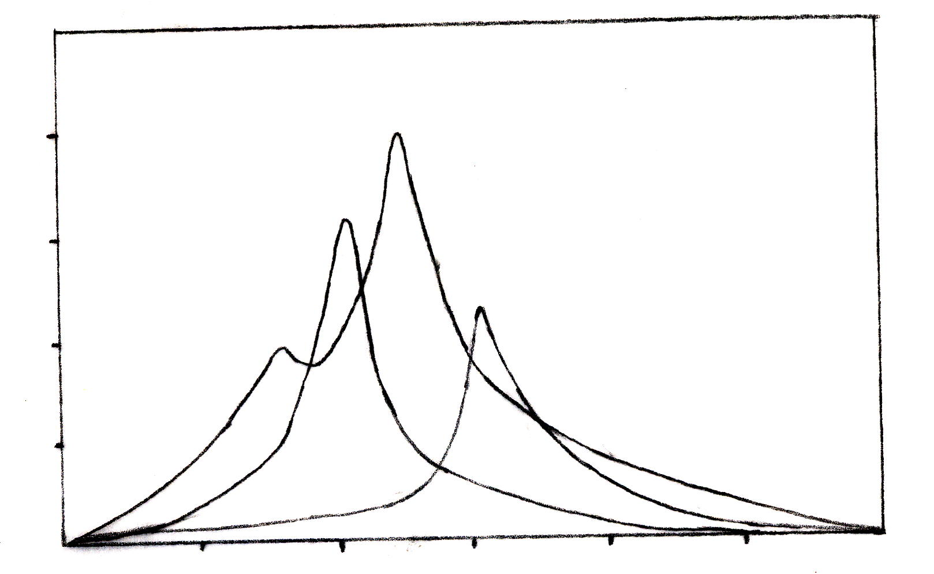
1.25
1.00
0.75
0.25
200
300
400
500
600
700
800
Absorbance
1
2
3
Wavelength /nm

Fig. (1): Absorption spectrum of:
(1) Co(II)-6NO₂ BTAR complex at pH=6.0
(2) 6NO₂ BTAR, 3.0x10⁻⁴ M.
(3) Co(II) solution, 2x10⁻²M

Effect of Reagent concentration
For up to 15μg of cobalt (II), the effect of reagent concentration on absorbance was studied by varying the amount of 6-NO₂BTAR from(0.5-4.5)ml. It was obtained that the complex formation was complete and absorbance was maximum when the amount exceeds from 2.5ml and no change in absorbance was observed above this range. An amount less than 2.5ml provides incomplete complex formation and the absorbance measured was low. So 2.5ml of reagent were used for all experiments.
ffect of pH
The absorbance of the complex Co(II)-6NO₂BTAR depends on the pH of the solution. The influence of pH was studied over the range (2-8) adjusted by means of 0.1 NHCl and 0.1N NaOH. The maximal and constant absorbance was obtained in the pH range of (5-6). At pH>7.0 a decrease in absorbance was observed due to precipitation of cobalt complex, fig (2).

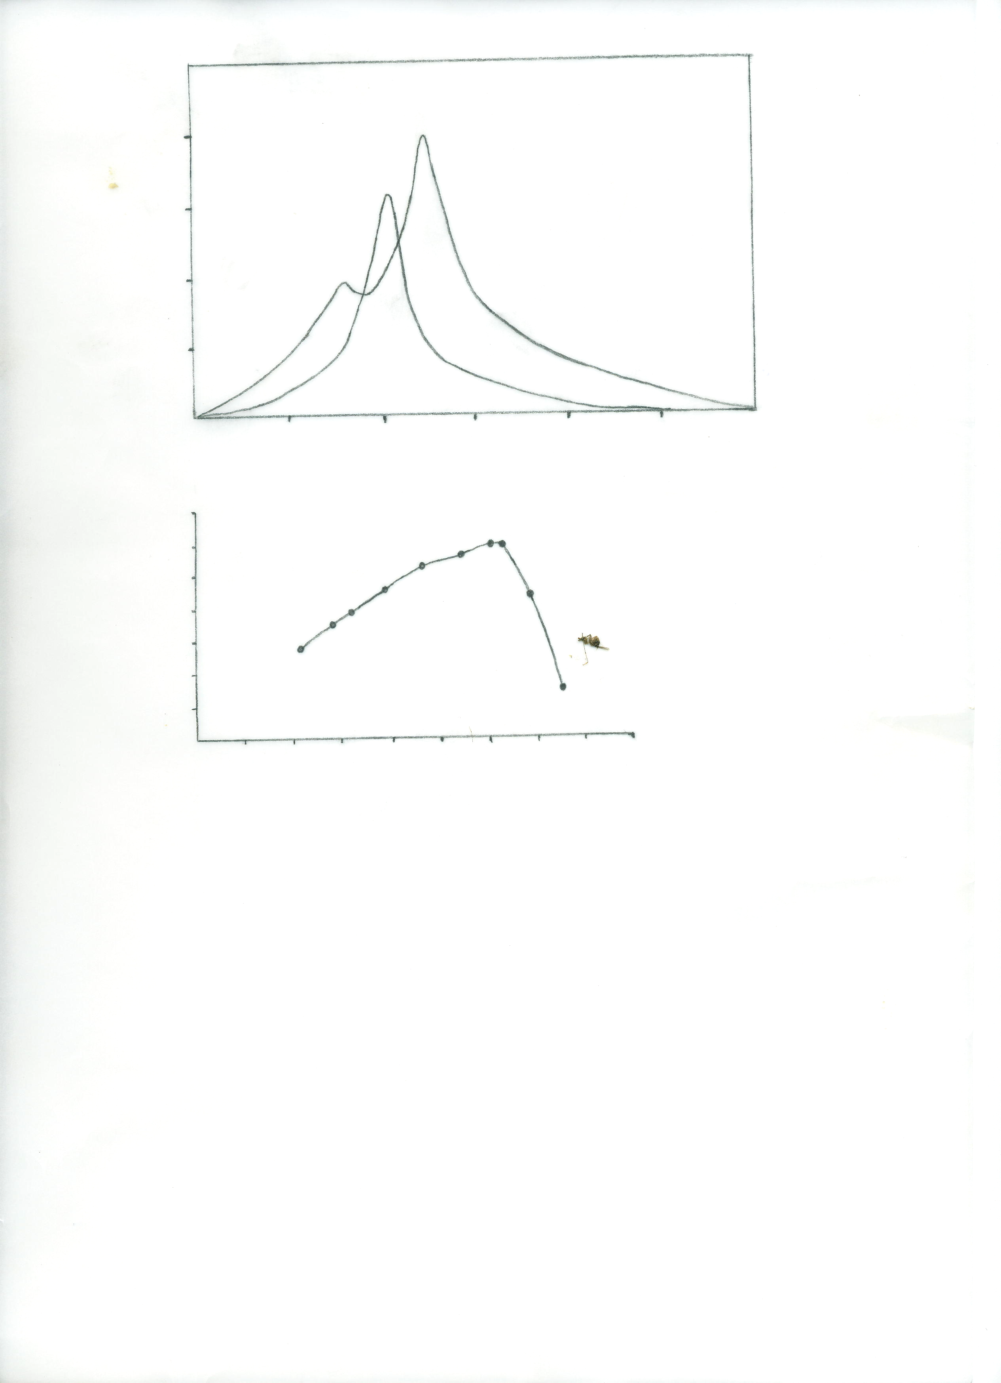
Absorbance
1.0500
0.9000
0.7500
0.60000
0.450000
0.3000000
0.1500000
1
2
3
4
5
6
7
8
9
pH

Fig. (2) Effect of pH on the absorbance of cobalt complex

Stability of the chromogenic system.
The stability of complex was checked by measuring the absorbance of the solution at different time of intervals. The absorbance reached its maximum within (4)min. The complex was found to be stable until 24h.
Effect of Temperature
The effect of temperature on the absorbance of Co(II)-6NO₂BTAR complex was studied. The study was performed at temperatures between 15 and 75°C. The maximum absorbance was obtained when the Temperature at 45°C. Moreover, at temperatures higher than 45°C the absorbance gradually decreased with increasing temperature until it reaches 75°C which may be due to dissociation of the complex with increasing temperature higher than 45°C. After 75°C the complex was vaporized.
Composition of Complex and Formation Constant
The complex composition was determined by job’s and mole-ratio methods ( Fig.3,4). Both methods indicated that the complex has a molar ratio of 1:2 (cobalt: 6NO₂BTAR)at pH 6.0 . The formation constant, calculated by applied procedure⁽²²⁾, was found to be 1.12×10⁷L².mol⁻².
Analytical characteristics
The calibration curve was made as described in the experimental procedure and good correlation coefficient was found. Beer’s law is obeyed from 1 to 8μg.ml⁻¹ of cobalt. The analytical sensitivity⁽²³⁾, the calibration sensitivity⁽²⁴⁾ the limit of detection⁽²⁵⁾ as well as other analytical characteristic of the procedure are summarized in table (1).

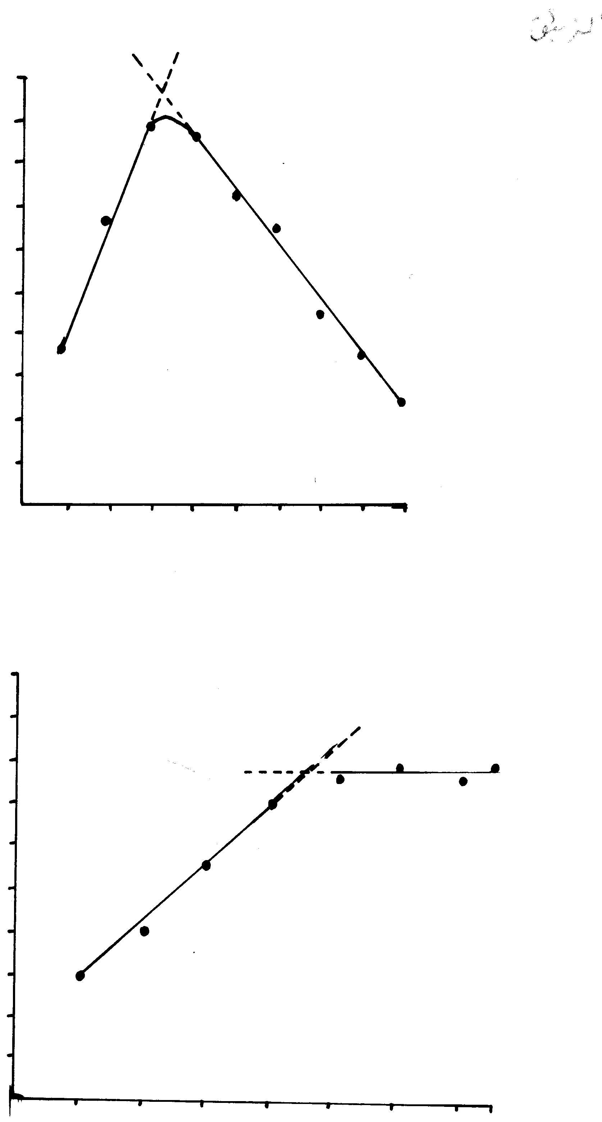
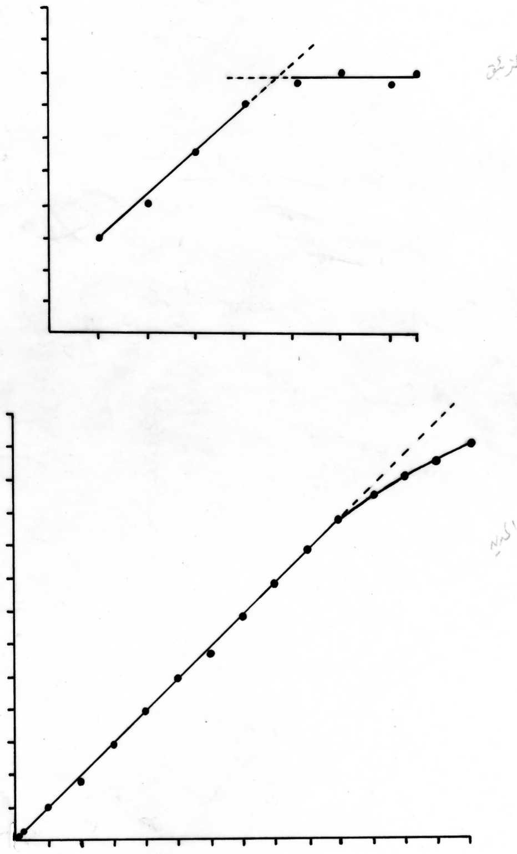
0.1
0.2
0.3
0.4
0.5
0.6
0.7
0.8
0.9
0.020
0.040
0.060
0.080
0.100
0.120
0.140
0.160
0.180
0.200
Absorbance
Vm / Vm + Vl
Fig(3) : Job plots . [6NO₂ BTAR ] = [Co(II) ] = 3 ×10⁻⁴ , pH = 6 .0
0.4
0.8
1.2
1.6
2.0
2.4
2.8
3.0
0.010
0.040
0.070
0.100
0.130
0.160
0.190
0.220
0.250
0.280
Absorbance
Mole R / Mole M
Fig(4) : Mole – ratio plots . [6NO₂ BTAR ] = [Co(II) ] = 3 ×10⁻⁴ , pH = 6 .0

Table (1) : Analytical characteristics of the proposed procedure (N= no. of determinations, σ= standard deviation)
Analytical parameter | Value
Molar absorptivity | 4857.1 L.mol⁻¹.cm⁻¹
Calibration sensitivity(m) | 0.08 ml.μg⁻¹
Analytical sensitivity (y) | 18.4 ml μg⁻¹
Inverse of the analytical sensitivity (1/y) | 54 ng.ml⁻¹
Correlation coefficient (r) | 0.9997
Limit of detection (3σ) | 0.2
Linear dynamic range | (1-8)μg.ml⁻¹
Percent Relative error | -1.32%
Percent Recovery | 98.68%
Relative standard deviation | 0.34% (N= 7)

Effect of Foreign Ions
A study of potential interferences in the determination of cobalt was performed. An error of ±5% in absorbance reading was considered tolerable. Solutions containing cobalt (8mg.l⁻¹) and other ions were prepared and the developed procedure was applied. The tolerance limits of various foreign ions are given in table (2). These results demonstrate that the effect of Al³⁺ , Ba²⁺, NH₄⁺, F⁻, I⁻, oxalalate and thiosulphate are negligible, while the effect of Cu²⁺, Ni²⁺, Zn²⁺, Fe²⁺,Hg²⁺, VO₃⁻ are seriously interfere.

Table(2) :Tolerance limit of foreign ions on cobalt (8 mg.l⁻¹) determination by proposed procedure.
Ions | Maximum tolerable ion amount/mg l⁻¹
NH₄⁺ | 600
F⁻ | 500
I⁻ | 300
Cu²⁺ | 5
VO₃⁻ | 25
Al³⁺ | 200
Zn²⁺ | 18
C₂O₄²⁻ | 1000
Ni²⁺ | 5
Hg²⁺ | 15
Ba²⁺ | 100
Fe²⁺ | 20
S₂O₃²⁻ | 1200

Application
The proposed method has been applied to the determination of cobalt in filling. Results are shown in table(3). The results obtained, as the average of three determinations are compared with those given by atomic absorption spectrophotometer (AAS) (standard addition method).

Table (3) Determination of cobalt in filling.
standard sample | certified content(%) | proposed method(%)*
Rua Funchal 376** | 3.30 | 3.05±0.13

*Average of three determinations, at 95% confidence level.
** provided from Degussa Dental Ltd., Brasil. Sample Composition Ag (71%), Sn (25.7%), Co(3.3%).

References
1- J. Pauwels, C. Hofman and H.K. Grobeeker, Fresenius J Anal. Chem., 1993, 345, 475.
2- A.I. Yuzeforsky, R.F. Lonardo and R. G. Michel, Anal. Chem., 1995, 67,2246.
3- A. Chow, G.F. Yamashita and R.F. Hamon, Talanta, 1981,28,437.
4-Q.E.Cao, Y.K. Zhao, S.Q .Wu and Z.D. Hu, Talanta, 2000, 51,615.
5- B. Maziere, J. Gros and D. Comar, J. Radioanal chem.. 1975, 24, 707.
6- Z. Li’. G.Y. Yang, B.X. Wang, C.Q. Jiang and J.Y. Yin, J. Chromatogr.2002, 971, 243.
7- Y.L.Yang, G.Y. Yang and Q. Lin, Microchim Acta, 2004, 144,297.
8- G.Y. Yang, Z.J. Huang, Q.F. Hu and J.Y Yin, Talanta, 2002, 58, 511.
9- L.M. Siroki, L. Maric, Z. Stefanac and M.J. Herak, Anal Chim Acta 1975, 75,101.
10- M.R. Khan and S.B. Khoo, Analyst, 1998,123,135.
11- G.Y. Yang, X.C. Dong, Q.F. Hn and J.Y. Yin, Anal lett, 2002, 35,1735.
12- M.S. Carvalho, I.C. Fraqa, K.C. Neto and E.Q Filho, Talanta, 1996, 43, 1675.
13- Q.F. Hu, Z.J. Huang and J.Y. Yin, Indian J. Chem, 2004, 43A,108.
14- Z. Li, G.Y. Yang, B.X. Wang and J.Y. Yin, Anal Bioanal chem., 2002, 374,1318.
15- H.B. Singh, N.K. Agnihotri and V.K. Singh, Talanta, 1999, 48,623.
16- C.I. Park and K.W. Cha, Talanta, 1998,46,1515.
17- H. Eskandari, H.S. Ghaziaskar and A.A. Ensafi, Anal Sci,2001,17,327.
18- A.S. Amin, I.S. Ahmed and M.E. moustafa, Anal lett, 2001, 34,749.
19- H. Eskandari, A.G. Saghseloo and M.A. Chamjangoli, Turk J. chem, 2006, 30, 49.
20- Q.F. Hu, G. yang, X. Dong and J.Y. Yin, Turk J chem., 2004,28,611.
21-A.A. Qhali, M. Sc. Thesis, University of Babylon, 2003.
22- Job, Ann. Chim.1928, 9, 113.
23-D.A.Skoog, “Principles of Instrumental Analysis”, 3rd edn, Saunder Golden Publishing, p22, 1985 .
24-D.A.Skoog, F.J. Holler, and J.A. Nieman, “Principles of Instrumental Analysis”, 5th edition, Saunders College publishing, p13, 1998 .
25- J.D. Ingle, J. Chem . Educ ., 1970, 42,100 .

