New six coordinate cobalt(III) complexes of
[1,2-diaminoethane –N,Ń-bis (2-butylidine -3-onedioxime)]

Mohamad Jaber Al-Jeboori College of Education | Eman I.Abdulkarim College of Education | Jassim S. Al-Dulaimi College of Education.
Ibn Al-Haitham, University of Baghdad,P.O. 4150, Adhamiyah, Baghdad, Iraq

(NJC)

(Received on 30/10/2006) (Accepted for publication on 27/5/2007)

Abstract
The ligand [1,2-diaminoethane –N,Ń-bis (2-butylidine -3-onedioxime)][H₂L]. was reacted with Co(NO₃)₂.6H₂O and KBr in ethanol with reflux in (1:1) metal : ligand ratio to give a new complex of the general formula [Co^{III}(HL)Br₂]. A series of new complexes with some heterocyclic nitrogen and aliphatic amine ligands of the general formula [Co^{III}(HL)(X)Br]Br (where: X=pyridine, 4-picoline, and 3-picoline, piperidine, octylamine, n-propylamine and Br) were prepared. All compounds have been characterised by spectroscopic methods [IR, U.V-Vis, atomic absorption, (¹H NMR, and EI-mass spectroscopy for the ligand)], microanalysis andwith conductivity measurements. From the obtained data, a distorted octahedral molecular structure about Co(III) ion has been proposed.
الخلاصة
- L. A. Chugaev, Zh. Russ. Physicochem. Soc. 41, 184, 1909.
تضمن البحث تحضير الليكند
1,2-diaminoethane- N,Ń-bis (2-butylidine -3-onedioxime) [H₂L]
وذلك من مفاعلة الاثيلين ثنائي الامين مع ثنائي الاسيتايل احادي الاوكزيم . ثم مفاعلة الليكاند مع نترات الكوبلت وبروميد البوتاسيوم باستخدام الميثانول وسطا للتفاعل و تحت التصعيد العكسي وبنسبة (1:1) حيث تكون معقد جديد ذي الصيغة العامة :
[Co(HL)Br₂ ]
كذلك تم تحضير سلسلة جديدة من المعقدات ذوات الصيغة العامة :
Br [Co(HL)Br.X]
حيث :
X= (pyridine, 4-picoline, 3-picoline, piperidine, octylamine, and n-propylamine).
شخصت جميع المركبات بالطرق الطيفية المعروفة ( الاشعة تحت الحمراء والاشعة فوق البنفسجية –المرئية ومطيافية التذرية و ( ¹H NMRوطيف الكتلة بتقنية القصف الالكتروني EI لليكند) ,كذلك شخصت المركبات بوساطة التحليل الكمي الدقيق للعناصرCHN مع التوصيلية المولارية الكهربائية. بينت الدراسات التشخيصية ان الشكل الفراغي المتوقع لمعقدات الكوبلت هو ثماني السطوح المشوه .

Introduction
It is well known that heterocyclic compounds play a significant role in many biological system, especially six members ring system being a component of several vitamins and drugs ^{[1]}.The chemistry of metal oximato complexes has been investigated intensively e.g., preparation of nickel^{(п)} dimethylglyoximate, and recognition of the chelate five- membered ring character of this complex by Chugaev ^{[2]}. Transition metal complexes with vic-dioxime have attracted attention of many researchers because of their similarity to vitamin B₁₂^{[3,4]}. Numerous chemical studies have been made on the cobalt(II)-cobalt(III)-bis(dimethylglyoxime)system which has been called a model system for the B₁₂ moiety,^{[5,6]} vic-Dioximes have great importance since they are used as chelating agents due to their stability of complexes with transitions metal ^{[7,8]}. Recently CoIII oxime based compounds showed the possibility of using in detergent industry, and 3,8-dimethyl-5,6-benzo-4,7-diazadeca-3,4-diene-2,9-diene dioxime CoIII complex is the candidate to be used as a cationic surfactant^{[9]}. The present paper describes the synthesis and characterisation of a new series of Coш -vic-dioxime cationic complexes with (pyridine, 4-picoline, 3-picoline, piperidine, octylamine, n-propylamine, and Br).

Experimental
Reagents were purchased from Fluka and Rediel- Dehenge Chemical Co. .I.R spectra were recorded as (KBr) discs using a Shimadzu 8400 S FTIR spectrophotometer in the range (4000-400) cm⁻¹. Electronic spectra of the prepared compounds were measured in the region (200-900) nm for10⁻³M solution in (DMF) at 25 ⁰C using a Shimadzu160 spectrophotometer, with 1.000+0.001 cm matched quartz cell. Mass spectrum for the ligand was obtained by Electron-Impact (El) on a Shimadzu GCMSQPA 1000 spectrometer. Nuclear Magnetic Resonance spectrum ¹H NMR for (H₂L) ligand was recorded in DMSO-d⁶ using a Jeol EX 270 MHz instrument with a tetramethylsilane (TMS) as an internal standard. Elemental microanalyses were performed on a (C.H.N.) analyser from Heraeus (Vario EL), at the University of Free Berlin/Germany. While metal contents of the complexes was determined by atomic absorption (A.A) technique using a Shimadzu A.A 680G atomic absorption spectrophotometer. The bromide contents for complexes were determined using potentiometric titration method, on 686-Titro Processor Dosimat-Metrahm-Swiss. Electrical conductivity measurements of the complexes were recorded at 25 ⁰C for 10⁻³ M solutions of the samples in (DMF) using a PW 9526 digital conductivity meter.

Synthesis of the ligand [1,2-diaminoethane-N,Ń-bis(2-butylidine-3-onedioxime)][H₂L]^{[10]}.
Synthesis of [Co(HL)Br₂]
To an ethanolic solution of Co(NO₃)₂.6H₂O (0.58g, 2mmole) in (10 ml) ethanol, KBr (0.24g, 2 mmole) was added. KNO₃ was separated by filtration. The solution was concentrated under reduced pressure and taken as CoBr₂. The ligand [H₂L] (0.9g, 4mmol) was added to the above solution, and the mixture was warmed to 40 ⁰C and stired for (30min), then cooled. Air was passed for 3 hrs, a yellow solid was formed which was collected by filtration, and dried under vacuum for (24 hrs.) to give [Co(HL)Br₂]. Yield 0.6g, (61%), m.p. (199-200 ⁰C).
Synthesis of [Co(HL)(py)Br]Br
To an ethanolic solution of Co(NO₃)₂.6H₂O (0.58g, 2mmole) in (10mL) ethanol, KBr (0.24g, 2 mmole) was added. KNO₃ was separated as precipitate, and then filtered off. The solution was concentrated under reduced vacuum and taken as CoBr₂. The above solution was warmed and stirred for 15 min. The ligand [H₂L] (0.9g, 4mmol) was added to the solution. The mixture was warmed and allowed to stir for (30min), and then cooled. A solution of (0.31g, 4mmol) of pyridine in (10mL) was added. The reaction was allowed to reflux for 2 hrs, and then air was passed for 4 hrs. The pale brown precipitate crystals which formed upon standing were collected, washed with (10 mL) diethylether, and dried to give 0.4g (64%) of the titled compound, m.p (220-224 ⁰C) dec.
Synthesis of [Co(HL)(pip.)Br]Br
A similar procedure to that described for [Co(HL)py.Br]Br was employed but with piperidine (0.34g, 4mmole) in place of pyridine. The quantities of the other regents were adjusted accordingly and an identical work-up procedure gave brown precipitate , which was washed with (10mL) diethyl ether to yield 0.35g (59%), m.p(226 -228 ⁰C) dec.
Synthesis of [Co(HL)(oct.)Br]Br
A similar procedure to that described for [Co(HL)py.Br]Br was used but with octylamine (0.5g, 4mmole) in place of pyridine. The quantities of the other regents were adjusted accordingly and an identical work-up procedure gave a yellow precipitate 0.48g (75%) of the title compound, m.p (180 -183⁰C).
Synthesis of [Co(HL)(n-pro.)Br]Br
The method used to prepare [Co(HL)(n-pro.)Br]Br was analogous to the procedure given for the complex [Co(HL)(oct.)Br]Br but with n-propylamine (0.236g, 4mmole) instead of octylamine . The quantities of the other regents were adjusted accordingly and an identical work-up procedure gave an orange precipitate 0.42g (74%),m.p(220 ⁰C).

Synthesis of [Co(HL)(4-pic.)Br]Br
A similar procedure to that described for [Co(HL)py.Br]Br was used but with (0.37g, 4mmole) of 4-picoline in place of pyridine. The quantities of the other regents were adjusted accordingly and an identical work-up procedure gave a pale brown precipitate, yield 0.39g (65%), m.p (210 ⁰C)dec.
Synthesis of [Co(HL)(3-pic.)Br]Br
The method used to prepare [Co(HL)(3-pic.)Br]Br. was analogous to the procedure given for the complex of 4-picoline but with 3-picoline (0.37g, 4mmole) instead of 4-picoline. The quantities of the other regents were adjusted accordingly and an identical work-up procedure gave a mustard precipitate 0.4g (67%), m.p (200 ⁰C) dec.
Results and discussion
Synthesis of the ligand
The [H₂L] pro- ligand was prepared according to published method^{[10]} as shown in Scheme(1). The (I.R) spectrum for (H₂L) displayed two bands at (1609) and (1473cm⁻¹) due to the υ(C=N) stretching for the imine and oxime groups respectively, Table(2). The band at (3145cm⁻¹) is attributed to the υ(O-H) stretching of the oxime group. The strong

bands at (1001) and (918cm⁻¹) are attributed to υ(N-O) stretching^{[11]}. The (U.V-Vis): spectrum exhibits a high intense absorption peak at (293nm) (34130cm⁻¹) (ε_{max}=1978 molar⁻¹.cm⁻¹) which assigned to overlap of (n→π*) and (π→π*) transitions^{[12]} Table (3). The EI(+) mass spectrum of the ligand Fig.(4), shows the parent ion peak at (m/z =226) wich corresponds to [M]⁺, and the fragments at,(209), (192), (166), (151), (125), (112), (96),and (68), are assigned to [M-(OH)]⁺, [M-{(OH)₂}]⁺, [M -{(OH)₂-CN}]⁺, [M-{(OH)₂-CN-CH₃}]⁺, [M-{(OH)₂-CN-CH₃-CN}]⁺, [M-{(OH)₂-CN-CH₃-CN-CH}]⁺, [M-{(OH)₂-CN-CH₃-CN-CH-NH₂}]⁺, [M-{(OH)₂-CN-CH₃-CN-CH-NH₂-CNH₂}]⁺, respectively. The ¹H NMR spectrum of [H₂L], in DMSO-d⁶ , Fig.(5) showed (OH) protons of the oxime appear as a broad signal at (11.46)ppm. This resonance was disappeared upon addition of D₂O to the solution ^{[13]}. The CH₂ protons are equivalent and appear as a singlet at (3.70) ppm. As can be seen from the spectrum the two sharp singlets at (2.02) and (1.89) ppm are due to the methyl groups on carbons (C-1,4) and carbons (C-2,3) respectively. However each peak is equivalent to six protons ^{[14, 15]}.

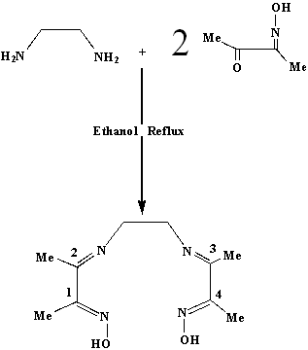
Scheme (1) The synthesis route for the ligand

Synthesis of the complexes
The synthesis of the new six coordinate complexes of the type [Co(HL)X]Br (X= pyridine, 4-picoline, 3-picoline, piperidine, octylamine, and n-propylamine] was carried out in EtOH solvent. These complexes are stable in EtOH solution. The analytical and physical data Table(1) and spectral data Table (2) and Tabl0e (3) are compatible with the suggested structure Fig.(1). The (I.R) spectral data of the complexes are presented in Table(2). In general the (I.R) spectra of the complexes show two bands within (1670-1630) and (1585-1562)cm⁻¹ range which assigned to the υ(C=N) for the imine and oxime groups respectively, indicating the coordination of nitrogen atoms of the imine and oxime groups.^{[16]}. The strong υ(N-O) stretching bands at (1001) and (918) cm⁻¹ for the free ligand are shifted markedly to higher frequencies by ca. (90) cm⁻¹ . This is presumably due to the complexation with the metal ions. For these complexes the two (N-O) bands are unequal^{[17]}. The weak and broad bands appeared within the region (2580 – 2405) cm⁻¹ and (1765 – 1736) cm⁻¹ are due to the υ(O…H-O) stretching and δ(O…H-O) bending for the hydrogen bond respectively, in which the ligand looses a proton and a hydrogen bonding will be formed. However, these bands are absent in the spectrum of the spectrum of the free ligand^{[10]}. The bands at (514-509)cm⁻¹ were assigned to υ(M-N) stretching, indicating that the imine and oxime nitrogens were involved in coordination with metal ion^{[18]}. The molar conductance of the complexes in (DMF) lie within the (60-75 Ω⁻¹.cm².mole⁻¹) range Table (3), indicating their electrolytic nature with 1:1 ratio (bar [Co(HL)Br₂] complex in which the molar conductance in DMF is 25 Ω⁻¹.cm².mole⁻¹, indicating its non-electrolytic nature)^{[19]}. The electronic spectral data of the complexes are summarised in Table (3). The (U.V-Vis.) spectra of the complexes
displayed a peak at (500-585)nm is due to (d-d) spin allowed transition type (³T_{2g} ←¹A_{1g}), suggesting distorted octahedral structure about Co^{(ш)} ion^{[20]}. The (³T_{2g} ←¹A_{1g}) band is masked by the intense charge transfer bands. The bands at the range (293-305)nm assigned to the intra-ligand (π→π*) transitions of the coordinated ligand. The bands occurring at the range (362-383)nm are assigned to charge transfer^{[21]}.

Table (1) Analytical and physical data of the ligand and complexes

Found , (Calc.) % |  |  |  |  | Yield% | M.P ⁰C | Colour | Compound
Co Br |  | N | H | C
- | - | (24.77) 24.34 | (7.96) 7.32 | (53.09) 52.50 | 56 | 164 | White | [H₂L] ( C₁₀ H₁₈ N₄ O₂)
(36.01) 35.42 | (13.27) 12.72 | (12.62) 12.14 | (3.83) 3.54 | (27.04) 26.50 | 61 | 199 | Yellow | [Co(C₁₀ H₁₇ N₄ O₂ ) Br₂]
(18.04) 17.64 | (13.30) 13.00 | (15.81) 15.30 | (4.97) 4.60 | (40.65) 40.10 | 64 | 220 | Brown | [Co(C₁₀ H₁₇ N₄ O₂ ) py.Br]Br
(17.84) 17.56 | (13.15) 12.71 | (15.63) 15.07 | (6.03) 5.75 | (40.19) 39.80 | 59 | 226 | Brown | [Co(C₁₀ H₁₇ N₄ O₂ ) pipe.Br]Br
(16.11) 15.50 | (11.88) 11.32 | (14.12) 13.72 | (7.26) 6.81 | (43.56) 43.20 | 75 | 180 dec | Yellow | [Co(C₁₀ H₁₇ N₄ O₂) oct.Br]Br
(18.76) 18.24 | (13.83) 13.20 | (16.44) 16.24 | (6.11) 5.82 | (36.63) 36.32 | 74 | 220 | Orange | [Co(C₁₀ H₁₇ N₄O₂) npro.Br]Br
(17.49) 17.21 | (12.89) 12.50 | (15.32) 15.00 | (5.47)  5.15 | (42.03) 41.65 | 65 | 210 dec | Pale brown | [Co(C₁₀ H₁₇ N₄ O₂) 4pic.Br]Br
(17.49) 17.00 | (12.89) 12.31 | (15.32) 15.10 | (5.47)  5.00 | (42.03) 41.37 | 67 | 200 dec | Mustard | [Co(C₁₀ H₁₇ N₄ O₂ ) 3pic.Br]Br

Table (2) The I.R. spectral data of the complexes and its complexesª
ª S: strong, m: medium, w: weak, br: broad, w.br: weak and broad
Additional peaks | υ(M-N) | δ(O..H-O) | υ(O..H-O) | υ(N-O) | υ(C=N) imine υ(C=N) oxime | υ(C-H) aliph υ(C-H) aroma | compound
1415(CH₂)(s) | - | - | - | 918 (sh)  1001 (sh) | 1609 (s)  1473 (s) | 2850(br) 3016(br) | [H₂L]
1430 (CH₃)(br) | 512(sh) | 1650(w) | 2500(w) | 979 (sh) 1091(sh) | 1670(sh) 1562(sh) | 2920 (br)  3018 (br) | [Co(HL) Br₂]
1450 (CH₃)(sh)  1615υ(C=C)  ring | 509 (sh) | 1753(w) | 2600(w) | 977 (sh)  1078 (sh) | 1660 (sh)  1563 (sh) | 2925 (w)  3053 (w) | [Co(HL) py.Br]Br
1445 (CH₃)(sh) | 510 (sh) | 1699(w) | 2630(w) | 979 (sh)  1024 (br) | 1655 (br)  1562 (sh) | 2952 (br)  3091 (br) | [Co(HL)pip.Br]Br
1425 (CH₃)(br)  1209υ(C-N)(w) | 513 (sh) | 1750 (w) | 2519 (w) | 1047 (w)  1091 (sh) | 1670 (w)  1585 (sh) | 2920 (br)  3045 (br) | [Co(HL) oct.Br]Br
1384 (CH₃)(sh) | 513 (sh) | 1755 (w) | 2565 (w) | 977 (w)  1006 (w) | 1670 (sh)  1575 (sh) | 2970 (sh)  3058 (br) | [Co(HL) n pro.Br]Br
1446 υ(C=C) ring | 514 (w) | 1720 (w) | 2661 (w) | 973 (sh)  1037 (w) | 1630 (sh)  1570 (sh) | 2956 (br)  3018 (br) | [Co(HL) 4 pic.Br]Br
1384 (CH₂) (s) | 510 (sh) | 1730 (w) | 2588 (w) | 983 (w)  1004 (w) | 1660 (w)  1565 (sh) | 2925 (br)  3095 (br) | [Co(HL ) 3-pic.Br]

Table (3) Electronic spectral data, and conductance measurements

for the ligand [H₂L] and it’s complexes
Λ_{m}  Ω⁻¹.cm².)  Mole⁻¹) in DMF | Assignment | ε_{max} Molar Cm⁻¹ | nm λ | Compound
- | (n→π*)  (π→π*) | 1978 | 293 | [H₂L]
25 | charge transfer | 1472 | 383 | [Co(C₁₀H₁₇N₄O₂) Br₂]
60 |  | 1293 | 376 | [Co(C₁₀H₁₇N₄O₂)(py)Br]
60 | (³T_{2g} ←¹A_{1g}) | 134 | 575 | [Co(C₁₀H₁₇N₄O₂)(py)Br]
65 |  | 2482 | 313 | [Co(C₁₀H₁₇N₄O₂)(pi)Br]
65 |  | 1222 | 376 | [Co(C₁₀H₁₇N₄O₂)(pi)Br]
65 | (³T_{2g} ←¹A_{1g}) | 74 | 570 | [Co(C₁₀H₁₇N₄O₂)(pi)Br]
70 |  | 2201 | 301 | [Co(C₁₀H₁₇N₄O₂)(oct)Br]
70 |  | 952 | 362 | [Co(C₁₀H₁₇N₄O₂)(oct)Br]
70 | (³T_{2g} ←¹A_{1g}) | 46 | 580 | [Co(C₁₀H₁₇N₄O₂)(oct)Br]
75 |  | 1334 | 379 | [Co(C₁₀H₁₇N₄O₂)(n-pro)Br]
75 | (³T_{2g} ←¹A_{1g}) | 81 | 500 | [Co(C₁₀H₁₇N₄O₂)(n-pro)Br]
72 |  | 1763 | 300 | [Co(C₁₀H₁₇N₄O₂)(4-pic)Br]
72 |  | 750 | 358 | [Co(C₁₀H₁₇N₄O₂)(4-pic)Br]
72 | (³T_{2g} ←¹A_{1g}) | 113 | 520 | [Co(C₁₀H₁₇N₄O₂)(4-pic)Br]
78 |  | 1472 | 383 | [Co(C₁₀H₁₇N₄O₂)(3-pic)Br]
78 | (³T_{2g} ←¹A_{1g}) | 51 | 535 | [Co(C₁₀H₁₇N₄O₂)(3-pic)Br]

Figure (1) The suggested structure for the propared complexes

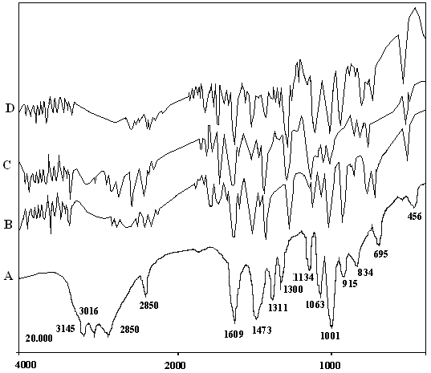
Figure (2) The IR spectra of
(A)The ligand [H₂L] .
(B)The complex [Co(HL)( py).Br]Br
(C)The complex [Co(HL)( pipi).Br]Br
(D)The complex [Co(HL)(n-pro).Br]Br

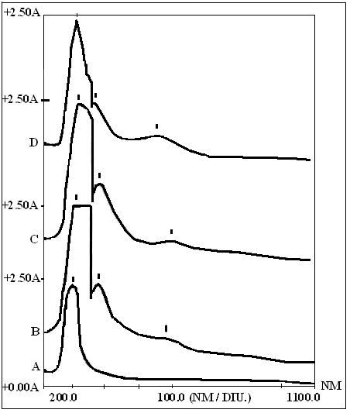
Figure (3) The U.V-Vis spectra of
(A)The ligand [H₂L]
(B) The complex [Co(HL)(py).Br] Br
(C) The complex [Co(HL)(pipi).Br]Br
(D) The complex [Co(HL)(4-pic).Br]Br

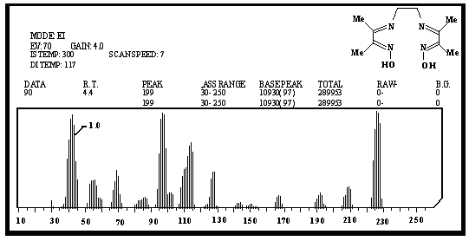
Figure (4) EI (+) Mass spectrum of [H₂L]

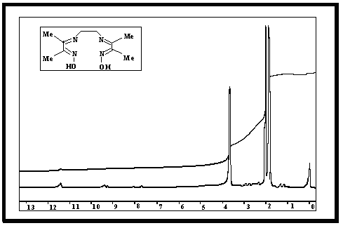
Figure (5) ¹H NMR spectrum of [H₂L] in DMSO-d⁶

References

- S.C. Nayak, P.K. Das and K.K. Sahoo. Asian J. Chem.,2003, 15, 911.
- L. A. Chugaev, Zh. Russ. Physicochem. Soc. 1909 , 41, 184.
- J. Halpem, Science,1985, 227, 869
- R.G. Finke, D.A. Schiraldi, and B.J. Mayer, Coord. Chem. Rev.,1984, 54, 1.
- E. Canpolat, M. Kaya, and A. Yazici, Russ. J. of Coord. Chem, 2004, l.30, 87
- L. Randaccio, N.B. Pahor, E. Zangrando, and L.G. Marzilli, Chem. Soc. Rev., 1989, Vol.18, No.(2), .225.
- G. N. Schrauzer., Accounts Chem. Res.,1968, 1, 97.
- B.D. Gupta, and S. Roy, Inorg. Chim. Acta., 1988, 146, , 209.
- M. N. Arumugham, K. Santhakumar, and S. Armachalam, Asian J. Chem.,2003, 15, 191.
- M. J. Al-Jeboori, A. S. A. Abdul Rahman and S. Atia, Ibn Al-Haitham J. for Pure & Appl. Sci., 2005, 18, 51.
- G. Socarates "Infrared Characteristic Group Frequencies" Wiley- Interscience Publication.,1980.
- W. Kemp, "Organic Spectroscopy" 2nd. Edition, 1987, 144.
- Y. GöK, S. Karaböcek and H. Kantekin, Trans. Met. Chem., 1995, 20, 234.
- V. Ahsen, F. Gökceli and Ő. Bekaroğlu, J. Chem. Soc. Dalton Trans., 1987, 1827.
- G. Irez and Ő. Bekaroğlu, Synth. React. Inorg. Met. Org. Chem., 1983, 13, 781.
- A. S. EL- Table, Trans. Met. Chem, 2002, 27, 166.
- M. J. Al-Jeboori, E. I. Abdulkarim and S. B. Abbass, National J. of Chem. (Iraq), 2004, 14, 182.
- K. Nakamoto "Infrared Spectra of Inorganic and Coordination Compounds"4th. Ed., J. Wiely and Sons, New York, 1996.
- W. J. Geary, Coord. Rev., 1971, 7, 81.
- L. Misra and A. K. Singh, Indian J. Chem., 2001, 40A, 1288.
- A. B. P. Lever, "Inorganic Electronic Spectroscopy", 2nd Edition, New York, 1984.

