Enzymatic and Vitamins Antioxidant Status in
β-Thalassemia Major

Lamia, A.M. Al-Mashhedy  College of Science | Oda, M.Y. Al-Zamely College of Science | Ahood, J. Al-Hamdany College of Education
University of Babylon |  | University of Basra

(NJC)

(Received on 18/2/2007) (Accepted for publication on 24/4/2007)

Abstract

The present study on β–Thalassemia major patients as regard to oxidative hypothesis to explain the influence of the free radicals and other reactive oxygen species (ROS) that accelerate the damage of cells and cause to complication of these patients. The measurement of antioxidant enzymes, Superoxide dismutase (SOD), Catalase (Cat) and glutathione reductase (GR) explanted a significantly increased for all age groups of patients compared with healthy controls. A significantly decrease of Vitamins E and A, which determined for the first time for thalassemia patients by using a Gas chromatography technique, our results proved that the patients suffer from deficiency on the levels of vitamins E and A as well as vitamin C, our study detect a significant decrease in Vitamin C (ascorbic acid) concentration at all age groups of patients as compared to healthy controls of similar age group.

Study of vitamin E / vitamin C ratio ( the means ± SD are 0.7 ± 0.3, 0.84 ± 0.21, 0.88 ± 0.23, 0.85 ± 0.46 ) for age groups of patients compared with healthy controls ( 1.5 ± 0.3 and 0.99 ± 0.4). Also the correlation between SOD and Cat activity were study which can use as an index for the iron overload and oxidative stress in patients with β– Thalassemia major.

366

الخلاصــة
تمت دراسة مرضى البيتا ثلاسيميا العظمى (فقــر الــدم البـحري, متماثل الأبوين) من خلال فرضية الأكســدة .لـمعرفة تأثير الجـذور الحرة المتولــدة في خلايـا المرضى على تطور المرض لديهم وقــد دُرســت مضـادات الأكسدة الإنزيمية مـثل سـوبرأوكسـيـد دســميـوتـيز(SOD), كـتـالـيز(Cat) والكلوتاثا يون رديكـيـتز ( GR) واوضحت الدراسة ارتـفاعا في مسـتوى هــذه الأنـزيـمـات ارتفاعا معنويا لكل الفـئات العـمريـة مقارنة بمجــموعتـي السـيطرة. أظـهرت الـدراسـة أنخـفاضا معنويــا فـي مسـتـوى فيـتاميـن C لدى المرضى المصابـين بفـقر الدم البـحري نـوع – بيـتا كما تـم دراســة فيتــامـيـن E,A لمرضى الثلاسيميا ولأول مرة مـن خلال تقنيـة كروموتـوغـرافــيا الغـاز(Chromatography (Gas -وقـد أثبتـت الدراســة أن المرضـى يعانـون نـقـصا حـادا ومعـنويـا فـي مستوى هـذه الفـيـتامــينات مقـارنـة بمجـاميـع السـيطرة.
دُرســت نـسـبة فيتامـين E / فيــتامــين C ووجـد أن (mean ± SD = 0.7± 0.3, 0.84 ± 0.21, 0.88 ± 0.23, 0.85 ± 0.46, ) للفئــات العمــرية كافــة مقــارنة بمــجموعــتي الســيطرة 1-6 و ≥7
سـنة على التـوالـي( mean ± SD = (0.99 ± 0.4 , 1.5 ± 0.3
كما تضمنت الدراسة إيجاد العلاقة بين سـوبرأوكسـيـد دســميـوتـيز(SOD), كـتـالـيز(Cat) والتي يمكن استخدامها كدليل جديد لارتفاع الحديد والجهد ألتأكسدي لدى مرضى البيتا ثلاسيميا العظمى
367

Introduction:
Thalassemia is an inherited type of anemia is characterized by a reduction in the rate synthesis of one or more type of globin chain, which formed the normal adult human hemoglobin molecule, resulting in decreased or reduction in filling of the red blood cells (RBC_{S}) with hemoglobin, lead to anemia and depending on the involved genes, the defect is identified as α–Thalassemia and β-Thalassemia ⁽¹⁾. Patients with β – Thalassemia have a reduction or a lack of synthesis of β – chain of hemoglobin while the α- chain synthesis remains unimpaired. The imbalance between α- and β –chain causes the α- chain to form unstable aggregates that precipitate and affect on erythrocyte membrane. This leads to erythrocyte destruction in the bone marrow and spleen, resulting in ineffective erythropoiesis and anemia and increase iron absorption ^{(2, 3)}

The ineffective erythropoiesis in β-Thalassemia major is due to defective hemoglobin synthesis, leading to severe anemia, increased erythrocyte turnover and excessive iron absorption, this lead to iron overload in the patients tissues⁽⁴⁾. To treat the anemia, patients have regular blood transfusions that lead to secondary iron overload⁽⁵⁾.
Under the physiological conditions, the iron toxicity is largely based on Fenton and Haber- Weiss chemistry, were catalytic amounts of iron are sufficient to yield hydroxyl radical(OH·) from superoxide anion (O₂·–), and hydrogen peroxide (H₂O₂). In Fenton reaction, ferrous ion react with hydrogen peroxide(H₂O₂) to form(OH·)⁽²⁾.

Fe(ΙΙ) + H₂O₂ Fe(ΙΙΙ) + OH· + OH– ------------- (1)

superoxide anion(O₂·–)can react with Fe(ΙΙΙ) to produce Fe(ΙΙ) via a perferryl intermediate.

Fe(ΙΙΙ) + O₂·– [ Fe⁺³-O₂– Fe⁺²-O₂ ] Fe(ΙΙ) +O₂ ------- (2)

From reaction (1,2) the oxo-iron intermediate is Haber- Weiss reaction⁽²⁾.

Fe
O₂·– + H₂O₂ OH· + OH– + O₂ -------------- (3)

Oxidative stress defined as an imbalance between oxidant and antioxidant resulting from a lack of antioxidant capacity caused by disturbance in production, distribution or by an overabundance of ROS from an environmental or behavioral stress ⁽⁶⁾. In Thalassemia major patients excess of redox iron aggravates oxidative stress, and lead to accelerated tissue degeneration ⁽⁷⁾. However oxidative stress it self regeneration iron free radical ⁽⁸⁾ ,although the amount of superoxide releasable iron is small and so ferritin bound iron is much safer than an equivalent amount of free iron. Hydrogen peroxide (H₂O₂) can degrade heme protein to release iron as mentions earlier ^{(8, 9)}.
368
Oxidative damage of erythrocytes in Thalassemia has been related to generation of free radicals by an excess of denatured α or β – globin chains, intracellular iron overload and low concentration of normal hemoglobin ⁽¹⁰⁾.
Antioxidants are defenses against the deleterious effect of free radicals and other ROS and RNS⁽¹¹⁾. An extensive, highly effective group of protective agent and defense mechanisms referred to collectively as the antioxidant defense system (ADS), act to regulate oxidative reaction ⁽¹²⁾.
The (ADS) includes: 1) Enzymes which are appear to occupy a central role against oxidative stress such as superoxide dismutase (SOD)which is removal (scavenger) excess of superoxide anion ( O₂•ˉ ) to form hydrogen peroxide and oxygen ^{(12, 13)}.

SOD
2O₂•ˉ + 2 H ⁺ H₂O₂ + O₂

Catalase(Cat) is serves as one of the body's defense system against hydrogen peroxide, have ability to use one molecule of H₂O₂ as a substrate electron donor and another H₂O₂ as oxidant or electron accepter, a strong oxidant that can cause intracellular damage ⁽¹²⁾ .

CA
2H₂O₂ 2H₂O + O₂

And glutathione reductase (GR) is essential for the glutathione redox cycle that maintains adequate level of GSH and catalyzes the reduction of oxidized glutathione (GSSG) to reduced glutathione (GSH) ⁽¹⁴⁾.

GR
GSSG + NADPH + H⁺ 2 GSH + NADP⁺

2) Vitamins such as α- tocopherol (vitamin E) act as antioxidant, breaking free radical chain reaction as a result of their ability to transfer a phenolic hydrogen for a peroxyl free radical to form peroxidizd PUFA ^{(15).}

ROO . + TocOH ROOH + TocO .

Vitamin C is a primary antioxidant in plasma and within cells, but it can also interact with the plasma membrane by donating electrons to α – Tocopherol radical, recycling of α – tocopherol by ascorbate helps to protect membrane lipids from perooxidation ⁽⁶⁾.

Toc O . Toc OH

Reduced Vit C oxidized Vit C
Ascorbic Acid (AA) Dehydro Ascorbic Acid (DHA)
[

369

Materials and Methods:
This study was involved 183 β -Thalassemia patients, age (1-30 ) years old (mean ± SE =11.3 ± 10.7), all of them had been characterized for beta globin gene mutation while the controls population involved 100 healthy individuals whose age was (1-25) years old (mean ± SE =9.8±10.2) . The patients groups were divided into four subgroups according to their age, 56 patients (1-6) years, 40 patients (7-12) years, 87 patients ≥13 years(divided to another subgroups according to the splenectomized (spl) and non splenectomized (non spl), were recruited with consent. while the control groups divided into two subgroup (1-6) years and ≥7years. Blood from thalassemic patients who attended the Thalassemia center in the Basra Maternity and children Hospital was collected just before the transfusion. After clotting, serum was separated by centrifugation and divided in several aliquots, stored at -20ºC until use for further biochemical determination.
Superoxide dismutase activity in serum was determined by using method based on the reduction of nitro blue tetrazolium (NBT) by superoxide radical produced by photochemistry under constant illumination and the formation of purple formula ⁽¹⁶⁾. Intracellular catalase activity was determined according to the modified method of (Zini A et al., 1993)⁽¹⁷⁾. The essay is based on the reduction in the absorption of hydrogen peroxide (H₂O₂) at 240 nm. The determination of GR activity is based on the oxidation of NADPH to NADP⁺ catalyzing by a concentration of glutathione reductase. One GR activity unite is defined as the amount of enzyme catalyzing the reduction of one micro mole of GSSG per minute at pH 7.6 and 25°C ⁽¹⁸⁾. A modified fast accurate gas chromatographic method was described by (Cof GO. et al., 1980) ⁽¹⁹⁾ for the determination of α – Tocopherol in serum, while vitamin A was determine with a modified method was described by (Catignani, G.L. & Bieri, J.C., 1983)⁽²⁰⁾.
370
The chemical methods which available for assessment of ascorbic acid are depending on either the reducing properties of the 1,2- enediol group that lead to absorbance changes in indicator dyes or formation of hydrozones⁽²¹⁾. In the 2,4–dinitrophenyl hydrazine(DNPH) methods, ascorbic acid (AA) is oxidized by Cu⁺² to dehydroascorbic acid DHA and diketogulonic acid ⁽²²⁾. When treated with DNPH, the 2,4 - dehydrophenyl osazon product forms with is the presence of sulfuric acid, forms an organ red complex that absorbs at 520 nm.

Statistical analysis. All results are expressed as means ± standard deviation SD. Comparison between control and Thalassemia patients were performed by the unpaired student's t-test. The correlations were used to determine relationships between covariates, tested statistically by a simple linear regression test by using SPSS program taken P ≤ 0.05 as the lowest limited of significant.

Results and Discussion. Patients with β- Thalassemia major shown a significant increase of serum SOD activity compared with healthy controls, Fig.(1). While the catalase(Cat) activity significantly increasing in serum of different age groups of patients compared with healthy control groups, Fig. (2).

0
mean
1
1.5
2
2.5
Cont ≥7

p ≥13
spl
p ≥13
non

Patient & control groups
p(7-12)
Cont.1-6
P1-6

Fig.(1) The Levels Of SOD Activity (U/ml) For Patients and Controls.
Patient & control groups
0
5
10
15
20
25
30
35
40
Cont.1-6
P 1-6
Cont ≥ 7.
P(7-12)
P ≥ 13 non
.
P ≥ 13 spl.
mean

Fig.(2) The Level Of Cat Activity (U/ml) For Patients and Controls.

The removal of toxic oxygen metabolites is the putative function of antioxidant enzymes such as SOD and Cat. It has already been demonstrated that oxidative stress induces antioxidative enzymes (SOD and Cat) ⁽²³⁾.
The increased activity of SOD in different age groups in β-Thalassemia major patients may be involved in scavenging the superoxide radical (O₂•–), thereby producing more hydrogen peroxide in the serum, which leads to increasing of catalase activity to detoxifying of H₂O₂⁽²⁴⁾.
This finding suggests that high iron produce an oxidative stress in cells, which respond by increasing their antioxidant defenses. The increase of intracellular antioxidant enzymes might be hypothesized to be a direct effect of increased intracellular iron or iron overloading which yield OH•, O₂•–, H₂O₂ and another ROS by Fenton and Haber- Weiss reactions ⁽²⁵⁾.
In fact, the rise in catalase activity is a compensatory increase of H₂O₂ concentration and seems to be a result of high concentration of ROS production in the serum of β-Thalassemia major patients

.

371

Fig.(3) Explain the different correlation between SOD and Cat activity for all patients and controls.

Fig.(3) The Correlation Between SOD and Cat Activity For: G (Patient 1-6 years), H ( Patient 7-12 years),X (Patient ≥13 years non spl.), Y (Patient ≥13 years spl.), M (Control 1-6 years), N (Control ≥7years).

GSH play a central role in defense against a variety of disease and both exogenous and endogenous insults, its functions include the detoxification of free radicals, peroxides; regulation of immune function and maintenance of protein structure, function and turnover⁽²⁶⁾.
372

0
10
20
30
40
50
60
P1-6
Con(1-6)
P7-12
P ≥13
non
P ≥13 spl
.
Cont. ≥ 7
Patient & control groups
mean

Fig.(4) The Levels Of GR Activity (mU/ml) For Patients and Controls.

The explanation of this observation is that the sulfhydryl group in the protein is oxidized by the overproduction of H₂O₂ and another ROS produced from the oxidative stress, thus the GSSG/GSH ratio is increased ⁽²⁷⁾, and cause increasing of Glutathione reductase (GR) activity, which essential for the glutathione redox cycle that maintains adequate levels of reduced cellular GSH. This fact is illustrated from results in Fig.(4). With regarded to splenactomy, the serum GR levels were higher in splenectomized than non splenectomized patients, which may be due to the role of spleen in removing the most pathological RBCs, therefore , in spl. Patients more abnormal RBCs will exist in the circulation ⁽²⁸⁾.
Compared with healthy controls a significantly decreased in levels of vitamin E and vitamin A in all age groups of patients, Fig.(5) and Fig.(6) respectively

0
5
10
15
20
Cont ≥7
P ≥13 spl
P ≥13 non

cont 1-6
p (1-6)
patient & control groups
mean

Fig.(5) Vitamin E levels(mg/l) for age groups of patients and controls.

373

0
0.1
0.2
0.3
0.4
0.5
cont ≥7
p≥13 spl
p≥13 non
p(7-12)
cont 1-6
P(1-6)
patient & control groups
mean

Fig.(6) Vitamin A levels(mg/l) for age groups of patients and controls.

Vitamin E and Vitamin A are considered as physiologically important determinant of antioxidative protection ⁽²⁹⁾, the depletion of serum vitamin E in all patient groups indicated a hyperconsumption as a radical scavenger to guard against oxidative hemolysis due to an iron overload ⁽³⁰⁾.
α- Tocopherol could be regarded as a defense substance against peroxynitrate attack, the protective action of the α- tocopherol was considered by their disappearance α- T formed α- T-quinone ⁽³¹⁾.

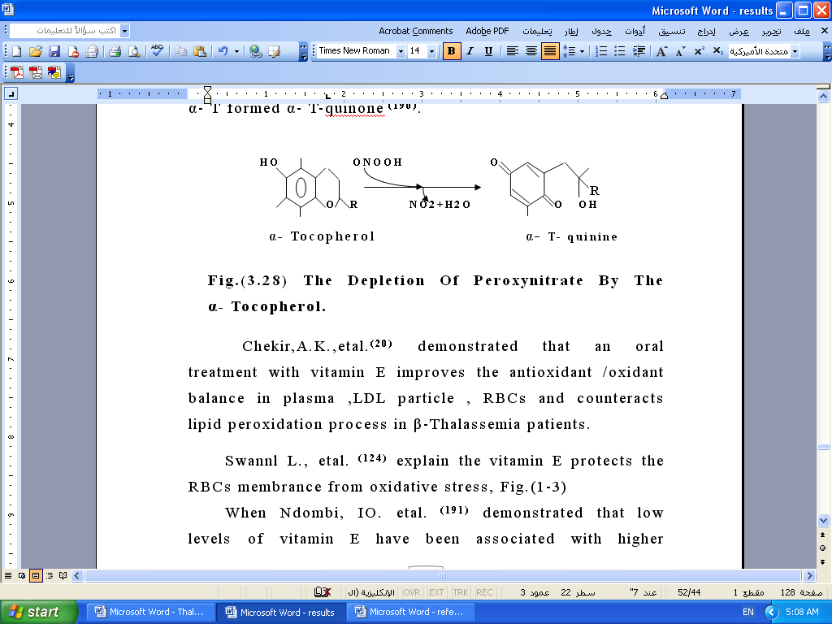

An increasing of oxidative stress and a decreased of vitamin E and vitamin A promote peroxidative damage to cell and organelle membranes in organs that accumulate excess iron, including spleen, liver, pituitary gland, pancreas and heart ⁽³²⁾.
A significant decrease in levels of total ascorbic acid was found in serum of all age groups of patients compared with controls, Fig. (7).

0
2
4
6
8
10
12
14
Cont ≥7
P ≥13 spl
P ≥13 non
p(7-12)
Cont(1-6)
p (1-6)
patient & control groups
mea

Fig.(7) Vitamin C levels (mg/l) for age groups of patients and controls.
374

Vitamin C functions as an antioxidant by reacting directly with ROS or regenerating vitamin E from α- tocopherol radical which illustrated above, thus, it protects cell membranes from external oxidants.
Free radicals formed in the body fluids in patients are detoxified by antioxidant including Vitamin C ⁽³³⁾, causing ascorbate oxidized rapidly⁽¹⁾, this may explain the depletion in vitamin C concentration in the present study.
Therefore Vit.C is prescribed for treatment of β-Thalassemia major patients beside it increases iron excretion by increasing the availability of chelatable iron, vitamin C is recommended not to give more than 2-3 mg/kg day as supplements; these should be taken of the time of the DFO infusion ⁽¹⁾.In fact the most patients don’t receive an optimum dose of DFO and vitamin C, especially the spl. patients >13 and non spl. because of the unavailability of the drug or the subcutaneous infusion pumps all the time, or due to the poor compliance of the patients to the treatment.

References:
1. Forget, B.G.; Thalassemia Syndromes. In: Hoffman, R., Bens, E.J., Shatil, S.J. et al. (2000), "Hematology; Basic Principles and Practice ", 3rd ed., Churchill Livingstone, New York, PP. 485-510.
2. Halliwell, B. and Gutteridge, J.M.C. and Cross, C.E. (1992) Jour. Lab. Clin. Med., 119(6): 598-615.
3. Borgna-Pignatti, C. et al. (1998),Annals of the New York Academy of Sciences, 850: 227-231.
4. Wang, C. and Richardson,D.R. (2003), The Interna. Jour. Biochem. And Cell Biol., 35:1144-1149.
5. Widad, N.M.(2002),M.Sc. Thesis, College of Medicine, University of Basra.
6. Padayatty, S. J. and Levine, M. (2001), Cand. Med. Assoc. Jour., 164: 353-355.
7. Papanikolaou, G.and Pantopoulos,K.(2004),Toxicology And Applied Pharmacology, PP. 1-13.
8. Bolann, B.J. and Ulvik, R.J.(1990),Eur. Jour. Biochem., 193: 899-904.
9. Sohal, R.S. and Weindruch, R. (1996), Science, 273(5): 59-63.
375

10. Vives-Corrons, J.L., Miguel-Garcia, A., Putjader, M.A. et al. (1995), Eur. Jour. Hematol., 55(5): 327-388.
11. Kaimal, N.G. (2001), Indian Medical Association, 17:1-11.
12. Buettner, G.R. and Schafer, F.Q.(2002), Free Radic. and Radia. Biol. Program, University of Iowa, PP. 1-4.
13. Stryer, L. (2000)," Biochemistry ", 4th ed., W.H. Freeman and Company, New York, PP. 553-554.
14. Puskas, F., Gergely,P., Banki,K. and Perl,A. (2000), FASEB Jour., 14:1352-1360.
15. Wolf, G. (1997), Nutrition Reviews, 55(10): 376-377.
16. Blokhina, O. (2000), Ph.D. Thesis, Dept.of Biosciences, University of Helsinki.
17. Zini, A., De-Lamirande, E. and Gagnon, C. (1993), Inter. Jour. Androl., 16:183-188.
18. Garlberg, L., Mannervik, B. (1985), Meth. Enzymol., 113: 485-490.
19. Cof, G.O. and Nyheim, A. (1980), Biomedi. Applicat., 183: 487-491
20. Catignani, G.L. and Bieri, J.C. (1983), Clinc. Chem., 29:708-712.

21. AL-Matoory, H.K. (2002), M.Sc. Thesis, College of Medicine, University of Basrah.
22. Burtis, C.A. and Ashwood, E.R. (1999), "Tiets Text- Book of Clinical Chemistry ", 3rd ed., W.B. Sannders Company, Tokyo, PP. 1034-1054.
23. Lu, D., Maulik, N., Moraru, I., Kreutzer, DL., , Das, Dk. (1993), Amer. Jour. Physiol., 264: C 715-722.
24. Chakraborty,D. and Bhattacharyya,M. (2001), Clinc.Chem. Acta., 305: 123-129.
25.Kassab-Ckekir, A., Laradi, S., Ferchichi,S.,Haj Khelil,A. et al.,(2003), Clinc.Chem. Acta., 338: 79-86.
26. Richic, J.P., Skowronsk, L., Abraham, P. and Leutzinger, Y. (1996), Clinc. Chem., 42: 46-49.

27. Ismaiel, M.A. (2001), Ph.D. Thesis, College of Science, University of AL-Mustansiriya.
28. Harrison"s (1998), "Principles of Internal Medicine", 14th ed., Vol.1, McGraw-Hill Companies, New York.
29.Esterbauer,H., Dieber-Rotheneder, M., Striegl, G. and Waeg, G, (1991), Amer. Jour. Clinc. Nutr., 53: 314S-321S.
30.Marwah,SS., Wheelwright,D., Blann,AD. et al. (2001), Br Jour. Haematol., 114(4): 917-919.
31. Wolff, G. (1997), Nutrition Reviews, 55(10): 376-377.
32. Brighthope, I. (1994), Jour. Austr. Coll. Nutr. Environ. Med., 13(1-2): 15-25.
33.Jordan, P., Brubacher, D., Moser, U., Stahelin, HB., and Gey, KF. (1995), Clinc. Chem., 41: 924-927.

p(7-12)
376

