The Influence of pH and Temperature on Tautomerism Reactions of Some Aromatic Mono and Bi Schiff Bases

A.S.P.Azzouz  College of Education | A.B.N. Al-Dabagh  College of Education
University of Mosul - Mosul ,Iraq

(NJC)

(Received on 30/5/2006) (Accepted for publication on 24/4/2007)

Abstract
The aims at investigation the tautomerism reaction of mono and bi aromatic Schiff bases by actions of different values of pH,s and temperatures. The pH under study was chosen in a range between 4-10.
Experiments prove the existence of Schiff bases under study, as tautomeric equilibrium mixture of different ratios of keto and enol forms , as well as , the formations of nitrilium and phenoxonium ions in acidic and basic media respectively. Equilibrium constants K for the tautomerism reaction are evaluated at a temperature range between 298-338k. the last shows an inverse relationship between K and T which facilitates the evaluation of thermodynamic parameters. Finally evidence for supporting the tautomerism reaction is mentioned and disussed.

الخلاصة
الهدف من البحث دراسة التفاعلات التوتومرية في قواعد شيف الاروماتية الأحادية والثنائية وذالك بفعل الدوال الحامضية ودرجات الحرارة المختلفة.
تضمنت الدراسة اختيار دوال حامضية بمدى يتراوح بين 4-10. لقد أكدت التجارب تواجد قواعد شيف تحت الدراسة على هيئة مخاليط توتومرية من اشكال الكيتو و الاينول وبنسب مختلفة , هذا بالإضافة الى تكوين ايونات النتريليوم و الفينوكسونيوم في الاواساط الحامضية و القاعدية على الترتيب . لقد حسبت ثوابت التوازن K بعدة درجات حرارية و في مدى محصور بين 298-338 مطلقة , و أن القيم لـ K كانت علاقتها عكسية مع درجات الحرارة المطلقة و التي سهلت استخراج المتغيرات الثرموديناميكية . و أخيراً فأن تفاعلات التوتومرية في المركبات تحت الدراسة قد اثبتت و نوقشت.

Introduction
The concept of tautomerism of carbonyl^{1,2} , analide³ and Schiff base⁴ had been extensively studied.
The enolization reaction is probably the most discussed type of prototropic tautomerism. The method ¹used for the determination of
keto enol equilibrium constants can be classified as chemical and physical , particularly spectroscopic method. In 2004 a new spectrophotometric method ⁵ had been developed for the determination of trace amounts of Schiff base benzylidene o-hydoxyaniline via coupling with suphanilic acid salt at pH 7.
A few publications¹ concerning the tautomerism of carbonyl compounds in the gas phase are observed in literature. This is due to experimental difficulties. The last encourage Azzouz⁶ to deal with tautomerism and thermodynamic study of deoxybenzoin and some related compounds by using the integrated ion current (IIC) curve by mass spectrometry.
Recently , and in our laborotary we have synthesized⁷ some Schiff bases derived from salicyladehyde and o-methoxy benzaldehyde with an appropriate primary amines, forming mono and bi base linkages. A prelimenary UV and IR spectral study on these Schiff bases revealed their tautomeric existence in 1,2-dichloro ethane solvent.
As a continuation for the last work , this paper describes the influence of pH and temperature on tautomerism reactions of Schiff bases mentioned.
Experimental
All chemicals used throughoul this work , the synthesis of Schiff bases and their characterization by melting points , UV and IR spectra have been mentioned⁷.
Apparatus:
All UV absorption measurements were made by using pye Unicam sp 8000 spectrophotometer using a matched silica cell. It is connected to julabo paratherm pt 40 ps water thermostat. A fixed temperature is obtained through cell compartment by water circulation.
Results and discussion
This investigation deals with studying the experimental factors
Affecting the tautomerism reactions in Schiff bases under study , namely the pH and temperature. Table (1) show the nomenclatures , structures and melting points of all mono and bi Schiff bases linkages used in this work. The following division of results are thought to be necessary :-
- Influence of pH on tautomerism reaction.
It is confirmed from UV and IR spectra in our pervious study⁷ that Schiff bases^{(1,4-6)} are able to from a double folds intramolecular hydrogen bondings of the type O-H∙∙∙N alone or a mixture of O-H∙∙∙N and N-H∙∙∙N. In the meantime Schiff bases 2 and 3 can from the mono intramolecular hydrogen bonding of the type O-H∙∙∙N. These bondings can give additional stabilities⁸⁻¹⁰ to such Schiff bases or they are kinetically stable or don't susceptible by hydrolysis¹¹ cleavage in water- ethanol mixture as known¹¹ on Schiff basess , especially the aliphatic ones. This encourage the workers to study the influence of pH in arrange 4-10 on tautomerism reactions in Schiff bases summarized as follow :-
  - salicylidene –o-aminoanilin (1).
This compound show three bands in its UV spectra at pH range 4-5. They attributed to nitrilum¹² ion at such acidic range , the keto and enol forms respectively. The wavelengths of these bands are in order of nitrilium ion >keto > enol. At pH 6-7, the nitrilium band is completely disappeared. Finally , when the pH is raised to a range 8-10 , also other three bands are generated.
They are assigned to the formation¹² of phenoxide ion , the keto and enol forms.
  - salicylidene m-amioanline
At pH range 4-7 a three UV bands are also observed. They are reffered to the keto form , the nilrium ion and the enol form and in order of increasing wavelenghths. The intensity of nitrilium ion band is founded to be decreased by elevation of pH. This observation is used here as a confirmation method for assigning the nitrilium ion band.At pH range between 8-10 , only two bands are observed for the keto and enol forms only.
  - salicylidene-p-aminoaniline(3).
This compounds shows only one band in its UV spectra at acidic range as assigned to enol form only. The tautomerism reaction are started at pH range 7-10 and resulted to the formation of enol and keto forms , at shorter and longer wavelengths respectively.
  - Disalicylidene –o-aminoanline.(4)
At pH range between 4-7 , it shows one UV band , with wavelength directly proportional to the pH of the medium as assigned to enol tautomer. Elevation of pH in a range 8-10 , resulted to the appearance of two UV bands as assigned to keto and enol forms.
  - Disalicylidene –m-aminoaniline (5).
This molecule shows one UV band at pH range 4-9. The wavelength of the band is increased by increasing pH and assigned to enol form only. Similarly , at pH 10, the molecule shows two UV bands for keto and enol forms.
  - Disalicylidene –p-aminoaniline (6).
At pH range 4-8 the comound shows one UV band for the enol form. The wavelength of the band is directly proportional to pH. An exclusion to the last case is observed at pH 6 and resulted to the formation of two bands as assigned nitrilium ion and enol forms. When the pH is raised 9-10, the compound shows two UV bands for enol and keto forms at lower and longer wavelengths respectively.

Tabel (1) Nomenclatures structures and melting

points of imines
No. | Nomenclature | Structure | Melting point (°C)
1 | Salicylidene-o-aminoaniline |  | 62-63
2 | Salicylidene-m-aminoaniline |  | 84-85
3 | Salicylidene-p-aminoaniline |  | 199-200
4 | Disalicylidene-o-aminoaniline |  | 165-166
5 | Disalicylidene-m-aminoaniline |  | 208-209
6 | Disalicylidene-p-aminoaniline |  | 218-219
7 | o-Methoxybenzylidene-o-aminoaniline |  | 90-92
8 | o-Methoxybenzylidene-p-aminoaniline |  | 105-107

- Influence of temperature.
Surely , the temperature as known has a great influence on many chemical reactions , as tautomerism⁶, formation of hydrogen bonds¹³⁻¹⁵ pK_{a} of benzaldoxime and other¹⁷.

The thermodynamic of tautomerism represents the various energies forms associated with enol keto reversible reaction. These required the evaluation of thermodynamic parameters , namely ∆G,∆H and ∆S.The last required the evaluation of equilibrium constant for the reaction outlined above from the relation K=A_{keto}/A_{enol} ,where A_{keto} and A_{enol} are absorbances of keto and enol respectively.The thermodynamic parameters of tautomerism are evaluated from standard equations(1-3) of forms :-

∆G=-RT lnK …(1)
lnK=const. - $\frac{ΔH}{\text{RT}}$…(2)
∆G=∆H-T∆S …(3)

Tables (2) and (3) show the equilibrium constants thermodynamic parameters calculated for the tautomerism reactions of Schiff bases at different temperatures and in 1,2- dichloroethane (1,2-DCE) and ethanol respectively. The plot of lnK versus the inverse of absolute temperature show a straight lines with correlation coefficients range 0.995792-0.999151 and standard error of estimation range 0.005376-0.009947 as evident from statagraph computer programme. A typical plots for the last are show in Fig. (1) for the tautomerism reaction in disalicylidene -o-aminoaniline in solvents 1,2DCE and ethanol..
Tables (2-3) show the thermodynamic parameters calculated and clearly indicate that the sign of ∆G are varied i.e plus or minus or depending on the structure or stability of Schiff base tautomer and the temperature and are highly expected. The positive sign of $\bar{Δ}\bar{G}$ as in Tables (2-3) means the nonspontaneous conversion of enol tautomer to keto tautomer. In other words greater stability of enol in Schiff bases compared to their keto forms , possibly by their strong hydrogen bonding ability with solvents mentioned. On the contrary to that the negative sign of $ΔG$ can be interpreted by the greater stability of keto tautomers and the ease of tautomerism process.
The enthalpy $ΔH$ of tautomerism process as calculated from equation (2) by plotting lnK versus T⁻¹ with typical plot shown in Fig (1) for the disalicylidene –o-aminoaniline in 1,2-DCE and ethanol solvents. All average $\bar{Δ}\bar{H}$ values calculated have a negative signs which means that the tautomerism reaction are exothermic. An exception to that is Schiff (6) which gives a positive $ΔH$ values in 1,2-DCE and ethanol. These abnormalities can be interpreted by assuming two processes happening in a consecutive steps. The first is the deassociation of Schiff base (6) to its monomer which required an absorption of heat $ΔH1$ to overcome on hydrogen bondings between reactants stated previously as a main step. The second minor step is the tautomersim reaction which is accompanied evolution of heat -$ΔH2$. when $ΔH1$ > $ΔH2$ so , net $\bar{Δ}\bar{H}$ =$ΔH1$-$ΔH2$ evaluated has a positive sign. This agrees with experimental findings. Also ∆S are calculated for the tautomerism process in Schiff bases at five different temperatures. These ∆S values for any Schiff base are very close to each other. This means the non dependence of ∆S at a narrow temperature range between (298-328)k. Actually ∆S=S₂-S₁ , where S₂ and S₁ are entropies of keto and enol forms respectively. Mostly as founded here S₁ Should have greater value than S₂. Therefore it is not astonishing to obtain a negative signs ∆S values for the tautomerism reactions founded here in the first five Schiff bases as in Tabels (2-3). This can happen by either the greater hydrogen bonding or the greater solute – solvent interactions of keto tautomers as compared with enols.

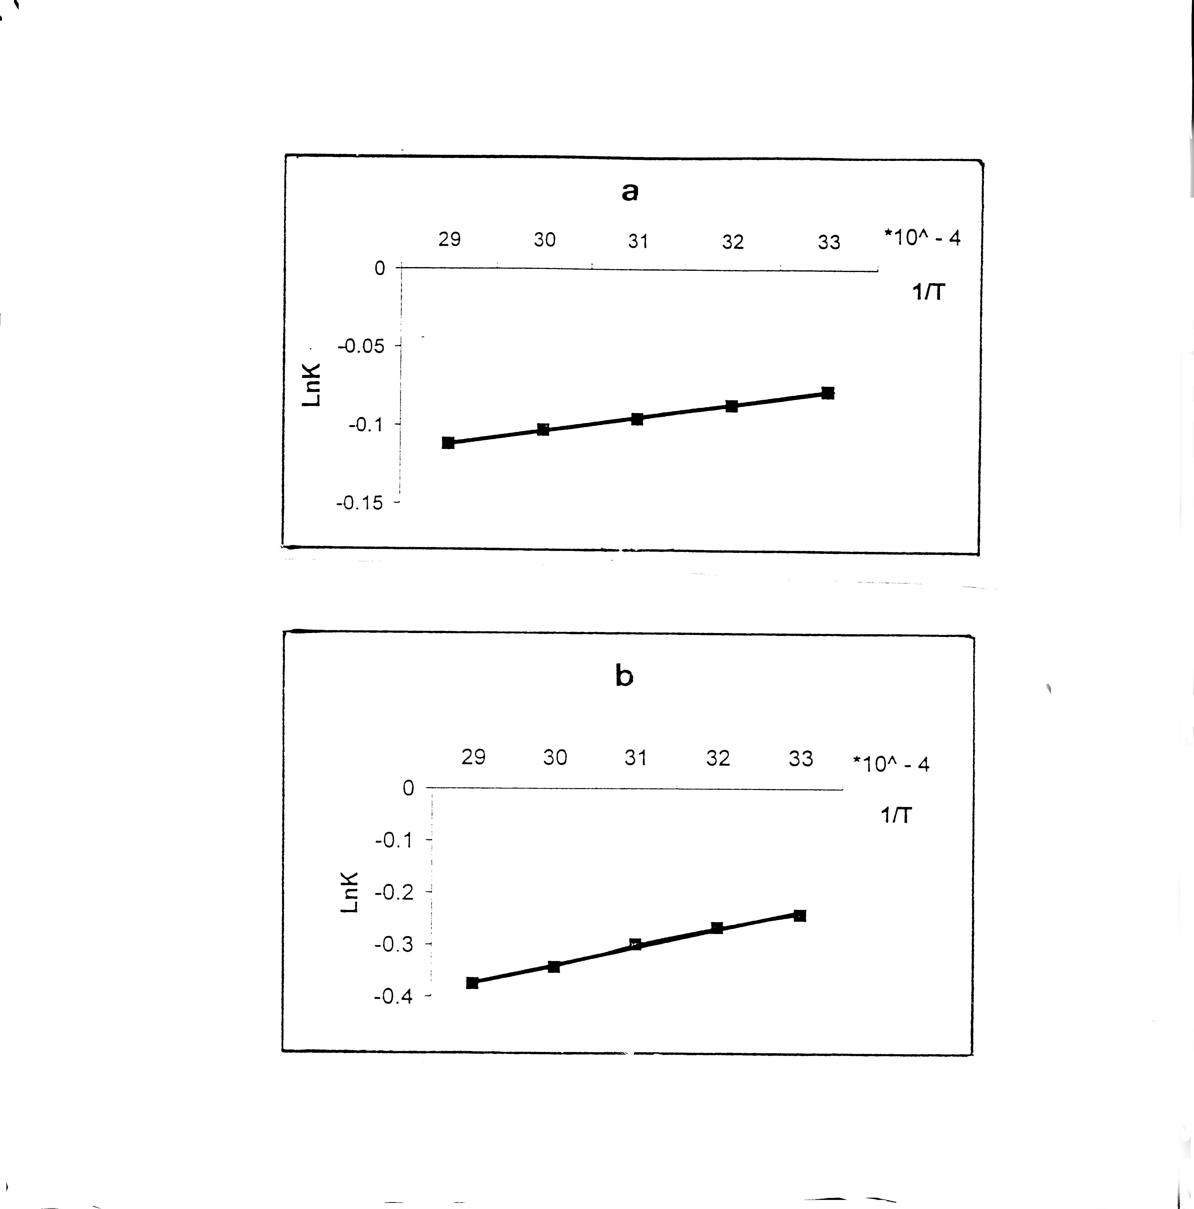
Fig.1 The relationship between lnK versus 1/T for disalicylidene
o-aminoaniline in solvents : a- 1,2-DCE
b- Ethanol

Table (2) Thermodynamic parameters and equilibrium constants
of tautomerism reactions in Schiff bases in 1,2-DCE
No. | Temp.(C˚) | lnK | ∆G  J.mole⁻¹ | ∆S  J.mole⁻¹ K⁻¹ | $\bar{Δ}\bar{H}$ J.mole⁻¹ | $\bar{Δ}\bar{G}$ J.mole⁻¹ | $\bar{Δ}\bar{S}$  J.mole⁻¹ K⁻¹
1 | 25 | 0.2350 | -582.2 | -409.6 | -122649.5 | -5.7 | -385.7
1 | 35 | 0.0149 | -38.2 | -398.1 | -122649.5 | -5.7 | -385.7
1 | 45 | 0.0300 | -79.3 | -385.4 | -122649.5 | -5.7 | -385.7
1 | 55 | -0.070 | 190.9 | -374.5 | -122649.5 | -5.7 | -385.7
1 | 65 | -0.171 | 480.5 | -364.3 | -122649.5 | -5.7 | -385.7
2 | 25 | -0.575 | 1424.6 | -10.6 | -1729.3 | 1637.8 | -10.6
2 | 35 | -0.600 | 1536.4 | -10.6 | -1729.3 | 1637.8 | -10.6
2 | 45 | -0.618 | 1633.9 | -10.6 | -1729.3 | 1637.8 | -10.6
2 | 55 | -0.638 | 1739.8 | -10.6 | -1729.3 | 1637.8 | -10.6
2 | 65 | -0.660 | 1854.6 | -10.6 | -1729.3 | 1637.8 | -10.6
3 | 25 | -1.304 | 3230.7 | -21.9 | -3300.7 | 3658.8 | -21.9
3 | 35 | -1.340 | 3431.3 | -21.9 | -3300.7 | 3658.8 | -21.9
3 | 45 | -1.378 | 3643.2 | -21.8 | -3300.7 | 3658.8 | -21.9
3 | 55 | -1.425 | 3885.9 | -21.9 | -3300.7 | 3658.8 | -21.9
3 | 65 | -1.460 | 4102.9 | -21.9 | -3300.7 | 3658.8 | -21.9
4 | 25 | -0.078 | 193.3 | -3.0 | -698.0 | 253.1 | -3.0
4 | 35 | -0.087 | 222.8 | -3.0 | -698.0 | 253.1 | -3.0
4 | 45 | -0.096 | 253.8 | -3.0 | -698.0 | 253.1 | -3.0
4 | 55 | -0.103 | 280.9 | -3.0 | -698.0 | 253.1 | -3.0
4 | 65 | -0.112 | 314.7 | -3.0 | -698.0 | 253.1 | -3.0
5 | 25 | -0.138 | 341.9 | -14.8 | -4060.0 | 622.6 | -14.7
5 | 35 | -0.176 | 450.7 | -14.6 | -4060.0 | 622.6 | -14.7
5 | 45 | -0.235 | 621.3 | -14.7 | -4060.0 | 622.6 | -14.7
5 | 55 | -0.285 | 777.2 | -14.7 | -4060.0 | 622.6 | -14.7
5 | 65 | -0.328 | 921.7 | -14.7 | -4060.0 | 622.6 | -14.7
6 | 25 | -0.050 | 123.87 | -356.9 | 106228.0 | -88.7 | -334.3
6 | 35 | -0.014 | 35.8 | -345.0 | 106228.0 | -88.7 | -334.3
6 | 45 | 0.040 | -105.8 | -333.7 | 106228.0 | -88.7 | -334.3
6 | 55 | 0.030 | -81.8 | -323.6 | 106228.0 | -88.7 | -334.3
6 | 65 | 0.148 | -415.9 | -313.1 | 106228.0 | -88.7 | -334.3

Table (3) Thermodynamic parameters and equilibrium constants
of tautomerism reactions in Schiff bases in ethanol
No. | Temp.(C˚) | lnK | ∆G  J.mole⁻¹ | ∆S  J.mole⁻¹ K⁻¹ | $\bar{Δ}\bar{H}$ J.mole⁻¹ | $\bar{Δ}\bar{G}$ J.mole⁻¹ | $\bar{Δ}\bar{S}$  J.mole⁻¹ K⁻¹
1 | 25 | -0.730 | 1808.6 | -13.5 | -2219.8 | 2067.6 | -13.5
1 | 35 | -0.750 | 1920.5 | -13.4 | -2219.8 | 2067.6 | -13.5
1 | 45 | -0.780 | 2062.2 | -13.5 | -2219.8 | 2067.6 | -13.5
1 | 55 | -0.807 | 2200.6 | -13.5 | -2219.8 | 2067.6 | -13.5
1 | 65 | -0.835 | 2346.4 | -13.5 | -2219.8 | 2067.6 | -13.5
2 | 25 | -0.020 | 1424.6 | -26.4 | -6446.5 | 1632.5 | -25.4
2 | 35 | -0.085 | 1536.4 | -25.9 | -6446.5 | 1632.5 | -25.4
2 | 45 | -0.180 | 1633.9 | -25.4 | -6446.5 | 1632.5 | -25.4
2 | 55 | -0.240 | 1713.2 | -24.9 | -6446.5 | 1632.5 | -25.4
2 | 65 | -0.330 | 1854.6 | -24.6 | -6446.5 | 1632.5 | -25.4
3 | 25 | -0.440 | 1090.1 | -35.5 | -9500.0 | 1795.1 | -35.5
3 | 35 | -0.560 | 1433.9 | -35.5 | -9500.0 | 1795.1 | -35.5
3 | 45 | -0.670 | 1771.3 | -35.4 | -9500.0 | 1795.1 | -35.5
3 | 55 | -0.795 | 2167.9 | -35.6 | -9500.0 | 1795.1 | -35.5
3 | 65 | -0.894 | 2512.2 | -35.5 | -9500.0 | 1795.1 | -35.5
4 | 25 | -0.243 | 602.1 | -11.5 | -2818.4 | 814.1 | -11.4
4 | 35 | -0.268 | 686.3 | -11.4 | -2818.4 | 814.1 | -11.4
4 | 45 | -0.300 | 793.2 | -11.4 | -2818.4 | 814.1 | -11.4
4 | 55 | -0.343 | 935.4 | -11.4 | -2818.4 | 814.1 | -11.4
4 | 65 | -0.375 | 1053.8 | -11.5 | -2818.4 | 814.1 | -11.4
5 | 25 | 0.400 | -991.0 | -13.2 | -4921.9 | -737.3 | -13.2
5 | 35 | 0.350 | -896.3 | -13.1 | -4921.9 | -737.3 | -13.2
5 | 45 | 0.278 | -735.0 | -13.2 | -4921.9 | -737.3 | -13.2
5 | 55 | 0.212 | -578.2 | -13.2 | -4921.9 | -737.3 | -13.2
5 | 65 | 0.173 | -486.2 | -13.1 | -4921.9 | -737.3 | -13.2
6 | 25 | -0.820 | 2031.6 | -12.7 | 1745.9 | 2048.1 | -11.9
6 | 35 | -0.810 | 2074.2 | -12.4 | 1745.9 | 2048.1 | -11.9
6 | 45 | -0.750 | 1982.9 | -11.7 | 1745.9 | 2048.1 | -11.9
6 | 55 | -0.760 | 2072.5 | -11.6 | 1745.9 | 2048.1 | -11.9
6 | 65 | -0.740 | 2079.5 | -11.3 | 1745.9 | 2048.1 | -11.9

Conclusions
- The occurrence of Schiff bases (1-6) as mono and bi folds intramolecular hydrogen bondings , which gives an additional stability to the molecules.
- The stability of the molecules stated above facilitate the study of influence of pH in a range between 4-7 on tautomerism process in Schiff bases by aid of UV spectra.
- A nitrilium ion is observed with some Schiff bases at a pH range 4-7 with enol and keto tautomers. Other Schiff bases show the enol tautomer at moderate acidic pH as well the keto tautomer and the phenoxide ion at higher basic pH.
- Generally the keto tautomers in Schiff bases absorb UV at longer wavelengths when compared to the same enol tautomers. The wavelengths of keto and enol tautomers are very sensitive to the pH of the medium.
- A direct relationships are observed between lnk versus T⁻¹ for Schiff bases (1-5)with exclusion of Schiff bases (6) and in 1,2-DCE and ethanol solvents.
- The thermodynamic parameters namely the $\bar{Δ}\bar{G}$ , $\bar{Δ}\bar{H}$ and $\bar{Δ}\bar{S}$ calculated confirm that the tautomerism reactions in Schiff bases are exothermic $\bar{Δ}\bar{H}$ =- mainly nonspontaneous (∆G⁼+) and are accompanied by an increase of order of keto tautomers ($\bar{Δ}\bar{S}$=-) as compared with enol.

References
- Ed.J.Zabicky, The Chemistry of Carbonyl Group , vol.2 , 1970 , Interscience, London , pp.157-240.
- G.Allen and R.A.Dwek, J.Chem. Soc., 1966 , 161.
- G.O. Dudek and E.P.Dudek , J.Amer.Chem.Soc. 1966 , 88 , 2407.
- G.O. Dudek and E.P.Dudek , J.Amer.Chem.Soc. 1964 , 86 , 2483.
- A.S.P.Azzouz and I.Z.Sulyman. J.Edu.Sci. 2004 , 16 , 125.
- A.S.P.Azzouz , Mutah J. For Res. and Stud. 1993 , 8 ,93.
- A.B.N. Al-Dabagh , M.Sc Thesis , 1999 , Mosul , University.
- W.Bruyneel , J.J.Charett and E.D.Hoffmann , J.Amer.Chem.Soc. 1966 , 88 , 3808.
- P.Teyssie and J.J. Charett , Spectrochem. Acta, 1963 , 19 , 1407.
- J.Charett , G.Fathansl and P.Teyssie , Spectrochem. Acta, 1964 , 20 , 597 .
- Ed.S.Patai, The Chemistry of Carbon Nitrogen Double Bond , 1979 , John Wiley and Sons , New York .
- M.S.Masoud , G.B.Mohammad , A.M.Hindawey and T.M.Abdel-Fattah , Mutah J. For Res. and Stud. 1991 , 6,2.
- G.C.Pimental and A .L.Mecellellan , The Hydrogen Bond 1960 , New York.
- S.K. Al-Dilami and A.S.Azzouz and N.G.Ahmad , Mutah J. For Res. and Stud. 1990 ,7 , 209.
- A.S.P.Azzouz and M.M.Al-Niemi , Z.Phys.Chem. 2005 ,1 ,20.
- A.S.P.Azzouz and N.N.Al-Azzawi , J.Edu. Sci. , 2002 , 1 , 20.
- A.R.Butler, Problems in Physical Organic Chemistry , 1972 , Wiley, London.

