Cross Linking Condensation Polymerization of Rayon Fiber

Jaleel Kareem Ahmad
College of Science - Babylon University

(NJC)

(Received on 7/1/2007) (Accepted for publication on 25 /6 /2007)

Abstract
The degree of cross linking condensation polymerization of rayon molecule
H
(C₆H₁₀O₅)₁₁
OH
under argon atmosphere is a function of temperature in the range (200 – 230)°C with liberation of 10%, 10.5%, and 10.9% water respectively from the fiber weight. Elemental analyses show increasing of carbon % on the expense of hydrogen and oxygen percents in the same order. Above 230°C self-carbon dioxide is generated. The fiber resulted from the polymerization shows fire resistance and insoluble in sulfuric acid which is in opposite behavior to the untreated fiber. Also treated fiber shows color change from white → yellow→ brown→ black depending on temperature degree and duration of heating with smooth and oily surface appearance due to the new bonding system and more close rayon molecules upon polymerization, accompanied with what is called chemiluminescence phenomenon.
Polymerization under nitrogen atmosphere shows early liberation of carbon dioxide gas beside water due to the presence of oxygen even in trace amount in the nitrogen gas which attacks the rayon molecules at the above temperature.

الخلاصة
إن درجة البلمرة التكثيفية التشابكية لجزيئة الحرير
H
( C₆H₁₀O₅)₁₁
OH
تحت جو من غاز الاركون تزداد مع زيادة درجة الحرارة وعلى النحو التالي 200ْم، 215ْم، 230ْم مع تحرر 10%، 10.5% و10.9 ماء على التوالي. التحاليل الكيمياوية اظهرت زيادة في نسبة الكاربون على حساب نسبة الهيدروجين والاوكسجين بنفس الترتيب. بعد درجة 230ْم يبدأ تحرر غاز ثاني اوكسيد الكاربون الذاتي.
الجزيئة الكبيرة الناتجة من البلمرة اظهرت مقاومة عالية ضد حامض الكبريتيك المركز وعلى مقاومة اللهب وكذلك اظهرت الياف الحرير تغير في لونها وكما يلي:
ابيض← اصفر ← قهوائي ← اسود معتمداً على درجة الحرارة وعلى زمن التعريض لها كما اظهرت سطح املس دهني بسبب نظام التآصر الجديد وتقارب جزيئات الحرير نتيجة البلمرة التشابكية العرضية المصحوبة بظاهرة ما يسمى بالتألق الكيميائي.
البلمرة تحت جو من غاز النتروجين اظهرت التحرر الذاتي لغاز ثاني اوكسيد الكاربون مبكراً اضافة الى الماء ويعود السبب الى تواجد نسبة قليلة من الاوكسجين في غاز النتروجين والذي يهاجم جزيئة الحرير في تلك الدرجات الحرارية.

Introduction
Rayon fiber is one of the precursor materials for carbon fiber production, in which rayon is heated under vacuum or inert atmosphere to convert their linear atomic bonding to a more thermally stable cross-linking bonding with elimination of water molecules by what is called self condensation polymerization reaction ⁽¹⁻³⁾.
$α$ - cellulose is the type used for the manufacturing of rayon with its molecule ^{(4,5)}.
H
(C₆H₁₀O₅)_{n}
OH
The process for making carbon fibers is part chemical and part mechanical. The precursor (Rayon) is drawn into long strands or fibers and then heated to a very high temperature without allowing it to come in contact with oxygen. Without oxygen fiber can not burn. Instead, the high temperature causes the atoms in the fiber to vibrate violently until most of the non-carbon atoms (oxygen and hydrogen) in the rayon are expelled. This process is called carbonization ⁽⁶⁻⁸⁾.

Experimental
- Continuous rayon fiber supplied by the state company for fine textile/ Hilla, Babylon⁽⁹⁾. Its properties is shown in Table 1.

Table 1: Specification of continuous rayon fiber.
Specification | Value
Linear density (Tex) | 16.7
Tenacity (g/Tex) | 17-19
Elongation (%) | 20
Moisture regain (%) | 18

2. cross linking of rayon fiber needs:-
- Electric furnace type Sola basic, Lindber, Germany, with heating range up to 1200°C which includes a capsule inside in which sample insert in it. It is provided with pipes for pumping gases or for making vacuum as shown in Figure 1.
- Desiccator.
- Precision balance with accuracy of ± 0.0001g, type metler, England.
3. Electric oven with temperature up to 300°C provided with air circulating fan for temperature homogenization and to prevents fiber adhesion used for humidity determination , type Gallen Kamp, England.
4. Argon and nitrogen gases are supplied from local market with purity of 99.9% and 99% respectively.
5. Methyl alcohol, 99% purity, BDH
6. Calcium oxide 99% purity, BDH
7. Sulfuric acid, 98% purity, BDH
8. Condensation process.
Condensation polymerization is performed by the system shown in
figure 1, (supplied by Sola basic, Lindber, Germany) as follow:-
Dry and clean fiber (using methyl alcohol for cleaning) with the specification listed In Table 1 are arranged in tension state inside the capsule of the electric furnace under argon atmospher with slightly positive pressure (20 torrs), the temperature rises from 100ºC to avoid humidity in the system in a rate of 1.5°C/ min until 200°C in which the sample stay for nearly two hours at this temperature until constant fiber and water weights obtained (see Figure 2). The weight of accumulated condensed water in the U-tube was in very good agreement with that of the weight loss from the fiber (Table 2). Continues heating in the same behavior was conducted at 215°C and 230°C and above that until carbon dioxide liberated in which calcium hydroxide solution becomes turbid.
9. Tests
a. Flammability test
Fibers are tested before and after polymerization. One fiber end with 12.5cm length are exposed to direct flame while hang from the other end.
b. Elemental chemical analysis of fiber for determination C, H, O contents is carried on Al-Nahryn University.
c. Humidity test is carried on by oven described in (item3).
d. Liberation of carbon dioxide from heating of fiber above 230°C was detected by calcium hydroxide solution as shown in Figure 1.
e. Solubility test
Fiber before and after polymerization immersed in 60% sulfuric acid for 20 minutes at 20°C.

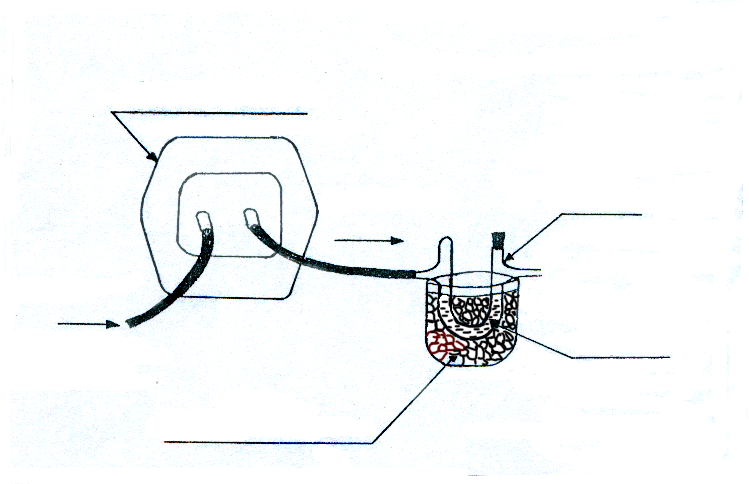
Electric furnace
Gas flow
Argon gas
Salty ice bath
Condensed water
Gas flow
Caclium hydroxide solution for detection carbon dioxide.
Figure 1: Polymerization system used.

Results and discussion
Rayon fiber was heated (starting temperature ~100ºC to avoid humidity in the whole system) under argon at 200°C, it shows the tendency for condensation polymerization with elimination of water molecules which accumulated by cooling in the U-type which is immersed in ice-salt bath of temperature -3°C (see Figure 1). At 200°C the percent of condensed water was found to be 10% of ten grams treated fiber in a good agreement with fiber weight loss (Table 2 and Figure 2).

Table 2: Weight of condensed water and fiber weight loss upon heating 10 g fiber for each experiment under argon atmosphere at various temperatures.
Temperature°C | Condensed water %* | Fiber weight loss %* | Average %
200 | 10.1 | 9.9 | 10
215 | 10.6 | 10.4 | 10.5
230 | 10.9 | 10.9 | 10.9
>230 | Carbon dioxide starts to liberation.

* the average of three experiments.

2
4
6
8
10
8.0
8.5
9.0
9.5
10.0
10.5
11.0
Pyrolysis time/ hour
Condensed water%
200°C
215°C
230°C

Figure 2: Pyrolysis of rayon fiber under argon gas atmosphere.

High temperature causes the atoms in the fiber to vibrate violently until most of the non – carbon atoms are expelled ^{(7,8)}. In this work hydrogen and oxygen atoms are expelled as water from rayon fiber and this process called carbonization. The high water percent makes the linear polymerization, i.e. condensation polymerization linkage through the two terminal groups –H and –OH of the two rayon molecules
unacceptable due to the theoretical low water percent elimination in spite of any n value, in this case calculation shows that in case of linear polymerization of two rayon molecules, the water percent
HO
( C₆H₁₀O₅)_{n}
H

=$\left(\frac{\text{18}}{2×\text{162}n+2H_{2}O}\right)\text{100}=\left(\frac{\text{18}}{\text{324}n+\text{36}}\right)\text{100}$...................................................(1) which is far away from 10% water.
For X molecules of rayon :-
HO
( C₆H₁₀O₅)_{n}
H
in case of linear polymerization, water percent liberated = $\left(\frac{\text{18}Χ−\text{18}}{\text{162}nΧ+\text{18}Χ}\right)\text{100}=\left(\frac{Χ−1}{9nΧ+Χ}\right)\text{100}$..............................................................(2) which

is far away from the experiments results 10% for any numbers for n and X.
- Thus the other possibility is the cross condensation polymerization in which each mer in the rayon molecule and each two terminal mers lost only one water molecule as shown in Figure 3. Since one water molecule lost resemble $\frac{\text{18}}{\text{162}}×\text{100}=\text{11}\text{.}\text{11}\text{\%}$ of the mer, but experimentally it was found that the lost is 10%. So the difference in the two percents is (11.11-10)%=1.11. This difference accumulated from each mer until reach the quantity of water required to complete the percent loss of water for the two vertical terminal mers which they lost
( C₆H₁₀O₅)

6
5
4
3
2
1
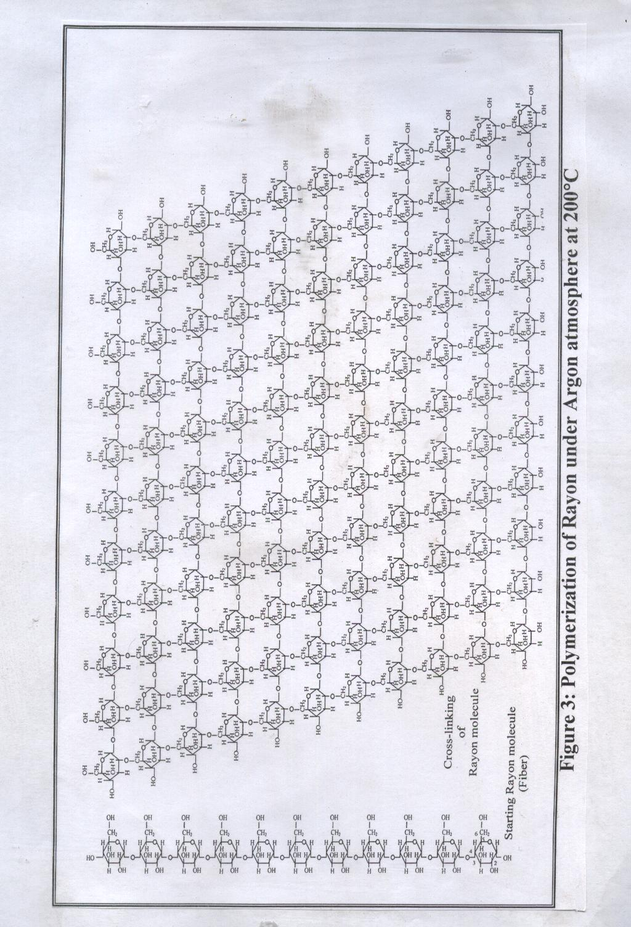

only one water molecule (18 g water) while they must loss 32.4g according to:(2 × 162) × 10%= 32.4g
∴ the weight of water required to complete the 10% lost for the two terminal =32.4 – 18 = 14.4 g.
∴ this quantity required the following:-
the percent difference 1.11% resemble 1.8g water (excess quantity from each mer).
∴ the number of mers that must be condensed to supply 14.4g equal to $\frac{\text{14}\text{.}4}{1\text{.}8}=8$.
Thus each mer in the rayon molecule (M. Wt.162) will lost 16.2g water according to the experimental losses (10%) in addition to that there is a lost of 1.8g water from the horizontal terminal water molecule
(M. Wt.18) (C₆H₁₀O₅)_{n}.H₂O or
H
( C₆H₁₀O₅)_{n}
OH
. Actually the mer loses one water molecule (18g), thus the excess quantity = 18-16.2=1.8g, this quantity accumulated from each condense mer until reach the quantity of water required to complete the percent loss from the two vertical terminal mers which they lost only one water molecule while they must loss 32.4g according to (2×162) ×10%=32.4g.
∴ the weight of water required to satisfied the 10% lost = 32.4-18=14.4g.
This quantity required $\frac{\text{14}\text{.}4}{1\text{.}8}=8$ mers to condense vertically.
∴ the total mers condensed = 8+2 vertical mers + one mer to substitutes the quantity of the 10% lost of the terminal water molecule , thus the overall mers that condense = 8+2+1=11.
∴ the number of rayon molecules
H
( C₆H₁₀O₅)_{n}
OH
that condensed as cross-link=11=X molecules.
Or more easily way that each mer lost one water molecule during condensation polymerization (part from the above mer plane and the other part from below its plane) while the two vertical terminals molecules lost only one water molecule. This leads us to:-

$\text{weight loss}=\frac{\text{water lost from condensed mers}}{\text{weight of that condensed mers}}=\frac{\text{18}Χ−\text{18}}{\text{162}Χ+\text{18}}$....................................(3)
$$0\text{.}1=\frac{Χ−1}{9Χ+1}$$
$$Χ−1=0\text{.}9Χ+0\text{.}1$$
∴ X =11, it resembles the number of mers or molecules that condensed.

To assign the chemical formula of the starting rayon molecule (i.e. to determine the number n) we follow:-
OH
H
11
n
The proposed chemical equation that describes the cross linking of the rayon molecule is :

11[HO (C₆H₁₀O₅)_{n} H]$\vec{{\text{200}}^{∘}\text{C Argon}}$ HO C₆H₈O₄ H + n(11-1)H₂O....(4)

or it can be rewrite in the form
$$\text{11}\left[\text{162}n+\text{18}\right]=\left[\text{11}\left(\text{144}n+\text{18}\right)+\text{18}n\right]+\left(\text{18}×\text{11}n\right)−\text{18}n$$
∴water liberated%=$\frac{\text{198}n−\text{18}n}{\text{1782}n+\text{198}}$....................................................(5)
$$0\text{.}1=\frac{\text{180}n}{\text{1782}n+\text{198}}$$
$$\text{180}n=\text{178}\text{.}2n+\text{19}\text{.}8$$
$$1\text{.}8n=\text{19}\text{.}8$$
$∴n=\text{11}$ is a constant, it resembles the number of mers of starting rayon molecules. [ ].
HO
( C₆H₁₀O₅)₁₁
H

Thus the general equation that relates % water liberated, n, and X is equation (4) which can rewrite it in general form

% water loss=$\frac{nΧ−n}{9nΧ+Χ}$...................................................................(6)

from this equation and the data listed in Table (2) we find (X) values at 215 and 230°C. The results are summarized in Table (3) taken in consideration that polymerization process continues above 200°C by combining two huge molecules which are formed at 200°C
OH
H
11
11
OH
H
22
11

HO
H
C₆H₈O₄
HO
H
C₆H₈O₄
to form molecule at 215°C.

After that polymerization continues, it seems that five molecules formed at 215°C (see above) combine to form new huge molecule at 230 °C as the result confirmed that from the weight of condensed water.
OH
H
110
11
HO
H
C₆H₈O₄

Above 230°C self carbon dioxide formation starts as indicated by turbidity of clear lime solution. Table 3 summarized these results and plotted in Figure2. Workers show that degradation of polymer materials is caused by various external factors such as heat ⁽¹⁰⁾.

Table 3: Number of cross-linked rayon molecules as a function of temperature.
Temperature  °C | % water eliminated or  % fiber weight loss | No. Of mers in the starting rayon molecules  (n) | No. Of cross-linked rayon molecules (X)
200 | 10 | 11 | 11
215 | 10.5 | 11 | 22
230 | 10.9 | 11 | 110
>230 | Carbon dioxide self-formation starts

Many tests are carried on for conformation cross-linking rayon fiber. One of them is the elemental chemical analyses which have revealed the stoichiometry of the rayon molecules polymerization [11], which show increasing of the carbon percent on the expense of hydrogen and oxygen percents upon heating comparing with that percents for unheated starting fiber (Table 4).

Table 4: Elemental chemical analyses of rayon fiber
Fiber | C% | H% | O% | Empirical Formula
Starting Fiber | 44.4 | 6.1 | 49.4 | C_{1.2}H₂O₁
Cross-linked at 200°C | 50 | 5.55 | 44.44 | C_{1.5}H₂O₁
Cross-linked at 215°C | 50.3 | 5.52 | 44.2 | C_{1.52}H₂O₁
Cross-linked at 230°C | 50.5 | 5.5 | 44.0 | C_{1.53}H₂O₁

The heat treatment of rayon fibers show high resistance against 60% sulfuric acid for 20 minutes at 20°C by immersion the sample in this acid solution according to the solubility test ⁽¹²⁾, as indicated by no change in the weight of the fiber before and after treatment in the above solution, while untreated fiber dissolved immediately in this acid. This new behavior of the fiber agrees with the literature which stated “that cross –linked polymers show temperature and solvents resistance” ^{(13,14)}.
Also treated fiber show good fire resistance comparing with the flammable untreated one. This test was carried according to the reference⁽¹³⁾. This agree with the literature that stated, “cross-linking and macromolecules formation give high fire resistance” ⁽¹⁵⁾.
Fiber shows color change as a function of temperature and time duration in the order:-
White → Yellow → brown → black as temperature increases with smooth and oily appearance surface similar to the graphite fiber. Such physical properties change in fiber may be due to the new bonding system results from the cross linking of the rayon molecules which make these molecules more close to each other with loses of water as the temperature increases. Workers show that heating of polymer resulting in brittleness and coloration / discoloration. The process of degradation is known to be accompanied by very week emission of chemiluminescence. Since chemiluminescence has a high sensitivity to thermal oxidation, chemiluminescence measurement has been used as a tool for the evaluation of the stability of polymer materials against heat ⁽¹⁰⁾. In this work rayon fiber was stable against heat nearly to 200°C in which water starts to liberates and color starts to develop and the formed fiber become more stable gradually as temperature increases up to 230°C due to the increases of the degree of polymerization (more cross-linked system).
The other part of this work is the polymerization of rayon fiber under 99% nitrogen gas. The results show that the weight of the accumulated water is less than that of fiber weight loss, which indicates that other material liberated with water passing the outlet nitrogen gas through clear lime solution which shows early liberation carbon dioxide, this may be due to the presence of oxygen with the nitrogen gas which attacks the rayon molecules at this temperatures (∼200°C).
Conclusions
- Cross-linking results in high fire - and chemical- resistance for the fiber due to more dense covalent bonds formed (see Figure 3).
- The color of the fiber changes due to the polymerization. Darker colors result as degree of polymerization rises (as a function of temperature and time duration).
- Theoretically the maximum liberated water from the self condensation polymerization of the rayon molecules is lower than 11% when n=11. practically we reach 10.9%. Also the maximum liberated water for any n and X values is not exceeds 11.11% theoretically according to the relation:
$\text{water\%}=\frac{\text{nx}−n}{9\text{nx}+x}$.
Such theoretical values may be reached at very drastic conditions of temperature and time after 230°C before carbon dioxide liberated.
- Self condensation polymerization seems to take place at positions 2 and 6
6CH₂OH
5
O
4
OH
1

O
OH
2
3

O

while position 3 located directly under position 5 to which the group –CH₂OH (Position6) is linked. These positions 3 and 6 make the self cross-link molecules in a rigid straight line without any flexibility as well as both of –OH and –CH₂OH groups located over the mer plane ⁽¹³⁾ which results in steric hindrance in case of attacks by self molecules. Position 2 shows that its hydroxyl group lies under the mer plane which gives a good chance to react.Katz ⁽¹⁶⁾ shows that cellulose with acetic acid, in which positions of the three hydroxyl groups 2,3, and 6 are attacked by the small molecule of acetic acid compares with large rayon molecule.
- At any temperature as the duration of heating time exceeds that of the time required for polymerization completion at that temperature, it shows an effects on the physical properties of the fiber such as color and mechanical properties but no effect on the amount of the accumulated water is detected. This mean that when the degree of polymerization reaches its maximum value at that temperature , no effect for time on it (see Figure 2).
Under inert atmosphere (Argon), rayon shows cross linking followed by degradation. In the presence of trace amount of oxygen, degradation and cross linking processes are in competition. Workers show cross linking appeared at lower temperature than phase changes like oxidation, degradation etc. ^{(2, 17, 18)}.

References
- Joyce A. Smith, “Extension Factsheet” , Ohio State University, HYG 2006, 02 ,5538.
- Jalil Karim Ahmad, “Carbon Fiber”, Al-Muntasser Institute, issue, 1999, No.001.
- Zuhair J. Al-Asidi, “Preparation of Polyacrylonitrile and Rayon Fiber for Carbon Fiber Production”, M. Sc. Thesis, Babylon University 2001.
- Ray Q. Brewster, and William E. M. Mc Ewen “Organic Chemistry”, 3 rd edition, prentice-Hall, 1971.
- Hardy, Craig; The rayon Fiber Process and Fiber Characteristics; principles of Nonwovens; Ind.
- High – performance structural fibers for Advanced Polymer Matrix Composite National Materials Advisory Board (NMAB) 2005.
- Carbon fiber: How products are made, http://www.enotes.com 2006.
- Russell J.Diefendorf, carbon/Graphite fibers, Rensselaer polytechnic Institute.
- Standard specifications, quality controle laboratory, company for textile industries, Hilla, Iraq, 2005.
- Satoru Hosoda, Yoshinori Seki, and Hayato Kihara, polymer 1993,. Vo l .34, No.22 .
- Jeffrey H. Simpson, David M. Rice and Frank E. Karasz and Frank C. Rossitto and Paul Lahti, Polymer, 1993, Vol.34, No.22.
- John Wiley and Sons, Inc. “Modern Textile”, printed in United States of America 1976.
- Malcom B. “Chemistry of Polymerization”, translated to arabic by Kabass A. K. Ibrahim, Basrah University 1984 .
- C. W. Wise, W. D. Cook, and A. A. Goodwin, polymer, 2000, 41, 4625-4633, .
- E. Fitzer and others, Carbon , Pergamon press PIC, England 1989, Vo l . 27, No. 4 , 621-645 .
- David A. Katz, polymers, 1921 Briar Hill Road, Gladwyne, PA 19035, USA, 1998.
- J. F. Rabek, Experiment Methods in Polymer Chemistry, Wiley and Son: Ltd., N. Y. 1980.
- J. A. Mikroyanidis, A. P. Milissaris, J. Appl. Polym. Sci.,1988, 36, 691-702 .

