Synthesis of New 5-Ethyl-5-Phenyl
Barbituric Acid Derivatives

Redha I. H. AL-Bayati
Department of Chemistry, College of Science, AL-Mustansiriya University
Baghdad, Iraq.
Raad M. Muslih and Nagham M. AL-Janabiy
Department of Chemistry, College of Science for girls, University of Baghdad
Baghdad, Iraq.

(NJC)

(Received on 16/ 10 /2004) (Accepted for publication on 23/3/2005)

Abstract
The reaction of some new Schiff bases (5-ethyl-5-phenyl-1,3-di[N-4-substituted benzilidin hydrazinyl] barbituric acids) with benzoyl chloride or 3,5-dinitrobenzoyl chloride were carried out. Subsequent reactions of these products di[N-(α-chloro(substituted benzyl)-N-benzoyl or 3,5-dinitro benzoyl)-5-ethyl-5-phenyl-1,3-di(acetic acid hydrazinyl) barbituric acids with thiourea afforded thioureas compounds.
The synthesized compounds were confirmed by their IR, UV spectra and C.H.N. analyses data.

الخلاصــة

تعطي تفاعلات قواعد شيف جديدة
(5-ethyl-5-phenyl-1,3-di[N-4-substituted benzilidin hydrazinyl]
barbituric acids)
مع كلوريد البنزويل أو كلوريد 5,3-ثنائي نتروالبنزويل مركبات
di[N-(α-chloro-substituted benzyl)-N-benzoyl or 3,5-dinitro benzoyl]
-5-ethyl-5-phenyl-1,3-di(acetic acid hydrazinyl) barbituric acids
وتفاعلات المركبات الناتجة مع الثايويوريا يؤدي إلى تكوين مركبات الثايويوريز.
شخصت المركبات المحضرة باستخدام بعض الطرق الطيفية (UV, IR) والتحليل الدقيق للعناصر.

Introduction
Phenobarbital derivatives are interesting series of heterocyclic compounds, which have been shown to be diverse pharmacological properties ⁽¹⁾ such as antifungal ⁽²⁾, antimicrobial ⁽³⁾, antipulsive ⁽⁴⁾ and antibacterial ^{(5,6)}. This paper reports the synthesis of some new phenobarbital compounds from the reaction of some phenobarbital system containing Schiff bases moiety with benzoyl and 3,5-dinitro benzoyl chlorides. Subsequent reactions of these products with thiourea afforded thioureas compounds.

Experimental
Melting points were recorded on a Gallen-Kamp MFB-600 melting point apparatus. IR spectra were recorded in KBr disc and film on a Pye-Unicam SP3-100 spectrophotometer. UV spectra were recorded on a Hitachi/UV-2000 spectrophotometer using absolute ethanol as solvent. Elemental analyses of some compounds were carried out on C.H.N. analyzer type 1160 (Carlo-Erba).

Preparation of Schiff bases (1-5): -
These compounds were prepared as reported previously ^{(7,8)}.

Preparation of 5-ethyl-5-phenyl barbituric acid derivatives (6-15) ⁽⁹⁾: -
To an appropriate Schiff base (0.0008 mole), benzoyl chloride or 3,5-dinitro benzoyl chloride (0.016 mole) in dry benzene (20 ml) was added. The mixture was refluxed for (6 hrs), cooled, filtered and recrystallized from suitable solvent (Tables 1,2,3,7).

Preparation of isothioureas compounds (16-25) ⁽⁹⁾: -
To an appropriate derivatives of (5-16) (0.001 mole) thiourea (0.002 mole) and Na₂CO₃ (0.002 mole) in absolute ethanol (25 ml) were added. The mixture was refluxed for (2-4 hrs), cooled and filtered. The filtrate was poured into crushed ice, the separated solid was collected and recrystallized from appropriate solvent (Tables 4,5,6,7).

Results and Discussion
Schiff bases (1-5) were prepared by condensation of 5-ethyl-5-phenyl-1,3-di(acetic acid hydrazide) barbituric acids with various aromatic aldehydes (p-ClC₆H₄CHO, p-OHC₆H₄CHO, p-OCH₃C₆H₄CHO, o-NO₂C₆H₄CHO and m-NO₂C₆H₄CHO). The reaction was followed by the appearance of absorption bands for (υC=N) at (1620-1640 cm⁻¹) in their IR spectra. In the present work the reaction of compounds (1-5) with benzoyl or or 3,5-dinitro benzoyl chlorides and subsequent reactions of above reaction products (6-15) with thiourea were carried out as shown in scheme (1).
However, treatment of Schiff bases with acid halides results in the formation of compounds (6-15) in which two groups (Cl and ArCO) were introduced in the same step of the reaction. This reaction was followed by disappearance of absorption bands at (1620-1640 cm⁻¹) for (υC=N) and appearance of new absorption bands at (1230-1250 cm⁻¹) and (730-750 cm⁻¹) which were attributed to (C-N) and (C-Cl) moieties.
The reaction was followed the attack by the azomethine nitrogen at the carbonyl group of the aroyl chlorides, displacing the chloride as chloride anion and forming the iminium cation. However, iminium cation was unstable, so the Cl⁻ attacked -⁺N=C moiety and afforded more stable covalently bonded compounds (6-15) (Scheme 2).
Moreover, the reactions of acid halides addition products (6-15) with thiourea were afforded thioureas products (16-25). So, heating compounds (6-25) under reflux with thiourea in the presence of Na₂CO₃ for (2-4 hrs) led to the nucleophilic substitution of Cl by S of
and compounds (16-25) were formed through the following mechanism (Scheme 3).
These compounds (16-25) were characterized by their IR spectra. New doublet absorption bands in the region (3200-3450 cm⁻¹) were attributed to (NH₂) and (NH) functional moieties. Other characteristic bands in the region (650-710 cm⁻¹) correlated to (C-S) moiety. Moreover, (δ C-Cl) around (730-750 cm⁻¹) disappeared.

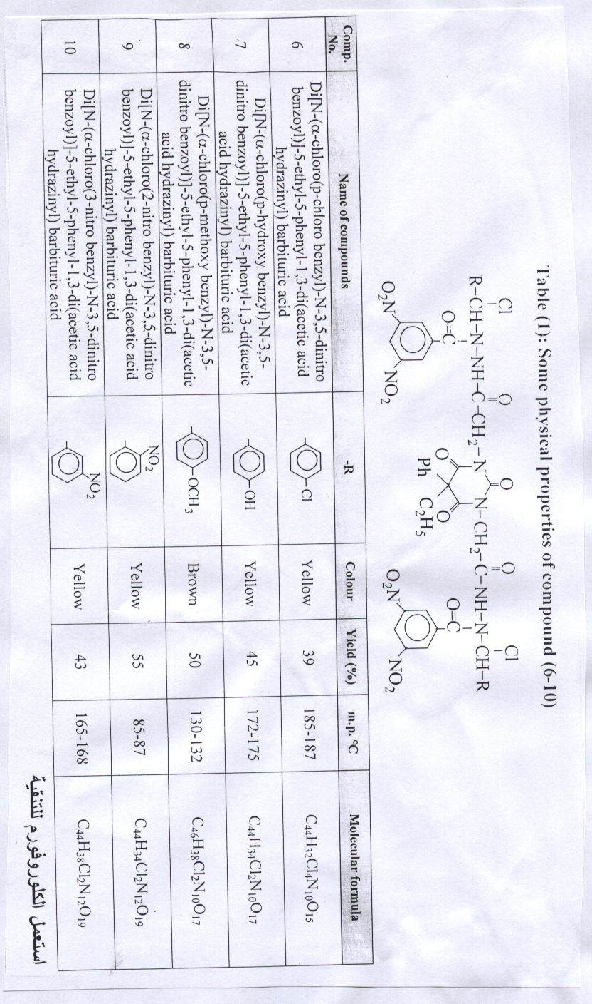
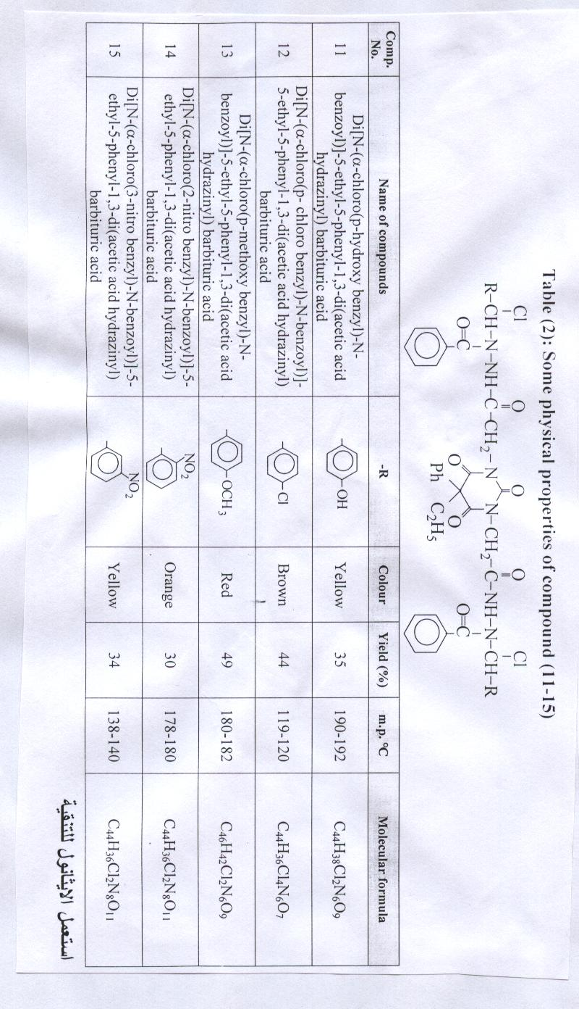
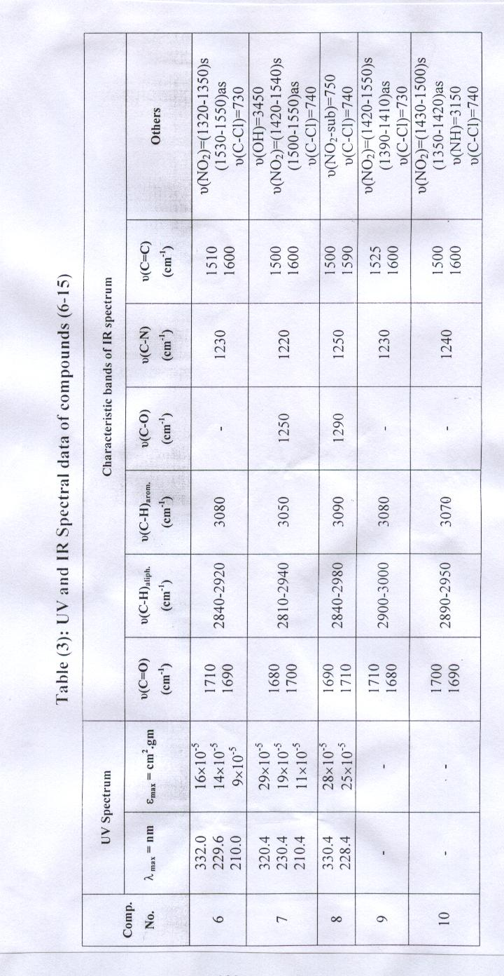
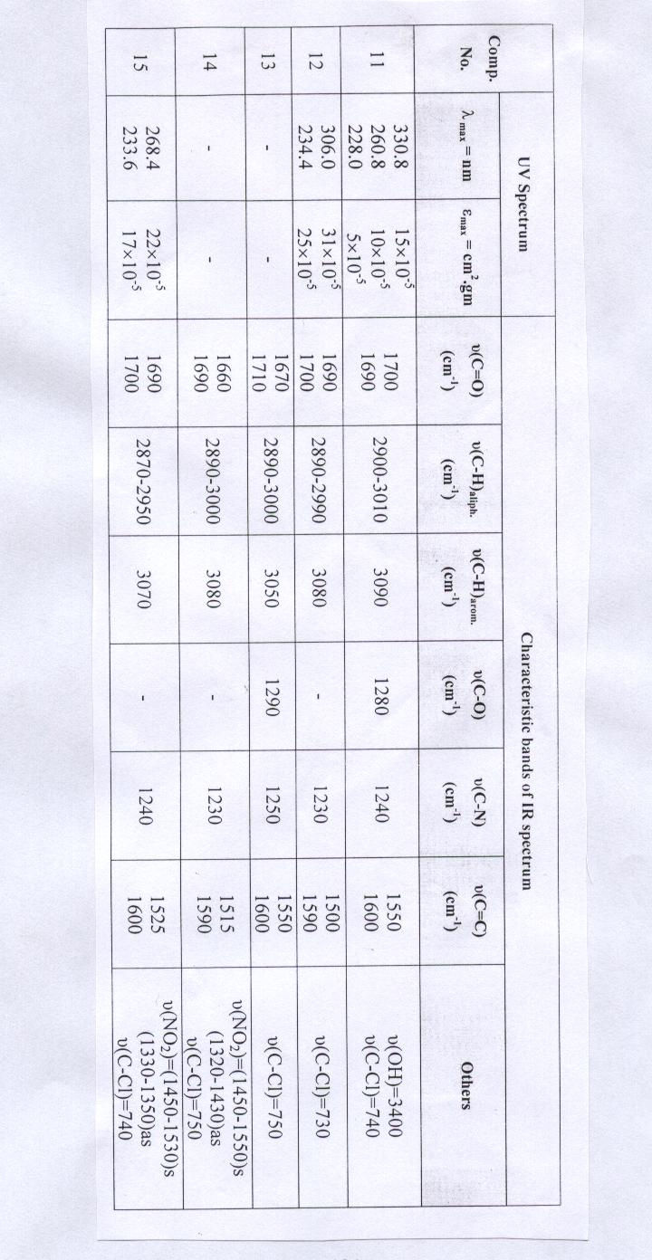
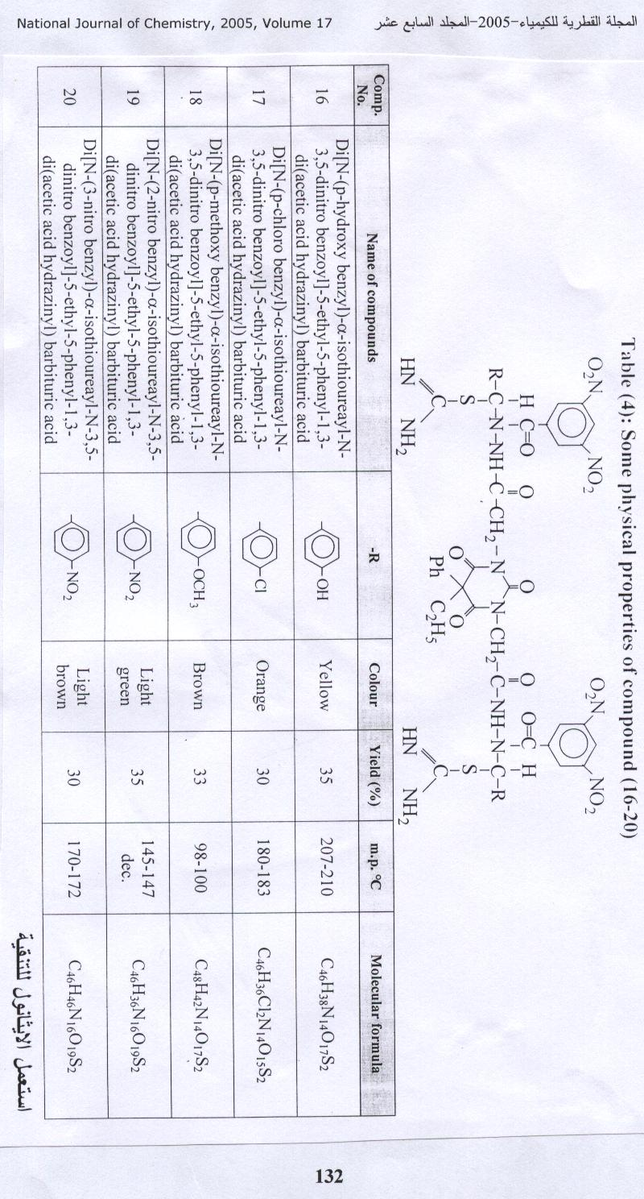

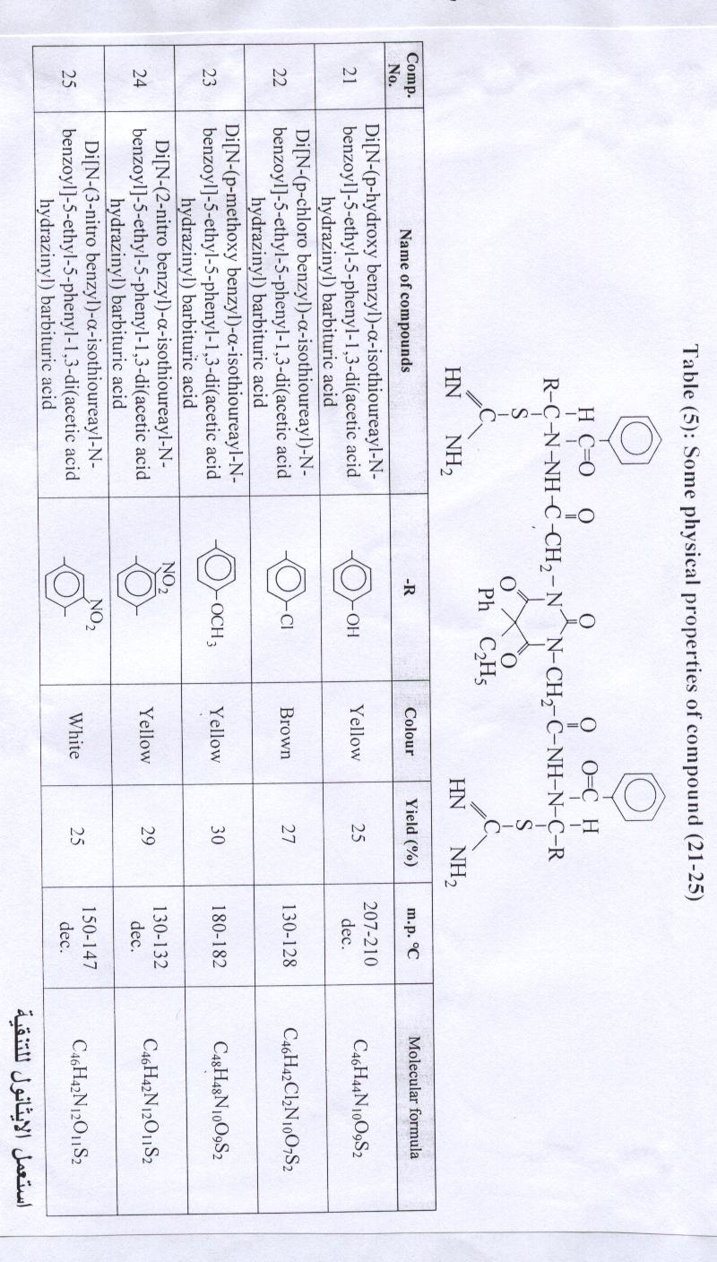
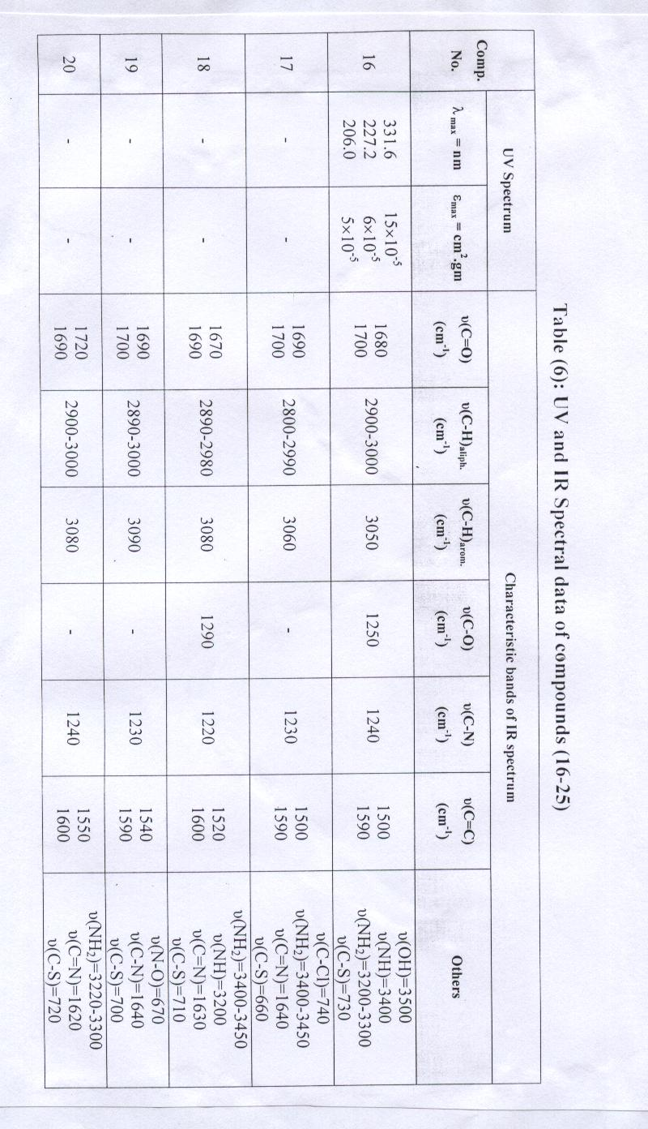
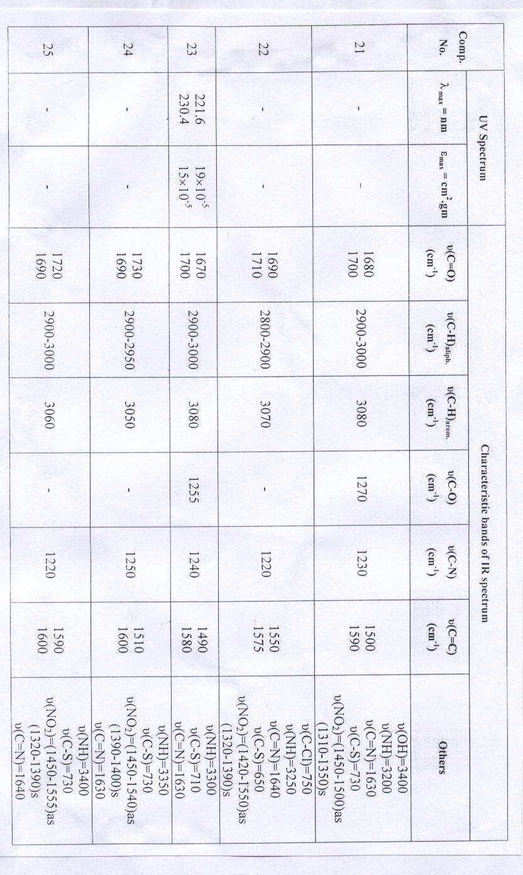
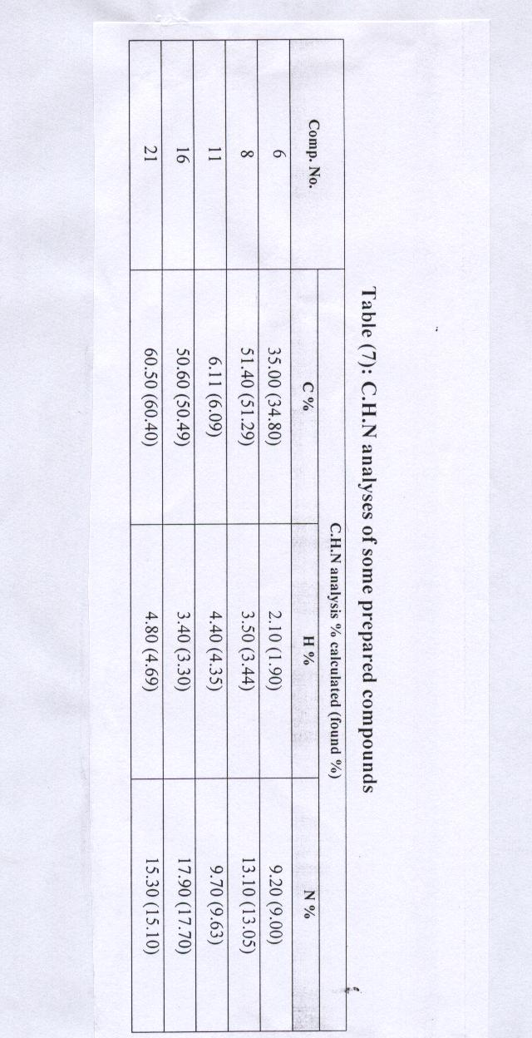

References
- N. M. AL-Janaby, M. Sc. Thesis, College of Science for girls, University of Baghdad (2003).
- E. Jeney and T. Zsolnai, Abt.1, Orig. 193(4), 516 (1964). Chem. Abstr.; 62, 3106 (1965).
- A. Montague, Philips Brit, 590, 714 (1947). Chem. Abstr.; 42, 2987 (1948).
- C. R. Lee, J. M. Glashan, Martindal “The complete Drug Reference”, 32nd Ed. (1999).
- K. F. Modi, N. Krishnakunar and H. J. Mehta, J. Ind. Chem. Soc.; 1977, LIV, 741.
- V. J. Ram, U. K. Singha and P. Y. Juru, Eur. J. Med. Chem.; 1990, 25, 533.
- S. Bahadur, A. K. Goel, R. S. Varma, J. Ind. Chem. Soc.; 1976, LIII, 590.
- R. M. Muslih, R. I. H. AL-Bayati and N. M. AL-Janaby (under publication).
- F. A. Hussein, I. T. Ali and D. F. Hassa, Iraqi J. of Chem.; 2001, 27(2), 445.

