pH Effect on the Photocatalytic Oxidation of
Butan -2 - ol over Naked Titanium Dioxide .

Abass J.Attia

Chem. Department , College of Science , Babylon University

(NJC)

(Received on 19/4 /2004) (Accepted for publication on 23/3/2005)

Abstract
The effect of pH on the photocatalytic oxidation of butan-2-ol over naked titanium dioxide has been investigated. The apparatus which is used in the photocatalytic reaction has a precies temperature control which gives a high precision for the reaction .
Spectrophotometric method was used in the determination of amount of the product formed, this method is based on the formation of 2,4 – dinitrophenyl hydrazone of the produced carbonyl product, followed by the addition of alcoholic potassium hydroxide to give a wine colour which is measured by spectrophotometric method .
The measurements were done at 298 K using different buffer solutions, and irradiation with ultraviolet light from mercury vapour lamp( 150 ) Watt .
الخلاصة
تم دراسة تأثير الدالة الحامضية على تفاعل الأكسدة الضوئية المحفـزة لكحـول البيوتان –2– أول باستعمال ثاني اوكسيد التيتانيوم المجرد . إن المنظومة المستخدمة في هذه الدراسة تمتاز بالسيطرة الدقيقة على درجة الحرارة أثناء التفاعل وهذا من شأنه إعطاء نتائج دقيقة للتفاعل.
لقد تم استخدام الطريقة الطيفية في تحديد كمية الناتج المتكون في التفاعل ، وهذه الطريقة تعتمد أساسا على تكوين المشتق 2،4 – ثنائي فينل الهايدرازون للمركب الناتج ، ثم إضافة هيدروكسيد البوتاسيوم الكحولـي حيث يعطي لون خمري يمكن قياسه طيفياً .
تم إجراء جميع القياسات بدرجة حرارة 298 كلفن وباستعمال محاليل بفـر مختلفة في التفاعل والتشعيع بالأشعة فوق البنفسجية المنبعثة من مصباح زئبقي ذوقدره(150) واط .

Introduction
In the last few decades a great interest has been done in the development of utilization from the solar energy by using semiconductors as a photocatlysts , photocatalytic oxidation of different organic substrates could be done over these photocatalysts . This application can be used in the decontamination treatment for the polluted water which resulted from industrial processes. The participation of semiconductors particles such as TiO₂ , ZnO , and CdSe in the photocatalytic reactions can provide a good mean for different newly applications which are necessary for the modern life such as an environmental clean up , production of a clean fuel , conversion of a solar energy to chemical potential , and in chemical synthesis as in production of carbonyl compounds from oxidation of their corresponding alcohols⁽¹⁾ .
In the heterogeneous photocatalysis systems , the solid photocatalyst is present in a separated phase from whole mixture. The irradiation of a photocatalyst particles with a light of enough energy ( hν ≥Eg ) can promot electron from valence band to the conduction band . This process generates (e-h) pair in conduction band, and valence band respectively⁽²⁾ . When these species are not consumed rapidly in a desired oxidation/ reduction reaction , they will recombine to produce thermal energy ( hv ≥hv⁻ ) or rapidly migrate to the surface, and then reacted with an adsorbates at the surface of photocatalyst⁽³⁾ .
As well as physical pathways for the fate of ( e⁻ - h⁺ ) pair which are produced in the initial step in the photoexcitation processes , the chemical events for the consumption of ( e – h ) pair also possible . The chemical events include trapped of photohole ( h+ ) by a surface hydroxyl group (OH⁻)_{sur} to generate hydroxyl radical ( OH. ) which is considered a strong oxidizing agent⁽⁴⁾ . The formation of hydroxyl radical in this mechanism was identified by (ESR) spectroscopy, on other hand photoelectron is trapped by the preadsorbed oxygen on the surface ( O₂ ) _{ads} to generate different oxygen species such as O₂ , and O⁻²₂ anions . These species are contributed in the oxidation of a differnt organic species which are adsorbed on the surface⁽⁵⁾.
The activity of semiconductor as a photocatalyst depends on some factors such as stability of the semiconductor particles under irradiation conditions, the selectivity toward formation of a desired products, and the band gap energy for the semiconductor particles⁽⁶⁾ . For example (CdS) has a small band gap energy and its becomes excited under visible light of the solar spectrum , but it dose not has enough stability toward light and its photodegraded with continuos of irradiation time⁽⁷⁾ . Among different types of the semiconductors titanium dioxide is the most important photocatalyst due to its high stability toward light, but it has a high band gap energy
( Eg = 3.23 eV ) for the anatase form of TiO₂ and ( Eg = 3.02 eV ) for rutile form . So that TiO₂ becomes excited in the ultraviolet region of solar spectrum ⁽⁸⁾.
The limitation of a certain semiconductor for a particular uses can overcome by the modification surface of the photocatalyst . Generally , there are different methods which are used in the modification of the surface such as metal-semiconductor modification , composite semiconductors , surface sensitization , and transition metal doping⁽⁹⁻¹¹⁾.
It has been found that there are many benefits resulted from the surface modification such as reduction the rate of recombination reaction between (e⁻ - h⁺) pair which is commonly occurs in the naked photocatalysts, increasing the response of the photocatalyst toward a high wavelengths of solar spectrum, and changing the selectivity toward formation of a particular products⁽¹²⁾ .
In the present work, the photocatalytic oxidation of butan-2-ol has been investigated over naked TiO₂ with the presence of different buffer solutions . The study was carried out at 298 K using ultraviolet light from mercury vapour lamp .
Experimental
Naked TiO₂ ( p-25 Degussa ) anatase form was used with a surface area of 55 m².g⁻¹ , and crystallite size of ( 25-35 )nm with a purity of 99.99%⁽¹³⁾ . The unit which is used in this study has a precise temperature control which facilitates the photocatalytic oxidation of butan-2-ol with a precies temperature. The apparatus which is used in this study was homemade and it is shown in Figure(1).
Photocatalytic oxidation of butan-2-ol was done by using ultraviolet light from mercury vapour lamp (150) Watt. The reaction cell was made up of a pyrex . In each experiment ( 150 ) mg of TiO₂ was suspended in ( 20 ) mL of reaction mixture which consist of ( 15 ) mL of absolute butan – 2 – ol with ( 5 ) mL of the used buffer solution . The reaction mixture was suspended by used motor driven stirrer. The controlling on temperature of reaction was maintained by mountining reaction cell in a closely fitting aluminum block . The temperature of aluminum block was controlled by frigister which is connected with electronic control unit . The circulation of water in a water-jacket in contact with a frigister to facilitate heat exchange.
Spectrophotometric method ⁽¹⁴⁻¹⁶⁾ was used for the determination of the butanone formation, this method is based on the formation of 2,4-dinitrophenyl hydrazone of butanone. Periodically (0.2)mL samples of reaction mixture were withdrawn by microsyringe, the sample then centrifuged to separate solid TiO₂ . The remaining liquid then analyzed for reaction product.
Samples (0.1) mL of supernatant liquid in a mixed hexane / ethanol solvent (3.7:5)mL were reacted with 2,4 dinitrophenyl hydrazine reagent (2)mL for (30) min , at (328) K to give 2,4 – dinitrophenyl hydrozone of the produced carbonyl product . The solution then cooled to the room temperature, and diluted to (25) mL with alcoholic potassium hydroxide. The absorbance then measured at (480)nm , the absorbance was directly proportional with concentration of the product , whose concentration was determined by using standard calibration curve . The calibration curve was consist of the absorbance versis concentration of carbonyl compound, the calibration curve was obtained by using standard butanone solutions in place of reaction mixture.
Results and Discussion:
From this study, it was concluded that, the photocatalytic oxidation of butan -2-ol could be carried out with the presence of TiO₂, air, and ultraviolet light. The used alcohol was photooxidized to its corresponding carbonyl product. These observations are in a good agreament with previous studies in this field ⁽¹⁷⁻²⁰⁾. The product was detected by using (IR) spectroscopy which exhibits absorption band at (1700) cm⁻¹ which deals with the absorption of carbonyl group of the resulted butanone . Also there is a broad band at (3100-3700) cm⁻¹ which deals with the absorption of hydroxyl group of the used alcohol .
Table (1) and Figure (2) show the results of photoconversion of buton -2-ol to the butanone, from these results it could be concluded that, the addition of the acidic buffers to the reaction mixture leads to the reduction in the activity of reaction with respect to the absence of these solutions in reaction mixture.
Generally, photoreactions over photocatalyst suspension poweders have a weak dependence of rate of reaction on the pH of solution⁽²¹⁻²⁵⁾ . It has been found that pH of solution can effect on the surface charge, and particle size of the photocatalyst⁽²⁶⁾ . The surface of photocatalyst at its isoelectric point does not have any charge , for the acidic solution ( pH< 7 ) the surface of photocatalyst becomes positively charged⁽²⁷⁾ .

Figure (1) Apparatus for the photocatalytic oxidation of alcohol
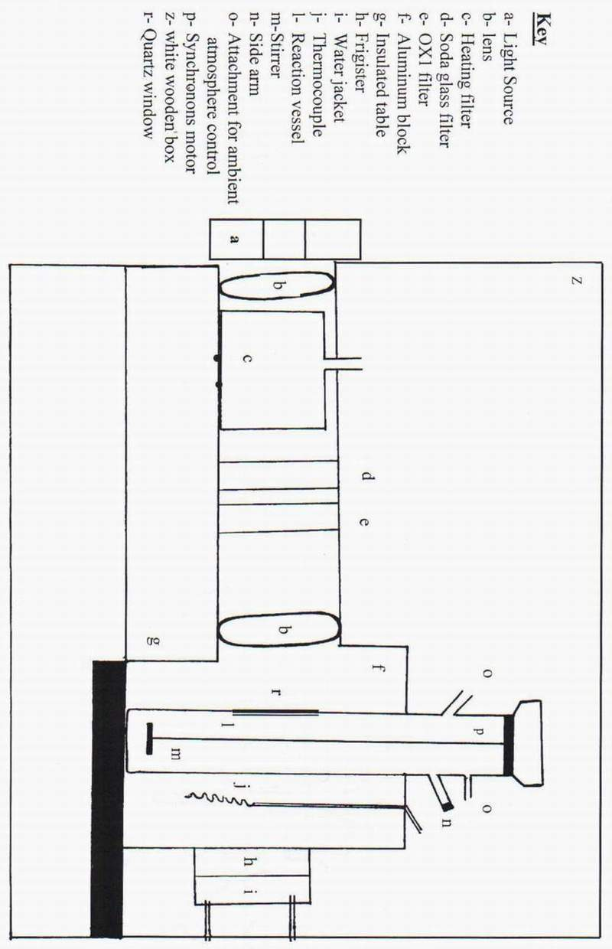

Table (1): Photoconversion of butan -2-ol to the butanone over TiO₂ and different acidic buffer solutions at 298 K for ( 75 ) min.

No | pH of the used acidic buffer | 10² x butanone con/mol. dm⁻³ | 10⁶ x rate/mol. dm⁻³.s⁻¹
1 | - | 0.58 | 1.360
2 | 5 | 0.52 | 1.200
3 | 4 | 0.45 | 1.050
4 | 3 | 0.30 | 0.600

Butanone con x 10²/mol.dm⁻³

Figure (2). Photoconversion of butan-2-ol to the butanone at 298 K using different
acidic buffer solutions.

Table (2) and Figure (3) show the results of photoconversion of butan -2-ol to the butanone with presence of different basic buffer solutions in reaction mixture. From these results, it could be concluded that, the presence of basic buffers reduces the activity of butanone formation with respect to the absence of these buffers from reaction mixture under the same conditions of reaction. The reduction in activity of butanone formation in this case can be attributed to the negatively charged surface for the basic solution (pH>7)⁽²⁷⁾ .
These observations could be explained by considering the effect of surface charge on the adsorption of reacted species , and desorption of reaction products . The decreasing in pH leads to the protonation of both bridging surface (O⁻) and surface hydroxyl groups on photocatalyst surface. These factors effected on the adsorption of alcohol molecules on the surface of TiO₂, the adsorption of alcohol molecules on TiO₂ surface is very important step in their photocatalytic oxidation which is related to the hydroxylation of the surface⁽²⁸⁾.
It has been found that, oxygen on TiO₂ surface is coordinatively unsaturated which is considered a suitable position for the adsorption of alcohol molecules on the surface . The adsorption of alcohol molecules on the surface occurs either by hydrogen bond as ( OH --- O ) , or by coordinative bond as (Ti – O) for the non dissociative alcohol⁽²⁹⁾ . The formation of these bonds also infulenced by the surface charge resulted from the variation in pH of reaction mixture which inturn leads to the reduction in the activity of butanone formation for acidic and basic buffer solutions, as it compared with the absence of these solutions from reaction mixture when used only reacted alcohol and TiO₂, without any buffer solution.
Mechanism of Reaction:
The first step in the photocatalytic oxidation of alcohol over TiO₂ surface is the excitation of photocatalyst particles by absorption ultraviolet light (λ < 400)nm . This process produces (e-h) pair in conduction band and valence band of TiO₂ particle respectively as follows⁽³⁰⁾: -
TiO₂ ^{hv} TiO₂ (e⁻ - h⁺) ……. (1)

TiO₂ (e⁻ - h⁺) e- _{cb} + h⁺ _{vb} …. (2)
Conduction band electron , and valence band hole are contributed in the formation of reactive radical species on the surface as follows :

e⁻ + O⁺ O₂ ⁻_{(ads)} ….. (3)

h⁺ + OH⁻_{(sur)} OH . _{(sur)} …. (4)

Both (O⁻₂)_{ads} and (OH.)_{sur} radicals are contributed in the dehydrogenation of the used alcohol by proton abstraction as follows :

O⁻_{2(ads)} + H₂O OH. _{(sur)} + HO₂ …. (5)

CHOH+OH_{(SUR)} COH + H₂O .. (6)

COH + HO₂ C==O + H₂O₂ … (7)

2 COH CHoH + C==O ….. (8)

This mechanism is in a good agreement with a similar previous studies in this field⁽³¹⁻³⁴⁾.

Table (2): Photoconversion of butan – 2 - ol to the butanone over TiO₂ and different basic buffer solutions at 298 K for ( 75 ) min .
No | pH of the used acidic buffer | 10² x butanone con/mol.dm⁻³ | 10⁶ x rate/mol.dm⁻³.s⁻¹
1 | - | 0.60 | 1.400
2 | 8 | 0.48 | 1.100
3 | 9 | 0.40 | 0.910
4 | 10 | 0.28 | 0.550

Butanone con x 10²/mol.dm⁻³

Figure (3). Photoconversion of butan-2-ol to the butanone at 298 K using different basic buffer solutions.

References
1- N.Serpone , E.Pelizzetti , Eds.Photocatalysis-Fundamentals and Applications , Wiley – Interscience , New York , 1989 .
2- M.Gratzel , Heterogeneous Photochemical Electron Transfer , CRC Press: Boca Raton , 1989 .
3- R.B.Draper , M.A.Fox , Langmuir , 1990 , 6,1396 .
4- C.S. Turchi,D.F.Ollise , J. Catal , 1990 , 122 , 178 .
5- P.Sedlak , J.Cunnigham , J.Photochem . Photobiol . A:Chem. , 1994 , 77 , 255 .
6- D.F.Ollis , H.Al-Ekabi,Eds . Photocatalytic Purification and Treatment of Water , and Air , Elservier : Amstrdam , 1993 .

7- A.Henglein , J.Phys.Chem. , 1982 , 86 , 2291 .
8- J.D.Jakson , Classical Electrodynamics , Wiley and Sons : New York , 1975 , P.424.
9- D.F.Ollis , Environ . Sci. Technol. , 1985 , 19 , 480 .
10- D.F.Ollis,E.Pelizetti , and N.Serpone,Environ . Sci. Technol. , 1991 , 25 , 1523 .
11- R.W. Matthews , J.Phys. Chem. , 1987 , 91 , 3328 .
12- S.Sato,J.White , Chem. Phys. Lett., 1980 , 72 , 83 .
13- C.Yogarasimhang , N.Rao , J.Chem.Soc.Faraday Trans . I , 1962 , 58 , 1579 .
14- G.R.Lappin , L.C.Clark, Anal . Chem., 1951 , 23 , 541 .
15- P.E.Toren , B.J-Heinrich,Anal.Chem., 1955 , 27 , 1986 .
16- D.E.Jordan,F.C.Veatch, Anal.Chem.,1964 , 36 , 120 .
17- R.B.Cundall,R.Rudham , and M.Salim , J.C.S. Farday Trans . I , 1976 , 72 , 1642
18- P.R.Harvey , R.Rudhan , and S.ward , J.C.S.Faraday Trans. I , 1983 , 79 , 1381
19- H.A.Habeeb , F.H.Hussein , J. Al-Qadisiya University,2000, 5, 3 .
20- M.Abdullah , G.K. Law , and R.W. Matthews , J.Phys.Chem. , 1990 , 94 , 682 .
21- F.Sabin , T.Turk , and A.Vogher , J.Photochem. , Photobiol . A:Chem., 1990 , 63, 99.
22- H.Harada , T.Veda , and T.Sakata , J.Phys. Chem., 1989, . 93, 1542
23- J.Sabate , M.Anderson , and C.G. Hill , J. Mol. Catal. 1992 , 71 , 57 .
24- T.L.Rose , C.Nanjundiah , J.Phys. Chem., 1985 , 89 , 3766 .
25- G.Enea , A.J.Bard , J.Nouv.J.Chem., 1985 , 9 , 281 .
26- B.Shiffert , J.M.Colloids Surf , 1991 , 53 , 79 .
27- Augustinki , J.Struct . Bounding , 1988 , 69 , 1 .
28- J.Cunnigham , B.Doyle , and E.M. Leahy , J.Chem. , Soc. Faraday Trans. I , 1979 , 75 , 100 .
29- J.Weiss , V.Hoffman , J.Mol. Struct. , 1990 , 218 , 441 .
30- R.I.Bickley , F.S.Stone , J.Catal. , 1973 , 31 , 388 .
31- R.B.Cundall , R.Rudham , and M.Salim , J.Chem. Soc. Faraday . Trans. I , 1976 , 72 , 642 .
32- H.A.Habeeb , M.Sc. Thesis , Babylon University , Iraq , 1998 .
33- R.I.Bickley , G.Munuera , and F.S.Stone , J.Catal , 1973 , 31 , 398 .
34- F.H.Hussein , A.H.Ibrahim , and R.K Jamel , Irq.J.Chem.,1990 , 15 , 133 .

