Natural Jarosite Bearing Rocks, Treatment with Acid and Bases and Structural Characterization

Regab A. Buker and Falaknaze R. Kadir
Department of Chemistry , College of Education, University of Mosul, Iraq

(NJC)

(Received on 18/ 11 /2004) (Accepted for publication on 23/3/2005)

Abstract
Jarosite-bearing rocks , which deposit in our country in a modest quantities , have been treated with different concentrations of acids and bases to obtain a natural adsorbent materials applied in fractionation processes . Jarosite adsorbents which have been obtained via the treatment of 25% hydrochloric acid show the best developing catalyst in activity and selectivity efficiency . Physical properties, chemical analysis, thermal analysis, infrared spectroscopy, x-ray diffraction and fluorescence were performed to characterized the jarosite samples . The results indicate the possibility of using them in fractionation processes . They have been used to fractionate Qaiyarah heavy crude oils into their sub-fractions .

الخلاصة
تم معاملة الصخور الطبيعية الحاملة لمعدن الجاروسايت والتي تتوفر في قطرنا بكميات لاباس بها ، بحوامض وقواعد متنوعة ومختلفة التراكيز وتبين من خلال ذلك ان الصخور التي تم معاملتها بحامض الهيدروكلوريك تركيز 25% تصلح ان تكون حفازات ذات كفاءة وانتقائية عالية . ان الصفات الفيزيائية والكيميائية والتحاليل الحرارية وطيف الاشعة تحت الحمراء وحيود وفلورة الاشعة السينية التي تم دراستها اثبتت احتمالية استخدام هذه الصخور في اعمدة الفصل الكروموتوغرافي وقد استخدمت في فصل مكونات نفط القيارة الثقيل الى تراكيب ابسط يمكن الاستفادة منها .

Introduction
Heavy crude oils in general and Iraqi heavy crude oil, especially , compose mainly of complex mixture and the feature constituent of these matrix is aliphatic , naphthenic and poly aromatic hydrocarbon⁽¹⁾ . It is , therefore, the problem of the workers to maintain a reliable technique to separate these complex mixture into groups of substances and to convert the heavy crude oil into products which are lighter and more valuable fuels ⁽²⁾. One of those applied techniques, which seemed to depend on the idea of the differences in polarity values among the mentioned constituent of heavy crude oils, is using a fractionating columns. The columns were packed with adsorbent materials like, zeolite , clays, alumina, silica gel, alunite, jarosite…etc, to perform fractionation processes in order to get the demand goal ⁽³⁾. The idea of adsorption and fractionation might be explained in term of the structure of the catalyst materials. They are porous in nature , so they can hold water molecules as adsorbed, interlayer or lattice-OH water . The adsorbed water at relatively low temperature is driven off by heating to about 500⁰C ⁽⁴⁾. Organic molecules are dipoles and act in the same manner as water molecules when they are in contact with the catalysts ⁽⁵⁾.
Silica gel , alunite, and jarosite bearing rocks are discovered in numerous patches in our country⁽⁶⁾ , and recent studies have been reported the application of those naturally materials in adsorption chromatography⁽⁷⁻¹⁰⁾. Accordingly , and in continuation of such studies the present research deals with employment of jarosite and treated jarosite bearing rocks in fractionation of Qaiyarah heavy crude oil petrolene (QP) into lighter and more valuable simple components. Treatment of the samples was constructed by using several concentrations of common acids and bases . The investigation also involve the physical and structural properties of the natural and treated samples.

Experimental
- Source and preparation of jarosite samples:
Natural jarosite-bearing rock samples were obtained from area around Mosul city /Iraq. These samples were studied using several chemical analysis methods⁽¹¹⁾ and x-ray fluorescence technique to determine their chemical composition.
- Solubility in acidic and basic mediums :
The jarosite samples were treated using several concentrations of HCl, HNO₃, H₂SO₄ and CH₃COOH.One gram of the samples in 100ml of acids and bases were left overnight, washed by water and dried in oven at 110⁰C . Meanwhile several concentrations of NaOH , KOH and Na₂CO₃ were used in treatment of the jarosite samples by basic medium . It was done by refluxing them for two hours , followed by washing by water and drying at 110⁰C. The difference in weights before and after treatment was recorded .
- Thermal analysis :
Thermogravimetric (TG) and differential thermal analysis (DTA) were obtained simultaneously on a Stan Redcroft STA-780 analyser at heating rate of 5 ⁰C/min , and $α$- Al₂O₃ was used as standard reference.
- Infrared spectra :
Absorption of jarosite and treated jarosite samples and related compounds were recorded on Pekmin-Elmer 557 IR spectrophotometer using KBr disk⁽¹²⁾.
- X-ray powder diffraction and x-ray fluorescence :
X-ray powder diffraction analysis carried out using Cu K$α$ radiation Ni-filter and the diffraction patterns were recorded using Phillips powder x-ray diffractometer fitted with a vertical goniometer. The phase contributing to the x-ray diffraction pattern were identified by reference to the joint committee on powder diffraction standards powder diffraction(P. D. F). On the other hands, and to support the results of wet chemical analysis , x-ray fluorescence spectrophotometer was employed to determine the chemical composition of jarosite and treated jarosite samples on Phillips/PW 1450/10 analysis⁽¹³⁾.
Applications
Jarosite and treated jarosite samples (120-150 mesh) were packed into chromatographic column as an adsorbent materials. Those samples were activated by heating in an over at the required temperature , which was determined by thermal analysis technique , for three hours and employed in fractionation. A known weight of Qaiyarah heavy crude oil petrolene (QP)⁽¹⁴⁾ was fractionated separately into four fractions to evaluate the adsorption capacity of jarosite samples under investigation.
Results and Discussion
- The solubility in acidic and basic mediums :
The jarosite bearing rock samples have been treated by several acids and bases with different concentrations. Results of such treatment presented in Table (1) which represent the weight percentage of loosing during the treatment . It is obvious that using 25% HCl is the best results in the study . Accordingly , and referring to the literature ⁽¹¹⁾,such treatment usually results in dissolving all carbonate and part of sulfate compounds in jarosite samples . Furthermore, this might lead to increase the weight percentage of other components present in the sample including the jarosite mineral. Therefore, such treatment suggest to produce activated jarosite rock samples and hence to be applied in chromatographic fractionation as adsorbent materials⁽¹⁵⁾.

Table (1) Solubility of jarosite sample in different mediums .
% Acids and bases | 5 | 10 | 20 | 25 | Conc.
HCl % dissolved | 11 | 13 | 20 | 25 | 25
H₂SO₄ % dissolved | 6 | 11 | 14 | 20 | 20
HNO₃ % dissolved | 7 | 13 | 20 | 23 | 23
H₃PO₄ % dissolved | 4 | 5 | 16 | 16 | 17
CH₃COOH % dissolved | 3 | 5 | 7 | 8 | 8
NaOH % dissolved | 15 | 14 | 11 | 11 | ------
KOH % dissolved | 14 | 13 | 7 | 7 | ------
Na₂CO₃ % dissolved | 4 | 4 | 3 | 2 | ------

- Chemical analysis :
Analytical chemical analysis supported by x-ray fluorescence results of jarosite bearing rock and treated samples are presented in Table (2). It seems that high percentage jarosite mineral rocks is seldom found in the nature . The rock sample components is therefore, jarosite in solid solution with small amount of alunite minerals associated with gypsum , quartz, calcite, dolomite and montmonorolite minerals. The above determined minerals were named via their primary and secondary elements and compositions⁽¹³⁾. Moreover, there is a notable difference between ore rocks and treated ones especially in jarosite and carbonate content.
- physical properties :
The observed physical properties (density, porosity, water contain, surface area, and pore size) of jarosite and treated jarosite samples were listed in Table(3). The capillary action was also measured and the rising water level observed in the rock sample as monitored with the time is taken as the measurement of the capillary action. The data of jarosite and treated jarosite sample are presented in Figure (1).
In comparison between the above two results , it seems that jarosite bearing sample shows slightly large density than treated one. Such result attributed to the present of large cavities or cages which are joined by wide opening in case of treated sample : They therefore have a high internal surface area in the form of pores of fixed geometry . Moreover , the absorption percent of water and the capillary action effect, which demonstrate the slow rise of water through the sample , reflect the above descriptions and the differences between the two sample under investigation.
- Structural investigation:
Natural rocks, clays and the related sedimentary materials are composed of more than one mineral, and the minerals may be mixed in several ways. Hence, the structural composition of such materials can be determined on the basis of may ordinary instrumental analysis including : powder x-ray diffraction, x-ray fluorescence thermal analysis, infrared spectroscopy……. Etc ⁽¹³⁾.
Careful x-ray diffraction studies will reveal the presence and the relative abundance of the minerals . Accordingly , powder x-ray diffraction of the jarosite rock samples under investigation was carried out and the related pattern are presented in Figure(2and 3). The pattern of natural jarosite sample contains reflections typical of jarosite as well as quartz, alunite, gypsum, calcite, dolomite and montmorolinite minerals ⁽⁷⁻¹⁰⁾. Meanwhile, the pattern of the treated jarosite sample contain of the above minerals in different intensities except calcite and dolomite which are disappeared as a result of the acidic treatment .

Table (2) Chemical analysis and x-ray fluorescence data of jarositeand treated jarosite samples.
Samples | Oxides
Samples | SiO₂ | Al₂O₃ | Fe₂O₃ | SO₃ | CaO | MgO | K₂O | Na₂O
Jarosite | 32.16 | 2.25 | 24.50 | 20.92 | 8.22 | 1.70 | 1.26 | 4.05
Treated jarosite | 30.03 | 3.39 | 37.60 | 18.03 | 4.18 | 0.10 | 1.52 | 5.15
Table (3) Physical properties of Jarosite and treated jarosite samples.
Samples | Density gm/cm³ | Porosity % | Water absorption % | Surface area gm/cm² | Pore size cm³/g
Jarosite | 2.53 | 90.93 | 108 | 215.41 | 2.16
Treated Jarosite | 2.13 | 101.62 | 256 | 256.25 | 3.71
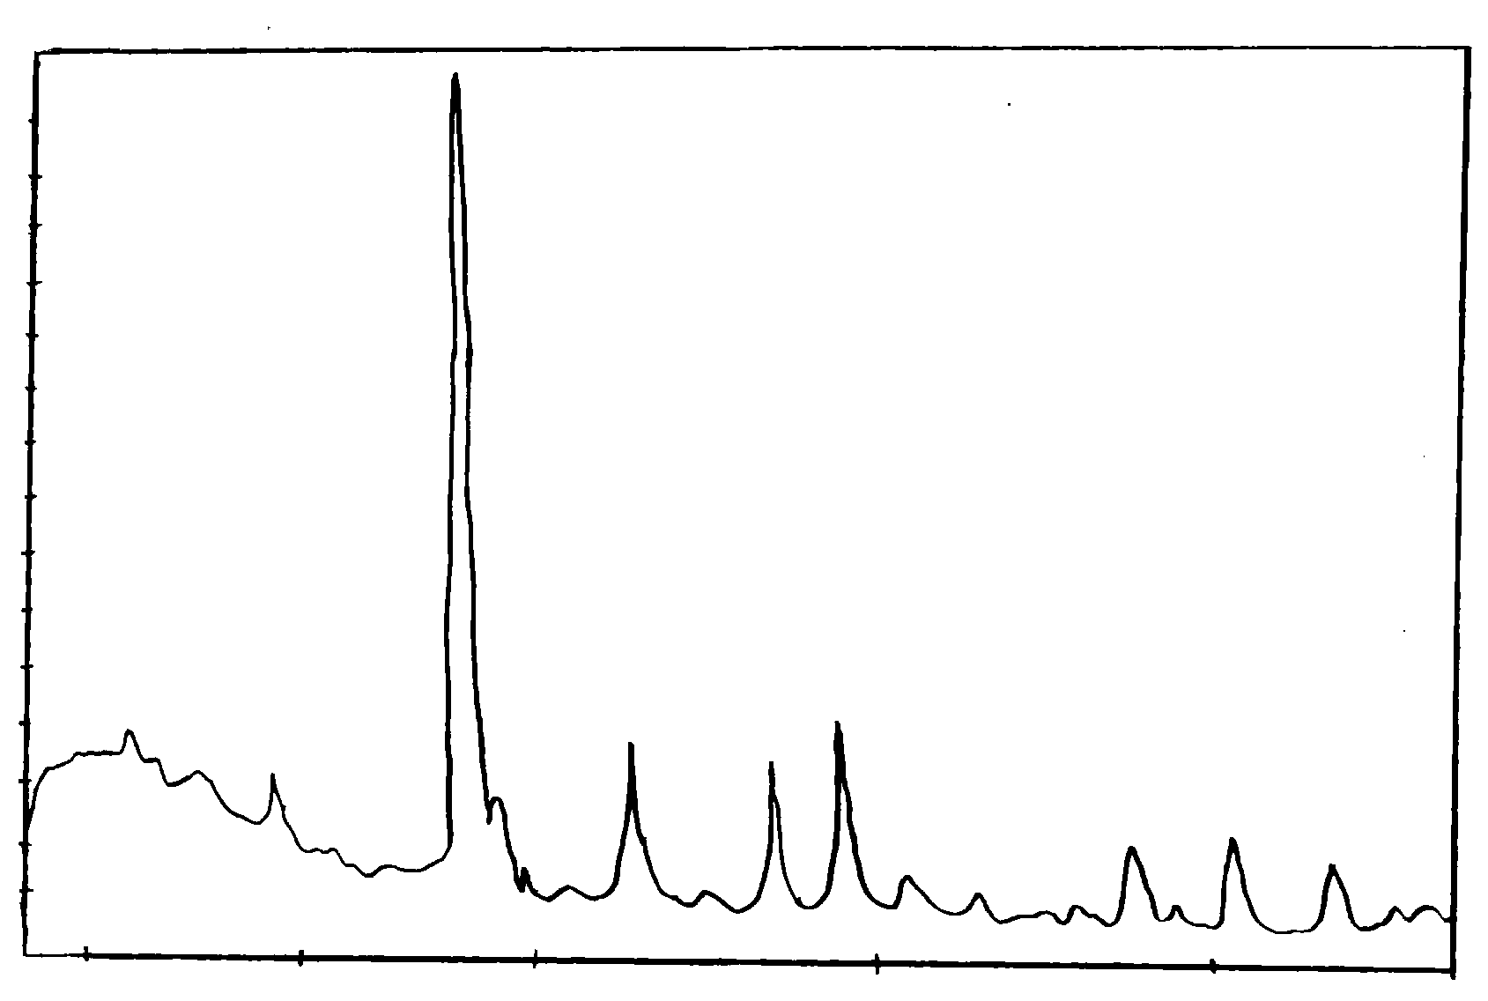
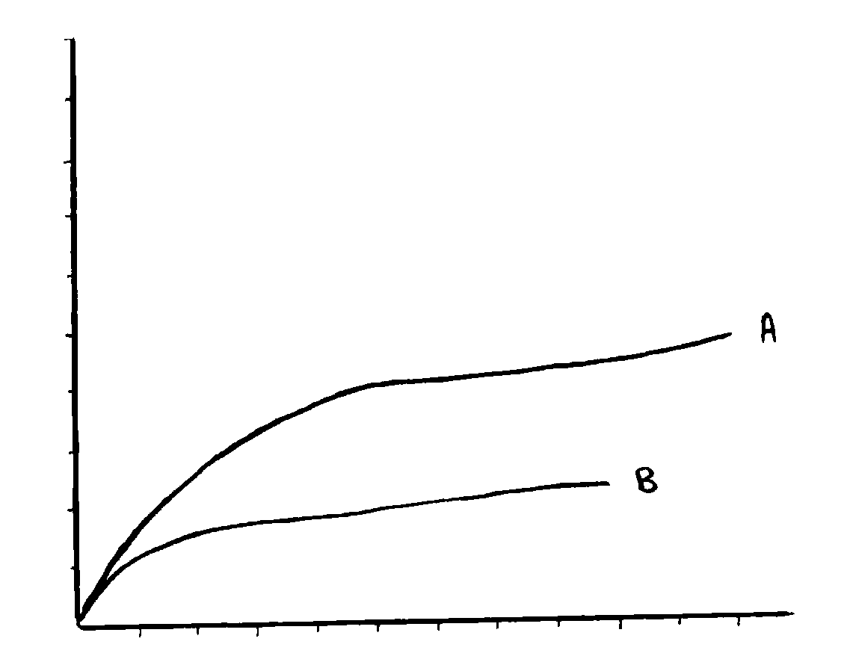
J= Jarosite
G= Gypsum
Q= Quartz
C+D= Calcite + Dolomite
M= Montmorolonite
122032404860
M
C+D
Q
J
J
A
G
Degrees of 2
Figure (2) : powder X-ray diffraction pattern of natural jarosite

Time (sec)

High
(Cm)
1
2
3
4
5
6
2
4
6
8
10
12
Figure (1) : Capillary action curves of (A) Jarosite
(B) Treated Jarosite samples

Table (4)shows the x-ray powder data of the treated jarosite sample. It is therefore of interest, on the base of such data and referring to the literature ⁽⁹⁾, to mention here that jarosite mineral is rhmbohedral in symmetry with unit cell values , a = 7.31(2) and c = 17.224(6) A⁰ . The compound formula can be represented as KFe₃(SO₄)₂ (OH)₆ .
Infrared spectra seemed to be useful technique to study the structure of jarosite bearing samples under investigation, therefore, a range of 400-4000 cm⁻¹ in frequency was used which focus the light on functional groups present in the sample like Si-O, -OH, Fe-O, Al-O, SO₄${}^{2−}$, CO₃²⁻, …. Etc⁽¹²⁾. On the other hands, infrared has been successfully used with thermal analysis techniques to determine the water molecules held by the samples. Such investigation reflects their classification and migration through the sample upon heating under specific temperature program. On other words, it is of interest to mention here upon inspection the propose results and referring to the literature⁽¹⁵⁾, that held water molecules might be classified into; The hydration water, which could be removed by heating at low temperature and the coordinated water which is diminished at high temperature. In order to interpret such foundation and since it is of a great importance and might determine the chemical adsorption properties of the jarosite bearing samples , Differential Thermal Analysis (DTA) and ThermoGravimeter (TG) the technique are therefore used to investigate the hydration phenomena. Figure (4) shows DTA curve of the treated jarosite sample which reveals three endothermic peaks represent obviously the hydration processes . TG curve of the above sample , Figure (5)shows the losses of 5.55 and 8.8% from the weight of the original sample correspond the migration of the classified adsorbed water molecules. Such migration phenomena have been investigated via infrared spectroscopy which show a significance variation in the position and sharpness of the vibrations related to the structural-OH group upon heating the sample within specified temperatures.
- Adsorption capacity:
Natural rocks and clays in fact composed of more than one mineral and most of these minerals are of great interest in fractionation processes as adsorbent materials. The rock samples under investigation, due to its physical and such structural properties might be good adsorbent in fractionation processes. They are suitable for the separation of complex mixture, Like petrolene matrix, into group of substances according to their polar activities . Moreover, treating the above samples by acids or bases might concentrate the clay minerals and leading to the formation of rich adsorption catalysts.

Table (4) Powder x-ray diffraction data of treated jarosite sample.
hkl | d-spacing | 2$θ$ | Minerals
100 | 4.290 | 19.1 | Montmonorolite
112;202 | 3.847 | 23.0 | Calcite and Dolomite
110 | 3.499 | 25.5 | Jarosite
101 | 3.349 | 26.5 | Quartz
006 | 2.844 | 31.4 | Jarosite
113 | 2.476 | 36.2 | Jarosite
113 | 2.334 | 38.5 | Alunite
211 | 2.205 | 40.8 | Gypsum
150;202 | 2.080 | 43.4 | Gypsum
024 | 1.996 | 45.3 | Jarosite
141 | 1.867 | 48.7 | Gypsum
426 | 1.748 | 52.2 | Gypsum
103 | 1.946 | 55.7 | Gypsum
202 | 1.595 | 57.7 | Jarosite
211 | 1.559 | 59.1 | Quartz

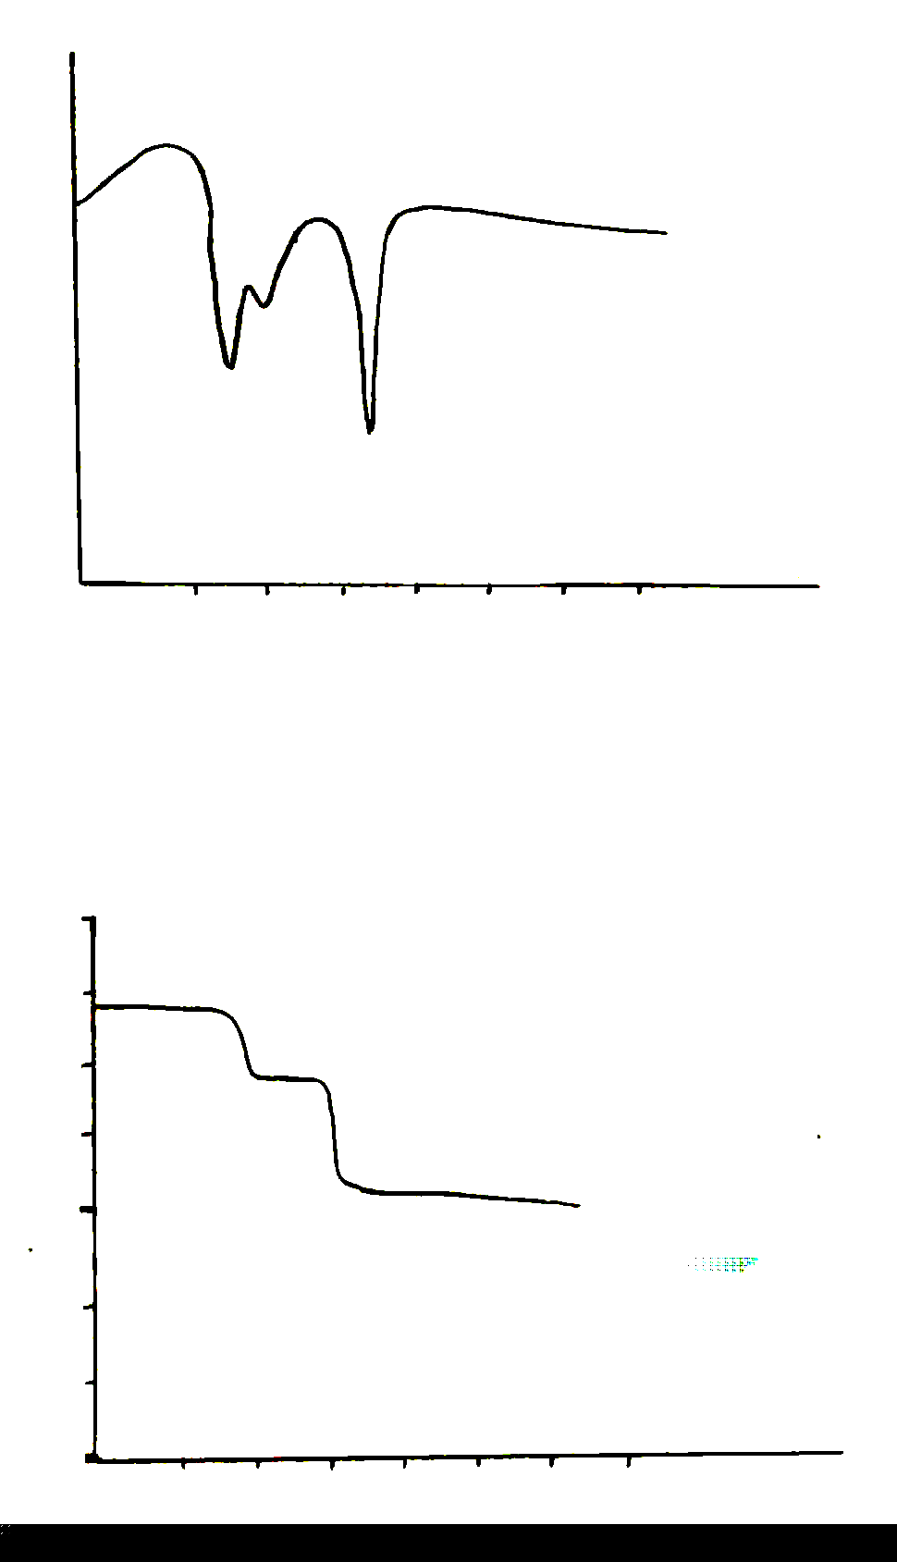
Exo.
Endo.
T
100
300
500
Temp. ⁰C
Figure(4) DTA Curve of jarosite sample
J= Jarosite
G= Gypsum
Q= Quartz
A=Alunite
M= Montmorolonite
122032404860
M
Q
J
J
A
Degrees of 2
Figure (3) : powder X-ray diffraction pattern of treated jarosite

J
G

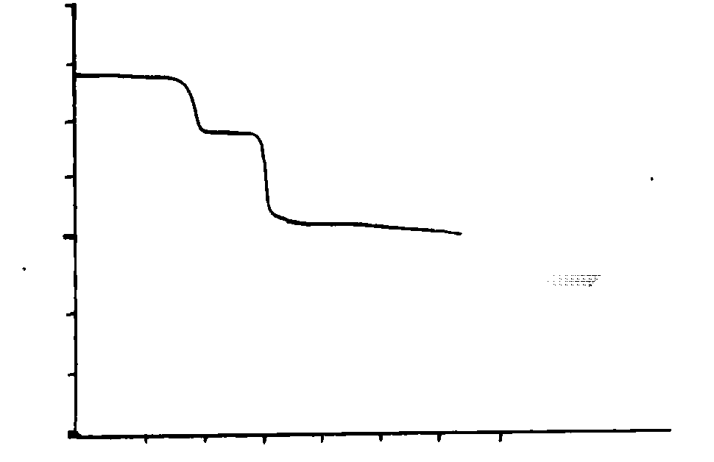
4
3
2
wt (g)
100
300
500
Temp. ⁰C
Figure(5) TG Cure of jarosite Sample

Therefore, jarosite rich rock samples adsorption chromatography were employed in comparison with other related ones. They employed in fractionation of QP and the observed results are presented in Table(5) which represent the percentages of the fraction eluted on using different solvent polarities . The chemical composition of the eluted fractions was adopted from the work of Ramadhan⁽¹⁴⁾ and for the sake of comparison and in order to interpret such results it is of the relevant to state here that QP in general compose mainly from straight aliphatic hydrocarbons which have lower polarity than branched aliphatic ones. QP also contain naphthenic and polyaromatic hydrocarbons which have a higher polarities in comparison with the above constituents⁽¹⁵⁾. Moreover, it should be noted that an ordinary manual fractionating column has been applied in the present research and a reasonable expecting results might be observed. Accordingly, the results may indicate the following:
1.The eluted fractions on using low polar solvents were mainly saturated paraffinic hydrocarbons. Meanwhile, as the polarity of the eluted solvent in creased naphthenic which followed by aromatic hydrocarbons were obtained.
2.Treated and activated jarosite bearing sample seemed to be the best adsorbent in activity and selectivity actions.

Table (5): Chromatographic Fractions (%) of QP* using different adsorbents.
Solvent | Polarities (Deby) | Natural jarosite rock (350⁰C) | Treated jarosite rock (350⁰C)
Petroleum ethen | 31.0 | 65.55 | 45.97
Toluene | 33.9 | 11.60 | 17.75
Chloroform | 43.0 | 10.23 | 21.24
Ethanol | 51.9 | 9.77 | 12.63
Loss |  | 2.25 | 3.01
* QP composition: 38% straight chain aliphatic, 27% branched aliphatic, 18% naphthenic , and 17% aromatic compounds⁽¹⁴⁾.

References
- L. H. Ali and K. A. Al-Ghanam, Fuel, 1990, 69, 519.
- S. Kaw and M. W. Lai, MCM-41, Amer. Chem. Soc., Chemted, 1998, Jan., 37.
- A. Yamada, Y. Ezaki, K. Matsuo, T. Yarita, and A. Nomura, J. Chromatog., 1995, 704(2), 345.
- K. Sasaki and H. Konno, Candian Mineral, 2000, 38(1), 45.
- P. Thune and R. Linke, J. Phys. Chem. ,2001, B., 105(15), 3073.
- S. Z. Jassim and S. Q. Al-Naqib, J. Geol. Soc. Iraq, 1989, 22(1), 112.
- R. A. Buker and N. H. Taher, Dirasat, 2000, 27B(2), 244.
- R. A. Buker and M. K. Al-Rashidy, Iraqi J. Chem., 2001, 26(2), 2.
- R. A. Buker and L. A. Mubarak, Rafidian J. Sci., ,2002, 13(2),32.
10.R. A. Buker and S. S. Hamid, National J. Chem., 2004,12, 13.
11.P. G. Jeffrey and D. Hutchesion, “ Chemical Methods of rock analysis”, Pergamon press, New York, P(30) ,1981.
12. D. H. Williams and I. Fleming, “ Spectroscopic Methods of Inorganic Chemistry”, 4th . Ed. McGraw-Hill Book Co. Ltd., London, P(97), 1981 .
13. J. Dana, “Mineral Science”, John-Willey and sons, Inc., New York, P(114) ,2002.
14. O. M. Ramdhan, Fuel Science and Technology International, 1992, L., 10, 82.
15. J. G. Speight, “The Chemistry and Technology of Petroleum” 1st. Ed., Longmans , Ltd., London,P(187) ,1980.
16. J. F. Brazdil, CHEMTECH, 1999, Jan., 23.

