Local Isolate of Bacillus stearothermophilus Producing Alkaline Phosphatase Activity by two Fermentation Systems

Haider Mussa Hamza
Dept. of Biology, College of Science, University of Sulaimani

Hamid Ghafory Hassan

Dept. of Chemistry, College of Science, University of Sulaimani

(NJC)

(Received on 20/ 10 /2004) (Accepted for publication on 23/3/2005)

Abstract
From soil samples in different region of Iraqi-Kurdistan, thirty-one isolates of Bacillus spp. were isolated and identified in all samples according to morphology of colonies, cells and their growth at 55°c. Using high temperature 75°c and some biochemical tests, only seven isolates were diagnosed as B. stearothermophilus.
The isolate no. 18 was selected based on its high activity of enzymes (amylases & proteases). Using two fermentation systems (liquid state & solid state fermentation), the isolate no.18 was examined for production of alkaline phosphatase (AP) enzyme activity. The liquid state fermentation method for this isolate gave a 4.9 un it/ml enzyme activity at optimum pH and 5.8 unit/mg protein specific activity, whereas the solid state fermentation (wheat bran) gave 11.32 unit/ml enzyme activity and 7.48 unit/mg protein specific activity.
Results revealed high activity of alkaline phosphatase screening from local isolate of Bacillus stearothermophilus using wheat bran in solid state fermentation.

الخلاصة
تم عزل 31 عزلة لبكتيريا Bacillus من نماذج ترب في مناطق مختلفة من إقليم كردستان العراق وشخصت في جميع النماذج حسب الصفات المورفولوجية للمستعمرات والخلايا وكذلك نموها بدرجة 55 م . باستخدام درجة حرارة 75 م وبعض الفحوصات الكيموحيوية , شخصت سبع عزلات فقط على أنها بكتيريا B. stearothermophilus .
اختيرت العزلة رقم 18 من بين العزلات الأخرى على أساس قابليتها في إنتاج أنزيمات الامليز والبروتيز لإنتاج أنزيم الفوسفاتيز القاعدي باستخدام نظامي تخمرات (تخمرات الحالة السائلة والصلبة) . أعطت العزلة (4.9 وحدة/مل) فعالية أنزيمية عند pH الأمثل و (5.8 وحدة/ملغم بروتين ) باستخدام تخمرات الحالة السائلة, بينما في تخمرات الحالة الصلبة (نخالة الحنطة) فقد أعطت (11,32 وحدة/مل) فعالية أنزيمية و (7,48 وحدة/ملغم بروتين) فعالية نوعية.
أظهرت النتائج فعالية عالية لأنزيم الفوسفاتيز القاعدي من العزلة المحلية B.stearothermophilus باستخدام نخالة الحنطة Wheat bran في تخمرات الحالة الصلبة.

Introduction
Alkaline Phosphatases (orthophosphoric monoester phosphohydrolases, EC.3.1.3.1), which catalyze the release of Pi from several phosphorylated compounds and classically described as homodimeric nonspecific metalloenzymes which catalyze phosphomonoestrase reactions ^{[1]}. APs are abundant and ubiquitous in nature. Although some from bacterial sources have already been cloned and sequenced ^{[2]}, their physiological functions and substrates still remain to be elucidated, and so far there has been only speculation on this, including resistance to phosphate starvation or intracellular signaling ^{[3]}.
As studying thermostable enzymes appears interesting for the understanding of life at high temperatures, as well as for industrial processes, new alkaline phosphatases exhibiting this property have been investigated. Thermostable alkaline phosphatases from the following thermophilic bacteria have been described: Thermotoga neapolitana ^{[4]}, Thermus caldophilus ^{[5]}, Thermus thermophilus ^{[6]}, and Bacillus stearothermophilus ^{[3]}.
In general, enzymes from thermophilic organisms are known to be more stable than their counterparts from mesophilic sources ^{[7]}. Their high stability should be helpful in investigating enzyme function and structure. Bacillus stearothermophilus is a well-known thermophile; most enzymes obtained from this bacterium have been reported to exhibit enhanced thermal stabilities and resistance to extended storage ^{[7]}.
The present study represents a first investigation of alkaline phosphatase from local isolate of B. stearothermophilus to obtain additional data towards understanding its properties.

Experimental

1/ Isolation of Thermophilic Bacillus spp.
Nutrient agar plates were used to isolate thermophilic Bacillus spp. from different soil samples in Iraqi-Kurdistan. The soil samples were dried in an oven at 50°c for overnight, and then serial dilutions were made from each sample, after that 0.1ml from suitable dilutions were spreaded on NA plates. All plates were incubated at 55°c/24 hrs.

2/ Identification of B. stearothermophilus
All bacterial colonies which were appear on NA plates at 55°c that were similar to features of Bacillus colonies, were selected and cultured on NA plates another time but at 75°c /24hrs. The morphological features of the colonies were registered, and then the microscopical examination and the following biochemical tests were used to detect the genus and species of bacteria according to Claus & Berkeley ^{[8]}, and Roa etal. ^{[9]}: starch hydrolysis, gelatine liquefaction, and growth at 3% NaCl, acid & gas production from glucose fermentation and indole production.

3/ Viable cells Measurement in the Inoculum
The viable cells were counted in the inoculum size according to ^{[10]}. Nutrient broth was prepared, sterilized and inoculated with loopful of bacteria. After incubation period was finished, serial dilutions were prepared 10⁻¹…10⁻⁹ in test tubes which are contain 9ml normal saline, 0.1ml from suitable dilutions was spreaded on NA plates, then all plates were incubated at 55°c/24hrs. After that the separated colonies were counted, then the number of cells/ml was determined.

4/ Maintenance of the Isolates
NA slants were used; the bacterial isolates were cultured on slants then stored at 4°c for 1-2 months.

5/ Production of Alkaline Phosphatase Activity
- Liquid state fermentation
N.B. in 250ml flasks was used for detecting of AP activity. The flasks were inoculated with 1ml/flask from isolate no.18, in which it contain 45 x 10⁸ cell/ml then the flasks were incubated at 55°c/72hrs. The broth culture was centrifuged in a centrifuge (NUVE NF615) at 5000 rpm/15 min. Then AP activity was measured in supernatant.

Solid state fermentation

An Erlenmeyer flask 250ml contains 10 gm wheat bran 1:4 w/v was used. The wheat bran was moisted with distilled water. The medium was adjusted to a pH 7.0 with (1N) NaOH before sterilization. After inoculation with 45x10⁸ cell/ml broth culture of no.18 isolate, the flasks were incubated at 55°c/72hrs ^{[11]}. The AP enzyme was extracted from the fermentation medium by adding 50ml distilled water to the fermentation flasks with mixing for about 20 min. The mixture was centrifuged in a centrifuge (Universal 32, Hettich) at 5000 rpm/25 min to remove the cells and the residues medium. The supernatant (crude enzyme) was clarified by filtration through glass wool and was used as a source of enzyme for further works.

6/ Determination of Enzyme Activity
The AP activity was determined according to King & King ^{[12]}. The assay mixture contained 0.5ml carbonate-bicarbonate buffer pH 10.0 and 0.5ml substrate (10mM disodium phenyl phosphate), after 5 min in water bath at 37°c, 0.5ml of sample was added. The tubes containing reaction mixture were incubated for exactly 30 min in water bath at 37°c. After that 1.2ml of NaOH (0.5N) was added, 1.2ml sodium bicarbonate, 1ml 4-aminoantipyrine and 1ml ferric cyanide were included, then the mixture was measured at 510nm in a spectrophotometer (TECHCOMP UV 7500). One unit of enzyme activity is defined as amount of enzyme required to release one umol of phenyl from disodium phenyl phosphate in one min.

7/ Total Protein assay
Protein concentration was determined by the absolute method ^{[13]}. The protein in the samples was precipitated by 7% v/v perchloric acid, after centrifugation at 5000 rpm/15 min; the precipitated protein was dissolved in minimum amount of (0.05N) NaOH. The absorbency was measured at 235 and 280nm respectively using (0.05N) NaOH solution as blank.

Results and Discussion

- Isolation & Identification:
Thirty –one isolates of Bacillus spp. were isolated from different soil samples in Iraqi- Kurdistan using nutrient agar plates at 55°c (Table 1), some isolates shows heavy growth after one day incubation period especially the isolates (no.18, 25, and 28) from Erbil, Sulaimani (Kelyasan) and Sulaimani (Qaladiza) respectively.
Seven isolates (18, 20, 24, 26, 27, 28, and 31) were recognized as thermophilic Bacillus spp. when they cultured at 75°c for 24hrs using the same medium among other isolates (Fig.1).

Table 1: Region and No. of cells of local Isolates

Isolate No. | Region | No. cells/ml | Isolate No. | Region | No. cells/ml
1 | Sulaimani-Rania | 22x10⁶ | 19 | Erbil | 31x10⁵
2 | Sulaimani-Rania | 14x10⁶ | 20 | Sulaimani-Iskan | 45x10⁶
3 | Sulaimani-Rania | 31x10⁶ | 21 | Sulaimani-Iskan | 12x10⁵
4 | Sulaimani-Rania | 28x10⁶ | 22 | Sulaimani-Iskan | 23x10⁵
5 | Sulaimani-Rania | 23x10⁶ | 23 | Sulaimani-Iskan | 14x10⁵
6 | Sulaimani-Rania | 13x10⁶ | 24 | Sulaimani-Kelyasan | 96x10⁶
7 | Sulaimani-Rania | 9x10⁶ | 25 | Sulaimani-Kelyasan | 83x10⁷
8 | Sulaimani-Rania | 7x10⁶ | 26 | Sulaimani-Kalar | 44x10⁶
9 | Sulaimani-Rania | 13x10⁵ | 27 | Sulaimani-Kalar | 62x10⁴
10 | Dohuk | 11x10⁵ | 28 | Sulaimani-Qaladiza | 67x10⁷
11 | Dohuk | 22x10⁶ | 29 | Sulaimani-Qaladiza | 22x10⁴
12 | Dohuk | 11x10⁴ | 30 | Sulaimani-Qaladiza | 42x10⁶
13 | Dohuk | 33x10⁴ | 31 | Sulaimani-Qaladiza | 54x10⁶
14 | Dohuk | 12x10⁴
15 | Erbil | 34x10⁶
16 | Erbil | 44x10⁵
17 | Erbil | 51x10⁵
18 | Erbil | 73x10⁷

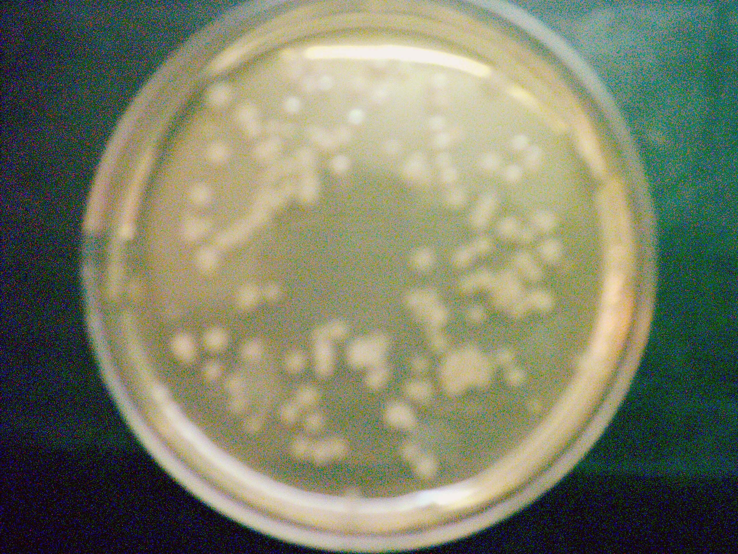

Figure 1: Growth of Thermophilic Bacillus spp. on NA plate at 75°c/24hrs.

The morphological features of the colonies were flat, opaque, rough surface and they had circular irregular edge ^{[14]}. All seven isolates were Gram positive, rod shaped; spore forming bacteria after microscopical examination was done (Fig.2) ^{[14]}.
The biochemical tests were done for diagnosis of the genus and species of bacteria according to ^{[8,9]}, as shown in (Table 2) and the results were similar to the features of B. stearothermophilus because they cannot produce indole, can grow very well at 75°c and in the presence of 3% NaCl, they can hydrolyze starch and gelatin, can produce acid and they cannot produce gas from glucose fermentation. These features regarded as optimum ^{[15,16]}.
Many of thermophiles produce enzymes that are not readily denatured at high temperatures. Sometimes unusual amino acid sequences occur in their proteins, stabilizing at high temperatures. Their membranes possess a major proportion of high molecular weight, and branched fatty acids that allow them to maintain semipermeability at high temperatures. Thermophiles have proportions of guanine and cytosine in DNA that raise the melting point and add stability to the DNA molecule^{[17]}.
Thermophilic Bacillus spp. could be potentially useful in industry because they produce high levels of enzymes such as amylases and proteases. Also the isolation and culture of these bacteria are very easy and they regarded as non-pathogenic.

- Efficiency of Local Isolate to Produce AP activity by Liquid & Solid state Fermentation

Phosphatases are widely distributed among living organisms, including many bacteria. The enzyme may be secreted into the medium or may be loosely or tightly cell-bound, the proportions of each depending on strain and medium composition ^{[18]}. AP is used to dephosphorylate nucleic acids in molecular biology, as a reporter enzyme for secreted proteins, and as an indicator of activity in research and diagnostic kit ^{[19]}.
Isolate no.18 was revealed high amylase and protease activities; therefore, it was selected among other isolates for the detection of AP- enzyme activity. Figure (3), shows the efficiency of solid state fermentation for the production of AP activity in comparison with liquid state fermentation. Since, the activity of the enzyme was 11.32 u/ml and the specific activity was 7.48 u/mg protein, whereas in the case of liquid state fermentation, the activity was 4.9 u/ml and the specific activity was 5.4 u/mg protein.
Wheat bran was used in this study as production medium because it contains 63.6% soluble carbohydrates, 15.8% crude proteins, 0.04% Ca⁺⁺, Mg^{++,} Zn⁺⁺, and Mn⁺⁺ ^{[11,20]}, and was regarded as supported medium for the production of alkaline phosphatase enzyme activity, since the role of Ca⁺⁺, Mg⁺⁺, and other ions are very important in the mechanism and stability of AP activity. Zappa et al. shows increasing the concentrations of Mg⁺⁺ results in an increase in enzymatic activity and activation following the addition of Mg⁺⁺ has been observed with mammalian APs and largely characterized using E.coli AP mutant ^{[21]}.
The characterization of new phosphatases will be particularly fruitful, because there is a high probability of discovering new types with novel properties and the literatures, are not mentioned the applications of solid state fermentation for AP production only they focused on the liquid state fermentation ^{[3, 22,23, 24]}.
The results of this study suggest the importance of local isolate of B.stearothermophilus because these bacteria are very efficient to produce the thermostable industrial enzymes and these enzymes are unaffected with denaturing agents during the different industrial processes. Also, this study indicates the importance of solid state fermentation technique, since it is very simple in application, obtaining high yield products, less energy and aeration requirements in comparison with liquid state fermentation. In addition, the high thermal stability of the alkaline phosphatase described here might permit its exploitation in biotechnical applications for instance in molecular cloning and as a second antibody-enzyme conjugate for immunoassay.

Acknowledgment
The authors acknowledgment Mr. Khattab, A. Shekhany, Mr.Ibrahim, S., Miss. Sazan, M. and Miss. Nasik, L. for their aids during the research.

Table 2: Cultural and Biochemical tests of Local Isolate of B.stearothermophilus

Test | Isolate No. |  |  |  |  |  |  | Standard
Test | 18 | 20 | 24 | 26 | 27 | 28 | 31 | Standard
Growth at 55°c | + | + | + | + | + | + | + | +
Growth at 75°c | + | + | + | + | + | + | + | +
Growth at 3%Nacl | + | + | + | + | + | + | + | +
Indole Production | - | - | - | - | - | - | - | -
Starch hydrolysis | +++ | + | + | + | + | + | + | +
Gelatin lique. | +++ | + | + | + | + | + | + | +
Acid production | + | + | + | + | + | + | + | +
Gas production | - | - | - | - | - | - | - | -
Motility | + | + | + | + | + | + | + | +
Gram staining | + | + | + | + | + | + | + | +

Note: (+++), the isolate no.18 can actively digest starch and gelatin.

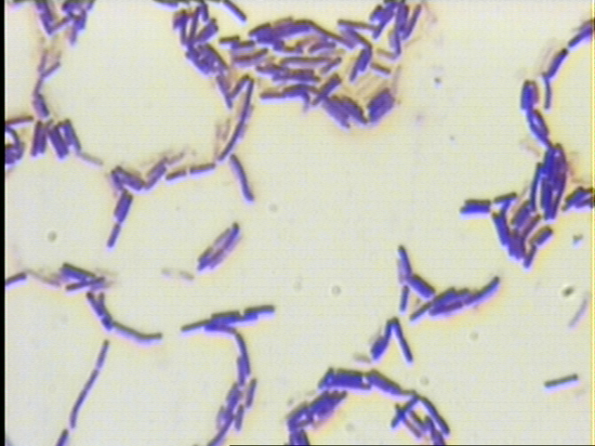
Figure 2: Cells of B.stearothermophilus, isolate no.18 (Gram staining Method, X1000)

Fig 3: AP activity (A) & specific activity (S) in both liquid and solid state system

References
1. Trowsdale, J., D.Mortin, D.Bicknell, and I.Campbell, Biochm. Soc. Trans., 1990, 18: 178.
2. Hulett, F.M., Mol. Microbio., 1996, 19: 933.
3. Mori, Sh., Okamoto, M., Nishiloori, M. and Ichimura, M., Biotechnol. Appl. Biochem, 1999, 29: 235.
4. Dong, G., and J.G.Zeikus, Enzyme Microb. Technol.,1997, 21: 335.
5. Park, T., J.H.Lee, H.K.Kim, H.S.Hoe and S.T.Kwon., FEMS Microbiol. Lett., 1999, 180: 133.
6. Pantazaki, A.A., A.A.Karagiorgas, M.Liakopoulou-Kyriakides, and D.A.Kyriakidis, Appl. Biochem. Biotechnol., 1998, 75: 249.
7. Sharp, R.J., Riley, P.W. and White, D., In thermophilic bacteria (Kristjansson, J.K., ed.), CRC Press, Florida, 19-50(1992).
8. Claus, D. and Berkeley, R.C.W., Genus Bacillus In: Bergeys Manual of systematic bacteriology (Sneath, P.H., ed.). The Williams and Wilkins Company Baltimore.vol.2(1986).
9. Rao, V.D., Leela, R.K.and Sankaran, R., J. Food. Sci. and Technol., 1979, 16: 166.
10. Steve, K.Alexander and Dennis, S., Microbiology: A photographic atlas for the laboratory, an imprint of Addison Wesley Longman, Inc., 111-112(2001).
11. Hamza, H.M. and Mhmood, Sh.A, Kurdi. Academ. J., 2001, 1A (1): 1.
12. King, P.R.N. and King, E.J., J. Clin. Path., 1954, 7: 322.
13. Hamza, H.M., J.of Zankoy Sulaimani, 2004, 7(1): 61.
14. Harris, O. and Field, N.L., Can. J. Microbiol., 1972, 18: 917.
15. Eipstein, L. and Grossowicz, N., J.Bact, 1969, 99(2): 414.
16. Marsh, C.L. and Larsen, D.H., J. Bacteriol., 1953, 65: 193.
17. Sharma, P.D., Microbiology, Rastogi Publications, India, 251(1998).
18. Paul, S. and Diana, S., Dictionary of microbiology and molecular biology, A Wiley-inter- science Publication.vol.2, 664(1995).
19. Prada, P.De, Curtze, J.L. and Brenchley, J.E., App. and Environ. Microbiol, 1996, 62(10): 3732.
20. Web site/ www. Nutrition Data. Com/ The composition of wheat bran.
21. Zappa, S., Rolland, J., Flament, D., Gueguen, Y. Boudrant, J. and Dietrich, J., App. and Environ. Microbiol, 2001, 67(10): 4504.
22. F.F.al-Fayadh, M.Sc. Thesis, University of Baghdad. College of Science (1985).
23. Sharipova, M.R., N.P. Balaban, A.M. Mardanova, N.V. Nekhotyaeva, A.M. Mardanova, A.A. Dementyev, and I.B. Leshchinskaya., Biochem. Mol. Int., 1996, 38: 753.
24. Sharipova, M.R., N.P. Balaban, A.M. Mardanva, N.V. Nekhotyaeva, A.A. Dementyev, O.A. Vershinina, A.V. Garusov, and I.B. Leshchinskaya., Bioch. (Moscow), 1998, 63: 1178.

