Geometry, Vibration Frequencies, Normal Coordinates and IR Absorption Intensities of

6-Radialine

Rehab M. Kubba, S. H. Rida and A. H. Hanoon
Department of Chemistry, College of Science, University of Baghdad,

Jadiriya, Baghdad, Iraq.

(NJC)

(Received on 16/ 6 /2004) (Accepted for publication on 23/3/2005)

الخلاصة
تضمن البحث حسابات نظرية شبه تجريبية بأسلوب MINDO/3-FORCES لدراسة و تحديد طاقات وترددات و شدد حزم الأشعة تحت الحمراء مع تصنيف الأنماط الاهتزازية تكافؤيا و تماثليا عند الأشكال الهندسية الفراغية المتوازنة و الأكثر استقرارا لجريئة 6-Radialine وفقا لنتائج الحساب و هما شكل الكرسي الذي يمتلك التماثل(D_{3d}) و الشكل المستوي الذي يمتلك التماثل (D_{3h}) حيث و جد أن شكل الكرسي هو الشكل الهندسي الفراغي الأكثر استقرارا من الشكل المستوي ويمتلك حرارة التكوين الأقل، كما أن ترددات المط للآصرة المزدوجة في شكل الكرسي (ν(C=C) str.) أعلى من نظيرتها في الشكل المستوي في حين وجد أن ترددات الانحناء لمجموعة المثلين (=CH₂) في الشكل المستوي أعلى منها لشكل الكرسي. تم إجراء مقارنات لجميع الأنماط الاهتزازية الأخرى عند الشكلين المستقرين طاقيا. كم تم إعادة الحساب باستخدام برنامجي MINDO/3 و PM3 لأجل المقارنة و التأكد من صحة النتائج.

Abstract

SCF-MO calculations, using MINDO/3-FORCES method, of the equilibrium geometry of 6-Radialine considering the two conformations, planar and chair, as well as the vibration frequencies and IR absorption intensities for each conformer are reported. The chair conformation is found to be more stable. The C=C str. frequencies of the chair form are found to be higher than those of the planar, the =CH₂ bending frequencies of the planar form are higher than those of the chair form. PM3 method was used too for the calculation of the vibration frequencies. The results are compared with the MINDO/3-FORCES results.

Introduction
Radialene molecules (3R, 4R, 5R and 6R fig. 1) form a class of cyclic hydrocarbons (CnHn) possessing n ring atoms and n exocyclic double bonds. Since 1962 ^{[1]} these molecules attracted much attention due to their unique properties. So, 6-Radialine may be considered as hexamethylene cyclohexane in which all ring carbons are sp2- hybridized (fig. 2).
The synthesis and characterization of 6-Radialene were performed applying different techniques ^{[2-3]}. Due to its instability, polymerizing quickly at room temperature, it was not be possible to estimate its geometry applying x-ray diffraction. Much attention was paid to its derivatives ^{[4-6]}. Theoretical studies using ab initio method were done by Galasso ^{[7]} and Tyutyulkov et al ^{[8]} for it. Kubba studied theoretically the vibration spectrum of 3-Radialene, applying the MINDO/3-FORCES method ^{[9]}.

Fig. 1: 3, 4, 5 and 6-Radialene molecules
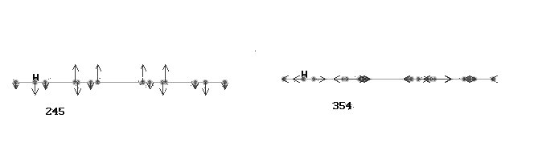
υ₄₂, E_{1u}, 355
υ₁₀, A_{2u}, 246

Fig 2. DRAW. MOL graphical representation of two vibration modes of 6-Radialene (planar-form), (a) out of plane; (b) in-plane.

The present study is based on the MINDO/3-FORCES method, which was developed and applied to the treatment of organic molecules by Shanshal et al. ^{[10]}. Such a treatment yields the equilibrium geometry and energy values for the molecules, in addition to their fundamental vibration frequencies (3N-6) and IR absorption intensities.
MINDO/3-FORCES method adopts the Pulay forces method to calculate the force constants of molecules ^{[11]}, which are introduced then to the Wilson secular equation of the following form ^{[12]};
$\sum_{j}{L_{j}}$ (F_{ij} - M_{ij} λ) = 0………(1)
Solution of this equation yields both vibration frequencies (λ = 4π²c²ν²) and vibration mode eigenvector coefficients (L), which are utilized in evaluating the atomic partial participation values (APP) (the partial contribution of each atom to the molecular vibration) ^{[10]}. The same coefficients (L) allow a graphical description of the vibration modes in the molecule when introduced to the DRAW.MOL routine developed by Shanshal et. al ^{[13]} (fig. 2).
In the present work Dewar’s MINDO/3 program ^{[14]} and PM3 ^{[15]} method were used too, for the calculation of the vibration frequencies for the two conformers of 6-Radialene. Both Dewar’s MINDO/3 and MINDO/3-FORCES programs yielded similar results.
Results and discussion
MINDO/3-FORCES treatment for 6-radialene showed that the chair form is more stable than the planar. It is known ^{[16]} that this method overestimates the ΔH_{f} values of cyclic planar unsaturated molecules by a ratio of approximately 40%. Considering this factor the calculated ΔH_{f} values are (ΔH_{f} = 94 kcal/mol) for the planar and (ΔH_{f} = 81 kcal/mol) for the chair form. The PM3 ^{[15]} treatment yields for the same molecule 95 kcal/mol for the planar and 98 kcal/mol for the chair form. However due to the fact that the lowest gradiant value (d²E_{ii} /dq_{i}²) acceptable for the geometry optimization process in MINDO/3-FORCES is ≤ 10⁻⁵ au/au, which is lower than the acceptable gradiant value in PM3, we prefered the relative stability order as predected by the MINDO/3-FORCES method. The evaluation of the relative stability of the chair over the planar form comes in agreement with experimental findings reported before ^{[17]}.
The treatment for the vibration frequencies was carried out for the equilibrium geometry of each conformer after minimizing its total energy as a function of all its 3N cartesian coordinates. The equilibrium geometric values for the two conformers are listed in (Table 1).

Table 1. MINDO/3-FORCES calculated geometric parameters for the planar and the
chair conformations of 6R molecule, length (A°)/ angle (deg.).

Bonds length and angles | MINDO/3-FORCES  Planar form | MINDO/3-FORCES  Chair form
(C-H)  (C=C)  (C-C)  > H-C-H  > H-C=C  > C=C-C  > C-C-C | 1.100  1.352  1.521  107.4  126.3  120  120 | 1.100  1.343  1.520  109.9  125.1  123.4  113.0

The values in the table Show similar C=C and C-C bond lengths for both conformations. The unusual small values of HCH bond angles may be attributed to the strain caused by the crowding of the HCH groups, which seems to be of bigger conformational influence in the planar than in the chair form, as shown through the bond angles of the planar form (HCH 107.4º) compared with those of the chair form (HCH 109.9º), (Fig. 3). The C-C-C angles of the planar form are trigonal (120º), those of the chair form are smaller (113.0º), obviously due to the strain of the chair form.

The planar conformation of 6-Radialene is of D_{6h} symmetry. Its total number of fundamental vibrations (3N-6) is 66, classified into the following irreducible representations;

(a)- In-plane: 4A_{1g} + 3A_{2g} + 4B_{1u} + 4B_{2u} + 8E_{2g} + 2A_{2u} + 7E_{1u}

(b)- Out of plane: B_{1g} + 3B_{2g} + 3E_{1g} + A_{1u} + 2A_{2u} + 4E_{2u}

where A_{1g}, E_{1g}, E_{2g}, are Raman active and IR inactive, while A_{2u,} E_{1u} are IR active and Raman inactive. It is clear that mutual exclusion holds because of the center of symmetry in the molecule. Table 2 includes the calculated vibration frequencies of the planar conformation. All vibration frequencies are scaled applying the following scaling factors ^{[9]}:

0.875 (CH₂ str.), 0.93 (C=C str.); 1.06 (CH₂ sciss); 1.115 (CH₂ twist.).

b
a

Fig. 3: Equilibrium geometry for (a) planar conformation (D_{3h}) and (b) chair conformation (D_{3d}) of 6R molecule as calculated by MINDO/3-FORCES and PM3 methods.

Inspection of the frequency values in Table 2 reveals the following relations:

νsym (=CH₂ str.) > νasym (=CH₂ str.)
δ(=CH₂ sciss.) > δ(=CH₂ rock.)
γ (=CH₂ (wag.)) > γ (=CH₂ (twist.))

Fig. 4. shows the graphical representation of some vibration modes of 6R (planar conformation) as drawn through the DRAW. MOL. Routine ^{[13]}.

Table 2: Calculated vibration frequencies and IR absorption intensities for planar conformation of 6R molecule.
Symmetry and description |  | MINDO/3-FORCES |  | PM3 | Expt.[17]
In-plane |  | Scaled  Freq.cm⁻¹ | Intensity  km/mol | Freq.cm⁻¹ | Freq.cm⁻¹
A_{1g}
 | =CH₂ sym.str. | 3091 | 0.00 | 3152 | ------
$$υ_{{}_{2}}$$ | C=C str | 1631 | 0.00 | 1744 | ------
$$υ_{3}$$ | $δ$(=CH₂ (sciss.)) | 1463 | 0.00 | 1402 | ------
$$υ_{4}$$ | $δ$ring (breathing) | 660 | 0.00 | 716 | ------
A_{2g}
$$υ_{6}$$ | =CH₂ sym.str. | 3080 | 0.00 | 3120 | ------
$$υ_{7}$$ | $δ$(=CH₂(rock.))+ring($δ$ccc) | 973 | 0.00 | 1105 | ------
$$υ_{8}$$ | ring($δ$ccc)+$δ$(=CH₂(rock.)) | 524 | 0.00 | 638 | ------
B_{1u}
$$υ_{\text{12}}$$ | =CH₂ sym.str. | 3086 | 0.00 | 3138 | ------
$$υ_{\text{13}}$$ | C=C str | 1643 | 0.00 | 1762 | ------
$$υ_{\text{14}}$$ | $δ$(=CH₂ (sciss.)) | 1406 | 0.00 | 1413 | ------
$$υ_{\text{15}}$$ | $δ$ring (CCC) | 572 | 0.00 | 590 | ------
B_{2u}
$$υ_{\text{19}}$$ | =CH₂ sym.str. | 3089 | 0.00 | 3138 | ------
$$υ_{\text{20}}$$ | ring str. | 1426 | 0.00 | 1468 | ------
$$υ_{\text{21}}$$ | $δ$(=CH₂ (rock.)) | 895 | 0.00 | 970 | ------
$$γ$$ | $δ$(=CH₂ (rock.)) | 451 | 0.00 | 638 | ------
E_{1u}
$$υ_{\text{26}}$$ | =CH₂ sym.str. | 3089 | 71.79 | 3148 | 3090
$$υ_{\text{27}}$$ | =CH₂asym.str. | 3083 | 75.02 | 3140 | 2920
$$υ_{\text{28}}$$ | C=C str | 1614 | 2.41 | 1723 | 1652
$$υ_{\text{29}}$$ | $δ$(=CH₂ (sciss.)) | 1450 | 12.46 | 1436 | 1390
$$υ_{\text{30}}$$ | $δ$ring (CCC) | 1109 | 2.67 | 1205 | 1061
 | $δ$(=CH₂(rock.))+ring($δ$ccc) | 819 | 1.53 | 936 | ------
$$υ_{\text{32}}$$ | $δ$(=CH₂(rock.))+ ring ($δ$ccc) | 355 | 1.18 | 440 | ------

Table 2: Continued
E_{2g}
$$υ_{\text{33}}$$ | =CH₂ sym.str | 3087 | 0.00 | 3133 | ------
$$υ_{\text{34}}$$ | =CH₂ asym.str | 3084 | 0.00 | 3130 | ------
$$υ_{\text{35}}$$ | C=C str | 1626 | 0.00 | 1714 | ------
$$υ_{\text{36}}$$ | ring str +$δ$(=CH₂ (sciss.)). | 1367 | 0.00 | 1484 | ------
$$υ_{\text{37}}$$ | ring str +$δ$(=CH₂ (sciss.)). | 1307 | 0.00 | 1363 | ------
$$υ_{\text{38}}$$ | $δ$(=CH₂ (rock.)) | 880 | 0.00 | 949 | ------
$$υ_{\text{39}}$$ | $δ$(=CH₂ (rock.)) | 413 | 0.00 | 537 | ------
$$υ_{\text{40}}$$ | ring ($δ$CCC) | 391 | 0.00 | 438 | ------
 | Out of plane
A_{1u}
$$υ_{5}$$ | $γ$(=CH₂ (twist.)) | 645 | 0.00 | 665 | ------
A_{2u}
 | $γ$(=CH₂ (wag.)) | 877 | 11.81 | 915 | 897
 | $γ$C=CH₂ (wag.) | 246 | 0.01 | 327 | ------
B_{1g}
$$υ_{\text{11}}$$ | $γ$(=CH₂(twist.)) | 628 | 0.00 | 597 | ------
B_{2g}
$$υ_{\text{16}}$$ | $γ$(=CH₂(wag.)) | 1001 | 0.00 | 949 | ------
$$υ_{\text{17}}$$ | ring (puck.) | 762 | 0.00 | 770 | ------
$$υ_{\text{18}}$$ | $γ$C=CH₂ (wag.) | 3 | 0.00 | 15 | ------
E_{1g}
$$υ_{\text{23}}$$ | $γ$(=CH₂(wag.)) | 874 | 0.00 | 920 | ------
$$υ_{\text{24}}$$ | $γ$(=CH₂(twist.)) +$γ$(CC) | 607 | 0.00 | 674 | ——
$$υ_{\text{25}}$$ | $γ$(CC) | 318 | 0.00 | 415 | ------
E_{2u}
$$υ_{\text{41}}$$ | $γ$(=CH₂ (wag.)) | 870 | 0.00 | 936 | ------
$$υ_{\text{42}}$$ | ring (puck.) | 701 | 0.00 | 773 | ------
$$υ_{\text{43}}$$ | $γ$(CC) + $γ$(=CH₂ (twist.)) | 486 | 0.00 | 528 | ------
$$υ_{\text{44}}$$ | $γ$(C=C). | 4 | 0.00 | 17 | ------

scaling factors: 0.875 (CH₂ str.), 0.93 (C=C str.); 1.06 (CH₂ sciss); 1.115 (CH₂ twist.).

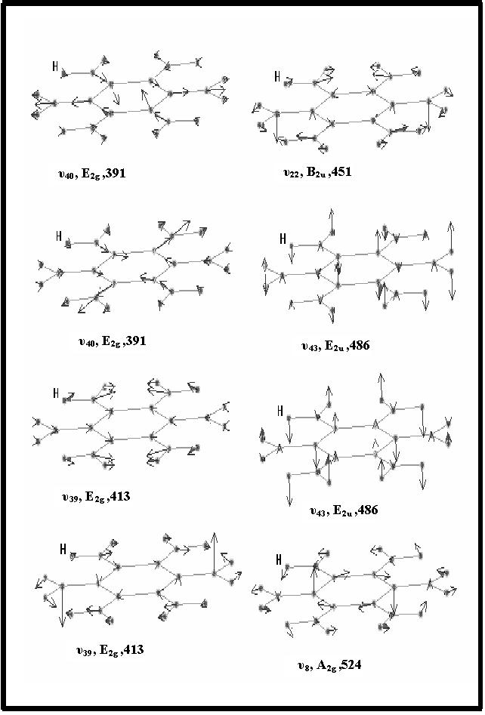

Fig. 4. The graphical representation of some vibration modes of 6R (planar conformation) as drawn through the DRAW. MOL. routine.

The fundamental vibration (3N-6) of the chair form with D_{3d} symmetry are classified into the following irreducible representations;
7A_{1g} + 4A_{2g} + 11E_{g} + 5A_{1u} + 8E_{2g} + 6A_{2u} + 11E_{u}

where A_{1g} and E_{g} are Raman active and IR inactive and A_{2u} and E_{u} are IR active and Raman inactive. The mutual exclusion holds here too, due to the center of symmetry in the molecule. Inspection of the frequency values in table 3 reveals the following relations:
νasym (=CH₂ str.) > νsym (=CH₂ str.) (in contrast to that of the planar form).
δ (=CH₂ (sciss.)) > δ (=CH₂ (rock.))
γ (=CH₂ (wag.)) > γ (=CH₂ (twist.))

Fig. 5. shows the graphical representation of some vibration modes of 6R (chair conformation) as drawn through the DRAW. MOL. routine.

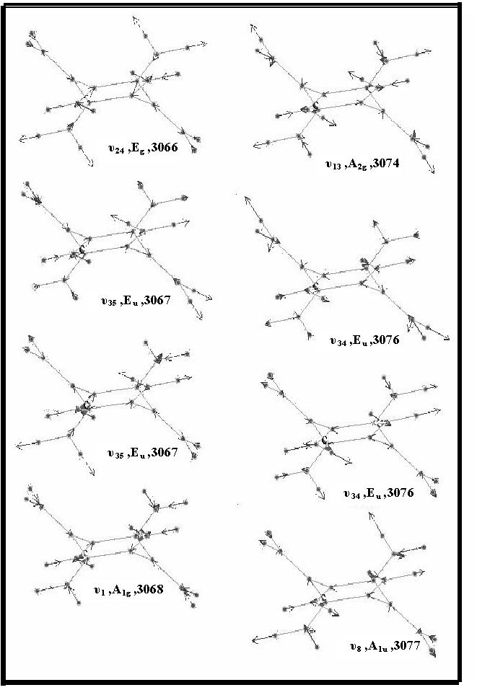

Fig. 5. The graphical representation of some vibration modes of 6R (chair conformation) as drawn through the DRAW. MOL. routine.

Table 3: Calculated vibration frequencies and IR absorption intensities for the chair conformation of 6R molecule.
Symmetry and description |  | MINDO/3-FORCES |  | PM3 | expt.[17]
In-plane |  | Scaled Freq.cm⁻ | Intensity  (A) km/mol | Freq.cm⁻¹ | Freq.cm⁻¹
A_{1g}
 | =CH₂ sym.str. | 3086 | 0.00 | 3134 | ------
$$υ_{{}_{2}}$$ | C=C str. | 1827 | 0.00 | 1880 | ------
$$υ_{3}$$ | $δ$(=CH₂ (sciss.)) | 1424 | 0.00 | 1347 | ------
$$υ_{4}$$ | $γ$(=CH₂ (wag.)) | 877 | 0.00 | 1033 | ------
$$υ_{5}$$ | ring puck. | 764 | 0.00 | 818 | ------
$$υ_{6}$$ | ring puck. | 692 | 0.00 | 709 | ------
$$υ_{7}$$ | $γ$C=CH₂ (wag.) | 104 | 0.00 | 104 | ------
A_{1u} |  |  |  |  | ------
$$υ_{8}$$ | =CH₂ asym. str. | 3094 | 26.87 | 3137 | ------
 | ring str. | 1372 | 0.00 | 1551 | ------
 | $δ$(= CH₂ (rock.)) | 872 | 0.00 | 940 | ------
$$υ_{\text{11}}$$ | $δ$(=CH₂ (twist.)) | 724. | 0.00 | 561 | ------
$$υ_{\text{12}}$$ | $δ$(=CH₂ (rock.)) | 281 | 0.00 | 342 | ------
A_{2g}
$$υ_{\text{13}}$$ | =CH₂ asym. Str. | 3092 | 0.00 | 3139 | ------
$$Γ_{i}$$ | $υ_{{}_{2}}$(=CH₂ ( rock.)) + $υ_{{}_{2}}$ring | 963. | 0.00 | 1054. | ------
$$υ_{3}$$ | $δ$(=CH₂ (twist.)) | 681 | 0.00 | 619. | ------
$$υ_{4}$$ | $δ$ring (CCC) + (=CH₂ (twist.)) | 463 | 0.00 | 540. | ------
A_{2u}
$$δ$$ | =CH₂ sym. Str. | 3084 | 29.74 | 3137 | 3090
$$δ$$ | C=C str. | 1654 | 0.69 | 1856 | 1652
$$υ_{8}$$ | $δ$(=CH₂ (sciss.)) | 1401 | 11.44 | 1307 | 1390
$$δ$$ | $γ$=CH₂ (twist.) | 992 | 21.90 | 1007 | 1061
$$υ_{\text{12}}$$ | $υ_{\text{14}}$ring (ring puck.) | 677 | 1.69 | 699 | 764
$$υ_{\text{13}}$$ | $υ_{\text{14}}$C=CH₂ (wag.) | 172 | 0.27 | 194 | ------

Table 3: Continued
E_{g}
$$δ$$ | =CH₂ asym. str. | 3095 | 0.04 | 3138 | ------
$$υ_{\text{15}}$$ | =CH₂ sym. str. | 3084 | 0.00 | 3135 | ------
$$δ$$ | C=C str. | 1659 | 0.00 | 1854 | ------
$$υ_{\text{19}}$$ | $υ_{\text{20}}$(=CH₂ (sciss.)) + ring str. | 1428 | 0.00 | 1465 | ------
$$υ_{\text{21}}$$ | ring str.+ $δ$(=CH₂ (sciss.)) | 1274 | 0.00 | 1298 | ------
$$γ$$ | $δ$(=CH₂ (rock.)) | 865 | 0.00 | 1007 | ------
$$υ_{\text{27}}$$ | $υ_{\text{28}}$(=CH₂ (twist.)) | 991 | 0.01 | 926 | ------
$$υ_{\text{30}}$$ | $υ_{\text{29}}$(=CH₂(twist.)) | 741 | 0.00 | 666 | ------
 | ring (puck.) | 523 | 0.00 | 524 | ------
$$δ$$ | $υ_{\text{30}}$(=CH₂(rock.)) + ring ($δ$CCC) | 295 | 0.00 | 335 | ------
$$δ$$ | $υ_{\text{32}}$C=CH₂ (wag.) | 225 | 0.00 | 274 | ------
E_{u}
$$δ$$ | =CH₂ asym. str. | 3094 | 102.34 | 3139. | 3090
$$δ$$ | =CH₂ sym. str. | 3085 | 47.28 | 3134. | 2920
$$υ_{\text{33}}$$ | C=C str. | 1677 | 0.08 | 1858 | 1652
$$υ_{\text{34}}$$ | $υ_{\text{35}}$(=CH₂ (sciss.)) | 1421 | 13.51 | 1350 | 1390
$$υ_{\text{36}}$$ | ring ($δ$ccc) | 1092 | 0.81 | 1193 | ------
$$υ_{\text{39}}$$ | $δ$(=CH₂ (wag.)) | 869 | 5.51 | 1019 | 897
$$υ_{\text{38}}$$ | $δ$(=CH₂ (rock.)) + ring (puck.) | 825 | 1.00 | 873 | ------
$$υ_{\text{39}}$$ | $δ$ring (puck.) + $δ$(=CH₂ (twist.)) | 689 | 1.51 | 732 | 764
$$υ_{\text{40}}$$ | $δ$(=CH₂ (twist.)) + ring (puck.) | 625 | 1.19 | 554 | ------
$$υ_{5}$$ | $γ$(=CH₂(rock.)) + ring (puck.) | 293 | 0.62 | 336 | ------
$$γ$$ | $γ$C=CH₂ (wag.) | 70 | 0.04 | 63 | ------

scaling factors: 0.875 (CH₂ str.), 0.93 (C=C str.); 1.06 (CH₂ sciss); 1.115 (CH₂ twist.).

Inspection of the frequency values in tables 2 and 3 reveals the following interesting results:

(a) νC=C str. > νC=C str.
Chair (1654 cm⁻¹) Planar (1614 cm⁻¹)

(b) δ (=CH₂ (sciss.)) > δ (=CH₂ (rock.))
Planar (1450 cm⁻¹) Chair (1421 cm⁻¹)

(c) γ (=CH₂ (wag.)) > γ (=CH₂ (twist.))
Planar (877 cm⁻¹) Chair (869 cm⁻¹)

Comparision of the calculated frequency values with the few available experimental frequencies, show the better agreement of the chair form frequencies with the experimental frequency values. This is true for all the vibration modes and particularly for the frequency 764 cm⁻¹ which seem to be completely absent in the planar form. The comparison of the calculated and experimental vibration spectra indicates the correct acceptance of a stable chair conformation for 6R.

Acknowledgement
The authors thank Prof. Dr. M. Shanshal for suggesting the problem, allowing them to use his computational facilities and for useful discussion of the results.

References
1- P. A. Waitkas, E. B. Sanders, L. I. Peterson, and G. W. Griffin, J. Am. Soc., 1962, 24(22), 89.
2- A. J. Barkovitch, E. S. Strauss, and P. C.Volhardt, J. Am. Chem. Soc.,1977, 99, 8321.
3- H. Hopf and G. Maas, Angew. Chem., Int. Ed. Engl., 1992, 31, 931.
4- W. March and J. D. Dunitez, Helv. Chim Acta, 1975, 58,767.
5- G.Wilke , Angew .Chem ., 1988, 100, 189.
6- A. Stranger, N. Ashkenazi, R. Bose, D. Sieser and P. Stelliberg, Chem, Eur. J. , 1997, 3 (No.2) ,20.
- V. Galasso, J. Mole. Struct., 1993, (Theochem , 281), 253.
8- N.Tyutyulkov,F. Dietz. K. Müllen, M. Baumgarten and S. Karabunarliev, Chemical Physics 189, 83-97 (1994).
- R. M. Kubba, Z. Naturforsc., 2001, 56a, 505.
10- A) D. H. Abed and M. Shanshal, Arbeitsberich Des Institüts FürTheoretische Chemie, Stüttgart, 27, 389 (1990). B)-D. H. Abed, S. F. Al-Saidi and M. Shanshal, Chim. Acta Turc., 1995, 23, 7.
11- P. Pulay, Mo . phys.,17,197 (1969).
12- E. B. Wilson, Ir., J. C. Decius, P. C. Cross, “ Molecular Vibration”, Mc Graw-Hill, New York, (1955).
13- D. H. Abed, M. B. Mammo, S. F. Al-Saidi and M. Shanshal, Iraqi, J. Sci., 1990, 9 31 , 539.
14- R. C. Bingham, M. J. S. Dewar and D. H. LC, J. Am. Chem. Soc., 1975, 97, 1285, 1294, 1302, 1307.
15-(a) J. J. P. Stewart, J. Comput . Chem ., 10, 209, 221 (1989). (b) R. Leach Andrew, “Molecular Modelling Principles and Applications”, Second Edition, Prentice Hall, London,(2001).
16- K. Shimizu, K. Miyamichi, H. Kato, T. Yonezawa, Nippon Kagaku
Zasshi, 1970( Japan), 91 (2) ,206.
17- P. Schiess and M. Heitzmann, Helv. Chim. Acta., 1978, 61,Fasc. 2–Nr.74.

