Effect of Molecular Structure on the Molecular Interactions of Some Binary Mixtures of Sulfolane: a Photophysical Study.

S.F.Al-Azzawi
Ministry of Science and Technology
Jadairia, Baghdad.
S.S.Al-Omar
Chemistry Dept., Science College for Women, Baghdad Univ.
Jadairia, Baghdad.

(NJC)

(Received on 16/ 11 /2004) (Accepted for publication on 23/3/2005)

Abstract
The shape and intensity of the sulfolane fluorescence spectra in its binary mixture with six solvents ; + DMSO , +acetone ( Ac) , + N,N-dimethylformamid (DMFA) , + ethylene glycol(EG) ,+methoxy ethanol(MEOH) and ethoxy ehtanol (EEOH) were studied using fluorescence quenching technique. All the solvents ,except DMFA,quenched sulfolane fluorescence emission.The main contribution to the quenching process might be due to the hydrogen bonding molecular interaction which have stronger forces to associate the unlike molecules than that for the like molecules.The quenching efficiency is dependent on the solvent structure . DMFA solvent has different behavior whearby it increase sulfolane fluorescence intensity by increasing solvent concentration. Changing the hydrogen atom in the ethylene glycol by a methyl group results in the decreasing of the quenching efficiency of sulfolane fluorescence. The quenching processes were almost having a static pattern.

الخلاصة
تمت دراسة التغيرات في شكل وشدة أطياف الفلورة لمركب السلفولان بأستخدام تقنية تثبيط الفلورة لمخاليطه الثنائية مع كل من المذيبات : ثنائي-مثيل سلفوكسايد DMSO ، الأسيتون Ac ،ثنائي-مثيل فورمأمايد DMFA ، الأثيلين كلايكول EG ، الميثوكسي ايثانول MEOH و الأيثوكسي ايثانول EEOH . أن المذيبين DMSO و Ac قاما بتثبيط فلورة السلفولان وبميكانيكية مختلفة في حين أزدادت شدة الفلورة بزيادة تركيز المذيب DMFA كنتيجة لنوع من التداخلات الجزيئية الخاصة والتي تجبر جزيئات السلفولان للتجمع بشكل كتلي.لقد ظهر ان تغيير التركيب الجزيئي من الأيثانول الى الأثيلين-كلايكول بأضافة مجموعة هايدروكسايل الى الطرف الآخر يزيد من فعالية التثبيط. كذلك تمت ملاحظة تاثير تعويض ذرة الهيدروجين في مجموعة الهايدروكسيل بمجموعة –مثيل او –أثيل، كما في MEOH و EEOH ، على فلورة السلفولان.لقد تبين ان العامل الرئيسي المؤثر على تثبيط فلورة السلفولان هو قوة التداخلات بين جزيئات المذيبات المختلفة لتكوين الروابط الهيدروجينية بينها بفعالية اكبر من قوة الربط بين الجزيئات المتشابهة في المذيب الواحد.كذلك لوحظ ان ميكانيكية تثبيط الفلورة هي من النوع الأستاتيكي في معظم الحالات.

Introduction
The importance of the sulfolane in the petroleum industry was due to its efficiency as an extraction solvent for the low molar mass aromatic hydrocarbons from the crud oil like benzene, toluene and xylene. Most of done work on sulfolane concentrated on the measurement of excess molar volume, refractive indexes, excess free energy for the study of molecular interactions between the solvents in their binary and ternary mixtures of sulfolane.⁽¹⁻⁸⁾ It has been noticed that the differences in shape, volume and properties between the molecules of these mixtures have their effect on the type of the molecular interactions.⁽³⁾
Sulfolane is an inert solvent .It has a high dipole moment (3.69 D) and exposed negative end. It was known that the spherical shape of the molecule effect the nature of its interactions with other solvents.
Recently, the molecular interactions of sulfolane with other solvents has been studied using fluorescence quenching technique.^{(9,10)} Ethanol solvent has different effect on the sulfolane fluorescence from that of linear alcohols with a large chain, as shown in some alkyl benzene derivatives. Also it was noticed the dependence of the molecular interactions (such as; dipole-dipole, induced dipole-dipole, hydrogen bonding and complex formation) in these systems on the type of the substituted groups in the benzene ring.⁽⁹⁾
We intend, in this work, to get more information concerning the effect of the shape and structure of the solvent molecules and substituted groups in determining the type of molecular interactions that occurs in the sulfolane-solvents systems.

Experiment
Sulfolane solvent is from Fluke Company (purity of 99.5%). DMSO, Ac, DMFO, MEOH and EEOH solvents from DBH. EG solvent from Fluke. The measured spectroscopic and physical data of these solvents are listed in Table-1-. Fluorescence excitation spectra and fluorescence spectra were detected using the sensitive specrofluorometer type JASCO, model FB-770. The emission and fluorescence quenching data were treated using Stern-Volmer equation:

F^{O} / F = 1 + K_{SV} [Q]

Where F^{O} and F represent the fluorescence intensity in the absence and presence of quencher. K_{SV} is the Stern-Volmer constant = k_{q} τ . k_{q} is the quenching rate constant in Mol⁻¹s⁻¹ and τ is the lifetime of the excited sulfolane molecule in ns. [ Q ] represent the quencher concentration.
It is clear from the measured spectra that no overlap was observed between the absorption spectra of the solvents and the fluorescence spectra of sulfolane.

Table 1: Spectroscopic and physical data of the solvents

Compound | Dipole moment (deby) | λ(ext.) nm | Λ(fluo.) nm | Quenching mechanism
Sulfolane | 3.69 | 382 | 476 | -----
DMSO | 3.8 | ---- | --- | Dynamic
Acetone | 2.85 | 350 | 395 | Static
DMFA | 3.36 | 327 | 440, 660
Ethanol | 1.66 | 295, 580 | 335, 633 | Static
Ethylene glycol | 2.28 | 340 | 400 | Static
MEOH | 2.04 | 283, 300 | 350, 410 | Static
EEOH | 2.36 | 290, 327, 647 | 324, 445, 625 | static

Results
Absorption spectra of the compounds Ac, EG, DMFA, MEOH AND EEOH were presented in Figure -1- whereas Figure -2- shows their fluorescence emission. Spectroscopic properties of these solvents were shown in Table -1-. The fluorescence quenching process of sulfolane emission by DMSO solvent was of dynamic mechanism having a straight line when applying Stern-Volmer equation in all range of the necessary concentration for the quenching process (i.e. 0.0047 mol/L) as shown in Figure -3-. With Ac solvent, the quenching mechanism is of static pattern in the high concentration where the quenching was clearly accelerated (Fig -4- ), whereas that in the lower concentrations (0.006 mol /L) is of dynamic pattern.
Figure-5- presents the variation in intensity of the sulfolane fluorescence with the change of the DMFA concentration. There is a clear increase in the fluorescence intensity with increasing DMFA concentration, instead of the quenching effect. Further more we notice a blue shift in the fluorescence peak in the wavelength 476 nm with increasing quencher concentration.
The mechanism of the quenching processes of the sulfolane fluorescence in using the quenchers EG, MEOH and EEOH is of static pattern in the three cases. This static nature of quenching reveal that there are more than one type of mechanism contribute to this process as shown in Figures 6,7 and 8 .

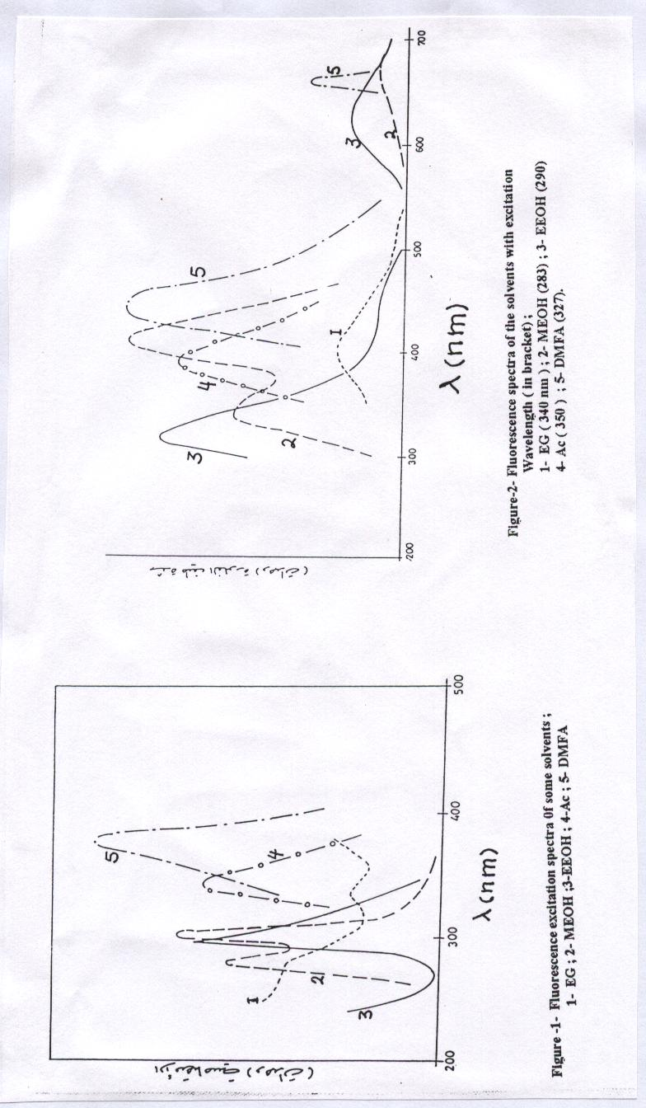
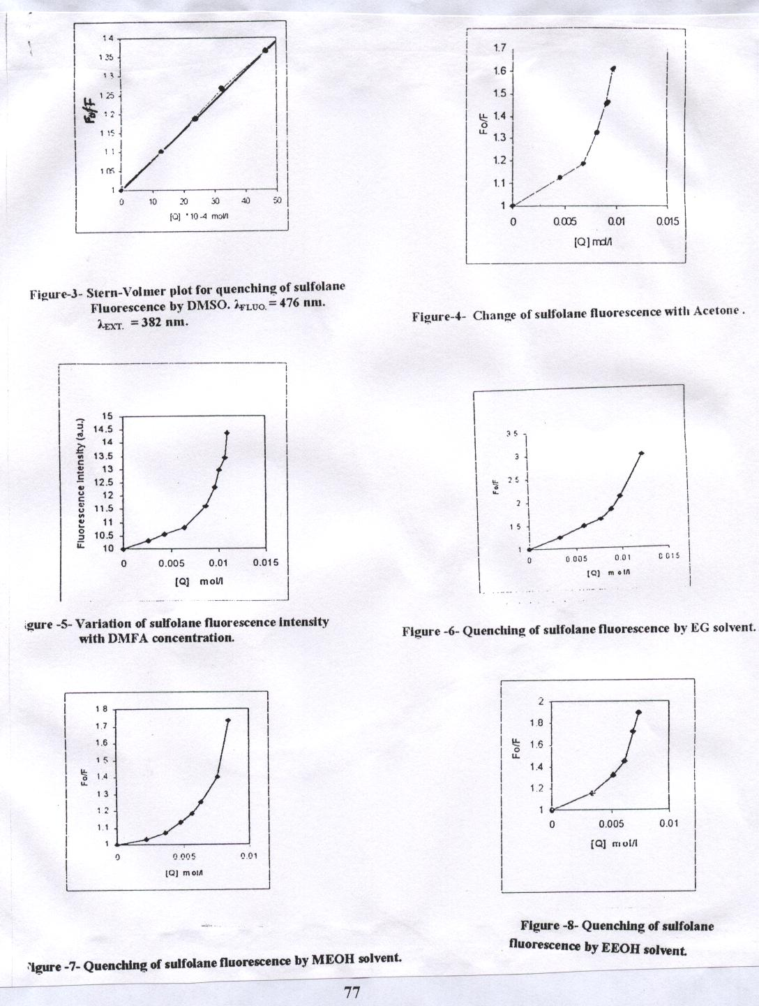

Discussion
The dynamic quenching
Figure- 3- presents the state of a simple and direct quenching of sulfolane fluorescence by DMSO molecules. The quenching process obeys Stern-Volmer equation. According to the properties of the mixture molecules and the forces effect on them, the observed quenching might be due to a molecular interaction of dipole-dipole type. It is clear that the mechanism is of a dynamic pattern, where the DMSO molecules diffuse regularly through the sulfolane molecules.
The dipole moment of these solvents is suitable for the dipole-dipole interaction to occur resulting in the quenching of the fluorescence emission of the excited sulfolane. Increasing the DMSO concentration higher than 0.0047 mol/L does not result in any further quenching.
The Photophysical processes of the sulfolane molecules excited at382 nm ,
Scheme-1-

S+hυ(382nm) → ¹S* Absorption

¹S → S + hυ (476 nm) emission ^{* 1}S*+DMSO→S+DMSO+heat quenching
¹S*→S other deactivation processes

Now, changing the sulfur atom by a carbon atom as in acetone solvent (Ac ) as a quencher, produce a dynamic pattern of quenching mechanism in the concentration range 0.0065 mol/L due to the dipole-dipole molecular interaction. Increasing Ac concentration to the range 0.01 mol/L increases the rate of quenching dramatically as shown in figure- 4 -. This increase in quenching may be due to the contributions coming from other mechanisms such as energy transfer process which cause a kind of deviation from Stern-Volmer plot seen in fig-4- ; scheme-2-

¹S*+Ac S+Ac quenching

¹S* ³S* ISC

¹S* + Ac S+¹Ac* singlet energy transfer
or / and

³S*+Ac S+³Ac* triplet energy transfer

The diffusion of Ac molecules in between the sulfolane (S ) molecules is thought to be easy firstly; because the Ac molecules are small , second; due to the possible orientation of Ac molecules which they may undergo during their diffusion. These unlike molecules will be separated by a distance R (a parameter of energy transfer) that allows the energy transfers process to occur. In the lower concentration of Ac solvent the contribution from this process to the quenching being quite small.

Sulfolane-DMFA system
The DMFA solvent posse’s two kinds of fluorescence emission (see figure-2- ). The first was detected at short wavelength of 440 nm whearse the second at longer wavelength of 660 nm. Its absorption spectra do not show any complex formation in S_{O} state (fig-1- ). The long wavelength fluorescence of the DMFA solvent may be due to the interaction of the intermolecular hydrogen bonding type which forms the dimmer complex. The addition of DMFA to sulfolane results in the increasing of sulfolane fluorescence intensity at 476 nm position in stead of quenching it, as shown in fig-5-. This enhancement of fluorescence intensity was quite large in the concentration range 0.0008- 0.01 mol /L. This addition has no effect on the absorption spectra of sulfolane.
The presence of DMFA molecules in the dimmer form may enhance the aggregation of sulfolane molecules in the ground state which on excitation produce a largely populated singlet excited state S₁. The molecular interactions between sulfolane and DMFA molecules are not strong enough to overcome the hydrogen bonding forces between DMFA dimmer molecules, which in turn, are not able to quench the sulfolane fluorescence. The highly populated S₁ state produces an intense fluorescence emission. It seems that excited sulfolane molecules were always surrounded by the dimmer complex molecules of DMFA which shown below;

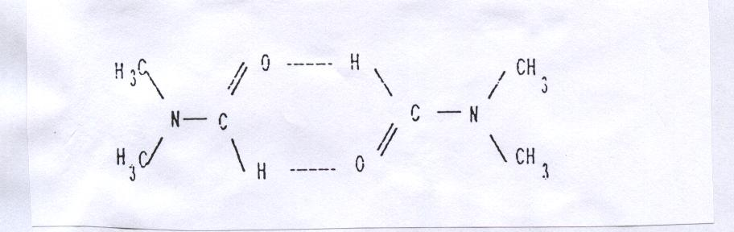

Another observation was detected on DMFA addition to sulfolane, which is the blue shift of sulfolane fluorescence peak at 476 nm as a function of DMFA concentration. The energy of the fluorescence transition of sulfolane molecules, which are more polar in the S₁ state ( nπ* state ) than in the S_{o} state, is affected by the DMFA polar molecules through the destabilization process of the nπ* state as the lowest singlet excited state. The destabilization results in a large energy difference between S₁ and S_{O} states ,as expected, which presented as a blue shift in the fluorescence peak.

Sulfolane-Ethanol derivative systems
In recent study of sulfolane-ethanol system, we concluded that ethanol quench sulfolane fluorescence with a static mechanism without any change in the shape of the fluorescence spectra¹⁰. Also, we noticed the increasing in the quenching efficiency with increasing aliphatic chain length of the alcohol and accompanied by a change in emission peak position. This behavior was explained in the light of the formation of complexes with a strong hydrogen bonding between sulfone group in sulfolane and hydroxyl group (OH) in ethanol. The intermolecular hydrogen bonding have the ability to overcome the self-association forces between the like ethanol molecules which in the presence of the orientation of the hydroxyl group will results in a strong interaction of OH group with sulfolane molecules to form the complex ^{6,10}. The substitution of α- H atom by OH group in the other end of ehtanol molecule give the ethylene glycol molecule, HOCH₂CH₂OH,(EG) which has a high probability of forming intermolecular hydrogen bonding with sulfolane as a molecular interaction due to the presence of two OH groups.Hense,EG is more efficient quencher of sulfolane fluorescence than ethanol ( see fig-6- ).It is the high ability of sulfolane molecules to break down the self-associated EG molecules and then forming a new intermolecular hydrogen bonding ,which is responsible mainly for the formation of sulfolane-EG intermolecular hydrogen bonded complex.
The probable structure and shape of bonding may take the following cases:

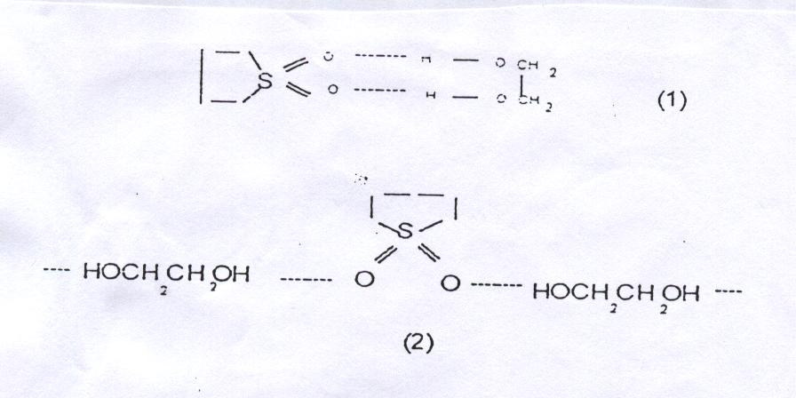

Now, using methoxy ethanol ( MEOH ),CH₃OCH₂CH₂OH, as a quencher of sulfolane fluorescence results in decreasing quenching efficiency ( fig-7-).It is clear that MEOH molecule lost part of its efficiency as a quencher since it lost OH group in its structure compared with EG molecule. This change results in a lower probability of forming intermolecular hydrogen bond with sulfolane molecule as a molecular interaction. At the same time MEOH molecules loss part of their ability to bound to the neighboring like molecules for the same reason. This competition in forming intermolecular hydrogen bonding between like or/and unlike molecules may leads to a decrease in the probability of molecular interactions between sulfolane and MEOH molecules. The result is a clear decrease in quenching efficiency of sulfolane fluorescence as shown in figure-7-. It is interesting to notice that one end of MEOH molecule is not polar for which the forces between solute and solvent molecules being of dispersion type.
Changing the quencher to ethoxy ethanol, EEOH, CH₃CH₂OCH₂CH₂OH, posses a change in quenching efficiency of sulfolane fluorescence (see fig. -8- ) due to the structural change of the EEOH molecules. The order of quenching efficiency of these solvents is:
EG>EEOH > MEOH > ETHANOL

Conclusion
The hydrogen bonding molecular interaction is the main effect and contributor to the quenching processes of sulfolane fluorescence in the sulfolane binary mixtures with the studied solvents. The quenching processes are thought to have complex mechanism accept that for DMSO quencher. Dimethyl form- amide solvent posses different behavior by enhancing fluorescence intensity in stead of quenching it.

References
- Hassan,Z.A., MSc. Thesis, College of Education-Ibn Al-Haitham,Baghdad Univ.,
( 1999).
- Al-Azzawi,S.F. and Awwad,A.M.,J.Chem.Eng.Data, 1990, 35, 411.
- Pansini, M.and Jannelli L., J.Chem.Eng.Data, 1986, 31, 157.
- Karvo M., J.Thermodyn., 1980, 12, 635.
- Salman, T.A., PhD.thesis, (2001), Saddam Univ., Science College.
- Lee, S. and Kim, H.J., J.Chem.Eng.Data, 1995, 40,499.
- Sacco, A.and Jannelli, L., J.Chem.Thermodyn., 1972, 4, 191.
- D, Aprano, A.Donat, I.D.and Liveri, V.T., J.Solution of Chem., 1990, 19(7), 711.
- Al-Omar, S.S. and Al-Azzawi, S.F., National J. of Chem., 2001, 2, 245.
10-Al-Omar, S.S. and Al-Azzawi, S.F., National J.for Chem., 2002, 5, 78.

