Synthesis & Spectroscopic Study of Some Lanthanide Complexes with the New Antipyrine –Azo Ligands
Asst. Prof. Dr. T. J. Al-Hasane Lecturer Dr. M. H. AL-Dheimy
College of Science College of Basic Education
University of Baghdad University of Babylon
Abstract
Azo compounds are among the most profoundly explored classes of organic reagent both from the theoretical and practical view point. The presence of an azo linkage in aromatic compounds makes them highly important in dye- stuff industry, pharmacy and analytical chemistry.
In the present work we prepared two new azo ligands (L₁-L₂) and characterized by I.R and UV-Vis spectra. The ligands L₁ also were characterized by Gc/ mass spectra.
Several new complexes of Y(III), La(III), Ce(III), Nd(III), Eu(III), Tb(III) with new azo ligands (L₁-L₂) were also prepared .
The structure of these complexes were deduced according to the molar ratio and Job methods, which were obtained from the spectroscopic studies of the complex solutions of the above ions. However, ratios of 1 : 3 , metal : ligand were obtained .
The percentage of the metals in the complexes have been measured by I.C.P technique . Micro elemental analysis C.H.N for some of these complexes were also deduced. Percentage of chloride, nitrate and sulphate ion have also been found by using "Mohr method and Spectrophotometric method"
Conductivity measurements have shown non-ionic character for solution of Ce(III) complexes with all the ligands in ethanol and DMF, while Y (III) , La (III), Nd (III) , Eu (III) , Tb(III) complex solution gave indication of (1:2) ionic character with all ligands.
The magnetic susceptibility measurements for all Y (III) , La (III) complexes exhibit diamagnetic behavior , while paramagnetic properties were recorded for all other complexes.
Introduction :-
Previously years a great deal of interest has been simulated to the preparation and studies of organic reagents¹⁻³. Azo compounds are among the most profoundly explored classes of organic reagent both from the theoretical and practical view point ⁴. The presence of an azo linkage in aromatic compounds makes them highly important in dye- stuff industry, pharmacy and dosimetry^{5,6}.
Azo compounds are characterized by the presence of azo group () ^{7,8} , which links two sp² hybridized carbon atoms . Often , these carbons are part of an extended delocalized electron system involving the aromatic ring , called a chromophore⁹ . Most azo compounds contain only one azo group , but some contain two ( di azo ) , three ( tri azo ) or more¹⁰ .
As with any double bond, the planar () bond is usually exists in two geometrical isomers cis and trans . The trans isomer is considered to be the more preferable one¹¹ .

Trans- azo benzene Cis- azo benzene

The change from trans to cis will be effected by exposure to UV- radiation . This can lead to photochromism , a light induced reversible color change in some dyes .This effect was considered a nuisance and has largely been eliminated by careful development of more stable dyes. But photochromic dyes are beginning to make a comeback in technology like sunglasses and sunroofs in cars^{12,13}.
The aromatic azo compounds were identified to be more stable than the aliphatic one . This is in fact because of the presence of a tautomeric equilibrium form.This involves the removal of a hydrogen from one part of the molecule , and the addition of a hydrogen to a different part of the molecule ,This is common when there is an (-OH) group ortho or para to the azo group¹⁴.
Hydroxyazo-form Ketohydrazo-form

Aliphatic azo compound () (R and / or R/ =aliphatic) are rather unstable . At an elevated temperature or by irradiation two carbon – nitrogen (R-N) bonds are cleaved simultaneously with the loss of nitrogen gas to generate carbon-centered radicals .Owing to this process some aliphatic azo compounds are utilized as radical initiators.

Two kinds of aromatic azo compounds were recognized , the homo- and the hetero – cyclic azo compounds . In the first kind , homogeneous aromatic rings were cited on both sides of azo group . The previously mentioned azo benzene is one of the typical homogeneous aromatic azo compounds¹⁵.
Lanthanides :-
It is now accepted that the "rare-earth elements" comprise the fourteen elements from ₅₈Ce to ₇₁Lu but are commonly taken to include ₅₇La and some times ₂₁Sc and ₃₉Y as well .To avoid confusion , and because many of the elements are actually far from rare , the terms lanthanide have been introduced¹⁶.
The lanthanides are the largest naturally occurring group in the periodic system . Although in fact they are not at all rare . Scandium and Yttrium are included since they are precursors of the rare earth family in group III of the periodic table .
The properties of lanthanides , are distinctly different than those of transition metals .The most stable oxidation state of lanthanides is the (+3) state¹⁷. The ( f ) orbital of the lanthanides are shielded by the 5d and 6s orbital . The poor screening of the 4f electrons (the lanthanides contraction) caused by the decrease in radius of the lanthanide ion(Ln³⁺) on crossing the series from La to Lu¹⁸. The majority of reactions and manipulations with lanthanides have utilized the (+3) oxidation state and have found important applications as Lewis acid and their interactions with ligand are predominantly ionic in nature¹⁹.Although the (+3) state is the most stable , some of the lanthanides have other stable ( or accessible ) oxidation states . Eu , Yb , and Sm have readily accessible (+2) oxidation states. Conversely, there is another group of lanthanides that have an accessible (+4) oxidation state. These include Ce , Pr , Nd ,Tb , and Dy²⁰.
Lanthanide achieved coordination numbered 9 by the reaction with N-benzoyl-acetoneglycine²¹.Many evidences suggest that the ligand act in monobasic tridentate manner and bonds to Ln(ІІІ) ions through the carbonyl oxygen , enamine, nitrogen, and carboxy group. The composition of the complexes was suggested to be Ln(HL)₃.2H₂O (Ln = trivalent lanthanide cations , L=C₁₂H₁₁O₃N⁻² )

Ln(HL)₃.2H₂O
Nine new binuclear lanthanide(ІІІ) complexes described as[Ln₂(NTPHA) (Me₂bpy)₄(ClO₄)₂](ClO₄)₂ (Ln = La , Nd , Sm , Eu , Gd , Tb , Dy, Ho, Er) were reported by Li , Zhang and Yan²² , where Me₂bpy stands for 4,4/-dimethyl-2,2/-bipyridine , and NTPHA represents the 2-nitroterephthalate dianions.
The authors proposed that these complexes present NTPHA-bridged structures consisting of two lanthanide ІІІ ions.
Anionic lanthanide chloride complexes of the type [(CH₃)₂NH₂] [LnCl₄(HMPA)₂] ( Ln = La(1) Nd(2) , HMPA= hexamethyl phosphoramide ) and [(CH₃)₂NH₂]₄[ LnCl₆]Cl₂ (Ln =Nd(3),Sm(4),Eu(5))were first known by Sasa Petricek²³ . The X-ray crystal structure of the complexes 1 and 2 showed that four chlorides and two oxygen atoms from HMPA molecules are octahedral coordinated to a La or Nd ion in [LnCl₄(HMPA)₂] .While six chloride coordinated to a Nd , Sm or Eu in compounds 3, 4 and 5 in a form of slightly distorted octahedron as shown in Figure(1) and Figure (2)
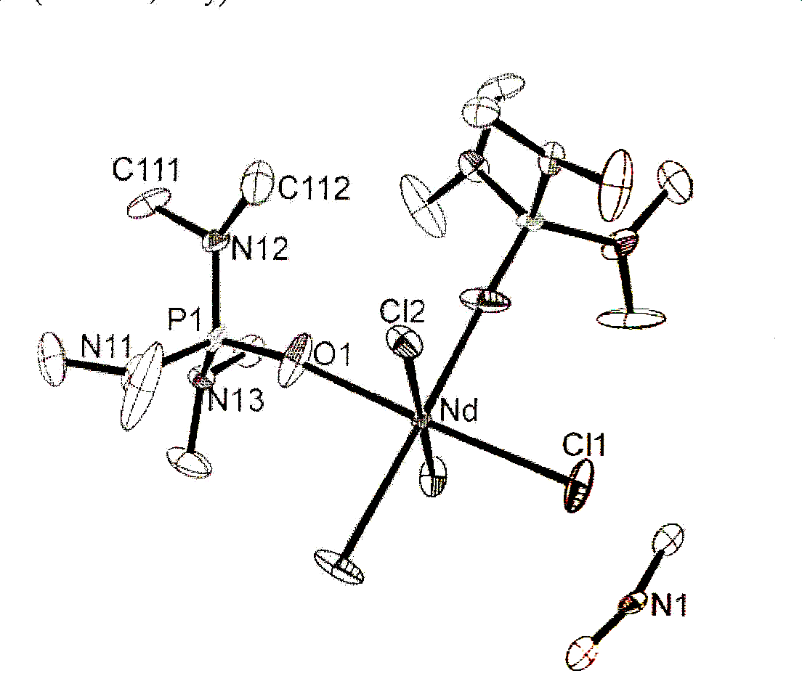
Figure(1)[(CH₃)₂NH₂]⁺ and [NdCl₄(HMPA)₂]⁻ ion in the complex 2 Hydrogen atoms are committed for clarity
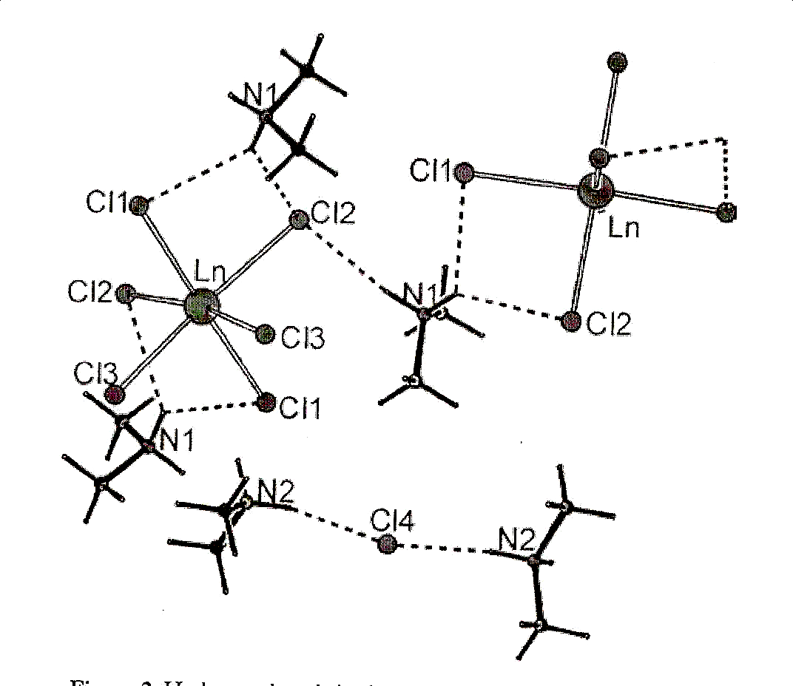

Figure(2) Hydrogen bonds in the complexes 3,4 and 5.
Experimental :-
All the chemical used in this work were of highest purity available and used without further purification . All solutions were prepared in doubly distilled deionized water
The Ligands were synthesized according to the general method²⁴ by dissolving (0.2g) (0.04M) of 4-Aminoantipyrin in a mixture consisting of (2ml) of sulphuric acid ,(10ml) ethanol and (10ml) of doubly distilled deionized water. The solution mixture was cooled to(5 ⁰C) .(10ml) of (10 ⁰/₀) sodium nitrite solution was added dropwise with stirring in order to obtain the diazonium salt solution. After 20 min the diazonium solution was slowly added to a cooled basic solution of (0.01M) of each of the following coupling reagents, (0.053g 4- amino salicylic acid and 0.0273g m-aminophenol) to obtain the ligands (L₁ and L₂ ) respectively. The dark colored mixture was neutralized by acetic acid and the solid precipitate was filtered off and washed several times with (1:1) (ethanol : water ) mixture then left to dry . The ligands solutions were prepared by dissolving the required weight of each ligand ( L₁ , L₂ ) in ethanol in a rang of concentrations similar to that of the metal salt solutions .
Preparation of Metal Salts Solutions:-
The metal salts solutions were prepared by dissolving the appropriate weight of each of the following salts Y(NO₃)₃.5H₂O, LaCl₃.7H₂O , Ce₂(SO₄)₃.5H₂O , NdCl₃.6H₂O , EuCl₃.6H₂O and TbCl₃6H₂O in the buffer solutions, These solutions were prepared in concentrations ranging between (1×10⁻⁵ - 1×10⁻³ )M .
In order to find M:L ratio , the absorption of many metal – ligand solutions mixture were obtained at optimum pH using the following methods
Preparation of the Complexes, General Procedure:-
All complexes were prepared in a M:L ratio of 1:3 by dissolving 0.2752 , and 0.2422 g ( 0.03M ) of L₁ , and L₂ respectively in minimum quantity of ethanol . The ligand solution was added gradually with stirring to the metal salt solution containing an accurate amount of each metal salt dissolved in buffer solution with an appropriate pH .The mixture was stirred until deep colored precipitate was appeared . The solution mixture was filtered off and the precipitate was washed several times with a (1:1) (water : alcohol) mixture then left to dry.
Spectrophotometric Measurements of the Ligand and Solid Complexes :-
The F.T.I.R spectra were recorded as dry solid CsI discs in the region (4000-200) cm⁻¹.UV-Vis spectra were also obtained for (1×10⁻⁴ M) of an ethanolic solution of the solid complexes using (1cm) quartz cell in the wave length range (200-1100) nm.

Results and Discussion:-
Mass Spectrum of Ligand L₂ :-
The mass spectrum of ligand (L₂) is shown in figure (3). .The spectrum exhibit a peak represent the parent fragment centered at m/z = 323 which appears to be corresponds with the formula C₁₇H₁₇N₅O₂.

Figure(3) Mass Spectrum of Ligand L₂

Study of the UV-Vis Spectra of the Liganeds and Complex Solutions:-
Aromatic azo dyes are among sensitive organic reagents suitable for the spectrophotometric determination of ions of transition elements in trace concentration. The intensity colored solutions formed from the reaction of the azo ligands with the metal ions is play an important rule for many UV-Vis spectral studies. This is because of the presence of a sharp and high absorption peak which belongs to the metal complex. The large bathochromic shift of this peak in the visible region with respect to that of the ligand may give a good indication on the complex formation. This means that the complexes have the ability to absorb light in the visible region.
The UV-Vis spectra of the four ligands under investigation Figures (4) and (5) display mainly three peaks observed in ethanol within the range 200-1100 nm. The first and second peaks 244-345 nm were assigned to the moderate energy π→ π* transition of the aromatic rings. The third broad peak (λ_{max}) in the range 419-431nm was related to the π→ π* transition of intermolecular charge-transfer taken place through the azo group() . Another peak was also observed as a shoulder at ~390 nm may be attributed to the n→ π* transition resulted from the presence of groups containing double bond , in addition to the presence of hetero atom carring a lone pair of electrons such as () and () .

Figure (4) UV-Vis Spectrum of
Ligand L₁

Figure (5) UV-Vis Spectrum of
Ligand L₂

The interaction between the metal ion and the ligand manifests itself in the absorption spectra by the appearance of a double absorption band with maxima in the range 431-442 nm .A great bathochromic shift in the visible region was detected in the complex solution spectra with respect to that of the free ligand . The high shift in the (λ_{max}) give a good indication for coordination and complex formation. Figure (6) showed a comparison between the spectra of the free ligand in ethanol and , the metal-ligand mixed solutions.

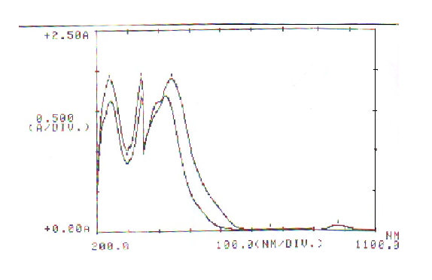
b
a

Figure (6) UV-Vis Spectra of a) free ligand solutions b) Eu-L₂ mixed solutions

All UV-Vis spectral data obtained in the previous study leads to ensure the optimum conditions in order to prepare solid complexes . The results obtained were listed in Table (1)

Table (1) Conditions of Preparation of Metal Complexes and Some of their Properties | % Elemental analyses | X anion Fou.(calc) | 13.12(13.5) | 7.60(7.90) | 18.60(18.80) | 7.10(7.80) | 7.20(7.80) | 7.10(7.70) | 14.50(14.90) | 8.40(8.70) | 20.10(20.60) | 8.50(8.69) | 7.90(8.60) | 8.20(8.50)
 | % Elemental analyses | M Fou.(calc) | 6.30(6.40) | 10.16(10.30) | 9.03(9.16) | 10.23(10.67) | 10.90(11.1) | 11.10(11.60) | 7.05(7.10) | 11.10(11.40) | 10.05(10.00) | 11.36(11.80) | 12.10(12.40) | 12.16(12.80)
 | % Elemental analyses | N  Fou.(calc) | 14.76(15.2) |  |  |  | 12.79(15.5) |  |  |  |  | 16.9(17.2)
 | % Elemental analyses | H  Fou.(calc) | 4.6(3.7) |  |  |  | 4.6(3.8) |  |  |  |  | 4.4(4.1)
 | % Elemental analyses | C  Foun(calc) | 41.87(47.00) |  |  |  | 41.80(47.00) |  |  |  |  | 51.90(50.10)
 | Color |  | Brown | Red Brown | Dark Brown | Brown | Red Brown | Brown | Light Brown | Dark Brown | Brown | Brown | Red Brown | Brown
 | M:L |  | 1:3 | 1:3 | 1:3 | 1:3 | 1:3 | 1:3 | 1:3 | 1:3 | 1:3 | 1:3 | 1:3 | 1:3
 | Optimum Molar Con×10⁻⁴ |  | 3 | 3 | 3 | 3 | 3 | 2.5 | 3 | 2.5 | 3 | 3 | 3 | 3
 | Opt. pH |  | 6.5 | 6.5 | 6.5 | 5.5 | 5.5 | 6.5 | 6.5 | 6.5 | 6.5 | 7 | 6 | 6
 | Metal Ion  Complex |  | [Y(L₁)₃NO₃](NO₃)₂ | [La(L₁)₃Cl]Cl₂ | [Ce₂(L₁)₃(SO₄)₃] | [Nd(L₁)₃Cl]Cl₂ | [Eu(L₁)₃Cl]Cl₂ | [Tb(L₁)₃Cl]Cl₂ | [Y(L₂)₃NO₃](NO₃)₂ | [La(L₂)₃Cl]Cl₂ | [Ce₂(L₂)₃(SO₄)₃] | [Nd(L₂)₃Cl]Cl₂ | [Eu(L₂)₃Cl]Cl₂ | [Tb(L₂)₃Cl]Cl₂
 |  |  | L₁ |  |  |  |  |  | L₂

Preparation and Characterization of the Solid Complexes :-
The complexes have been prepared by direct reaction of alcoholic solutions of the ligands with the aqueous solutions of the metal ions at the optimum pH and in a (1:3) metal to ligand molar ratio . Some physical and characterization data for solid complexes are presented in Table (1). The complexes are quite stable to air, are fairly stable to heat and have been all found to melt above 360⁰C. They are insoluble in water but highly soluble in most organic solvents such as ethanol, methanol, acetone DMF , and DMSO.
The effective magnetic moment (µ_{eff.}) of the prepared complexes was measured at (25⁰C). Table (2), and it is found to be in good agreement .
Table(2) Calculated and Experimental Magnetic Moments for the Prepared Complexes at 25 ⁰C
Complexes | Magnetic Moments
Complexes | Theoretical |  | Experimental (B.M.)
Complexes | $$μ_{S}=\sqrt{4S(S+1)}$$ | $$μ_{S+L}=\sqrt{4S(S+1)+L(L+1)}$$ | Experimental (B.M.)
[Y(L₁)₃NO₃](NO₃)₂ | 0.00 | 0.00 | 0.00
[La(L₁)₃Cl]Cl₂ | 0.00 | 0.00 | 0.00
[Ce₂(L₁)₃(SO₄)₃] | 1.70 | 3.87 | 2.08
[Nd(L₁)₃Cl]Cl₂ | 3.87 | 7.10 | 3.25
[Eu(L₁)₃Cl]Cl₂ | 6.90 | 7.70 | 3.48
[Tb(L₁)₃Cl]Cl₂ | 6.90 | 7.70 | 8.40
[Y(L₂)₃NO₃](NO₃)₂ | 0.00 | 0.00 | 0.00
[La(L₂)₃Cl]Cl₂ | 0.00 | 0.00 | 0.00
[Ce₂(L₂)₃(SO₄)₃] | 1.70 | 3.87 | 2.10
[Nd(L₂)₃Cl]Cl₂ | 3.87 | 7.10 | 3.37
[Eu(L₂)₃Cl]Cl₂ | 6.90 | 7.70 | 3.87
[Tb(L₂)₃Cl]Cl₂ | 6.90 | 7.70 | 8.60

Molar Conductance Measurements:-
The molar conductance values of the complexes in DMF and ethanol (1×10⁻⁴ M) were determined at 25⁰C .Table (3) show that the chloride and nitrate complexes of Y(III), La(III), Nd(III), Eu(III) , and Tb(III) with the ligands L_{1 ,} L₂ behave as 1:2 electrolytes . All Ce(III) complexes considered as non electrolytes in these solvents.
The molar conductance ranges obtained for these complexes are in good agreement with that reported in the literature for non electrolyte , and for 1:2 electrolytes in both DMF and ethanol solvent²⁵.
These results is consistent with the stoichiometry assumed for the complexes on the bases of analytical data. It also confirm the composition of these complexes listed in Table (3)

Table (3) Molar Conductance Values of the Complexes in DMF and Ethanol (10⁻⁴ M)
Ligand | Complexes | Λ_{m}(S . mol⁻¹. Cm²)
Ligand | Complexes | Ethanol | DMF
L₁ | [Y(L₁)₃NO₃](NO₃)₂ | 80.45 | 183.00
L₁ | [La(L₁)₃Cl]Cl₂ | 73.00 | 180.00
L₁ | [Ce₂(L₁)₃(SO₄)₃] | 7.04 | 23.92
L₁ | [Nd(L₁)₃Cl]Cl₂ | 72.48 | 159.86
L₁ | [Eu(L₁)₃Cl]Cl₂ | 63.18 | 154.90
L₁ | [Tb(L₁)₃Cl]Cl₂ | 63.50 | 156.00
L₂ | [Y(L₂)₃NO₃](NO₃)₂ | 80.92 | 154.96
L₂ | [La(L₂)₃Cl]Cl₂ | 74.36 | 154.97
L₂ | [Ce₂(L₂)₃(SO₄)₃] | 2.04 | 10.52
L₂ | [Nd(L₂)₃Cl]Cl₂ | 79.25 | 152.26
L₂ | [Eu(L₄)₃Cl]Cl₂ | 79.47 | 154.74
L₂ | [Tb(L₄)₃Cl]Cl₂ | 79.25 | 153.16

UV-Vis Spectra of the Solid Complexes:-
The UV-Vis spectra of the prepared complexes dissolved in ethanol (10⁻⁴ M) (measured against reagent blank as reference) have been measured and the data obtained were included in Table (4). As it was mentioned before, that the spectra of the free ligands L₁ and L₂ in the visible region exhibited doublet absorption bands with a variable intensity in the region (390-431 nm). This doublet was assigned to the π→ π* transition due to the azo linkage .
Coordination to metal ions caused strong bathochromic shift for the doublet absorption bands suggesting the involvement of the ligands in the bond formation with the lanthanides
The bands due to f→f transitions corresponding to the lanthanide metal ions usually appeared in the region (500-600 nm)²⁶. Could not be located in the spectra of the prepared complexes as they were very weak and were masked by the intense absorption bands of the ligand molecules.

Table (4) λ_{max} and ( ε) for Solid Complexes Dissolved in Ethanol with Concentration 10⁻⁴ M
Complexes | (λ _{max}) nm | ( ε×10⁴ L .mol⁻¹Cm⁻¹)
[Y(L₁)₃NO₃](NO₃)₂ | 548 | 0.496
[La(L₁)₃Cl]Cl₂ | 575 | 1.704
[Ce₂(L₁)₃(SO₄)₃] | 559 | 1.595
[Nd(L₁)₃Cl]Cl₂ | 599 | 1.181
[Eu(L₁)₃Cl]Cl₂ | 554 | 1.502
[Tb(L₁)₃Cl]Cl₂ | 592 | 1.887
[Y(L₂)₃NO₃](NO₃)₂ | 548 | 0.873
[La(L₂)₃Cl]Cl₂ | 549 | 1.504
[Ce₂(L₂)₃(SO₄)₃] | 593 | 1.538
[Nd(L₂)₃Cl]Cl₂ | 583 | 1.271
[Eu(L₄)₃Cl]Cl₂ | 551 | 1.465
[Tb(L₂)₃Cl]Cl₂ | 554 | 1.393
The IR Spectra of the Ligands and Complexes:-
For characterization, the IR spectra of the prepared complexes in CsI were compared with those of the prepared ligands . The spectra of the complexes showed the absorption bands characteristic of the ligands with some differences ascribed to the formation of respective ion associated, Table ( 5) shows the more characteristic infrared spectral bands of the free ligands and their complexes . The most significant information on the geometry of these complexes comes from the analysis of the antipyrine carbonyl group, the azo bridge and the OH, NH₂ absorption regions .

Table(5)The Most Important Band and their Assignments of the Ligand and their Complexes ( Values in cm⁻¹)
Compounds | ν OH | ν NH | ν+  ν | ν +  ν CNNC | ν | ν | ν | R. def | SO₄⁻² /  NO₃⁻⁻¹
L₁ | 3463w br. | 3394w br | 1620 v.s.  1590 s.sh. | 1530 m.sh.d  1496 s.d | 1326m. | 1164 m d  1134 w d | 1070v.w t  1049 w t  1020 w t | 879 w  840 sh.  702 m
[Y(L₁)₃NO₃](NO₃)₂ | 3417v.s t. | 3379v s t | 1620 s.d  1580 m.d | 1520 s.d  1496 m.d |  | 1141 m | 1049 v.s | 771 s  702 s | 1357 vs  1045 s  833 m
[La(L₁₃)₃Cl]Cl₂ | 3440 vst br | 3379vst br | 1640 v.s.d  1581 s.d | 1520 sd  1488 m.d | 1350 m d  1311 m d | 1141 m | 1049 v.s | 840 w  771 s  402 s
[Ce₂(L₁)₃(SO₄)₃] | 3425 | 3386 | 1620 s.d  1581 m.d | 1530 md  1496 md | 1350 w d  1319 w d |  |  | 840 w  771 s | 1126 s.br  1080 s.sh  970 m.sh
[Nd(L₁)₃Cl]Cl₂ |  | 3386 br. | 1620 v.s.d  1580 s.d | 1520 s.d  1488 s.d | 1350 w d  1319 w d | 1110 m | 1049 v.s | 848 w  771 s  702 s
[Eu(L₁)₃Cl]Cl₂ |  | 3379 s.br | 1620 s.d  1581 s.d | 1520 m.d  1496 m.d | 1350 w d  1319 w d | 1110 w | 1049 v.s. | 771 s  702 s
[Tb(L₁)₃Cl]Cl₂ | 3355s.br. |  | 1620 v.s.  1580 s.sh. | 1520 s.d  1496 m.d | 1357 w d  1319 w d | 1110 s | 1041 v.s. | 848 m  771 s  702 s
L₂ | 3425 s.br. | 3380 s.br | 1635v.s. d  1596 s.d | 1527w.sh.d  1496 s,d | 1319 m. | 1134 s | 1072 w.t  1049 m.t  1026 w.t | 763 v.s  694 v.s
[Y(L₂)₃(NO₃)₂]NO₃ | 3440 s.br | 3380 br. | 1620 v.s.d  1580 s.d | 1525 s.d  1496 s.d |  | 1141 m | 1026 m  972 w | 763 s  702 s | 1357 v.s  833 w
[La(L₂)₃(Cl)₂]Cl | 3409 | 3371 s.br | 1620 s.d  1600 d | 1530 md  1496 md | 1350 w d  1319 d | 1110 m | 1049 v.s.d  987 m.d  918 m | 771 m  702 m
[Ce₂(L₂)₃(SO₄)₃] | 3456 | 3386 | 1610 sd  1581 sd | 1520md  1488md | 1350 m.t  1311m.t  1300m.t |  | 1049 s.d  972 m.d  902 m | 763 v.s  702 v.s | 1126 s  972 m
[Nd(L₂)₃(Cl)₂]Cl | 3456 s.br. | 3370 s.br | 1620 br. | 1527 d  1480 d | 1360 w.t  1319 w.t  1300 w.t | 1134 m | 1040 s.d  1026 m.d  972 m | 771v.s  702v.s
[Eu(L₂)₃(Cl)₂]Cl | 3409 s.br | 3386 s.br | 1612 br. | 1527 d  1496 d | 1360 md  1319 md | 1141 m | 1040 s.d  1026 s.d  972 w | 763 s  702 s
[Tb(L₂)₃(Cl)₂]Cl | 3409s.br. |  | 1620 sd  1600 sd | 1527 d  1488 d | 1350 md  1319 md | 1141 m | 1045 s.d  1026 m.d  972 m | 763 v.s  702 v.s

s=strong ; m=medium ; w=weak ; v=very ; sh=sharp ; br=broad ;d=doublet ;t=triplet

References :-
- 1- K. Yoshimura , Y. Toshimitsu and S. Ohashi ; Talanta., 27(1980)693
- M. S. Masoud , E. M. Soliman , A. E. Elkholy , and E. A. Khalil ; Thermochimica Acta., 136(1988)1
- J. L. P. Pavon , B. M. Cardero , J. H. Mendez , and J. C. Miralles ; Analyst , 114 (1989) 849
- R. N. Goyal , M. S. Verma , and N. K. Singhal ; Croatica Chemica Acta (CCACAA) ,71(3)(1998)715
- H. Freman ; National Textile Center Annual Report , September , 1994
- J. Sokolowska-Gajda , H. Freeman , and A. Reifc ; Textile Res. J., 64 (7) (1994) 388
- S. Blumel , H. Knackmuss , and A. Stolz ; App. And Env. Micr. 68(8)(2002)3948
- Z. Holbecher , L. Divis , M. Kral , L. Sucha , and F. Vlacil "Hand book of Organic Reagents in Organic Analysis" John Wiley and Sons , New York , 1976
- A. Catsch , A. E.Harmuth , and D. P. Meller ; "The Chelation of Heavy Metals" Pergaman Press , Oxford , New York 1979
- H. Klaus "Azo Dyes" Chemistry of dyes , (2006)1
- P. F. Gordon , and P. Gregory ; "Organic Chemistry in Colour" (Springer-verlag , New York 1983)
- M. Brierley , S. Carter , P. France , and J. Pederson ; Electron. Lett., 26 (1990) 329
- Y. M. Issa , and B. E. El-Anadolu ; Ind. J. of Chem., 22(1983)386
- H. Nishihara ; Bull. Chem. Soc. Jpn., 77(2004)407
- S. Patel ; "The Chemistry of the Hydrazo , Azo and Azoxy Group" John Wiley and Sons. New York, Part(I)1975
- P. Blackwell "Nomenclature of Inorganic Chemistry , Recommendations , International Union of Pure and Applied Chemistry " Publ. Blackwell( 1990)
- A. I. Voloshin , N. M. Shavaleev , and V. P. Kazakov ; Journal of Photochemistry and Photobiology A : Chemistry 131(2000)61
- G. Nickless ; Mechanistic Studies of Lanthanide Mediated Organic Reaction ; Lanthanide Project (2006)
- T. Lambert " Lanthanides in Organic Synthesis " MacMillan Seminar 22 Feb., 2000
- Y. Toshimitsu ; Cerium , A Guide to its Role in Chemical Technplogy; Molycorp , Inc., CA U.S.A , 1995
- J. Q. Wu , Y. M. Song , R. W. Deng , and Z. N. Chen ; Chem. Papers., 53(3)(1999)210
- Y. T. Li , J. Zhang , and C. W. Yan ; Polish J. Chem., 77(2003)797
- S. Petricek ; Acta. Chim. Slov., 52(2005)398
- J. A. Connor , and D. J. Fine; J. Chem. Soc. Dalton , 4(1981)599
- P. K. Radhakrisnan ; Inorg. Chim. Acta.,110(1985)211
- K. Venkataraman ; "The Chemistry of Synthetic Dyes" (Academic press, New York 1970 )

