Impact of Non-Standard Varieties and Other Languages in Arabic Media
Researcher. Hasanein Hasan Shaheed
University of Babylon\ College of Quranic Studies
أثر اللهجات العربية غير القياسية في الاعلام
الباحث. حسنين حسن شهيد
جامعة بابل / كلية الدراسات القرآنية
الملخص
يبين الباحث المخاطر التي حدثت في لغة الاعلام العربي الحديث (المطبوعات والاعلام المسموع والمرئي) وذلك نتيجة دخول اللهجات العربية واللغات الاجنبية اليه وخاصة في العقدين الماضيين. يركز البحث على الاعلام المرئي اكثر من غيره من الانواع وذلك لتأثيره الكبير على المتلقي وخاصة الاطفال والمراهقين والشباب (بغض النظر عن جنسهم) لانهم ينشؤون معه ويركزون عليه اكثر من المسموع. يستمع الاطفال والمراهقين والشباب الى الاغاني والاناشيد الدينية فقط ويظهرون اهتماما قليلا بالمطبوعات اذ يقرؤون مطبوعات الازياء.
Abstract
Research shows risks which have been occurred to modern Arabic media language (print, audio, and visual media) from entering different Arabic varieties and foreign languages to it, especially in the last two decades.
Work focuses on visual media more than other types of media, because it has a significant effect on recipient viewers in particular among kids, teenager and young adults (irrespective of sex), as they are more up to it than the rest of the other age groups, and as they are more exposed to visual media than the audio one. Kids, teenagers and young are only hear songs and religious sermons, and they show less interest in print only except for reading fashion vogue. Specifically girls are fascinated to fashion news unlike boys who prefer sport news. Printed media has its targeted readers in the age between 35-65 years old.
In Modern time Arabian people are not much attentive in the language usage. Main reason for that is new technology, the second one is integration of cross culture varieties, and they are learning new languages and traditions, so day by day they losing their ability in the usage of Arabic language correctly. Research has to be done to find a middle language which has been put between standard Arabic language and different varieties in Arabic which is using in media, this language will be easy to understand to all age categories in different classes and races, on the other hand, this language preserves characteristics and features of standard Arabic and will be comprehensible, recognized by all its users.
Introduction
Language in each community system is co individual in its followers. They use it basically to express what they think, in their understanding with each other, therefore; we can not study the effect of media language in public opinion objectively by examining the behavior of individual or individuals only as separated atoms, as if we try to study qualities of water by reference to the characteristics of both hydrogen and oxygen, which consists of them (Abed Al-'Aziz 2004: 12). Language is not the thing which is made by a particular individual or individuals, but it creates the nature of assembly and it emits to gathered life. Requirements of this life are expression of thoughts and exchange of ideas. Every one of us grows up existing in his hands a linguistic system using in society and he received it automatically in learning and imitating, as he got all other social systems (Abed Al-'Aziz 2004:13).
Language –particularly media language- is a type of matters which every one (sender or receiver) finds himself obeying to all what it is drawing, because media language forms in the end as part of predominant general linguistic system, therefore; if this language differs from general linguistic system then it will be rejected by the receiver (Al-Sayeed2000:15-17). Believe some of mass media which using dialects in most their programs are essential for attracting audience, considering that compatibility with development and to emulation modern nations; so that media language should departing standard Arabic language to use dialects or varieties. Appointing the concept of media language doesn't work without results of linguistic studies in different fields, which provide media language with linguistic phenomenon, and what linguistic studies discover in technical researches that useful in study media language by refining its utterances, expanding its range, promoting its vocabularies, entering new words to its words and reinforcing characteristics of media language by clarifying, simplifying and nearing it from reality cultured language without anticlimax or dropping into vernacular. Using practical language which expresses about life, motion, work and accomplishment is the real influential media language.
Linguistics can be benefited from media language; because the relationship between both is affecting and affected relationship. Interchanged relation between linguistics and media language is a linguistic growth relationship. Media's means of communication contribute in existing words which they were not occurring in language before and also it works to disuse words which they were using in language completely. Media's means of communication reflect the main factors which give new vocabulary in language, as requirements in naming a modern social activity, whether it is sociological or economical system, new scientific or philosophical theory, and new invented material. Nowadays there are many new words (vocabulary) which are used in political and economical fields using in Arabic media such as privatization, globalization, unipolar and first square, nevertheless; those words are transferred literally from foreign culture (Khori 2005:197).In sport's media language also emerges new vocabularies that have never been heard before by audience such as Classico, derby, hatric and lega.Linguistics needs media for its survival and development, simultaneously media needs language for sustainability and contact with recipients(Eco 1976: 7), but in the latest years we find that Arab media is away from using Standard Arabic; especially in television programs, political interviews, and dialogues in social programs. In all these programs or interviews media (television or radio) is using dialects or varieties in one hand, in another hand it is using many foreign words from different languages such as English, French, Spanish, Turkish, Persian, Hindi......etc., so Arabian society needs a middle language which is used by Media to be zestfully understood by all classes and creed.
Aim
The main aim of this paper is to indicate/extract foreign language words (vocabulary) which are used in media language as well as the use of dialects in media especially in recent days. Research also has to be done to find out medium or middle language which is occupied between standard Arabic and varieties that can be used in media to be understood by large number of receivers. So, research plays pivotal role to extract those words and to refine them for the use in media. It also supports workers in media field to use Arabic words more than words of other languages or dialects because standard Arabic is more comprehensible to all Arabic speakers. Finally to bring the importance of media language to focus in the society, as it rightly reflects the Arabian society.
Media Language and Level of Linguistic Expression
There are three levels of linguistic expression: first is Artistic and Aesthetic level which is used in arts and literature. Second is Scientific, Theoretical and Abstracting level which is used in science. Third one is Normal Social Scientific level that is used by press and media. These three levels exist in all human communities (Abed Al-'Aziz 2004:63); the difference between healthy community and passive one is that, linguistic levels are close to each other in first one while in second, they are well-extended. Rapprochement in linguistic levels is an evidence of community homogeneity, culture vitality and integration in its mentality. It is constant matters that ages which have rapprochement in their linguistic levels (scientifically, literary and practically) are most vivid and perfect ages, but if they are remote from each other, then this will cause deteriorating, senility and vanishing of words( Abedal-'Aziz 2004: 84).
Linguists and literati are working to develop language and making it wealthy, but roots of language do not go deep without fertile soil which provides it nourishment. So language will die and vanish as many ancient languages died out because they ceased their relevance with people speech (Mercer et al. 1979:17). Thus should not be a gap between language of literature, science and their vocabulary with daily dialogue of people, this gap if gets bigger, therefore; literary and scientific language becomes an artificial language which neither interacts with the language of population nor deals with their ambition. Language of journalist and media man should be built on purposeful, clearness, and brightening job. The art of press and media is comprehensive social expressing, and its language is compound phenomenon that deals with all cultural activities such as science, art, music, and plastic art besides that policy, commerce, economy, and general topics. So, the art of press/ the stylistic ground of press language and media are an applicative art that aims to connect people and should convey meanings and thoughts to the mass. It is a functional instrument, but isn't the art of esthetic for itself, nevertheless; language of media art is different because recipients audience are not one category in a society but all the society, therefore; media man speaks and writes to all the people that he must strive to achieve the goal, is to make his message understood by everyone (Bradley 1989: 33-35). While these days in Arab homeland we find the media uses many foreign languages and different Arabic dialects as if directed to a specific category or a particular Arabic country, the use of standard Arabic is almost very rare or does not exist. For example,
Below a short essay which is written about a new technology, smart cell phones (Galaxy S III mini), many words in this short article words are founded which are written in foreign language but it is in Arabic scripts as transliteration. So, large numbers of Arab readers don't know the meanings of these words in Arabic language or they don't know their translation. In this case, they try to use them in their daily life but without any understanding of its real meanings.
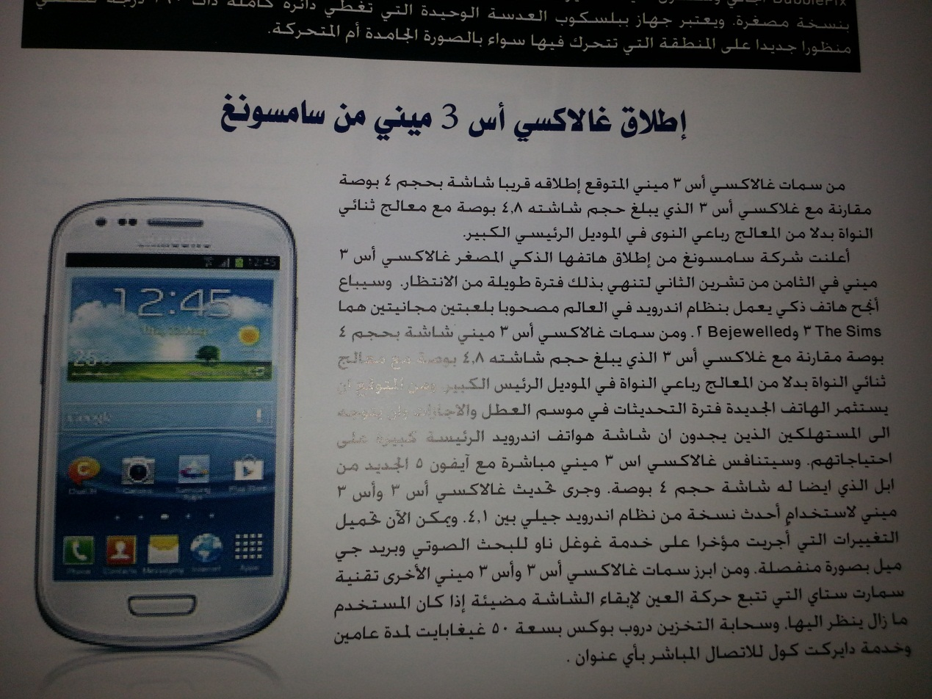
Note: This article contains 44 English words which they are only transliteration into Arabic but in Arabic script.

Media Language and Multiplicity of Meanings
The possessing of language is one of the main conditions at media career. If media person doesn't have any ability to pen down the language profoundly or doesn't know how s/he uses language to achieve required goals, then media work loses its capability for convincing. Meanings of some words and idioms do not express only apparent meanings, but expanding to other boundaries around them i.e. circumstances interfere to give away their meanings (McDaniel 1998: 15). Approximately, all words do not have one meaning, but multiple meanings. One word can function differently with different meaning in different context. Objects themselves can have / can be called by different names. So, this is one of the main difficulties which occurred because of un-uniformity of speakers' vocabulary and its understanding. In the Modern dictionary of Arabic language, there are some words which have ten or more meanings for example; the word "waqef" means "stop" its meanings are: "stand", " extant on his feet'', " located", " motionless", "jobless", " pause", " live/v./", "existent", and "occupied /v./ a gladiatorial site" , in most Arabic dialects this words means " gift" or " give something without money"or " determined money is used for certain thing in particular time" ( 'At Allah 1997:93-96),another example of the varieties of some Arab countries the word "mashi" has many meanings as "okay", "agree", " I will do", " gone or left", "walker", "mashi ?" Means "Do you agree?". Functionality of a word in different context/Multiplicity of meanings in one word is necessary aspect of media person to be equipped of the knowledge of it, therefore; he/she has to improve upon the usage of word in appropriate context. So, that it is given only the intended meaning which he/ she wants to convey to the recipient, because everyone has his own world knowledge about the word and self-inflicted perceptions that derived from his environment and culture, Media person makes mistake if he thought that information and ideas which he introduces will be understood as per his understanding of the word-knowledge. There are many obstacles in this process, such as bias, bigotry, superstition, and delusions in addition to age, language, religion, and trends.
Media Language between Classical Language and Vernacular
Arabic language is a poetic language/ a language of poetry; it is built on poetical structure in its artistic and musical origins. Arabic language in its sentence is an organized and harmonic art in sounds and rhythms, therefore; it is a language of poetry. Concurrently, it is a media language too and we want to build a media language in modern concept. Media language shows simple items which will be easy to audiences to understand as if it suits with values, culture and traditions of Arabic society, so Arab vocalizations indicate Arab's thinking and their outlook to things (Abed Al-'Aziz 2004:133), therefore; the language of media do not differ in the curriculum development of what linguists and language guards want, despite being the fact that the media person is demanded to adapt of his news and articles and arts editorial in accordance with the published templates press, so he will be keen on the usage of the rules of grammar and rhetoric, and if the media language is keen to take into account linguistic rules, then media persons are also trying to keep other characteristics such as structural simplicity, brevity and clarity. Also direct access to the recipient clearly and firefly, because every word in the media language must be understood by the public as it should be presented in an attractive manner and delivers enjoyment to reader or listener, either puns and multi meanings or emotional auras about vocalizations and other literature arts that lead to specific meanings in poetry, but in fact it is quite far from the language of media, because it cut stream connection that must be its course clear and obvious to the recipient (Mithun 1998: 189). That the use of standard Arabic in both sides, eloquent and slang in the media and its suitability and non-suitability led to the emergence of two trends. The first one supported the use of classical Arabic language in media while the other rejects this principle, calling for the use of a vernacular instead of the classical, the first group (classical Arabic) focuses on the use of vernacular corrupting the language, culture, customs and traditions of the Arabic community, in addition to the classical language lead to development of artistic sense of language aesthetic and create continual immunity to factors retail nationalism and patriotism, political and geographical. So this emphasize the use of vernacular (dialects) devote these factors mentioned and thus lead to a linguistic suicide. While others believe that the reality of situation requires the use of the vernacular language because it is closest to the common understanding of the public, in addition to it gives the privacy of every community and country and focuses on the local customs and traditions of this country and its communities.
This is what we see clear and evident in most of the Arabic satellite channels and radio stations, as every Arab country established TV channel and radio which broadcasts in local dialect and exposure programs and serials in this dialect in order to support the country and its domestic customs or traditions for the purpose of making the dialect of this country is the first in the Arab world, thus get away completely from classical Arabic language. And more than that, there are a lot of common TV programs in the Arab world are using foreign languages (Code Mixing), especially in their title such as "The Voice", "The X Factor", "Arab Idol", " Arabs' got talent "," Star Academy"….etc. Those titles are not Arabic at all, although they can be easily translated into Arabic. We find in many Arab countries erroneous translation of traffic signs or explanatory signs in the streets and buildings as well, this indicates to stay away from the classical Arabic language dramatically in Arab societies' media, below many signs written wrongly in Arabic streets and buildings

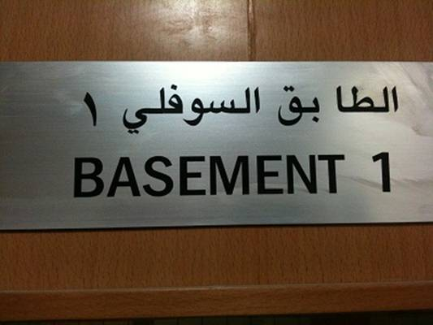
"Basement" is translated wrongly into Arabic and error in writing.

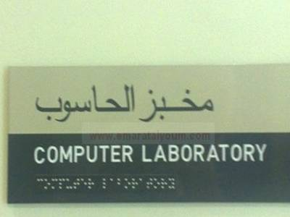
"Laboratory" is translated as "bakery" into Arabic.

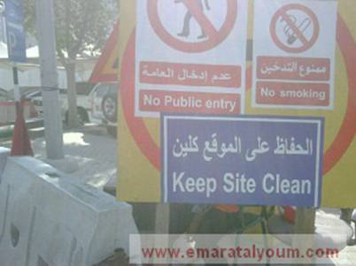
"Clean" is transliterated not translated to Arabic.

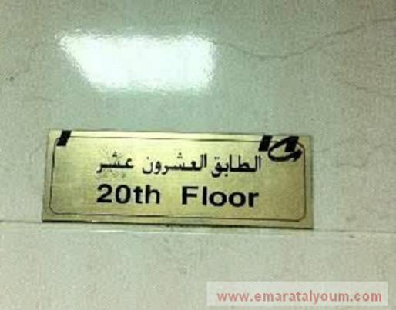
"20^{Th"} is translated into "20+10" in Arabic. It is big wrong.

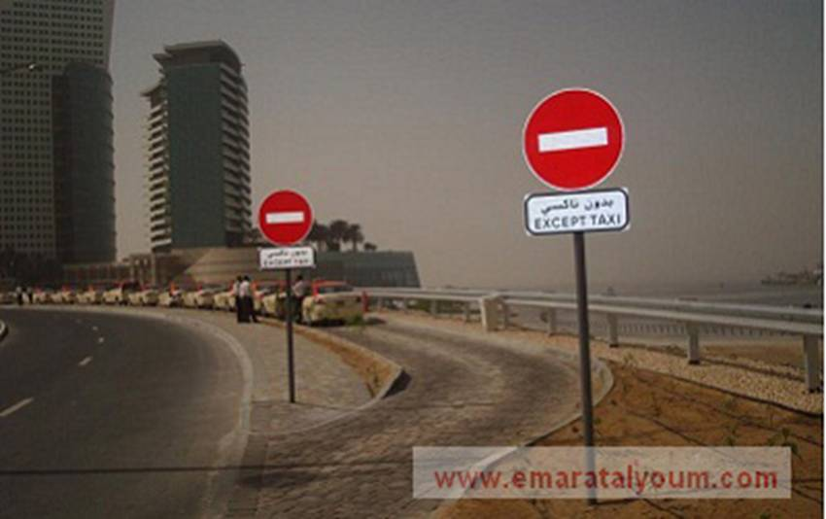
This traffic sign means is forbidden to stop vehicles except taxi but written up side down in Arabic.

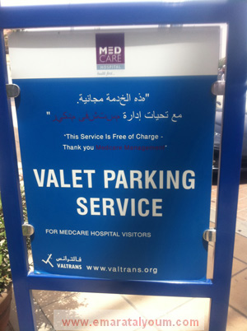
Writing (dictation) in Arabic is entirely wrong.

Conclusions& Suggestions
- The use of dialects (Non-Standard Varieties) or words of foreign languages in media language led to the division of the Arab world mentally and intellectually, thus also increases the rift of geographical division. Each and every Arab country wants to highlight the dialect as the best and most practical way, so the best way to reach this goal is the use of media in all its aspects; even in traffic signals or advertisement.
- The popular media made media's audience containing classes illiterate or semi-illiterate alphabetically and culturally, that makes classical language as a barrier idiomatically and connecting, which cannot be avoided only by using slang or using words from other languages.
- Belief some of mass media that the dialect they use in their programs is the best way for attracting audience, so they are imagining that compatibility with development and emulation by deserting standard language and using dialects (Ferial Mahna).
- Declining implications in media materials especially recreational programs make mass media use dialects rather than classical because standard language is not suitable in its nature with such programs.
- Adherence of some cultural and academic mediums in alphabetical of standard Arabic heritage to the extent of intolerance, prompting many media officials to abandonment of standard language gradually.
Arabic language, because of this issue seems today is the most confused languages between its loyalty to past (history) and its adaptation of recent culture or sticking to reality requirements of modern events. The effort should be made to ensure the safety of classical Arabic of retail, dispersion and loss, not to mark terrain of culture language level in public, at the same time not to use language which fails to express the reality account. Of course new van is required to seek linguistic balance which is creativity between loyalty to the past and commitment to the present.

References:
- Al-Syaid, Mohammad. 1995. Society and language issues. Alexandria: Dar Al-ma'rfah Al-Jamea.
- Chambers, J.K. and Trudgill, Peter.2004. Dialectology. 2nd ed, Cambridge: Cambridge University Press.
- Crystal, David. 2003. Language Death. 1st ed. Cambridge: Cambridge University Press.
- May, R. 1987. Logical Form as a Level of Linguistic Representation. in: Lepore, E.(ed.).
- Miller, G. 1978. Semantic Relations Among Words. In: Halle, M. and als(eds.).
- Naher, Hadi. 1998. Sociolinguistics at the Arabs. 1st ed. Irbid: Dar Al-Amal for Publishing & Distribution.
- Partee,B.H.: 1979. Semantics-Mathematics or Psychology?. Semantics from Different points of view, Springer- Verlag.
- Winograd,T. 1985. Moving the Semantic Fulcrum. Linguistics and Philosophy 8.1.
- Yoneyama, M. 1986. Motion Verbs in Conceptual Semantics. Bulletin of the Faculty of Humanities, N21. Seikei University. Tokyo.
IVSL References:
- Chaise La Dousa. The Native Speaker and Mother Tongue. Language Sciences Journal, Volume 32, Issue 6, November 2010: Page 602-614.
- D'Arcy and Taylor. Ethics and Social Media: Implications for Sociolinguistics in the Networked Public. Journal of Sociolinguistics 16/4,2012: page 532-546.
- Yamaguchi,Masataka. Non- Understanding as a Heuristic to Hypothesizing cultured Models: Ameta-Oriented Sociolinguistic Strategy. Journal of Sociolinguistics, 13/3, 2012: page 387-410.
Arabic References:
- Al- Rumhein, Atallah. Logic and Non-logic in Media Discourse. Damascus University press. Damascus. Page 93-96.
- Abdel Jalil, Manqur. Semantics. Arab Writers Union. Damascus. Page 57.
- Al-Syaid, Mohammad. Language of media Discourse. Dar Al-feiker AlArabi. Cairo. Page 15-17.
- Sharaf, Abdel 'Aziz. Media Language. Beirut. Dar Al-Jeel. page 12.
- Sharaf, Abdel 'Aziz. Media Science of Linguistic. University Cultural Center. Cairo. Page 9.
- Khori, Saqer. Thought & Language. Syrian Knowledge Magazine. No. 496. 2005: page 179.
- Felfel, Mohammad. Arabic Language between Stability & Change. Syrian Knowledge Magazine. N0. 403. 1997: page 115.

