The Impact of Using Role Play Techniques on Improving Pupils' Speaking Skill for Primary School
Ass.prof.Dr. Jassim Mohammed Rayhan
Babylon University\ College of Basic Education
Abstract
The current study aims at investigating the impact of using role -play on improving students' speaking ability for the primary school. The study is restricted to sixth grade female pupils in the primary schools in Babylon City during the second term of the academic year 2011–2012.The population consists of (160) Iraqi EFL students distributed over two sections A and B. Sixty students are chosen randomly to represent the main study sample and other twenty students represent the pilot administration.
To achieve the aim of the study, two tests are constructed. The total number of items of the first test which represents written test is (10). While, the second test represents oral test. From the analysis of the data, it is found that the mean of post- scores of the experimental group is (57.7333), which is higher than the mean scores of the control group that is found to be (48.1000). This indicates that students’ achievement in the experimental group is better than that of the control group, which shows that role –play technique is more useful for them in teaching speaking skill than the lecture method teaching.
1.1The Problems of the Study
As the ability to speak English is a very complex task considering the
nature of what is involved in speaking and not all of the students in an EFL speaking class have the courage to speak. Therefore, many of the students feel anxious in a speaking class (Padmadewi, 1998: 3), and some are likely to keep silent (Tutyandari, 2005:65).
Thus, Scott et al (1990:33) state that what is important with students is finding the balance between providing language through controlled and guided activities and at the same time letting them enjoy natural talk. Most of students have little opportunity to practice speaking English outside the classroom and so need lots of practice when they are in class.
Padmadewi (1998:12) found out that students attending a speaking class often felt anxious due to pressure from the speaking tasks, which require them to present individually and spontaneously within limited time.
Accordingly, Tutyandari (2005:65) states that the role-play would seem to be the ideal activity in which students could use their English creatively and it aims at stimulating a conversational situation in which students might find themselves and give them an opportunity to practice and develop their communication skill. For these reasons, the researcher is interested in analyzing the use of role-play in teaching speaking for the students of Iraqi primary school. He also wants to know the advantages and the problems encountered by learners and teachers in using it.
1.2 Aims
This study aims at:
- Finding out the effectiveness of using role-play technique on improving female students' speaking ability for the primary school.
1.3 Hypothesis of the Study
It is hypothesized that there is no statistical significant difference between the mean achievements scores of the students who are taught dialogue by the “Lecture Method”, which is the traditional method, and those who are taught dialogue by the “role –play Technique”, according to their pre and post -tests results
1.4 Limits
The study is limited to:
1. The use of Role –play technique in teaching dialogue of the experimental group and the use of the traditional way- lecturing- to teach the student of the control group.
2. Sixth grade female pupils in the primary schools in Babylon City during the second term of the academic year 2011–2012.
1.5 Definitions of Basic Terms
1.5.1 Role-Play
Harmer (1998: 92), offers this definition, “Role-play activities are those where students are asked to imagine that they are in different situations and act accordingly.
Role play as a vehicle by which students can more easily learn the fundamentals of English conversation in a specific situation, requiring the use of key words which act as signifiers for that particular situation(Stocker ,2006:1).
1.5.2 Speaking
In Oxford Advanced Dictionary (1987: 827) the definition of speaking is “to express or communicate opinions, feelings, and ideas etc. Speaking as talking involves the activities in the part of the speaker as psychological (articulator) and
Physical (acoustic) stages."
1.6 The Understanding of Speaking
Speaking is significant to an individual’s living processes and experiences as are the ability of seeing and walking. Speaking is also the most natural way to communicate. Without speaking, people must remain in almost total isolation from any kind of society. For most people, the ability to speak a language is the same with knowing a language since the speech is the most basic means of human communication. When we speak, a great deal more than just mouth is involved such as nose, pharynx, epiglottis, trachea, lungs and more. However, speaking is not just making sound. Birds, animals, babies make sound and though it may be communication of sorts, is not speaking.

According to Webster (1980: 1), speaking has a variety of meanings: a. to tell, to say, to make known or as by speaking, to declare; to announce. b. To proclaim, to celebrate. C. To use or be able to use (a given language) in speaking.
Meanwhile, Trigon, etal (1998:7) define that speaking is a skill of conveying words or sounds of articulation to express or to deliver ideas, opinions, or feelings.
Similarly, Byrne (1986:54) states that, “oral communication (or speaking) is a two way process between speaker and listener and involves the productive skill of speaking and the receptive skill of understanding”. Based on the previous four definitions, it can be synthesized that speaking is the process of sharing with another person, or with other persons, one’s knowledge, interests, attitudes, opinions or ideas. Delivery of ideas, opinions, or feelings is some important aspects of the process of speaking which a speaker’s idea become real to him and his listeners.
1.7 The Functions of Speaking
Several language experts have attempted to categorize the functions of speaking in human interaction. According to Richard, (2007: 1) “The functions of speaking are classified into three types; they are talk as interaction, talk as transaction and talk as performance. Each of these speech activities is quite distinct in term of form and function and requires different teaching approaches”(Trigon, etal,1998:8). Below are the explanations of the functions of speaking
- As Interaction
Being able to interact in a language is essential. In fact, much of our daily communication remains interactional. This refers to what we normally mean by “conversation”. The primary intention in talk as interaction is to maintain social relationship. Meanwhile, talk as interaction has several main features as follows:
1. Has a primarily social function.
2. Reflects role relationships.
3. Reflects speaker’s identity.
4. May be formal or casual.
5. Uses conversational conventions.
6. Reflects degrees of politeness.
7. Employs many generic words.
8. Uses conversational register.
Some of the skills (involved in using talk as interaction) are:
a. Opening and closing conversation.
b. Choosing topics.
c. Making small talk.
d. Recounting personal incidents and experiences.
e. Turn-taking.
f. Using adjacency pairs.
j. Interrupting.
h. Reacting to others.
Mastering the art of talk as interaction is difficult and may not be a priority for all learners. In talk as interaction, the ability to speak in natural way is required in order to create a good communication. That is why some students sometimes avoid this kind of situation because they often loss for words and feel difficulty in presenting a good image of themselves. This can be a disadvantage for some learners (Richards,1986;2).
b. Talk as Transaction
This type of talk or speaking refers to situations where the focus is on what is said or done. The message is the central focus here and making oneself understood clearly and accurately, rather than the participants and how they interact socially with each other (Ibid;3).
In transaction, talk is associated with other activities. For example, student may be engaged in hand-on activities (e.g. in language lesson) to explore concept associated with tenses and derivations. Burns (1999:52) distinguishes talk as transaction into two different types. One is a situation where the focus is on giving and receiving information and where the participants focus primarily on what is said or achieved. Accuracy may not be a priority as long as information is successfully communicated or understood. The second type is transactions, which focus on obtaining goods or services, such as checking into a hotel.
In this type of spoken language, students and teachers usually focus on meaning or on talking their way to understanding. Meanwhile, talk as transaction has several main features as follows:
1. It has a primarily information focus.
2. The main focus is the message and not the participants.
3. Participants employ communication strategies to make themselves understood.
4. There may be frequent questions, repetitions, and comprehension checks.
5. There may be negotiation and digression.
6. Linguistic accuracy is not always important some of the skills involved in using talk for transactions are:
7. Explaining a need or intention
8. Describing something
9. Asking questioning
10. Confirming information
11. Justifying an opinion
12. Making suggestions
13. Clarifying understanding
14. Making comparisons
Compared with talk as interaction, talk as transaction is easier for some students because it only focuses on messages delivered to the others. Also, talk as interaction is more easily planned since current communicative materials are a rich resource of group activities, information-gap activities and role plays (Richards, 1986:3) .
Talk as transaction can provide a practicing source of how to use talk from sharing and obtaining information as well as for carrying out the real-world transactions.
c. Talk as Performance
This refers to public talk or public speaking, that is, talk that transmits information such as morning talks, public announcements, and speeches. Talk, as performance tends to be in the form of monolog rather than dialog. Often follows a recognizable format is closer to written language than a conversational language. Similarly, it is often evaluated according to its effectiveness or impact on the listener, something which is unlikely to happen with talk as interaction or transaction. Examples of talk as performance are giving a class report about a school trip, conducting a class debate, making a sales presentation, and giving a lecture. The main features of talk as performance are:
There is a focus on both message and audience.
1. It reflects organization and sequencing.
2. Form and accuracy are important.
3. Language is more like written language.
4. It is often. Some of monologue skills involved in using talk as performance are:
a. Using an appropriate format.
b. Presenting information in an appropriate sequence.
c. Maintaining audience engagement.
d. Using correct pronunciation and grammar.
e. Creating an effect on the audience.
f. Using appropriate vocabulary.
g. Using appropriate opening and closing (Richard,2007: 2).
It is clearly seen from the features and skill involved in using talk as performance, that initially talk as performance needs to be prepared in the same way as written text. Therefore, this kind of talk requires a different teaching strategy.

1.8. Dialogues and role-play work
Working with dialogues is a useful way to bridge the gap between guided practice and freer activities. Controlling dialogues can easily develop into freer work when the pupils are ready for it.
Putting pupils into pairs for doing the dialogues is a simple way of organizing even large classes. Dialogues, which involve some sort of action or movement, are the ones which work best with the pupils. Intonation is terribly important too, and pupils love to play around with it (Scott et al, 1990:33).
Students pretend that they are in various social contexts and have a variety of social roles. In role-play activities, the teacher gives information to the learners such as who they are and what they think or feel. Thus, the teacher can tell the student "You are David; you go to the doctor and tell him what happened last night." (Harmer, 1990: 91)
Howe(1990:91) states that “in role play the pupils are pretending to be someone else like the teacher , or a shop assistant , or one of their parents , etc. " One way of getting student to speak in different social context and to assume varied social roles is to use role-play activities in the classroom.
Role plays can be performed from prepared scripts, created from a set of prompt and expression or written using and consolidation knowledge gained from instruction or discussion of the speech act and its variations prior to the role plays themselves (Stocker ,2000: 34).
1.9. Significance of Role Play in Teaching Speaking
One way of getting student to speak in different social context and to assume varied social roles is to use role-play activities in the classroom. Because socio-culture is so crucial in the production of speech acts, it is suggested that discourse rating task, in which students rate dialogues or scenarios on various continua of formality and the like, can raise awareness about language and can transfer this knowledge to production activities such as role-plays. Besides, the social interaction activities, on the other hand, also requires the learner to pay more attention to the establishment and maintenance of social relationships. Meanwhile, two things can be added to this description. Firstly, the teacher could make the role-play a whole-class activity by having all the students act out a public meeting with many speakers. Secondly, not all role-plays part the situation, for example, all you might need to do is to set the party scene and then tell students to go either as themselves or as a living or dead person they would like (Murcia, 2001 :108).
Role-play is one of the activities to promote speaking. Through role-play activities, the students learn how to express ideas, opinions, or feeling to others by using words or sounds of articulation.
Paulston and Bruder (1976:70) define role –plays as “exercises where the student assigned a fictitious role from which he has to improvise some kinds of behavior towards the other role characters in the exercise”
Similarly, livingstone (1986:6) defines role-play as “a classroom activity which gives the student the opportunity to practice the language, the aspects of role behavior and the roles he may actually meet outside the classroom.”
Larsen Freeman (2000:68) explained that role-plays are important in the communicative approach because they give learners an opportunity to practice communicating in different social contexts and different social roles. A role-play is a highly flexible learning activity, which has a wide scope for variation and imagination.
By the same, Ladousse (1995:4) states that a role-play uses different communicative techniques and develops fluency in the language, promotes interaction in the classroom and increases motivation.
Thus, role play can improve learners’ speaking skills in any situation, and helps learners to interact .As for the shy learners, role play helps by providing a mask, where learners with difficulty in conversation are liberated .In addition, It is fun and most learners will agree that enjoyment leads to better learning.
Several reasons for using role-play in teaching speaking quoted from ladousse (1995: 4) as follows
- A very wide variety of experience can be brought into the classroom and the teachers can train their students in speaking skill in any situations through role-play.
- Role-play puts students in situation in which they are required to use and develop those certain forms of language which are so necessary in oiling the works of social relationships, but which are so often neglected by the language teaching syllabuses.
- Some people are learning English to prepare for specific roles in their lives. It is helpful for those students to have tired out and experimental of a classroom.
- Perhaps the most important reason for using role-play is that it is fun.
- Role-play helps many shy students by providing them with a mask.
In conclusion, role-play is a technique, which can develop students’ fluency in target language, promotes students to speak or interact with others in the classroom, increases motivation and makes the teaching – learning process more enjoyable.
1.10 Features of the Role Play
Bolton (1986:229) lists the features of the role-play technique as follows:
- While using time and place as its medium, thought predominates over action.
- Because it is a consciously contrived event, there is a special degree of awareness by the participant.
- It combines cognitive and affective adjustment to the present situation.
- The act of taking on a role is a movement from the general to the particular – the new situation is , in part ,an instance of what is already understood as a general case .The significant phrase here for the educationalists is for the major learning potential lies in the degree to which novelty may be injected into the present situation.
- It is an approximation of any required event. The juxtaposition of two often seemingly incompatible context.
- It is a form of hypothesis – “What would happen if …?”
1.11. The Population Sample of the Study
"A population refers to all of specified groups of objects usually persons”
(Lehman and Mehrens, 1971: 18).The total number is 160 female students,
Distributed in two sections, A, and B.
Al-hadaf primary school for girls at Babylon Governorate during the academic year 2011-2012, selected randomly. One section B has been selected randomly as an experimental group, while the other one section A is the control group. The number of students in section A is 32, while the number of students in section B is 32. After excluding the repeaters in every section, the total number of the sample subjects is 60 students, 30 students in each section, as shown in Table 1.
Table (1)
The Number of the Subjects before and after Excluding the
Repeaters
Groups | Section | Type of Treatment | No. of Subjects before Excluding | No. of Subjects After Excluding
Experimental | B | With the Role Play Technique | 32 | 30
Control | A | With the Lecture Method | 32 | 30
Total |  |  | 64 | 60
1.12. Instruction Period
The experiment lasted for five weeks during the academic year 2011-2012. It started on the fifteenth of March and ended on the tenth of April 20012.
1.13. Prescribed Teaching Materials
The analyzed material is extracted from units (5-9). These units are chosen from pupil’s book (4) Iraqi opportunities for Sixth grade of the primary education (Book 4) and from the workbook and manual (4) for sixth grade of the primary stage.
1.14. Scoring Scheme of the Oral Post Test
To get rid of subjectivity and personal bias, the students’ responses have been evaluated in term of grammar, vocabulary, comprehension, fluency ,and pronunciation, by using the scale suggested by Brown(2004:172-173) each element scores from 5-1 marks (see Table 2). The interviewer used schedule
Table (2)
Scoring Scheme-Criteria Evaluating
The Oral Test
No | Criteria | Rating Scores | Comments
1. | Pronunciation | 5 | Has few traces of foreign language
 |  | 4 | Always intelligible, thought one is conscious of a definite accent
 |  | 3 | Pronunciation problem necessities concentrated listening and occasionally lead to misunderstanding
 |  | 2 | Very hard to understand because of pronunciation problem, most frequently be asked to repeat
 |  | 1 | Pronunciation problem to serve as to make speech virtually unintelligible
2. | Grammar | 5 | Make few (if any) noticeable errors of grammar and word order
 |  | 4 | Occasionally makes grammatical and or word orders errors that do not, however obscure meaning
 |  | 3 | Make frequent errors of grammar and word order, which occasionally obscure meaning
 |  | 2 | grammar and word order errors make comprehension difficult, must often rephrases sentence and or rest rich himself to basic pattern
 |  | 1 | Errors in grammar and word order, so, severe as to make speech virtually unintelligible
3. | Vocabulary | 5 | Use of vocabulary and idioms is virtually that of native speaker
 |  | 4 | Sometimes uses inappropriate terms and muster phrases ideas because of lexical and equities
 |  | 3 | Frequently uses the wrong words conversation somewhat limited because of in adequate vocabulary
 |  | 2 | Misuse of words and very limited vocabulary makes comprehension quite difficult.
 |  | 1 | Vocabulary limitation so extreme as to make conversation virtually impossible
4. | Fluency | 5 | Speech as fluent and efforts less as that of native speaker
 |  | 4 | Speed of speech seems to be slightly affected by language problem
 |  | 3 | Speed and fluency are rather strongly affected by language problem
 |  | 2 | Usually hesitant, often farced into silence by language limitation
 |  | 1 | Speech is so halting and fragmentary as to make conversation virtually impossible
5. | Comprehension | 5 | Appears to understand everything without difficulty
 |  | 4 | Understand nearly everything at normal speed although occasionally repetition may be necessary
 |  | 3 | Understand most of what is said at slower than normal speed without repetition

1.15. Face Validity
In order to a certain face, and content validity as well as authenticity validity of the oral test, the test has been exposed to the jury members. Recommendations and modifications of the jury members are considered in the refined version of the test.
Table (3)
The Academic, Ranks, Names, and Locations of the Jury Members
N | Academic Rank | Name | College
1 | Professor, Ph.D in ELT | Asim A. Alwani | College of Education, University of Babylon
2 | Ph.D in Applied Linguistics | Sheima Albakri | College of Education, university of  Baghdad
3 | Ass.Prof.,Ph.D. in Applied Linguistics | Hameed B. | College of Education University of  Babylon.
4 | MA in Applied Linguistics | Hussein Mosa | College of Basic Education, University of Babylon
5- | MA in ELT | Muhtaram A. Wahid | College of Basic Education, university of Babylon.

1.16. Pilot Administration of the Oral Post Test
The aims of administrating the pilot test as Harris (1969:103-104) mentioned are:
- To check the suitability of the items 2-To discover the weakness of the test.
3. To try out the test directions, and four To find out the time required to answer the test.
The test is given to a sample of twenty students from section (A) and (B) randomly selected from the whole population as mentioned before. It has been found out that the items are appropriate to the students’ level, and the directions are clear enough. The average time required to answer the oral test is 10 minutes for per testee.
1.17. Reliability
Since scoring of an oral test is considered highly subjective (Lado, 1961:330), the researcher used some criteria to increase the reliability of the oral test:
Firstly, the researcher has adopted the test sheet for students’ scores. Secondly, after fourteen days, the researcher scored the test again. Reliability coefficient is obtained by comparing the score of the first rating to the score of the second rating (the researcher’s score rating when he listened to the tape recorder).
The correlation is found to be (o.975) and this is considered a high stable coefficient.
1.18 Final Administration of the Oral Post Test
After the pilot administration, the oral test was finally applied on 10th-13th .May, 2012. The students have been evaluated according to six criteria of scoring as mentioned before. Each student is given (10) minutes to be interviewed. The responses of each student are recorded on a tape recorder.
The oral test is scored out of (30) marks. (See Appendix 3). The written test is scored out of (20) marks. The total score is 50. (See Appendix 2)
1.19. Scoring Scheme of the Written Post Test
The written test has ten questions as it is shown in appendix (2) .The researcher has tested the students’ abilities in Grammar ,vocabulary and general information in teaching dialogues .The Written test consists of filling in blanks .The correct questions is giving two mark, while the incorrect question is given zero.
1.20. Final Administration of the Written Post Test
The written test has been applied on the control and experimental groups on the 15th .May, 2012. Then the tastes’ papers are corrected by the researcher himself.
1.21. Data Analysis
1.22. Comparison of the Pre-Test and the Post-Test Scores.
1.22.1. Comparison of the Pre-Test and Post-Test Scores of the Control Group
In the pre-test of the control group, the mean score is 44.1000, whereas in the post-test it is 48.100. The t-test formula for the two dependent samples is used to show if there is any significant difference between the scores of the control group in the pre-test and post-test. The t-test calculated t-value is 2.498 at 0.05 level of significance that indicates that there is a significant difference in the achievement of the control group in both test scores. See Table (4)
Table (4)
Mean Standard Deviation, T-Test Value of a Pre-Test and Post-Test of the Control group
Variables  Test | No. of Students | “X”  Mean | Stranded  Deviation | Degree Of  Freedom | T-Value
 |  |  |  |  | Calculated Value | Distribution
Pre-Test | 30 | 44.100 | 14.8123 | 29 | 2.498 | 2.045
Post-Test |  | 48.100 | 11.3756

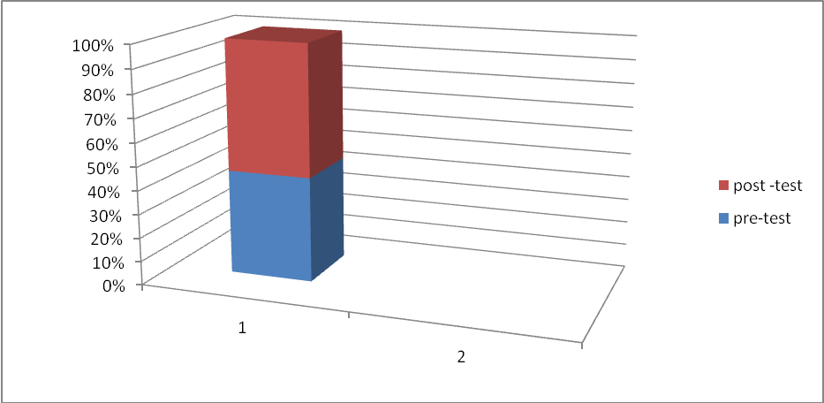

1.22.2. Comparison of the Pre-Test and Post Test Scores of the Experimental Group
The mean score of the experimental group in the pre-test is found to be 46.2203, whereas in the post-test it is found to be 57.733. The t-test formula for two dependent samples is also used to show if there is any significant difference between the scores of the experimental group in the Pre-test and the post-test. The t-test value is found to be 9.233 at 0.05 level of significance, which indicates that there is a statistical significant difference between the two scores because of the influence of the role –play technique teaching. See Table 5.
Table (5)
Mean, Standard Deviation, T-Test Value of the Pre-Test and Post-Test of the
Experimental Group
Variable Tests | No. of  Students | “X”  Mean | Standard  Deviation | Degree of Freedom | T-Value
 |  |  |  |  | Calculated | Table
Pre- Test | 30 | 46.2203 | 14.2203 | 29 | 9.233 | 2.045
Post-Test |  | 57.7333 | 14.8253

1.22.3. Comparison of the Post-Test Scores of Both Experimental and
Control Groups
By comparing the mean score of the post-test of the experimental group, which is found to be 57.7333 with the control group, which is found to be 48.100, the t-test formula is used to find out if there is a significant difference in the post-test scores of both groups. The t-test calculated value is found to be 2.824 at the level of significance 0.05 and 58 degrees of freedom. This indicates that there is a significant difference between both groups, i.e., the achievement of the experimental group who we taught according to the role –play technique is higher than the achievement of the control group who were taught according to the lecture method. Accordingly, role –play teaching is more effective than the Lecture Method teaching. Therefore, the null hypothesis that is presented earlier is rejected.
See Table 6 below.

Table (6)
Mean, Standard Deviation, and t-Test Value of the Post-Test Scores of the
Experimental and Control Group

Variables  Groups | No. of  Students | “X”  Mean | Standard  Deviation | Degree  Of  Freedom | T-Value
 |  |  |  |  | Calculated | Table
Experimental | 30 | 57.7333 | 14.8253 | 58 | 2.824 | 2
Control |  | 48.1000 | 11.3756
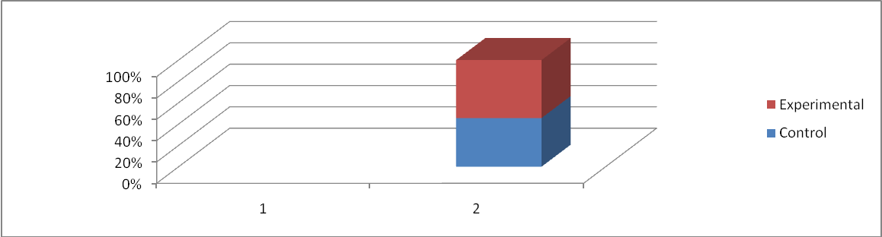

1.23. Discussion of the Results
From the analysis of the data, it is found that the mean of post- scores of the experimental group is (57.7333), which is higher than the mean scores of the control group that is found to be (48.1000). This indicates that students’ achievement in the experimental group is better than that of the control group, which shows that role –play technique is more useful for them in teaching speaking skill than the lecture method teaching.
The results of the present study are compatible with the results of Susanti (2007) and Umam (2011), which revealed that role- play is a successful method in the material studied.
The results also show that role –play technique is a successful method in teaching dialogue and this may be due to the following:
1. Role play gives the students more chances to use the spoken and written forms of English language through role-play lecture activities like presentation of the reports, discussions, and debates, which can consequently develop their accuracy and fluency
2. The students are more confident in their abilities because they have the support and encouragement of fellow group members.
3-Interaction among team members promotes their psychosocial adjustment as the individual effort of every student is encouraged and supported in order to achieve group process.
4- The students in that role–play feel important actors because they perform roles that are essential to the completion of the group tasks.
5- The students have opportunities for using a variety of instructional techniques such as whole- class brainstorming, discussion, question and answer.
6- The students depend on cooperation rather than competition, explanation, rather than memorization.
7- The construction of groups from students of heterogeneous levels of proficiency enforces those of low levels to work hard to be equal with their mates and they get benefit from those of high levels through exchanging information.

1.24. Conclusions
The present study in both of its theoretical and practical aspects has led to the following conclusions:
- According to the findings of this study, the subjects of the experimental groups who were taught by using role-play technique have significantly improved in speaking. This has been based on a comparative statistical treatment of the subjects’ scores on both groups of pre and posttests.
- In Role play’s class the students seemed more engaged with the lesson, negotiate with each other and help each other than they are in a traditional lecture.
- Role-play’s class provided an efficient mechanism for students to take more responsibility for their own learning and share their information.
1.25. Recommendations
The researcher has recommended the followings:
- The use of role-play technique in teaching in schools and colleges, especially with practical subjects.
- The teachers in which Students have the opportunities to produce the foreign language mostly for interest and often to break the routine of working the speaking course activities should use enjoyable, authentic materials.
BIBLIOGRAPHY
Bolton, Gavin. (1986)Selected Writings. Lawrence: Longman
Brown (2004:172-173) (2004) Language Assessment Principles and Classroom Practice. San Francisco: Pearson Education, Inc.
Burns, A. (1999). Collaborative action research for English language teachers.
Cambridge: Cambridge University Press.
Byrne, Donn, Teaching Oral English: Longman Handbooks for English
Teacher. Singapore: Longman Group, 1986.
Cornbleet, S. and Carter, (2001) The Language of Speech andWriting, London: Routledge publisher.
Haris, David P. (1969) Testing English as a Second Language,.New York: Mc. Graw Hill Book Company,
Harmer. (1986).The Practice of English Language Teaching. Edinburgh Harlow: Longman
---------- (1990). How To Teach English. New York: Longman,
------- (1998). How to Teach English. England: Addison Wesley Longman Hornby, AS (1987) Oxford Advance Learner ’sDictionary.Oxford: Oxford University Press, Sixth Edition
Howe, D.H. (1986). English Today. A 6 – level course for Children, Oxford: Oxford University Pres.
Jack C.Richard, (2007) Developing Classroom Speaking Activities; From Theory to Practice,Http://www.professorjackrichard.com/developing-classoom-speaking-activities.pdf, p.2, It was retrieved on November 1 2007
Lado, R. (1961). Language Testing. Ann Arbor: University of Michigan Press Larsen, Freeman .Techniques and Principle Teaching.2nd Oxford: Oxford University Press (2000).
Ladousse, Gillian Porter, (1995) Role Play: Resources Book for the Teacher Series.New York: Oxford University Press,
Lehmann, Irvin, Jnad Mehrens, William A. (1971). Educational Research Reading in Focus. U.S.A.: America Winston INC.
Livingstone, H. (1986:6) Role Play: in English Learning. Essex: Longman LTD
Murcia, Marianne Celce-, (2001) Teaching English As A Second or Foreign Language. (Boston: Heinly and Heinle, a Division of Thomson Learning,Inc.
Padmadewi, N. N. (1998). Student’s anxiety in speaking class and ways of minimizing it. Jurnal Ilmu Pendidikan, 5(Supplementary Edition), 60-67
Paulston,C.B. and Bruder, M.N. (1976) Teaching English as a Second
Richards, J. C., & Rodgers, T. S. (1986). Approaches and methods in language teaching. Cambridge: Cambridge Language Teaching Library
Language Techniques and Procedures. Cambridge .Winthrop Published.
Scott ET, A.W and Ytreberg, L.H. Teaching English to Children. Longman Group UK Limited, 2003
Stocker,D. (2000). English Language Teaching Articles: ESL Role-play. Retrieved July 19, 2006, from http://www.eslbase.com/articles/roleplay.asp
Susanti Ayu, D.H. (2007) Using Role –Play in Teaching Speaking, State Islamic University
Tarigan, Henry G. (1981) Berbicara Sebagai Suatu Ketrampilan Berbahasa, Bandung: Angkasa
Tutyandari, C. (2005). Breaking the silence of the students in an English language class. Paper presented at the 53rd TEFLIN International conference, Yogyakarta, Indonesia
Umam, C. (2011)Improving the Students’ Speaking Ability through Role-Playing Technique. Langganan : Poskan Komentar (Atom ).
Van Dalin, D.B. (1973) Understanding Educational Research: An Introduction. (3rd ed.) New York: McGraw- Hill Book Company.
Webster, Noah1 (1980) .Webster’s New Twentieth Century Dictionary, 2nd Edition, (New York: William Collins Publishers,

Appendix (1)
The Final Version of the Test
University of Babylon
College of Basic Education
Department of English
Dear Mrs. /Mr…………………………
The researcher intends to carry out a research entitled " The Impact of Using Role Play Techniques on Improving Female Pupils' Speaking Skill for the
Primary School” The attached test has been constructed. You are kindly requested, as an expert, to read it and express your opinions on the suitability of its items. Any comments, suggestions, and modifications will be highly appreciated.
Thank you for your cooperation.

Appendix (2)
The Final Version of Written Test
Q1: Answer the questions the boy is asking

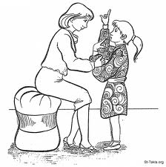
I'd like to ---------------
1-a. What is your favorite lesson?
b. My favorite lesson -----------
a. What is your favorite color?
My ---------------
b. My favorite color -----------

I ---------------
2- a. What do you like, Hani?
b. Hani ----------------
a. What does Huda like doing?
b. Huda ----------------

3- a. When are you hungry?
b. I'm hungry when I ---------
a. When are you thirsty?
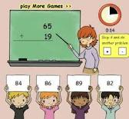
b. I'm thirsty when I---------

4-a.What Do you prefer?
b. I prefer the ----------
a. What do you take on holiday?
b. I sometimes take ------------

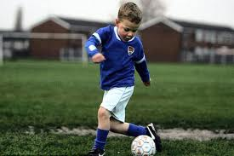
5-a. What is she doing?
b. She's ------------
a. What is he doing?
b. He's ------------

6-a.What is your favorite season.
b. I like ---------------?
a. Why do you like it?
b. I like it because -----------?

7- a. How tall is a camel?
b. It is usually -----------
a. What does it eat?
b. It……………
8. a .I'd like a kilo of olives.
b. How much is it?
a. It is…………..

9- a. What would you like for dessert?
b. Can I have ----------
a When you were six , you could ----------
b. When you were eight , you couldn't ---------

10-a. He could walk when he was four .
b. He ----------- Age 6
c. He ----------- Age 10
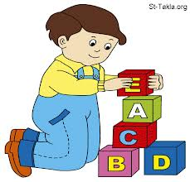
--------

Appendix (2)

The Final Version of Oral Test

You are a customer .You inter in a Babylon Mall to buy something choose from these items and ask me about the size, Color , and the price . I am a clerk of this Mall.

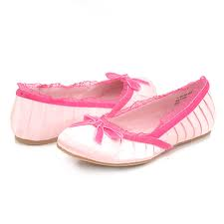
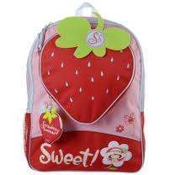
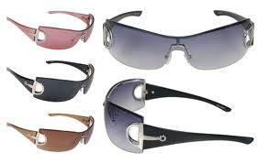

Clerk: can I help you .
Customer: Yes, I want ----------

