ANALYSING ERRORS COMMITTED BY IRAQI EFL UNIVERSITY LEARNERS IN USING CONJUNCTIVE ADJUNCTS IN TRANSLATION
A Research Drawn from M.A Thesis
Dr.Jassim M. Rayhan Shuruq Fakher Abdul-Zahra
Babyloon university
The analysis of the data has shown some considerable differences in the number of translation errors in types of conjunction relations. The results have indicated that the most difficult relation of conjunctive adjuncts to translate to the least difficult one are as follows: "temporal relation 26%", "adversative relation 34%", "continuative relation 38%", "additive relation 49%", and "causal relation 53%". However, it can be noticed that the temporal, adversative, and continuative types are more difficult to translate than the additive and causal ones. Thus the major findings of this study are: 1) Many errors are attributable to interference from Arabic than to other learning problems. 2) The most common errors in translation of conjunctive adjuncts are substitution, false application, and ignorance of English language rules.
CHAPTER ONE
INTRODUCTION
1. 1 The Problem
The present study is based on contrastive analysis and error analysis of conjunctive adjuncts (henceforth, CAs) (the additive, adversative, causal, temporal, and continuative) and the equivalent conjunctive constructions in English and Arabic.
Fraser (1999: 931) states that CAs are a class of lexical expressions drawn primarily from the syntactic classes of conjunctions, adverbs and prepositional phrases. With certain exceptions, they signal a relationship between the interpretation of the segment they introduce, S2, and the prior segment, S1. They have a core meaning which is procedural, not conceptual, and their more specific interpretation is 'negotiated' by context. People always use them to indicate pauses, transitions, or other aspects of communication when they are talking or writing. Statistics shows that they occur frequently, in both formal and informal English speech and writing. A good demand of using CAs not only helps people process their communication smoothly but also helps them achieve a cohesive force. In Arabic linguistics, Fareh (1998: 305) claims that CAs have been primarily investigated from a structural perspective. Arab grammarians have been concerned with classifying such particles (أدوات) into classes in accordance with their syntactic properties (ibid).
In Arabic, the CAs have not been given importance. Very few studies have been conducted on the analysis of CAs and the role they play in the interpretation of discourse (Hussein and Bukhari, 2009: 3). Hence, translating these conjunctives is not an easy task; it has been claimed to be one of the most difficult tasks
that bilingual translators encounter when attempting a professional rendition of a text (Fareh, 1998: 306).
The difficulties that Iraqi EFL university learners encounter in translating the CAs from English into Arabic may be ascribed to a number of causes. The fact that conjunctives do not have exact equivalents may contribute to this problem. This means that there is usually no one-to-one correspondence between conjunctives in both languages. This is due to the fact that these two languages are genetically unrelated. That is to say, English and Arabic belong to two different language families; while Arabic is a member of the Semitic language family, English belongs to the Indo-European language family. Furthermore, the multiplicity of functions of conjunctives creates significant difficulties for foreign language learners. This means that a conjunctive may signal various relations between sentences. For example, the conjunctive and may signal an additive function in a text as in:
-Every ring, every necklace, every little Chinese box-she had a passion for little boxes-had a name on it. And each had some memory for him.
(Woolf, 1980: 281)
-هذه الخواتم كلها, وهذه القلائد, وهذه العلب الصينية كلها - وما كان أشد ولعها بمثل هذه العلب- تحمل كل منها اسماً تركت له. وكل واحدة منها تحمل له ذكرى جميلة. (جبرا، 1955، 48)
The same conjunctive, however, marks off a conjunctive relation of causality. The following is another illustrative example:
-When it is proposed to me to meet some person distinguished above his fellow by his rank or his attainments, I seek for a civil excuse
that may enable me to avoid the honor; and when my friend Diego Torre suggested giving me an introduction to Santa Ana I declined.
(Maugham, 1951:351)
- عندما يقترح البعض علي أن أقابل امرأ يتميز عن أقرانه بمنزلته العليا أو بأعماله, فأنني أتلمس عذراً لطيفاً يتسنى لي به أن أتجنب التشرف بمعرفته. ولذا لما اقترح علي صديقي دييغو توري أن يعرفني على سانتانا رفضت اقتراحه.
(جبرا، 1955، 38)
A particular function of a conjunctive may also be realized by more than one conjunctive such as and then, and so, and yet, etc. which can express temporal, causal, adversative relations and can sometimes be ignored or avoided in translation.
Iraqi EFL learners need to be aware of the CAs and the sources of difficulty and the types of errors they make which affect the quality of translation and cause ambiguity and misunderstanding. This study is an attempt to fill in this gap.

1.2 Aims
The study aims at:
- Identifying and classifying the CAs errors in translation made by Iraqi EFL university learners.
- Finding out if those learners are aware of these errors in terms of type and frequency.
- Giving suggestions and solutions to learners' errors.
- Familiarizing the teachers of translation with the causes of these errors: internal difficulties or to external ones.
1.3 Hypotheses
It is hypothesized that:
- Iraqi EFL university learners' knowledge of CAs and their functions is very limited
- Many of these conjunctives are wrongly avoided or ignored in the learners' translations.
- The mistranslation of English conjunctives into their Arabic counter- parts is likely to lead to drastic changes in meaning or to unintended meanings.
1.4 Procedures
In order to achieve the aims of the present study, the following steps have to be followed:
- Investigating the concept of CAs in both English and Arabic languages.
- Proposing an analytical framework for the investigation of the CAs and their components.
- Conducting a test which aims at finding out learners' abilities in translating the CAs.
CHAPTER TWO
ENGLISH CONJUNCTIVE ADJUNCTS: THEORETICAL BACKGROUND
2.1 Preliminaries
This chapter aims at defining and discussing the concept of CAs, cohesion and coherence, presenting the adopted model that is to be used for the purpose of the analysis. Finally, it is also surveying some relevant studies that have dealt with CAs in English only, and both in English and Arabic.
2.2 The Concept of Conjunctive Adjuncts
The main cohesive category CA (conjunction) involves the use of formal markers to relate clauses, sentences and paragraphs to each other. Conjunction signals the way the writer wants the reader to relate what is about to be said to what has been said before.
A cursory look at the literature reveals that there are different views on the concept of CA. Words such as for example, however, hence, therefore, in other words, also, nevertheless, etc. are all connectives. They help to make the organization of descriptions clear to the reader. They have been called "thought connectives" because their function is to show the relationship between the thought expressed in one main clause or sentence and the thought expressed in the next main clause or sentence (Swales, 1971:129).
Connectives are words which express "relations between propositions of facts which are typically expressed by a set of expressions from various syntactic categories" (Dijk, 1977:52). To this set belong the connectives from the syntactic category of conjunctions, both coordinating and subordinating, e.g.: and, or, because, etc. Their function is to make (compound) and (complex) sentences from (simple) sentences. Another subset of connectives comes from the category of sentential adverbs, such as yet, nevertheless, etc. (ibid).
2.3 Cohesion and Coherence
Cohesion and Coherence are two important notions in discourse analysis. According to Bell (1991:164-5), coherence and cohesion are distinct from each other but share one crucial characteristic: both have the function of binding the text together by creating sequences of meanings. But it is the nature of the 'meaning' involved that they differ.
In this respect, Halliday and Hasan (1976: 4-6) consider cohesion as a relation sets up where "the INTERPRETATION of some element in the discourse is dependent on that of another. The one PRESUPOPSES the other, in the sense that it cannot be effectively decoded except by recourse to it." They (ibid: 26) maintain that "Cohesion does not concern what a text means; it concerns how the text is constructed as a semantic edifice". The semantic relations that make the text cohere are referred to as cohesive ties.
Hatim and Mason (1990: 195) believe that cohesion is one of the manifestations of coherence, stating that "the way in which this underlying coherence is reflected on the surface of the text - the cohesion, or sequential connectivity of the surface elements - are much more likely to be language -specific or text -specific".
For Baker (1992: 180), cohesion is a surface relation connecting together the actual words and expressions that we can see or hear.
Finch (2000: 210) regards coherence as a more important criterion for the identification of a text than cohesion. He goes so far as to decide that coherence can do without cohesion since the latter is used only for the purpose of giving the text its clarity.
2.4 The Adopted Model
In the present study, conjunction is investigated on one level: inter-sentential (non-structural). To account for the non -structural level, Halliday and Hasan's model of cohesion (1976) has been adopted.
It should be emphasized, however, that the reason behind selecting this model lies in the fact that it gives an account of aspects of contemporary English which would be both found on theory and applicable in practice. Halliday and Hasan's (1976) model of cohesion provides the treatment of the subject to the extent that their work has been considered as "the standard text in this area" (Brown and Yule, 1993:190). Further, it supplies an extended, often illuminating, discussion of the relationships indicated by conjunctives such as and, but, so and then - which relate what is about to be said to what has been said before - together with an extended taxonomy (ibid: 191).
This model is not followed literally, rather, it is liable to some modifications that the researcher has found it necessary in order to make the chapter of the analysis more practical. In the following section, the one level (non – structural) of the model will be discussed in detail.
In Halliday and Hasan's (ibid: 232-3) discussion of cohesion, a CAs has first position in the sentence which dominates the whole sentence, i.e. its meaning extends over the entire sentence, unless it is repudiated. The sentence extends from capital letter to full stop, or a terminator. However, there is some indeterminacy or perhaps flexibility of the English punctuation system, the sentence itself is very common to find CAs occurring in written English following a colon or semicolon.
Several attempts have made to set up a classification of the conjunctions in English. But all of them face the same difficulty each classification highlighted only different aspects of the facts. This is due to the broadness of the conjunction relations. Halliday and Hasan, in their model, have based their classification of the conjunctions in terms of their cohesive relations in discourse, which they claim, are capable of handling all the possible sub-categories.
Halliday and Hasan (ibid: 238) adopt a framework of just four major categories: additive, adversative, causal, and temporal. In addition, continuative as a minor category is discussed.
A representation of the analytical framework of the model adopted in the present study in discussing conjunction is given in the figure below:

Inter-sentential (Non – structural)

Cohesion

Conjunction

Additive Adversative Causal Temporal Continuative
Figure (1): The Analytical Framework of the Model Adopted from Halliday & Hasan (1976)
2.4.1. Additive
a According to Halliday and Hasan (1976: 234), the additive relation operates conjunctively between two sentences when the second sentence is preceded by conjunctive having a sense of adding new information to what has gone in the first sentence. The typical conjunctive and the most common one is and as in:
1. He heaved the rock aside with all his strength. And there in the recesses of a deep hollow lay a glittering heap of treasure.
2.4..2 Adversative
The basic meaning of adversative relation is "contrary to expectation". This relation takes the form of a contrast or a concession and can be realized by a number of conjunctives. Allerton (1979: 277) mentions that these conjunctives "show that the sentence has to be seen as detracting from what went before and thus either reducing the impact of the previous point or replacing it with a different one".
An adversative relation is expressed in its simple form by the words but, yet, though, only…etc. Beside these simple words, Hallidy and Hasan (1976: 250- 1) present other conjunctives such as however, instead, on the contrary, nevertheless, etc.
The main and the most frequently used item of this category is realized through the use of but as in:
All this time Tweedledee was trying his best to fold up the umbrella, with himself in it … But he couldn't quite succeed, and it ended in his rolling over, bundled up in the umbrella, with only his head out.
2.4.3 Causal
The relationship between two sentences can be causal, which according to Biber et al. (1999: 877)، show that "the second unit of discourse states the result or consequence of the preceding discourse". This category is commonly realized by the simple form so having the sense 'with the result' as in:
- She worked hard all day. So by night she finished everything.
Causal relation subsumes the specific relation of result, reason, and purpose (Halliday and Hasan, 1976: 256). These are not distinguished in the simple form of CAs. For instance, so in example (16) above means three different interpretations: 'as a result of this', ' for this reason' or 'for this purpose'. A prepositional phrase tends to remove ambiguity and make these relations clearer and more precise, i.e. distinct.
Comparable to so in this function is the resultative CA therefore. For example:
- It's always warm in Hawaii. Therefore, there is never snow there.
(Leech et al, 2001: 715)
2.4.4 Temporal
Temporal relationships can be marked by adverbials and prepositional phrases which function as CAs. In temporal relationship, the two sentences of the text cohere because of their successiveness within the scope of time. The repertoire of linkers that signal temporality is: then, meanwhile, at one time, at which moment, a moment later, by this time…etc.
2.4..5 Continuative
In this category of conjunction there are a number of individual items which do not express any particular one of the other four categories identified above. Halliday and Hasan (1976: 267) consider the category of continuatives as "a residual category of the usual 'miscellaneous' type".
In brief, the main four continuatives will be discussed: now, of course, well, after all.
- Now
Now as a continuative is not an adverb of time, but as a cohesive CA. This for Leech et al. (2001: 305) means "I am changing the subject, and returning to something I was thinking about before." A continuative now helps to achieve the necessary connection through its role in opening of a new stage in the communication (new incident in the story, a new point in the argument, etc.).
- Are you ready? Now when I tell you to jump, close your eyes and jump.

- Of Course
The continuative of course means that it has an assertive force for something that should have been known already as in the example below:
-They were going to come to the meeting. Of course they may have changed their minds.
- Well
This item is somehow different from the other continuatives in that it occurs at the beginning of a response in dialogue.
-Do I look very pale?' said Tweedledum, coming up to have his helmet tied on …'Well-yes-a little,' Alice replied gently.
Well in this example serves to indicate that what comes next is in fact a response to what has preceded.
- After all
The CA after all can be interpreted as: "after everything relevant has been considered, what remains is …" (Halliday and Hasan, 1976: 271).
- You needn't apologize. After all nobody could have known what would happen.
CHAPTER THREE
ARABIC CONJUNCTIVE ADJUNCTS
3.1 Preliminaries
The present chapter is devoted to discussing CAs in Arabic with the different sub-categories they encompass in the same order in which English CAs are discussed.
3.2 The Concept of Conjunctive Adjuncts
Arab grammarians usually refer to the CAs-according to their different significance-as (أدوات الإعراب) or (حروف العطف).
Beeston (1970: 95) defines conjunctive particles as "all words which are neither verbs, nor entity terms, nor nouns functioning adjectively, under the heading of al- huruf (functional)". He adds prepositions are included under this heading. Sometimes they are treated under the headings of (عطف نسق) 'conjunctive of sequence' and (عطف بيان) 'explicative apposition' (الغلاييني, 2004: 574-6). Furthermore, عزيز (1990: 202) refers to these conjunctive particles as 'ظروف الوصل'.
For most of the Arab grammarians, conjunctives are treated as linking devices, and their function is mainly to connect units such as words, phrases, clauses, sentences, etc. (Othman, 2004: 5). While old classical Arab grammarians were mainly interested only in (الإعراب), i.e. case or mood inflection, in their descriptions of the conjunctives. That is, they paid little attention to the discourse functions of these conjunctives and the role they play as text-building devices (Fareh, 1998: 305).
Ibn Jinni 1952 (cited in Hussein and Bukhari, 2009: 13) claims that there are three categories of linguistic expression in Standard Arabic: nouns, verbs, particles (al-huruf). He maintains that the linguistic expressions in third category do not have meaning in themselves, but rather get their meanings from the context they are used in. In other words, the particles in Standard Arabic have no semantics. The only way to interpret them is to look at the context in which they are used (ibid.).
أنيس (1966: 312) points out that the frequent use of conjunctives seems to be stylistic requirements in Arabic texts. This agrees with what Arab grammarians usually assert that Arabic is a syndetic language in which almost every sentence is linked to the preceding one with a conjunctive.
3.3 Cohesion and Coherence
A review of Arabic literature on cohesion shows that it is studied under different labels such as "التلاحم", "الاتساق" etc.; an area which reflects variation of opinion, disagreement on its nature and devices, and the lack of standard terminology.
Modern Arab linguists like Aziz (1985, 1998) and Abdul Hafiz (2004) rely heavily on English linguists for a definition of cohesion and do not even trouble themselves to provide cohesion with an Arabic term. Aziz (1985, 1998) applies Halliday and Hasan's (1976) criteria for analysing cohesion to texts but does add slight modifications to suit Arabic texts, Aziz (1985: 149) mentions eight major categories of devices in spoken Arabic texts: Reference,
Lexical Cohesion, Repetition, Question-Response, Ellipsis, Substitution, Conjunction and Parallel Cohesion. In a later study of cohesion, Aziz (1998: 78) discusses the major cohesive devices in English and Arabic, contrasts these devices and discusses their implications for translation of these two languages. Aziz believes that "All the four main types of cohesive devices, Reference, Ellipsis and Substitution, Conjunction and Lexical Cohesion are used in Arabic. The main difference is in the sub-types and fine details" (ibid: 91). He, then, adopts Halliday and Hasan's (1976) taxonomy of cohesion and merely applies it to Arabic texts. Abdul Hafiz (2004:1) also adopts Halliday and Hasan's (1976) definition and taxonomy of cohesion in general. Actually, cohesion in Arabic is not accorded sufficient attention nor studied comprehensively by modern Arab linguists.
خطابي (1988) proves to be an exception. خطابي delves deeper into the realms of cohesion in Arabic and gives it the Arabic term "الاتساق". He tries strongly to highlight the role of the early Arab linguists and rhetoricians concerning this conception. For خطابي, cohesion is defined as follows: By cohesion is normally meant that close sticking together of the parts constituting a text/ discourse and where the focus is on linguistic formal techniques that tie the elements making up part of, or an entire, discourse (ibid: 5). For خطابي cohesion markers are tools that play an important role in keeping the text a compact whole. However, he does acknowledge that some texts do exist without cohesion (ibid.).
خطابي terms coherence "الانسجام" in Arabic and considers it as more general and profound than "الاتساق". Although he adopts Halliday and Hasan's (1976) model of cohesion and its taxonomy, he does not fall into the overlap of cohesion-coherence. He (1988: 6) maintains that cohesion does not occur in a vacuum because it takes the text processor into account. He is in line with the belief that cohesion is the result not the reason for coherence. He also says cohesion cannot be the sole decisive factor in judging whether or not a certain linguistic work is a text (ibid: 232). He adds that a reader does not base his judgment of a given linguistic work whether it is a text or not on the degree of its cohesion. We may come across non-cohesive discourses but deal with them as coherent (ibid: 237).
3.4 Explicit Conjunctive Adjuncts
The aspect of connectivity, again, involves the cohesive relation of CA (conjunction) whereby sentences are connected to each other by means of a number of items representing different semantic relations.
Connectivity in Arabic is felt to be related to different notions in the literature. To begin with, the notion of connectivity is related to the notion of explicit connectivity (الوصل) in the theory of explicit and implicit connectivity (الوصل والفصل) initiated by الجرجاني (1969: 230-50). Rhetoricians following him present this theory briefly. القزويني (n.d.: 147), for example, defines explicit connectivity (الوصل) as the way in which clauses are linked by the use of a conjunctive particle, especially و(wa), while implicit connectivity (الفصل) is defined as the way in which clauses are linked without a conjunctive particle. It is pertinent here to refer to the realization of the notion of clause in Arabic. The notion of clause in Arabic is equivalent to (الجملة), which consists of a subject (المسند) and a predicate (المسند اليه) (السامرائي, 1998:5-3).
3.5 Inter-sentential Conjunctive Adjuncts
Most of modern scholars believe that Arabic is characterized by the extensive use of conjunctive particles. Almost two sentences in Arabic are related by means of a certain type of conjunctive relation. In the following sections, most of the semantic relationships discussed concerning English CAs have the same order in Arabic.
3.5.1 Additive
A mere look at Arabic texts, shows that additive relation is a very common relation of conjunction in these texts which are loaded with the conjunctive particle و(wa) as a cohesive marker of additive, i.e. the sentence it introduces is related to what has gone.
Holes (1995: 217) notes that وis the most commonly encountered sentence-connective and has the widest variety of uses, analogous in these aspects to English and. Unlike English and, however, وregularly functions as a textual, as well as a sentence-connective (ibid.).
Regarding the use of وand ف, Wright (1974: 330) asserts that the Arabs often connect single verbs and entire sentences with one another merely by means of the particles وand ف …They use و… where we would prefer a disjunctive or adversative; as in Qur'anic verse الله يعلم وانتم لا تعلمون 'God knows, but you do not know' (ibid.). In such cases, however, وhas in reality only a copulative force; the adversative relation lies in the nature of the two clauses themselves. Wright also notes that وin Arabic, like its equivalents in other Semitic languages, connects two clauses, the second of which describes either the state or condition of an element either the subject or one of its complements of the first clause, or else of a new subject.
Another type of وexists in Arabic and is called by Arab grammarians waw of comitative (واو المعية), or (واو الجمع), or (واو المصاحبة), all of which mean the waw of simultaneousness actions, and explain by مع أنْ (ibid.). This type of وis used according to Wright "when the governed verb expresses an act subordinate to, but simultaneous with, the act expressed by the previous clause"; as in:
- لا تَنْهَ عن خُلقٍ وتأتي مثلهُ
-Do not restrain (others) from any habit, whilst you yourself practise one like it. (ibid: 32-3)
Another usage of the conjunctive particle وis when it is used to link two nouns; in this case it is known as (واو اللزوم), i.e. waw of adherence, if the two nouns belong necessarily together:
- كلُ انسانٍ وهمهُ
-Every man has his own care. (ibid: 84)
Here, وis not regarded here as a cohesive device because it is used to link phrases in a structural sense similar to the structural and in English. Unlike the English structural and however this use of the conjunctive particle وhas no additive either. Rather, the function may be rhetorical (ibid.).
The additive conjunctive وcan present sentences that are linked by other cohesive relations; it may express one of the following relations:
- Adversative Relations
The conjunctive particle وis used in Arabic to express an adversative relation between clauses it connects. Cantarino (1975:18) in this context writes that the two sentences connected by the conjunctive particle وmay be, and in fact frequently are, in an adversative relationship, such as but, yet especially when one of the statements is negative. This is presented as follows:
- كأنها في المدينة وليست منها
-As if she was in the city, yet out of it.
- أنكِ اليوم تجهلين وغداً تعلمين
-You do not know today, but you will tomorrow.
- Temporal Relations
The conjunctive وcan be used to express temporal relations between the clauses that it connects, i.e. it links successive episodes in a narrative, as in:
- ابتاعوا الإناء وأخذوا مهروس البلح وألقوه في الإناء وطبخوه....
(The researcher's translation)
-They bought out the pot wa took the mashed dates wa threw them into the middle of the pot wa mashed them… (Holes, 1995: 218)
Here, the conjunctive particle وis used to signal the successive relation between the four clauses.
c) Condition Relations
The conjunctive particle wa can be used to express conditional relations when the first clause is a condition of the second clause:
- ساعدني وسأكافئكَ
- Help me and I will reward you (Fareh, 1998: 307)
Quirk et al. (1985: 931) state that this function is usually associated with threats and promises.
The other semantic relation incorporated within the main category of additive inter-sentential conjunction is that of exemplification realized by the use of the particles على سبيل المثال, مثلا، corresponding to English exemplification item for instance/ example as in:
مـن المعلوم أن الفواكه مصدر أساسي للفيتامينات الضرورية للجسم. ودائما ما ينصح الأطباء بتناول الفواكه بشكل مستمر ومن نعم الله على عباده إن هذا المصدر متوفر طوال العام فعلى سبيل المثال نجد إن البرتقال والتفاح متوفران في الأسواق بشكل مستمر وهي من الفواكه الغنية بالفيتامينات الضـرورية للجسم.
- As known, fruits are an essential source of vitamins that are necessary for human. Doctors always recommend eating fruits. The existence of this source over the year is one of the God's merciful. For example, you can find orange and apples in the shops in all over the year and they contain useful vitamins for the bodies. (Mathkour et al., 2008: 717)
In this example, the conjunctive particle المثال على سبيل/ for example is related to all units that came before it.
3.5.2 Adversative
The prototypical adversative conjunction in Arabic is لكِنّ. Both لكِنّ and لكِنْ, which is another version of لكِنّ, are said to denote the general meaning of contrast. This relation and the relation concession might correspond to an Arabic relation that may be called by Arab grammarians retraction (استدراك) (ibid: 716). In Arabic, there are number of conjunctive particles having this sense as بالأحرى, بل …etc., e.g.
- كانت كسولة بل غبية
- She is lazy; or rather stupid. (عزيز, 1990: 207)
The difference between the two particles لكِنّ and لكِنْ is highlighted by various linguists. Cantarino (1975), for example,
notes that Arab grammarians consider the particle لكِنّ as the basic form, whereas لكِنْ is seen to be a/ the lightened form derived from it.
Some linguists like Cantarino (1975) and others do not consider the adversative item لكِنّ and its lighter form لكِنْ as conjunctive particles as they cannot stand by themselves, i.e. they require one of the properly conjunctive particles وor ف to precede them. In this context, Cantarino (ibid: 45) writes:
Lakina actually precedes the sentence without having any ties which might structurally connect the particle with the sentence. Hence, Arabic may use this particle to introduce clauses in an adversative relationship to the preceding situation or statement even in cases when the subordinate precedes the main clause. In the instance, the main clause is introduced by the conjunctive fa or, at times, also by wa.
Nevertheless, it must be pointed out that the adversative relationship is sometimes obscured by the use of the additive item وin place of an adversative item. A case in point is a suggestion put forward by Cantarino (1975: 39) who notes that only the adversative meaning of the two propositions will reveal the actual nature of the construction.
A number of conjunctives having the sense of contrariness are used in Arabic to indicate adversative relations between sentences like على العكس من ذلك, عوضا عن ذلك, ف, على النقيض من ذلك … etc., e.g.
- . فـتزوج من أمرأة غريبة أراد أبوه أن يزوجه من أبنة عمه
- His father wanted him to marry his cousin. He married a stranger instead. (عزيز, 1990: 208)
3.5.3 Causal
Arabic causal relations are expressed via a number of conjunctive particles. The main member of this category is the particle ف. The conjunctive particle ف is regarded by Arab grammarians as a signal of causality between clauses where the first clause implies a reason and the second a result. The function of ف as a signal of causal is highlighted by Cantarino (1975: 23-4) who notes:
fa implies an internal-and logical-relationship between the two coordinate sentences. It may refer back to the preceding statement as a necessary premise for the action of the second. It may also unite two sentences hat have a causal relationship pointing toward the effect, or fact, and its consequences.
In another context, Cantarino (ibid.) points out that ف may also be used to introduce an action which is intended as the aim of a previous action, or which is the logical result of an action designed to achieve such a consequence.
A similar point of view is upheld by Beeston (1968: 56) who states that the mind may progress from a cause to its effect and in this case ف corresponds to English so as in:
- لقد ادليتَ بحجة قاضية لهذا فـسأعتقدها
- You have adduced a decisive argument for this, so I will believe it.
Alternatively, ف may signal the reverse of the above, i.e. "the mind can proceed from a phenomenon to a consideration of its cause or justificatory generalization, and in this case fa corresponds to English for" as in:
- قد أخطأت, فـالخطأ أنساني
-You have erred, for to err is human. (ibid.)
Arabic comprises a number of conjunctive particles signalizing a causal relationship besides ف. Some correspond to ف in its first function, namely, that of indicating a cause or an explanation such as ذلك أن, لأن while others correspond to ف in its second function, as entailing a sequence and/ or result as بذلك, هكذا, بهذا, لهذا.

Chapter Four
The Test
The test adopted in this study aims at identifying the major problems that Iraqi EFL university learners of English may encounter when translating English texts containing CAs into their Arabic counterparts.
4.1 Description of the Test
The study attempts the descriptive analytical approach which describes the errors that Iraqi EFL university learners make when they translate such texts. Accordingly, the proposed test is composed of twenty items. These items are classified into five types. Almost each type aims at testing a different sort of conjunctive relation and how to be translated into Arabic.
In addition, the features of validity, reliability, economic, scoring, and administration are all taken into consideration as criteria of a good test.
4.2 The Sample
The data for this study are collected from testing one hundred learners chosen from the fourth - year (2008 – 2009) of the Department of English at the College of Education, University of Babylon. All the learners are native speakers of Arabic. All of them are graduated from public schools, which means that they have studied English as a foreign language for about 8 years before joining the university.
4.3 Data Elicitation Procedure
The data analyzed in this study are collected through a diagnostic test on translation task that is specifically designed for the purpose of this study.
The learners are asked to translate twenty items from English into Arabic. Most of the items are extracted from several literary texts and some other grammar references. These literary texts are surveyed in order to identify the discourse functions of CAs. Maclean and Chapman 1989 (cited in Al-Jarf 2001) state that a factor that affects cohesion comprehension is the type of text that learners read. Both good and poor readers found it easier to perceive cohesion in fiction than in non-fiction, and good readers were able to maintain the global unity of the text better than poor readers.
Furthermore, most of the CAs of the test are selected on the basis of their familiarity and practicality to the learners.
The items used in the test are borrowed from the following references:
- Aronson (1984). English Grammar Digest.
- Hemingway (1974). The Old Man and the Sea.
- Lodge (1975). Changing Places.
- MaCarthy and O'Dell (2001). English Vocabulary in Use.
- Maugham (1951). The Poet.
- Woolf (1980). The Legacy.
The reason behind choosing the texts from these books is that their English is simple, clear, and objective. Moreover, the learners are familiar with such type of texts such as The Old Man and the Sea which is considered as part of their syllabus at the second year and most items of the test are extracted from it.
The learners are given enough time to perform the translation task in both the pilot and the final administrations of the test. They are also allowed to use bilingual dictionaries.
In the correction of the translation test, the researcher focuses only on the translation of the target conjunctives, ignoring all other types of grammatical or lexical errors since they are beyond the focus of the study.
The translation task consists of twenty items (see Appendix A) representing five types of CAs i.e. additive, adversative, causal, temporal, and continuative relations. Most of the functions of the CAs are selected on the basis of frequency and practicality. Table (2) illustrates the distribution of the types of CAs and the number of items in the translation test that represent each type:

Type of CA | No. of Items | Item No. in Translation Test
Additive | 4 | 1, 6, 11, 16
Adversative | 5 | 3, 7, 12, 15, 20
Causal | 4 | 2, 4, 8, 18
Temporal | 5 | 5, 9, 13, 14, 17
continuative | 2 | 10, 19
Total | 20
Table (2): Distribution of the CAs Types and the Number of Items in
English Data
4.5 Scoring Scheme
For the purpose of objectivity and reliability of the test, an accurate scoring scheme has been adopted. The whole test has been scored out of 100. Each correct response has been given one mark and zero for the incorrect one. The items that are left with no answer have also been given zero.

CHAPTER FIVE
RESULTS AND DISCUSSIONS
5.1 Preliminaries
In this chapter, the researcher aims at discussing the results in relation to giving interpretations of these results and analyzing them.
5.2 Results and Discussions
Five functions of CAs were represented in the translation test. These functions were manifested in 20 items. Most of the items were extracted from larger texts, which are not included in the appendix for the sake of economy and practicality.
The functions of Arabic CAs were determined by two scholars who are specialists in Arabic to confirm the possible translations of the items of the test. Most of these translations were taken from translated texts by جبرا (1955), البعلبكي (1977), and عزيز (1990), with the help of another scholar who is a specialist in translation (see Appendix B).
The researcher has adopted semantic accuracy in judging fact that semantic accuracy is not by any means the only consideration that should be taken into account in determining the acceptability of a translation. Dickens et al. (2002: 228-30) draw the attention to the notion of strategic prioritizing in translation in which devising a translation strategy includes "prioritizing the cultural, formal, semantic, stylistic, and genre-related properties of the Source Text (henceforth, ST").
In the light of the statistical results, Table (3) shows the number of the items, CAs, percentage and rank order of difficulty of all possible Conjunctive Responses (henceforth, CRs).
Item's No. | CAs | % CRs | RD
1 | for instance | 48 | 12
2 | Hence | 50 | 14
3 | on the contrary | 25 | 8
4 | Therefore | 62 | 16
5 | Meanwhile | 2 | 2
6 | And | 81 | 19
7 | But | 82 | 20
8 | So | 72 | 17
9 | Then | 30 | 11
10 | of course | 76 | 18
11 | in other words | 49 | 13
12 | However | 27 | 10
13 | at which moment | 26 | 9
14 | at last | 53 | 15
15 | by contrast | 12 | 3
16 | As | 16 | 4
17 | Now | 23 | 7
18 | Accordingly | 22 | 6
19 | after all | 0 | 1
20 | Yet | 21 | 5
Table (3): Distribution of the CAs, the percentage of CRs and Rank Difficulty (henceforth, RD) in the Data
The table above shows that item number (19) is the most difficult, since all the responses are incorrect, i.e. 0%; whereas item
number (7) is the least difficult one, as 82% of the responses are correct.
The above table can be represented graphically which embodies a much greater visual impact as it comprises the responses for CAs scores.

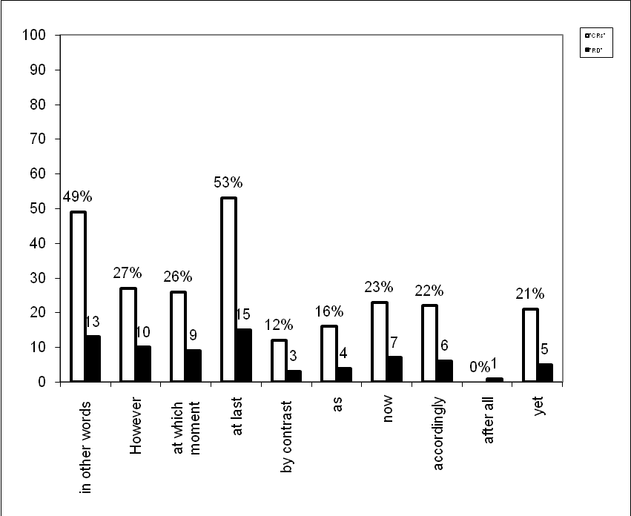
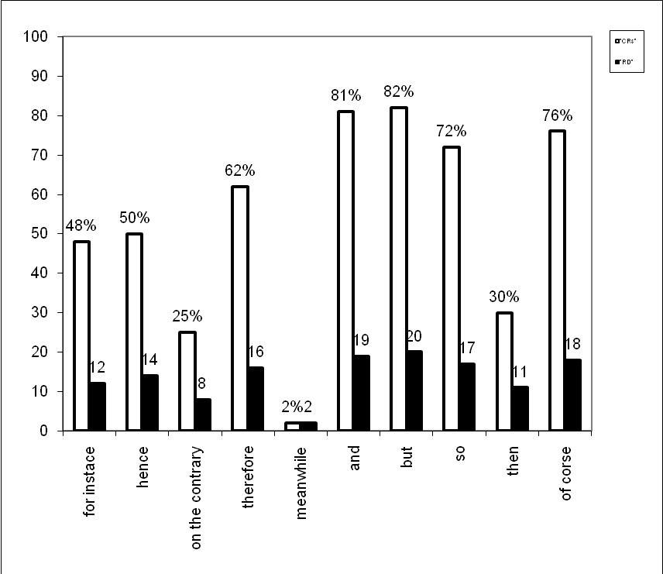

Figure (1): Learners' Performance of the Individual CAs, CRs, and RD in the Data
This is a histogram in which the pillar (bars) represent values of CRs and the RD made by the learners. The light pillars stand for the CRs while the dark pillars represent the RD. It also shows how individual CAs are viewed by the learners.
As the translation test consists of 20 items and is given to 100 learners, we would expect to have a total of 2000 translated items. Table (4) shows the type of CAs, No. of items, No. of Expected Responses (henceforth, ERs), No. of CRs, percentage of CRs, and rank order of difficulty:
No. | Type of CAs | No. of Items | No. of ERs | No. of CRs | % of CRs | RD
1 | Additive | 4 | 400 | 194 | 49 | 4
2 | Adversative | 5 | 500 | 167 | 34 | 2
3 | Causal | 4 | 400 | 209 | 53 | 5
4 | Temporal | 5 | 500 | 134 | 26 | 1
5 | Continuative | 2 | 200 | 76 | 38 | 3
Total |  | 20 | 2000 | 790 | 40 | -
Table (4): Distribution of the CAs Types, No. of items, No. of ERs, No. of CRs, percentage of CRs, and RD in the Data
It also indicates that the translation of English CAs into Arabic is rather difficult. The percentage of correctly translated items is 40. This means that less than two thirds, i.e. 60% of the learners have translated the items incorrectly. Besides, the table shows that the most difficult types are ordered according to the hierarchy of difficulty, from the most difficult CAs to the least difficult ones. CAs of temporal relation occupies the first rank of difficulty with a percentage of 26. The second rank of difficulty is the CAs of adversative relation with a percentage of 34. CAs of continuative
relation occupies the third rank on the hierarchy of difficulty with a percentage of 38. CAs of additive relation occupies the fourth most difficult type with a percentage of 49. The least difficult type which occupies the fifth rank on the hierarchy of difficulty with a percentage of 53 is the CAs of causal relation.
Figure (2) below represents the statistical examination of the data appeared in Table (3). The different pillars reveal the standard of five relations of CAs tested and their RD. These pillars illustrate which of these relations are more successful in translating CAs and when have more difficulty.
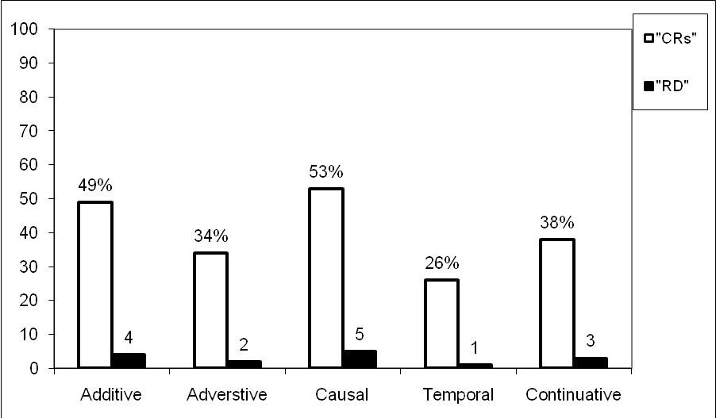

v

Figure (2): Learners' Performance of the Five Relations of CAs, CRs, and RD in the Data
A conclusion one might make is that four of these five types are almost alike in their failure to get the desired scores.
Table (5) shows the CAs and the percentage of Incorrect Responses (henceforth, IRs),Avoided Responses (henceforth, ARs), and the total responses in each item of the test:
Item's No. | CAs | % IRs | % ARs | Total
1 | for instance | 45 | 7 | 52
2 | Hence | 36 | 14 | 50
3 | on the contrary | 58 | 17 | 75
4 | Therefore | 20 | 18 | 38
5 | Meanwhile | 72 | 26 | 98
6 | And | 8 | 11 | 19
7 | But | 7 | 11 | 18
8 | So | 9 | 19 | 28
9 | Then | 58 | 12 | 70
10 | of course | 17 | 7 | 24
11 | in other words | 43 | 8 | 51
12 | However | 64 | 9 | 73
13 | at which moment | 62 | 12 | 74
14 | at last | 38 | 9 | 47
15 | by contrast | 71 | 17 | 88
16 | As | 27 | 57 | 84
17 | Now | 39 | 38 | 77
18 | Accordingly | 54 | 24 | 78
19 | after all | 0 | 100 | 100
20 | Yet | 60 | 19 | 79
Table (5): Distribution of the CAs and the percentage of IRs، ARs and the Total in Each Item of the Test in the Data
The table above indicates that item number (19) is the most difficult, as 100% of the responses are incorrect whereas item number (7) is the least difficult one, as 7% of the responses are incorrect.
It also shows that item number (19) is the most difficult, as 100% of the responses are avoided and items number (1) and (10) are the least difficult ones, as 7% of both items of the responses are avoided.
Figure (3) below illustrates the values of the data appeared in Table (4). It gives the values of IRs and ARs, and the total of the individual CAs. The light pillars stand for the IRs, the dark pillars signify the ARs, and the dotted pillars represent the total of the individual CAs in the data. A glance at this histogram shows the difficulty the learners had when dealing with such type of test.

Figure (3): Learners' IRs, ARs, and the Total of the Individual CAs in the Data
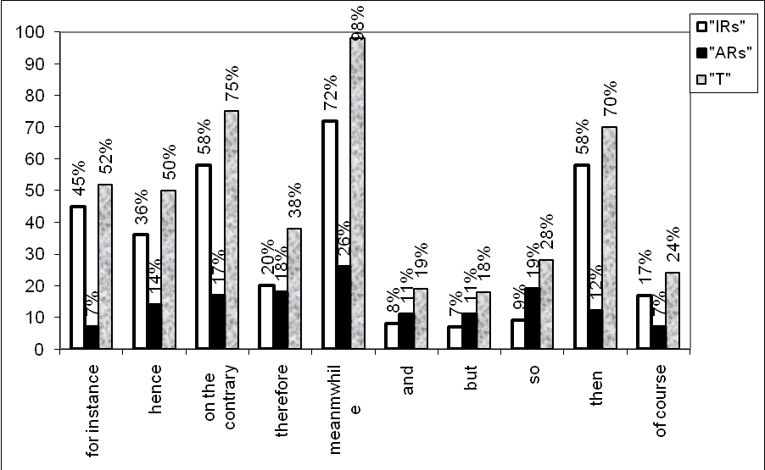
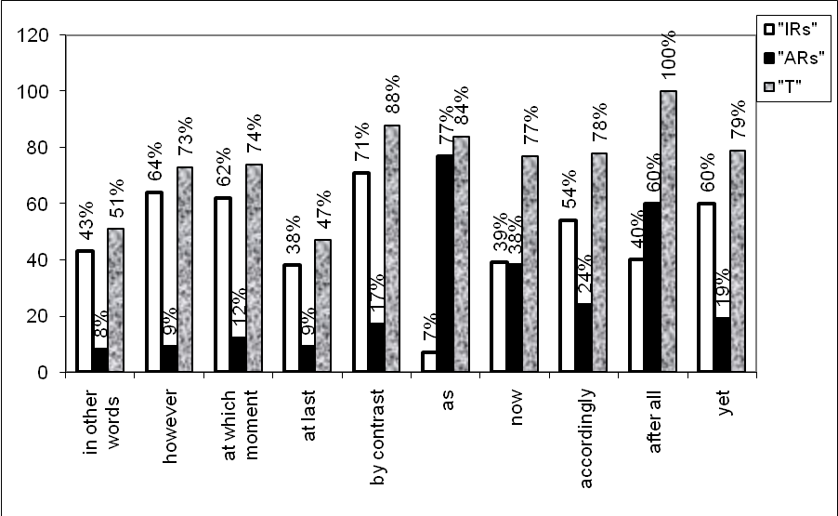
Table (6) below shows the number and percentage of incorrect, avoided, and total number of responses of the whole items of the test:
No. of IRs | % No. of IRs | ARs | % ARs | TRs | % Total
775 | 39 | 445 | 21 | 1220 | 60
Table (6): Distribution of the No. and percentage of IRs, ARs, and
the TRs of the Whole Test in the Data
Table (6) reveals that the number of IRs is (775) and the percentage is 39. It also presents that the number of ARs is (445) and the percentage is 21.Scharchter (1974:65) claims that learners have a tendency to avoid Target Language (henceforth, TL) items which they are not sure of, and so not to commit errors they would be expected to commit. She concludes that learners resort to avoidance if they find a structure difficult. Moreover, the table shows that the total number of incorrect and avoided responses is (1220) and the percentage is 60.
Figure (4) demonstrates the values of the data appeared in table (5). It gives a clearer picture of the percentages of IRs, ARs, and the TRs elicited from the translation test. It also shows that the pillars which correspond to the IRs and ARs scored high in the data.

Figure (4): Learners' IRs, ARs, and the Total of These CAs in the Data
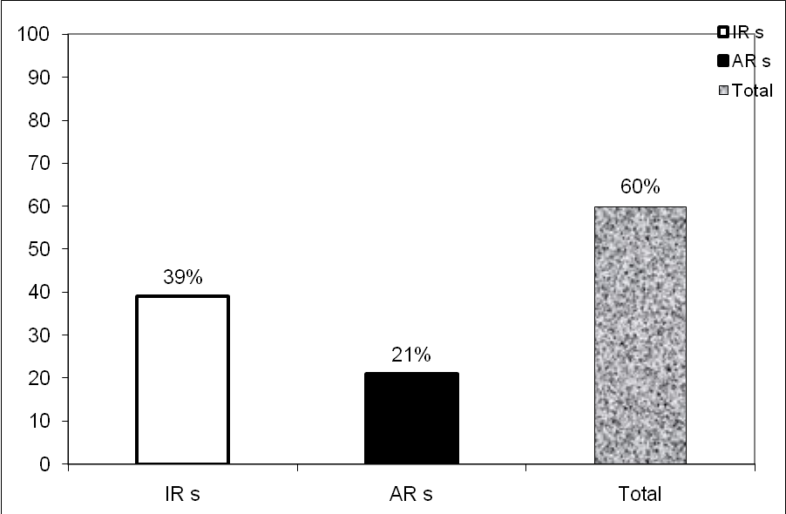

In what follows, the difficulties encountered in translating each type of the test, i.e. additive, adversative, causal, temporal, and finally the continuative will be discussed and illustrated in more detail. The English Conjunctive Item (henceforth, CI) will be presented followed by an acceptable translation into Arabic. Illustrative examples of faulty translations will also be provided. It should be noted here that the learners' renderings of the translation task are cited as they have exactly appeared in their versions; hence any error whatsoever is retained.
The functions of CAs will be discussed in order of rank of difficulty from the most difficult CAs to translate to the least difficult ones. It may be worth stating, at the outset, that only the items that are erroneously translated at least eight times will be referred to in the discussion. Errors in translation influence the quality of the final product and the degree of miscomprehension by the reader. Accordingly, translation errors are often based on their importance and frequency [Albir 1995 cited in (Waddington, 2001:33)].
5.3 Responses to the Temporal Relation
Table (2) (p. 28) above shows that this type occupies the first rank in the hierarchy of difficulty. It is represented by 5 items, i.e. 25% of the whole test. Table (6) gives a summary of the distribution of the number of item, CAs, percentage of the CRs, and RD of this category as represented in the data:
Item's No. | CAs | % CRs | RD
5 | Meanwhile | 2 | 1
9 | Then | 30 | 4
13 | at which moment | 26 | 3
14 | at last | 53 | 5
17 | Now | 23 | 2
Total | 5 | 26 | -

Table (6): Distribution of the CAs, Percentage of CRs, and RD of the Temporal Relation in the Data
Figure (5) below displays the CRs and RD of temporal relation appeared in Table (6) in which the CI meanwhile scored the lowest among the other CAs whereas at last scored the highest one. The conjunctive now scored the second lowest CI while at which moment scored the third lowest one. Finally, then scored the fourth lowest CI in this category.
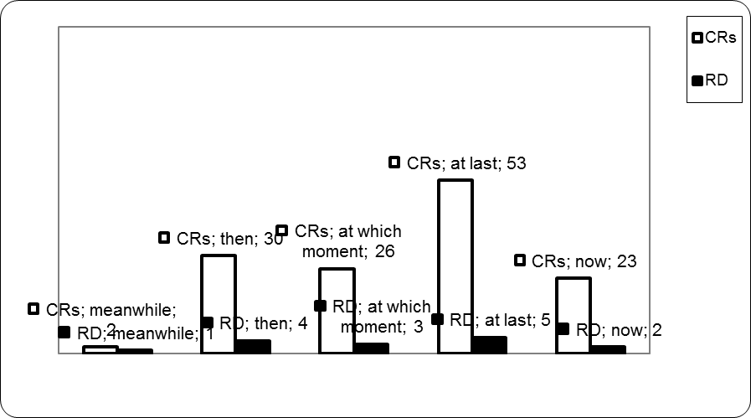

Figure (5): Learners' CRs and RD of Temporal Relation in the Data
Table (6) shows that the conjunctive meanwhile is the most difficult to translate. Table (3) (p. 30) shows that the percentage of the correct responses is only 2. The analysis of the data reveals that 72% of the learners have erroneously translated this item. Furthermore, they have not clearly identified the function of the CI in the Source Language (henceforth, SL), so 26% avoided translating it. The sum of the incorrect and the avoided responses is 98%.
In this item, the conjunctive meanwhile is used to indicate that sentences, or more exactly events described in such sentences, are stated as taking place at the same time. Simultaneity is again implied through the use of this CI which further conveys the notion of duration. The possible translations of this conjunctive include في غضون ذلك, في تلك الأثناء، عندها, حينئذ, في نفس الوقت. The possible translation of the English text containing this conjunctive includes:
انه لا يذكر الا أنجلا وهي تقص عليه الخبر. وقد انزعجت أنجلا بما لديها من مقدرة فائقة على العطف, انزعاجا كثيرا. حينئذ نهضت سيسي ميلر.
The learners inappropriately have used بينما, عندما, بعد فترة, وللحظة, بعد لحظات, بعد ذلك, بعدها … etc. The following examples are from the learners' incorrect responses:
*هو يستطيع ان يتذكر فقط قول انجيلا, انجيلا مع موهبة العطف, واضطراب رهيب بينما سيسي ميلر برزت
*استطاع تذكر فقط انجيلا تقول له: انجيلا فائقة في العطف لكنها مستاءة بكثرة وللحظة ظهرت سيسي ميل
*يمكن ان يتذكر انجلا تقول له, انجلا بعاطفتها الفائقة وكانت منزعجة بصورة واضحة. بعد فترة ظهرت سيسي ميلر
* استطاع ان يتذكر انجلا ما اخبرته, انجلا بحنانها الفائق. بعد ذلك اشرقت سيزي ميلر
It has been observed that most of the learners have introduced this CI either subordinators of time like when, while etc. or sequential temporal relation as after awhile, then, next and so on. Moreover, many of them failed to identify the category of this conjunctive by using the conjunctive of adversative relation but. The faulty translations can be ascribed to the fact that the learners have not captured the meaning of the CI and to the incomplete mastery of rules of Target Language Text (henceforth, TLT).
The second most difficult CI is now. The analysis of the data shows that the percentage of correct answers is 23. 39% of the learners erroneously translate it. They also have not clearly identified the function of CI in the Source Language Text (henceforth, SLT) in which 38% of them avoided translating it. Thus, the sum of incorrect and avoided answers is 77%. The acceptable translations include the use of في تلك اللحظة, في هذه اللحظة. The acceptable meaning of the English text containing this CI includes:
وتطلبت سمكة ما خيطا يزيد طوله على ثلاثمائة قامة. وفي تلك اللحظة راقب العجوز وضع العيدان الثلاثة من فوق جانب القارب.
The learners wrongly use الآن, والآن, و, ف to translate this CI. The following examples are from the learners' answers:
*السمكة تستطيع ان تأخذ ثلاثة خيوط. الآن الانسان يشاهد عددا منها
*كان بامكان السمكة ان تجر الحبل الذي طوله ثلاثمائة متر. والآن شاهد الرجل السمكة على جانب القارب
*السمكة يمكن ان تسحب اكثر من ثلاثمائة قامة من الطول والرجل شاهد العمق لثلاث عصي على جانب القارب
*طول السمكة يصل ما يقارب ثلاث مئة من الخط فـالرجل شاهد الغطس ثلاث خطوط من جانب القارب
Such faulty translations can be attributed to the fact that most of the learners have regarded the item 'now' as an adverb of time instead of discourse element which is used to connect two main clauses or sentences logically. According to Aijmer [2002 cited in (Cesare, 2003: 67)], if 'now' is a separate tone unit, it functions as a discourse element rather than a temporal adverb. She adds discourse particles are "polysemous items whose meanings can be related to each other in a motivated way, for example as extensions from a prototype". Many of them also map this conjunctive to another different type as the additive relation and.
In addition, these can be attributed to the fact that the learners do not understand the connotative or emotive meaning aimed at in the original text as shown in their poor translations to this item.
The conjunctive at which moment is the third most difficult item in this type. The percentage of correct responses is 26. The erroneous responses are 62%. The avoided responses are 12%. The sum of the erroneous and the avoided responses is 74%.
Here, at which moment also expresses a simultaneous relation between two events described as being accomplished immediately. It, therefore, expresses simultaneity by virtue of the immediate specification which it implies. The possible translations of the conjunctive particle include في تلك اللحظة, في هذه اللحظة. The possible translation of this item includes:
وكان موريس يفكر في الجو المحزن وغير الموثوق به, وفي تلك اللحظة سمع قرعا على الباب.
The learners unsuitably use في لحظة, عند لحظة, بلحظة, في أي لحظة, إن تلك.اللحظة, للحظة
It has been noticed that the learners failed to identify the function of the sentence in the SL and literally translated it without conveying the sense of the original one such as the temporal expressions in (at) a moment, at any moment etc. The following are illustrative examples from the wrong responses:
*الطقس شيء غير موثوق ومحزن, موريس فكر. في أي لحظة هنالك من يطرق بابه
*الجو محزن وغير موثوق في اللحظة التي طرقت الباب
*فكر موريس ان الجو محزن وغير موثوق به وفي لحظة كان هناك نقر على الباب
*جو محزن غير موثوق به حقيقة اعتقد موريس عند لحظة ما سيطرق الباب
By examining the faulty translations, it can be concluded that most learners translate the item literally in a form of prepositional phrase (prep. + noun). This error is due to the incomplete mastery of temporal constructions in English which begin with prepositions. Besides, following literal translation rather than the equivalent structures in both English and Arabic languages is a main cause of this kind of errors.
The CI then is the fourth difficult to translate. The percentage of the correct answers is 30. 58% of the learners fail completely to answer it appropriately. The avoided responses are 12%. The sum of the incorrect and the avoided responses is 70%.
The possible meaning of this CI is ثـم. The possible Arabic meaning of this item comprises:
وانتزع الشيخ الشص من فم السمكة, وطعَم الخيط. ثـم اتخذ سبيله, وئيدا وئيدا, الى مقدم القارب.
The analysis of the translation data reveals that a large number of the learners who answered this item incorrectly are completely unaware of the CI's function. It is shown that they map the source CI into a different type in the TL. In other words, the translated text and original text are different types as the additive and causal relations.
The learners inappropriately use وand لذلك. It might be mentioned at this point that وlike ثم signal temporal between sentences in some situations (see 3.5.1). In sequential function, Hussein and Bukhari (2009: 12) assert that ثم encodes a long-time span temporal sense; whereas وdoes not necessarily imply the sequential occurrence of events, i.e. happening one after the other without unusual interpretation.
Therefore, translating then in the SL into وdoes not precisely denote the meaning of ثـم in the TL texts as in the following examples:
*انتزع الرجل العجوز السمك, طعَم الخيط. وبدأ عمله ببطيء الى وراء مقدم القارب
*انتزع الرجل الشص وطعَم الخيط ورجع الى مقدم القارب ببطء
They also shift the state type to a causal type to indicate the notion of the cause and effect relationships of the first sentence and the conjunctive one. The following are illustrative examples from the learners' erroneous responses:
*الرجل الكبير انتزع الشص من السمكة, وطعَم الخيط. لـذلك هو عمل بطريقة بطيئة للرجوع الى مقدم القارب
*الرجل العجوز انتزع السمكة من الشص, وطعَم الخيط. لـذلك تراجع ببطيء الى مقدم القارب
Other learners make translations like بعد ذلك, بعدهـا which can express a sequential temporal relation in a manner similar to their English counterparts after that and next.
The erroneous translations can be attributed to both lack of understanding of the original text and the intra-lingual impact of the TL, i.e. treating then as and or therefore. Richards (1974: 3-18) states that one of the causes of intra-lingual errors is due to the semantic errors such as building false concepts/ systems, i.e. faulty comprehension of distinctions in the TL.
The least difficult CI of this relation is at last. The analysis of the data shows that the percentage of the correct answers is 53. The incorrect answers are 38%. The avoided responses are 9%. The sum of the erroneous and the avoided answers was 47%.
The acceptable translation of this CI is.أخيراً A large number of the learners use في النهاية which can express a conclusive temporal relation in a way similar to its English counterpart finally. At last and finally have the same meanings. They have the idea that someone has waited for a long time (Kouyu, 2008:15). The acceptable translation of this item includes:
لم يجب على الجرس أحد مع انني سمعته يدق داخل المنزل, ولذا سحبته مرة أخرى, ومرة ثالثة. وأخيراً جاءت الى الباب عجوز لها شارب كثيف.
Again, the learners translate this conjunctive literally as a prepositional phrase (prep. + noun) like في نهاية, بالنهاية, عند النهاية. These give the meaning of the temporal expressions at (in) the end, by the end. The following examples are from the learners' wrong answers:
*بالرغم من اني سمعت الجرس يدق داخل البيت ولا احد قام بفتحه وحاولت للمرة الثانية والثالثة. بالنهاية أتت امرأة كبيرة السن ذات شارب كثيف وفتحت الباب.
*على الرغم من أني اسمع الجرس يدق لكن لا يوجد احد في البيت لكي يجيبني وقرعت الجرس مرة ثانية وثالثة. عند النهاية جاءت امرأة عجوز معها شارب ثقيل جاءت.
The free translations, i.e. recreation of the original texts, on the other hand, appear both awkward and aloof from the original. For Savory (1968: 52-5) a more reliable translation, then, necessitates little alternations on the original text to bring out the effect required. Such a translation should appear as if it were really the original text reflecting its freshness and spirit. Such a noticeable tendency might be ascribed to their wish to convey the intended meaning expressed in texts. The following are illustrative examples from the learners' erroneous responses:
*سمعت الجرس يدق لكن لا احد أجاب عليه في المرة الأولى والثانية وفي المرة الأخيرة وجدت امرأة كبيرة جاءت الى البوابة.
*بينما سمعت الجرس يدق في البيت فلم يجيب احد فطرقت الباب مرة ثانية وثالثة بنهاية المطاف جاءت امرأة بشارب كثيف.
*رغم اني سمعت الجرس يدق خلال البيت لم يجب احد وشرعت بالطرق مرة ثانية وثالثة وفي آخر الأمر جاءت امرأة مسنة الى الباب.
Colloquially marked uses of this CI are found to be common in the learners' translations, as in the examples below:
*اعتقدت الجرس كان يدق خلال المنزل ولم يجب احد فضغطته مرة ثانية وبعد ذلك مرة ثالثة وفي الآخر جاءت امرأة مسنة ذات لحية ظاهرة للعيان جاءت لتفتح الباب.
*مع انني سمعت الجرس يدق في البيت ولكن لا احد اجاب وحاولت مرة ثانية وثالثة بالأخير أتت سيدة عجوز لها شارب الى الباب.
The faulty translations may be ascribed to the fact that the learners do not have the complete knowledge of this conjunctive, so
they translate it literally or recreating the original text i.e. free translation. Like the conjunctive at which moment, these also may be due to the incomplete mastery of the temporal expressions which begin with prepositions.
5.4 Responses to the Adversative Relation
Like the temporal relation, the adversative relation is represented by 5 items in the translation task, i.e. 25% of the test items. Table (4) (p.32) indicates that the adversative relation occupies rank two in the hierarchy of difficulty. Table (7) illustrates the distribution of the item number, CAs, percentage of CRs, and RD of this category in the data:
Item's No. | CAs | % CRs | RD
3 | on the contrary | 25 | 3
7 | But | 82 | 5
12 | However | 27 | 4
15 | by contrast | 12 | 1
20 | Yet | 21 | 2
Total | 5 | 34 | -
Table (7): Distribution of the CAs, Percentage of CRs, and RD of the Adversative Relation in the Data
Figure (6) manifests the correct answers and RD of adversative relation appeared in table (7). This histogram shows that the CI by contrast scored the lowest among the other CAs while but scored the highest one. Yet scored the second lowest CI whereas on the contrary scored the third one. The conjunctive however scored the fourth lowest CI in this relation.
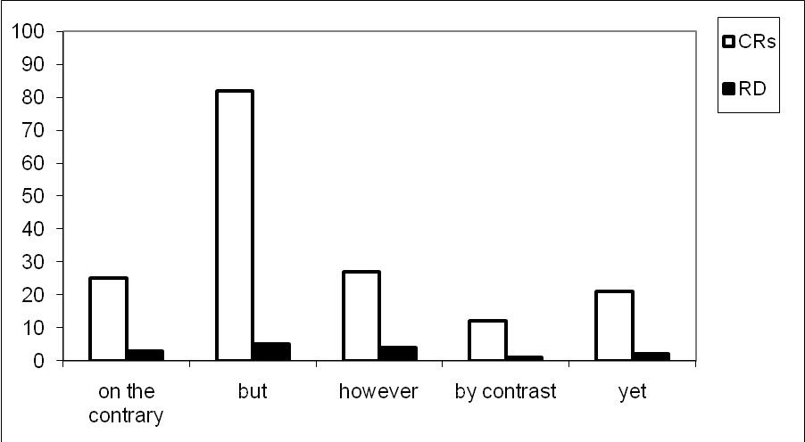
%25
%82
%27
%12
%21
Figure (6): Learners' CRs and RD of Adversative Relation in the Data
Table (7) above reveals that conjunctive by contrast is the most difficult item for the learners to translate. The percentage of correct responses is 12. The analysis of data shows that 88% of the learners erroneously translated it. The wrong responses are 71%; whereas 17% of responses are avoided.
Fraser (2005: 6-13) regards that CAs like by (in) contrast and in comparison are almost identical. He defines them as comparative contrasts of CAs with similar meanings. With negative comparison such as by contrast, Halliday and Hasan (1976: 248) note "we are approaching the adversative type of conjunctive relation, where it has the sense of 'not…but…'; that is, where the first term in the comparison is denied in order to make room for the second one." Thus, the acceptable Arabic translations comprise the use of خلافا لـ, مقارنة بـ, أما, بالمقارنة; while the acceptable Arabic meaning of the item is:
فالمنطقة الأولى تتألف من مراع خضراء وسهول شاسعة. أما المنطقة الثانية فهي وعرة جبلية.
Influenced by Arabic, the learners have produced alien English forms. In this item, the learners go so far that they neglect the syntactic form of the English CA into other forms such as verbs and nouns. They unsuitably use يناقض, تناقض, تناقضت, مناقضة, مناقض, تتناقض …etc. The following examples are from the learners' incorrect responses:
*في المنطقة الأولى جعلت مراعي خضراء وسهول مناقض للمنطقة الثانية مليء بالجبال.
*الأول صنع من المراعي الخضراء والسهول. ومن التناقض المنطقة الأخرى جبلية ووعرة.
*الإقليم الأول اخترع من مراع خضراء وسهول واسعة يناقض الإقليم الثاني مكان وعر ومناطق جبلية.
*المنطقة الأولى عملت فيها مراع خضراء وسهول مناقضة للمنطقة الثانية فهي وعرة جبلية.
Once more, like the CIs at which moment and at last, a number of learners translated them literally. This indicates that they lack the complete information about English prepositions when they attach to verbs or nouns to form units with different meanings. The learners improperly use للتناقض, بالعكس, بالتناقض, بالنقيض, على خلاف, من التناقض, على التناقض, etc.
Also, colloquial uses of CAs such as بعكس, عكس, على عكس, عكسه are noticed to be common in the learners' translations, as in the following examples from the erroneous responses to the translation test:
*المنطقة الأولى كانت تحوي مراع خضراء وسهول واسعة عكس المنطقة الأخرى كانت وعرة جبلية.
*الحقل الأول متكون من المراعي والنباتات عكسه الحقل الثاني هو في مناطق جبلية وعرة. *إن أول منطقة صنعت من مراع خضراء وسهول واسعة بعكس المنطقة g
The faulty translations may be attributed to the interference from the mother tongue. It is evident that the renderings above are all awkward since they failed to represent the real meaning of the SL. These also can be due to that the learners have overemphasized the textual structure of SL. This attitude resulted in the literal translations of CAs which do not have a corresponding meaning in the TL.
The second most difficult conjunctive is the conjunctive yet. The analysis of the data indicates that the percentage of correct responses is 21. 60% of the learners erroneously translated it. The avoided responses are 19%. The sum of the erroneous and the avoided responses is 79%.
According to Halliday and Hasan (1976: 251), in some instances the adversative relation between two sentences appears, where the second sentence and not the first would correspond to the 'although clause' in a hypotactic structure. Here the normal cohesive form is yet. Therefore, the acceptable Arabic translations encompass the use of ومع ذلك, على الرغم من, بالرغم من whereas the possible Arabic translation of the English item is:
كانت كما لو أنها قد تنبأت بموتها. ومع ذلك كانت بأتم صحة عندما غادرت المنزل ذلك الصباح.
It has been observed that the majority of the learners erroneously use لحد الآن. The following are illustrative examples from the learners' erroneous responses:
كأنها تنبأت بموتها. لحد الآن هي بصحة جيدة عندما تركت البيت بذلك الصباح. *
*كانت كما لو أنها تنبأت بوفاتها. لحد الآن قد كانت بصحة جيدة عندما غادرت البيت ذلك الصباح.
One can notice that the learners seem to have not clearly identified the function of yet as an adversative CA and confused it with not yet as an adverb of time. Swan (1986: 33) asserts that the problem is that yet can be used as an adverb as well as a conjunction. When yet is used as an adverb, it is used to talk about something over a period of time, up till now. Swan says that it is often used with the negative when you are saying that something has not happened up to the present time. Furthermore, Tylor (1975: 79) considers "any error which can be attributed to the application of a rule of English in appropriate situation" is overgeneralization or analogy error.
To translate this item many learners unsuitably use بل, بيد أن, في الواقع, في الحقيقة، which correspond to the adversative CAs but, in fact etc. The following examples of the incorrect responses are from the translation task:
*هي تنبأت موتها بيد أنها بصحة جيدة عندما غادرت المنزل
*هي كما لو كانت قد تنبأت بخبر موتها في الواقع هي كانت في صحتها الكاملة عندما غادرت في الصباح
*كأنها تنبأت بموتها. في الحقيقة هي بصحة جيدة عندما غادرت البيت صباح
They also miscategorize the state relation by using the CAs of the additive, causal, and temporal relations. They wrongly use و, لذلك, لأن, الآن which correspond to the English CAs and, therefore, thus, now etc. The following examples are from the learners' wrong responses:
*تبدو أنها تنبأت بموتها وهي بكامل صحتها عندما غادرت البيت ذلك الصباح.
*كأنه هي تنبأت موتها. لذلك كانت بصحة جيدة عندما غادرت المنزل ذلك الصباح.
*تنبأت موتها. لأنها كانت جدا مريضة عندما تركت بيتها صباحا.
*إذا ما هي تنبأت بموتها. الآن تبدو بصحة تامة عندما غادرت البيت صباحا.
The faulty translations may have resulted from the incomplete application of rules by using not yet instead of yet. This can result from analogical extension or the rote learning of rules. These errors can also result from faulty comprehension of distinction in the TL. The learners misunderstand the use of yet, they think yet as the corresponding marker of the and, thus, now etc., i.e., false concept hypothesized. It is evident that the difficulty of the TL, English, caused an intra-lingual interference.
The third most difficult CI is on the contrary. The percentage of correct answers is 25. 58% of the learners erroneously translated it. The avoided answers are 17%. The sum of the incorrect and avoided responses is 75%. The possible Arabic translations include بل, على النقيض من ذلك and على العكس. The possible Arabic meaning of the English item is:
إن الذين رآهم على تلك الجزيرة لم يكونوا أناسا متوحشين بل أصحاب حضارة عريقة.
Many learners incorrectly think that this CI means the same as on the other hand. For Kouyu (2008: 1-10) there are two usages of on the contrary: a) the most common meaning is: "that's untrue and I'll tell you the true situation." Or, "I disagree and this is what I think." b) it is also used to emphasize a negative statement you just made by repeating the statement in appositive and more emphatic way. That is, the expression on the contrary is followed by a statement that means the same as the negative statement but it is expressed in a positive sense and this statement exceeds the strength of the first statement. In usage b, the meaning is similar to saying in fact, as a matter of fact or actually, whereas on the other hand states two contrasting points in a balanced way, not emphasizing the difference (ibid: 12). The learners inappropriately use من ناحية اخرى, من جهة اخرى. the following examples are from the learners' responses:
*الناس الذين من قابلهم في تلك الجزيرة كانوا غير متوحشون. من ناحية اخرى كانوا يمتلكون حضارة عريقة
*الناس الذين قابلهم في تلك الجزيرة ليسوا اناس غير متحضرين. من جهة اخرى هم اصحاب حضارة قديمة
A large number of the learners miscue the conjunctive on the contrary. Miscue is a term coined by Goodman (1969: 78) referring to an incorrect guess made by a reader when reading a text, for instance, the word contrary as country. In translation, some learners with poor reading skills transfer the miscue into their translated text. They wrongly use في البلد, في القطر, في البلاد, في الوطن, في المدينة. The following examples are form the incorrect answers:
*الناس الذين التقوا في الجزيرة كانوا وحوش في البلد كانوا مواطنين قدماء.
*الناس الذين قابلهم في تلك الجزيرة لم يكونوا وحشيين. في القطرهم المالكين لحضارة قديمة.
*الناس الذين التقاهم على الجزيرة ليسو متوحشين. في البلاد هم أصحاب حضارة عريقة.
*الناس الذين التقينا بهم هم غرباء وفي الوطن هم الذين يملكون الحضارة القديمة. *الشخص الذي يعزل في جزيرة يكون متوحش. في المدينة هم كانوا ممتلكين الحضارة.
Some of the learners add more items to the original text, thus providing an extra meaning as in the following example:
*لم يكن القوم الذين قابلهم على تلك الجزيرة همجيين. بل على العكس كانوا اصحاب حضارة موغلة في القدم
The faulty translations may be ascribed to three major sources of error: the learners' misinterpretation of the English lexical meaning in which many learners select a wrong alternative equivalent having a difficult meaning by using on the other hand instead of on the contrary, i.e. errors in propositional meaning. According to Baker (1992: 67), the propositional meaning refers to the relationship between a word and what it refers to or describes as conceived by the speakers as true or false.
Another major source of error may be due to the impact of learners misreading of Source Text (henceforth, ST) vocabulary in their translation tasks. Deeb (2007: 4) suggests that the learners are relying on word shape recognition while they are reading, and are confusing words with similar shapes; this misreading is then incorporated into their initial mental model of the text, which then prevents access to the correct interpretation when learners reread while translation.
The third major source is referred to as redundant errors (addition). Scott and Tucker 1974 (cited in Hamdallah & Tushyeh, 2009: 6) define redundant errors as an unnecessary word put in or that two or more words used where only one was required.
The CI however is the fourth difficult one in this type. The percentage of correct responses is 27. The analysis of the data shows that 64% of the learners erroneously translated it. The avoided responses are 9%. The sum of the incorrect and the avoided responses is 73%.
Fraser (2005: 7) says that however differs from but, but not very much. Like but, it can have as its target the direct S1 (the prior segment), and an indirect message conveyed by S1; while but signals a simple contrast between S2 (referring to the segment CAs introduce) and S1, hence the interchangeability of semantics when the target is the direct message conveyed by S1, the core meaning of however signals that S1 is being emphasized, placing S2 message in a more subordinate role. This difference is difficult to show, since but can occur in all however contexts, and can be interpreted as emphasizing S2 when it does so (ibid.). He also mentions that although is equivalent to however, which introduces a segment only when it is combined syntactically with S1 (ibid: 8). So, the suitable Arabic translations of this CI are ومع ذلك, ولكن, بالرغم من ذلك، and the suitable Arabic meaning of the English text containing this CI is:
كانت الهزيمة بينة ومع ذلك استمر اللاعبون ببذل أقصى ما عندهم ليكسبوا المباراة.
It has been shown that the majority of learners inappropriately used على أية (أي) حال. It may be argued that these expressions may have a conclusive meaning, corresponding to such English items as any way/ any how/ at any rate. The conjunctive على أية حال guides the hearer/ reader to interpret the first proposition as a 'conclusion' and the second proposition as a premise. However, the instance in
which this expression has occurred, and has just been illustrated, does not have a strict conclusive function, and it is therefore considered as a case of an adversative linkage. The following are illustrative examples from the learners' erroneous responses:
*الخسارة كانت واضحة. على أية حال اللاعبين استمروا في بذل أفضل جهدهم ليربحوا المباراة. *الخسارة كانت واضحة, على أي حال استمر اللاعبين محاولاتهم باذلين جهدهم لربح اللعبة.
Examining the faulty translations, one can notice that the learners seemed to take into account lexical and grammatical knowledge of English expressions but not their pragmatic use. These errors may also be attributed to the learners' problem in using the dictionary. Perhaps, they hastily choose the first definition of a word without considering the possibility of another alternate meaning which would better fit the context.
The least difficult conjunctive of this type is but. The analysis of data demonstrates that the percentage of correct responses is 82. This means that the learners seem to have identified the semantic function of this CI. 7% of the learners fail to translate it correctly. The avoided responses are 11%. The sum of the incorrect and the avoided responses is 18%.See table (5) p. 34.
As for this CI, it is mainly used to contrast one idea to another, a case in which the learners showed a good level of agreement. This could be due to the fact that in some cases the English CAs correspond exactly to their Arabic equivalent as in the conjunctive but which made them use it satisfactorily. The acceptable Arabic translation of this conjunctive includes the use of لكن. The acceptable Arabic translation of it is:
وسال الدم على خده بعض الشيء. ولكنه ما لبث أن تخثر وجف قبل أن ينتهي إلى ذقنه.
The faulty translations of the remaining incorrect answers may be attributed to the fatigue, boring, etc. Richards (2001: 164) stresses that "there are sorts of errors which can be described as mere failures to memorize a segment of language or as occasional lapse in performance due to memory limitations, fatigue, and the like". The following are illustrative examples from the wrong responses of the learners:
*سقط الدم على خده وقبل وصوله الى الرقبة قد تخثر
*الدم تدفق في احشائه وبعد ذلك تخثر وجف
*سال الدم من خده بطريقة صغيرة. لذلك تخثر قبل ان يصل ذقنه
5.5 Responses to the Continuative Relation
Table (8) shows that this type occupies rank three in the hierarchy of difficulty. It is represented by two items, i.e. it covers 10% of the whole translation task. Table (8) summarizes the distribution of the item number, CAs, percentage of the CRs, and RD of this category in the data.
Item's No. | CAs | % CRs | RD
10 | of course | 76 | 2
19 | after all | 0 | 1
Total | 2 | 38 | -
Table (8): Distribution of the CAs, Percentage of CRs, and RD of the Continuative Relation in the Data
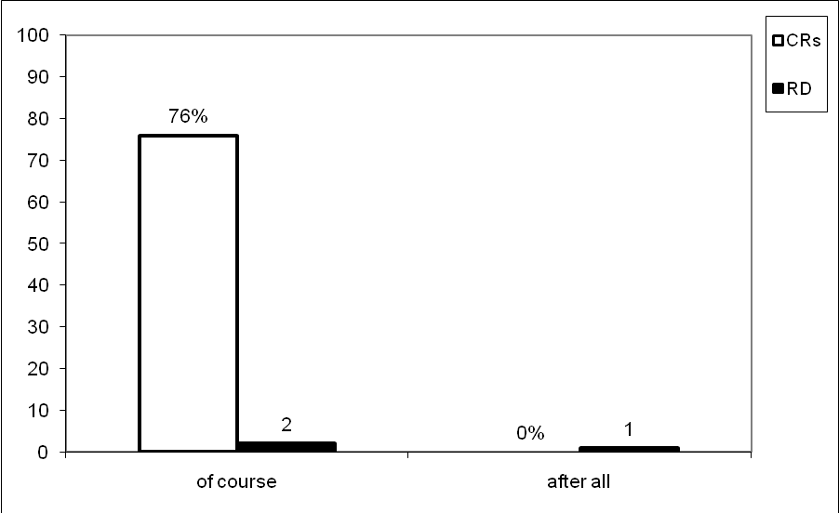
Figure (7) shows the CRs and RD of continuative relation appeared in Table (8). This histogram displays that the conjunctive after all scored the lowest CI while of course scored the highest one in this type.
Figure (7): Learners' CRs and RD of Continuative Relation in the Data
Table (8) above demonstrates that conjunctive after all is of special difficulty. The percentage of correct responses is 0. This means that all learners have omitted an equivalent for after all or completely avoided translating this item. After all is a subclass of inferential markers which signals that the conjunctive segment is to be taken as conclusion based on the prior segment, i.e. the prior segment provides grounds for drawing the conclusion. It specifies that the conjunctive segment provides a reason for the content presented in the prior segment, whether it is assertive or an imperative (Fraser, 1999: 31-4). The appropriate Arabic translations of this CI include the use of the expression على أية (أي) حال; whereas the possible Arabic translation should be as follows:
قال فيليب لنفسه وهو يقود سيارة الكورفير في المنعطفات الحادة في شارع سقراط والعجلات تئز لطيفة فوق القار الناعم والمساكن والحدائق تدور في المرآة الخلفية بشكل يسبب الدوار. قد انتهى به المطاف الى قيادة سيارة زاب على أية حال.
Notice how the learners have omitted an equivalent for after all. According to Aijmer and Vandenbergn (2009: 25), zero translations are frequent in the case of non-propositional elements and can be seen as inadequate because some elements of the interpersonal meaning is missing in the Target Text (henceforth, TT) as compared with its source. The following examples are from the wrong responses:
*فكر فيليب ان يقود سيارة حول المنعطفات الحادة لشارع سقراط. العجلة تئز بهدوء على القار الناعم, بيوت, حدائق تدور. اكمل سياقته قبل الكل
*فكر فلب انه يقود كورفير تدور حول المنعطفات الحادة في شارع سوكرت. يسمع صوت العجلة تئز على طريق ناعم دارت السيارة حول البيوت والحدائق. هو لم يقود ابدا سيارة موريز زابر
*فكر فيليب وهو يقود الكورفير حول المنعطفات الحادة لشارع سقراط والعجلات تئز بنعومة حول القار. انتهى بسياقة سيارة زاب
One cannot fail to observe the impact of the intra-lingual interference since learners are not aware of this function in English and then lacked the competence to give its equivalent translation in Arabic. This may be due to the learners' unfamiliarity with the usage of such words continuative connectors. Another possible reason is that Iraqi EFL learners do not have sufficient knowledge of the flexibility of connector- positioning. Thus, they wrongly think that CAs can only come in sentence-initial position.
The CI of course is the least difficult one in the continuative category. The percentage of correct answers is 76. The erroneous answers are 17%; while the avoided answers are 7%. The sum of the erroneous and the avoided answers is 24%.
The analysis of the translation task reveals that a large number of learners correctly translated it. This proves that they are capable of recognizing and choosing the right meaning of this CI. This is due to one logical reason depending on the learners' knowledge and understanding of this CI and how it should be correctly used.
Dictionaries and grammar books invariantly gloss of course's meaning as synonymous with 'naturally', 'as can be expected', etc. and the function of it is that of marking strong agreement and disagreement on the one hand and providing feedback (backchannel behavior), on the other (Furko,2007: 1-8. Thus, the suitable Arabic translations of this CI comprise the use of بالطبع, طبعاً. The acceptable translation is as follows:
فكأنها قد أجابت عن سؤاله, وكأنه بها تقول: طبعاً إن النساء يجدنك جذاباً.
Notice that how the learners use the expressions بالتأكيد, بالفعل instead of بالطبع or طبعا to answer this CI. The expressions above have the sense of certainly, verily, surely, etc. These are used as adverbial adjuncts (intensifier adjuncts) for emphasis. The following are wrong answers from the translation task:
*بدا وكأنها أجابت عن تساؤله. بالتأكيد وبدت وكأنها تحاول ان تقول, انت شخص جذاب جدا لأمرأة
*كانت كأنها جاوبت سؤاله. بالفعل بدت كأنها قائلة: انت جذاب جدا للنساء
The translation of of course by means of other adverbials with dissimilar forms does not generally affect meaning and it responds to the differentiated behavior of these units in Arabic.
By investigating the erroneous translation, it is obvious that negative transfer from the native language has taken place.
5.5.1 Responses to the Additive Relation
Table (2) p28 shows that the additive relation occupies rank four in the hierarchy of difficulty. It is represented by four items i.e. 20% of the total number of the test. Table (9) gives a summary of the distribution of the item number, CAs, percentage of the CRs, and RD of this category.
Item's No. | CAs | % CRs | RD
1 | for instance | 48 | 2
6 | And | 81 | 4
11 | in other words | 49 | 3
16 | As | 16 | 1
Total | 4 | 49 | -
Table (9): Distribution of the CAs, Percentage of CRs, and RD of the Additive Relation in the Data
Figure (8) illustrates the CRs and RD of additive relation appeared in Table (9). It also shows that the conjunctive as scored the lowest among the other CAs whereas and scored the highest one. The CI for instance scored the second lowest CI whereas in other words scored the third lowest one in this category.
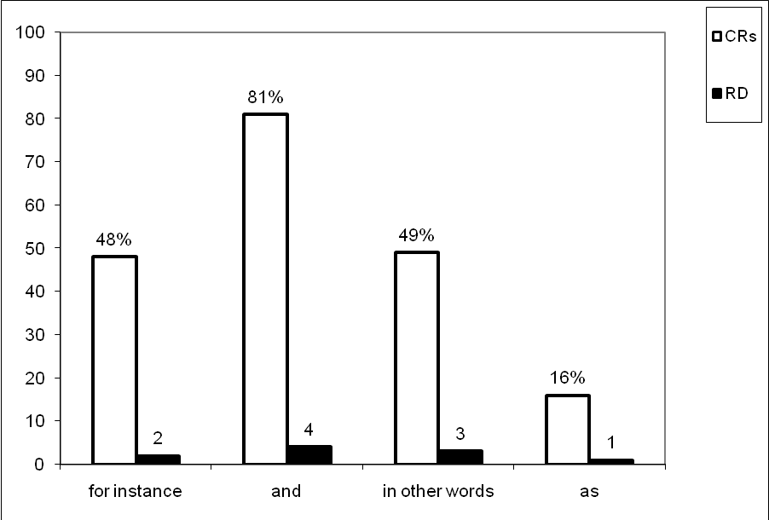

Figure (8): Learners' CRs and RD of Additive Relation in the Data

Table (9) above indicates that the CI as is the most difficult one of this category. The percentage of correct responses is 16. The mistaken answers are 27%; the avoided answers are 57%. The sum of the mistaken and the avoided answers is 84%.
Here, the CI of similarity, as, asserts that the information stated in a sentence is similar to that in the following sentence in which it is added to. The possible Arabic translations of this CI encompass the use of كما, مثلما and the inseparable particle ك, whereas the possible translation of this item is as follows:
كان من الصعب أن يصدق بأن عند صعوده الطائرة يمكن أن يعود خلال ساعات كما يسهل أن يصدق أنه يمكن أن يخطو عبر مرآة المزينة ليجد نفسه عائداً لغرفة نومه.
A review of the results of translating as allows us to conclude that omission is the main strategy, along with translation by means of other separable and inseparable Arabic prepositions like من and ب. These correspond to the English prepositions from and at, by, in, with. the following examples are from the empirical task:
*كان من الصعب التصديق ان الصعود على متن الطائرة خلال ساعات اسهل ان يصدق ان يخطو عبر مرآة منضدة الزينة ويجد نفسه في غرفة نومه
*من الصعب فهم ذلك. الصعود على متن الطائرة هو يستطيع الرجوع خلال ساعات. من السهل ان تصدق هو يخطو خلال مرآة منضدة الزينة ويجد نفسه يرجع لغرفة نومه
*انه من الصعب تصديق ان يعود بعد صعوده على متن الطائرة خلال ساعات بـبساطة التصديق بأنه استطاع ان يرى نفسه امام مرآة الزينة راجعا الى غرفته
Consequently, the most mistranslations of as by the learners are the inexact translations. They intentionally omit it from the representative SL item. Another reason is the substitution of the English prepositions instead of the additive particle as. Scott and Tucker 1974 (cited in Hamdallah & Tushyeh, 2009: 4) define
substitution errors as the use of a wrong word. This means that the learners underwent the effect of the mother language; Arabic.
The analysis of the data reveals that the conjunctive for instance is the second difficult one of this type. The learners have got 48% of the correct responses. The incorrect responses are 45 %; 7% is the avoided responses. The total of the incorrect and the avoided responses is 52%. The acceptable translations included the use of مثلاً, على سبيل المثال, أذ and the appropriate Arabic translation of this item should have been as in:
أنه لا يكترث لممتلكاته الخاصة, إذ فقد ثلاث كاميرات في السنتين الأخيرتين.
The most frequent faulty translations of additive for instance are because, so, therefore, for this reason which correspond to the Arabic particles لأن, لذا, لذلك, لهذا السبب. It is clear that most of the learners translated additive for instance as causal as can be shown from the faulty replacements of for instance by these CAs. The following are examples from erroneous responses of the learners:
*هو غير مهتم بممتلكاته الشخصية لأنه اضاع ثلاث كاميرات في السنتين الماضيتين
*هو غير حريص على ممتلكاته الشخصية لذلك خسر ثلاث كاميرات في السنتين الماضيتين
These faulty replacements indicate that the learners failed to recognize the logical relationship held between the two sentences. The inappropriate use of because, so, etc. instead of the connective for instance changed the intended meaning of the Target Language Text (henceforth TLT). This may be due to their miscomprehension of the English text.
The conjunctive in other words is the third most difficult one
to translate in additive relation. The analysis of data demonstrates
that the percentage of correct answers is 49%. 43% of the learners erroneously translate it; the avoided responses are 8%. The sum of the erroneous and the avoided responses is 51%.
According to Hussein and Bukhari (2009: 4), in other words can be used at phrase, clause, paragraph level to indicate explanation and reiteration similar to the Arabic يعني. The other possible translations are بمعنى آخر, بعبارة أخرى, قل. This item can better be translated as follows:
لم يرغبوا في البقاء مدة أطول. قـل أنهم ملوا المكان.
The data presented in this item show that there are three strategies in translating in other words into its Arabic counterpart. The first strategy is the learners' tendency to translate this CI literally; this produces an awkwardly non-cohesive sentence loaded with extra words. The following examples are from the incorrect responses of the learners:
*هم لا يريدون ان يطيلون البقاء بكلمات اخرى هم ملوا المكان
*هم لا يريدون البقاء اكثر في بعض كلمات هم ملوا المكان
*هم لا يريدون ان يبقوا لمدة اطول في كلمات اخرى هم ملوا المكان
The second strategy is that the learners adhered mostly to recreation of the original text as in the following examples:
*هم لا يريدون البقاء اطول في صياغة اخرى هم كارهين المكان
*لا يستطيعون البقاء مطولا في سياق آخر لقد ملوا المكان
*هم لا يريدون البقاء مدة طويلة وبصورة اخرى هم ملوا المكان
The third strategy is the inappropriate use of the contrastive on the other hand instead of the additive in other words. This altered the proposed meaning of the original text as in:
*لا يريدون البقاء اكثر من ناحية اخرى ملوا المكان
*هم لا يريدون ان يبقوا اكثر بطريقة اخرى هم ملوا هذا المكان
The serious errors committed by learners may be ascribed to the limited translation experience, lexical complexities, and poor development of abilities in the TL.
The least difficult CI of this category is and. The results of this item display that the percentage of correct responses is 81. 8% of the learners fail to translate it correctly. The avoided responses are 11%. The sum of the incorrect and the avoided responses is 19%.
As in the conjunctive but, the percentages above give an indication that learners are satisfactorily successful in the way they view this CA. The relative ease with which the learners translate the SL item of the additive and can result from the fact that and has the meaning of وin Arabic which is its English nearest equivalent. Positive transfer is transfer which makes learning easier, and may occur when both the SL and the TL have the same form (Richards et al., 1992: 205). The acceptable Arabic translation includes:
أستمر في القراءة: "ما أشد افتخاري بأنني زوجته!" وكان هو فخوراً جداً بأنه زوجها ايضاً.
The learners' inability to translate this CA, on the other hand, may be attributed to the fact that they might be biased towards the perception of conjunctive use and consequently gave unreliable answers as in:
*قرأ "كم ان فخورة ان اكون زوجته". كانت فخورة دائما لأن تكون زوجته
*استمر في القراءة قائلا بأنه كانه كان يفخر دائما كونه زوجها
5.5.2 Responses to the Causal Relation
Like the additive relation, the causal relation is represented by 4 items in the translation task, i.e. 20% of the whole test. Table (4) p 32 indicates that the causal relation is the easiest to translate and occupies rank five in the hierarchy of difficulty. Table (10) displays the distribution of the item number, CAs, percentage of the CRs, and RD of this category in the data.
Item's No. | CAs | % CRs | RD
2 | Hence | 50 | 2
4 | Therefore | 62 | 3
8 | So | 72 | 4
18 | Accordingly | 22 | 1
Total | 4 | 53 | -
Table (10): Distribution of the CAs, Percentage of CRs, and RD of the Causal Relation in the Data
Figure (9) displays the CRs and RD of causal relation in Table (10). The histogram below indicates that the CI accordingly scored the lowest among the other CAs while so scored the highest one. Finally, the conjunctive hence scored the second
Figure (9): Learners' CRs and RD of Causal Relation in the Data

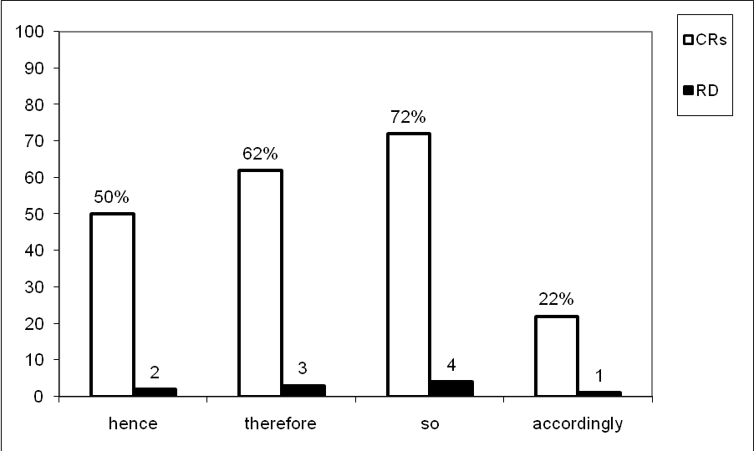
lowest CI while therefore scored the third lowest one in this relation.
Table (10) above reveals that CI accordingly is the most difficult one to translate. The analysis of translations obtained from the learners shows that the percentage of correct responses is 22. 54% of the learners erroneously translate this conjunctive, whereas the avoided responses are 24%. The total of the erroneous and the avoided answers is 78%.
Notice that the conjunctive accordingly signals that the second segment is to be taken as a consequence of the situation based on the first segment (Fraser, 1999: 32). The possible translations comprise the use of وبناءً عليه, بناءً على ذلك, وفقاً لذلك, وفقاً لهذا, على ذلك. The appropriate Arabic translation includes:
كان هناك حادث بالأمس, وبناءً عليه كانت الأخبار المأساوية زائفة.
The learners' imperfect translations include the use of حسب الاخبار, بموجب الاخبار and many other different translations. Here are examples from the wrong responses of the learners:
*كانت البارحة حادثة مؤسفة حسب الأخبار غير موثوقة.
*كانت حادث البارحة بموجب الأخبار كانت حزينة ومزيفة.
Very often learners use a CI which can be classified as a conjunction but whose meaning does not correspond to that in the SL. This type of errors can be attributed to the fact that learners are aware of their task, but they paid scant attention to the appropriate semantic meaning. They may have consulted dictionaries, but they have failed to recognize the right meaning of a certain conjunctive. According to Tylor (1975: 60), translation errors are ones which change the desired response in a significant way. Errors of this kind involve simple substitutions of one syntactically correct structure for another equally syntactically correct, but semantically incorrect, alternative.
The second most difficult conjunctive is the conjunctive hence. The analysis of the data shows that the correct answers are 50%. 36% of the learners erroneously translate this CI. The avoided answers are 14%. The sum of the incorrect and the avoided answers is 50%. The suitable translations include the use of لذا, لذلك, ف, على ذلك, نتيجة لذلك, استناداً لذلك, من هنا. In this item, عزيز's (1990: 206) translation is اللغة جزء لا يتجزأ من الثقافة؛ أذن ينبغي أن لا تدرس بمعزل عنها. He uses أذن for hence while it should be لـذا or the other translations above which are more relevant conjunctives to the context of Arabic translation. Therefore, the translation would be:
اللغة جزء لا يتجزء من الثقافة؛ لـذا لا ينبغي ان تدرس بمعزل عنها.
It should be noted, here, that many learners translate it appropriately using the Arabic particle ف. This may be ascribed to the fact that there is a specific type of ف in Arabic called فاء السببية which introduces the clause and provides the cause of or the reason for the event stated in the sentence.
Those who erroneously translate it fail to understand the function of hence in English. They incorrectly use التي, هنا, من الآن which correspond the English that, here, from now, etc. The following examples are from the incorrect responses:
*اللغة هي الجزء المكمل للثقافة التي لا يجب ان تدرس بشكل منعزل
*اللغة هي جزء متكامل من الثقافة. هنا فانه لا يجب ان تدرس بمعزل
*اللغة هي جزء مدمج من الثقافة. الآن يجب ان لا تدرس في عزلة
The faulty translations show that the use of a conjunctive that does not signal a causal relationship between the two sentences or clauses enjoined by hence would yield an acceptable translation because of the change in the intended meaning of the SL item. These also show that the absence of knowledge make the learners try to build up hypotheses about the second language from their limited experience of it.
The least difficult CAs of the causal relation are therefore and so. The results display that the percentages of correct responses for therefore and so is 62 and 72. The incorrect responses to each one of these CAs are 20% and 9%, while the avoided responses are 18% and 19%. The sum of the incorrect and the avoided responses is 38% and 28% respectively.
The relatively high percentages of correct answers may be due to the fact that therefore and so can be easily replaced by لذلك, لذا, لهذا, which are commonly the most frequent acceptable English equivalents. These renditions signal a conclusive relationship between two elements of discourse similar to therefore and so in English (Hussein and Bukhari, 2009: 4). The following are the possible translations of these two items respectively:
ففي كبد السماء تبدو الطائرات صغيرة الحجم لكنها كبيرة الحجم على المدرج. ولذا فهي لا بد ان تبدو اكبر حجما عندما تقترب-الا انها واقعا ليست كذلك.
اصغيت لدوران عجلاته ودوي محركه حتى انني لم استطع تحمله اكثر؛ لذا ارتديت معطفي وحذائي وخرجت لدفعه.
In the remaining portion of the faulty responses, the learners erroneously use because, since, for this reason etc. for therefore and so, which correspond to لأن, بسبب etc., when translating them into Arabic. The following example is from the erroneous answers:
*في السماء الكواكب تبدو صغيرة. على المدرج الكواكب تبدو كبيرة. لأن كلما اقتربنا من السماء. الكواكب تبدو لنا كبيرة. لكن في الحقيقة الكواكب لم تبدو كبيرة.
A close examination of these faulty translations indicates that the learners do not distinguish between the causal and resultative functions of therefore and so.
5.6. Conclusions
The following conclusions can be drawn in the light of the results of the study:
1. The translation of CAs is not easy. The overwhelming majority of learners do not possess knowledge of translating CAs.
2. Avoidance or ignorance of translating CAs may be the most frequent strategies used to overcome the translation of semantic functions of these conjunctives.
3. The most common errors in the translation of CAs include learners' overuse of guessing strategies, incomplete rules application, omission, substitution, and building false hypotheses.
4. Relying heavily on bilingual dictionaries, apart from context not give the appropriate translation.
5.The analysis of the data reveals how problematic inconsistent knowledge about cohesion in both English and Arabic can be for the Iraqi EFL learners. In many cases, the learners fail to keep the propositional content of the ST because they misunderstand or misuse the CAs of the SL and the TL respectively. The mistranslation of these CAs produce an awkwardly non-cohesive sentences loaded with extra words. These renditions are "so badly done that the original is deformed and mutilated'' (Aziz, 1971:15-41). This verifies the third hypothesis that the mistranslation of an English conjunctive into its Arabic counterpart makes English text lose its intended meaning.
6. Many of errors are attributable to interference from Arabic than to other learning problems.

Bibliography
Abdul-Hafis, A.S (2004). "Lexical Cohesion in the Translation Novels of Najib Mahfouz" The Evidence from the Thief and the Dogs. Babel. Vol.49, No3, pp. 229-252. Retrieved June 2009 from http;/ / www.arabicwata.org
Aijmer,K, Vandenbergn, (2009)"The Discourse Particle Well" from http;/ / people.bu.edu.
Aziz,A.Y. (1989)"The Holy Qur'an; Text, Translation and
Baker, M. (1992) "In Other Words; ACoursebook on Translation." London ; Routledge.
Beeston, A.F.L. (1968)"Written Arabic ; An Approach to the Basic Structure." Cambridge; CUP.
Bell, T.R (1991)"Translation and Translating; Theory and Practice." New York; Longman Inc.
Bider, D, Johansson, S, (1999)"Grammar of Spoken and Written English". London ; Pearson Education Limited.
Cantarino, V. (1975) "Syntax of Modern Arabic Prose". Vol.3 Indiana University Press.
Cesare, A.M De (2003).Aijmer (2002)."English Discourse Particles from http/ / linguist,org/ issues.
Deeb, Z. (2007)"First Reading= Lasting Meaning" Tripoli; Al Fateh University.
Dickens ,J. (2002) "Thinking Arabic Translation" London; Routledge.
Dijk Van (1977)"Text and Context Exploration" London ; Longman Group Ltd.
Fareh, Sh. (1998)"The function of And and Wa in English and Arabic Written Discourse" Papers and Studies in Contrastive Linguistics. Vol.34 pp303-312.
Fareh, G. (2000) "Linguistics Term and Cocepts. London Macmillian press.
Fraser, B. (1999) "What are Discourse Marker? Journal of Pragmatics. Vol.31 pp 931-952.
………… (2005) "On the Universality of Discourse Marker. Boston University, from http/ / sws 1.bu.edu/ bfraser.
Furko,p.B (2007)"The status of/ of course/ as Discourse Marker. University of Debrecen English and Arabic Studies, from http/ / husse8.extra.hu/ wp-content/ 2007/ o4/ furko.
Goodman, K.S91969)"Analysis of Oral Reading Miscue; Applied Psycholinguistics Vol. 5 pp 9-50.
Halliday, M.A.K; Hassan, R. (1976)"Cohesion in English. London Longman.
…………… (1994)"Introduction to Functional Grammar.2nd ed" London Edward Arnold.
…………. (1991)"Context and Text; Aspects of Language in a Social- Semiotic Perspective. Oxford ; OUP.
Hamdalla, R.W (2009)"A contrastive Analysis of Selected English and Arabic Prepositions. Nabuls; An-Najah National University.
Hatim, B. Mason. (1990)"Discourse and the Translator. London Longman.
Holes, C. (1995). Modern Arabic ; Structures, Functions and Varieties. London Longman.
Hussein, M. ; Bukhari, N. (2009)"Discourse Marker and Procedural Meaning. The Case of / fa/ in Standard Arabic.
Kouyu, Y. (2008)"Cohesive Discourse Marker, from http/ / www.yasi-kouyu.com.cn.
Leech, G; (2OO1)"An-A-Z OF English Grammar and Usage. Longman ; Pearson Education Limited.
Macarthy، M. (1991) "Discourse Analysis and Grammar. Cambridge. C.U.P.
Marthkour, H. (2008)"Parsing Arabic Text. Journal of Computer Science. Vol.4 pp 713-721.
Othman, W. (2004)"Subordination and Coordination in English- Arabic Translation. Al-Basaer. Vol.8, No 2 pp12-23.
Quirk, R. (1985)"Comprehensive Grammar of English Language" London; Longman Ltd.
Richards, J.C. (1974)"Error Analysis; Perspective on Second Language Acquisition. London; Longman.
Savory, Th. (1968)"The Art of Translation. London; Jonathon Cape.
Swale, J. (1971) Writing Specific English. Reprinted in 1974.
Taylor, B. (1975)"The Use of Overgeneralization " ESL, Language Learning ,Vol.5, pp 45-90.
Wright, W. (1974)"A Grammar of the Arabic Language. Vol.2.Beirut.
Arabic Refere s:nce
القزويني, جلال الدين محمد بن عبد الرحمن (د. ت). الإيضاح في علوم البلاغة.ج 1. بغداد: مكتبة المثنى.
مطلوب, أحمد والبصير حسن (1999). البـلاغــة والتـطبيــق. بغداد: وزارة التعليم العالي والبحث العلمي.
أنيس, إحسان (1966). من أســـرار اللغـــة. القاهرة: المكتبة الأنجلو- مصرية.
الجرجاني, عبد القاهر (1969). دلائــل الأعجــاز. تعليق وشرح محمد عبد المنعم خفاجي. القاهرة: مكتبة القاهرة.
خطابي, محمد (1988). لســانيـات النـص مدخـل الى انسـجام الخـطاب. أكادير: المركز الثقافي العربي.
عزيز, يوئيل يوسف (1990). مبـادىء الترجمـة من الانكـليزيـة الى العـربيـة. الموصل: مطبعة الجمهور.
الغلاييني, الشوخ للطباعة والنشر.
THE DATA OF THE TEST
Aronson, T. (1984). English Grammar Digest. New Jersey: Prentice-Hall, Inc. Englewood Cliffs.
Hemingway, E. (1974). The Old Man and the Sea. Harmondsworth: Penguin Books.
Lodge, D. (1975). Changing Places: A Tale of Two Campuses. Harmonds- worth Penguin Books.
Maugham, S.W. (1951). The Complete Short Stories of W. Somerset Maugham. Vol. I. London: Heinemann.
McCarthy, M.; O'Dell, F. (2001). English Vocabulary in Use. Cambridge: CUP.
Woolf, V. (1980). The Legacy. London: Hogarth Press Ltd.
البعلبكي, منير (1977). الشيـخ والبحـر وثلـوج كليمنجارو (ترجمة). بيروت: دار العلم للملايين.
عزيز, يوئيل يوسف (1990). مبـادئ التـرجمة من الانكليـزية إلى العربيـة. الموصل: مطبعة الجمهور.
جبرا, جبرا إبراهيم (1955). قصص من الأدب الإنكليزي (ترجمة). بغداد: منشورات دار السعيدي.
APPENDIX (A)
THE TEST
Q/ Translate the following sentences into Arabic. Pay special attention to the conjunctive adjuncts:
- He's careless about his personal possessions; for instance, he has lost three cameras in the last two years.
- Language is an integral part of culture. Hence it must not be studied in isolation.
- The people whom he met on that island were not savages. On the contrary, they were the owners of an ancient civilization.
- In the sky the planes look very small. On the runways they look big. Therefore close up they should look even bigger-but in fact they don't.
- He could remember only Angela telling him; Angela with her genius for sympathy, had been terribly upset. Meanwhile Sissy Miller had risen.
- He read on. 'How proud I am to be his wife'. And he had always been very proud to be her husband.
- The blood ran down his cheek a little way. But it coagulated and dried before it reached his chin.
- I listened to his wheels spinning and his engine howling until I could not stand it any longer. So I put on my fur coat and boots and went out to give him a push.
- The old man unhooked the fish, rebated the line. Then he worked his way slowly back to the bow.
- It was as if she had answered his question. Of course, she seemed to say, you're very attractive to women.
- They did not want to stay any longer. In other words they were bored with the place.
- Defeat was obvious; however, the players continued to try their best to win the game.
- Real pathetic fallacy weather, Morris thought. At which moment there was a knock on his door.
- Though I heard the bell peal through the house no one answered it and I rang a second and then a third time: at last an old woman with a heavy moustache to the gate.
- The first region is made up of green meadows and vast plains. By contrast, the second region is rugged and mountainous.
- It was difficult to believe that by boarding an airplane he could be back, within hours. As easy to believe that he could step through Desiree's dressing-table mirror and found himself back in his own bedroom.
17. A fish could take out over three hundred fathoms of line.
Now the man watched the dip of three sticks over the side Of the skiff.
- .There was an accident yesterday; accordingly the tragic news was false.
- 19.Philip thought, steering the Corvair round the tight beads of Socrate's Avenue, tyres squealing softly on the smooth tarmac, houses and gardens rotating dizzily in the rear-view mirror. He had ended up driving Morris Zapp's car after all.
- .It was as if she had foreseen her death. Yet she had been in perfect health when she left the house that morning.
APPENDIX (B)
THE TEST'S POSSIBLE TRANSLATIONS
- أنه لا يكترث لممتلكاته الخاصة إذ فقد ثلاث كاميرات في السنتين الأخيرتين.
- اللغة جزء لا يتجزأ من الثقافة؛ لذا لا ينبغي أن تدرس بمعزل عنها.
- أن الذين رآهم على تلك الجزيرة لم يكونوا أناساً متوحشين بل أصحاب حضارة عريقة.
- ففي كبد السماء تبدو الطائرات صغيرة الحجم لكنها كبيرة الحجم على المدرج. ولذا فهي لا بد ان تبدو اكبر حجما عندما تقترب-إلا إنها واقعاً ليست كذلك.
- أنه لا يذكر ألا أنجلا وهي تقص عليه الخبر. وقد انزعجت أنجلا, بما لديها من مقدرة فائقة على العطف, انزعاجا كثيرا. حينئذ نهضت سسي ميلر.
- أستمر في القراءة: "ما أشد افتخاري بأنني زوجته!" وكان هو أيضا فخوراً جداً كونه زوجها.
- سال الدم على خده بعض الشيء. ولكنه ما لبث أن تخثر وجف قبل أن ينتهي إلى ذقنه.
- أصغيت لدوران عجلاته ودوي محركه حتى أنني لم استطع تحمله أكثر من ذلك. لذا ارتديت معطفي وجزمتي وخرجت لدفعه (دفع السيارة).
- انتزع الشيخ الشص من فم السمكة, وطعَم الخيط. ثم أتخذ سبيله, وئيدا وئيدا, إلى مقدم القارب.
- فكأنها قد أجابت على سؤاله, وكأنه بها تقول: طبعاً إن النساء يجدنك جذاباً جداً.
- لم يرغبوا في البقاء مدة أطول قل إنهم ملوا المكان.
- كانت الخسارة بينة ومع ذلك أستمر اللاعبون ببذل أقصى ما عندهم ليكسبوا المباراة.
- كان موريس يفكر في الجو المحزن وغير الموثوق به, وفي تلك اللحظة سمع قرعا على الباب.
- لم يجب على الجرس احد مع إنني سمعته يدق داخل المنزل, ولذا سحبته مرة أخرى, ومرة ثالثة. وأخيرا جاءت إلى الباب عجوز لها شارب كثيف.
- فالمنطقة الأولى تتألف من مراع خضراء وسهول شاسعة. أما المنطقة الثانية فهي وعرة جبلية.
- كان من الصعب أن يصدق بأن صعوده الطائرة يمكن أن يعود خلال ساعات. مثلما يسهل ان يصدق أنه يمكن أن يخطو عبر مرآة المزينة ليجد نفسه عائداً لغرفة نومه.
- وتطلبت سمكة ما خيطاً يزيد طوله على ثلاثمائة قامة. وفي تلك اللحظة راقب العجوز وضع العيدان الثلاثة من فوق جانب القارب.
- كان هناك حادث بالأمس وبناءً عليه كانت الأخبار المأساوية زائفة (خاطئة).
- قال فيليب لنفسه وهو يقود سيارة الكورفير في المنعطفات الحادة في شارع سقراط والعجلات تئز لطيفة فوق القار الناعم والمساكن والحدائق تدور في المرآة الخلفية بشكل يسبب الدوار. لقد انتهى به المطاف إلى قيادة سيارة زاب على أية حال.
- كانت كما لو أنها قد تنبأت بموتها. ومع ذلك كانت بأتم صحة عندما غادرت المنزل ذلك الصباح.

