Fire Flame Exposed Behavior Analysis OF Reinforced Concrete Columns Eccentrically Under Axial Loads Using Finite Element Method

Mohammed M. Kadhum
Civil Engineering/College of Engineering /University of Babylon

Abstract
This investigation is conducted to study the behavior and load carrying capacity of reinforced concrete columns exposed to fire flame. The exposure of reinforced concrete columns to fire causes changes in their structural behavior.
Finite element method was used to idealize the effect of burning by fire flame exposed to reinforced concrete columns. The specimens that were subjected to fire flame at temperature levels of (400, 600 and 750 ºC ) for 1.5 hour period of exposure at age of 60 days were determined.
A three-dimensional nonlinear finite element model was adopted to investigate the structural behavior of reinforced concrete column specimens with and without exposure to burning. Good agreement was observed between the adopted finite element model results and experimental results. The experimental to theoretical ultimate load ratio ranges from (1.01-1.07) before burning and (1.03-1.23) after burning for the analyzed column specimens. The adopted finite element analysis showed, also, good agreement with experimental results throughout the load-deflection behavior before and after burning.

الخلاصة
تم أجراء هذا البحث لدراسة سلوك وسعة التحمل القصوى للأعمدة الخرسانية المسلحة والمعرضة إلى لهب النار المباشر. . إن تعرض الأعمدة إلى لهب النار المباشر يسبب تغيرات في سلوكها الإنشائي.
تم استخدام طريقة العناصر المحددة لتمثيل تأثير الحريق بواسطة لهب النار المباشر على الأعمدة الخرسانية المسلحة. عرضت نماذج الأعمدة الخرسانية إلى لهب النار في مستويات حرارة (400، 600، 750) درجة مئوية ومدة 1,5 ساعة من التعرض للحرق، وكانت النماذج بعمر 60 يوما.
تم استعمال التحليل اللاخطي بواسطة العناصر ثلاثية الأبعاد لتحري أداء الأعمدة الخرسانية المسلحة قبل وبعد التعرض إلى لهب النار المباشر. أظهرت النتائج المستحصلة من طريقة العناصر المحددة توافقا جيدا مع النتائج العملية حيث تراوحت نسبة الحمل الأقصى من التجارب العملية إلى الحمل الأقصى التحليلي بين (1,07-1,01) قبل الحرق و(1,23-1,03) بعد الحرق لجميع الأعمدة. كذلك تم الحصول على توافق جيد بين منحنيات الحمل-التشوه الجزء التحليلي والجزء العملي.
Introduction
Concrete columns are considered to be important structural elements in reinforced concrete structures because they support the structure and transfer the loads to the supports or foundation, so any failure or damage occurs in the column may cause a partial or complete failure of the structure by perhaps chain action (Sakai and Sheikh, 1989).
Kodur et al., 2005 investigated the behavior of fibre reinforced polymer (FRP) wrapped (confined) reinforced concrete columns under exposure to the standard fire. Three full-scale reinforced concrete columns, two of these columns were circular and the third column was square in cross-section. The circular columns were 400 mm in diameter, while the square column was 406 mm in width. All three columns were 3810 mm long. The longitudinal reinforcement in the circular columns was comprised of eight 19.5mm diameter bars, with 40mm clear cover to the spiral reinforcement and 10mm for lateral reinforcement. The square column had four 25mm diameter longitudinal reinforcing bars with 40mm cover to the ties, and 10mm diameter for ties spaced at 406mm. These specimens were heated in furnace chamber by 32 propane gas burners, arranged in eight columns containing four burners each. The test results showed that the FRP materials used as externally bonded reinforcement for concrete structures were sensitive to the effects of elevated temperatures. They also noticed that the providing proper fire insulation a (5 and 4) hours fire endurance rating can be achieved for loaded circular and square reinforced concrete columns strengthened with FRP wraps respectively.
Dong and Prasad, Accepted for publication in 2008 conducted a furnace test on three full-scale two-story, two-bay composite steel frames to understand the performance of structural frames under fire loading. The three tests differed from each other in the number of heated compartments by the furnace and in the relative location of the heated compartments. For each test, the burners were operated so as to replicate the temperature prescribed by ISO 834 standard and the loads were applied using vertical loads at the top of each column by hydraulic jacks in addition to block loads placed on each composite beam. In the first test, the burners in compartment "I" were in operation, while in the second test the burners in compartment "I" and "II" were in operation, Figure (1). In the third test, the burners in compartments "I" and "III" were in operation.
In all tests, the beam to column connections as well as the columns were protected. None of the columns in any of the three tests showed signs of local buckling. Observations on local buckling of steel beams, cracking of concrete slabs and failure of the beam-to-column connections are presented.
The results showed that the deformation process and time to failure of a structure are highly dependent on the number of compartments that are heated and the relative location of the compartments that are subjected to fire loading.
Figure (1): Elevation of the tested two-story two-bay portal frame (Dong and Prasad, 2008).

-Modeling of Cracked Concrete
Three different approaches for crack modeling have been employed in the analytical studies of concrete structures using the numerical technique of the finite element method. These are (1) smeared cracking modeling as shown in Figure (2), (2) discrete cracking modeling, and (3) fracture mechanics modeling.
For ANSYS computer program (ANSYS help, 2005), crack modeling of concrete depends on smeared cracks. Therefore, general description for this modeling is given below.

-Smeared Crack Model
This model does not account for real discontinuities in the mesh. It was firstly introduced by (Reshid, 1968) . Cracking concrete is assumed to remain a continuum and material properties are modified to account for the damage due to cracking. Concrete is initially isotropic, but cracking induces anisotropy. After cracking, concrete is assumed to become orthotropic, with the principal material axes oriented along the directions of cracking. Material properties are varied depending on the state of strain and stress. The Young’s modulus is reduced in the direction perpendicular to the crack plane, and Poisson’s effect is usually neglected due to the lack of continuity of the material. The shear modulus parallel to the crack plane is also reduced.
In the present work, the smeared crack approach was adopted because it offers:
- Unchanging of topology of the mesh throughout the analysis, and only the stress-strain relationship need to be updated when cracking occurs.
- Complete generality in possible crack direction.
- Computational efficiency.
In ANSYS computer program (ANSYS help, 2005), the presence of a crack at an integration point is represented through modification of the stress-strain relations by introducing a plane of weakness in a direction normal to the crack face. Also, a shear transfer coefficient is introduced which represents a shear strength reduction factor for those subsequent loads which induce sliding (shear) across the crack face.
Figure (2): Idealized representation of a single crack in the smeared cracking modeling
approach (Chen and Saleeb, 1981).
y
x
X
Y

Crushing Modeling
In ANSYS computer program, the material is assumed to crush at an integration point if the material at that point fails in uniaxial, biaxial, or triaxial compression. In concrete element, crushing is defined as the complete deterioration of the structural integrity of the material (e.g. material spalling). Under conditions where crushing has occurred, material strength is assumed to have degraded to an extent such that the contribution to the stiffness of an element at the integration point in question can be ignored.
Used Model
FEM Input Data
For concrete, ANSYS computer program requires input data for material properties, as follows (Kachlakev and McCurry, 2000):
- Elastic modulus().
- Ultimate uniaxial compressive strength ($f_{c}^{'}$).
- Ultimate uniaxial tensile strength (modulus of rupture, f_{r}).
- Poisson's ratio (υ).
- Shear transfer coefficient for opened and closed cracks (β_{o} and β_{c} respectively).
- Compressive uniaxial stress-strain relationship for concrete.
An experimental effort was made to estimate the ultimate uniaxial compressive and tensile strength ($f_{c}^{'}$and f_{r} ) of test reinforced concrete column specimens. Details about these values and others related are in chapter three.
From the ultimate uniaxial compressive strength ($f_{c}^{'}$), obtained from appropriate tests, the elastic modulus of concrete () for each column specimen was calculated according to (ACI 318-08) by using equation (1). Poisson’s ratio for concrete was assumed to be 0.2 (Bangash, 1989) for all reinforced concrete columns.
(1)
(in N/mm² or MPa)
The shear transfer coefficient, β, represents conditions of the crack face. The value of β ranges from 0.0 to 1.0, with 0.0 representing a smooth crack (complete loss of shear transfer) and 1.0 representing a rough crack (no loss of shear transfer) (ANSYS, 2005).
The value of β_{o} is used in many studies of reinforced concrete and composite steel-concrete structures, however, varied between 0.05 and 0.25 (Bangash, 1989, Huyse et al., 1994 and Hemmaty, 1998). A number of preliminary analyses were attempted in this study with various values for the shear transfer coefficient within this range, but convergence problems were encountered at low loads with β_{o} less than 0.2. Therefore, the shear transfer coefficients for closed and opened cracks, used in this study, were taken equal to 0.85 and 0.2 respectively for all column specimens.

Compressive Uniaxial Stress-Strain Relationship For Concrete
The ANSYS computer program requires the uniaxial stress-strain relationship for concrete in compression. For numerical expressions (Desayi and Krishnan, 1964), the following equations 2 and 3, were used along with equation 4 (Gere and Timoshenko, 1997) and equation 2 (ACI 318-08) to construct the uniaxial compressive stress-strain curve for concrete in this study.
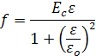
(2)
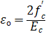
(3)
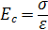
(4)

Where:
=stress at any strain , N/mm².
=strain at stress f.
=strain at the ultimate compressive strength $f_{c}^{'}$.
Figure (3) shows the simplified compressive uniaxial stress-strain relationship that was used in this study.
Figure (3): Simplified compressive uniaxial stress-strain curve for concrete (Huyse et al., 1994).

The simplified stress-strain curve for concrete model is constructed from six points connected by straight lines. The curve starts at zero stress and strain. Point 1, at 0.30 $f_{c}^{'}$, is calculated from the stress-strain relationship of concrete in the linear range (equations 4 and 1). Points 2, 3, and 4 are obtained from equation 2, in which is calculated from equation 3. Point 5 is at and $f_{c}^{'}$. In this study, an assumption was made of perfectly plastic behavior after point 5 (Huyse et al., 1994).

Failure Criterion for Concrete
The model to be used is capable of predicting failure for concrete material. Both cracking and crushing failure modes are considered. The two input strength parameters (i.e., ultimate uniaxial tensile and compressive strengths) are needed to define a failure surface for the concrete. Consequently, a criterion for failure of the concrete due to a multiaxial stress state can be calculated (Willam and Warnke, 1975).
A three-dimensional failure surface for concrete is shown in Figure (4). The most significant nonzero principal stresses are in the x and y-directions, represented by σ_{xp} and σ_{yp} , respectively. Three failure surfaces are shown as projections on the σ_{xp}-σ_{yp} plane. The mode of failure is a function of the sign of σ_{zp} (principal stress in the z -direction).
For example, if σ_{xp} and σ_{yp} are both negative (compressive) and σ_{zp} is slightly positive (tensile), cracking would be predicted in a direction perpendicular to σ_{zp} . However, if σ_{zp} is zero or slightly negative, the material is assumed to crush (ANSYS, 2005).

Figure (4): 3D-failure surface for concrete (ANSYS, 2005).

In a concrete element, cracking occurs when the principal tensile stress in any direction lies outside the failure surface. After cracking, the elastic modulus of the concrete element is set to zero in the direction parallel to the principal tensile stress direction. Crushing occurs when all principal stresses are compressive and lies outside the failure surface; subsequently, the elastic modulus is set to zero in all directions (ANSYS, 2005), and the element effectively disappears.

Model Generation
The ultimate purpose of a finite element analysis is to recreate mathematically the behavior of an actual engineering system. In other words, the analysis must use an accurate mathematical model of a physical prototype. In the broadest sense, this model comprises all the nodes, elements, material properties, real constants, boundary conditions, and other features that are used to represent the physical system.
In ANSYS terminology (ANSYS, 2005), the term model generation usually takes on the narrower meaning of generating the nodes and elements that represent the spatial volume and connectivity of the actual system. Thus, model generation in this discussion will mean the process of defining the geometric configuration of the model's nodes and elements. Element (SOILD65) used for concrete was chosen to represent every type of materials that depending on the agreements with experimental study.

-SOILD65 Element Description
SOLID65 (or 3-D reinforced concrete solid) is used for the 3-D modeling of solids with or without reinforcing bars (rebar). The solid is capable of cracking in tension and crushing in compression. In concrete applications, for example, the solid capability of the element may be used to model the concrete, while the rebar capability is available for modeling
reinforcement behavior. The element is defined by eight nodes having three degrees of freedom at each node: translations of the nodes in x, y, and z-directions. Up to three different rebar specifications may be defined.
The most important aspect of this element is the treatment of nonlinear
material properties. The concrete is capable of cracking (in three orthogonal directions), crushing, plastic deformation, and creep. The rebars are capable of tension and compression, but not shear. They are also capable of plastic deformation and creep. This 8-node brick element is used, in this study, to simulate the behavior of concrete (i.e. plain concrete). The element is defined by eight nodes and by the isotropic material properties. The geometry, node locations, and the coordinate system for this element are shown in Figure (5).
Figure (5): SOLID65 geometry (ANSYS, 2005).

-LINK8 Element Description
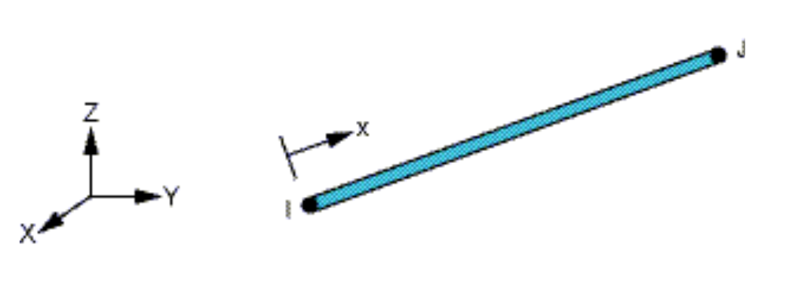
LINK8 is a spare ( or truss) element which may be used in a variety of engineering applications. This element can be used to model trusses, sagging cables, links, springs, etc. The 3-D spare element is a uniaxial tension-compression element with three degrees of freedom at each node: translations of the nodes in x, y, and z-directions. As in a pin-jointed structure, no bending of the element is considered. Plasticity, creep, swelling, stress stiffening, and large deflection capacities are included. This element is used in this study, to simulate the behavior of steel reinforcement which works as main longitudinal and ties reinforcement. The geometry, node locations, and the coordinate system for this element are shown in Figure (6).
Figure (6): link8 geometry (ANSYS, 2005).

- SOLID45 Element Description
An eight-node solid element, SOLID45, is used for the steel plates at the supports in the column models. The element is defined with eight nodes having three degrees of freedom at each node-translations in the nodal x, y, and z directions. The geometry and node locations for this element type are shown in Figure (7). The element has plasticity, creep, swelling, stress stiffening, large deflection, and large strain capabilities. A reduced integration option with hourglass control is available.

Figure (7): SOLID45 geometry (ANSYS, 2005).

- SOLID70 Element Description
This element has a 3-D thermal conduction capability. The element has eight nodes with a single degree of freedom, temperature, at each node. The element is applicable to a 3-D, steady-state or transient thermal analysis. If the model containing the conducting solid element is also to be analyzed structurally, the element should be replaced by an equivalent structural element. This 8-node brick element is used, in this study, to simulate the behavior of concrete The geometry, node locations, and the coordinate system for this element are shown in Figure (8).
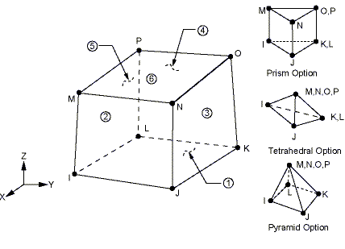
Figure (8): SOLID70 geometry (ANSYS, 2005).

-LINK33 Element Description
This element is a uniaxial element with the ability to conduct heat between its nodes. The element has a single degree of freedom, temperature, at each node point. The conducting bar is applicable to a steady-state or transient thermal analysis. If the model containing the conducting bar element is also to be analyzed structurally, the bar element should be replaced by an equivalent structural element. This element is used in this study, to simulate the behavior of steel reinforcement which works as main longitudinal and ties reinforcement. The geometry, node locations, and the coordinate system for this element are shown in Figure (9).

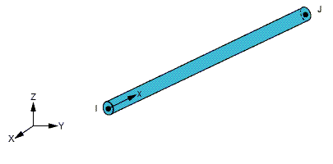
Figure (9): link33 geometry (ANSYS, 2005).

-Analysis Termination Criterion
In the physical test under load control, collapse of a structure takes place when no further loading can be sustained. This is usually indicated in the numerical tests by successively increasing iterative displacements and a continuous growth in the dissipated energy. Hence, the convergence of the iterative process cannot be achieved. A maximum number of iterations for each increment is specified to stop the nonlinear solution if the convergence limit has not been achieved for this study. It has been observed that a maximum number of about (25-50) iterations are generally sufficient to predict the solution divergence or failure. This maximum number of iterations depends on the type of the problem, extent of nonlinearities, and on the specified tolerance.

Thermal Analysis
-Transient Thermal Analysis
The governing equation for transient thermal analysis is as follows (ANSYS, 2005):
(5)
where:
=specific heat matrix
=conductivity matrix
=vector of nodal temperatures
=time rate of nodal temperatures
=applied heat flows

The procedure employed for the solution of equation 5 is the generalized trapezoidal rule:
(6)
where:
θ = transient integration parameter
Δt = tn+1−tn
= nodal DOF values at time tn
=time rate of the nodal DOF values at time tn
Equation 5 can be written at time tn+1 as:
(7)
Substituting {u̇n+1} from equation 6 into equation 7 yields:
(8)
Once {u_{n+1}} is obtained, is updated using equation 6. In a nonlinear analysis, the Newton-Raphson method is employed along with the generalized trapezoidal assumption.
Three methods are available to do a transient analysis: full, mode superposition and reduced.
- The full method uses the full system matrices to calculate the transient response (no matrix reduction). It is the most general of the three methods because it allows all types of nonlinearities to be included (plasticity, large deflections, large strains and so on).
- The reduced method condenses the problem size by using master degrees of freedom and reduced matrices. After the displacement at the master DOF have been calculated, ANSYS expands the solution to the original full DOF set.
- The mode superposition method sums factored mode shapes (eigenvector) from a modal analysis to calculate the structures response. This is the only method available in the ANSYS/Linear Plus program.
The last two methods do not apply to first order systems (that is, the systems are first order in time); therefore the full method is adopted in the present work (ANSYS, 2005).

-Nonlinear Thermal Analysis

For nonlinear thermal analysis, the ANSYS program allows a choice from three solution options: the full option, the quasi option and the linear option (ANSYS, 2005). Nonlinearity in the present problem comes from the temperature dependence of concrete and steel thermal properties. In this work, the full option is used which corresponds to the default full Newton-Raphson algorithm.
-Convergence Criterion for Thermal Analysis

The computer program considers a nonlinear solution to be converged whenever specified convergence criteria are met. Convergence checking maybe based on temperatures, heat flow rates, or both. The convergence criterion is given by [value × tolerance]. For temperatures, the program compares the change in nodal temperatures between successive equilibrium iterations to the convergence criterion. For heat flow rates, the program compares the out-of-balance load vector to the convergence criterion. The out-of-balance load vector represents the difference between the applied heat flows and the internal (calculated) heat flows. In this work, convergence is based on temperatures.
Analytical Results And Discussion
A nonlinear finite element analysis has been carried out to analyze all the reinforced concrete columns tested in the current study. The analysis consists of two parts: thermal analysis to evaluate the fire temperature distribution history inside the column, and structural analysis to evaluate its structural response, see Figure (10). The analysis was performed by using ANSYS computer program (Version 10, copyright 2005)
Figure (10): Data flow of the computer program.
Thermal Analysis
Structural Analysis
Thermal Results File
Structural Results File

-Mesh Generation of Reinforced Concrete Column Specimens
As an initial step in the finite element analysis, the reinforced concrete column specimens are divided into a number of small elements, after that the loads and boundary conditions are applied, and the stresses and strains are calculated at integration points of these elements. An important step in the finite element modeling is the selection of the mesh density.
Convergence of results is obtained when the structure is divided to adequate number of elements. This is practically achieved when an increase in the mesh density has a negligible effect on the results. Therefore, in the present finite element modeling, a convergence study was carried out to determine the appropriate mesh density. The convergence study was made by increasing the number of elements (mesh) in each direction Z, Y and X. When an increase in mesh density has a negligible effect on the results of deflection, it is assumed that the convergence of results is obtained. Figure (11) shows the mesh of column specimens which is adopted in this study. This mesh is used for all columns concentric and eccentric loaded. Details about the orientation of steel reinforcement in reinforced concrete columns with different tie spacing (transverse steel ratio) are shown in Figure (12).

Steel Loading Plate
Steel loading Plate
Figure (11): Mesh of concrete column specimens and steel loading plate.

Ø8mm Ties
4-Ø10mm Main Longitudinal Reinforcement
Spacing Between Ties
= No Ties
= 250 mm
= 150 mm
= 50 mm
Figure (12): Details of reinforcement for column specimens.

-Loads and Boundary Conditions
To get a unique solution, the model should be constrained by using displacement boundary conditions. At Y=L displacement in the direction of X=Y=Z=zero. The displacement in the plane of loading was achieved by leaving Y free (unsupported) and (X, Z=0), to ensure the accurate modeling of the experimental boundary conditions. The external applied load (P) was represented by dividing the total load on the top nodes of the column specimen. The force, P, applied at the steel plate is applied across the entire centerline of the loading plate. Figure (13) shows the details of the boundary condition, and applied loads.
The application of the load up to failure was done incrementally as required by the Newton-Raphson procedure. Therefore, total applied load was divided into a series of load increments (load steps). At certain stages in the analysis, load step size was varied from large (at points of linearity in the response) to small (when cracking and steel yielding occurred). Failure of each of the models is defined when the solution for a minimum load increment still does not converge (convergence fails). It is important to note that although the location of load is variable in each column specimen (axially and eccentricity of 30, 80mm), it is found that this type of mesh is also suitable for the location of load and gives good accuracy in results.
The deflected shape of column specimens B₃₁ and B₁₂ due to external applied loads is shown in Figure (14).
Figure (13): Details of boundary condition and applied loads.
U=W=Zero
L
Loading Applied on the Plate
Boundary Conditions on the Plate
Boundary Conditions at Support
U=V=W=Zero
U=W=Zero
L

Figure(14): Deflected shape of column specimens B31 and B12.
Axial Deformation for Column B₁₂
Lateral Deformation for Column B₃₁

-Thermal Analysis
The thermal analysis is carried out using the finite element method utilizing ANSYS 10.0 software to compute the thermal distribution history in the column specimen subjected to fire flame temperature-time curve which is presented in chapter five.
The column specimens are exposed to fire flame temperature on their four sides with reference temperature 25°C, with temperature increasing for 1.5 hours period of exposure. The concrete column and steel loading plate are modeled using 8-node brick elements (SOLID70), the steel reinforcement is modeled using 2-node brick element (LINK33) in the thermal analysis. The material properties at various temperatures used in the analysis of the column specimens are presented in Table (6-1) (Purkiss, 2007 and Aboalyonan, 2008).
Table (1): Material properties used in thermal analysis.

Material | Property | Temperature °C | Value
Concrete | Conductivity (W/m.°C) | 25-750 | 2.6
Concrete | Specific Heat (J/kg.°C) | 25-750 | 1138
Concrete | Density (Kg/m³) | 25-750 | 2320  2375
Steel | Conductivity  (W/m.°C) | 25  100  200  400  600  750 | 53.2  50.7  47.3  40.7  34.0  29.0
Steel | Specific Heat  (J/kg.°C) | 25  100  200  400  600-750 | 463  470  480  613  713
Steel | Density (Kg/m³) | 25-750 | 7850
-Results and Discussion
In the analysis, the column specimens were exposed to fire flame from all sides. The column specimens were burnt at temperature levels (400, 600 and 750°C) under concentric and eccentric loading (e=30 and 80mm) for 90minutes period of exposure.
A Contour plot of the temperature distribution in the column specimen A₂₂ after 90minutes of burning is shown in Figure (15).
The computed relations between temperature at different depths from the centerline of the column section and time as well as the experimental results are shown in the Figures (16) to (18).
From these Figures, it is clear that with the increase in depth from the surface of the column section the temperature decrease towards the core of the column specimens.
These Figures show that the predicted temperatures are in good agreement with experimental values which confirm the validity and accuracy of the thermal analysis model and the program used.
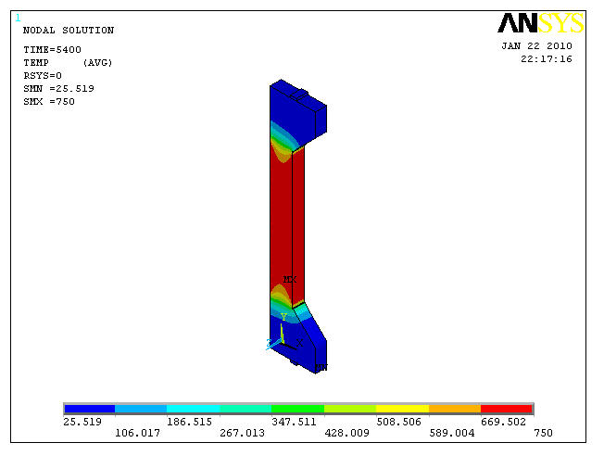
Figure (15): Contour plot of temperature distribution in column specimen
A₂₂ after 1.5 hour of heating.

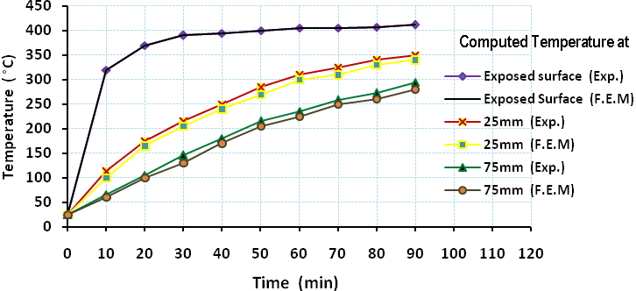
Figure (16): Finite element and experimental temperature distribution at various
depths of column specimen A₂₂, (T=400°C).

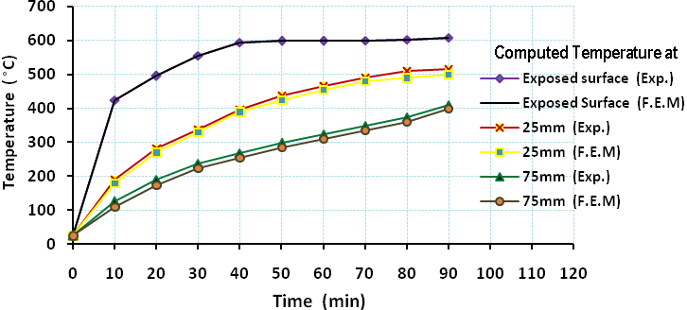
Figure (17): Finite element and experimental temperature distribution at various
depths of column specimen A_{22,} (T=600°C).

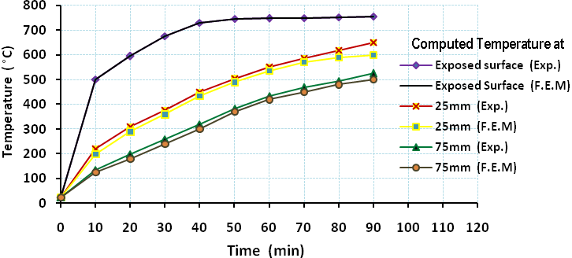
Figure (18): Finite element and experimental temperature distribution at various
depths of column specimen A_{22,} (T=750°C).

Structural Analysis
-Finite Element Idealization
In the present study, brick element 8-nodes (SOLID65) is used to represent concrete core, brick element 2-nodes (LINK8) is used for representation of longitudinal (main) and tie steel reinforcement. Brick element 8-nodes (SOLID45) is used for representation of steel plate which is used for loading and supporting the column specimen. The finite element analysis has been carried out in general using 8-point (2×2×2) integration rule for the reinforced concrete brick elements and 8-point (2×2×2) integration rule for the contact elements (steel plate), with a convergence tolerance of 1%. The full Newton-Raphson method has been adopted in the analysis.
-Results of Analysis of Column Specimens
To illustrate the validity of the proposed numerical method for the analysis of reinforced concrete column specimens under concentric and eccentric loading, the tested columns will be analyzed by using ANSYS computer program. The analysis follows the procedure presented in chapter four taking into account the variation in material properties, dimensions and other specifications described in chapter three.
Load-lateral midheight deformation curves of column specimens that have been presented in the experimental work were compared with the curves computed from ANSYS computer program. The geometrical and material properties of the column specimens that were used in the analysis are presented in Table (6-2). All these columns were loaded by concentric and eccentric loading with and without exposure to fire flame. In order to analyze these columns numerically by using the finite element method, it is required to transform their geometric and material configuration into a mathematical modeling and insert it as input data to ANSYS computer program to simulate the actual behavior of the column, as presented in Chapter four.
Table (2): Material properties of the reinforced concrete columns investigated.

Concrete | Label | Description | Value
Concrete | E_{c} | Young's Modulus, GPa | 29.85 and 34.42
Concrete | fَ_{c} | Compressive strength, MPa | 38.5 and 49.6
Concrete | ft | Tensile strength, MPa | 3.81 and 4.52
Concrete | v | Poisson’s ratio | 0.2
Concrete | Shr-Op | Shear Retention Parameters | 0.2
Concrete | Shr-Cl | Shear Retention Parameters | 0.85
Steel | E_{sl} | Longitudinal Bars Young's Modulus (GPa) | 200
Steel | ρ₁ | Longitudinal Steel Ratio | 0.01396
Steel | D_{l} | Longitudinal Bar Diameter (mm) | 10.0
Steel | f_{yl} | Longitudinal steel Yield Stress (MPa) | 585
Steel | E_{st} | Transverse Bars (ties) Young's Modulus (GPa) | 200
Steel | D_{t} | Transverse Diameter Bar (mm) | 8.0
Steel | f_{yt} | Transverse steel Yield Stress (MPa) | 523.5
Steel | S | Spacing of Ties (mm) | 50, 150, 250 and No ties
Steel | v | Poisson’s ratio | 0.3

-Effect of Burning on Midheight Lateral Deflection and Axial Deformation of Column Specimens
Midheight lateral deflections at the center of left outer face for eccentric loaded column specimens were measured. The load versus midheight lateral deflection curves obtained from the Finite Element analysis and the experimental results are presented and compared.
Figures (19) to (21) show a comparison between the load-midheight lateral deflection and axial deformation relationship respectively for the column specimens before and after burning experimentally and theoretically. In general, it can be noted from the load-midheight lateral deflection plots that the finite element analyses agree well with the experimental results throughout the entire range of behavior before and after burning. Also, it can be concluded that there is a remarkable drop in the structural stiffness of the column specimens after exposure to fire flame which makes these specimens yield softer stiffness response.

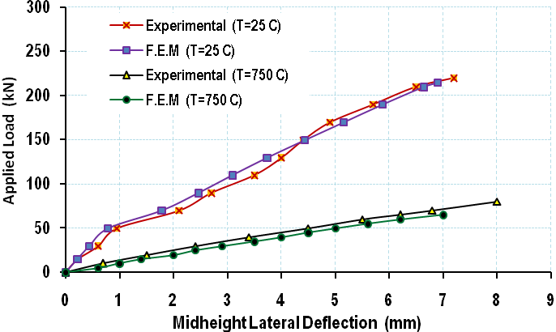
Figure(19): Load-midheight lateral deflection behavior for column specimens B₃₁ before and after burning.

°
°
°
°

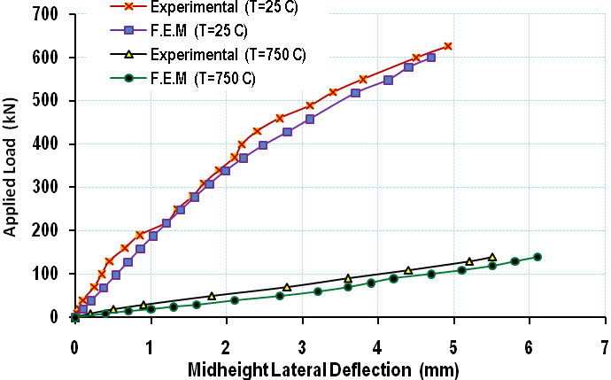
Figure(20): Load-midheight lateral deflection behavior for column specimens B21 before and after burning.
°
°
°
°

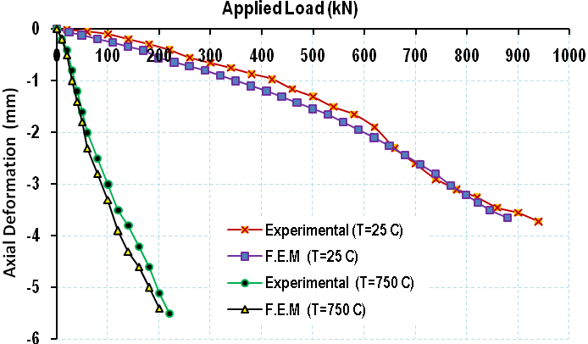
Figure(21): Load-axial deformation relationship for column specimens B11 before and after burning.

°
°
°
°

-Cracking Pattern
The ANSYS program records the crack pattern at each applied load step. It displays circles at locations of cracking or crushing in concrete elements. Cracking is shown with a circle outline in the plane of the crack, and crushing is shown with an octahedron outline. If the crack has opened and then closed, the circle outline will have an X through it. Each integration point can crack in up to three different planes. The first crack at an integration point is shown with a red circle outline, the second crack with a green outline, and the third crack with a blue outline.
Symbols shown at the element centroid are based on the status of all of the element's integration points. If any integration point in the element has crushed, the crushed (octahedron) symbol is shown at the centroid. If any integration point has cracked or cracked and closed, the cracked symbol is shown at the element centroid. If at least five integration points have cracked and closed, the cracked and closed symbol is shown at the element centroid. Finally, if more than one integration point has cracked, the circle outline at the element centroid shows the average orientation of all cracked planes for that element (ANSYS Help, 2005).
Crack patterns at different load steps obtained from the finite element analysis for concentric and eccentric applied load with (e= 30 and 80mm) are shown in Figures (6-10) to (6-12). At the midheight, the cracks were seen to be initiated from the tension zone and propagated towards the compression zone. Such cracks occured in samples with eccentricity equals 80mm, while for concentric and eccentric loaded e=30mm the cracks were located near support, at tension and compression zone.
On the other hand, variations of stress and strain in the longitudinal y-direction (SY and εY) it can be seen that there is no significant change in these parameters along the column specimen B₁₂, are shown in Figures (22) and (24).

Figure (22): Crack pattern of B₁₁ carried out by ANSYS computer
program for different stages of loading.

(a) At load=0.2 P_{u}
(d) At load=0.94 P_{u}
(c) At load=0.60 P_{u}
(b) At load=0.35 P_{u}

Figure (23): Crack pattern of B₂₁ carried out by ANSYS computer
program for different stages of loading.
(b) At load=0.40 P_{u}
(a) At load=0.20 P_{u}
(d) At load=0.94 P_{u}
(c) At load=0.60 P_{u}

Figure (24): Crack pattern of B₃₁ carried out by ANSYS computer
program for different stages of loading.
(b) At load=0.40 P_{u}
(a) At load=0.20 P_{u}
(d) At load=0.95 P_{u}
(c) At load=0.70 P_{u}

Conclusions
- The three-dimensional finite element model used in the present work is able to simulate the behavior of reinforced concrete columns. The cracking loads predicted is very close to that measured during the experimental test.
- The crack patterns at the final loads from the finite element models corresponded well with the observed failure modes of the tested columns.
- It is found that the experimental values of column capacity exceeds the theoretical values by a margin ranging between (1-23%).
- The results from testing and finite element analysis show that the prediction of the lateral deflection at midheight and axial deformation by the proposed analytical method show good agreement with the test results from the experimentally tested column specimens.
References
Sakai, K., and Sheikh, S.A., 1989, "What Do We Know About Confinement in Reinforced Concrete Columns", ACI Structural Journal, Vol.86, No.2, Mach-April, PP.192-207.
Kodur, V.R.K., Bisby, L.A., Green, M.F., and Chowdhury, E., 2005, "Fire Endurance Experiments on FRP-Strengthened Reinforced Concrete Columns", National Research Council of Canada, Institute for Research in Construction, Research Report No.185, March, 41pp.
Dong, Y. and Prasad, K., 2008, "Thermal and Structural Response of a Two-Story, Two-Bay Composite Steel Frame under Fire Loading", Proceedings of the Combustion Institute,8pp.
ANSYS, Copyright 2005, "ANSYS Help", Release 9.0.
Reshid, Y.R., 1968, "Ultimate Strength Analysis of Prestressed Concrete Pressure Vessels", Nuel. Eng. Des., Vol. 7, pp 334-344.
Chen, W. F. and Saleeb, A. F., 1981, "Constitutive Equations for Engineering Materials", West Lafayette, Indiana, December, 580 pp.
Kachlakev, D.I. and McCurry, D., Jr., 2000, "Simulated Full Scale Testing of Reinforced Concrete Beams Strengthened With FRP Composites: Experimental Results and Design Model Verification", Oregon Department of Transportation, Salem, Oregon, June.
Bangash, M.Y.H., 1989, "Concrete and Concrete Structures", Numerical Modeling and Applications, Elsevier Science Publishers Ltd, London, England.
Huyse, L., ,Hemmaty, Y., and Vandewalle, L., 1994, "Finite Element Modeling of Fiber Reinforced Concrete Beams", Proceeding of the ANSYS Conference ,vol.2. Pittsburgh, Pennsylvania, May.
Hemmaty, Y., 1998, "Modeling of the Shear Force Transformed Between Cracks in Reinforced Concrete Structures" Proceeding of the ANSYS Conference, Vol.1, Pittsburgh, Pennsylvania, August.
Desayi, P. and Krishnan, S., 1964, "Equation for the Stress-Strain Curve of Concrete", Journal of the American Concrete Institute, Vol. 61, March, PP. 345-350.
Gere, J.M., and Timoshenko, S.P., 1997, "Mechanics of Materials", PWS Publishing Company, Boston, Massachusetts.
Willam, K. J. and Warnke, E. P., 1975, "Constitutive Model for the Triaxial Behavior of Concrete", Proceedings, International Association for Bridge and Structural Engineering, Vol. 19, ISMES, Bergamo, Italy, pp. 174.
Aboalyonan, T.T., 2008, "High Temperature Behavior of Composite Beams", M.Sc. Thesis, College of Engineering, Department of Civil Engineering, University of Nahrain, December, 114 pp.
Purkiss, J.A., 2007, "Fire Safety Engineering Design of Structures", Second Edition, Printed and bound in Great Britain, 389pp.

