Convective Heat Transfer Behaviors of Power-Law Fluid in a Channel between two Parallel Plates

Hisham M. M. Al.Tamimi
Chemical Engineering Department, University of Al.Qadisiya/College of Engineering

Abstract
Laminar forced convection heat transfer in a non-Newtonian fluid flow in a channel between two parallel plates has been investigated analytically. Fully developed laminar velocity distributions obtained by a power-law fluid rheology model were used, and viscous dissipation was taken into account. The theoretical analysis of the heat transfer is performed under a constant heat flux case. An important feature of this approach is that it permits an arbitrary distribution of the surrounding medium temperature and an arbitrary velocity distribution of the fluid. These techniques were verified by a comparison with the existing results. The effects of the Brinkman number and rheological properties on the distribution of the local Nusselt number have been studied. It is shown that the Nusselt number strongly depends on the value of power law index. The Nusselt number sharply decreases in the range of 0 < n < 0.1. However, for n > 0.5, the Nusselt number decreases monotonically with the increasing n, and for n > 1, the values of Nusselt number approach a constant value.
Keywords: Forced convection, heat transfer, Non-Newtonian fluid, viscous dissipation, laminar flow, parallel plates.
الخلاصة
تم دراسة سلوك انتقال الحرارة بالحمل ألقسري الطبقي للموائع الغير نيوتينية الجارية في قناة بين صفيحتين متوازيتين تحليليا.تم الحصول على توزيعات للسرعة الطبقية المكتملة التطور باستخدام نموذج الريولوجيا لمائع ذو قانون القدرة ,والتبدد أو التشتت اللزج تم أخذها في الحسابات.التحليل النظري لانتقال الحرارة نظم في حالة أنه تدفق الحرارة يكون ثابتا. اللمحة المهمة لهذا الاقتراب هو أن يسمح للتوزيع الاعتباطي أو ألتبددي لدرجة الحرارة المحيطة وتوزيع السرعة الاعتباطي أو ألتبددي للمائع. وتم التحقق من هذه التقنيات من خلال المقارنة مع النتائج الخارجة. وقد تم دراسة الآثار المترتبة على عدد برينكمان والخصائص الريولوجية على توزيع عدد نسلت ألموقعي. ويظهر أن عدد نسلت يعتمد بشدة على قيمة دليل قانون القدرة. عدد نسلت يتناقص بشكل كبير بحدود 0 <n <0.1. ومع ذلك ، لقيمة n> 0.5، وعدد نسلت يتناقص بصورة أضطرادية بأزديادة قيمة n، وبالنسبة n> 1، قيم عد نسلت تقترب من أن تكون قيمة ثابتة.

List of symbols
B vertical distance between the two stationary plates, m
Br Brinkman number = mu_{m} ^{n+1}b^{n-1}/ [k (T_{w} − T_{c})]
c_{p} specific heat (J kg⁻¹ K⁻¹)
h local heat transfer coefficient (W/m² .K)
n power-law model parameter (Pa.s^{n} )
Nu local Nusselt number = 2hb/k
T fluid temperature (K)
u axial fluid velocity (m/s)
u_{m} mean axial fluid velocity (m/s)
Pe Peclet number = 2u_{m} b/$α$
q_{w} constant heat flux (W/m²)
x horizontal coordinate (m).
y vertical coordinate (m).

Greek symbols
η dimensionless horizontal coordinate =x/(u_{m}b² .$α$)
k thermal conductivity (W/m K)
θ dimensionless fluid temperature = (T_{w} − T)/(T_{w} − T_{c})
$φ$ dimensionless velocity = u/u_{m}
$α$ thermal diffusivity (m²/s)
ρ fluid density (kgm⁻³)
τ_{rx} shear stress (Pa/m²)
ξ dimensionless vertical coordinate = y/b

Subscripts
b bulk
c centerline
w wall

1. Introduction
An understanding of convection heat transfer in non-Newtonian fluids between two parallel plates is crucial to the design of several types of thermal equipments. From this viewpoint, heat transfer problems of this type have been investigated by a number of researchers (Ou, Cheng, 1973), (Basu, and Roy, 1985), (Barletta, and Zanchini, 1997) .The problem pertaining to the derivation of the local Nusselt number in the thermal region when an incompressible fluid flows through a pipe with a fully developed velocity distribution is of particular interest; this problem is referred to as the Graetz problem. It has attracted the interest of not only engineers but also applied mathematicians because of the difficulties involved in deriving its solution. The original Graetz problem, which was first analytically solved by Graetz, therefore it is important to refer to the classical Graetz –Nusselt problem in single phase flow that neglects the effects of axial heat conduction, viscous dissipation, and thermal energy sources within the fluid. It is regarded as one of the most important solutions in the heat transfer science and it governs forced convection heat transfer for fluid with known velocity profile and involves finding of the heat transfer rate in a fully developed flow of fluid flowing inside conduit of various cross-sectional geometries with constant heat flux or constant wall temperature mode of heating. This type of solution allows temperature profile to be calculated from the coupled equations of motion and energy (Kays, and Crawford, 1993).A comprehensive analytically studies for the fully developed power-law fluid flowing in a circular tube for both uniform wall heat flux and wall temperature has been done (Abdulmohsin, and Abid, 2002) but the authors neglected the effects of viscous dissipation. They show that the value of Nusselt number for a power-law fluid within uniform heat flux is given by:
$\text{Nu}=\frac{8(8n+1)(4n+1)}{\text{31}n^{2}+\text{13}n+1}$ … (1)
Where $n$is the power-law index. For Newtonian fluid, i.e. for$n=1$, Eqn. (1) yields the well known result as:
$\text{Nu}=8=\text{const}\text{.}$ … (2)
Where this result in Eqn. (2) was confirmed early by many number of authors (Lin, et al., 1983), (Rohsenow, et al., 1985). However, the Graetz problem has been extended over problems that focus on turbulent flows, non-Newtonian flows, forced convection in a porous medium, and the effects of viscous dissipation for Newtonian fluid and that include effects of heat conduction (Dang, 1983 ),( Liou, and Wang, 1990), (Lawal, and Mujumdar, 1992) ,(Zanchini, 1997), (Lahjomri,et al., 2003), (Nield, et al., 2003) and (Aydin, 2005). In all the works cited above there is no studied related to the effects of viscous dissipation on heat transfer with non-Newtonian fluid.
Therefore, the objectives of this study is to mathematically solve the forced convection heat transfer problem between two stationary plates subjected to constant heat flux for fully developed region, which is a type of Graetz problem, and derive completely analytical solutions for the fluid temperature profile and local Nusselt number. Since the present study focuses on heat transfer with a sufficiently large Peclet number$\left(\text{Pe}\right)$, the axial heat conduction is considered negligible. However, viscous dissipation is taken into account. Numerical calculations are performed to demonstrate the effects of the Brinkman number $\left(\text{Br}\right)$ and rheological properties on the distribution of the local Nusselt number

2. Mathematical Model and Formulation
Figure 1 shows the physical model and coordinate system. A non-Newtonian fluid with fully developed velocity profile $u(y)$flows between two rectangular stationary plates of a part$b$.The plates are convectively heated or cooled by the surrounding medium of constant heat flux$q_{w}$.

Constant heat flux, q_{w}

Entry region
y=b
y b=B/2 flow of velocity profile u(y)

x
b=B/2 fully developed flow region
y=b

Constant heat flux, q_{w}
Figure 1: Notations and axes of the problem.

According to the type of fluid flowing between the paralleled plates, a power-law fluid, which can approximate the non-Newtonian viscosity of many types of fluids with good accuracy over a wide range of shear rates, is considered here. The shear stress $\left(τ_{\text{xy}}\right)$acting on the viscous fluid is given by the formula (Bird et al., 2002):
$τ_{\text{xy}}=−m{\left|\frac{\text{du}}{\text{dy}}\right|}^{n−1}\frac{\text{du}}{\text{dy}}$ … (3)
Where $m$ and $n$ are the power-law model parameter and index, respectively. Depending on power law index$\left(n\right)$; there are three cases as:
a. $n<1$ indicates that the fluid is a pseudo-plastic fluid,
b. $n=1$indicates that the fluid is equivalent to a Newtonian fluid, and
- $n>1$ Indicates that the fluid is a dilatants fluid.
As stated earlier, the fully developed velocity distribution is derived in terms of mean velocity $\left(u_{m}\right)$ as follows (Bird, B., Stewart, E., and Lightfoot, N., 2002):

$\frac{u(y)}{u_{m}}=\frac{3n+1}{n+1}\left[1−{\left(\frac{y}{b}\right)}^{\frac{n+1}{n}}\right]$ … (4)
where $\left(u_{m}\right)$ is the mean velocity.
By coupling Eqn. (3) with Eqn. (4), the shear stress for non-Newtonian power-law can be expressed by:
$τ_{\text{xy}}=m{\left[\left(\frac{u_{m}}{b}\right)\left(\frac{3n+1}{n}\right){\left(\frac{y}{b}\right)}^{1n}\right]}^{n}$ … (5)
In order to illustrate the solution technique without complicating analytical procedure further, a number of simplifying assumptions are made for the simplified of the basic equation as:
- The flow mode is laminar, steady and axial symmetry.
- The fluid physical properties are independent of temperature and pressure,
- The axial heat conduction is negligible relative to vertical heat conduction,
- The natural convection effects are neglected
In this case, the steady-state heat balance taking viscous dissipation into account is expressed as follows [18]:
$k\frac{∂}{∂y}\left(\frac{∂T}{∂y}\right)={ρc}_{p}u(y)\left(\frac{∂T}{∂x}\right)−τ_{\text{xy}}\left(\frac{\text{du}}{\text{dy}}\right)$ … (6)
Where ρ, c and k are the density, specific heat and thermal conductivity, respectively. In addition, the second term on the right-hand side is the viscous dissipation term effects.
In order to avoid difficulties of definitions the heat transfer and to simplify the mathematical treatments, three modified boundary conditions are proposed and employed for special process requirements as:
-At center; by applying constant centerline temperature gives:
B.C 1 at $y=0$ $T=T_{c}$ … (7)
-By symmetry, there can be no heat flux across the centerline in the rectangular; this case means that the vertical temperature gradient is zero, therefore:
B.C 2 at $y=0$ $\frac{∂T}{∂y}=0$ … (8)
-At wall; the identified temperature gives the third boundary condition:
B.C 3 at $y=b$ $T=T_{w}$ … (9)
Now, substituting the velocity profile, Eqn. (4), into energy balance Eqn. (6) yields;
$\frac{∂}{∂y}\left(\frac{∂T}{∂y}\right)=\frac{u_{m}}{α}\left(\frac{3n+1}{n+1}\right)\left[1−{\left(\frac{y}{b}\right)}^{\frac{n+1}{n}}\right]\left(\frac{∂T}{∂x}\right)+\frac{m}{k}{\left(\frac{3n+1}{n}\right)}^{n+1}{\left(\frac{u_{m}}{b}\right)}^{n+1}{\left(\frac{y}{b}\right)}^{\frac{n+1}{n}}$ … (10)
Where $α$ is thermal diffusivity and defined by:
$α=\frac{k}{{ρc}_{p}}$ … (11)
Generally, one tries to select dimensionless quantities so as to minimize the number of parameter in the final problem formulation and that is useful in scale-up problems by introducing the following dimensionless variables:
$\begin{aligned}\left.ξ=\frac{y}{b};η=\frac{x}{2\text{bPe}} | \right\}\end{aligned}$ … (12)
Substitution of Eqn. (12) into Eq. (10) yields a dimensionless partial differential equation as:
$\frac{∂}{∂ξ}\left(\frac{∂θ}{∂ξ}\right)=\frac{1}{4}\left(\frac{3n+1}{n+1}\right)\left[1−ξ^{\frac{n+1}{n}}\right]\left(\frac{∂θ}{∂η}\right)−\text{Br}{\left(\frac{3n+1}{n}\right)}^{n+1}ξ^{\frac{n+1}{n}}$ … (13)
Where the Brinkman number $\left(\text{Br}\right)$ is defined by:
$\text{Br}=−\frac{{\text{mu}}^{n+1}}{{\text{kb}}^{n−1}\left(T_{w}−T_{c}\right)}$ … (14)
and the Peclet number $\left(\text{Pe}\right)$is given by :
$\text{Pe}=\frac{2u_{m}b}{α}$ … (15)
Based on these new parameters and Eqns. (7), (8) and (9), the dimensionless boundary conditions becomes as:
B.C: 1 at $ξ=0$ ; $θ=1$ … (16)
B.C: 2 at $ξ=0$ ; $\frac{dθ}{dξ}=0$ … (17)
B.C: 3 at $ξ=1$ ; $θ=0$ … (18)
Generally for the case of constant heat flux, radial temperature profiles are well stabilized; so that $θ(ξ,η)$ is a function of dimensional vertical coordinate $\left(ξ\right)$ alone, the constancy of the flux implies that:
$\frac{∂θ}{∂η}=A_{0}$ … (19)
Where$A_{0}$ is a constant; substituting Eqn. (19) into Eqn. (13) yields an ordinary differential equation, as:
$\frac{d}{dξ}\left(\frac{dθ}{dξ}\right)=\frac{A_{0}}{4}\left(\frac{3n+1}{n+1}\right)\left[1−ξ^{\frac{n+1}{n}}\right]−\text{Br}{\left(\frac{3n+1}{n}\right)}^{n+1}ξ^{\frac{n+1}{n}}$ … (20)
Let introduce new other simplified parameters as:
$N={\left(\frac{3n+1}{n}\right)}^{n+1}\text{Br}$ … (21)
$C_{0}=\frac{A_{0}}{4}\left(\frac{3n+1}{n+1}\right)$ … (22)
and
$β=\frac{n+1}{n}$ … (23)
Now, substituting Eqns. (21), (22) and (23), into Eqn. (20) yields;
$\frac{d}{dξ}\left(\frac{dθ}{dξ}\right)=C_{0}\left(1−ξ^{β}\right)−{Nξ}^{β}$ … (24)
This separable differential equation can be directly integrated twice with respect to dimensionless vertical coordinate$(ξ)$; the results give temperature profile between two parallel plates as follows:
$θ\left(ξ\right)=C_{0}\left(\frac{1}{4}ξ^{2}−\frac{1}{{\left(β+2\right)}^{2}}ξ^{β+2}\right)−\frac{N}{{\left(β+2\right)}^{2}}ξ^{β+2}+C_{1}\text{ln}ξ+C_{2}$ … (25)
in which $C_{1}$and $C_{2}$are constants of integration. These two constants can be evaluated from the first two boundary conditions Eqn. (16) and Eqn. (17) and by utilizing of Eqn. (25), as:
$C_{1}=0$ and $C_{2}=1$ … (26)
These two expressions of integration constants can be inserted into Eqn. (25) and rearranged to give the dimensionless temperature profile as follows:
$θ\left(ξ\right)=C_{0}\left(\frac{1}{4}ξ^{2}−\frac{1}{{\left(β+2\right)}^{2}}ξ^{β+2}\right)−\frac{N}{{\left(β+2\right)}^{2}}ξ^{β+2}+1$ … (27)
Based on the third boundary condition, Eqn. (18), with Eqn. (27), one can find parameter
$C_{0}=4\left[\frac{\left(N−{\left(β+2\right)}^{2}\right)}{\left(4−{\left(β+2\right)}^{2}\right)}\right]$ … (28)
When substitution for $C_{0}$ into Eqn. (27), the local temperature distribution becomes as:
$θ\left(ξ\right)=\left(\frac{\left(N−C_{0}\right)}{{\left(β+2\right)}^{2}}\right)ξ^{β+2}+\left(\frac{C_{0}}{4}\right)ξ^{2}+1$ … (29)
In another form:
$\frac{T_{w}−T(y)}{T_{w}−T_{c}}=\left(\frac{\left(N−C_{0}\right)}{{\left(\frac{3n+1}{n}\right)}^{2}}\right){\left(\frac{y}{b}\right)}^{\frac{3n+1}{n}}+\left(\frac{C_{0}}{4}\right){\left(\frac{y}{b}\right)}^{2}+1$ … (30)
This equation represents the temperature profile for power-law fluid between two parallel plates with viscous effects under the effect of constant heat flux.
In fully-developed flow, it is usual to utilize the bulk temperature (mean fluid temperature),$T_{b}$, rather than the center-line temperature when defining the Nusselt number [8,18]. This mean or bulk temperature is given by (Bird, B., Stewart, E., and Lightfoot, N., 2002):
$T_{b}=\frac{{ρc}_{p}\int_{0}^{b}{T(y)u(y)\text{dy}}}{{ρc}_{p}\int_{0}^{b}{u(y)\text{dy}}}$ … (31)
In dimensionless form of bulk temperature$\left(θ_{b}\right)$, Eqn. (31) becomes:
$θ_{b}=\frac{\int_{0}^{1}{θ(ξ)φ(ξ)dξ}}{\int_{0}^{1}{φ(ξ)dξ}}$ … (32)
Where $φ$the dimensionless velocity is profile and defined as:
$φ=\frac{u}{u_{m}}$ … (33)
By substitution velocity and temperature profiles Eqns. (4) and Eqn. ( 29) into Eqn. (32) becomes:
$θ_{b}=\frac{\int_{0}^{1}{\left\{\left[\left(\frac{\left(N−C_{0}\right)}{{\left(β+2\right)}^{2}}\right)ξ^{β+2}+\left(\frac{C_{0}}{4}\right)ξ^{2}+1\right]\left(1−ξ^{β}\right)\right\}dξ}}{\int_{0}^{1}{\left(1−ξ^{β}\right)ξdξ}}$ … (34)
Taking the generality of the analysis into account, this equation, Eqn. (34), can be readily integrated to obtain the dimensionless forms of bulk temperature as follows:
$θ_{b}\text{==}\left[\frac{2\left(N−C_{0}\right)}{\left(β+2\right)\left(β+3\right)\left(2β+3\right)}\right]+\left(\frac{C_{0}\left(β+2\right)}{8\left(β+4\right)}\right)+1$ … (35)
According to the axes that shown in Figure 1, the local heat transfer coefficient between two plates is normally defined by: he local heat transfer
$q_{w}=h\left(T_{w}−T_{b}\right)=k\frac{\text{dT}}{\text{dy}}|_{y=b}$ … (36)
According to the definition the local Nusselt number $\left(\text{Nu}\right)$ is given by:
$\text{Nu}=\frac{\text{hB}}{k}=\frac{2b\frac{\text{dT}}{\text{dy}}|_{y=b}}{\left(T_{w}−T_{b}\right)}$ … (37)
Based on dimensionless parameters, the local Nusselt number $\left(\text{Nu}\right)$ is can be expressed by:
$\text{Nu}=2\frac{\frac{dθ}{dξ}|_{ξ=1}}{\left(θ_{w}−θ_{b}\right)}$ … (38)
Where $θ_{W}$ is the dimensionless wall temperatures, which could be evaluated by$θ_{w}=θ|_{ξ=1}$, therefore when substitution in Eqn. (29), the results could be as:
$θ_{w}=θ|_{ξ=1}=\left[\frac{\left(N−C_{0}\right)}{{\left(β+2\right)}^{2}}\right]+\left(\frac{C_{0}}{4}\right)+1$ … (39)
In addition, from Eqn. (29), the temperature gradient at wall $\left(\frac{dθ}{dξ}|_{ξ=1}\right)$is given as:
$\frac{dθ}{dξ}|_{ξ=1}=\frac{\left(2N+{βC}_{0}\right)}{2\left(β+2\right)}$ … (40)
By substitution the Eqns. (35), (39) and (40) into Eqn. (38) and simplified the results, the final results of Nusselt number $\left(\text{Nu}\right)$can be evaluated and expressed as:
$\text{Nu}={\left[\frac{\text{31}n^{2}+\text{13}n+1}{8(8n+1)(4n+1)}+2^{n−1}\text{Br}{\left(\frac{3n+1}{n}\right)}^{n}\right]}^{−1}$ … (41)
This equation represents the Nusselt number for power-law fluid between two stationary plates with viscous effects under the effect of constant heat flux for fully developed laminar flow.

3. Results and Discussion
In the absence of viscous dissipation (Br=0) the solution is independent of whether there is wall heating or cooling. However, viscous dissipation always contributes to internal heating of the fluid; hence the solution will differ according to the process taking place. The Brinkman number (Br) is chosen as a criterion which shows the relative importance of viscous dissipation. For brevity and standing in a reasonable range, -1 < Br < 1. Where positive values of $\text{Br}$correspond to wall heating (T_{w} > T_{c} and Br>0) case that mean heat is being supplied across the walls into the fluid, while the opposite is true for negative values of Br, that mean wall cooling cases (T_{w} < T_{c} and Br<0).
As stated earlier that the thermal boundary conditions have been considered for the plates wall as constant heat flux. For this boundary condition both wall heating or wall cooling cases are examined and treated separately.
Figures 2a, b and c shows the temperature profiles made dimensionless using this scale for wall heating, no viscous dissipation and wall cooling cases, respectively, where these profiles based on Eqn. (29). These plots make clear the aforementioned effects of increased dissipation. As expected, increasing dissipation increases the bulk temperature of the fluid due to internal heating of the fluid. For the wall heating case, this increase in the fluid temperature decreases the temperature difference between the wall and the fluid, as will be shown later, which is followed with a decrease in heat transfer. When wall cooling is applied, due to the internal heating effect of the viscous dissipation on the fluid temperature profile, temperature difference is increased with the increasing Brinkman number$\left(\text{Br}\right)$. In fact, wall cooling is applied to reduce the bulk temperature of the fluid, while the effect of the viscous dissipation is increasing the bulk temperature of the fluid. Therefore, the amount of viscous dissipation may change the overall heat balance. When the Brinkman number exceeds a certain limiting value, the heat generated internally by viscous dissipation process will overcome the effect of wall cooling.

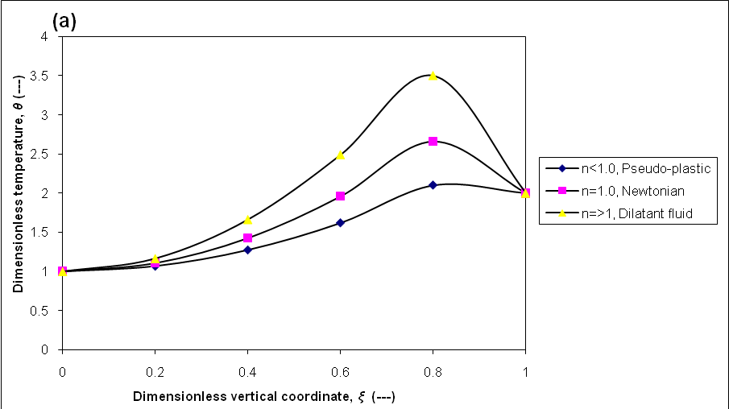

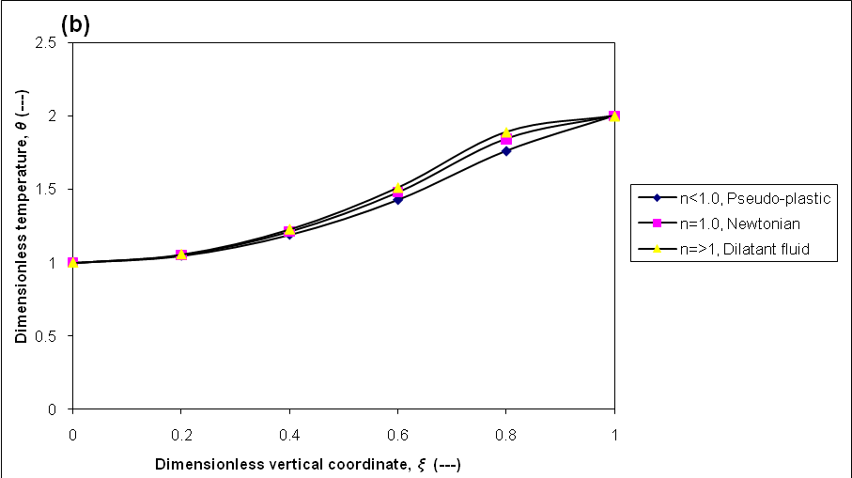

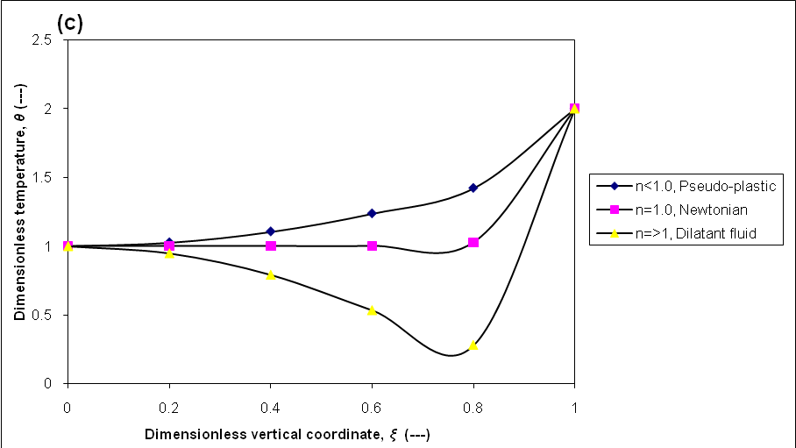

Figure 2: Effects of power law index on dimensionless fluid temperature profiles for: (a) heating wall (Br=-1.0), (b) no viscous dissipation (Br=0.0), and (c) cooling wall (Br=1.0).

Figure 3 represents the variation of Nusselt number with the rheological properties (power-law index) for constant heat flux case with different values of Brinkman number. Where the asymptotic and downstream Nusselt number profiles are shown clearly for wall heating (Br > 0). When wall cooling (Br < 0) is applied to reduce the bulk temperature of the fluid, as explained earlier, the amount of viscous dissipation may change the overall heat balance. With increasing value of Br in the negative direction, the Nusselt number reaches an asymptotic value. As noticed, when Br goes to infinity for either the wall heating or the wall cooling case, the Nusselt number reaches the same asymptotic value. This is due to the fact that the heat generated internally by viscous dissipation processes will balance the effect of wall cooling. Generally, Nusselt number with viscous effects for both wall heating and wall cooling is less than Nusselt number for non viscous dissipation.

Figure 3: Effects of power-law index on Nusselt number for different values of Brinkman number.

While Figure 4 represents the variation of Nusselt number with the Brinkman number for constant heat flux case with different values of power law index (n). As shown, a singularity is observed at Br < 0.5. Actually, this is an expected result, when Eqn. (41) is closely examined. For the wall heating case, with the increasing value of Br, Nu decreases to reach constant values. This is because the temperature difference which drives the heat transfer decreases. At Br=0.5, the heat supplied by the wall into the fluid is balanced with the internal heat generation due to the viscous heating. For Br > 0.5, the internally generated heat by the viscous dissipation overcomes the wall heat. When Br=1.0, Nu reaches an asymptotic value. Generally, Nusselt number Newtonian fluid is higher than those for pseudo- plastic and dilatants fluids.
Figure 4: Effects of Brinkman number on Nusselt number for different values of power-law index.

4. Conclusion
The forced convection heat transfer problem with viscous dissipation between two plates subjected to constant heat flux has been solved mathematically, which is a type of the Graetz problem. Completely analytical solutions for the fluid temperature and local Nusselt number (Nu) have been derived. The effects of the Brinkman number (Br) and rheological properties (power-law index) on the distribution of the local Nusselt number have been shown through numerical calculations. The following conclusions are drawn:
1. The local Nusselt number in the thermal region tends to increase with a decrease in the power-law model index (n).
2. It has been shown that viscous dissipation in the fluid can significantly influence laminar flow heat transfer.
3. With regard to the Graetz problem, the present analytical method can be applied to heat transfer not only in a channel between parallel plates but also in a concentric annulus;
4. It can also be applied to heat transfer in a channel with a moving wall because there is no restriction on the velocity distribution form of a fluid.

5. References
Abdulmohsin, R., and Abid, B., “Modeling of heat transfer to non-Newtonian power-law fluid between two plates”, Eng. Journal of Nahrain University, Vol.6, pp.249-269 (2002).
Aydin, O. "Effects of viscous dissipation on the heat transfer in a forced pipe flow; Part 2: thermally developing flow" Energy Conversion and Management, Vol. 46, pp.3091–3102 (2005).
Aydın, O., "Effects of viscous dissipation on the heat transfer in a forced pipe flow; Part 1: hydrodynamicly developing flow " Energy Conversion and Management, Vol. 46, pp.757–69 (2005).
Barletta, A., and Zanchini, E. "Forced convection in the thermal entrance region of a circular duct with slug flow and viscous dissipation" Int. J. Heat and Mass Transfer, Vol. 40, pp.1181–90 (1997).
Basu, T., and Roy, N. "Laminar heat transfer in a tube” Int. J. Heat and Mass Transfer, Vol. 28, pp.699–701(1985).
Bird, B., Stewart, E., and Lightfoot, N., “Transport phenomena” 2nd Edition, John Wiley & Sons, New York (2002).
Brinkman, C. "Heat effects in capillary flow” Appl. Sci. Res., A2, pp.120–124, (1951).
Dang, D. "Heat transfer of a power-law fluid at low Peclet number flow" J. Heat Transfer, Vol.105, pp.542–549 (1983).
Kays,W., and Crawford, M., “Convective heat and mass transfer”, 2nd Edition, McGraw-Hill, New York (1993).
Lahjomri, J., Zniber, K., Oubarra, A., and Alemany, A. "Heat transfer by laminar flow in the thermal entrance region with uniform wall heat flux: the Graetz problem extended” Energy Conversion and Management, 2003, Vol.44, pp.11–34 (2003).
Lawal, A., and Mujumdar, S. "The effects of viscous dissipation on heat transfer in arbitrary cross sectional ducts" Int. J. Heat and Mass Transfer, Vol. 35, pp.437–46 (1992).
Lin, F., Hawks. H., and Leidenfrost, W. "Analysis of heat transfer in laminar flows between two plates with convective boundary conditions" Int. J. Heat and Mass Transfer, Vol. 26, pp. 97–105 (1983).
Liou, T., and Wang, S. "Solutions to the extended Graetz problem for a power-law fluid with different entrance boundary conditions" Numerical Heat Transfer, Vol. 17, pp. 91–108 (1990).
Nield, A., Kuznetzov, V., and Xiong, M. ‘Thermally developing forced convection in porous medium: parallel plate channel with walls at uniform temperature, with axial conduction and viscous dissipation effects”, Int. J. Heat and Mass Transfer, Vol.46, pp.643–51(2003).
Ou, J.,and Cheng, C. "Heat transfer in pipes with uniform heat flux" Appl. Sci. Res. Vol. 28, pp.289–301 (1973).
Rohsenow, W., Hastnetti, J., and Gonic, E. " Handbook of heat transfer applications" 2nd Edition , McGraw-Hill Com., New York (1985).
Zanchini E. "Effect of viscous dissipation on the asymptotic behavior of laminar forced convection in circular tubes" Int. J. Heat and Mass Transfer, Vol. 40, pp.169–78 (1997).

