Compressive Behavior of Plain Concrete Columns, Confined with CFRP Wraps

Khalid Karim Shadhan Mohammed Jassam Mohammed Awad Ali Sagheer
University of Babylon University of Babylon University of Karbala
College of Engineering College of Engineering College of Engineering

Abstract
This work consists of fabrication and testing of fourteen plain concrete short columns. Ten of these columns have been wrapped by various plies of Carbon Fiber Reinforced Polymer (CFRP) sheets. The experimental variables considered in the test program include, the unconfined concrete core strength , the number of CFRP layers ,the fiber orientation in the laminate structure and the column cross section. All concrete columns are tested under concentric compression. The experimental results are evaluated for determining the contribution of CFRP wraps on the compression behavior of low, normal and high strength concrete. It is found out that for both low and normal strength concrete, CFRP wraps can significantly enhance the compression performance. The confinement effectiveness reduced with increase in the unconfined concrete strength. Shape of cross sections of columns can directly affect the confinement effectiveness of externally bonded CFRP wraps. Benefit of strength is higher for circular than for square section. Poor confinement may be due to sharp edges in cross-sections.
الخلاصة:
يتكون هذه العمل من إنشاء و فحص أربعة عشر نموذجا من الأعمدة الخرسانة القصيرة, عشرة نماذج منها مطوقة بطبقات من صفائح البوليمر المقوى بألياف الكاربون. المتغيرات الاختبارية التي تم اعتمادها في الفحص المختبري شملت مقاومة الخرسانة غير المطوقة , عدد طبقات صفائح البوليمر المقوى بألياف الكاربون, زاوية ميلان ألياف الكاربون بالإضافة إلى شكل مقطع العمود. تم فحص الأعمدة الخرسانة جميعها تحت أحمال ضغط مركزية. تم تقييم النتائج فيما يتعلق بمساهمة أطواق من صفائح البوليمر المقواة بألياف الكاربون بمقاومة الخرسانة الواطئة والاعتيادية والعالية المقاومة. وقد وجد إن أطواق البوليمر بإمكانها تقوية أداء الانضغاط للخرسانة الواطئة والاعتيادية بشكل كبير, كما وجد إن كفاءة التقييد تقل بزيادة مقاومة الخرسانة. إن شكل مقطع العمود يؤثر بشكل مباشر على كفاءة أطواق صفائح البوليمر المقوى بألياف الكاربون, كما إن مقدار الفائدة يكون اكبر في المقاطع الدائرية الشكل أكثر منه في المقاطع المربعة الشكل والذي يمكن أن نعزوه إلى الحافات الحادة في هذه المقاطع.
1. Introduction
Low concrete quality and lack of adequate confinement reinforcement in reinforced concrete column, which may cause structural damage leading to the collapse of structures, are among major deficiencies for existing reinforced concrete structures in Iraq. To overcome these problems, these deficient columns may be wrapped by FRP composites in transverse direction. Due to the passive lateral confinement pressure provided by FRP composites, significant enhancement on compressive strength and ductility of the structural members is possible (Ilki, et al., 2002). Several advantages are observed in using FRP wraps compared to the most common other techniques based on the use of steel reinforcements such as: the high-mechanical properties of the materials (tensile strength and elasticity modulus) compared with its lightness , its insensitivity to corrosion, the ease of applying the reinforcing materials (Campione , 2006).
In Ilki et al. (2002), twelve slandered cylinders (150mm×300mm) specimens wrapped by of CFRP jackets and two specimens without any wrap. The only variable studied is the number of layers. The 180 days average compressive strength of the unconfined concrete strength specimens was 6.2 MPa. The effectiveness ratio of the specimens wrapped by 2, 4 and 6 layers of CFRP wraps increases to 6.6, 12. 4 and 17.5, respectively.
Buyukozturk and Au (2005) investigated the effect of fiber orientations on the behavior of FRP confined concrete cylindrical specimens (150mm×375mm). The unconfined concrete strength was 24.2 MPa. Three types of ply configurations are tested (0º hoop, 0º/90º hoop/vertical, and -45º/45º bi-angular fiber orientation). The effectiveness ratio varies from 1.1 to 2.0.
Modarelli et al. (2005) tested 124 plain concrete specimens, which included 85 specimens with FRP. The variables studied were the cross section shape (circular, square and rectangular), the effect of corner radius (10mm and 20mm), the unconfined concrete strength (28MPa and 38MPa), the amount of confinement in terms of the number of CFRP sheet layers (1,2 and 3), and the type of fiber ( carbon and glass). The effectiveness ratio varies from 1.0 to 3.3.
Shehata et al. (2007) tested a series of 99 concrete short columns under axial compression. The variables studied were the column cross section shape (circular, square and rectangular), the column size, and the amount of confinement in the number of CFRP sheet layers (one or two layers). The unconfined concrete strength varies form 23.7MPa to 61.7MPa. The effectiveness ratio varies from 1.1 to 2.4.
Benzaid et al. (2008) investigate the behavior of concrete square prisms confined by E-glass fiber composite. Twenty-one prisms of size 100mm×100mm×300mm were tested under strain control rate of axial loading. The unconfined concrete strength was 54.8MPa. The variables studied were the effect of corner radius (0-sharp edge, 8mm and 16mm), and the amount of confinement in the number of GFRP sheet layers (1 and 2). The effectiveness ratio varies from 1.0 to 1.4.
In most of these studies, normal and high strength concrete specimens are taken into consideration. Research studies deal with low strength concrete (concrete compressive strength less than 20 MPa) is found very limited.

2. Experimental Program
2.1 Specimens
The experimental program consisted of axial compressive tests on plain concrete specimens wrapped with CFRP composites. Eleven concrete cylinders 100mm×200mm and three prisms 100mm×100mm×200mm are tested. The variables studied are the unconfined concrete core strength, the amount of confinement expressed in the number of CFRP sheet layers applied to the specimen , the fiber orientation and the column cross section . Table (1) presents the geometric and strength characteristics of the test specimens.
The effect of unconfined concrete core strength is examined by using three target strengths of 10, 25 and 50 MPa which represent low, normal and high strength concrete, respectively. However, the obtained average strengths of concrete batches are 8.7, 20.4 and 48.1 MPa, respectively. The low, normal and high strength concrete cylinders are wrapped with one layer of CFRP sheet with $0^{ο}$fiber orientation with respect to the hoop direction (specimens L-HP-1, N-HP-1 and H-HP-1).
The effect of number of layers of CFRP in a confining jacket is examined using three specimens (L-HP-1, L-HP-2 and L-HP-3) of number of layers including 1, 2 and 3 layers of CFRP resulting in the jacket thickness equal to 0.13mm, 0.26mm and 0.39mm, respectively. These levels are chosen to examine the sensitivity of CFRP jacket thickness on compressive behavior of confined specimens. In this comparison, the concrete core strength is 8.7 MPa and the fiber orientation is chosen 0º with respect to the hoop direction.
The effect of fiber orientation is examined by wrapping the 8.7 MPa concrete cylinders with two layers of CFRP sheet and three different ply configurations. For the first configuration, the two layers are placed with $0^{ο}$fiber orientation with respect to the hoop direction. For the second configuration, the first layer is placed with +90º and the second layer with 0º fiber orientation with respect to the hoop direction. For the third configuration, the first layer is placed with +45ºand the second layer with -45º fiber orientation with respect to the hoop direction. The three ply configurations discussed above, are briefly presented as 0º/0º,0º/90º and -45º/45º fiber orientation, respectively and shown in Figure (1).
To study the effect of the radius of corner , the confined concrete prisms are divided into reprehensive specimens: LP-0-1 sharp-edged square section of 100mm width; LP-0.15-1 square section with corner radius equal to 15mm that correspond to 0.15 of the width of the square section; LP-0.3-1 square section with corner radius equal to 30mm that correspond to 0.3 of the width of the square section.

Table (1): Geometric and strength characteristics of the test specimens
Specimen | $$f_{c^{′}}$$  (MPa) | Shape |  | Number of layers | Ply configuration
Specimen | $$f_{c^{′}}$$  (MPa) | *Dimensions (mm) | r/b | Number of layers | Ply configuration
L-NL-0 | 8.7 | C100×200 | --- | 0 | ---
L-HP-1 | 8.7 | C100×200 | --- | 1 | 0º
L-HP-2 | 8.7 | C100×200 | --- | 2 | 0º/0º
L-HP-3 | 8.7 | C100×200 | --- | 3 | 0º/0^{o/}0º
L-BI-2 | 8.7 | C100×200 | --- | 2 | -45º/45º
L-VH-2 | 8.7 | C100×200 | --- | 2 | 0º/90º
N-NL-0 | 20.4 | C100×200 | --- | 0 | ---
N-HP-1 | 20.4 | C100×200 | --- | 1 | 0º
H-NL-0 | 48.4 | C100×200 | --- | 0 | ---
H-HP-1 | 48.4 | C100×200 | --- | 1 | 0º
LP-NL-0 | 9.7 | P100×100×200 | 0 | 0 | ---
LP-0-1 | 9.7 | P100×100×200 | 0 | 1 | 0º
LP-0.15-1 | 9.7 | P100×100×200 | 0.15 | 1 | 0º
LP-0.30-1 | 9.7 | P100×100×200 | 0.30 | 1 | 0º
*C: Cylinder (diameter × height), P: Prism (width ×depth× height)

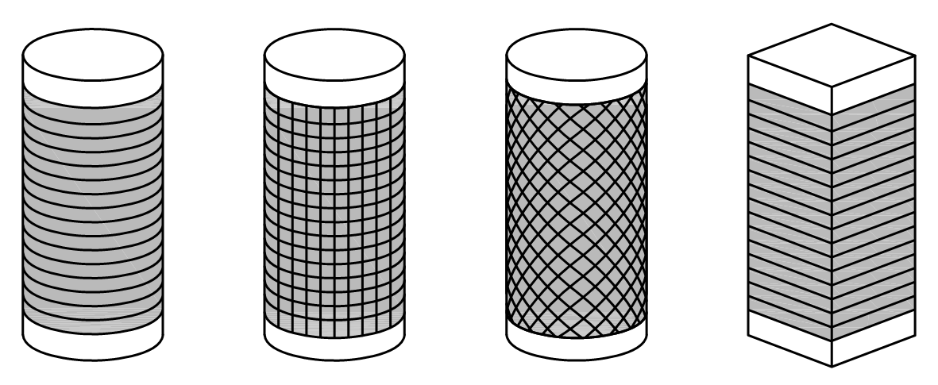
(a): 0º/ 0º
Hoop
(b): 0º/90º
Hoop/Vertical
(c): 45º/-45º
Bi-angular

Figure (1): Ply configurations in confined concrete specimens

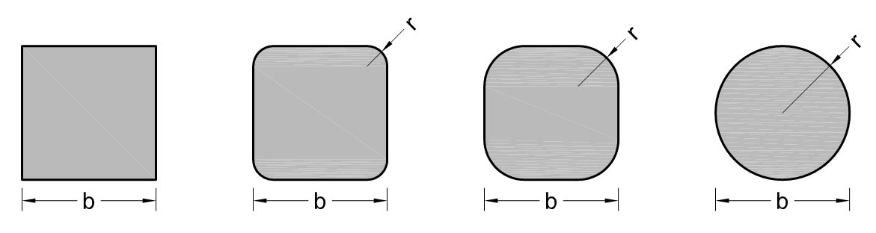
(a):
(b):
(c):

Figure (2): Ply configurations in confined concrete specimens

2.2 Materials
Three different concrete strengths are obtained by using different cement content and water to cement ratios as recommended in Neville (1995). The proportion of the mixtures is presented in Table (2). The carbon fiber fabric used for confinement of concrete specimens is SikaWarp® Hex-230C. A unidirectional carbon fiber reinforced polymer (CFRP) is produced by hand lay up technique using this product with Sikadur®-330 (two-part epoxy impregnation resin). The mechanical properties of carbon fibers and impregnation resin are taken from manufacturing specifications (Sika.2005) and shown in Table (3) and (4), respectively.

Table (2): Concrete mix proportions
Concrete type | Cement (kg/cm³) | Water  (kg/cm³) | w/c  Ratio | Super plasticizer  (%) | Coarse aggregate  (kg/cm³) | Fine aggregate  (kg/cm³)
Low | 286 | 200 | 0.7 | ---- | 940 | 908
Normal | 400 | 200 | 0.5 | ---- | 940 | 794
High | 600 | 180 | 0.3 | 0.80 | 1122 | 544

Table (3): Technical properties of CFRP composites (Sika, 2005)
Properties | SikaWarp® Hex-230C
Tensile strength (MPa) | >3500
E-modulus (GPa) | 230
Elongation at break (%) | >1.5
Width (mm) | 600
Thickness (mm) | 0.13

Table (4): Technical properties of bonding material (Sika, 2005)
Properties | Sikadur®-330
Tensile strength , MPa | > 30
Bond strength , MPa | Concrete fracture
E-modulus , GPa | 4.5
Elongation at break , % | 0.9
Open time , min. | 30 (at +35ºC)
Full cure , days | 7(at +35ºC)
Mixing ratio | 1:4

2.3 CFRP wrapping process
The surface of the concrete specimens should be clean and sound before being wrapped. The surface may be dry or damp but free of standing water. Therefore, existing dust, oil or curing is removed from the surface of the concrete specimens. Corners of the square cross section columns are rounded off to a required radius in order to prevent breakage of the CFRP sheets due to sharp bends.
A two-part impregnation resin (Sikadur®-330) is mixed in required proportion, until the color is a uniform grey, and then applied with a special tool to the concrete surface to a thickness of ~1.5 mm. The adhesive is also applied to the CFRP sheet to the same thickness. The CFRP sheet is then placed on the concrete ,epoxy to epoxy, and a rubber roller is used to properly seat the CFRP sheet by exerting enough pressure so the epoxy is forced out on both sides of the CFRP sheet and the adhesive line did not exceed 2mm in thickness. Next, another layer of resin is applied on the first layer and additional layers are applied, if required. After the specimens are confined, they are left in laboratory conditions for 7 days after gluing to be completely cured.
In all strengthened columns , each layer have an overlap of about 100mm to assure the development of full composite strength . In the case of columns strengthened with two or three layers , the overlap positions, one for each of the CFRP layers , are opposite to one another (Shehata et al.,2007).

3. Experimental results
Collapse of CFRP-warped specimens is due to fibers rupture ,failure occurred in a sudden and explosive way and is only preceded by typical creeping sounds. Test specimens after failure are shown in Figure (3). Fiber rupture in square section columns occurred close to the corner regions as expected from theoretical considerations. Effectiveness ratio for all tested specimens versus experimental variables are presented in Figure (4).
In Table (5) the experimental results are summarized , the increase in terms of confinement effectiveness ratio (f_{cc}/f_{co} where f_{cc} and f_{co} are the compressive strength of the confined and unconfined concrete specimens , respectively). It is evident that in all cases the presence of external CFRP wrapped increased the compressive strength of plain concrete , in different amount according to the number of CFRP layers , concrete properties and cross section geometry.
The influence of the concrete strength has been investigated on three different concrete strength: low-strength (specimen L-HP-1), normal-strength (specimen N-HP-1) and high-strength (specimen H-HP-1) . Fixed the geometry and the CFRP amount. As can be seen in Table (5), the increase of load capacity is higher for lower concrete strength than the one found for the higher concrete strength. The effectiveness ratio is 4.4,2.4 and 1.2 for concrete specimen with low , normal and high concrete strength , respectively. These specimens after failure are shown in Figures (3.a, 3.b and 3.c) , respectively.
As expected, the experiments indicated that any increase in CFRP jacket thickness caused an increase in maximum stress of the strengthened specimens. When the thickness of the wrapped CFRP composite jackets increase, the improvement on the behavior becomes much more significant. The effectiveness ratio of the specimens wrapped by 1,2 and 3 plies of CFRP wraps increases to 4.4 , 7.4 and 9.2 , respectively. These specimens after failure are shown in Figures (3.a, 3.d and 3.e) , respectively.
The effect of fiber orientation of CFRP in a confining jacket is examined using three sets of fiber orientations. In this comparison, the concrete core strength was 8.7MPa and the cylinders are confined with 2-layers of CFRP sheet. The fiber orientations included 0º/0º (specimen L-HP-2), 0º/+90º (specimen L-BI-2 ) and -45º/45º ( specimen L-VH-2). The effects of fiber orientation of layers on compressive behavior of confined concrete are shown in Table (5) and Figures (3.d,3.f and 3.j). A maximum increases of 7.4 in effectiveness ratio is observed for the specimen 0º/0º fiber orientation. The effectiveness ratio is 1.6 and 2.2 for specimen wrapped with -45º/45º and 0º/+90º fiber orientation, respectively.
It is observed in Table (5) that the corner radius of square sections has a fundamental importance for confinement effectiveness, in fact the increase of effectiveness ratio is of 1.6 for the specimen with r/D=0.0 , while the effectiveness ratio has been remarkably higher for the specimen with r/D=0.15 and r/D=0.30 being equal to 2.2 and 3.0 , respectively. Two of these specimens after failure are shown in Figures 3.h and 3.i.

Table (5): Ultimate strength and effectiveness ratio of tested specimens
Specimen | $$f_{\text{co}}$$  (MPa) | $$f_{\text{cc}}$$  (MPa) | Effectiveness ratio (f_{cc}/f_{co})
L-NL-0 | 8.7 | 8.7 | ----
L-HP-1 | 8.7 | 38.0 | 4.4
L-HP-2 | 8.7 | 64.7 | 7.4
L-HP-3 | 8.7 | 79.7 | 9.2
L-BI-2 | 8.7 | 22.8 | 2.6
L-VH-2 | 8.7 | 35.1 | 4.0
N-NL-0 | 20.4 | 8.7 | ----
N-HP-1 | 20.4 | 49.7 | 2.4
H-NL-0 | 48.4 | 48.4 | ----
H-HP-1 | 48.4 | 58.7 | 1.2
LP-NL-0 | 9.7 | 9.7 | ----
LP-0-1 | 9.7 | 15.7 | 1.6
LP-0.15-1 | 9.7 | 21.8 | 2.2
LC-0.30-1 | 9.7 | 29.1 | 3.0

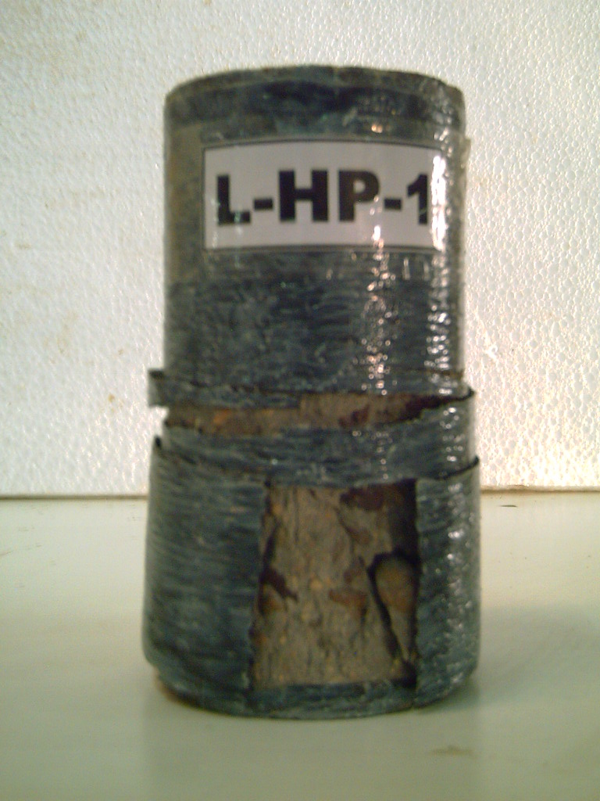
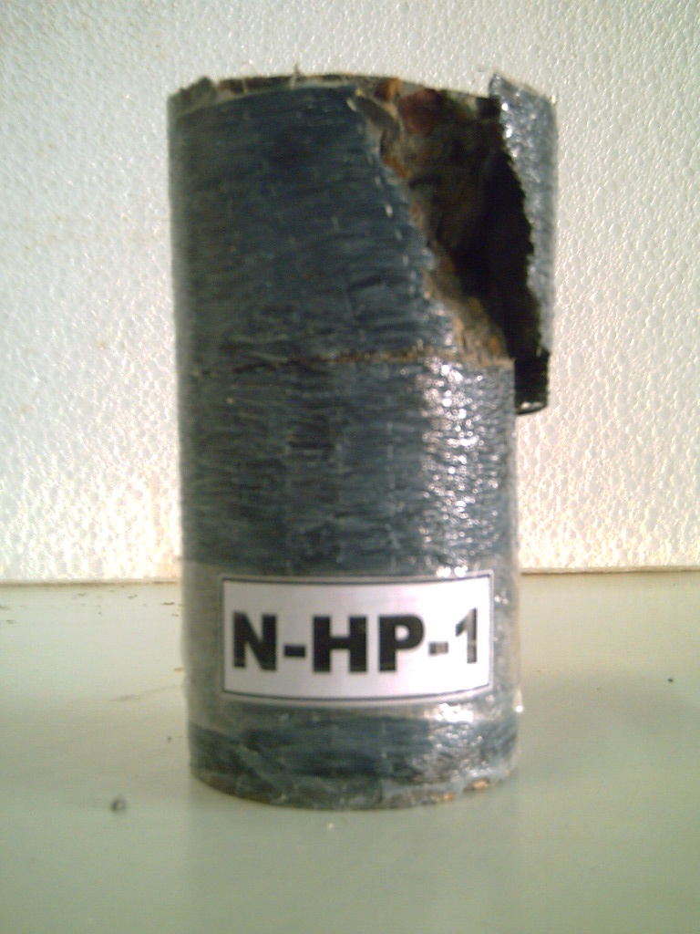
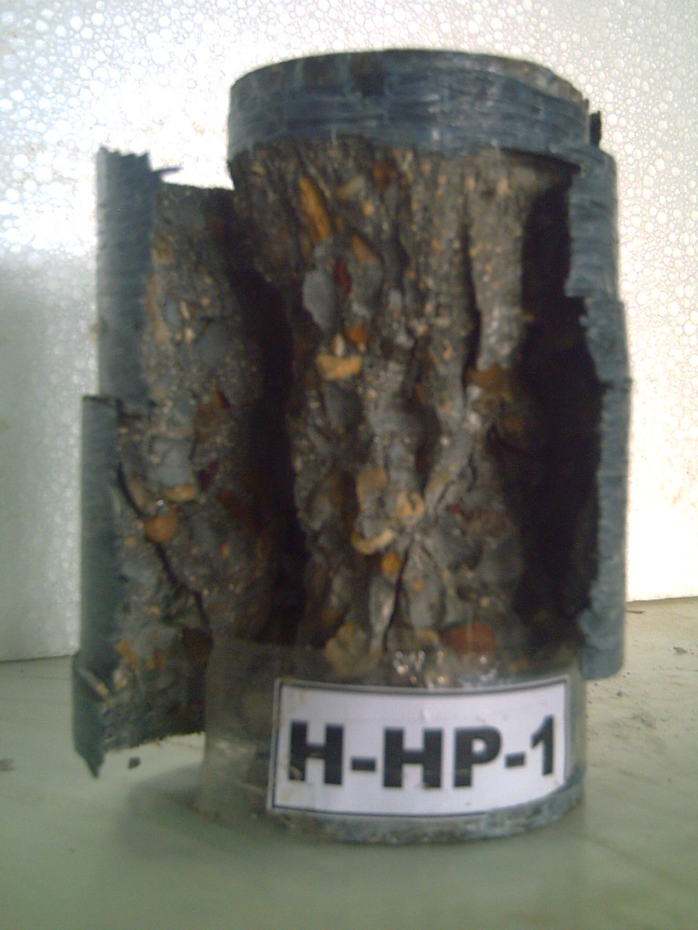
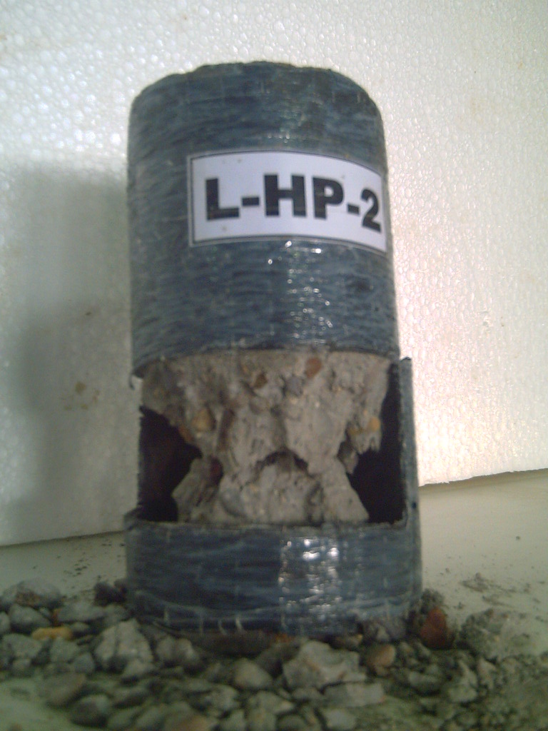
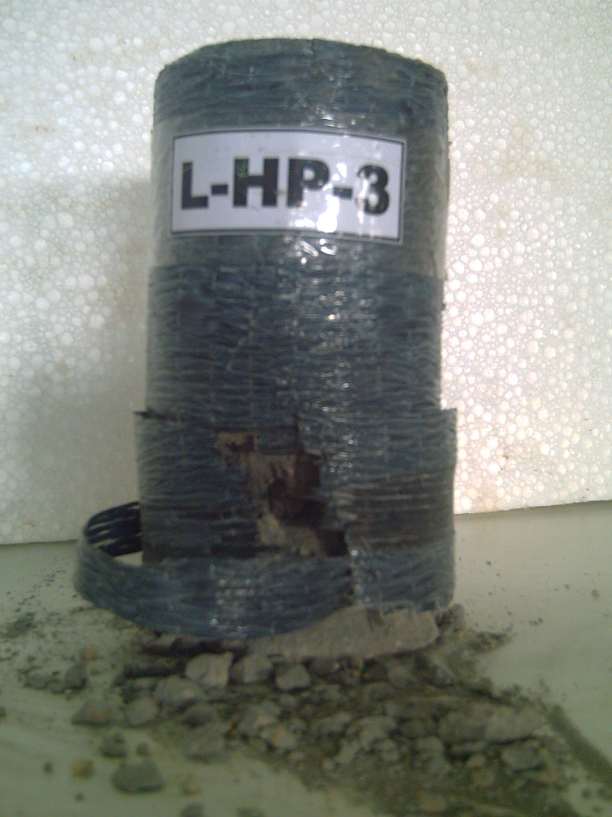
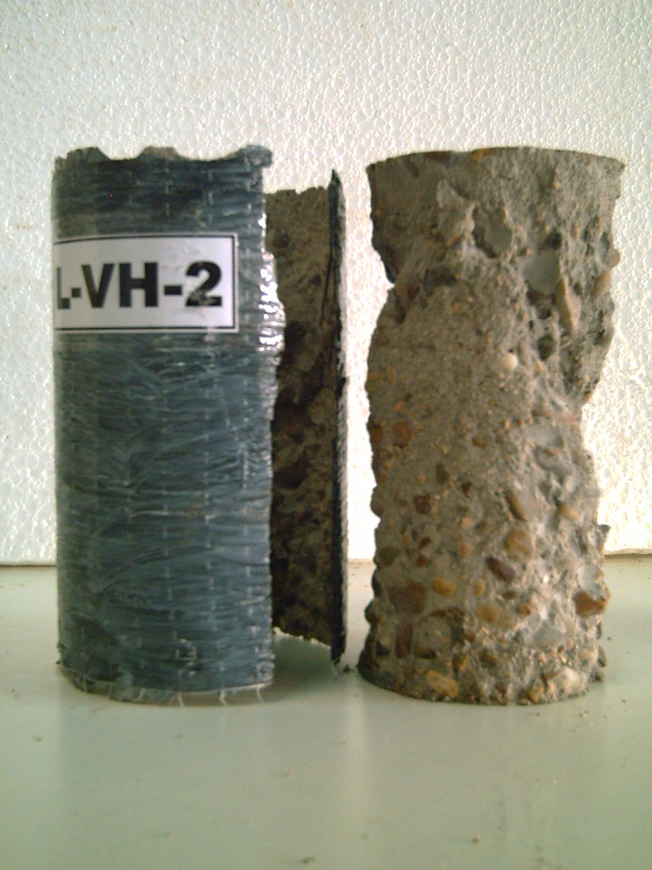
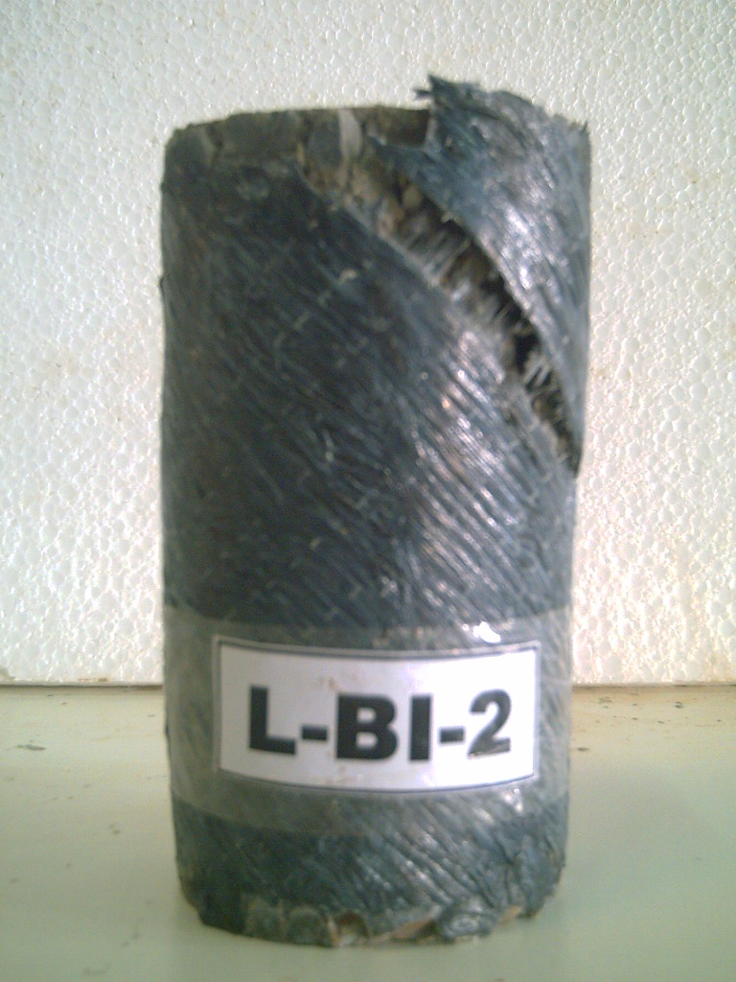
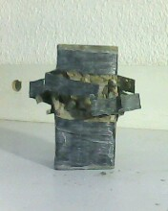
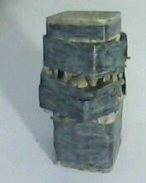
(a): L-HP-1
(b): N-HP-1
(c): H-HP-1
(d): L-HP-2
(e): L-HP-3
(f): L-VH-2
(j): L-BI-2
(h): LP-0-1
(i): LP-0.15-1

Figure (3): Failure modes for confined concrete specimens

Unconfined concrete strength
Effectiveness ratio
No. of layers
Effectiveness ratio
Fiber orientation
Effectiveness ratio
r/b ratio
Effectiveness ratio

(a): Effect of concrete strength (b): Effect of No. of layers

(c): Effect of fiber orientation (d): Effect of r/b ratio

Figure (4): Effectiveness ratio vs. experimental variables

4. Conclusions
Based on the analysis of experimental results, in terms of load carrying capacity, obtained from tests on circular and square sections, wrapped with external carbon fiber composite, it can be concluded that:
- The external confinement with CFRP can significantly increase the strength of the specimen under concentric compression. In addition, the greater the number of CFRP layers, the greater the gain in axial load-carrying capacity with respect to unconfined specimens.
- Reinforced concrete column with low-quality concrete can be wrapped by CFRP composite for a highly improved load carry capacity. The confinement effectiveness reduced with increase in the original unconfined concrete strength.
- The 0º/+90º ply configuration more efficient than -45º/+45º ply configuration. The specimen which is wrapped with 0º/0º ply configuration exhibited the highest efficiency.
- The radius of the corner in square specimens affected the behavior. It determines stress concentration effect . A large radius can expand the strong constraint zone and diminish the stress concentration.

5. References
Benzaid, R., Chikh, N. and Mesbah H., (2008),”Behavior of Square Concrete Column Confined with GFRP Composite Warp", Journal of Civil Engineering and Management, 14(2):115-120.
Buyukozturk, O. and Au, C., (2005),”Effect of Fiber Orientation and Ply Mix on FRP-Confined Concrete", Department of Civil and Environmental Engineering, Massachusetts Institute of Technology, Cambridge.
Campione G., (2006),”Influence of FRP Wrapping Techniques on the Compressive Behavior of Concrete Prisms", Cement & Conc. Comp., 28,497-505.
Ilki, A., Kumbasar, N. and Koc V., (2002),"Strength and Deformability of Low Strength Concrete Confined by Carbon Fiber Composite Sheets", 15th ASCE Engineering Mechanics Conference, Columbia University, New York.
Modarelli, R., Micelli, F. and Manni O., (2005),"FRP-Confinement of Hollow Concrete Cylinder and Prisms", SP-230-58.
Neville, A.,M, Properties of Concrete , 4th ed. , John Wiley and Sons , Inc. , New York, 1995.
Shehata, I., Carneiro, L. and Shehata L., (2007),”Strength of Confined Short Concrete Columns", FRPRCS-8, University of Patras, Greece.
Sika (2005), "SikaWrap230C-Woven carbon fiber fabric for Structural Strengthening", Technical Data Sheet, Edition 2.
Sika (2005), "Sikadur 330-Two Part Epoxy Impregnation Resin ", Technical Data Sheet, Edition 2.

