Performance analysis of Spectral Amplitude Coding Optical Code Division Multiple Access (SA-OCDMA) systems
Ibrahim Abdullah Murdas Murad Aobeed Al-Hilo
University of Babylon, college of Eng. University of Babylon, college of Eng.

Abstract
In this paper we simulate the incoherent spectral amplitude optical code division multiple access (SA-OCDMA) system with three simultaneous users. the effect of dispersion on the bit rate and fiber length is analyzed. In our analysis the intensity noise suppression was performed by adding the semiconductor optical amplifier (SOA) in each individual channel. and estimate the optimum fiber length according to input and received optical power. The performance of the system tested by using the BER and eye diagram criteria
الخلاصة
في هذا البحث تمت محاكاة أنظمة السعة الطيفية اللامتشاكهة لمقسم الشفرات متعدد المحاور مع ثلاث مستخدمين أنيين. تم تحليل تأثير التشتت على كل من سرعة البيانات وطول الليف البصري . في هذا التحليل تم إخفاء تأثير شدة الضوضاء بواسطة إضافة المضخمات الشبه موصلة البصرية في كل قناة منفردة وكذالك تم تخمين طول الليف المناسب طبقا الى القدرة البصرية المستلمة . أدائية المنظومة تم اختبارها بواسطة استخدام تقنية BER
1.Introduction
In the recent years optical code-division multiple access (OCDMA) systems have experienced increasing research attention because they offer several attractive features such as asynchronous access, privacy and security in transmission, ability to support variable bit rate and busy traffic and scalability of the network. Here all the users can asynchronously access the network in a very flexible manner without any timing devices and optical to electrical conversion. Until now, researches on OCDMA are focused on direct time spread OCDMA [Gafur2009].
Optical CDMA can be implemented based on incoherent or coherent operation. For an incoherent optical CDMA, unipolar codes are utilized with matched filtering and direct detection at the receiver [Fei Zeng et al 2007]. Spectral amplitude coding (SAC) optical code division multiplexing (OCDMA) has been studied extensively as a flexible implementation of an optical local area network (LAN) used to transmit: video on demand, voice over IP, [Penon 2006] . Linear dispersion is widely studied in fiber-optic systems, as it limits the rate and reliability of information transfer. Dispersion causes the pulses to broaden, thereby introducing inter symbol interference, which makes it difficult for the receiver to decode the information. In practice, only the second and third-order dispersion terms contribute to pulse broadening [Xiang Zhou 2000].Ultimately, all SAC-OCDMA systems are intensity noise limited. In this paper, analysis is carried out for use of broadband sources due to their low cost and large emission bandwidth compared to coherent sources. The intensity noise in an incoherent system is inversely proportional to the effective optical bandwidth and proportional to the electrical bandwidth. For a given bit rate, systems with greater optical bandwidth would offer better performance in terms of BER or, for fixed BER, could accommodate more users for greater capacity. Since intensity noise is the principal noise source, frequency guard bands reduce the occupied bandwidth; hence, they reduce the effective optical bandwidth and, therefore, the capacity to suppress the effect of intensity noise the semiconductor optical amplifier (SOA) was presented in each channel .and also we taken the effect of fiber chromatic dispersion on the SAC OCDMA system for different fiber length, and the maximum input and output power that will limit the fiber length.
2. Theory
2.1 CDMA Techniques in Optical Domain
OCDMA can be classified into temporal and spectral according to the way the optical signal is encoded as briefly introduced in the following sub-sections. Temporal OCDMA performs the coding in time domain by using very short optical pulses e.g. 10 ps at data-rate 1 Gbps and code-length of 100, using optical tapped delay lines (OTDL) to compose the coded optical signal. Spectral OCDMA, on the other hand, encodes the phase or intensity of the spectral content of a broadband optical signal by using phase or amplitude masks. Wavelength-hopping can be considered as a temporal-spectral coding where the coding is done in both dimensions[Karbassian, 2009]. In spectral coding an unmodulated wide-band signal is generated and spectrally decomposed. In the coding process amplitude or phase of the spectral components is modulated according to the appropriate code [Frigyes 2006].
2.1.3 Temporal coding
To spread the spectrum of an intensity-modulated optical field, the self-evident solution is the application of on-off keying (OOK). I.e.: the signature sequence should be composed of 0-s and 1-s, (i.e. of short pulses, pulses of duration T_{c}, called chip-time), superimposed on the data modulation. Thus in the spread spectrum signal an information bit “0” corresponds usually to 0-intensity, an information bit “1” corresponds to the spectrum spreading code. Processing gain is thus T/T_{c}. Each user (normally: each sink) has a distinct signature code.[Frigyes 2006]
2.1.4 On-off vs. Pulse Position Modulation
While in OCDMA the basic modulation principle is OOK, M-ary PPM can have advantages over simple OOK. With this n = log2M bits are united into one symbol. The Mary symbol contains the signature sequence in the appropriate position. So an orthogonal signal set is formed.
2.1.5 Two- and three-D modulation
In 2D time and frequency are modulated. In 3D parts the 2D signal are transmitted through more than one fiber.
2.2 Spectral coding of OCDMA
Since frequency encoding FE-CDMA systems are based on encoding the spectrum of optical sources, natural alternatives to mode-locked lasers are non coherent sources such as multimode lasers or LED’s. For these sources, the large frequency bandwidth is caused by photons being produced with different energy, and is independent of the modulating signal. It is then clear that filtering the spectral of these sources will not affect the temporal shape of the modulating signal’. Therefore, the multiple-access capacity cannot be based on the differences of intensity levels between the and the un coded waves. New coding strategic have to be found [Kavehrad1995]
The FO-CDMA system is based on spectral encoding of non coherent optical sources [J. Penon 2006]. The incoherent sources are On–Off shift-keyed with information data, then fiber Bragg gratings (FBGs) [Xiang Zhou 2000] are introduced to control the amplitude spectra of the broadband incoherent optical signals. The precise spectral filtering of FBGs on the input optical spectrum will cause reflected or transmitted spectral components from the designed “high” or “low” frequency chips band. The spectral frequency pattern, with spectral chips centered about the grating frequencies, is determined by the FO-CDMA signature sequence codes properly written in the FBGs [Jen-Fa Huang2000].
A typical fiber-optic CDMA network is shown schematically in Fig. 1. Consider the transmitter and receiver pairs are connected in a star configuration to share the same optical fiber medium . At the transmitter, each bit of information from the user is On–Off shift keying the broadband incoherent optical sources to fulfill the E-O modulation. The broadband optical field corresponding to each data bit is directed to an FBG encoder for the spectral slicing (see Fig. 2).With a properly written CDMA coding pattern, the reflected light field from an FBG will be spectrally encoded onto an address code denoted by code vector . Here, is the length of the code (or the number of chips per bit), for, is the chip value of the user’s spectra code. A set of passive star couplers is assumed to connect the local network users in the system. Each transmitter broadcasts its spectrum-encoded signal to all the receivers in the network. The received signal spectrum is a sum of all the active users’ transmitted signal spectra , where are the user’s information bit. The receiver applies a CDMA correlator to the incoming signal to extract the desired user’s bit stream. The correlator output consists of the desired data stream and the undesired multiple-access interference (MAI). In order to reduce the influence of the MAI, orthogonal (or nearly orthogonal) codes are required. Instead of making a direct correlation operation, we configure an FBG decoder scheme on the basis of orthogonal correlation functions of the nearly orthogonal m-sequence codes. [Jen-Fa Huang2000]

Figure (1) Typical fiber optic CDMA network [Jen-Fa Huang2000]

Figure 2 FBG encoder for an optical CDMA.[ Jen-Fa Huang2000]

FBGs are employed to realize the frequency discrimination in our proposed system for the following reasons. First, FBGs have been widely used to control and modify the amplitude and phase spectra of signals transmitted in fiber optical systems. In particular, for CDMA systems, FBG array (multiple FBGs fabricated in a single fiber but physically separated) can easily achieve wavelength-temporal coding scheme due to its “first in line, first reflected” feature . Second, very sophisticated filter frequency responses can be achieved by manipulating the fabrication parameters during the FBG writing process, which makes the proposed frequency discriminator with an optimized frequency response possible. Third, the reflection wavelength can be tuned via changing the grating pitch by applying strain or varying temperature, thus, allowing for programmable encoding and decoding [Fei Zeng et al 2007].Based on the above theoretical analysis, we know that the steepness and the width of the slopes determine the overall conversion efficiency and operational signal bandwidth, while both the reflectivity and phase response at the slopes should be linear, and any nonlinearity will introduce distortions to the recovered electrical signal. Therefore, the fabrication parameters of the FBG such as grating length, refractive index modulation depth, and apodization profile should be properly determined to obtain an optimized system performance. Basically, a strong FBG usually has a longer length or larger refractive index variation compared with a weak FBG, which can provide higher conversion efficiency and a flat top but a narrower transition bandwidth. For the FBGs having identical lengths and refractive index variations, apodization will then play an important role in the FBG design to find out the best compromise between the system conversion efficiency and the linearity. In our numerical simulations, FBGs with uniform and Gaussian profiles are evaluated to understand the effects of apodization on the performance of the proposed frequency discriminator. [Wei, 2002].Thus this system has various advantages. It operates with cheap light-sources. The number of available codes is higher than that of OOCs. And (under ideal conditions) there is no MUI [Frigyes, 2006]
2.2.1 Spectral Phase Coding (SPC)
Figure 3 shows an encoder and decoder of the spectral phase encoding system. The information source modulates the very short laser pulses. The generated short pulses are Fourier transformed and the spectral components are multiplied by the code corresponding to a phase shift of 0 or . Fourier transform can be implemented by the Grating and lens pair as shown in Figure 3. As a result of phase encoding, the original optical ultra-short pulse is transformed into a low intensity signal with longer duration. The liquid crystal modulator (LCM) can be utilised to set the spectral phase to maximum-sequence phase. The LCM has a fully programmable linear array and individual pixels can be controlled by applying drive levels resulting in phase shifts of 0 or π . By a phase mask, the dispersed pulse is partitioned into N_{c} frequency chips by the aid of a phase mask that can be a LCM. Each chip is assigned a phase shift depending on the users address code sequences[Karbassian2009]

Figure 3 Principle of SPC-OCDMA[M.M. Karbassian2009]

2.2.2 Spectral Amplitude Coding (SAC)
In SAC-OCDMA format, frequency components of the signal from a broadband optical source are encoded by selectively blocking or transmitting them in accordance with a signature code . Compared to SPC-OCDMA, SAC-OCDMA is less expensive due to incoherent optical source. For the access environment, where cost is one of the most decisive factors, the SAC-OCDMA seems therefore to be a promising candidate. Figure 4 shows the principle structure of a SAC-OCDMA system. The receiver filters the incoming signal through the same direct decoder filter A(w) at the transmitter as well as its complementary decoder A(w) .The outputs from these decoders are detected by two photo-detectors connected in a balanced structure.

Figure 4 Principle of the SAC-OCDMA scheme[M.M. Karbassian2009]

In spectral amplitude coding ( also known as frequency encoder CDMA) the available optical source spectrum is divided into multiple spectral –sliced (chip) that are then used to form a given user code spectrum as shown in figure (4) .
Various code will be formed spectrally by the presence on or absence (off) of a spectral sliced in this teaching the data is modulated onto the broadband optical carrier signal which is then encoded using a filter frequency response such as that given a above and transmitted along with other encoded data signal .
All channels occupy the same spectral bandwidth a filter with match code is used at each receiver to recover the original message . at the receiver the input signal is split into two paths one path is correlated with the match code X while the other path I correlated with the complementary code . the signal after correlation are then sent into a balanced differential receiver which outputs the difference between the two signals when the received signal is that of the desired channels the differentials received output will be high .while when the received signal is that of an undesired channels. The output will be zero. With a properly written CDMA coding pattern, the reflected light field from an FBG will be spectrally encoded onto an address code denoted by code vector () = . Here, is the length of the code (or the number of chips per bit), {0,1}, for is n^{the} chip value of the kth user’s spectral code. A set of passive star couplers is assumed to connect the local network users in the system. Each transmitter broadcasts its spectrum-encoded signal to all the receivers in the network. The received signal spectrum is a sum of all the active users’ transmitted signal spectra, where b_{k} {0,1} for are the kth user’s information bit. The receiver applies a CDMA correlator to the incoming signal to extract the desired user’s bit stream. The correlator output consists of the desired data stream and the undesired multiple-access interference (MAI). In order to reduce the influence of the MAI, orthogonal (or nearly orthogonal) codes are required. Instead of making a direct correlation operation, we configure an FBG decoder scheme on the basis of orthogonal correlation functions of the nearly orthogonal m-sequence codes.
In spectral amplitude coding optical CDMA systems the frequency slots of different user will always be in use and multiuser interference can be completely canceled out as long as the used code ((0,1) sequences )) satisfy the following conditions : i) all the code words have the same weight ( defined as the number of '1"s in it; ii) for every two different codeword () = and () = , we have = =λ where λ is a constant. indeed any receiver that compute will then reject the interference from any user having sequence (Y) where )] = =. for convenience we define (N, w, λ) code as family of (0,1)sequence of length N, weight w and θ_{XY} = λ. In [Xiang Zhou2000] ,(0,1) m- sequences code were proposed for spectral amplitude coding optical CDMA systems. Its can be expressed as a (, code of size [Xiang Zhou2000].
2.2.3 M-sequences A unipolar M-sequences of length is obtained from bipolar version by replacing each binary 1 by a 0 and each -1 by a 1.
Consider the sequences as being where is the operator that shift vectors cyclically to the left by one place , that is in that case:
Which result in 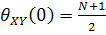 for k = 0 and to 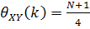 for k=1 to N-1.the sum is taken modulo N. these results come from the shift – and –add property of M- sequence which says that the modulo-2 sum of an M –sequences and any cycle phase shift of the same m-sequence. Is another phase of the same sequence . in other word half the 1 s in coincide with the 1 s of (x) while the other half coincide with the 0 s where ( is the k cycle shift of (x). a receiver that computes
k)-
*(N+1)/4-(N+1)/2
=0
Will reject the signal coming from the interference user having sequence ( . this is true for any k , and by assigning the N cycle shifts of s a single M-sequences to N subscriber we have a network that can support N simultaneous users without any interference. Complete orthogonally between users is a achievable theoretically.

3. System Analysis
The spectral Amplitude encoding OCDMA system has been well described in references [Wei, 2002]. Briefly, each encoder/decoder in the OCDMA system is a fiber Bragg grating with equally spaced gratings tuned to wavelengths corresponding to the Bin family of codes.
Figure (5 ) shows SAC OCDMA the transmitter and the receiver needed for the pair of communicating users , at the transmitter the data directly modulate the optical source the broadband optical field corresponding to each data bit is then directed to the optical fiber Bragg grating arrangement to perform spectral slicing. The encoder is an FBG working in transmission that takes a broadband source and filter out all spectral content except those frequencies included in the users unique spectral code .all the users in the system share the same optical band width and content frequency elements from the same band ; they access the channel asynchronously and without coordination. [Jen-Fa Huang2000]. The reflected light field from an FBG will be spectral encoded onto an address code. An N * 1 coupler is used to combine all signals onto one fiber to the central office (co). At the receiver the following needs be realized k) -. Where k) the periodic cross correlation his can easy be done by using 2 photo detector, one to receive and the other to receive
and subtracting theirs output . one way to doing this is to split the incoming signal in two parts each one going through mask pattern oppesit of the one used for . And the signal spectrum is a sum of all the users transmitted spectra where X_{k} code vector b_{k} {0,1}, for k= 1,2,…..K are the K_{th} users information bit. the receiver applies a CDMA correlator to the incoming signal to extract the desired users bit stream. the receiver for SAC OCDMA is the balanced detector illustrated in figure (5) and would be the same at the CO. balanced detection eliminate MAI for code with the fixed cross correlation leaving only intensity noise.th upper arm contain an FBG with the decoder DEC identical to the ENC for the data to be received . n^{the} lower arm the complementary decoder C-DEC is orthogonal to the ENC spectral response , i.e, it contains only the frequency bins that are not present in the ENC. A FBG decoder scheme on the basis of orthogonal correlation function of the nearly orthogonal m-sequence codes.
FBG
PIN
Error Detector
Filter
Channel
Transmitter
Reciver
Data
Data
Modulator
Spliter
FBGG
PIN
Error Detector
Filter
ENC.
Optical source
Multiplexer
ENC.
SPLITER

Figure (5) a block diagram of SAC-OCDMA simulated system

4. Performance Evaluation The performance of the system are simulated by using the simulation software OptiSystem Version 7.0. a simple schematic block diagram consist of three users . as illustrated in figure (5) a chip has spectral width of 0.8 nm and data rate 200Mb/s for 10 Km distance single mode optical fiber and the remains parameter attenuation factor ( 0 .2 dB/Km ) , dispersion coefficient (16.75 ps/nm/km) and nonlinear effect in the receiver electron charge 1.6e⁻¹⁹ c Boltzmann constant 1.38e⁻²³ Dark current (10nA) The performance was tested by using the bit error rate BER and the eye diagram criteria as shown in the figures (6,7,8) we used the FBG spectral decoder to decode the code at data level. The detector used in receiver is a PIN detector followed by Bessel filter at cut off frequency (0.65*signal bit rate MHz) .
5. Dispersion limitation
5.1 Bit rate limitation
A result of the dispersion – induced signal distortion is that a light pulse will broaden as it travels along the fiber . after a certain a mount of overlap has occur a adjacent pulses can no longer be individually distinguished at the receiver and errors will occur . thus dispersion properties determine the limit of the information capacity of the fiber. A measure of information capacity of an optical waveguide is usually specified by the bandwidth – distance product [G.P. Agrawal2005].
If the system operate way from the zero dispersion fiber and the chirp frequency neglected because large spectral width the broadening factor is obtained from [G.P. Agrawal2005 ]
------------- ( 1 )
Where , : is the RMS width of the pulse
: is the RMS width of the input Gaussian pulse 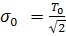
D : Dispersion parameters
L: optical fiber length
: is the RMS source spectral width in a wavelength unit
The output pulse width is thus given by
--------------- ( 2 ) Where : = provide a measured of dispersion induced broadening . We can relate to the bit rate by using the criterion that the broadening pulse should remain inside the allocated bit slot 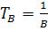 where B is the bit rate. The limiting bit rate is given by: . in the limit , and the condition becomes
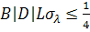 ----------------- ( 3 )
The eye diagram for the evaluated OCDMA system performance was achieved. The limitation imposed on the bit rate by fiber dispersion can be quite different depending on the source spectral width. In figures ( 6-a,b,c ) observe that for the same fiber length the increase bit rate will effect on the performance of SAC – OCDMA the eye diagram criteria was used and observed that the open eye obtained for low data rate figure (6a) and the eye will become closer because the dispersion effect at high data rate and according to equation (3) and table (1) ,figures (6- c,d,e,f) .

Table (1)illustrate dispersion limitation on bit rate
Fiber length =10 Km | Bitrate(Mb/s) | Max.Q-factor | Min.BER | Eye Height
Fiber length =10 Km | 200 | 8.75 | 8.488e-019 | 5.36 e-006
Fiber length =10 Km | 250 | 9.955 | 3.533e-022 | 5.462e-006
Fiber length =10 Km | 500 | 2.22 | 0.0128 | -1.7e-006
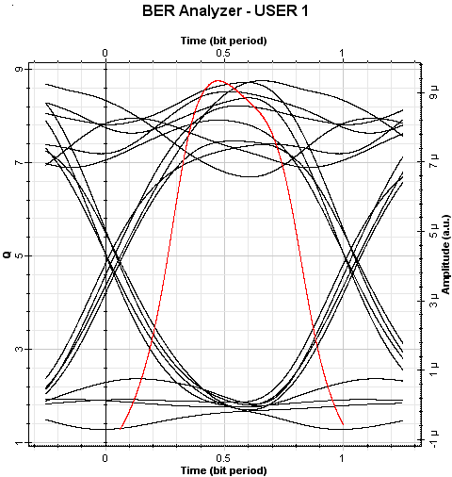
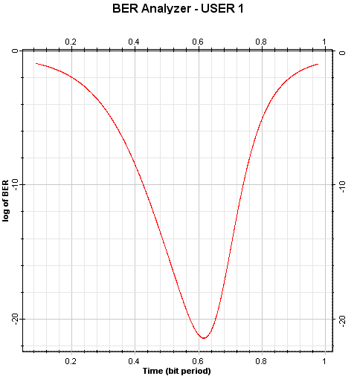

Figure (6a) eye diagram at Bit Rate at 200Mb/s Figure (6b) Min.BER at Bit Rate at 200Mb/s

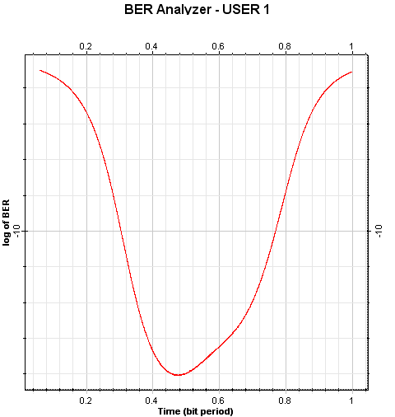
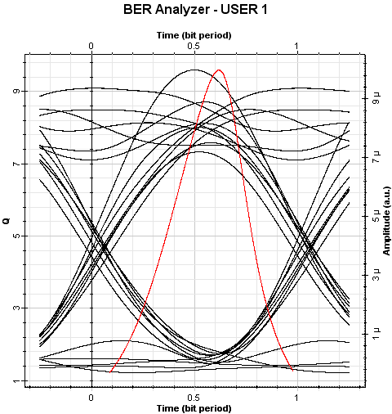

Figure (6c) eye diagram at Bit Rate at 250Mb/s Figure (6d) Min.BER at Bit Rate at 250Mb/s

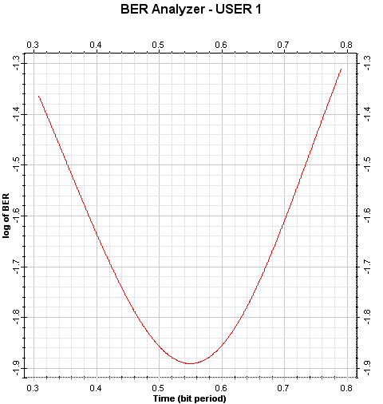
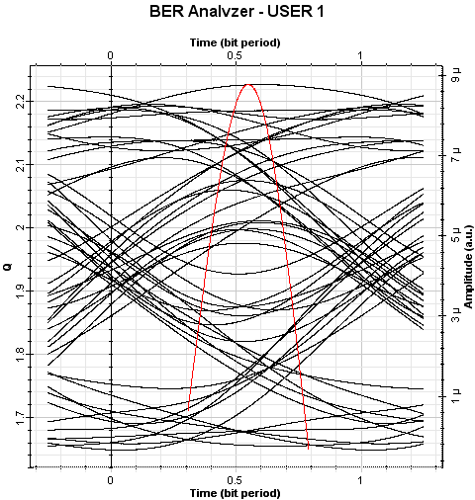

Figure (6e) eye diagram at Bit Rate at 500Mb/s Figure (6f) Min.BER at Bit Rate at 500Mb/s

5.2 Fiber length limitation
It's clear that in any LED system ,dispersion will limit the system length (10 s of kilometer at most ) due to intersymbol interference of adjacent data bit. The dispersion effect(index of chromatic dispersion, ) on the fiber length is given by [Gafur, 2009]
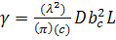 ----------------- (4)
Where :λ represent the wave length of optical carrier , c is the light velocity and ,L is the fiber lengths, D the coefficient of chromatic dispersion of optical fiber ,b_{c} the rate of the chip. For different fiber lengths 10Km ,50Km,and 80 Km , for the same dispersion value as shown in figures ( 7,a,b,c) at opened eye this means a good performance of the OCDMA systems. while closed eye or distorted it means a dispersion exist. According equation (4) the dispersion effect directly on the performance of SAC OCDMA for different fiber lengths .the dispersion limitation enhancement by add 200m dispersion compensation fiber (DCF) the results illustrated in table (3)

Table (2) illustrate dispersion limitation on fiber length
Fiber Length (Km) | Max.Q-factor | Min.BER
10 | 8.75 | 8.488e-019
50 | 4.33 | 7.202e-006
80 | 1.82 | 0.0335

Table (3) illustrate the adding DCF
Fiber length =10 Km  Bit Rate =200Mb/s |  | Max.Q-factor | Min.BER
Fiber length =10 Km  Bit Rate =200Mb/s | Without DCF | 8.75 | 8.488e-019
Fiber length =10 Km  Bit Rate =200Mb/s | With DCF | 8.902 | 2.277e-019

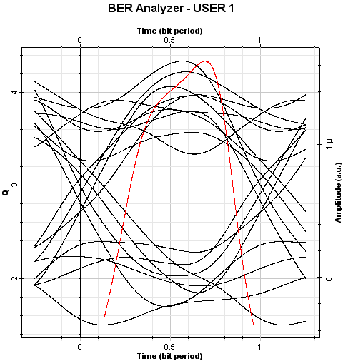
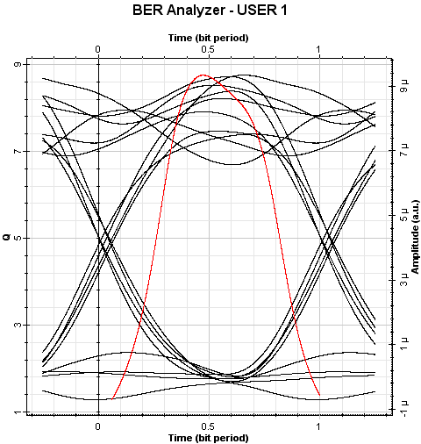

Figure (7a) eye diagram at fiber length 10Km Figure (7b) eye diagram at fiber length 50Km

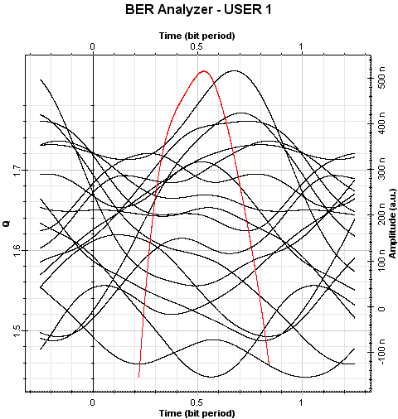

Figure (7c) eye diagram at fiber length 80Km

6. Max. Input power limitationThe max. input power that we can launched into the fiber is limited. This also limit the maximum transmission distance L. if p_{in} max is the max. input power the transmission distance L and P_{r} is the min receiver power then equation (4) shows the max. input power that can be sent into the fiber. The optical signal attenuation in a fiber [Fadhil, 2008]
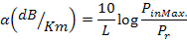
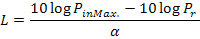
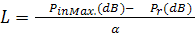 -------- ( 4 )
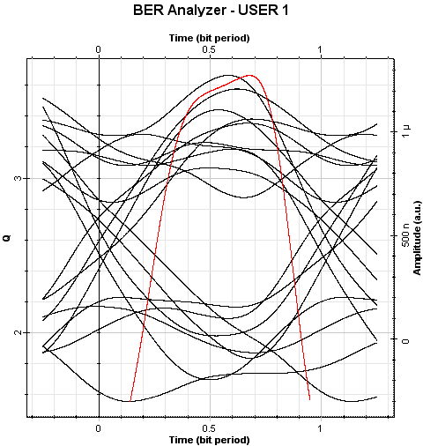
The optical power at the receiver end has to b within the dynamic range of the receiver otherwise it damage the receiver ( if it exceeds the max. value )or the receiver cannot differentiate between 1s and 0s if the power level is less than the minimum value . this is given by the dynamic range of the received and it set the max. and min. power range for the receiver to function. For OCDMA , -7dBm to -28 dBm is a typical dynamic range of a receiver using equation (5) we can find the Max. Transmission distance for our scheme without amplification which is equal to 56 Km. figures (8) the eye diagrams at distances 56km .

Figure (8) eye diagram at 56 Km fiber length
7.Noise limitation
We consider the two principle noise source in incoherent SAC-OCDMA the intensity noise which is inversely proportional to the effective optical B.W and multi access interference MAI [Hassan Yousif2009]
- Intensity noise at receiver with high power
- MAI
In this paper, we use gain saturated semiconductor optical amplifier (SOA) to suppress both optical beat noise and MAI p[14].from the relationship between the optical gain of the SOA and the input power. It can be seen that as the input power increases By ensuring that the one level of the optical signal is close to the saturation point of the device, an SOA acts as an optical intensity limiter thereby reducing the amount of beat noise and improving the overall system performance [Karl J. Dexter2009].
7.1. SOA based Noise suppression
Using gain saturated SOA to enhanced the performance of SAC systems As expected the use of the saturated SOA provides a noticeable performance improvement relative to the standard approach with no noise mitigation . at higher bit rate the intensity noise creates a significant system penalty which in turn a lows the SOA to provide grater benefit to the system performance.
For the single channel system a peak Q of 10.424 ( BER 9.515e-026) and 8.7563 (BER 8.7e-019) was a achieved with and without noise reduction respectively. However the eye quality degrades noticeable for the 2-channels system. As shown in figures ( 9,a,b )

Table (4) illustrate the effect of adding SOA
Fiber length =10 Km  Bit Rate =200Mb/s |  | Max.Q-factor | Min.BER
Fiber length =10 Km  Bit Rate =200Mb/s | Without SOA | 8.75 | 8.448e-019
Fiber length =10 Km  Bit Rate =200Mb/s | With SOA | 10.424 | 9.515e-026

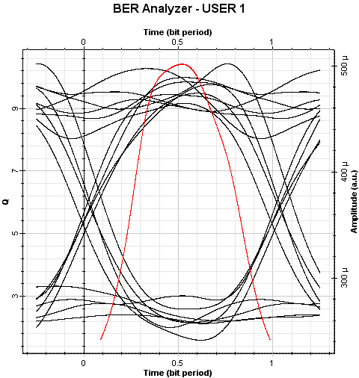
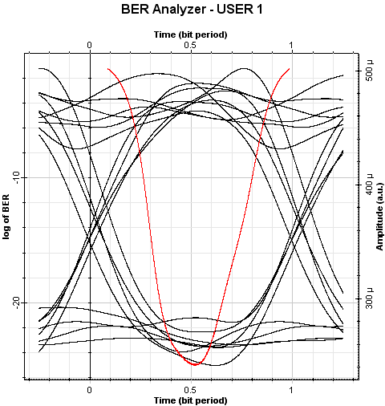

Figure (9a) eye diagram with SOA Figure (9b) Min.BER with SOA
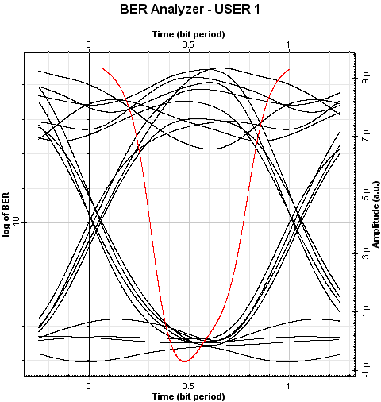

Figure (9c) eye diagram without SOA Figure (9d) Min.BER without SOA

8. Conclusions
In our analysis the BER and eye diagram results are evaluated at different data rate for spectral amplitude coding optical code division multiple access (SA-OCDMA) using SMF fiber. the results provide that the optimum fiber length 56Km for maximum input optical power (-0.035dBm),received power (-12.4dBm),and 200Mb/s data rate at given dispersion index value . The performance of the system was improved significantly because using the SOA in each channel and DCF with length 200m.
References
Agrawal G.P."Lightwave technology telecommunication systems " John Wiley & Sons., 2005
Fadhil, H. A. ; S. A. Aljunid, and R. B. Ahmed " Performance of Random diagonal codes for spectral amplitude coding optical CDMA systems" World Academy of Science, Engineering and Technology 47 2008
Fei Zeng, Qing Wang, and Jianping Yao, "Sequence-Inversion-Keyed optical CDMA coding/decoding scheme using an electrooptic phase modulator and fiber Bragg gratin arrays", IEEE Journal of selected topics in quantum electronics Vol.13,No.5,septemper /October 2007
Frigyes I. "CDMA In Optics" IEEE Ninth International Symposium on Spread Spectrum Techniques and Applications 2006
Gafur, A. "Dispersion effect on optical CDMA system performance" thesis Blekinge Institute of Technology,2009.
Hassan Yousif Ahmed, Ibrahima Faye, N.M.Saad and S.A. Aljined" Spectral amplitude coding optical CDMA performance analysis of PIIN reduction using VC code family" International Journal of Electronics, Communications and Computer Engineering 1:2 2009 .
Jen-Fa Huang and Dar-Zu Hsu" Fiber-Grating based optical CDMA spectral coding with nearly orthogonal M-sequence codes." IEEE Photonics Technology Letters, Vol. 12, NO. 9, September 2000.
Karbassian M.M. " Design and analysis of spreading code and transceiver architectures for optical CDMA network" thesis, university of Birmingham 2009.
Karl J. Dexter, Douglas Alexander Reid, and Liam P. Barry," Reduction MAI and beat noise in OCDMA systems using an SA-SOA-TPA-based receiver" IEEE photonics technology letters Vol.21,No.22,November 15,2009.
Kavehrad, M. ; D. Zaccarh " Optical code – division multiplexing systems based on spectral encoding of Noncoherent sources" Journal of Light wave Technology , Vol. 13,No.3,March 1995.
Penon, J. ; S. Ayotte, L. A. Rusch and S. LaRochelle " Incoherent SAC OCDMA System at 7×622Mbps" © 2006 Optical Society of America.
Wei, D. P. ; R. Slavík, J. Magné and S. LaRochelle "Comparison of BER measurements n a FFH-OCDMA system with incoherent and coherent sources" Proceedings of SPIE Vol. 4833 (2002).
Xiang Zhou, H.H.M. Shalaby, Chao Lu and Teehiang Chen " Code for spectral amplitude coding optical CDMA systems" Electronics Letter Vol.36 No.8. 13th April 2000.

