Nonlinear Analysis of Solid and Box-section RC Beams Strengthened in Torsion with CFRP Reinforcement

Mustafa B. Dawood

Engineering College, Babylon University

Abstract
This study is devoted to investigate the behavior and performance of solid and box-section R.C. beams strengthened with (CFRP-reinforcement) and subjected to pure torsion. Also, compares the effectiveness and efficiency of two strengthening techniques viz. FRP bars as NSM reinforcement and CFRP strips as external reinforcement. For this analysis, a system of computer program (ANSYS V.9.0) is used for this study. The ordinary reinforced concrete was modeled by 8-noded isoparametric brick elements, while the steel reinforcing bars and NSM reinforcement were modeled as axial members (bar elements) connecting opposite nodes in the brick elements with full interaction assumption. The CFRP strips were modeled by shell elements. The interface elements were modeled by contact element to represent slip and uplift separation between the ordinary concrete beams and CFRP-reinforcement. The results showed that the torsional capacity of the strengthened beams can be increased by either decreasing the spacing of the CFRP, or increase compressive strength of concrete, or replacing of CFRP strips by NSM FRP.
Keywords: reinforced concrete beam, torsional strengthening, near surface mounted, CFRP strips.
الخلاصة
أن الغرض من هذا البحث هو التحري عن تصرف وأداء الاعتاب الخرسانية المجوفة والصلدة المسلحة والمقواة بألياف الكاربون البوليمرية كذلك يقدم هذا البحث مقارنة بين اداء و فاعلية طريقتين من طرق تقوية العوارض الخرسانية المسلحة لمقاومة قوى اللي وذلك بغرس قضبان تسليح معدنيةسطحية ولصق صفائح كاربونية من الخارج. في الدراسة الحالية تم استخدام برنامج الحاسبة التحليلي (ANSYS V. 9.0). تم تمثيل الخرسانة العادية باستخدام العناصر الطابوقية ثمانية العقدة. إما قضبان التسليح الاعتيادية وقضبان التسليح المعدنية السطحية فقد تم تمثيلها كعناصر محورية تربط نقاط متقابلة في العنصر الطابوقي مع فرض وجود تلاصق تام وتم تمثيل الصفائح الكاربونية المركبة كعناصر رقائقية وتم تمثيل السطح البيني بعنصر التصاق لمقاومة الانزلاق والانفصال بين الخرسانة العادية وألياف الكاربون البوليمرية. تُوضّحُ النَتائِجُ ان مقاومة اللي للاعضاء المقواة يمكن ان تزداد بواسطة نقصان المسافة بين ألياف الكاربون البوليمرية او تغيير ألياف الكاربون البوليمرية الى قضبان التسليح البوليميرية المسلحة بالالياف السطحية.
Introduction
The use of epoxy-bonded fiber-reinforced polymers (FRP) materials to the surface of reinforced concrete (RC) members as external reinforcement is a promising and a recent development technique for strengthening and rehabilitation of deficit concrete elements. The lightweight, the advanced mechanical properties and the easy to-apply character of these composite materials allow their use for upgrading or repairing inadequate or damaged RC members and structures.
In the last decade substantial research has been conducted on the upgrading of RC beams using FRP fabrics and laminates. Most research in this area has been carried out for the flexural strengthening, whereas studies on the shear strengthening are more limited. Several studies have demonstrated the effectiveness of the use of FRP in strengthening works of RC beams under static loads of flexure Li LJ et al. (2006) and shear Triantafillou (1998).
The experimental investigation deals with the torsional strengthening of concrete beams without stirrups using epoxy-bonded carbon fiber-reinforced-polymer (FRP) sheets and strips as external transverse reinforcement were presented by Constantin E. Chalioris (2008). The experimental program comprises 14 rectangular and T-shaped beams tested under pure torsion. Based on the measured values of the torsional moment at cracking and at ultimate, the corresponding twists, the behavioural curves and the failure modes of the beams, useful concluding remarks are indicated. The strengthened rectangular beams using full wrapping with continuous FRP sheets performed enhanced torsional behaviour and higher capacity than the strengthened beams with FRP strips. U-jacketed flanged beams exhibited premature debonding failure and substantial reductions of the potential torsional capabilities are reported.
Ghobarah et al. (2002) [4], experimentally investigated the effectiveness of carbon and glass FRP sheets and strips as additional external reinforcement to rectangular beams with bars and stirrups under torsion. Salom et al. (2004), studied experimentally and analytically the torsional behaviour of six spandrel beams which had been strengthened with FRP laminates. Both studies addressed that, in general, FRP materials caused a significant increase on the torsional capacity of the tested beams.
A more recent and less investigated method for shear strengthening of RC members is the use of near-surface mounted (NSM) FRP reinforcement, usually in the form of round bars or of rectangular bars with large width to thickness ratio (herein briefly indicated as strips). In the NSM method, the reinforcement is embedded in grooves cut onto the surface of the member to be strengthened and filled with an appropriate binding agent such as epoxy paste or cement grout. A review of available research on
NSM strengthening of RC structures is reported in De Lorenzis and Teng (2007). For shear strengthening with NSM reinforcement, the grooves are cut on the sides of the member at a desired angle to the beam axis.
An ANSYS finite element model was produced by Kachlakev et al. (2001), to study the effects of shear strengthening by comparing the behaviors of two full-scale reinforced concrete beams (a reinforced concrete beam with no shear stirrups; and a reinforced concrete beam externally reinforced with Glass Fiber Reinforced Polymer (GFRP) on both sides of the beam). It was found that the general behaviors through the linear and nonlinear ranges up to failure of the finite element models show good agreement with observations and data from the experimental full-scale beam tests. The addition of GFRP reinforcement to the control beam shifts the behavior of the actual beam and model from a sudden shear failure near the ends of the beam to flexure failure by steel yielding at the mid span. The shear reinforcement increases the load carrying capacity by 45% for the experimental beam and by 15% for the finite element model. This finite element model can be used in additional studies to develop design rules for strengthening reinforced concrete bridge members by using FRP.
1-Finite Element Representation of Reinforced Concrete beam with NSM FRP Reinforcement:
The element types for this model are shown in Table (1-1).The SOLID65 element was used to model the concrete. This element has eight nodes with three degrees of freedom at each node translation in the nodal x, y and z directions. This element is capable of plastic deformation, cracking in three orthogonal directions and crushing. Link 8 was used to represent the flexural reinforcement and NSM FRP reinforcement while Shell41 represents the CFRP strips, SOLID45 element were used to model the plate loading and supporting, ANSYS-9 (2004).

Table (1-1): Element types for working model.

ANSYS element | Material type
SOLID 65 | Concrete
LINK 8 | Flexural Reinforcement and NSM FRP and stirrups
SHELL 41 | CFRP strips
SOLID45 | Plate loading and supporting
CONTACT 52 point to point | Interface element

  - Concrete Brick Element:
The 8-node isoperimetric linear element (SOLID65) in ANSYS 9 program is shown in fig. (1) and used in this study. Each of the eight corner nodes has three degrees of freedom u, v, and w in the X, Y and Z directions respectively.
Figure (1): Brick element with 8 nodes (SOLID65 in ANSYS 9) .

1-2 Finite Element Idealization of Reinforcement:
In this study the discrete model is used to represent steel reinforcement and NSM FRP. The three-dimensional two-node bar element (link8) is a uniaxial tension-compression element with three degrees of freedom at each node (nodal translation in x, y and z) directions. The axial normal stress is assumed to be uniform over the entire element. The element x-axis is oriented along the length of the element form node (1) towards node (2), fig. (2).

ξ

u `
z
y
x
1
2
y `

x`

z`
O

w``
v ' `
x`
z`
w`
ξ

Figure (2): Bar element (LINK 8 in ANSYS 9).

As the element is capable of carrying axial loads only, then the strain-displacement relationship is as follows:
----------------------- (1)
Where : U' local displacement, X' local coordinate.

  - SHELL41 Element ( Membrane shell )
A shell 41 element was used to model CFRP strips. SHELL 41 is a 3-D element shown in fig. (3), having membrane (in-plane) stiffness but no bending (out-of-plane) stiffness. It is intended for shell structures where bending of the elements is of secondary importance. The element has three degrees of freedom at each node: translations in the nodal x, y, and z directions. The element can have variable thickness, stress stiffening and large deflection.
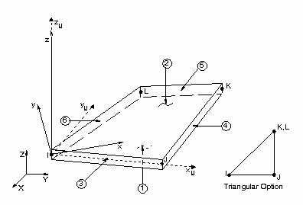

Figure (3): SHELL 41 geometry [8].
1-4 Interface Finite Element Idealization:
A three-dimensional point-to-point contact element (Contact 52) ANSYS 9.0 [8], is used to model the nonlinear physical contact behavior of the surface between the CFRP-reinforcement and the ordinary concrete beam in a composite concrete beam. This model also includes the definition of the stress transfer. The element joins two surfaces that may maintain or break the physical contact and may slide relative to each other. Also, the element is capable of supporting only compression in the direction normal to the interface between the two surfaces, as shown in fig. (4).

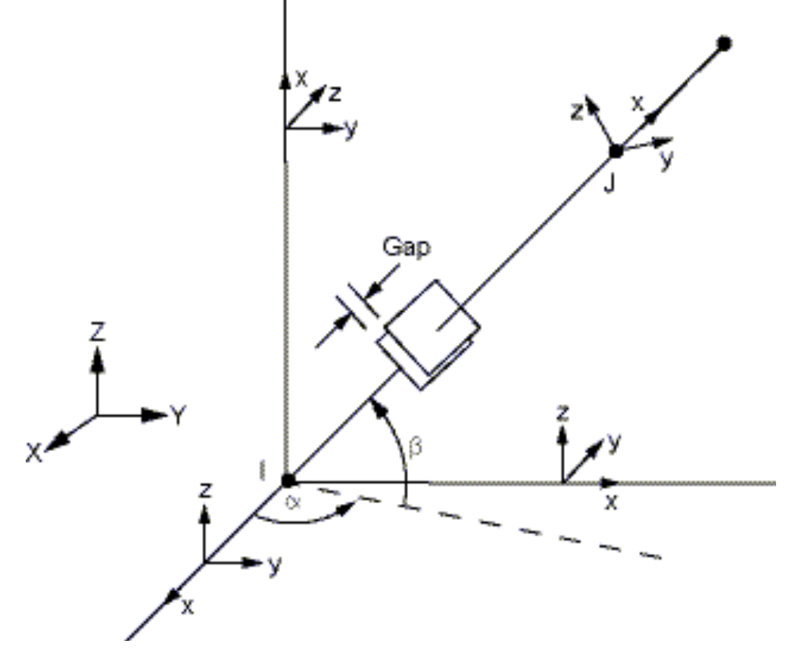
Figure (4): 3-D Point-to-point contact element [8].

Concrete Modeling:
- Stress-Strain Relationship:
The Solid 65 element requires linear isotropic and multilinear isotropic material properties to properly model concrete as shown in fig. (5). The modulus of elasticity was calculated by equation of ACI- code (2008) [9].
$Εc=\text{4730}\sqrt{f_{c}^{'}}$
----------------------- (2)
The ANSYS program requires the uniaxial stress-strain relationship for concrete in compression as shown in fig. (5). Numerical expressions, equations (3) and (4), were used along with equation (5) Gere et al., (1997) [10] to construct the uniaxial compressive stress-strain curve for concrete in this study.
$f=\frac{E_{c}ε}{1+{\left(\frac{ε}{ε_{o}}\right)}^{2}}$ ----------------------- (3)
$ε_{o}=\frac{2f'c}{E_{c}}$ ----------------------- (4)
$E_{c}=\frac{f}{ε}$ ----------------------- (5)
Where: ƒ = Stress at any strain ε.
ε = Strain at stress ƒ.
ε_{ο} = Strain at the ultimate compressive strength ƒ'c.

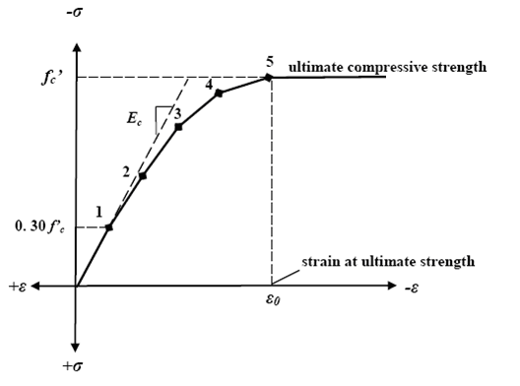
Figure (5): Simplified compressive uniaxial stress-strain curve for concrete Kachlakev et al. (2001).

- Cracking Modeling:
In the finite element analysis of concrete structures, three different approaches have been employed for cracking modeling, ANSYS 9.0 (2004).
- Smeared- cracking model.
- Discrete-cracking model.
- Fracture-mechanism model.
In the present study is considered through an adjustment of material properties which effectively treats the cracking as a smeared band of cracks with fixed crack orientation.
- Modeling of Crushing:
If the material at an integration point fails in uniaxial, biaxial, or triaxial compression, the material is assumed to crush at that point. Under this condition, material strength is assumed to have degraded to an extent such that the contribution to the stiffness of an element at the integration point in equation can be ignored, ANSYS 9.0
Modeling of Reinforcement:
Typical stress-strain curves for reinforcing steel bars used in concrete construction are obtained form coupon tests of bars loaded monotonically in tension. For all practical purposes steel exhibits the same stress-strain curve in compression as in tension. The steel stress-strain relation exhibits an initial linear elastic portion, a yield plateau, a strain-hardening range in which stress again increases with strain and finally a range in which the stress drops off until fracture occurs. The extent of the yield plateau is a function of the tensile strength of steel, Cervenka et al. (1990).
Where, E_{w} =0.1E_{s}

f_{y}

Figure (6): Typical stress-strain curve for steel bar, Mattock (1981)].

Modeling of FRP Reinforcement:
The stress-strain behavior of FRP reinforcement is linear-elastic to failure. As a result, the FRP reinforcement is classified as brittle versus steel which is ductile. As a comparison, the yield strain of grade 60 steel is approximately 0.002, which is about one-tenth of the ultimate strain available in the FRP reinforcement. Thus, if a masonry structure is reinforcement with some type of FRP, the structure will continue to gain strength until there is either a bond failure between the FRP and the masonry, rupture of the FRP reinforcement, or crushing of the masonry. Fig. (7), shows the typical constitutive relationships for common materials.
CERP
GERP
Steel
Stress
Strain
Figure (7): Behavior of Typical Materials, John (2009) .

Nonlinear Solution Techniques
The nonlinear behavior of any reinforced concrete structure may be generally attributed to either material or geometric nonlinearity or a combination of both types. Only material nonlinearity is considered in the present study.
Full Newton-Raphson procedure:
The stiffness matrix is formed at every iteration. The advantage of this procedure may give more accurate result. The disadvantage of this procedure is that a large amount of computational effort may be required to form and decompose the stiffness matrix.
Convergence Criterion:
The convergence criteria for non-linear structural problems can usually be classified as:
- Force criterion.
- Displacement criterion.
- Work done criterion.
For forces convergence the norm of the residual forces at the end of each iteration is checked against the norm of the current applied forces as:

$\left\|\left\{R\right\}\right\|=(\sum{R_{i}^{2})^{0\text{.}5}}≤T_{n}(\sum{F_{i}^{a2})^{0\text{.}5}}$ ……………. (6)
Where{R} is the residual vector:
{R} ={Fª} − {F^{nr}} ……………. (7)
In this study, the tolerance T_{n} is taken equal to 0.1% up to the ultimate load for load control.
Numerical Example
Four RC beams of 500*350 mm deep cross-section and 2500 mm long were constructed for this study (fig. 8) tested by Al-Mahaidi and Adrian Hii (2007). A summary of the specimen details can be found in Table (1-2), along with the average concrete compressive strength of cores extracted. The reinforcement layout was designed for minimum torsional capacity to simulate a box-girder that was now torsionally deficient. The stirrups were spaced at 125 mm centers in the test zone for all the beams. The fibre modulus, thickness and width of the sheet was 240 GPa , 0.176 mm and 50 mm respectively.
The test setup is shown in fig. 9. One end of the specimen was fixed by a steel collar to an anchored base so no longitudinal, vertical, transverse and rotational movements were allowed. On the other end, the specimen was supported by a spherical seat on linear bearings that allowed the loaded end to twist freely and elongate/shorten. Torque was applied on the 1.8 m test zone through the lever arm by a single 250 kN capacity hydraulic actuator.
Table (1-2):Summary of specimen details and concrete core compressive strength
beam | Layout  scheme/  section type | No.  of  layers | Strip  spacing | Concrete core  compressive  strength (MPa) | Inclined of CFRP
SC | Control  beam (solid) | None | None | 52.5 | 90
FS | Full strips  (solid) | 2 | 0.50D | 56.4 | 90
CH | Control  beam (box) | None | None | 48.9 | 90
FH | Full strips  (box) | 2 | 0.50D | 52.8 | 90
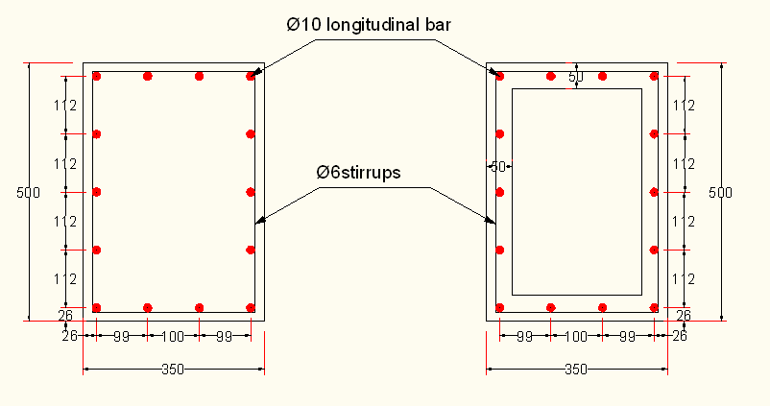
(a)
(b)
All dimension in (mm)
Figure (8); Steel reinforcement layout of (a) solid beams (b) box-section beams .

Figure (9): Photo of test setup (North face) .

Finite Element Idealization:
The load was represented in the finite element model by 4 equivalent nodal forces across the width of the beam, as shown in fig. (10).
Beams | Number of elements
Beams | Solid 65 | Solid 45 | Link 8 | Shell 41 | Contact 52
SC | 3000 | 12 | 2800 | 0 | 0
FS | 3000 | 12 | 2800 | 446 | 977
CH | 4400 | 12 | 2800 | 0 | 0
FH | 4400 | 12 | 2800 | 446 | 977
Equivalent load on onde
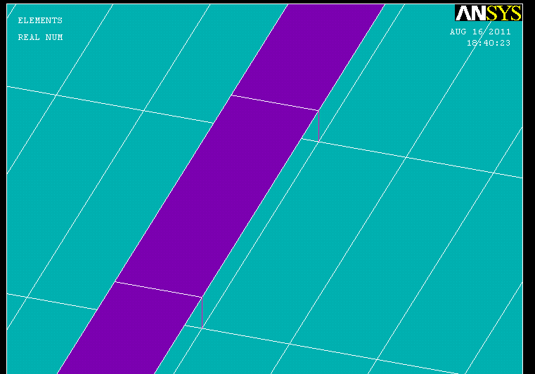

Contact elements

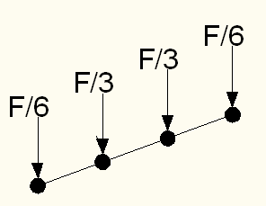

Fixed in y ,z and x directions

Contact elements

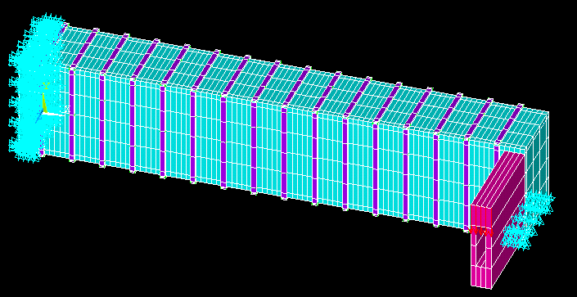
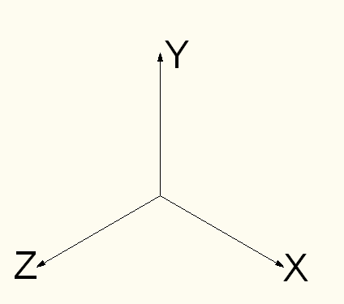
Figure (10): Finite elements mesh and load simulation for beams used in ANSYS program .
Fixed in y ,z directions

Found load-displacement relationship from ANSYS program and by using curve fitting by GRAF4WIN program obtained on angle of twist.

Results of the finite element model:
Figures (11, 12, 13 and 14) showed the relationship between angle of twist and torque, for both the experimental tests and the numerical analyses. The analytical angle of twist (3.6, 9.9, 7.8 and 5.8) is detected quite well compared with that experimentally observed (2.8, 8, 7 and 5.6) for beam (CS, FS, CH and FH) respectively.

Figure (11): Torque-twist curve for beam CS

Figure (12): Torque-twist curve for beam FS

Figure (12): Torque-twist curve for beam FS

Figure (13): Torque-twist curve for beam CH

Figure (14): Torque-twist curve for beam FH

Parametric Study:-
1- Effect of the spacing between CFRP.
To study the influence of the spacing between CFRP strips on the torsional strengthening efficiency of RC beams, different values of spacing for the same amount of reinforcement ratio (by CFRP) were considered. Figures (15 and 16) show that the torque capacity of the strengthened beams can be increased by decreasing the spacing of the CFRP. Decreasing the spacing of the CFRP from (0.75D to 0.25D) led to increase in capacity of 18% and 20% for FS &FH respectively.

2-Effect of Variation of CFRP strips to NSM FRP.
To study and compares the effectiveness and efficiency of two strengthening techniques viz. steel rebars as NSM reinforcement and CFRP strips as externally bonded reinforcement ( with the same area of polymer material), in improving the torque capacity of reinforced concrete beams. The near surface mounted (NSM) FRP bars were used as transverse reinforcement and as longitudinal torsional reinforcement (fig. 21). Figures (17, 18, 19&20) show torque capacity of the beams strengthened with NSM rods increased by 5.71 %, 8%, 12% &15% for solid and box section respectively when compared with CFRP beams.
Figure (15): Torque-twist curve for beam FS

Figure (16): Torque-twist curve for beam FS

Figure (16): Torque-twist curve for beam FH

Figure (17): Torque-twist curve for beam FS for sec 1-1

Figure (18): Torque-twist curve for beam FH for sec 1-2

Figure (19): Torque-twist curve for beam FS for sec 1-3

Figure (20): Torque-twist curve for beam FH for sec 1-4

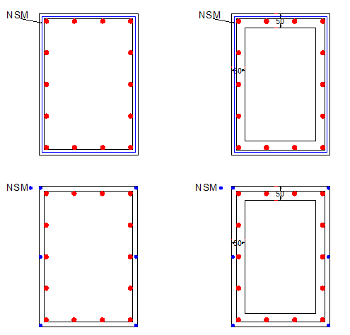
Sec 1-1
Sec 1-2
Sec 1-4
Sec 1-3
(a)
(b)

Figure (21): NSM reinforcement (a) transverse reinforcement (b) longitudinal reinforcement.

Conclusions
1-The three-dimensional nonlinear finite element model presented in this study by using the computer program (ANSYS V.9.0) is able to simulate the analysis of solid and box-section RC beams strengthened in torsion with CFRP reinforcement. The numerical results were in good agreement with experimental torque-twist curves throughout the entire range of behavior.
2- The test results confirm that the strengthening technique of CFRP system is applicable and can increase the torque capacity of RC beams. In this study CFRP strengthening ranged between 49.12% to 77.6% for solid and box section respectively.
3- The near surface mounted (NSM) technique presents a good method for external strengthening of RC beams torque capacity of the beams strengthened with NSM increased by (5-12)% for solid and (8-15)% box section when compared with CFRP beams.
4-The spacing of CFRP strips also affects the torque capacity of the strengthened beams. For the same amount of reinforcement ratio (by CFRP), decreasing the spacing between the CFRP strips was more effective than increasing the width of the strips.

References:
“ANSYS Manual”, Version 9.0, U.S.A., 2004.
American Concrete Institute, ACI Committee 318, (2005), "Building Code Requirements for Structural Concrete (ACI 318-05) and Commentary (ACI 318R-05)", American Concrete Institute, Farmington Hills, MI.
Cervenka, V., Eligehausen, R. and Pulkl, R., “Sbeta-Computer Program for Nonlinear Finite Element Analysis of Reinforced Concrete Structures”, Report 90/1, Institute of Building Materials, University of Stultgort, 1990.
Constantin E. Chalioris ‘Torsional strengthening of rectangular and flanged beams using carbon fibre-reinforced-polymers – Experimental study’’, Construction and Building Materials 22 (2008) 21–29. Available online at www.sciencedirect.com
De Lorenzis L, Nanni A. ‘’Shear strengthening of reinforced concrete beams with NSM fiber-reinforced polymer rods’’, ACI Struct. J 2001; 98(1):60–8.
Gere, I.M. and Timoshenko, S.P., (1997), “Mechanics of material”, PWS Publishing Company, Boston, Massachusetts.
Ghobarab A, Ghorbel MN, Chidiac SE. ‘’Upgrading torsional resistance of reinforced concrete beams using fiber-reinforced polymer’’, J Compos Constr ASCE 2002; 6(4):257-63.
Kachlakev Damian and Thomas Miller, "Finite element modeling of reinforced concrete structures strengthened with FRP laminates”, Technical Report, Oregon Department of Transportation, pp.99, May (2001).
Li LJ, Guo YC, Liu F, Bungey JH. ‘’An experimental and numerical study of the effect of thickness and length of CFRP on performance of repaired reinforced concrete beams’’, Constr Build Mater 2006;20(10): 901–9.
Mattock, A., “Cyclic Shear Transfer and Type of Interface”, Journal of Structural Division, ASCE, Vol.107, N0.ST10, pp.1945-1964, October 1981.
Riadh Al-Mahaidi and Adrian K.Y. Hii’’ Bond behaviour of CFRP reinforcement for torsional strengthening of solid and box-section RC beams’’ Composites: Part B 38 (2007) 720–731. Available online at www.sciencedirect.com
Salom PR, Gergely JM, and Young DT ‘’Torsional strengthening of spandrel beams with fiber-reinforced polymer laminates’’ J Compos Constr ASCE 2004; 8(2):157-62.
Triantafillou TC. ‘’Shear strengthening of reinforced concrete beams using epoxy-bonded FRP composites’’, ACI Struct J 1998;95(2):107–15.
Wylie J. C., ‘’Experimental Testing of Unreinforced Masonry Walls Strengthened with Orthogonal Near-Surface Mounted CFRP Subjected to Out-of-Plane Loading’’, M.Sc. Thesis, University of North Carolina (2009).

Notation:
E_{s} Modulus of Elasticity of Steel
$f_{c}^{'}$ Uniaxial Compressive Strength of Concrete (Cylinder Test)
f_{y} Yield strength of steel bar.
ε Strain , $σ$ Stress

