Nonlinear Analysis of Reinforced Concrete Beams Strengthened in Shear with NSM FRP Rods

Ali H. Adheem
Technical Institute Karbala

Abstract
The present study includes using of near-surface mounted (NSM) fiber reinforced polymer (FRP) rods for increasing the shear strength of reinforced concrete beam. Compares the effectiveness and efficiency of two strengthening techniques viz. steel rebars as NSM reinforcement strips and CFRP strips as external reinforcement. For this analysis, a system of computer program (ANSYS V.9.0) is used for this study. The ordinary reinforced concrete was modeled by 8-noded isoparametric brick elements, while the steel reinforcing bars and NSM reinforcement were modeled as axial members (bar elements) connecting opposite nodes in the brick elements with full interaction assumption. The CFRP strips were modeled by shell elements with full interaction assumption. The results explain the shear capacity of the strengthened beams can be increased by either decreasing the spacing of the NSM rods, or anchoring the rods into the flange, or changing the inclination of the rods from vertical to 45 degrees.
الخلاصة
تَتضمّنُ الدراسةُ الحاليةُ استخدام قضبان تسليح معدنية سطحية لزيادة مقاومة للخرسانة المسلحة كذلك يقدم هذا البحث مقارنة بين اداء و فاعلية طريقتين من طرق تقوية العوارض الخرسانية المسلحة لمقاومة قوى القص وذلك بغرس قضبان تسليح معدنيةسطحية ولصق صفائح كاربونية من الخارج. في الدراسة الحالية تم استخدام برنامج الحاسبة التحليلي (ANSYS V. 9.0). تم تمثيل الخرسانة العادية باستخدام العناصر الطابوقية ثمانية العقدة. إما قضبان التسليح الاعتيادية وقضبان التسليح المعدنية السطحية فقد تم تمثيلها كعناصر محورية تربط نقاط متقابلة في العنصر الطابوقي مع فرض وجود تلاصق تام وتم تمثيل الصفائح الكاربونية المركبة كعناصر رقائقية مع فرض وجود تلاصق تام. تُوضّحُ النَتائِجُ ان مقاومة القص للاعضاء المقواة يمكن ان تزداد بواسطة نقصان المسافة بين القضبان التسليح المعدنية السطحية او تثبيت القضبان الى السطح العلوي للعتبة او تغير درجة الميلان من قائمة الى 45^{0.}
Introduction
Concrete is a construction material with high compressive strength and a poor tensile strength. A concrete structure without any form of reinforcement will crack and fail when subjected to a relatively small load. The failure occurs in most cases suddenly and in a brittle manner. One of the major applications of fiber-reinforced polymer (FRP) composites for strengthening of reinforced concrete (RC) members is their use as additional web reinforcement to increase the shear capacity of the members. Over the last few years, shear strengthening with externally bonded FRP laminates has become a well established technique upon extensive experimental verification and with the development of analytical models reflected in the relevant code provisions. A state-of-the-art review of existing research on this topic can be found in Teng et al. (2004).
A more recent and less investigated method for shear strengthening of RC members is the use of near-surface mounted (NSM) FRP reinforcement, usually in the form of round bars or of rectangular bars with large width to thickness ratio (herein briefly indicated as strips). In the NSM method, the reinforcement is embedded in grooves cut onto the surface of the member to be strengthened and filled with an appropriate binding agent such as epoxy paste or cement grout. A review of available research on
NSM strengthening of RC structures is reported in De Lorenzis and Teng (2007). For shear strengthening with NSM reinforcement, the grooves are cut on the sides of the member at a desired angle to the beam axis.
Two different failure modes were identified in De Lorenzis and Nanni (2001), for beams strengthened in shear with NSM bars. The first was debonding of the FRP bars by splitting of the epoxy cover and cracking of the surrounding concrete, associated with the diagonal tension failure of concrete. This failure mode was prevented by providing better anchorage of the NSM bars crossing the critical shear crack, by either anchoring the bars in the beam flange or the use of inclined (e.g. 45_) bars at a sufficiently close spacing to achieve a longer total bond length. Once this mechanism was prevented, separation of the concrete cover of the steel longitudinal reinforcement became the controlling failure mode. This second mode, however, may be attributed to the fact that no or very limited steel stirrups were present in these beams. The dowel forces due to shear, not restrained by stirrups, give rise to tensile stresses in the surrounding concrete. These, in combination with the wedging action of the bar deformations, produce splitting cracks along the longitudinal reinforcement which eventually lead to failure of the beam. This mode is unlikely in beams with a more realistic amount of steel stirrups. The most important failure mode is thus debonding of the FRP reinforcement. Although it has not been observed so far, tensile rupture of the NSM reinforcement is another possible failure mode.
An ANSYS finite element model was produced by Kachlakev et al. (2001), to study the effects of shear strengthening by comparing the behaviors of two full-scale reinforced concrete beams (a reinforced concrete beam with no shear stirrups; and a reinforced concrete beam externally reinforced with Glass Fiber Reinforced Polymer (GFRP) on both sides of the beam). It was found that the general behaviors through the linear and nonlinear ranges up to failure of the finite element models show good agreement with observations and data from the experimental full-scale beam tests. The addition of GFRP reinforcement to the control beam shifts the behavior of the actual beam and model from a sudden shear failure near the ends of the beam to flexure failure by steel yielding at the mid span. The shear reinforcement increases the load carrying capacity by 45% for the experimental beam and by 15% for the finite element model. This finite element model can be used in additional studies to develop design rules for strengthening reinforced concrete bridge members by using FRP.
1-Finite Element Representation of Reinforced Concrete beam with NAM FRP Reinforcement:
The element types for this model are shown in Table (1-1).The SOLID65 element was used to model the concrete. This element has eight nodes with three degrees of freedom at each node translation in the nodal x, y and z directions. This element is capable of plastic deformation, cracking in three orthogonal directions and crushing. Link 8 was used to represent the flexural reinforcement and NSM FRP reinforcement while Shell41 represents the CFRP strips, SOLID45 element were used to model the plate loading and supporting, ANSYS-9 (2004).

Table (1-1): Element types for working model.

ANSYS element | Material type
SOLID 65  LINK 8  SHELL 41  SOLID45 | Concrete  Flexural Reinforcement and NSM FRP  CFRP strips  Plate loading and supporting

  - Concrete Brick Element:
The 8-node isoperimetric linear element (SOLID65) in ANSYS 9 program is shown in fig. (1) and used in this study. Each of the eight corner nodes has three degrees of freedom u, v, and w in the X, Y and Z directions respectively.
Figure (1): Brick element with 8 nodes (SOLID65 in ANSYS 9) [5].

1-2 Finite Element Idealization of Reinforcement:
\In this study the discrete model is used to represent steel reinforcement and NSM FRP. The three-dimensional two-node bar element (link8) is a uniaxial tension-compression element with three degrees of freedom at each node (nodal translation in x, y and z) directions. The axial normal stress is assumed to be uniform over the entire element. The element x-axis is oriented along the length of the element form node (1) towards node (2), fig. (2).

ξ

u`
z
y
x
1
2
y`

x`

z`
O

w``
v ' `
x`
z`
w`
ξ

Figure (2): Bar element (LINK 8 in ANSYS 9)

As the element is capable of carrying axial loads only, then the strain-displacement relationship is as follows:
----------------------- (1)

  - SHELL41 Element ( Membrane shell )
A shell 41 element was used to model CFRP strips. SHELL 41 is a 3-D element shown in fig. (4), having membrane (in-plane) stiffness but no bending (out-of-plane) stiffness. It is intended for shell structures where bending of the elements is of secondary importance. The element has three degrees of freedom at each node: translations in the nodal x, y, and z directions. The element can have variable thickness, stress stiffening and large deflection.
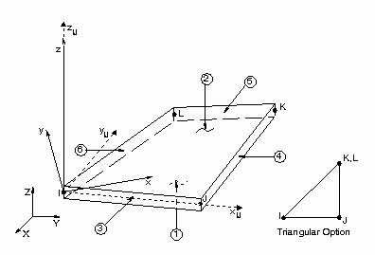

Figure (4): SHELL 41 geometry.

Concrete Modeling:
- Stress-Strain Relationship:
The Solid 65 element requires linear isotropic and multilinear isotropic material properties to properly model concrete as shown in Fig. (5). The modulus of elasticity was calculated by equation of ACI- code (2008).
$Εc=\text{4730}\sqrt{f_{c}^{'}}$
----------------------- (2)
The ANSYS program requires the uniaxial stress-strain relationship for concrete in compression as shown in Fig. (5). Numerical expressions, equations (3) and (4), were used along with equation (5) Gere et al., (1997) [7] to construct the uniaxial compressive stress-strain curve for concrete in this study.
$f=\frac{E_{c}ε}{1+{\left(\frac{ε}{ε_{o}}\right)}^{2}}$ ----------------------- (3)
$ε_{o}=\frac{2f'c}{E_{c}}$ ----------------------- (4)
$E_{c}=\frac{f}{ε}$ ----------------------- (5)
Where:
ƒ = Stress at any strain ε.
ε = Strain at stress ƒ.
ε_{ο} = Strain at the ultimate compressive strength ƒ'c.
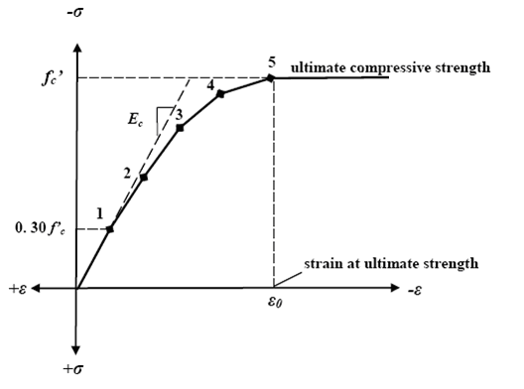
Figure (5): Simplified compressive uniaxial stress-strain curve for concrete Kachlakev et al. (2001).
Modeling of Reinforcement
Typical stress-strain curves for reinforcing steel bars used in concrete construction are obtained form coupon tests of bars loaded monotonically in tension. For all practical purposes steel exhibits the same stress-strain curve in compression as in tension. The steel stress-strain relation exhibits an initial linear elastic portion, a yield plateau, a strain-hardening range in which stress again increases with strain and finally a range in which the stress drops off until fracture occurs. The extent of the yield plateau is a function of the tensile strength of steel, Cervenka et al. (1990) [8].
Where, E_{w} =0.1E_{s}

f_{y}

Figure (6): Typical stress-strain curve for steel bar, Mattock (1981) .

Modeling of FRP Reinforcement:
The stress-strain behavior of FRP reinforcement is linear-elastic to failure. As a result, the FRP reinforcement is classified as brittle versus steel which is ductile. As a comparison, the yield strain of grade 60 steel is approximately 0.002, which is about one-tenth of the ultimate strain available in the FRP reinforcement. Thus, if a masonry structure is reinforcement with some type of FRP, the structure will continue to gain strength until there is either a bond failure between the FRP and the masonry, rupture of the FRP reinforcement, or crushing of the masonry. Fig. (7), shows the typical constitutive relationships for common materials.
CERP
GERP
Steel
Stress
Strain

Figure (7): Behavior of Typical Materials, John (2009) .

Numerical Example
Three full scale reinforcement concrete beams with a T-shaped cross section and total length of (3m) tested by Laura and Antonio (2001). The amount of steel flexural reinforcement was the same for all the beams and was designed to obtain a shear failure despite the envisioned shear capacity enhancement provided by NSM FRP rods. The beams had a flexural reinforcement of two steel reinforcing bars (nominal diameter 28.7 mm). The dimensions of the beam cross section are given in fig. (8).
The average concrete strength (31 MPa). The internal steel flexural reinforcement had nominal yield strength (414 MPa). CERP deformed No. 3 rods, with a nominal diameter of (9.5 mm), were used in this program. Fig. 9 shows their surface configuration, along with that of other currently used types of FRP rods. Tensile strength and modulus of elasticity of the CFRP rods (1875 MPa and 104800 MPa), respectively. The specimen details are indicated in Table (1-2).

Table 1-2 Specimen details.
Beam  code | Steel  stirrups | NSM FRP rods
Beam  code | Steel  stirrups | Quantity | Spacing (inch) | Angle degree | Anchoring
BV | --------- | --------- | ---------- | -------- | No
B90-5 | -------- | No. 3 | 5 | 90 | No
B45-5 | -------- | No. 3 | 5 | 45 | No
B45-7 | -------- | No. 3 | 7 | 45 | No
B90-7 | -------- | No. 3 | 7 | 90 | No
B90-5A | ------- | No. 3 | 5 | 90 | Yes

Figure (9): cross section of beams tested
by Laura and Antonio (2001) .

Figure (8): Surface configuration of some types of FRP rods.

Figure (10): Test setup by Laura and Antonio (2001)

Finite Element Idealization:
The mid span load was represented in the finite element model by 12 equivalent nodal forces of the beam, as shown in fig. (11)
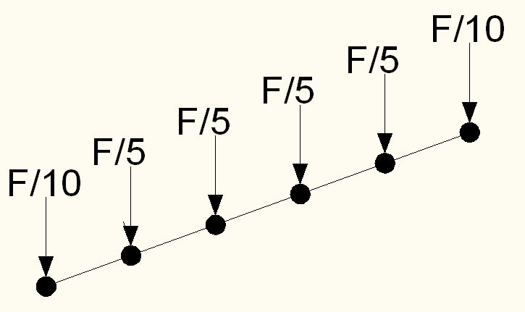

Nodal load
Equivalent load on onde

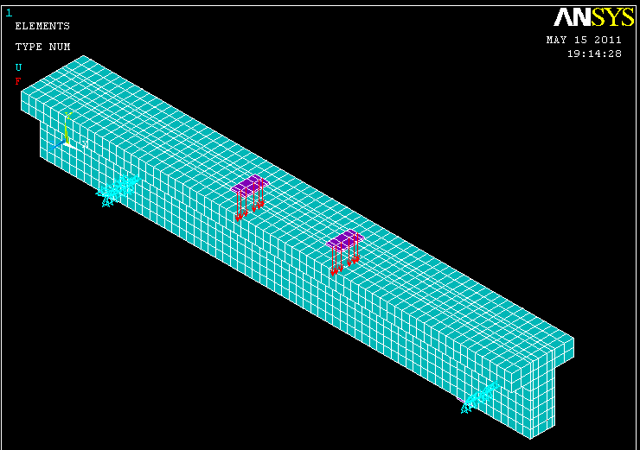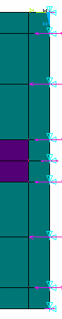
Supporting
Figure (11): Finite elements mesh and load simulation for beams used in ANSYS program
Results of the finite element model:
Figures (12, 13, 14) shown the relationship between deflection at beam mid-span and load, for both the experimental tests and the numerical analyses (assuming perfect bond). The analytical ultimate deflection (8.1, 10, 6.1mm) is detected quite well compared with that experimentally observed (7.3, 8.7, 5.77mm) for beam (BV, B45-5, B90-5) respectively.

Figure (12): Load –deflection curve for beam
(BV)

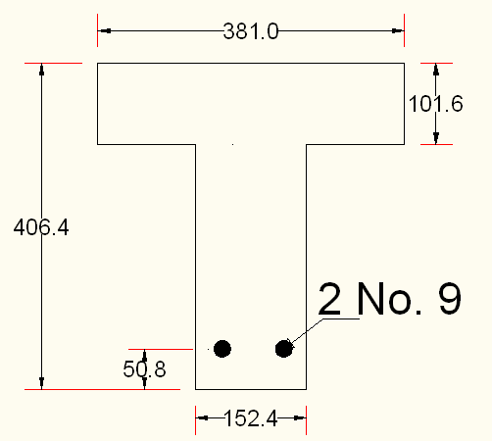
Figure (13): Cross section for beam
(BV)

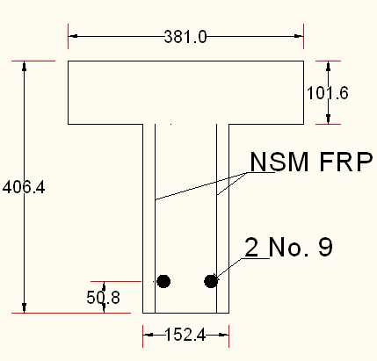
Figure (15): Cross section for beam
(B45-5)

Figure (14): Load –deflection curve for beam
(B45-5)

Figure (16): Load –deflection curve for beam
(B90-5)

Figure (17): Cross section for beam
(B90-5)

Parametric Study
1- Effect the spacing between NSM FRP and anchorage.
Figures (15, 16, 17) shown the shear capacity of the strengthened beams can be increased by either decreasing the spacing of the NSM rods, or anchoring the rods into the flange. Increasing the spacing of the rods from (5 to 7 in), which corresponding to a 28.5% decrease in the amount of FRP material, led to decrease in capacity of 6.8% and 13.5% in the case of 45and 90 degree rods, respectively. Anchoring the rods in the flange increased the capacity by 33.5%. These comparisons seem to indicate that the most efficient way to increase the shear capacity of RC T-beam is by using NSM rods anchored into flange.

Figure (15): Load –deflection curve for beam
(B45-5)

Figure (15): Load –deflection curve for beam
(B45-5)

Figure (16): Load –deflection curve for beam
(B90-5)

Figure (17): Load –deflection curve for beam
(B45-5)

Figure (17): Load –deflection curve for beam
(B90-5)

2-Effect of Variation of NSM FRP to CFRP strips.
To study and compares the effectiveness and efficiency of two strengthening techniques viz. steel rebars as NSM reinforcement and CFRP strips as externally bonded reinforcement ( with the same area of polymer material), in improving the shear capacity of reinforced concrete beams. Fig. (18) show shear capacity of the beams strengthened with FRP sheets decreased by 4.36% when compared with NSM beams.
Figure (18): Load –deflection curve for beam
(B90-5)

2-Effect of shear span ratio.
To study the effect of shear ratio (n) on the behavior of the beam, different values of (a/d) were considered. These values were (3, 2.75, 2.5, and 2.25). With reference to fig. (18), the shear capacity increase with decreasing (a/d) where the failure mode can be flexural.
Figure (18): Load –deflection curve for beam
(B90-5)

Conclusions
1-The three-dimensional nonlinear finite element model presented in this study by using the computer program (ANSYS V.9.0) is able to simulate the behavior of reinforced concrete beams strengthened in shear with NSM FRP rods. The numerical results were in good agreement with experimental load-deflection curves throughout the entire range of behavior.
2- The test results confirm that the strengthening technique of NSM FRP system is applicable and can increase the shear capacity of RC beams. In this study NSM FRP strengthening ranged between 45% to 100%.
3- Shear capacity of the beams strengthened with FRP sheets decreased by 4.36% when compared with NSM beams.
4-The spacing of CFRP strips also affects the shear capacity of the beams strengthened.
4- The results explain anchoring the rods in the flange (33% more material) increased the capacity by 33.5%.
References:
“ANSYS Manual”, Version 9.0, U.S.A., 2004.
American Concrete Institute, ACI Committee 318, (2008), "Building Code Requirements for Structural Concrete (ACI 318-05) and Commentary (ACI 318R-05)", American Concrete Institute, Farmington Hills, MI.
Cervenka, V., Eligehausen, R. and Pulkl, R., “Sbeta-Computer Program for Nonlinear Finite Element Analysis of Reinforced Concrete Structures”, Report 90/1, Institute of Building Materials, University of Stultgort, 1990.
De Lorenzis L, Nanni A. ‘’Shear strengthening of reinforced concrete beams with NSM fiber-reinforced polymer rods’’, ACI Struct. J 2001; 98(1):60–8.
De Lorenzis L, Teng JG. ‘’Near-surface mounted FRP reinforcement an emerging technique for structural strengthening Composites’’, Part B 2007; 38(2):119–43.
Gere, I.M. and Timoshenko, S.P., (1997), “Mechanics of material”, PWS Publishing Company, Boston, Massachusetts.
Kachlakev Damian and Thomas Miller, "Finite element modeling of reinforced concrete structures strengthened with FRP laminates”, Technical Report, Oregon Department of Transportation, pp.99, May (2001).
Laura De Lorenzis and Antonio Nanni.’’ Shear Strengthening of Reinforced Concrete Beams with Near-Surface Mounted Fiber-Reinforced Polymer Rods’’ ACI Structural Journal/January-February 2001.
Mattock, A., “Cyclic Shear Transfer and Type of Interface”, Journal of Structural Division, ASCE, Vol.107, N0.ST10, pp.1945-1964, October 1981.
Teng JG, Lam L, Chen JF. ‘’Shear strengthening of RC beams with FRP composites’’, Prog. Struct. Eng. Mater 2004; 6:173–84.
Wylie J. C., ‘’Experimental Testing of Unreinforced Masonry Walls Strengthened with Orthogonal Near-Surface Mounted CFRP Subjected to Out-of-Plane Loading’’, M.Sc. Thesis, University of North Carolina (2009).
Notation:
E_{s} Modulus of Elasticity of Steel
$f_{c}^{'}$ Uniaxial Compressive Strength of Concrete (Cylinder Test)
f_{y} Yield strength of steel bar.
ε Strain , $σ$ Stress

