Modeling the Removal of Phenol by Natural Zeolitein Batch and Continuous Adsorption Systems

Shahlaa E. Ebrahim
Environmental Engineering Department-College of Engineering-Baghdad University

Abstract
The adsorption of phenol from aqueous solution onto natural zeolite was studied using a fixed bed column. Experiments were carried out to study the effect of influent concentration, flow rate, bed depth and temperature on the performance of the fixed bed. The equilibrium data fitted with theoretical models. A batch adsorber model has been used to determine the external mass transfer coefficient and diffusion coefficient for the phenol system.
A mathematical model was formulated to describe the mass transfer kinetics in the fixed bed adsorption column. The results show that the mathematical model which includes external mass transfer and surface diffusion using nonlinear isotherm, provides a good description of the adsorption process for phenol onto fixed bedof natural zeolite.
Key words
Adsorption, fixed bed, natural zeolite, phenol, mathematical model, mass transfer coefficient.
Introduction
Phenols are generally considered to be one of the important organic pollutants discharged into the environment causing unpleasant taste and odor of drinking water. The major source of phenol pollution in the aquatic environment is wastewater from paint, pesticide, coal conversion, polymeric resin, petroleum and petrochemical industries (Calace, et. al,2002, andAkbal and Onar, 2003).Phenol is a colorless-to-white solid when pure, phenol has a distinct odor that is sickeningly sweet and tarry. Phenol is a toxic and mutagenic substance at high concentrations and may be absorbed through skin. Phenol is for the most part biodegradable (Ahmaruzzaman, 2008). When phenol presents in water exceeds the limit it result in the destruction of the organisms, the majority of which are food for the fish. When comes in contact with chlorine compounds it produces medical taste (Laszlo, et. al., 2003).
Adsorption techniques are widely used to remove certain classes of pollutants from wastewater. Adsorption is an efficient process for the removal of organic matter from waste effluents. Although commercial activated carbon is a preferred adsorbent for phenol removal, its widespread use is restricted due to the high cost. Because of their low cost and local availability, natural materials such as natural zeolitesare classified as low-cost adsorbents (Ahmaruzzaman, 2008). Zeolites are hydrated aluminosilicate materials having cage-like structures with internal and external surface areas of up to several hundred square meters per gram and cation exchange capacities of up to several meq./kg. At least 41 types of natural zeolites are known to exist, and many others have been synthesized. Both natural and synthetic zeolites are used in industry as adsorbents, soil modifiers, ion exchangers, and molecular sieves (Ghiaci, et. al., 2004, and Kuleyin, 2007). The adsorption process of a solute on an adsorbent takes place at the liquid- solid boundary; and the interface of the two phases represents a special environment under dimensional or topological constraints (Gaspard, et. al., 2006)
To design and operate a fixed bed adsorption process successfully, the column dynamics must be understood; that is the breakthrough curves under specific operating conditions must be predictable. A mathematical model of fixed bed adsorbers is very useful for the proper design and the determination of the optimal operating conditions. Different models for the adsorption process on fixed beds were proposed in the literature and various numerical techniques have been developed for the solution of these models. The differences between these models arise from the different representation of the equilibrium behavior, the different expressions of the mass transfer inside and outside the adsorbent particle and from how the axial dispersion is taken into account in the material balance for the adsorbate in the fixed bed column (Hsu, et. al., 1997).
Homogeneous surface diffusion model (HSDM) takes into consideration most of the physical transport mechanism, but ignore pore diffusion and dispersion. Due to its simplicity and acceptable accuracy, the model was used by several researchers to best-fit experimental results and to evaluate the sensitivity of parameters that affect breakthrough curves(Crittenden and Weber, 1978, and Pota and Mathews, 1999)
Under a wide range of operating conditions, the key process parameters in adsorption such as isotherm constants and mass transfer coefficients are obtained by conducting batch studies of adsorption. Langmuir and Freundlichisotherms have been applied to describe the equilibrium between liquid-solid phases. The parameters that are responsible for mass transfer operation are the external mass transfer coefficient and surface diffusion coefficient.
The aim of this study is to remove pollutants using low cost adsorbent. Cost is actually an important parameter for comparing adsorbent materials. A solid can be considered as low-cost adsorbent if it is required little processing and abundant in nature. To achieve this aim natural zeolite for adsorbing phenol was investigated in fixed bed system.An experimental programme was designed and performed using different phenol concentrations, flow rates, bed depth and different solution temperatures. The experimental results obtained from varying concentration, flow rate and bed depth were compared with those obtained from theoretical formulation of the Homogenous Surface Diffusion Modelwhich includes film mass transfer andsurface diffusion coefficient.
2. Theory
2.1 Fixed bed
Fixed bed dynamics are described by convection-diffusion equations, coupled with source term due to adsorption and diffusion inside adsorbent particles. The solution of these equations will give rise to the prediction of the needed breakthrough curves (Crittenden, et. al., 1986).
The Homogenous Surface Diffusion Model can be used as an effective tool to generate the breakthrough curves for any desired set of operating conditions; the model assumes that the adsorbent particles are spherical and homogeneous. Homogeneity implies that the solid-phase concentration, adsorbent density, and surface area are only a function of the radial location in the particle (Hand, et. al., 1983).
The assumptions used in deriving the model are (Thacker, et. al., 1981):
- The rate of adsorption is diffusion-limited, thus local equilibrium exists at the surface of adsorbent particle.
- The adsorbent particle is a homogeneous solid.
- The adsorbent particle is spherical.
- Flow in the column is plug flow.
- Pore diffusion and bulk dispersion are negligible.
- Temperature and pressure are uniform in the bed.
The various differential equations that describe the HSDM are:
- The rate of accumulation of adsorbate on the surface of adsorbent particles can be described by the following partial differential equation with initial and boundary conditions (14):
$\frac{∂q}{∂t}=D_{s}\left(\frac{∂^{2}q}{∂r^{2}}+\frac{2}{r}\frac{∂q}{∂r}\right)$ ….1
$t=0$$;0≤r≤R_{p}$$;q=0$
$t≥0$ ; $r=0$ ; $\frac{∂q}{∂r}=0$
$t≥0$ ; $r=R_{p}$ ; $\frac{R_{p}^{2}K_{f}(C−C_{p})}{ρ}=\frac{∂}{∂t}\int_{0}^{R_{p}}{{\text{qr}}^{2}}\text{dr}$
$r=R_{p}$; $C=f(q_{s})$
- The mass balance of adsorbate in the entire bed and the corresponding initial and boundary conditions are:
- $\frac{∂C}{∂t}=\left[−V\frac{∂C}{∂Z}−\frac{3\left(1−ε_{b}\right)}{R_{p}ε_{b}}\right]K_{f}\left(C−C_{s}\right)$ ….2
- $t=0$ ; $0≤Z≤L$ ; $C=0$
- $t=0$$Z=0$ ; $C=C_{o}$
Where C_{s} and q_{s} are the adsorbate liquid and solid concentration at the external surface of the particle, respectively.
The HSDM model equations are solved numerically, for single solute with uniform adsorbent size, using the orthogonal collocation method. The orthogonal collocation method is used to convert the partial –differential equation into first-order ordinary differential equation. It should be mentioned that the surface diffusion coefficient D_{s} and the external mass transfer coefficient K_{f}are to be determined from batch experiments (Dwiwedi, and Upadhyay, 1977, and Ruthven, 1984)

2.2 Batch adsorber
The mathematical model for the batch adsorber is potentially affected by the external film resistance and the surface mass transfer resistance. The batch surface diffusionmodel is based on the following assumptions:
- Spherical isotropic particles with homogeneous size and density.
- Constant diffusion coefficient during the adsorption process.
- Isothermal process and fast intrinsic adsorption kinetics(Leyva, and Geankoplis, 1985, Liu, et. al., 2006, and Ping, and Guohua, 2001).
-Mass balance in the bulk-fluid phase
$V_{L}\frac{{\text{dC}}_{b}}{\text{dt}}+\frac{3W_{A}}{ρ_{p}R_{p}}k_{f}\left(C_{b}−C_{s,r=R_{P}}\right)=0$ ….3
Where V_{L} = volume of fluid in the batch adsorber.
W_{A} = mass of solid adsorbent (zeolite) in the batch adsorber.
-Mass balance at the surface of the particle
Molecules migrate along the surface when and adjacent adsorption site is available, and the molecules have enough energy to leave the site it is presently occupying. The driving force is the local adsorbent phase gradient (Hand, et. al., 1983).
$ρ_{p}\frac{∂q}{∂t}=ρ_{p}D_{s}\left(\frac{∂^{2}q}{∂r^{2}}+\frac{2}{r}\frac{∂q}{∂r}\right)$ ….4
Subject to the initial and boundary conditions:
$$t=0,C=0,q=0$$
$$r=0,\frac{∂C}{∂r}=0$$
$r=R_{p}$$ρ_{p}D_{s}\frac{∂q}{∂r}=k_{f}\left[C_{b}−C_{s,r=\text{Rp}}\right]$

For Langmuir isotherm model:
$q=\frac{q_{m}{\text{bC}}_{s}}{1+{\text{bC}}_{s}}$ ….5
The external mass transfer coefficient for the solute adsorbed at certain particle size and optimum speed of agitation, can be obtained by the analytical solution of equation (3) (Ping, and Guohua, 2001, and Alexander, and Zayas, 1989).
$k_{f}=−\frac{R_{p}ρ_{p}V_{L}}{3W_{A}t}\text{ln}\left(\frac{C_{t}}{C_{o}}\right)$ ….6

Where R_{p} and ρ_{p}are the particle radius and density respectively and C_{o} and C_{t}are the solute concentration at time zero and time t, respectively.
W_{A} is the amount of zeolite required to reach equilibrium concentration of C_{e}/C_{o}=0.05 obtained from equation (5) as follows:

$W_{A}=\frac{V_{L}(C_{o}−C_{e})}{q_{e}}=\frac{V_{L}(C_{o}−C_{e})}{(q_{m}{{\text{bC}}_{e}}/1+{\text{bC}}_{e})}$ ….7
Experimental concentration-time data are compared to predicted concentration-time profile for the above batch absorber model and the best statistical description was used to determine the surface diffusion coefficient.

3. Experimental work
3.1 Materials
Adsorbate: phenol was used as an organic pollutant; supplied by Sdfine-Chem limited, India.
Adsorbent: natural zeolite was used as an adsorbent; it was obtainedfrom the local market.
3.2 Methods
Thephysical properties of natural zeolite used in the experiments are listed in table (1).The zeolite was sieved on28/32 mesh with geometric mean diameter of 0.5mm. The zeolite was boiled, washed three times in distilled water and dried at 300ºC for 48 hours in order to remove any traces of moisture or other contaminants, before being used as adsorbent. The aqueous solution of phenol was prepared using reagent grades.

Table 1: Characteristics of natural zeolite
Bulk density (kg/m³) | 580
Particle density(kg/m³) | 2120
Bed porosity | 0.3
Surface area (m²/g) | 650

The experiments were adjusted at the initial pH of 5 for phenol (Ping, and Guohua, 2001). The pH value was adjusted to an accuracy of 0.01 mol/l HCl.
The fixed bed experiments were carried out in Q.V.F. glass column of 50 mm internal diameter and 50 cm in height. The zeolite was confined in the column by fine stainless steel screen at the bottom and glass packing at the top of the bed to ensure a uniform distribution operforated plate fixed at the top of the column. The feed solution was prepared in Q.V.F. vessel supplied with immersed heater with a temperature controller to adjust the temperature of the solutionat 30ºC.A schematic diagram of the apparatus is shown in figure (1).
For the determination of adsorption isotherms, 250 ml flasks were filled with known concentration of solute and a known weight of zeolite. The flasks were then placed on a shaker and agitated continuously for 30 hours at 30ºC. The concentration of phenol in the solution was determined by a UV-160A spectrophotometer at 270nm.
The adsorbed amount was calculated by the following equation:
$q_{e}=\frac{V_{L}\left(C_{o}−C_{e}\right)}{W_{A}}$ ….8

The surface diffusion coefficient was estimated using the following steps:
- The optimum agitating speed used for batch adsorber to reach the needed equilibrium concentration of phenol was 1000rpm (Ebrahim, 2008).
- Estimating the mass transfer coefficient in batch process at optimum agitation speed.
- Applying numerical solution of batch adsorber model to obtain the surface diffusion coefficient. This was done by using the surface diffusion model to best fit the experimental results.
For the determination ofsurface diffusion coefficient for phenol a 2 liter Pyrex beaker fitted with a speed mixer of 1000rpm was used. The beaker was filled with 1 liter of known concentration solution and agitation started before adding the zeolite. At time zero, an accurate weight of zeolite was added. Samples of solution were taken every 5 minutes for analysis.
The necessary dosage of zeolite, to reach equilibrium related concentration of C_{e}/C_{o} equal 0.05, were calculated from the isotherm model and mass balance equation.

4. Results and discussion
4.1 Adsorption isotherms
The adsorption isotherms display a nonlinear dependence on the equilibrium concentration. The adsorption data for the system was fitted by Langmuir model (Lucas, and Cocero, 2004, Seader, and Herley, 1998), and Freundlich model (Weber, and Walter, 1972, Kulegin, 2007).The correlation coefficient was employed to ascertain the fit of each isotherm with experimental data as presented in table (2). Table (2) indicates that Langmuir model provides the best fit as judged by its correlation coefficient.The Langmuir model was therefore selected to be introduced in the fixed bed model where:
$q_{e}=\frac{q_{m}{\text{bC}}_{e}}{1+{\text{bC}}_{e}}$ ….9
The equilibrium isotherms for phenol adsorption onto natural zeoliteare presented in figure (2). The parameters q_{m}, b of the Langmuir model are evaluated to be:
q_{m,} = 0.07612 kg/kg
b=71.11 m³/kg

Table 2: Parameters of isotherms for phenol and correlation coefficient for Langmuir and Freundlich models
Model | Parameters | Phenol
Langmuir  $$q_{e}=\frac{q_{m}{\text{bC}}_{e}}{1+{\text{bC}}_{e}}$$ | q_{m},  b, m³/kg  Correlation coefficient | 0.0761  71.11  0.9993
Freundlich  $$q_{e}={\text{KC}}_{e}^{1/n}$$ | K,  n,  Correlation coefficient | 0.2369  2.2406  0.9771

4.2 Surface diffusion coefficient
The amounts of zeolite used for phenol removal was calculated for final equilibrium related concentration of C_{e}/C_{o}=0.05. Using the Langmuir equation with mass balance in one liter of solution. The initial concentrations were 0.2 Kg/m³ with the doses of natural zeolite of 3.9×10⁻³Kg.
The optimum agitation speed needed to achieve C_{e}/C_{o}=0.05 was found to be 1000 rpm. It is clear that, if the speed is above 1000 rpm, the equilibrium relative concentration is less than 0.05; this is due to pulverization of activated carbon at high speed agitation (Ebrahim, 2008).
There were a good matching between experimental results and predicted data using surface diffusion model for batch operation as shown in figure (3).
The surface diffusion coefficient and the mass transfer coefficient for the system are found from the experiments to be D_{s} =2.2×10⁻⁹ m²/sec and 9.5510⁻⁶m/sec respectively.

4.3 Breakthrough curves
Figures (4) to (6) show the experimental and predicted breakthrough curves for phenol adsorption onto zeolite at different flow rates, bed depths and initial concentrations of adsorbate at constant temperature of 30ºC. It can be seen from these figures:
- An increase in the initial concentration of phenol makes the breakthrough curves much steeper, this would be anticipated on the basis that the driving force for mass transfer increases with increase of concentration of adsorbate in the solution (Malkoc, and Nuhoglu, 2006). A high adsorbates concentration may saturate the adsorbent more quickly, thereby decreasing the breakthrough time.The same conclusion was obtained by (Gupta, et. al., 2001, Lin, and Wang, 2002, Sulaymon, and Ahmed, 2007, and Sulaymon, et. al., 2009).
- An increase in the adsorbate flow rate decreases the breakthrough time due to the decrease in the contact time between the adsorbate and the adsorbent along the adsorption bed. Increasing the flow rate may be expected to make reduction of the surface film. Therefore, this will decrease the resistance to mass transfer and increase the mass transfer rate and there is not enough time for adsorption equilibrium to be reached which results in low bed utilization and the adsorbate solution leaves the column before equilibrium. These results agree with that obtained by (Gupta, et. al., 2001, Lin, and Wang, 2002, Sulaymon, et. al., 2009, and Babu, and Gupta, 2004).
- It is observed that shorter bed heights are generally responsible for earlier break points, because a short bed height would exhaust more rapidly.Furthermore, increasing the bed height will give a sufficient contact time for the adsorbate to be adsorbed on adsorbent surface. The time provided for the contact of the adsorbate with adsorbent is longer at a long bed height. These results also agree with results obtained by (Gupta, et. al., 2001, Lin, and Wang, 2002, Sulaymon, and Ahmed, 2007, and Sulaymon, et. al., 2009)
- The breakpoint was related to the flow rate, bed depth and initial concentration, i.e. the time required to reach breakpoint decreases with the increases of flow rate, decreases of bed depth, and increases of solute initial concentration.

4.4 Effect of solution temperature
Figure (7) shows the effect of temperature on the experimental breakthrough curve. Rate of diffusion represented by the surface diffusion coefficient increases with temperature (i.e., D_{s} is proportional to T^{3/2}) and this in turn increases the mass transfer coefficient (Azni, and Katayon, 2003). The same conclusion was obtained by (Wa’adalla, 2006).

Conclusions
The equilibrium isotherm data were correlated with two models, Langmuir model gave the best fit for the experimental data. The batch experiments were helpful in estimating the isotherm model constants such as surface diffusion coefficient,and mass transfer coefficient. There was a good matching between experimental and predicted data in batch experiment by using surface diffusion method. Hence the transfer of phenol within the natural zeolite is controlled by surface diffusion. The Homogeneous Surface Diffusion Model (HSDM) which includes film mass transferand surface diffusion resistance provides a good description of the adsorption process. An increase in the initial concentration of phenol makes the breakthrough curves much steeper, which would be anticipated with the basis of increases driving force for mass transfer with the increase of phenol concentration. The increase in the bed depth of natural zeolite will increase the breakthrough time and the residence time of the phenol in the column. While increasing the solution flow rate decreases the breakthrough time due to the decrease in the contact time between the adsorbate and the adsorbent along the adsorption bed. Increasing the temperature of phenol solution will decrease the breakthrough timebecause of the increase in surface diffusion coefficient with temperature.

References
- Ahmaruzzaman, Md. Adsorption of phenolic compounds on low-cost adsorbents: A review, Advances in Colloid and Interface Science, 2008, 143, 48-67.
- Akbal, F., Onar AN. Environmental Monitor Assess, 2003, 83, 301.
- Alexander, P. M. and Zayas, I. Particle size and shape effects on adsorption rate parameters, J. Environmental Engineering, 1989, 115, 1, Feb., 41-55.
- Azni, I. and Katayon, S., Possible utilization of silica gel sludge for the removal of phenol from aqueous solution laboratory studies, The Environmentalist, 2003, 23, 329-334.
- Babu, B.V. and Gupta, S. Modeling and simulation for dynamics of packed bed adsorption. Chem. Conf., Mumbai, 2004.
- Calace, N., Nardi, E., Petronio, B. and Pietroletti, M. Environmental Pollutant, 2002, 118, 315.
- Crittenden, J. C., Berrigan, J. K., Hand, D. W. and Lykins, B. Design of rapid small-scale adsorption tests for a constant diffusivity. J. WPCF, 1986, 58, 4, 312-319.
- Crittenden, J. C. and Weber, W.J., Predictive model for design of fixed bed adsorbers: parameter estimation and model development. J. Env. Eng. Div., 1978, ASCE, 104, 185.
- Dwiwedi, P. N., and Upadhyay, S. N., Particle fluid mass transfer in fixed bed fluidized bed”, Ind. Eng. Chem. Proc. Des., 1977, No. 16, 157-165.
- Ebrahim, S. Evaluation of a mixture adsorbent and glass bed for the removal of phenol and methylene blue from water, 2008, PhD thesis.
- Gaspard, S. A., Passe-Coutrin, N., Ouensanga, A. and Brouers, F. Parameters from a new kinetic equation to evaluate activated carbon efficiency for water treatment, Water Research, 2006, 40, 3467-3477.
- Ghiaci, M., Abbaspur, A., Kia, R., and Seyedeyn-Azad, F. Equilibrium isotherm studies for the sorption of benzene, toluene and phenol onto organo-zeolites and as synthesized MCM-41, Separation and Purification-Technolgy, 2004, 40, 217-229.
- Gupta, A., Nanoti, O. and Goswami, A. N., The removal of furfural from water by adsorption with polymeric resin, Separation Science and Technology, 2001, 36, 13, 2835-2844.
- Hand, D. W., Crittenden, J. C., and Thacker, A. M., User-oriented batch solution to the homogeneous surface diffusion model, Journal of Environmental Engineering, 1983, V. 109, No. 1, 82-101.
- Hsu, Y. C., Chiang, C. C. and Yu, M. F., Sep. Sci. Tech., 1997, 32, 2513.
- Kulegin, A., Removal of phenol and 4-chlorophenol by surfactant-modified natural zeolite,Journal of Hazardous Materials, 2007, 144, 307-315.
- Kuleyin, A. Removal of phenol and 4-chlorophenol by surfactant-modified natural zeolite, Journal of Hazardous Materials, 2007, 144, 307-315.
- Laszlo, K., Podkoscielny, P. And Dabrowski, A. Heterogeneity of polymer-based active carbon in adsorption of aqueous solutions of phenol and 2, 3, 4-trichlorophenol, Langmuir, 2003, 19, 9719-9723.
- Leyva, R. R. and Geankoplis, C.J., Model simulation and analysis of surface diffusion of liquids in porous solids, Chemical Engineering Science, 1985, 40,5,799-807.
- Lin, S. H. and Wang, C. S., Treatment of high-strength phenolic wastewater by a new two-step method, Journal of Hazardous Materials, 2002, B90, pp 205-216.
- Liu, B., Yang, Y. and Ren, Q. Parallel pore and surface diffusion of levulinic acid in basic polymeric adsorbents, Journal of Chromatography A., 2006, 1132, 190-200.
- Lucas, S. and Cocero, M. J., Adsorption isotherms for ethylacetate and furfural on activated carbon from supercritical carbon dioxide. Fluid Phase Equilibria, 2004, 219, 171-179.
- Malkoc, E. and Nuhoglu, Y., Fixed bed studies for the sorption of chromium (VI) onto tea factory waste. Chemical Engineering Science, 2006, 61, 4363-4372.
- Ping, L. and Guohua, X., Adsorption and desorption of phenol onto activated carbon fibers in fixed bed, Separation Science and Technology, 2001, 36, 10, 2147-2163.
- Pota, A. A., and Mathews, A. P., Effect of partial stratification on fixed bed adsorber performance, J. Env. Eng., 1999, V. 125, N.8, 705-711.
- Ruthven, D. M., Principles of adsorption and adsorption processes. John Wiley and Sons, Inc., 1984.
- Seader, J. D. and Herley, E. J., Separation process principles, John Wiley and Sons, New York, 1998.
- Sulaymon, A. H., and Ahmed, K. W., Competitive adsorption of furfural and phenolic compounds onto activated carbon in fixed bed column, Environ. Sci. Technol, 2007,
- Sulaymon, A. H., Ali, A. M., and Al-Naseri, Natural organic matter removal from Tigris River water in Baghdad, Iraq, Desalination, 2009, 245, 155-168.
- Thacker, W. E., Snoeyink, V. L., and Crittenden, J. C., Modeling of activated carbon and coal gasification char adsorbents in single solute and bisolute systems, Water Resour. Ctr. Rep., 1981, No. 161, Univ. of Illinois, Urbana, III.
- Wa’adalla, K., “Removal of multi-pollutants from wastewater by adsorption method”, Ph. D. Thesis, University of Baghdad, 2006.
- Weber, J. R. and Walter, J., Phtsicochemical processes for water quality control. Wiley Inter Science, New York, 1972.

Notation
Symbols

b | Langmuir constant, l/mg
C | Concentration in fluid, kg/m³
C_{o} | Initial concentration, kg/m³
C_{e} | Concentration of solute at equilibrium, kg/m³
C_{p} | Concentration in the particle phase, kg/m³
C_{s} | Adsorbate liquid concentration at the external surface of the particle
D_{s} | Surface diffusion coefficient, m²/sec
d_{p} | Particle diameter, m
K | Freundlich empirical constant
k_{f} | Fluid to particle mass transfer coefficient, m/sec
L | Length of bed, m
n | Freundlich empirical constant
Q  q | Fluid flow rate, m³/sec  The amount of adsorbate per unit weight of carbon at equilibrium kg/kg
q_{e} | Internal concentration of solute in particle at equilibrium, kg/kg
q_{m} | Adsorption equilibrium constant defined by Langmuir equation, mg/gm
q_{s} | Adsorbate solid concentration at the external surface of the particle
R_{p} | Radius of particle, m
t | Time, sec
T | Temperature, K
V | Interstitial velocity $\left(\frac{Q}{{Aε}_{b}}\right)$, m/sec
V_{L} | Volume of solution, m³
W_{A} | Mass of natural zeolite, kg
Z | Axial distance, m

Greek symbols
ε_{b} | Bed porosity
ρ_{p} | Bulk density of natural zeolite, kg/m³

TI
TC
Feed
To drain
To drain
Sampling point
Sampling point
Centrifugal pump
Immersed heater
Rotameter

Effluent tank
Feed distributor
Adsorber
Temperature controller
Temperature indicator

Figure 1: Schematic representation of experimental equipment
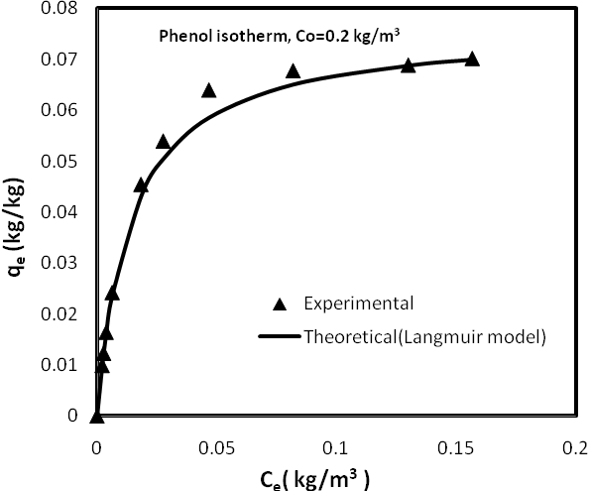
Figure 2: Adsorption isotherm for phenol onto natural zeolite at 303K

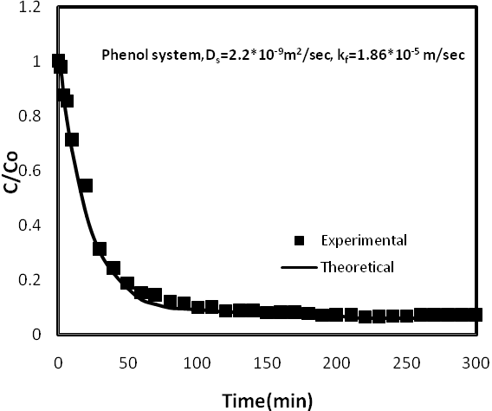
Figure 3: Comparison of measured concentration with that predicted by surface diffusion model in batch adsorber for phenol system
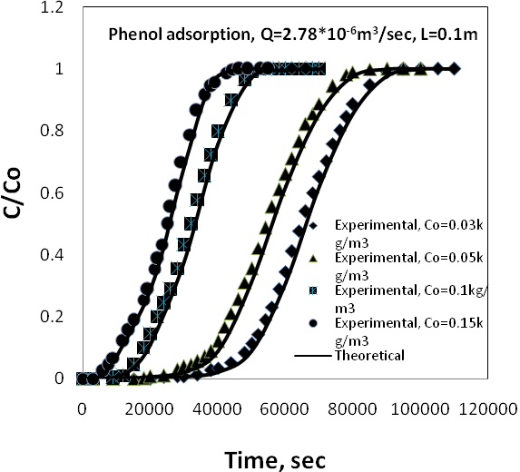
Figure 4: Experimental and predicted breakthrough curves for phenol adsorption onto natural zeolite at different initial concentrations
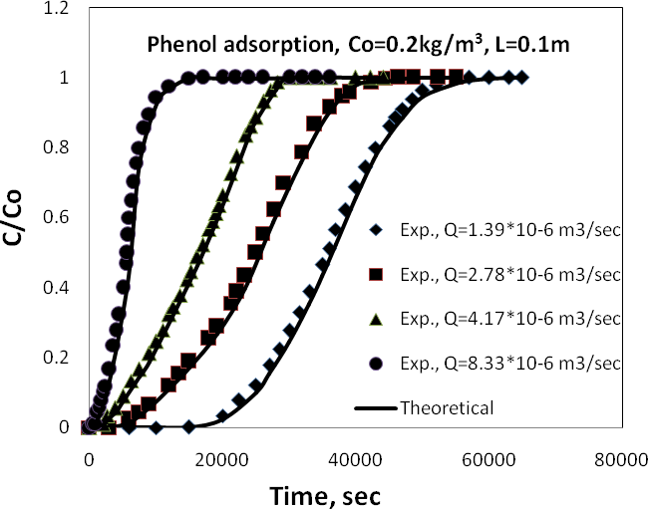
Figure 5: Experimental and predicted breakthrough curves for phenol adsorption onto natural zeolite at different flow rates
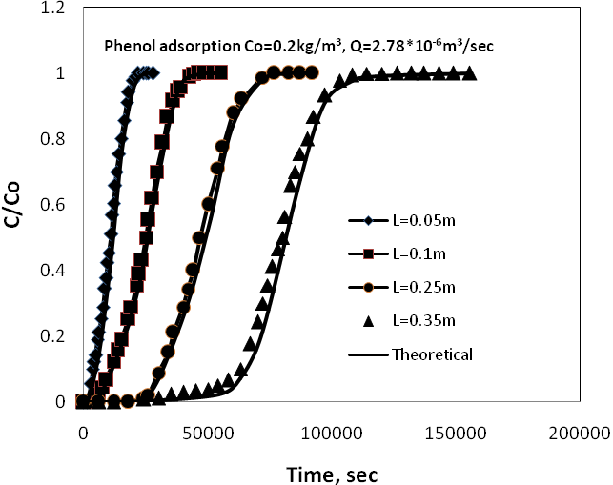
Figure 6: Experimental and predicted breakthrough curves for phenol adsorption onto natural zeolite at different bed depths
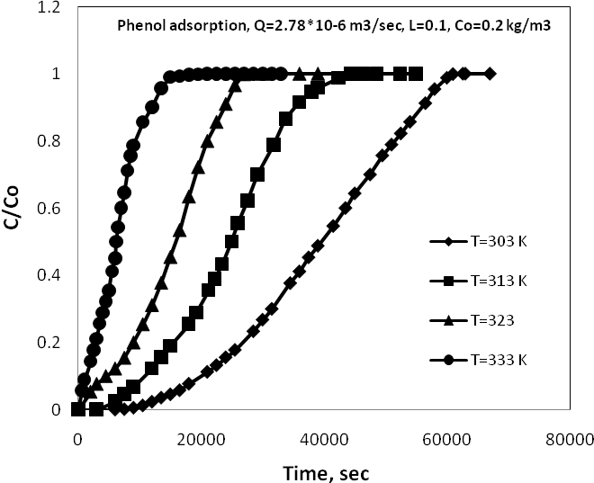
Figure 7: Experimental breakthrough curves for adsorption of phenol onto natural zeolite at different temperatures

