**Neural Network for QoS Multicast Routing in Computer Networks**

**Ali Kadhum Idrees**

**Department of Computer Science, College of Science for Women, University of Babylon**

**E-mail:** ali_al_saadi@yahoo.com

**Abstract:**

In this paper, a Neural Network (NN) for Quality of Service (QoS) Multicast Routing in Computer Networks is proposed. The NN will uses an efficient objective function that reflect several QoS parameters such as cost, bandwidth consumption, and transmission delay to evaluate the multicast routes between one source node and multiple destination nodes. Our proposed NN finds the multicast tree with minimum cost subject to bandwidth and delay constraints. The NN is distributed at each node in communication network and it makes its decision based on a database of alternate routes between each pairs of nodes in the network dynamically**.** The simulation results explain that the proposed NN exhibits a good quality of solution and a good rate of convergence to optimal solution that lead to high speed response in high speed computer networks.

**Keywords:** Multicasting, Neural Network, QoS, Communication Networks, Combinatorial Optimization.

**شبكة عصبية لغرض التوجيه المتعدد محطات الاستقبال المستند على جودة الخدمة في شبكات الحواسيب**

**الخلاصة**

أُقترح في هذا البحث، شبكة عصبية لغرض التوجيه المتعدد محطات الاستقبال المستند على جودة الخدمة في شبكات الحواسيب. ستستخدم الشبكة العصبية دالة هدف كفوءة تعكس عدة معاملات جودة خدمة مثل الكلفة ، استهلاك عرض النطاق ، وتأخير النشر لتقييم المسارات المتعددة محطات الاستقبال بين عقدة مصدر وحيدة وعدة عقد استقبال. وزعت الشبكة العصبية على كل عقدة في شبكة الاتصالات وهي تصنع قرارها بالاستناد على قاعدة بيانات من المسارات البديلة بين كل زوج من العقد في الشبكة ديناميكياً. تُوضّحُ نَتائِجَ المحاكاةَ بأنّ الشبكة العصبية المُقتَرَحة تعْرضُ نوعية حل جيدة ونسبة تقارب جيدة للحل الأمثل والذي يقود إلى جواب عالي السرعة في شبكات الحواسيب السريعة.

**1. Introduction:**

The recent advances in high speed networking technology have created opportunities for the development of multimedia applications. These applications integrate several media such as text, graphics, audio and video. In addition, they are characterized by multiple QoS requirements. QoS is becoming increasingly important for both private intranets and the Internet and is beginning to have a fundamental affect on the way we design networks, particularly large public networks like the Internet (Kenyon,2002). Quality of service has many definitions. For example, according to the QoS Forum: “Quality of Service is the ability of a network element to have some level of assurance that its traffic and service requirements can be satisfied.” (Marchese, 2007; Kuipers, 2004). Two of the key issues in supporting QoS in communication networks are QoS specifications and QoS routing. QoS specifications aim to investigate and specify what requirements needed for QoS are and to quantify them accurately (Alkahtani et. al., 2003).

QoS routing can be defined as moving information across a network from a source to a destination(s) while considering QoS requirements in order to achieve more satisfaction for customers and more optimization of network resource usage (Kenyon, 2002; Alkahtani et. al., 2003; Crawley et. al., 1998). This is also called QoS Multicast routing. The major advantage of multicast routing lies in its capability of saving network resources since only one copy of message needs to be transmitted over a link shared by paths leading to different destinations (Chiang et. al., 2006). The challenge is how to build multicast trees to deliver the multicast data from each source to the appropriate receivers in such a way that QoS requirements are satisfied and the total cost of the constructed multicast tree is minimized (Zahrani et. al., 2006).

In the past, most of the applications were unicast in nature and none of them had any QoS requirements. Therefore, the routing algorithms were very simple. However, with emerging distributed real-time multimedia applications such as video conferencing, distance learning, and video on demand, the situation is completely different now. These applications will involve multiple users, with their own different QoS requirements in terms of throughput, reliability, and bounds on end-to-end delay, jitter, and packet loss ratio. Accordingly, a key issue in the design of broad-band architectures is how to manage efficiently the resources in order to meet the QoS requirements of each connection. The establishment of efficient QoS routing schemes is, undoubtedly, one of the major building blocks in such architectures (Haghighat et. al., 2004).

The QoS based multicast routing problem is a known NP-complete problem that depends on (1) bounded end-to-end delay and link bandwidth along the paths from the source to each destination, and (2) minimum cost of the multicast tree can be formulated as an optimization problem and can be solved by using Hopfield Neural Network (HNN). The major advantage of the HNN lies in that it is implementable by hardware, and thus provides a possible way to find the solution in an extremely short time (Feng, 2001; Smith et. al., 1998). The hardware implementation of HNN makes it very efficient for real-time applications. This feature is very important in QoS multicasting in computer networks.

There are several heuristics proposed by researchers to construct a static least-cost multicast tree which satisfies either single or multiple constraints using the genetic algorithm (GA) (*Chen and Sun,2005;* Hwang et. al.,2000; Zhengying et. al., 2001; Sun and Li, 2004; Bao, 2006; Haghighat et. al., 2004; Tsai et. al., 2004; Wu et. al., 2000; Sun, 1999; Zhang and Leung, 1999; Bauer and Varma, 1997; Xu and Chen, 2006; Chen and Xu, 2006; Randaccio and Atzori, 2007; Tseng et. al., 2006; Yuan and Yan, 2004; Vijayalakshmi and Radhakrishnan, 2008a ) However, sometimes such schemes will be trapped in local search due to the inherent shortcomings of GA, such as, prematurity, slow convergence speed, weak global searching capability, and so on. In (Zhang et. al., 2009; Forsati et. al., 2008; Xing et. al., 2009; Vijayalakshmi and Radhakrishnan, 2008b), algorithms based on genetic simulated annealing, Harmony search, A multi-granularity evolution based Quantum Genetic Algorithm ,and Artificial immune based hybrid GA algorithms have been adopted for multicast routing problem. Nevertheless, they seem complicated to be operated, and need more time to arrive at the solution. Zhang and Liu (2001) proposed a Chaotic Neural Network for solving Multicast Routing Problem and then Yin et. al. (2005) uses the same Chaotic Neural Network for solve the Multicast Routing Problem with improved energy function. Both of neural networks are more complex and the results don’t show the performance of the neural network clearly, as well as Poor optimization performance may be obtained, since the values of correlative coefficients are hard to be determined. Pornavalai et.al. (1995) introduces a Hopfield neural network for solving the multicast problem with only the delay constrained. Their neural network is more complex and they are don't give enough results to show the performance of your neural network that may have Poor optimization performance , since the values of correlative coefficients are hard to be determined.

In this paper, a new way to construct a minimum cost QoS multicast routes in Computer Networks by using Hopfield Neural Network (HNN). Initially we must determine all possible routes between each SD-pair of nodes in communication network, and then store these routes in the database to be used later by the HNN. The HNN by basing on these routes will generate the optimal bandwidth-delay-constrained low-cost multicast routes between one source node and multiple destination nodes. The HNN is distributed on each node in the network and it makes its decision dynamically. The simulation results show that the proposed HNN can give a good quality of solution (the optimal bandwidth-delay constrained multicast routes with the minimum cost) and a good rate of convergence to optimal solution.

The remainder of the paper is organized as follows: Section 2 gives The Problem definition of QoS multicast routing, Neural network for optimization, and Generating the alternative routes. Section 3 describes the proposed HNN for QoS multicast routing. Experimental results are illustrated in section 4. Conclusions and future work are drawn in section 5.

**2. Preliminaries:**

**2.1. The Problem definition of QoS multicast routing:**

QoS-guaranteed multicast routing is to construct a multicast tree that optimizes a certain objective function (e.g. making effective use of network resources) with respect to performance-related constraints (e.g. end-to-end delay bound, inter-receiver delay jitter bound, minimum bandwidth available, and maximum packet loss probability) (Li and Li, 2004).The challenge is how to build multicast trees to deliver the multicast data from each source to the appropriate receivers in such a way that QoS requirements are satisfied and the total cost of the constructed multicast tree is minimized (Zahrani et. al.,2006). The problem of finding bandwidth-delay-constrained minimum cost multicast routes can be formulated as the following Optimization problem: suppose we have a Communication network consist of nodes connected through links. The nodes are the originators and receivers of information, while the links serve as the transport between nodes. A network is modeled as a directed weighted graph G = (V,E) where V is a finite set of nodes representing routers or switches and E is a set of edges representing communication links between network nodes. Let R+ denote the set of non-negative real numbers. Three non-negative functions are defined associated with each link e (e $∈$ E): the delay function D(e): E $→$ R+, the bandwidth function B(e): E $→$ R+, and cost function C(e): E $→$ R+. Suppose each link be symmetric, that is, the costs, bandwidths and the delays of the link e = (i, j) and the link e~ = (j, i) will have the same values. Let s and M be the source node and the set of destinations respectively. The path P(s,d) is a unique path in the multicast tree from the source node s to a destination node d $∈$ M. We also define the non-negative cost, delay, and bandwidth functions for any path P(s,d) as follow:

The cost of the path from s to any destination d is the sum of the costs of edges along P(s,d) is as follow:

$Cost(P\left(s, d\right)=\sum_{e ∈P(s, d)}{C(e)}$…………… .… (1)

The total path delay from s to any destination d, is the sum of the delay of edges along P(s,d), i.e.

$Delay(P\left(s, d\right)=\sum_{e ∈P(s, d)}{D(e)}$…………….…. (2)

The bandwidth of the path from s to any destination d, denoted by Bandwidth (P(s,d)) is defined as the minimum available residual bandwidth at any link along the path:

$Bandwidth(P\left(s, d\right)=Min(B\left(e\right), e∈P\left(s, d\right)$…(3)

Let $∆$ be the delay constraint and $β$ the bandwidth constraint for each destination node d $∈$ M. The bandwidth-delay-constrained minimum-cost multicast routing problem is defined as minimization of the $Cost(P\left(s, d\right)$ $∀ d∈M$ subject to

……….(4)

$Delay(P\left(s, d\right)$ $≤ ∆ , ∀ d ∈M$

$Bandwidth(P\left(s, d\right) ≥ β , ∀ d ∈M$

In QoS multicast routing, we will minimize the cost of each route from s to d in the multicast tree with using two QoS parameter delay and bandwidth.

**2.2. Neural network for optimization:**

In recent years, Hopfield neural networks (HNNs) have found many applications in a broad range of areas such as associative memory, repetitive learning, classification of patterns, and optimization problems (Mou, 2008). The employment of the neural approach simplifies complicated software algorithmic implementations (Graupe, 2007). There are growing interests in the Hopfield neural network because its advantages over other approach for solving optimization problems. The advantage includes massive parallelism, convenient hardware implementation of the neural network architecture, and a common approach for solving various optimization problems (Zeng, 1998; Graupe, 2007). QoS multicast routing can be formulated as an optimization problem, and we can use a Hopfield neural network to solve it.

**2.3. Generating the alternative routes:**

We must first determine the all alternative routes between each Source-Destination (SD) pairs in computer network. I propose an algorithm for generating all paths between each two nodes in the grid network. We can also use the algorithms suggested by (Feng, 2001). The cost, delay, and bandwidth between each two nodes can be generated randomly. This algorithm will be implemented only at the configuration of the network to generate all routes between each two nodes in the network. The generated routes will be saved in a database of alternative routes to be used later by the neural network.

**Algorithm AllPaths**

Input: positive integer N, $nbr$ that contains the neighbors of each node in grid network.

Output: Plist that contains all the routes from s to d in the grid network.

Save the routes with one edge from s to each ${nbr}_{s}^{i}$ that its no. pn in Pathsand set its PathCancel to false

Convert each route in paths that its last node equal to d in Plist and set its PathCancel to true

For i ← 2 To N - 1

npn ← 0

For j ← 1 To pn

If PathsCanceli = false Then

For k ← 1 To ${nbr_no}_{{lp}_{j}}$

npn ← npn +1

npathsnpn ← Pathsj with added ${nbr}_{{lp}_{j}}^{k}$

npathsCancelnpn ← false

Next

Endif

Next

For k ← 1 To npn

If ( ${npaths}_{{lp}_{k}}$ = d ) And ( npathsCancelk = false ) Then

pl ← pl + 1

Plistpl ← npathsk

npathsCancelk ← true

Endif

If npathsCancelk  = false Then

If new added node is previously found in npathsk Then

npathsCancelk ← true

Endif

Endif

Next

Convert the routes in Paths that it’s PathsCancel equal to false and its no. newnpn to Paths

pn ← newnpn

Next

**End of Algorithm**

Where N: the number of nodes in the network, s: source node, d: destination node,Paths and npaths contains the routes from s to d. pn and npn the number of routes in each of Paths and npaths respectively. PathsCanceli and nPathsCanceli are the flags that related to each Pathsi and npathsi respectively. ${lp}_{j}$ is the last nod in the route Pathsj. is the number of neighbors of node ${lp}_{j}$. ${nbr}_{{lp}_{j}}^{k}$ is the kth neighbor of the node ${lp}_{j}$.

**3. The Proposed HNN for QoS Multicast Routing:**

The proposed Hopfield Neural Network (HNN) for QoS multicasting consists of M row of neurons, each row contains Pni of neurons, where pni represent the number of routes from s to the ith destination node in multicast group. Each neuron represents a route from the set of the alternative routes. The first row of neurons is dedicated for the first destination node in the multicast group, and the second row is dedicated for the second destination node in multicast group, and the M row is dedicated for the M destination node in multicast group. Figure 1 shows the architecture of the proposed HNN for QoS multicasting.

**. . .**

**. . .**

**. . .**

**. . .**

**. . .**

**. . .**

**. . .**

Figure 1: The architecture of the proposed HNN for QoS multicasting.

The proposed Hopfield neural network is a competitive (winner-take-all) network that quantifies the flow of the multicast packets in the system. At each row of the HNN, one and only one neuron will attain a value of 1, when the output of the neuron N1,2 is one, this means that the alternate route number 2 is optimal and satisfy the QoS constraints, and the packet will sent across this route to first destination node in the multicast route.

***3.1 Motion Equations and Parameter Values:***

In this study, we apply the proposed system to make the QoS multicast routing in the nodes of the communication network using Hopfield Neural Network. The HNN has its own constraints to make the QoS multicast routing decisions and as follow:

1. One and only one neuron will attain a value of 1 at each row in HNN.
2. Packet will be transmitted to each node in multicast group such that the cost of each route to each destination node in multicast group is minimized with satisfying the two constraints the delay and the bandwidth.
3. Guarantee that the summation of all outputs of neurons of each row (that correspond to specific destination node in multicast group) in HNN is equal to 1.

The dynamics of the yth neuron for the kth destination node of the HNN based QoS multicast routing is governed by



${Uacts}_{k,y}={Uacts}_{k,y}- C1\left(\sum_{i=0}^{{pn}_{{Tset}_{k}}-1}{{Wgt}_{k,y,i}*{Vouts}_{k,i}}\right)$

t1



$+ C2\left(\frac{1}{\sum_{j=0}^{\left({Path}_{s}^{{Tset}_{k}}y,0\right)-2}{{Cost}_{{Path}_{s}^{{Tset}_{k}}y,j+1 ,{ Path}_{s}^{{Tset}_{k}}y,j+2}}}\right)$

t2



$* Ψ\left(\sum_{j=0}^{\left({Path}_{s}^{{Tset}_{k}}y,0\right)-2}{{Dcost}_{{Path}_{s}^{{Tset}_{k}}y,j+1 ,{ Path}_{s}^{{Tset}_{k}}y,j+2}}\right)$

t2



$* Φ\left( Min \left({Bcost}_{{Path}_{s}^{{Tset}_{k}}y,j+1 ,{ Path}_{s}^{{Tset}_{k}}y,j+2}\right)\right)$

t2

$0≤j ≤ \left({Path}_{s}^{{Tset}_{k}}y,0\right)-2$

$- C3\left(\left(\sum_{i=0}^{{pn}_{{Tset}_{k}}-1}{{Vouts}_{k,i}}\right)-1\right)$…………...….(5)



t3

Where

${Wgt}_{k,y,i}=1 if y≠i, 0 otherwise$

= Synaptic weight between neurons y and i for the (k+1)th destination node in multicast group(.

${Vouts}_{k,i}≡$ Output of neuron i for the (k+1)th destination node in multicast group.

${pn}_{{Tset}_{k}}≡$ The number of alternative routes for the destination node ${Tset}_{k}$.

${Path}_{s}^{{Tset}_{k}}y,0≡$ The number of nodes in the yth alternate route.

${Path}_{s}^{{Tset}_{k}}y,j+1 ≡$ The node in the location j+1 of the yth alternative route from s to the destination node ${Tset}_{k}$.

${Cost}_{{Path}_{s}^{{Tset}_{k}}y,j+1 ,{ Path}_{s}^{{Tset}_{k}}y,j+2 }≡$ The cost between the node ${Path}_{s}^{{Tset}_{k}}y,j+1$ and the node ${Path}_{s}^{{Tset}_{k}}y,j+2$ from s to the destination node ${Tset}_{k}$.

${Dcost}_{{Path}_{s}^{{Tset}_{k}}y,j+1 ,{ Path}_{s}^{{Tset}_{k}}y,j+2 }≡$ The delay between the node ${Path}_{s}^{{Tset}_{k}}y,j+1$ and the node ${Path}_{s}^{{Tset}_{k}}y,j+2$ from s to the destination node ${Tset}_{k}$.

${Bcost}_{{Path}_{s}^{{Tset}_{k}}y,j+1 ,{ Path}_{s}^{{Tset}_{k}}y,j+2 }≡$ The bandwidth between the node ${Path}_{s}^{{Tset}_{k}}y,j+1$ and the node ${Path}_{s}^{{Tset}_{k}}y,j+2$ from s to the destination node ${Tset}_{k}$.

$C1, C2, C3 ≡$ Coefficients.

Also the index y range 0.. ${pn}_{{Tset}_{k}}$-1 and the index k range 0.. $DsetNo$-1.

$DsetNo$: represent the number of destination nodes in the multicast group $Tset$.

$Ψ\left(z\right)$ and $Φ\left(z\right)$ are penalty functions and can be explained as follow:

1 if ( z - $∆$) ≤ 0

$Ψ\left(z\right)=$…………………………..……………(6)

$ρ$ Otherwise

1 if ( z - $β$) ≥ 0

$Φ\left(z\right)=$.………………….………………...….(7)

$ρ$ Otherwise

Where $ρ$ is the penalty factor.

The yth neuron for the kth destination node in HNN is modeled as a nonlinear device with sigmoidal characteristics given by

${Vouts}_{k,y}=\frac{1}{1 + Exp\left(- * {Uacts}_{k,y}\right)}$…………………………………… (8)

= output of the yth neuron for the kth destination node with input ${Uacts}_{k,y}$.

: governs the gradient of the sigmoid function.

The inner states and outputs of neurons of HNN for QoS Multicast routing are updated by eq. (5) and (8). The neurons in each row in the HNN compete each other until one and only one neuron is excited. In Eq. (5), the term **t1 is** represents the constraints (i), the term **t2** represents the constraints (ii). The term **t3** represents the constraints (iii). The function **Min** in **t2** returns the minimum bandwidth value along the path. HNN is a competitive (winner-take-all) network that determines the flow of the QoS multicast packets in the system.

In order to show that the system will always converge to a good solution, we define the following energy function of the HNN for QoS multicast routing.

$E=C1\left[\sum_{k=0}^{DsetNo-1}{\sum_{i=0}^{{pn}_{{Tset}_{k}}-1}{\sum_{\begin{aligned}j=0 \\ i≠j\end{aligned}}^{{pn}_{{Tset}_{k}}-1}{{Wgt}_{k,i,j}*{Vouts}_{k,j}*{Vouts}_{k,i}}}}\right]$

 $+ C2\left[\sum_{k=0}^{DsetNo-1}{\sum_{i=0}^{{pn}_{{Tset}_{k}}-1}{\sum_{j=0}^{{pn}_{{Tset}_{k}}-1}{{Vouts}_{k,j}* \left(\left(\frac{1}{\sum_{l=0}^{\left({Path}_{s}^{{Tset}_{k}}i,0\right)-2}{{Cost}_{{Path}_{s}^{{Tset}_{k}}i,l+1 ,{ Path}_{s}^{{Tset}_{k}}i,l+2}}}\right)* Ψ\left(\sum_{l=0}^{\left({Path}_{s}^{{Tset}_{k}}i,0\right)-2}{{Dcost}_{{Path}_{s}^{{Tset}_{k}}i,l+1 ,{ Path}_{s}^{{Tset}_{k}}i,l+2}}\right)Φ \left( Min \left({Bcost}_{{Path}_{s}^{{Tset}_{k}}i,l+1 ,{ Path}_{s}^{{Tset}_{k}}i,l+2}\right)\right)\right)}}}\right]$

$+\frac{1}{2}C3\left[\sum_{k=0}^{DsetNo-1}{{\left(\sum_{i=0}^{{pn}_{{Tset}_{k}}-1}{-1}\right)}^{2}}\right]$……………………………………… (9)

The first and the third terms of the energy function in eq. (9) are inhibition terms, which account for the winner-take-all property. The second term in Eq. (9) show the condition of the minimum cost multicast routes from s to each destination node in multicast group that satisfy the two QoS constraints: the delay and the bandwidth.

***3.2 Coefficients of neurons state equations:***

The values of coefficients C1, C2, and C3 in the Eq. (5) and (9) have a great influence on the quality of solution. However the choice of reasonable values is more complex. After many experiments we can define the values of these parameters as follow: C1= 1.5, C2= 1.95, C3= 0.008. The parameter is set to 3.

**4. Simulation Results:**

In this section, the proposed HNN for QoS multicast routing algorithm is simulated on a network consists of 9-Routers to test its performance. The network example that used in this paper is illustrated in figure (2), the all edges are labeled with (cost, delay, bandwidth), where the cost refer to costs incurred by the use of the network link between nodes i and j. This include leasing costs, maintenance costs, etc., while the delay refer to the time needed to transmit information between nodes i and j. The bandwidth is the residual bandwidth of the physical or logical link. The delay bound  is set to 8 and bandwidth constraint $β$ is set to 3 in all experiments. The (cost, delay, bandwidth) on edge (i, j) is the same as with (j, i).

By using the algorithm that I proposed in section 2.3, we obtained for each SD pair in the network in figure (2) on the all possible routes and then stored in a database to be used later by the HNN for selecting the optimal multicast routes that satisfy the two QoS parameters: delay and bandwidth constraints for sending the packet from the source router to the destination routers set. This algorithm will be executed at each router in the network and only during the network configuration or changing the network topology. This experimental simulation is achieved by using Visual Basic 2008 professional edition on Dell laptop 1525 with processor T8300 2.4 GHz Core 2 due and RAM 2GB to implement this HNN for QoS multicast routing. By the simulation, many experiments will be made to explain the performance of the proposed HNN for QoS multicast routing.

(1.4, 2, 2)

(0.7, 1, 3)

(1.6, 1, 4)

(1.1, 3, 3)

(0.5, 3, 5)

(0.9, 1, 4)

(1.2, 1, 2)

(0.6, 4, 2)

(0.2, 1, 2)

(1.3, 4, 3)

(0.3, 2, 3)

(0.8, 2, 3)

**0**

**1**

**2**

**3**

**4**

**5**

**6**

**7**

**8**

Figure (2): 9-Routers computer network example.

Our performance metric measures include the Average number of Iteration of HNN (AvgItr), the Optimality of the Multicast Routes (OMR) that satisfies the two constraints: delay and bandwidth, Multicast tree cost, convergence rate, and the execution time. The AvgItr and the OMR are calculated by using the following relations:

$AvgItr=\frac{\sum_{i=1}^{1000}{{Itr}_{i}}}{1000}$…………………………....(10)

$OMR=\frac{OMRN}{1000}$……………………………….…(11)

Where ${Itr}_{i}$: the maximum number of iteration that needed by HNN to converge to optimal solution in the ith run. $OMRN$: the number of convergence of HNN to optimal multicast routes that satisfy the bandwidth-delay constraints after running it 1000 times.

The initial states of the neurons are reset to small random values because that each row in the HNN is considered as a kind of competition system and the update of each neuron in the HNN depends on the equation (5) which represents the conditions of QoS multicast routing system. All the experiments in this section are simulated on the network in figure 2.

***4.1. The impact of the penalty factor on the OMR and the No. of iterations of the HNN:***

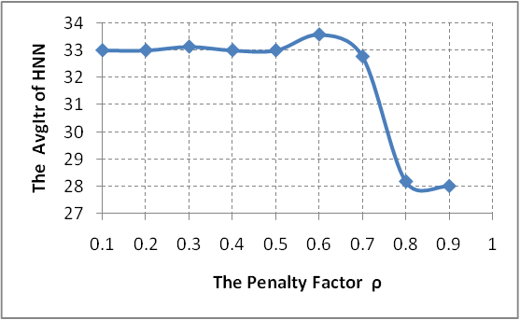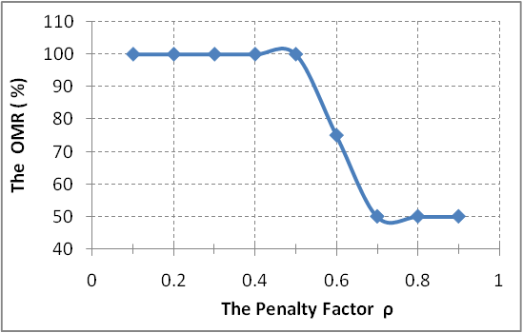In this experiment, we study the impact of the penalty factor on the AvgItr and (OMR). We set the $DsetNo$ to 4. Figures 3 and 4 shows the effect of the penalty factor $ρ$ on the OMR and AvgItr respectively.

Figure (3): the penalty factor versus the OMR Figure (4): the penalty factor versus the AvgItr of HNN.

From above figures, we see when the $ρ$ increase the optimality of multicast routes OMR decrease, while the AvgItr remain the same until decrease at the end. But we will select $ρ=0.1$ that produce OMR 100% and acceptance rate of convergence AvgItr =33.

***4.2. The dynamics of neurons and the convergence rate of the HNN:***

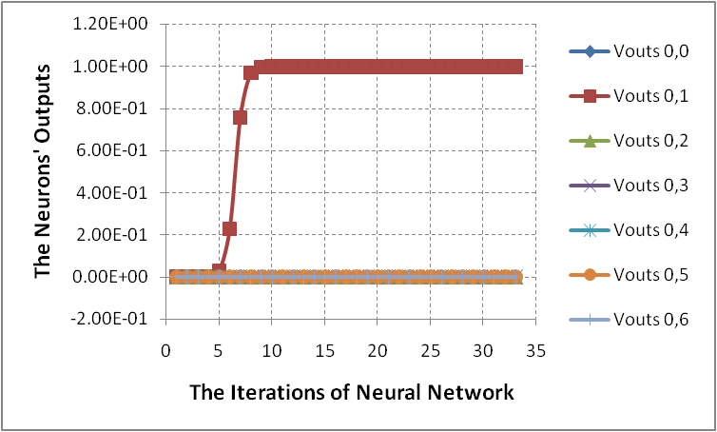In this experiment, we study the dynamics of neurons at each row in HNN architecture that corresponding to specific destination node in multicast group. We set the $DsetNo$ to 3.figures 5, 6, and 7 shows the dynamics of neurons at each row in the HNN and figure 8 shows the energy function values during convergence HNN to optimal solution.

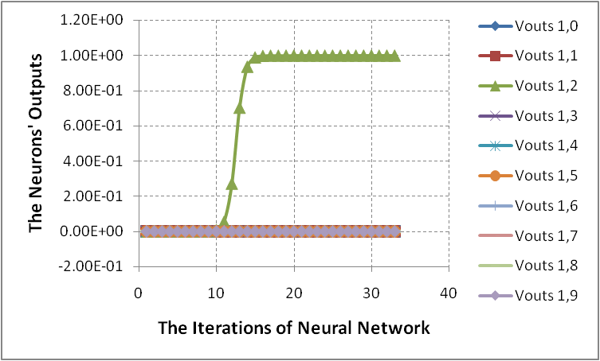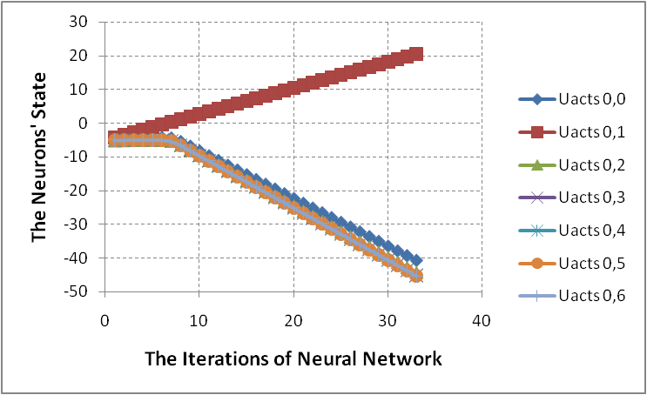Figure (5): The dynamics of neuronsfor the first row in the HNN

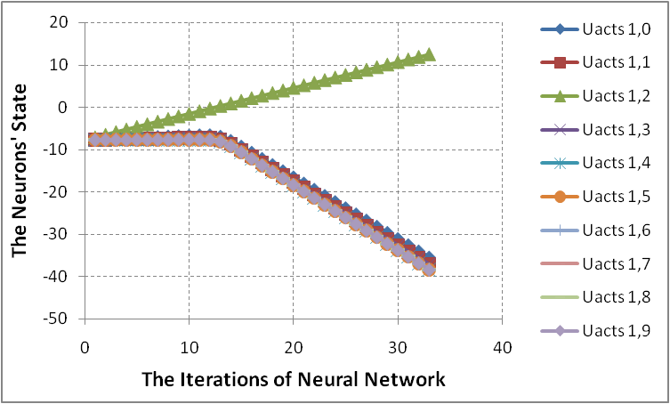Figure (6): the dynamics of neurons for the second row in the HNN.

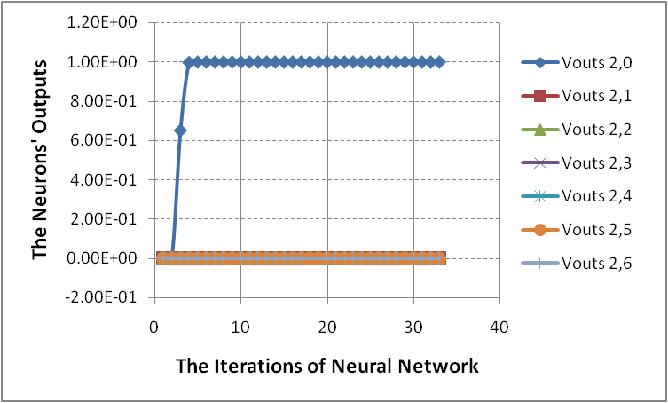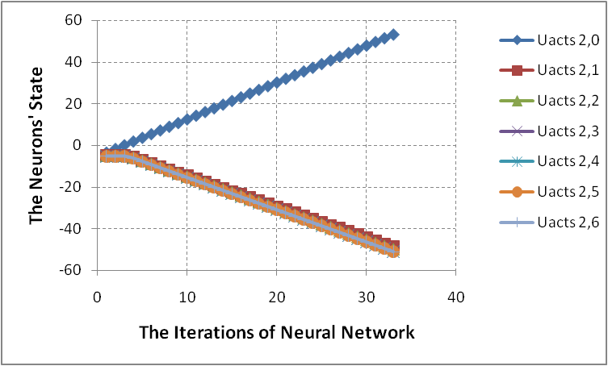

Figure (7): the dynamics of neurons for the third row in the HNN.

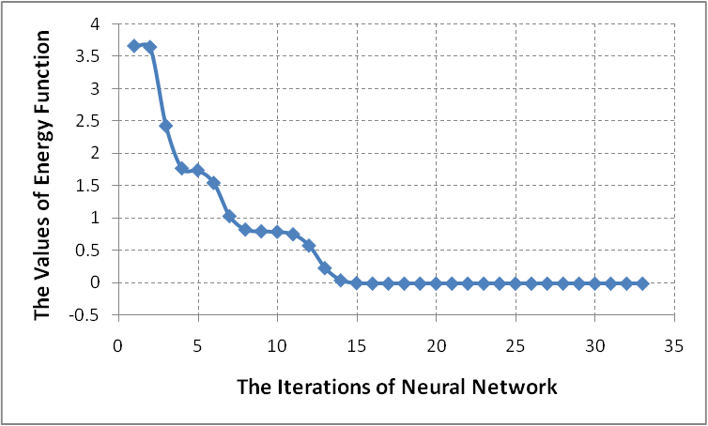

Figure (8): the energy function values versus the Iterations of HNN.

From the simulation results we see that the QoS Multicast routing system has high-speed convergence to produce the optimal multicast routes that constrained by the bandwidth and delay. The speed of convergence of the proposed QoS multicast routing system is derived from the small Hopfield neural networks that are used to make the QoS multicast routing decisions in the network.

***4.3. The impact of Multicast Group Size on the AvgItr of the HNN:***

In this experiment, we study the impact of increasing the multicast group size on the AvgItr of HNN. We will choose the source node and the destination nodes in multicast group randomly one time for each 1000 run to HNN. Figure 9 show the impact of increasing the multicast group size on the AvgItr of HNN.

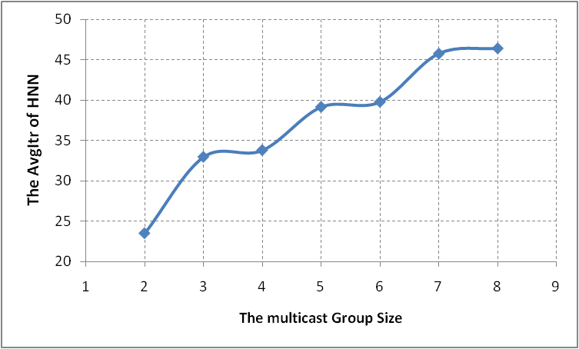

Figure (9): the impact of the multicast group size on the AvgItr of HNN

From the simulation results we see whenever increasing the multicast group size the AvgItr of HNN will increase. The increasing in the AvgItr is acceptable and don't impact on the rapid response of the HNN for QoS multicast routing.

***4.4. The impact of Multicast Group Size on the OMR for different delay constraints:***

In this experiment, we study the impact of increasing the size of multicast group on the OMR for different values for delay constraint. Figure 10 shows the OMR versus Multicast Group size for different delay constraints.

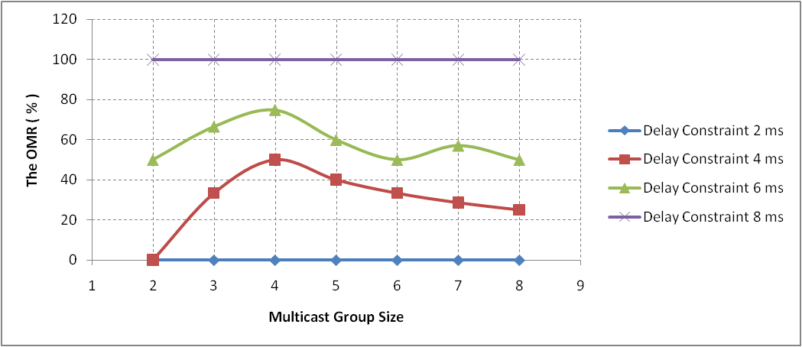

Figure (10): the OMR versus Multicast Group size for different delay constraints.

From the simulation results we see whenever increasing the value of the delay constraintthis leads to increase the OMR because giving a chance for more alternative routes to satisfy the delay constraint.

***4.5. The impact of Multicast Group Size on the Multicast Tree Cost:***

In this experiment, we study the impact of increasing the size of multicast group on the multicast tree cost. We set to 8 and $β$ =3.

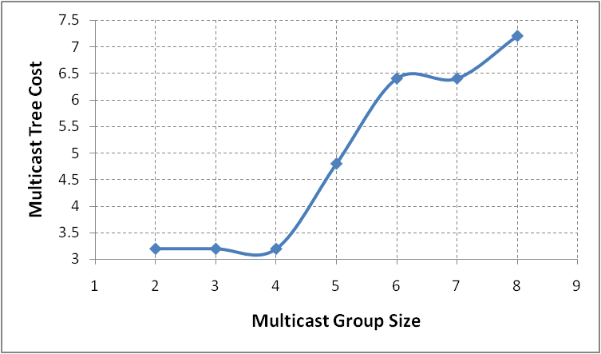

Figure (11): *the Multicast Group Size versus the Multicast Tree Cost*

From the simulation results we see whenever increasing the multicast group size this leads to increase the cost of the multicast tree, but my HNN can achieves better optimal tree cost in both small and large multicast group size.

***4.6. The impact of Multicast Group Size on the Execution Time:***

In this experiment, we study the impact of increasing the size of multicast group on the Average of execution time of HNN per 1000 run. We set to 8 and $β$ =3.

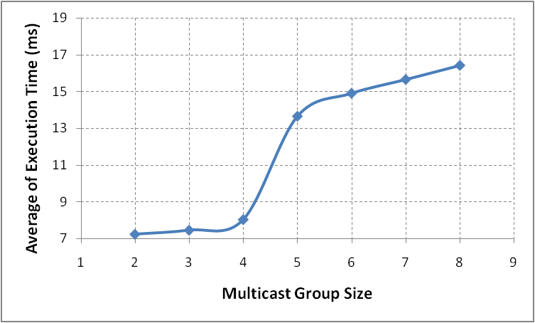

Figure (12): *the Multicast Group Size versus the Execution Time*

From the simulation results we see whenever increasing the multicast group size this leads to increase the execution time that needed by HNN to give optimal solution, but my HNN for QoS multicasting required less execution time because the high speed convergence of the simple structure of HNN to find the optimal Multicast routes that satisfy the bandwidth-delay constraints.

***4.7. The ability of the HNN in producing the optimal QoS multicast routes:***

In this experiment, we study the *ability of the HNN in producing the optimal QoS multicast routes*. We set to 8 and $β$ =3. Table 1 show the resulted optimal QoS multicast routes by HNN

Table (1): the resulted optimal QoS multicast routes by HNN

|  |  |  |  |
| --- | --- | --- | --- |
| **#** | **Source node** | **Destination set** | **The optimal QoS multicast routes that produced by the HNN** |
| 1 | 0 | [1,2,3,4,5,6,7,8] | {{0-3-4-1},{0-3-4-1-2},{0-3},{0-3-4},{0-3-4-1-2-5},{0-3-4-7-6},{0-3-4-7},{0-3-4-7-8}} |
| 2 | 1 | [0,2,3,4,5,7] | {{1-4-3-0},{1-2},{1-4-7-6-3},{1-4},{1-2-5},{1-4-7}} |
| 3 | 2 | [0, 1, 8] | {{2-1-4-3-0},{2-1},{2-1-4-7-8}} |
| 4 | 3 | [2,8] | {{3-4-1-2},{3-4-7-8}} |
| 5 | 4 | [0,2,6,8] | {{4-3-0},{4-1-2},{4-7-6},{4-7-8}} |
| 6 | 5 | [0,1,7] | {{5-2-1-4-3-0},{5-2-1},{5-2-1-4-7}} |
| 7 | 6 | [2,3,4,5,7,8] | {{6-7-4-1-2},{6-7-4-3},{6-7-4},{6-7-4-1-2-5},{6-7},{6-7-8}} |
| 8 | 7 | [0,1,5] | {{7-4-3-0},{7-4-1},{7-4-1-2-5}} |
| 9 | 8 | [0,2,3,4,6] | {{8-7-4-3-0},{8-7-4-1-2},{8-7-4-3},{8-7-4},{8-7-6}} |

From the simulation results we see that the proposed HNN for QoS multicast routing can give optimal QoS multicast routes from the source node to the set of the destination nodes in multicast group that satisfy the two QoS parameters, the bandwidth and delay constraints.

**5. The Conclusions and Future Work:**

The simulation results show that the proposed HNN for QoS multicast routing can quickly converge to accurate decision (optimal bandwidth-delay constrained low cost multicast routes) based on alternative routes database. By using this architecture of HNN for QoS multicasting, it can also adapt to the dynamically changing network environment such as congestion or router failure. Whenever increase the penalty factor in the penalty function leads to decrease the OMR. The dynamics of neurons and the energy function of the proposed HNN based QoS multicasting show high speed convergence to optimal QoS multicast routes from source node to the destination node set in multicast group. The increase in the multicast group size cause increasing the AvgItr of HNN but in acceptance rate. Our HNN based QoS multicast routing algorithm produces the optimized result for delay constraint 8. The propose d HNN can achieve better optimal tree cost that satisfies the bandwidth-delay constraints in both small and large multicast group size. Our HNN based QoS multicasting algorithm takes less execution time to converge to optimal solution since it uses the alternative routes which was created during the first stage of our proposed system. The produced multicast routes by the proposed HNN show its efficiency in quantifying the optimal QoS multicast routes from source node to the set of destination nodes. Our future study is to design QoS multicast router that makes the QoS multicast routing based on appropriate QoS parameter to satisfy the needs of specific application.

**References:**

**Alkahtani,** A. M. S., Woodward, M. E. and Al-Begain, K.( 2003 ). An Overview of Quality of Service (QoS) and QoS Routing in Communication Networks. 4th PGNET2003 Symposium, Liverpool, UK, pp. 236-242, 16-17/6/2003.

**Bao,** G., Yuan, Z., Zheng, Q., and Chen, X.(2006). A novel genetic algorithm to optimize QoS multicast routing, in: Lecture Notes in Control and Information Sciences, Vol. 344, pp. 150–157.

**Bauer**, F. and Varma, A. (1997). ARIES: a rearrangeable inexpensive edge-based on-line Steiner algorithm, IEEE Journal on Selected Areas in Communication, Vol. 15, No. 3, pp. 382–397.

***Chen****, H. and Sun, B. (2005).* Multicast Routing Optimization Algorithm with Bandwidth and Delay Constraints Based on GA, Journal of Communication and Computer, Vol. 2, No. 5, pp. 63-67.

**Chen,** L. and Xu, Z. (2006).Effective multicasting algorithm for dynamic membership with delay constraint, J. Zhejiang Univ. , Vol. 7, No. 2, pp. 156–163.

**Crawley,** E., Nair, R., Rajagopalan, B., and Sandick, H.(1998). A Framework for QoS-based Routing in the Internet, RFC 2386, <http://www.ietf.org/rfc/rfc2386.txt>.

**Feng,** G. (2001). Neural network and algorithmic methods for Solving Routing Problems in High-Speed Networks, Ph.D. Thesis, University of Miami, USA.

**Forsati** , R., Haghighat, A.T., Mahdavi, M.(2008).Harmony search based algorithms for bandwidth-delay-constrained least-cost multicast routing, Computer Communications, Vol. 31, No. 10, pp. 2505–2519.

**Graupe,** D.(2007). PRINCIPLES OF ARTIFICIAL NEURAL NETWORKS, 2nd Edition, World Scientific Publishing Co. Pte. Ltd.

**Haghighat,** A.T., Faez, K., Dehghan, M., Mowlaei, A., and Ghahremani, Y. (2004). GA-based heuristic algorithms for bandwidth-delay-constrained least-cost multicast routing, Computer Communications, Vol. 27, No. 1, pp. 111–127.

**Hwang**, R., Do, W., Yang, S.(2000) Multicast routing based on genetic algorithms, J. Inform. Sci. Eng., Vol. 16, No. 5, pp. 885–901.

**Kenyon,** T. (2002). Data Networks: Routing, Security, and Performance Optimization, Digital Press an imprint of Elsevier Science.

**Kuipers,** F. A. (2004). Quality of Service Routing in the Internet Theory, Complexity and Algorithms, Delft University Press.

**Li,** L. and Li, C.(2004). A QoS-guaranteed multicast routing protocol, Computer Communications, Vol. 27, No. 1, pp. 59–69

**Liu,** C.,   Chiang, T, and   Huang, Y.(2006). A near-optimal multicast scheme for mobile ad hoc networks using a hybrid genetic algorithm, Expert Systems with Applications, Vol. 33, No. 3, pp. 734-742.

**Marchese,** M. (2007). QoS OVER HETEROGENEOUS NETWORKS, John Wiley & Sons Ltd.

**Mou,** S., Gao, H., Lam, J., and Qiang, W.(2008). A New Criterion of Delay-Dependent Asymptotic Stability for Hopfield Neural Networks With Time Delay, IEEE TRANSACTIONS ON NEURAL NETWORKS, VOL. 19, NO. 3, pp. 532-535.

**Pornavalai,** C., Chakraborty, G., and Shiratori, N. (1995). A neural network approach to multicast routing in real-time communication networks, [Proceedings 1995 International Conference on](http://ieeexplore.ieee.org/xpl/RecentCon.jsp?punumber=4039) Network Protocols, 7-10 Nov 1995, pp. 332-339.

**Randaccio,** L. S. and Atzori, L.(2007).Group multicast routing problem: A genetic algorithms based approach, Computer Networks , Vol. 51, No. 14, pp. 3989–4004.

**Smith,** K., Palaniswami, M., and Krishnamoorthy, M.(1998). Neural techniques for combinatorial optimization with applications, IEEE transaction on neural networks, Vol. 9, No. 6, pp. 1301-1315.

**Sun,** Q.,(1999).A Genetic algorithm for the delay-constrained minimum-cost multicasting, Technical Report, IBR, TU Brancunschweig, Butenweg, 74/75, 38106, Brancunschweig, Germany.

**Sun,** Q. and Li, L.(2004) Optimizing on multiple constrained QoS multicast routing

algorithms based on GA, J. Syst. Eng. Electron., Vol. 15, No. 4, pp. 677–683.

**Tsai,** C.F., Tsai, C.W., and Chen, C.P. (2004). A novel algorithm for multimedia multicast routing in a large scale networks, J. Syst. Software, Vol. 72, No.3, pp. 431–441.

**Tseng**, S.Y., Huang, Y.M. and Lin, C.C. (2006) Genetic algorithm for delay- and degree constrained multimedia broadcasting on overlay networks, Computer Communications, Vol. 29, No. 17, pp. 3625–3632.

**Vijayalakshmi,** K. and Radhakrishnan, S. (2008a).Dynamic Routing to Multiple Destinations in IP Networks using Hybrid Genetic Algorithm (DRHGA), International Journal of Computer Science Vol. 4, No. 1, pp. 43-52.

**Vijayalakshmi,** K. and Radhakrishnan, S. (2008b). Artificial immune based hybrid GA for QoS based multicast routing in large scale networks (AISMR), Computer Communications, Vol. 31, No. 17, pp. 3984–3994.

**Wu**, J., Hwang,R., and Lu, H. (2000).Multicast routing with multiple QoS constraints in ATM networks, Int. J. Inform. Sci., Vol. 124, No.1, pp. 29–57.

**Xing,**H., Liu, X., Jin, X., Bai, L. and Ji, Y. (2009). A multi-granularity evolution based Quantum Genetic Algorithm for QoS multicast routing problem in WDM networks, Computer Communications, Vol. 32, No. 2, pp. 386–393.

**Xu,** Z. and Chen, L. (2006). An effective algorithm for delay-constrained dynamic multicasting, Knowledge Based Syst., Vol. 19, No. 3, pp. 172–179.

**Yin**,Y., Sun, L. and Ruan, X. (2005). The Implementation of A Routing Algorithm Based on Chaotic Neural Network in Multicast Routing Problems, International Journal of Information Technology, Vol. 11, No.9, pp. 82-90.

**Yuan**, Y. and Yan, L.(2004). QoS-based dynamic multicast routing design using genetic algorithms, Chinese Journal of Electronics, Vol. 13, No. 4, pp. 575–578.

**Zahrani**, M. , Loomes, M., Malcolm, J. , and Albrecht, A. (2006). Landscape analysis for multicast routing, Computer Communications, Vol. 30, No. 1, pp. 101–116.

**Zeng**, C. X. (1998). Improvement the performance of the Hopfield network for solving optimization problems, master Thesis, Brigham Young University.

**Zhang,** L., Cai, L., Li, M., and Wang, F.(2009). A method for least-cost QoS multicast routing based on genetic simulated annealing algorithm, Computer Communications Vol. 32, No. 1, pp. 105–110.

**Zhang**, Q. and Leung, Y.W. (1999). An orthogonal genetic algorithm for multimedia multicast routing, IEEE Trans. Evolutionary Computation Vol. 3, No. 1, pp. 53–62.

**Zhang,** S., Liu, Z.(2001). A New Multicast Routing Algorithm Based on Chaotic

Neural Networks, Chinese Journal of Computers, Vol. 24, No. 12, pp. 1256-1261.

**Zhengying,** W., Bingxin, S., and Erdun, Z.(2001). Bandwidth–delay-constrained least-cost multicast routing based on heuristic genetic algorithm, Computer Communication Vol. 24, No. 7–8, pp. 685–692.