Extinction Coefficient Measurements of Turbid Media
Khalid K. Mohammad
Dept. of Physics, College of Science,University of Sulaimani

Abstract
Using the collimated transmission method , with a Helium-Neon laser , operating at 632.8 nm , total extinction coefficients have been measured for two different turbid media , a pure scatterer ( milk ) and a pure absorber ( black ink ) . It has been found that Lambert–Beer’s law applies very well in the range of concentrations considered .
الخلاصة
باستخدام طريقة الحزمة النافذة المسددة وبواسطة ليزر هيليوم – نيون يعمل عند الطول الموجي 632.8 نانومتر تم قياس معاملات التوهين الكلية لوسطين عكرين أحدهما ذو استطارة خالصة (محلول مسحوق الحليب) والآخر ذو امتصاصية خالصة (حبر أسود) . وقد وجد أن قانون ( لامبرت – بير ) يصح بشكل جيد ضمن مدى التراكيز المأخوذة بنظر الاعتبار.
(1) Introduction
Turbidity is the cloudiness of a fluid caused by suspended and dissolved materials .When a light beam is incident on a turbid media , it interacts with suspended particles through two different phenomena , absorption and scattering (Webb 2010) . Absorption is very often happened when light beam propagates through the medium . Scattering of light is caused by the refractive index mismatch at microscopic boundaries of the constituents (Abebe 2007) . Both of these phenomena cause the incident light beam to be diminished as it is projected through the particles . Some decrease is due to redirection of rays by scattering and some is due to loss of the photons by absorption . This reduction in the energy of the incident beam leads to concept of extinction , which is the degree of attenuation of the incident light energy (Webb 2010).
(2) Theory
Collimated transmission method is used to find the total extinction coefficient of two different turbid media , a pure scatterer ( milk ) and a pure absorber ( black ink ) . These two turbid media are often used as phantom tissues (Srinivasan et. al 2002) .
In optics , Lambert-Beer’s law is an empirical relationship that relates the absorption and scattering of light to the properties of the material through which the light is traveling ( Abebe 2007) .This law may be written as (Gwamuri et. al 2006) :
I = I₀ exp ( - µ _{t} . c . r ) ---------------- (1)
or
µ _{t} . c = ln ( I₀/I ) / r ---------------- (2)
where I₀ is the intensity of the incident light
I is the intensity of the transmitted light
r is the thickness of the sample
c is the concentration of the sample , and
µ _{t} is the total extinction coefficient of the sample.
The total extinction coefficient is the sum of absorption and scattering coefficients. Equation(1) applies well for low concentrations .

(3) Experiment
A 1 mW He–Ne laser source emitting at 632.8 nm operating in continuous wave (cw) [which has proved suitable for low-power laser interaction with matter], was directed horizontally to a cell (glass box) of thickness 25 mm containing the sample . The collimated transmitted (unscattered ) light was detected with an Si- photodetector, having a spectral range from 390 nm (UV) to 1150 nm (IR) . In order to avoid the optical noise we let the whole path of the laser beam be within black-walled cylindrical tubes until it entered the photodetector . This has eliminated the optical noise to about zero. To avoid the entrance of scattered light into the detector , black-walled cell was used, having two opposite transparent apertures for the passage of laser beam through the sample contained in the cell . A multi-range meter with extremely good measuring range was used to measure very small currents up to 20 nA . Two samples were used as turbid media , aqueous solutions of powdered milk and black ink (Dollar Industries), each diluted in distilled water .

(4) Results and Discussion
Figures (1) and (2) show that the transmitted intensities decrease exponentially with concentration for both milk and black ink solutions .
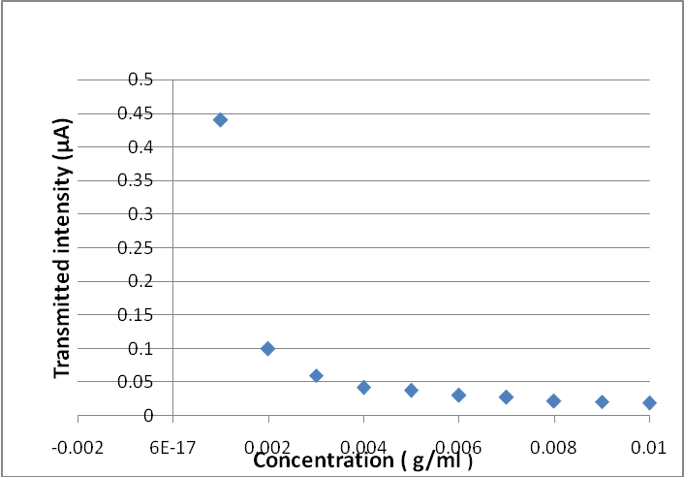
Fig.(1) Transmitted intensity versus concentration for milk solution

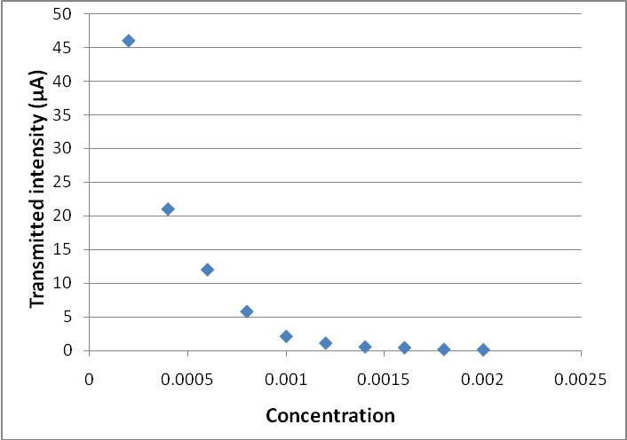
Fig.(2) Transmitted intensity versus concentration for black ink solution

The exponential decrease confirms the applicability of Lambert-Beer’s law in the range of concentrations considered here .
In Figures (3) & (4) values of ( 1/r ) ln( I₀/I ) was plotted against concentration .
Figures (1) & (3) refer to the results of powdered milk with measurements of concentrations ranging from 0.002 g/ml to 0.010 g/ml in steps of 0.001g/ml . Figures (2) & (4) refer to the results of black ink for concentrations ranging from 0.0002 to 0.0020 ( unitless since they were taken in ml/ml) in steps of 0.0002.
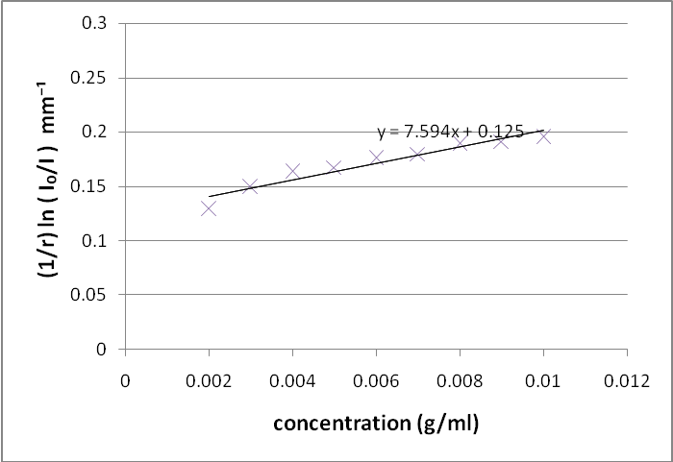
Fig.(3) Values of (1/r) ln ( I₀/I ) versus concentration for milk solution

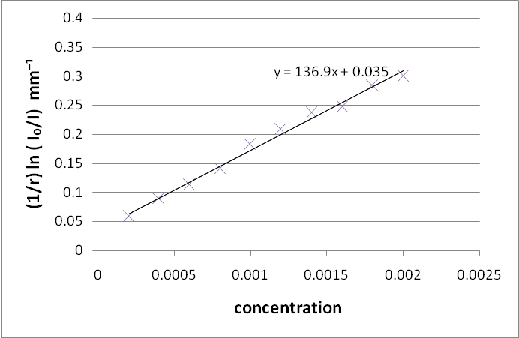
Fig.(4) Values of (1/r) ln( I₀/I ) versus concentration for black ink

The results were linearly fitted for the measurements taken on the samples . The slope represents the total extinction coefficient µ _{t} . The intercept is very small relative to the slope value .
The total extinction coefficient µ _{t} for diluted concentrations of milk , at 632.8nm is found to be
µ _{t} = 7.954 (g/ml)⁻¹mm⁻¹
where units of µ _{t} come from the fact that mass concentrations in units of ( g/ml ) are considered . And the total extinction coefficient for diluted concentrations of black ink at 632.8nm is
µ _{t} = 136.9 mm⁻¹ .
Values of total extinction coefficient depend on wavelength ( Coen et. al. 2004) since its components ( absorption and scattering coefficients ) have a significant dependence on wavelength .
The linearity of the result show that Equation(1) is well applicable in the range of concentrations considered here . This is in good agreement with the results obtained by Gwamuri et. al. (2006).
It should be noted that values of total extinction coefficient µ _{t} for milk depend on type of milk considered , fat concentration , and protein concentration . Also , values of µ _{t} for black ink depend on its composition .

(4) Conclusions
Collimated transmission method , with a He-Ne laser , operating at 632.8nm has been used to find total extinction coefficients for two turbid media , a pure scatterer ( milk) and a pure absorber (black ink) . The linearity of the results obtained in Figures (3) & (4) show that Lambert-Beer’s law applies very well in the range of concentrations considered . From these two figures , values of total extinction coefficients for diluted concentrations of milk and black ink were found to be µ _{t} = 7.954 (g/ml)⁻¹mm⁻¹ and µ _{t} = 136.9 mm⁻¹ respectively at a wavelength of 632.8nm.
References
Abebe E (2007). Determination of Fat and Protein Content of Milk using He-Ne Laser Light Scattering , M.Sc. Thesis , Addis Ababa University .
Coen MC, Weingartner E, Schaub D, Hueglin C, Corrigan C, Henning S, Schwikowski M , and Baltensperger U . (2004) . Saharan dust events at the Jungfraujoch: detection by wavelength dependence of the single scattering albedo and first climatology analysis . 4 , 2465-2480. http://hal.archives-ouvertes.fr.
Gwamuri J, Gholap AV, Shartir TSM , and Bassuah PK. (2006). Investigating Light Propagation in Turbid Media by Evaluating Optical Properties of Phantom Tissues. Proceedings from the 2nd International Conference on Appropriate Technology. Bulawayo , Zimbabwe, July 12-15 .
Srinivasan R, Kumar D and Singh M (2002). Optical Tissue-Equivalent Phantoms for Medical Imaging. Trends Biomater. Artif. Organs.15,42-47, http://medind.nic.in.
Webb PA (2010), A primer on Particle Sizing by Static Laser light Scattering , Micromeritics Instrument Corp. , http://www.particletesting.com.

