Drying Shrinkage Cracking Of Self Compacting Concrete

Jinan Jawad Hassan Alwash
College of Engineering – Babylon University

Abstract
Self-compacting concrete (SCC) describes a concrete with the ability to compact itself by means of its own weight without the requirement of vibration. This study included producing SCC from locally available materials according to the requirement of workability measurements, and then studying the effect of some fillers (pigment and limestone powder) on dimensional changes of SCC beams. End retrained beams were used to study free shrinkage and restrained shrinkage cracking. To determine the workability, different test methods are adopted in this research such as slump-flow, T50 slump flow, L-box, U-box and V-funnel.
Based on the results of this work, it can be concluded that the free shrinkage of SCC mix with pigment is higher than normal concrete mix by ( 19 %) for 3 days and ( 3.7%) for 65 days. Free shrinkage of SCC with pigment is higher than that the SCC mixes with limestone powder by ( 28.5 %) for 3 days and ( 8.9 %) for 65 days. The first cracking time for SCC mix containing pigment powder and super plasticizer occurs earlier [after (20) days].while for SCC mix containing limestone powder and super plasticizer the cracking time is ( 40days).
الخلاصة
توصف الخرسانة ذاتية الرص على انها خرسانة لها القابلية على رص نفسها تحت تأثير وزنها دون الحاجة الى متطلبات الاهتزاز. هذه الدراسة خططت لانتاج خرسانة ذاتية الرص من المواد المتوفرة محلياً طبقاً لمتطلبات قابلية التشغيل، ومن ثم دراسة تأثير بعض المواد المالئة مثل الاصباغ (pigments) والحجر الجيري الناعم (limestone powder) على التغيرات الحجمية للعتبات الخرسانية الذاتية الرص ومقارنتها مع الخرسانة الاعتيادية. ثم استخدام عتبات خرسانية (Beams) مقيدة النهاية لدراسة تشققات الانكماش الحر والمقيد. استخدمت عدة طرق لقياس قابلية التشغيل منها فحص الانسياب و زمن الانسياب والصندوق على شكل حرف L، الصندوق على شكل حرف U، والقمع على شكل حرف V.
اعتماداً على نتائج البحث يمكن الاستنتاج بان انكماش الجفاف الحر للخرسانة ذاتية الرص مع الاصباغ اعلى بالمقارنة مع الخرسانة الاعتيادية بمقدار (%19) لثلاثة ايام و %3.7 لـ 65 يوم ).
وكان الانكماش الحر للخلطة الخرسانة ذاتية الرص مع الاصباغ اعلى من الخلطات الخرسانية مع الحجر الجيري الناعم بمقدار ( %28.5 لـ3 يوم و %8.9 لـ 65 يوم) في العتبات المقيدة النهاية. وقت حدوث التشققات يكون مبكراً عند اضافة الاصباغ والملدن (SP) الى الخلطة ( كان بعد 20 يوم). بينما وقت حدوث التشققات في الخلطة الخرسانية الحاوية على الحجر الجيري الناعم والملدن (40 يوم).
Introduction
Shrinkage of Concrete
Shrinkage of concrete exposed to dry environment is an important characteristic, and it may cause cracking if the concrete element is restrained [Zhang 2005].
The main factors that affect the magnitude of drying shrinkage in concrete include the cement fineness and content, the aggregate size and content, the W/C ratio, curing period, the relative humidity and the member size. The aggregate used in the concrete mixture acts to restrain the shrinkage of cement paste. Concrete with a higher aggregate content has less shrinkage than that of lower aggregate content. Aggregate with a higher modulus of elasticity or rougher surface has more resistant to shrinkage. In general, a higher water-to- cement (W/C) ratio will produce greater drying shrinkage. [Mokarem 2002].

Self- Compacting Concrete.
The concept of self-compacting concrete (SCC) was proposed in 1986 by professor Hajime okamura (1997), but the prototype was first developed in 1988 in Japan, by professor ozawa 1989 at the university of Tokyo [Okamura and Hajimar 1997 , Ozawa 1989] . SCC describes a concrete with the ability to compact itself only by means of its own weight without the requirement of vibration . This new concrete was deliberately designed to be able to fill every corner of the form and encapsulate all reinforcement with maintained stability only under the influence of gravitational forces, without segregation or bleeding. This makes SCC particularly useful wherever placing is difficult, such as in heavily-reinforced concrete members or in complicated work forms-to fulfill nation request, concrete need to has special properties in fresh state. On the other hand, the flow ability of concrete has to avoid segregation. These properties of the fresh concrete can be realized by high enough mix design, a proportion of aggregate is replaced by powder material while the water contents is kept constant [M.A. Ahmadim et . al].
[Jianxin and Holger 2002] concluded that the application of new super –plasticizers and powders in a high performance concrete gives opportunity to produce SCC that reaches very high compressive strength. These concretes show a very good workability in the fresh state, also the hardened concrete shows excellent quality .

Experimental Program
To determine the workability, different test methods are adopted such as slump-flow, T50cm, L.box, U-box and V-funnel. The mechanical properties studied are, compressive strength, splitting tensile strength, free and end restrained shrinkage. Table (1) shows the mix proportions by weight for normal concrete and self-compacting concrete in this work.

Table (1):Mix proportions by weight
Materials | Normal concrete mix | Self-compacting concrete mix
Cement (kg/M³) | 450 | 450
Filler (kg/M³) | - | 65
Fine aggregate (kg/M³) | 750 | 750
Coarse aggregate (kg/M³) | 790 | 790
SP (Liter/100 kg cement) | - | 2
W/P | 0.45 | 0.45
W/C | 0.51 | 0.51

Materials
1. Cement
Ordinary Portland Cement (O.P.C) manufactured by united cement company , commercially known [TASLUJA – BAZIAN] was used throughout this investigation. This cement complied with the Iraqi specification No. 5: 1984. The chemical composition and physical properties are presented in Tables (2) and (3).

2. Fine Aggregate
Natural sand from AL-Akaidur region was used. The result of physical and chemical properties of the sand are listed in Table (4). Its grading is conformed to the IQS No. 45:1984 Zone 2.
Table (2): Chemical composition of the cement
Oxide | % | IQS No. 5: 1984
CaO | 62.52 | -
SiO₂ | 20.90 | -
Al₂O₃ | 4.76 | -
Fe₂O₃ | 3.92 | -
MgO | 2.71 | ≤ 5.0
SO₃ | 2.4 | ≤ 2.8
Free lime | 1.4 | -
L.O.I | 2.31 | ≤ 4.0
Compound Composition | % | IQS  No. 5: 1984
C₃S | 45.55 | -
C₂S | 25.55 | -
C₃A | 5.98 | -
C₄AF | 11.93 | -
L.S.F | 0.89 | 0.66-1.02

Table (3): physical properties of cement
physical proposition | Test results | IQS  No. 5:1984
Fineness, Blaine, Cm²/gm  Setting time, Vicat,s method  Initial hrs : min  Final hrs : min | 3300  2 : 20  3 : 55 | ≥ 2300  ≥ 00:45  ≤ 10:00
Compressive strength Mpa  3 days  7 days | 24  33 | ≥ 15  ≥ 23

Table (4 ): Properties of fine aggregate
Sieve size (mm) | Passing % | IQS. No 45 : 1984
9.5 | 100 | 100
4.75 | 97 | 90-100
2.63 | 82 | 75-100
1.18 | 71 | 55-90
0.6 | 55 | 35-59
0.3 | 27 | 8-30
0.15 | 4 | 0-10
0.075 | 0.95 | 5
Properties | Test results | IQS. No 45: 1984
SO₃% | 0.3 | ≤ 0.5
Fineness Modulus | 2.64
Specific gravity | 2.55
Absorption % | 1.5

3. Coarse Aggregate
The coarse aggregate was AL-Nibaee gravel with a maximum size of 14 mm. the results of physical and chemical properties of the coarse aggregate are listed in Table ( 5 ). The coarse aggregate is complying with IQS No. 45: 1984.

Table (5): Properties of coarse aggregate
Sieve size (mm) | Passing % | IQS. No 45 : 1984
14 | 100 | 95-100
10 | 88 | 85-100
5 | 9 | 0.25
2.36 | 0 | 0-5
Properties | Results | IQS
Specific gravity  SO₃% | 2.65  0.09 | -  ≤ 0.1
Absorption % | 0.60 | -

4. Super plasticizer
To achieve high workability needed to produce SCC , super plasticizer known as Flocrete SP33 was used According to ASTM C494- 92, this SP is classified as type A and F. The technical description of the super plasticizer is given in Table (6).

Table (6): Technical description of the super plasticizer
Color | Brown liquid
Freezing point | -2Cº approximately
Specific gravity | 1.18 kg / 1 @ 25 Cº
Air entrainment | Less than 2%
Chloride content | Nil
5. Limestone Powder
Limestone Powder, which has been brought from local market is used to increase the amount of powder (cement filler) in the SCC mixes. Particle size less than 0.125 mm was saved to increase the workability and density of the SCC. the chemical composition of limestone powder is shown in Table ( 7 ).

Table (7): Chemical composition of limestone powder
Oxide | Content %
SiO₂ | 1.34
Fe₂O₃ | 0.12
Al₂O₃ | 0.69
CaO | 55.13
MgO | 0.13
SO₃ | 1.70
L.O.I | 40.56

6. Pigment:
Pigment is used for the coloration of building, and filling material to improve the properties of fresh and hardened concrete. This material was brought from local market, then it was used in the concrete mixes after passing sieve number 0.075 mm. the chemical composition of pigment is shown in Table(8).

Table (8):Chemical composition of pigment
Oxide | Content %
SiO₂ | 4.13
Fe₂O₃ | 0.10
Al₂O₃ | 0.50
CaO | 63.12
MgO | 0.14
SO₃ | 0.70
L.O.I | 31.15

Test producers
1. Fresh Tests
The workability of SCC can be characterized by the following properties:
- Filling ability.
- Passing ability.
- Segregation resistance.
In order to evaluate the filling, passing ability and segregation resistance of the fresh concrete, slump-flow, T 50 cm, L. box, U-box and V. funnel tests, as shown in Fig (1).

2. Hardened Tests
2.1 Compressive Strength
Compressive strength was carried out and tested according to BS 1881 : part 116 : 1989. All specimens were cured in Water until testing age. Each result of compressive strength obtained is the average for three specimens.

2.2 Splitting Tensile Strength
The splitting tensile strength was determined according to the procedure outlined in ASTM C-496. Cylinders were cast, demolded and cured in a similar way as the cubes. Each splitting tensile strength result was the average of strength for two specimens. The splitting strength is calculated from the equation:
δ=
Where:
δ =Tensile strength (NImm²)
L = The cylinder length (mm)
P = The applied compressive load (N)
D = The cylinder diameter (mm).

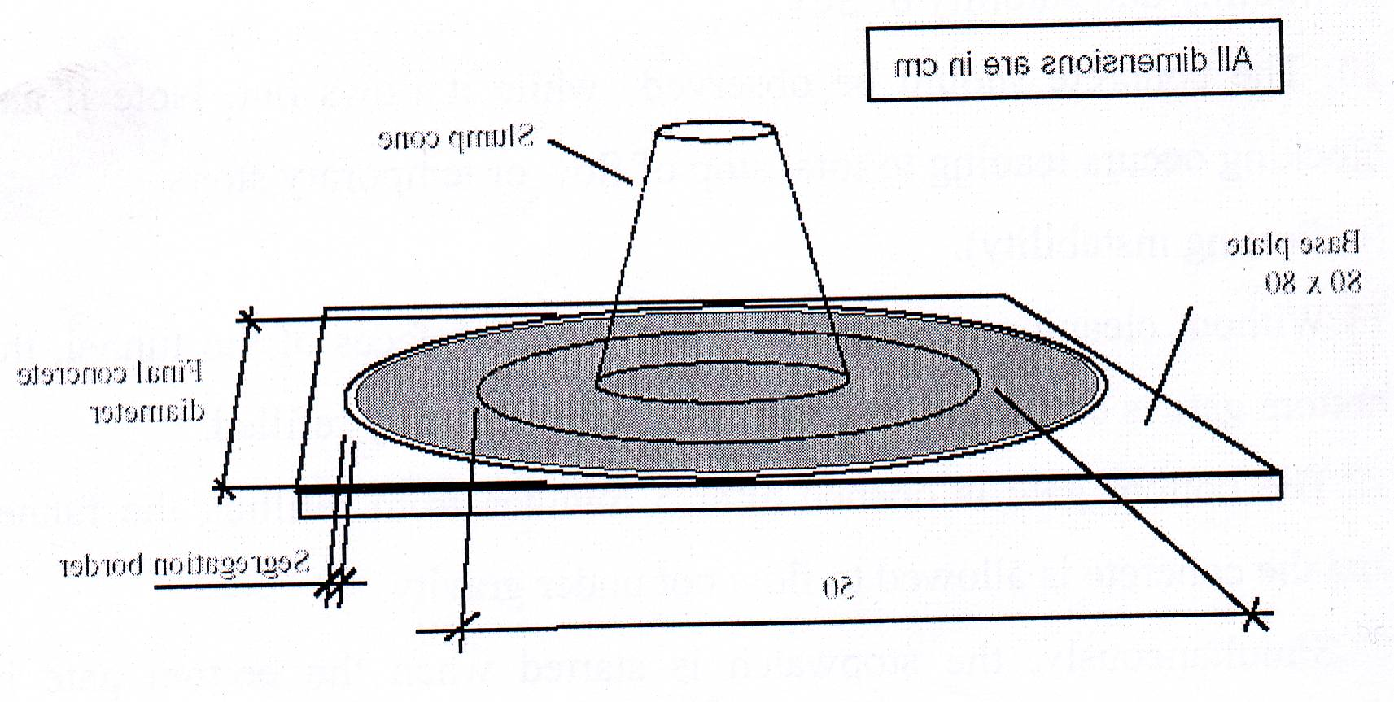
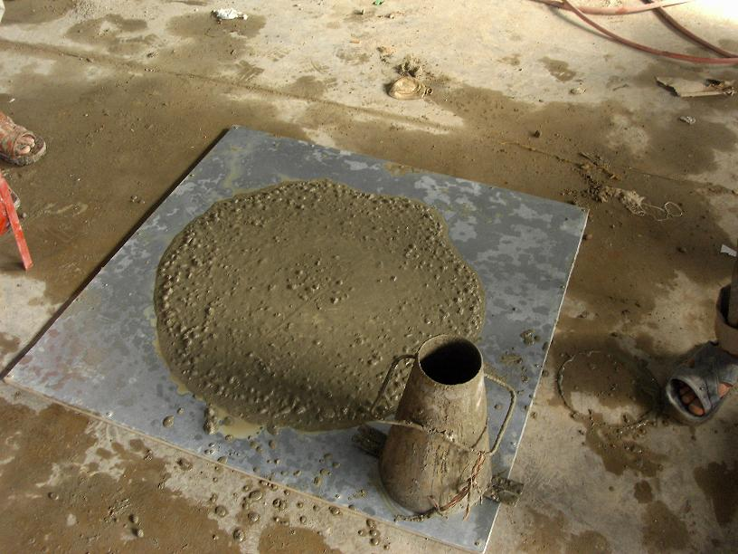

a. Slump – flow and T50
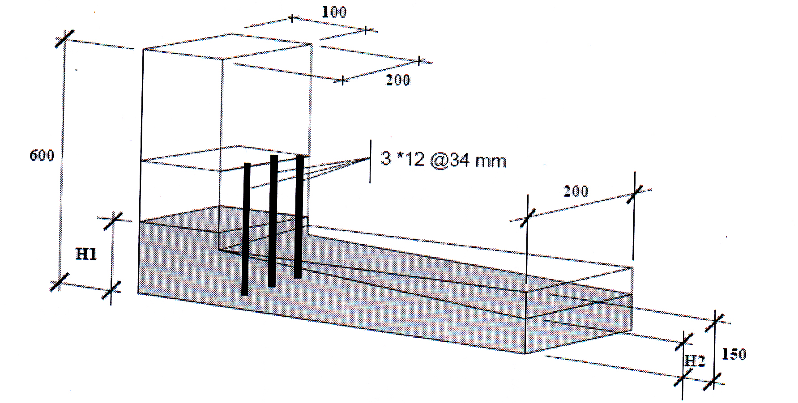
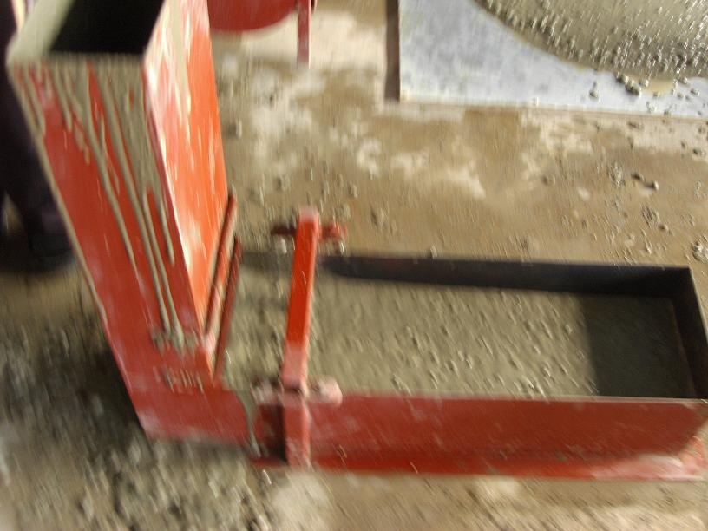

b. L – box test
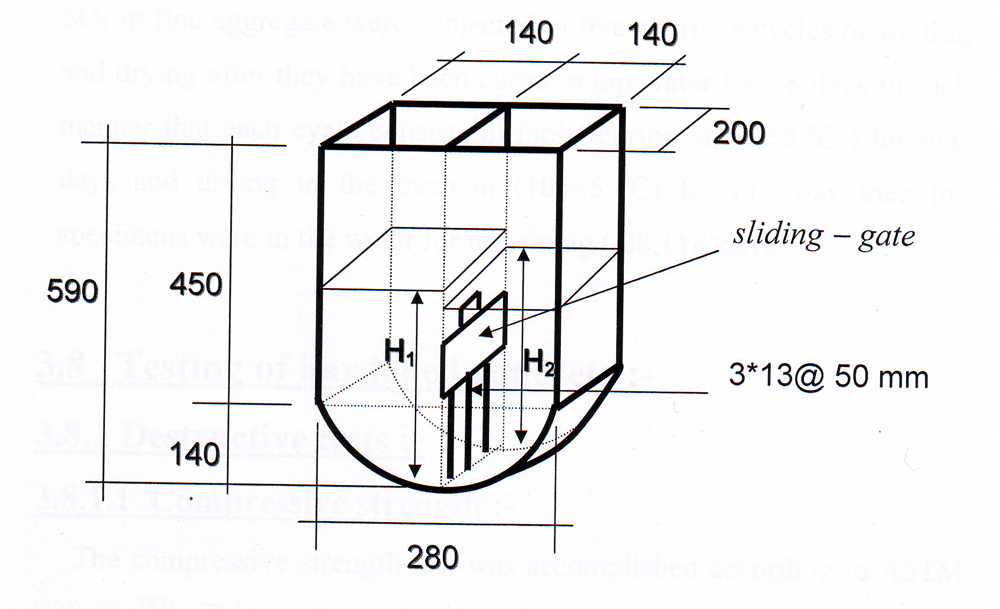
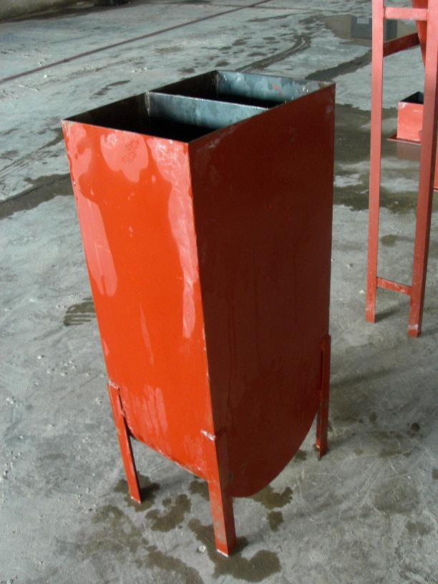

c. U box test
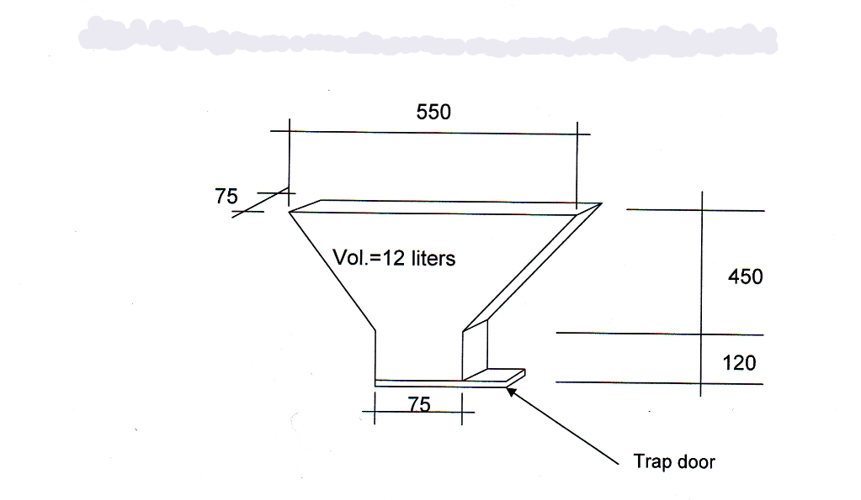
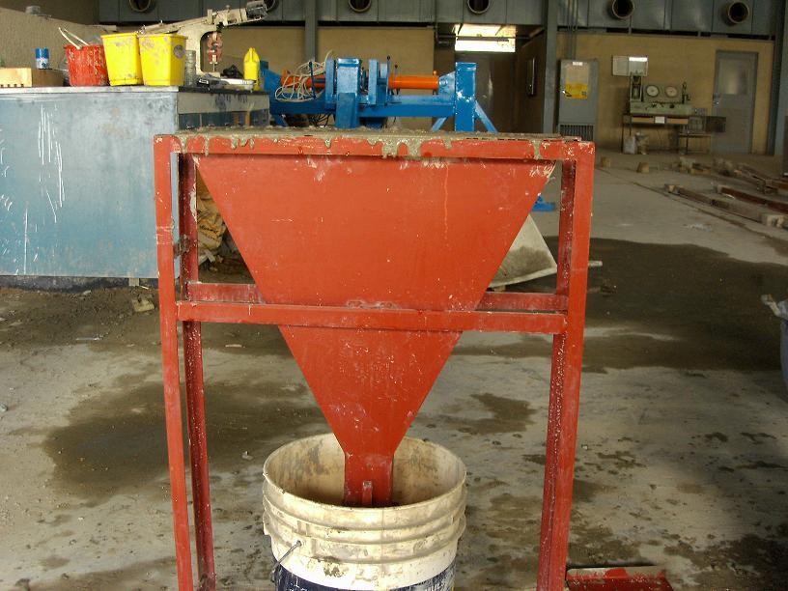

d. V- funnel test
Fig (1): Fresh concrete test
2-3 Shrinkage Test
Moulds having a channel section where used to study free shrinkage and shrinkage cracking of end restrained concrete members for normal and self-compacting concrete. This model was devised by [Al-Rawi 1985] with a modification by making it narrow at the middle of the web Fig (2). Two beam were cast for normal concrete mixture (without filler and super Plasticizer), and four beams were cast for self compacting concrete (for each filler (pigment and limestone powder). For each type of concrete two beams were filled. The first was supplied with artificial inserted diaphram (crack opening) in the web for free shrinkage determination as can be seen in Fig (3), and other for restrained shrinkage testing. The beams were cured by covered them with Hessian and polythene sheets and wetted once every day for first 7 days. Then they were subjected to drying in laboratory conditions. The model devised by [Al-Rawi 1985] was adopted for shrinkage measurements.
The contraction at the surface of the drying concrete web was measured by the distance between the demec points, using a mechanical extensometer with an accuracy of (0.002mm / division). The demec points were fixed (during the first stage of curing period) along the center of the web (20 cm) distant. After the occurrence of cracking, measurement of strain was repeated to record the recovery of free contraction of concrete (the elastic tensile strain capacity) at the onset of cracking. Further demec points were fixed at the beam side in order to measure the amount of loss of restraint, which is due to shortening of the steel mould prior to cracking. The free shrinkage was determined by daily measuring the widening of the artificial crack in the middle of the beam. Readings were taken from the next day after casting, until a drying period of 65 days. The tensile strain capacity is equal, the free shrinkage strain of the specimen due to drying from the moment of casting until the occurrence of cracking taking into account the loss in restraint during this period.
T. S.C = F.S – loss of restraint.

Where:
T.S.C : tensile strain capacity x 10⁻⁶.
F.S : free shrinkage x 10⁻⁶.
While, the creep strain was calculated by subtraction the elastic tensile strain capacity from the tensile strain capacity.
The crack width was measured by a portable graded microscope.
C = T .S.C – E.T.S.C.
Where:
C : creep strain ( at cracking time ) x 10⁻⁶.
E.T.S.C : elastic tensile strain capacity x 10⁻⁶.

Fig (2):Schematic diagram of the mould
* all dimensions in millimeters

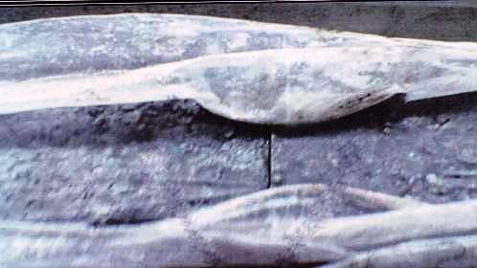
Fig (3): The artificial gap

Result And Discussion
The properties of fresh SCC as presented in Table (9 ) these result show that the SCC used complying with the requirements of SCC.
Table (9): Properties of fresh SCC
Workability tests | Unit | Type of filler |  | Limitation
Workability tests | Unit | Lime stone Powder | Pigment | Limitation
Slump-flow | mm | 710 | 700 | 650-800 mm
T 50 cm | sec | 2.5 | 3.0 | 2-5 sec
L-box | (H2/ H1) | 0.91 | 0.88 | 0.80-1.00
U-box | (H1-H2) mm | 10 | 12 | 0-30 mm
V-funnel | sec | 6 | 7 | 6-12 sec

From the results of compressive strength shown in Table (10), it can be seen that the compressive strength of SCC with (limestone + SP) is higher than that the compressive strength of SCC with( pigment + SP).

Results of the 28 days splitting tensile strength of SCC are shown in Table (11) it is clear that the results reveal identical trend as for results of compressive strength.
Free shrinkage strain development of concrete beams for different drying periods of normal concrete and self-compacting concrete are shown in Fig ( 4 ). It can be seen that the drying shrinkage of SCC mix with pigment is higher than that the normal concrete mix by (19 % for 3 days and 3.7% for 65 days). This is may be relating to the effect of volume of paste on drying shrinkage amount and high content of fine materials (powder) which increase drying shrinkage. This is compatible with the study carried out by [Johansen and Hammer]. It can be seen also that the SCC mix with pigment is higher than the SCC mixes with limestone powder by ( 28.5% for 3 days and 8.9% for 65 days. This may be attributed to the large surface area of the pigment which is presented to the reaction with the water and hydration takes place rapidly. This is compatible with the study carried out by [Hols chemacher and Klug 2002 , Rahim 2005].
The determination of tensile strain capacity was based on the end restrained shrinkage beam. Table (12) show the values of tensile strain capacity obtained in the present work. In general it can be observed from the results that the tensile strain capacity increases with the increase of date of crack. From this Table it can be observed that the cracking time decreases with the addition of pigment powder and super plasticizer to the mix. This may be related to the fact that these additions would increase drying shrinkage, thus, the possibility of cracking at early ages will be increased, and the time required for cracking will be lower.
From the results shown in Fig (5 ) it can be seen that the crack width development of SCC mix after cracking is higher than its companion of the normal concrete mix. This may be due to the present of fine powder.

Table (10) : Results of the compressive strength ( MPa ) of SCC mixes
Mix notation | Compressive strength  (MPa)  at age of :
Mix notation | 7 days | 28 days
SCC ( limestone + sp) | 23.6 | 34.7
SCC ( pigment + sp) | 22.2 | 33

Table (11) : Results of the splitting tensile strength

Mix notation | Splitting tensile strength ( MPa)  at 28 days
SCC ( limestone + sp) | 3.45
SCC ( pigment + sp) | 3.37

Table (12): Properties of end restrained beam
Mix notation | Date of crack  (days) | Free shrinkage strain  x 10⁻⁶  1 | Loss of restraint  x 10⁻⁶  2 | Tensile strain capacity  x 10⁻⁶  3=1-2 | Elastic tensile strain capacity  x 10⁻⁶  4 | Creep strain at cracking  x 10⁻⁶  5=3-4
Normal concrete mix | 28 | 537 | 98 | 439 | 133 | 306
SCC mix  (pigment + sp) | 20 | 470 | 85 | 385 | 111 | 274
SCC mix  (limestone + sp) | 40 | 558 | 100 | 458 | 142 | 316

Fig (4): Free shrinkage development with drying time for end
restrained beam

Fig (5): Development of crack width with drying period of beams for normal mix and SCC mixes

Conclusions
1-SCC can be produced with locally available material (pigment and limestone ) by careful proportioning mixing .
2- The free shrinkage of beam cast with SCC mix with pigment is higher than the normal mix by (19% for 3 days and 3.7% for 65 days)
3- The free shrinkage of beam cast with SCC mix with pigment is higher than the SCC mix with limestone powder by (28.5% for 3 days and 8.9% for 65% days) .
4- The cracking time in the end restrained beam for SCC mix containing pigment powder and super plasticizer occurs earlier after (20) days , while the normal mix without addition the cracking time is (28 days) , and for SCC mix containing limestone and super plasticizer the cracking time is (40 days) .

References
Ahmadi, M. A., Aldoust, O., Sadrinejad,I., and Nayeri, M., "Development of Mechanical Properties of Self Compacting Concrete Contain Rice Husk Ash", International Journal of Computer, Information, and Systems Science, and Engineering volume 1 number 4.
Al- Rawi, R. S., Aug-1985, "New Method of Determination of Tensile Strain capacity and Related properties of Concrete Subjected to Restrained Shrinkage", ACI symp, Singapore .
Holschemacher K., and Klug Y., 2002, "A Data Base for the Evaluation of Hardened properties of SCC",, LACER No. 7, Leipzing University.
"Iraqi Organization of standards ", IQS , 5 : 1984, for Portland Cement .
Jianxin M., and Holger S., 2002, "properties Ultra-High performance Concrete", University of Leipzing .
Johansen, K., and Hammer T. A., "Drying Shrinkage of Norwegian Self-Compacting Concrete", MSC Eng., Research Engineer, SINTEF Civil and Environmental Engineering, 7465 Trondheim Norway.
Mokarem, D. W., May-2002 "Development of Concrete Shrinkage Performance Specifications", Ph.D Dissertation, Civil and Environmental Engineering , Blacksburg, Virginia.
Okamura, Hajime, 1977, "Self-Compacting High-Performance Concrete", Concrete international, 19 (7 )
Ozawa, K, 1989, "Development oh High Performance Concrete Based on the Durability Design of Concrete Structures ", EASEC-2 Vol.1, PP445-450 .
Rahim J. O., August - 2005, " The Influence of Volume Ratio and Size of Coarse Aggregate on the Properties of Self-Compacting Concrete ", MSC .Thesis , University of Al- Mustansiriya , College of Engineering.
Zhang, Mar/ Apr-2005, "Shrinkage of High – Strength Light Aggregate Concrete Exposed to Dry Environment", ACI Materials Journal.

