Study the Effect of Some Plant Extract on the Levels of Antioxidants in Mice

Oda M. Yasser Mahmoud H. Hadwan
Babylon University, College of Science, Chemistry Department
Shaima Abed Al-Hadi Manar H. Abed Salih
Babylon University, College of Science, Biology Department

Abstract
Background: Oxidative stress, an imbalance in oxidant-antioxidant status is characterized by an increase in lipid peroxidation (LPO) and a decrease in activities of antioxidant enzymes.
Objective: This study was undertaken to investigate the effect of water extract of fenugreek (Trigonella foenum-graecum L.), cinnamon (Cinnamomum Zeylanicum) and green tea (Camellia sinensis) on blood antioxidants levels (Super oxide dismutase, Catalase, Total thiol levels and Total antioxidants status) in peroxide induced oxidative stress albino mice.
Methods: Water extract of fenugreek, cinnamon, and green tea was tested in peroxide induced oxidative stress albino mice. It was administered in drinking water. Its effect on blood antioxidants levels (Super oxide dismutase, Catalase, Total thiol levels and Total antioxidants status) were studied in experimental mice.
Result: Treatment with water extracts of fenugreek, cinnamon, and green tea, resulted in a significant elevation of blood antioxidants levels (Super oxide dismutase, Catalase, Total thiol levels and Total antioxidants status)
Conclusion: The results suggest here that the mode of action of fenugreek, cinnamon, and green tea may be caused by their contents of natural products through elevation the decreased blood antioxidants levels, thereby preventing oxidative stress with converting blood pathology caused by peroxide to normal pattern.
الخلاصة
الخلفية: الاجهاد التأكسدي هو عدم التوازن في محتوى مضادات الاكسدة ويمكن تشخيصه بزيادة مستويات اكسدة الدهون وانخفاض فعالية الانزيمات المضادة للاكسدة.
الاهداف: هذه الدراسة صممت لحساب تأثير المستخلصات المائية للحلبة(Trigonella foenum-graecum) والدارسين (Cinnamomum Zeylanicum) و الشاي الاخضر(Camellia sinensis) على مستويات مضادات الاكسدة (انزيم السوبراوكسيد دسميوتيز و انزيم الكاتليز و مستوى الثايول الكلي و مستوى مضادات الاكسدة الكلية) في دم الفئران المختبرية الذي استحث فيها الاجهاد التأكسدي عن طريق بيروكسيد الهيدروجين في مياه الشرب.
طرائق العمل: المستخلصات المائية للحلبة و االدارسين و الشاي الاخضر اعطيت للحيوانات المختبرية عن طريق مياه الشرب وبعد ذلك تم قياس مستويات مضادات الاكسدة (انزيم السوبراوكسيد دسميوتيز و انزيم الكاتليز ومستوى الثايول الكلي و مستوى مضادات الاكسدة الكلية) في دم الفئران المختبرية الذي استحث فيها الاجهاد التأكسدي عن طريق بيروكسيد الهيدروجين في مياه الشرب.
النتائج: لوحظ وجود ارتفاع معنوي(p < 0.05) في مستويات مضادات الاكسدة (انزيم السوبراوكسيد دسميوتيز و انزيم الكاتليز و مستوى الثايول الكلي و مستوى مضادات الاكسدة الكلية) في دم المجاميع التي عوملت بالمستخلصات النباتية عند مقارنتها بالمجموعة التي اعطيت بيروكسيد الهيدروجين فقط.
الأستنتاجات: تقترح النتائج هنا بأنّ نمط عمل الحلبة و الدارسين والشاي الأخضر قَدْ يكون سببه محتوياتهم مِنْ المنتجات الطبيعية ممايؤدي الى إرتفاع مستويات مضادات الاكسدة ،و بذلك يمنع الاجهاد التأكسدي برفع مستويات مضادات الاكسدة (انزيم السوبراوكسيد دسميوتيز و انزيم الكاتليز و مستوى الثايول الكلي و مستوى مضادات الاكسدة الكلية) في دم المجاميع التي عوملت بالمستخلصات النباتية إلى المستوى الطبيعي.
Introduction
Oxidative stress was reported to be involved in cardiovascular diseases, hypertension (Hiroko Negishi et al., 2004), diabetes mellitus (Al Mashhedy et al., 2007), and obesity (Hadwan, 2009). Living tissues maintain defense systems against ROS through enzymatic antioxidants (superoxide dismutase, glutathione peroxidase and catalase) and non enzymatic antioxidants (vitamin E, vitamin C, carotenoids and polyphenols). Diets with antioxidant properties include many fruits and vegetables, which are considered to be important sources of antioxidants. Dietary antioxidants including vitamin E, vitamin C, carotenoids and polyphenols have received much attention in the prevention of oxidative stress and its risk factors. (Peschel et al., 2006).
The electron acceptor molecule oxygen counteracts the free radicals transforming them into a reactive oxygen species (ROS). The primary derivatives of oxygen, such as superoxide anion radicals (O^{2-•}), hydroxyl radicals (OH•), hydrogen peroxide (H₂O₂) and the singlet oxygen (¹O₂), play an important role in mediating ROS-related effects. Short living reactive species generated in living system can react with non-radicals and produce chain reactions. ( Teissedre et al.,2000) In the last years there has been a constantly rising interest in the anti-oxidative constituents of various medicinal plants, due to their potential in controlling the levels of free radicals and the process of lipid peroxidation (Schmidt et al., 2006).
At present, follow a line of investigation is focused on the extraction of natural antioxidants {e.g. also from Trigonella foenum – graecum, Cinnamomum Zeylanicum, and Camellia sinensis) that would be less toxic and more effective than the commonly applied synthetic antioxidants (Synthetic antioxidants, such as butylated hydroxytoluene (BHT), butylated hydroxyanisole (BHA)} to fight oxidative stress, which is a highly pathological situation.
Fenugreek (Trigonella foenum graceum) is noted for its several pharmacological properties especially it's hypoglycemic effects. (Randhir and Shetty, 2007) The seeds are rich in proteins and contain the unique amino acid 4-hydroxyisoleucine, which is one of the active ingredients for blood glucose control by inducing insulin release in rats and humans. ( Broca et al., 1999). Various reports have demonstrated that the Fenugreek seeds have hypocholesterolemic and hyperinsulinomic effects on type-1 and type-2 diabetes mellitus in human and experimental animals (Puri et al., 1995). This medicinal herb is considered to be an excellent candidate for oral therapy as it is effective, non-toxic and without serious side effects. The chemical constituents of Fenugreek seeds include volatile oils, alkaloids, saponins, sapogenins, flavonoids and mucilage (Siddiqui et al., 2005).
Green tea (Camellia sinensis) has a high content of polyphenols, which would make green tea taste excessively bitter (Cabrera et al., 2006). Green tea chemical composition is complex: proteins (15–20% dry weight) amino acids (1–4% dry weight) carbohydrates (5–7% dry weight) lipids as linoleic and linolenic acids; sterols as stigmasterol; vitamins (B, C, E); xanthic bases such as caffeine and theophylline; pigments as chlorophyll and carotenoids; volatile compounds as aldehydes, alcohols, esters, lactones, hydrocarbons, etc.; minerals and trace elements (5% dry weight) such as Ca, Mg, Cr, Mn, Fe, Cu, Zn, Mo, Se, Na, P, Co, Sr, Ni, K, F and Al. Polyphenols constitute the most interesting group of green tea leaf components, and in consequence, green tea can be considered an important dietary source of polyphenols, particularly flavonoids. Flavonoids are phenol derivatives synthesized in substantial amounts (0.5–1.5%) and variety (more than 4000 identified), and widely distributed among plants (Vison et al., 1995). The main flavonoids present in green tea include catechins (flavan-3-ols) (McKay and Blumberg, 2002).
Cinnamon is used to flavor most foods in Arabian countries.(Said et al.,2009), its widely used in food products. It has exhibited beneficial properties to health, such as antimicrobial activity, for controlling glucose intolerance and diabetes, inhibiting the proliferation of various cancer cell lines, and for treating the common cold (Anderson and Broadhurst, 2004). The essential leaf oil of Cinnamomum Zeylanicum is rich in eugenol, benzyl benzoate, linalool and eugenyl acetate as well as further aroma-active volatiles, responsible for the pleasant cinnamom and clove-like (strong eugenol- note) and warm-floral scent of this sample (Schmidt et al., 2006).
The objective of the present study was to examine the antioxidant activity of water extracts of Trigonella foenum – graecum, Cinnamomum Zeylanicum, and Camellia sinensis against oxidative stress induced by H₂O₂ in mice.
Materials and Methods:-
Materials:-
Fenugreek (Trigonella foenum – graecum), cinnamon (Cinnamomum Zeylanicum) powder and green tea (Camellia sinensis) was obtained from the local market at Al-Hilla city, Iraq. All reagents and solvents used in this study were purchased from Fluka Company unless otherwise stated.
Preparation of extracts:-
The extracts were prepared by dissolving powder (30 g /L boiling water (90 ºC) with shaking 7 min for (Camellia sinensis), 25 min for (Trigonella foenum – graecum, and Cinnamomum Zeylanicum). The extracts filtered (Whatman No.1), and the supernatant used in the study. All extracts prepared daily.
Preparation of peroxide:-
30% H₂O₂ diluted with tap water to produce 1mM peroxide solution. Many studies used peroxide solution to induce oxidative stress and to examine the antioxidant activity of water extracts of various medicinal plants. (Meera et al., 2009)
Animals:-
Albino mice were used for all the experiments. Animals were kept in the animal house at temperatures of 22–26°C with a 12:12-h dark–light cycle. Animals were divided into five groups. The animals were fed standard chow, and given tap water until treatment or time of sacrifice. All the animals were obtained from the animal house (Babylon University, college of science). Each group contained 10 mice. The control groups were given standard diet for 21 days. Experimental groups were fed standard diet plus supplementation of different extracts such as below:-
Group I: (control group) was fed standard diet plus supplementation of tap water.
Group II: (Peroxide group) was fed standard diet plus supplementation of tap water and peroxide solution.
Group III: (green tea group) was fed standard diet plus supplementation of tap water, peroxide solution and green tea extract.
Group IV: (Cinnamon group) was fed standard diet plus supplementation of tap water, peroxide solution and Cinnamon extract.
Group V: (Fenugreek group) was fed standard diet plus supplementation of tap water, peroxide solution and Fenugreek extract. The study design shown in fig (1), animals were given tap water or extracts according to method describe by Hiroko Negishi, et al., (2004) with some modifications.

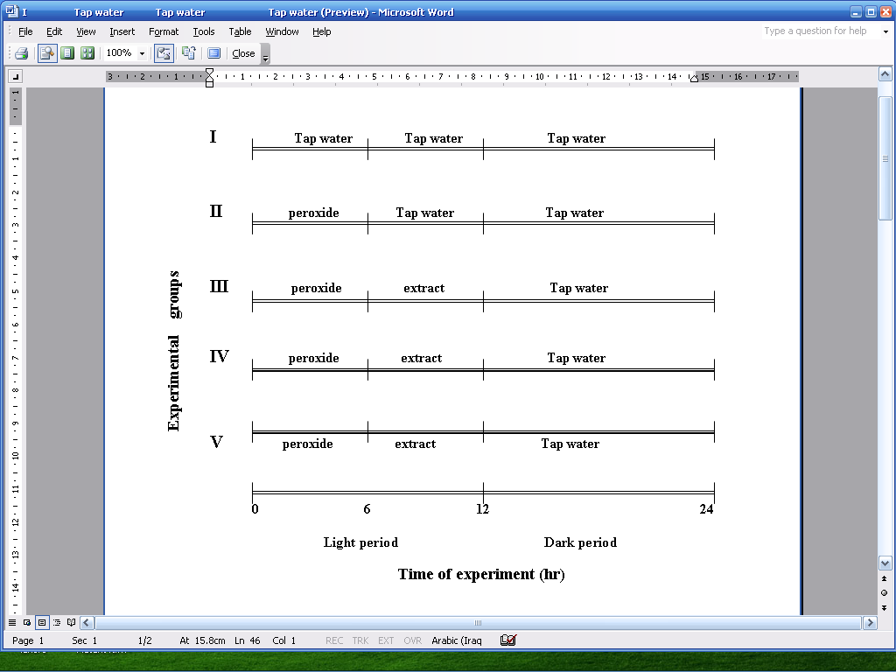

Fig (1):-Study Design for Different Groups.
The experiment was terminated at 21 day and all animals were sacrificed after an overnight fast. Biochemical estimations were carried out in erythrocytes samples of experimental and control animals. Erythrocytes were obtained from 1 ml of blood by centrifugation at 805 g for 10 minutes, at room temperature, immediately after the blood was drawn; they were washed three times in a 0.9 mol/L NaCl solution and stored at -30 °C until analysis. Samples were haemolysed by the addition of ice cold distilled water (1/10), cell membranes were removed by centrifugation, and the supernatant was used for the analysis.
Antioxidant enzymes: The activity of SOD (EC 1.15.1.1) was measured by the method of Marklund and Marklund (1974) using an assay based on the ability of SOD to inhibit the autoxidation of pyrogallol by 50%. One unit of enzyme is defined as the amount of enzyme that causes half maximal inhibition of pyrogallol autooxidation/mg Hb. The assay of catalase was performed colorimetrically at 570 nm by the method of (Sinha, 1972), in brief, to 0.2 ml of sample was added 1.0 ml of 0.01 M phosphate buffer solution (pH 7) and 0.3 ml of 0.2 M H₂O₂. The reaction was stopped after three minute by 1.5 ml of dichromate-acid reagent. Total antioxidant status was measured in whole blood by the method of Benzie and strain (1996). This assay measures the change in absorbance at 593 nm owing to the formation of a colored Fe2+-tripyridyltriazine compound from the colorless oxidized Fe3+ form by the action of electron donating antioxidants. The FRAP reagent consist of 300 mM acetate buffer (pH = 3.6), 10 mM TPTZ in 40 mM HCl and 20 mM FeCl3.6H2O in the ratio of 10:1:1. Briefly, 50 μl of sample was added to 1.5 ml freshly prepared and pre-warmed (37°C) FRAP reagent in a test tube and incubated at 37°C for 10 min. The absorbance of the colored complex was read against reagent blank (1.5 ml FRAP reagent + 50 μl distilled water) at 593 nm. Standard solutions of Fe2+ in the range of 100 to 1000 mM were prepared from ferrous sulphate (FeSO4.7H2O) in distilled water.(FRAP value). Total thiol group was measured in whole blood using DTNB {5, 5' dithio bis (2-nitro benzoic acid)} as the reagent. This reagent reacts with the thiol groups to produce a yellow colored complex which has a peak absorbance at 412 nm. (Ellman, 1959). Haemoglobin in hemolysate was measured according to the method of Drabkin and Austin, (1932).
Statistical analysis
All experiments were repeated at least three times. Means ± SD were calculated for each group and student’s t test was used to calculate statistical significance. Differences were considered statistically significant when p < 0.05. Peroxide group assays compared with control group assays. While, other group assays compared with Peroxide group assays.( Chap T. Le. 2003)
Results
Table (1) depicts the enzymatic antioxidants levels in erythrocytes of control and experimental groups. The enzymes were significantly (p<0.05) decreased in peroxide exposed animals when compared with control animals. However, the enzymatic antioxidants levels were significantly (p<0.05) increased (return to normal value) in other experimental group when compared to the peroxide exposed animals.

Table (1): Super oxide dismutase U/mg Hb and catalase katal/gm Hb activities in experimental groups and control group.

Enzyme activity | Group I  Mean±SD | Group II Mean±SD | Group III Mean±SD | Group IV Mean±SD | Group V Mean±SD
SOD U/mg Hb | 3.35±0.353 | 1.12±0.15  * | 2.706±0.6  ** | 2.71±0.291  ** | 3.1±0.439  **
CAT katal/gmHb | 0.3±0.019 | 0.12±0.02  * | 0.35±0.08** | 0.38±0.081  ** | 0.389±0.2  **
* = SN₁ {clinically significant versus control group (group I)} ** = SN₂ {clinically significant versus Peroxide group (group II)}
Table (2) shows the total antioxidants levels and total thiol levels in erythrocytes of control and experimental groups. These parameters were significantly (p<0.05) decreased in peroxide exposed animals when compared with control animals. However, the levels of this antioxidants were significantly (p<0.05) increased (return to normal value) in other experimental group when compared to the peroxide exposed animals.

Table (2): Total antioxidants µmol/ gm Hb and total thiol Mmol/ gm Hb in experimental groups and control group.

Antioxidants | Group I  Mean±SD | Group II Mean±SD | Group III Mean±SD | Group IV Mean±SD | Group V Mean±SD
Total antioxidants µmol/ gm Hb | 52±7.1 | 26±5.9  * | 34±7.7  ** | 38±11  ** | 52±7  **
total thiol  mmol/ gm Hb | 0.498±0.02 | 0.243±0.022  * | 0.393±0.27  ** | 0.45±0.045  ** | 0.53±0.07  **
* = SN₁ {clinically significant versus control group (group I)} ** = SN₂ {clinically significant versus Peroxide group (group II)}

Discussion
Many studies have been undertaken with various medicinal plants in attempt to develop new process for decreased oxidative stress. In the present study, simple peroxide model for oxidative stress induction was used to investigate the antioxidants effect of some medicinal plants. As shown in table (1) SOD & CAT activities showed a significant decrease in peroxide group compared with control group. The decreased activities of SOD and Catalase may be a response to high levels of H₂O₂, also, hydroxyl radicals produced from the dissociation of H₂O₂ act to lower the activity of these enzymes. Hodgson and Fridovich (1975), Argano et al (1997) and Pigleot et al (1990) have reported the partial inactivation of these enzyme activities by hydroxyl radicals and hydrogen peroxide.
Table (2) shows a significant decrease the levels of total antioxidants and total thiol in peroxide group compared with control group. The depletion of TAS could beyond to increased H₂O₂ levels and consume antioxidants enzymes in tissue of animals; the other cause to decrease TAS is decreased vitamin A and vitamin C concentration in tissues to resistance oxidative stress. On the other hand, the depletion of total thiol levels clears of the role of thiol group in resistance oxidative stress. The decrease of thiol group levels may be beyond to increment the levels of reactive oxygen species such as hydrogen peroxide (H₂O₂), and the hydroxyl radical (HO▪) in oxidative stress, these oxygen species in turn can oxidize many other important group such as thiol group RSH.
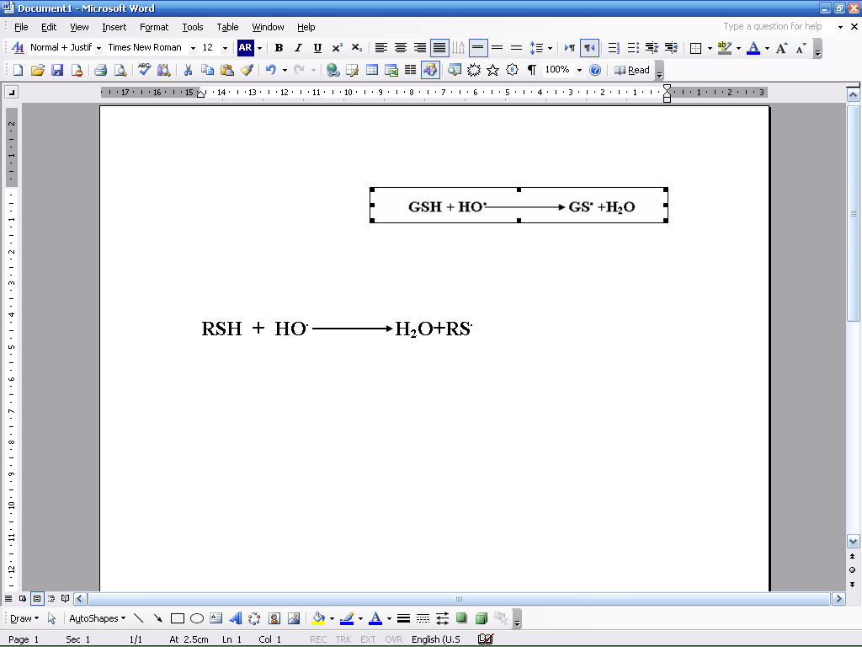
The other cause to decrease RSH is the utilization of RSH to regenerate reduced ascorbate (vitamin C) and tocopherol (vitamin E).
As shown in table 1&2 the treatment of the experimental animals with (Trigonella foenum – graecum, Cinnamomum Zeylanicum) and green tea (Camellia sinensis) restored the activity of SOD, Catalase, total thiol levels and total antioxidants status to normal value {normal value compared with control group, while abnormal compared with peroxide group} That’s beyond to the chemical composition of these medicinal plants.
The fenugreek (Trigonella foenum – graecum) extracts has high level of hydrophobic phenolic forms. These phenolics appear to be effective quenchers of free radicals they may be protect the tissues against elevated oxidative stress generated during consumption of water, which contain H₂O₂. Reduction of phenoxyl radicals by reductants can recycle phenolic antioxidants, thus enhancing the antioxidant activity further. The antioxidant activity of phenolics is mainly because of their redox properties that allow them to act as reducing agents, hydrogen donors, singlet oxygen quenchers and metal chelators. (Reena and Kalidas, 2007). Fenugreek seeds are reported to contain flavonoids (100 mg/100 g seeds) as reported by Nair and Nagar (1997). It could be possible that the fenugreek seeds exert their antioxidant activity through its content from flavonoids.
(Cinnamomum Zeylanicum) was the second medicinal plant used in this study, Schmidt et al., (2006) have reported the two feature of antioxidative properties of Cinnamon extracts. The first, it showed high hydroxyl radical-scavenging activity that intensified with the increase of concentration, reaching 90.0% at 0.1μg/ml, while at an equal concentration the dominant component of cinnamon oil – eugenol, caused 71.30 % inhibition of the hydroxyl radical formation. Substantially weaker was the antioxidant activity of quercetin – 77.8% at 20 μg/ml concentration. The capture of OH• by cinnamon oil is attributed to the hydrogen-donating ability of the phenol eugenol, which is found in high concentrations (75.00 %) in cinnamon essential oil. The second, Cinnamon oil inhibited effectively the conjugated diene formation and the generation of secondary products from lipid peroxidation at concentrations equivalent to those of the standard BHT. Even more inhibited was the stage of the generation of secondary products of lipid autoxidation, i.e. cinnamon oil could also be applied as an antioxidant at a more advanced stage of lipid oxidation.
The scavenging of free radicals by green tea extract is attributed to the hydrogen- donating capacity of the phenolic component such as catechin, which present in significant concentrations in the green tea extract. Also, the chelative activity of catechin with respect to the transition elements, resulting in a prevention of hydroxyl radical's initiation. (These activity beyond to hydroxyl group of catechin, as shown in figure-1- )

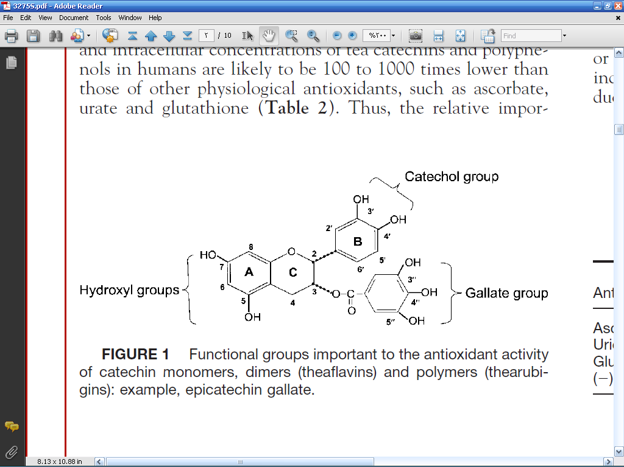
Figure (1):- Functional groups important to the antioxidant activity of catechin
Green tea extract has several advantages to prevent oxidative stress. The first, it was found to inhibit cyclooxygenase and lipoxygenase activities in human colon mucosa cells and human colon cancer cells. (Hong et al., 2001) also, Tea polyphenols may inhibit the formation of reactive oxygen species by inhibiting the enzyme, xanthine oxidase. Xanthine oxidase catalyzes the oxidation of both hypoxanthine and xanthine to uric acid, while reducing O₂ to O₂-. and H₂O₂. (Lin et al., 2000) the second advantages, Flavonoids found in tea scavenge nitric oxide (NO) and peroxynitrite produced from superoxide radicals and NO. (Kerry et al., 1999)
References
Al Mashhedy L. A., Hadwan M. H., Khalil T. T. (2007). The decrement of glutathione peroxidase activity associated with the elevated diene hydroperoxide levels in serum of patients with diabetes mellitus type I. J. Al qadisiya for pure science.12(3):152-160.
Anderson R. A. and Broadhurst C. L. (2004). Isolation and characterization of polyphenol type-A polymers from cinnamon with insulin-like biological activity. Journal of Agricultural and Food Chemistry, 52: 65-70.
Argano M., Brignardello E., Tamagno O. and Boccuzzi G. (1997) Dehydroeppiandrosterone administration prevents the oxidative damage induced by acute hyperglycemia in rats; J. Endocrinol., 155 233–240.
Benzie I.F.F., Strain J.J., (1996) The ferric reducing ability of plasma (FRAP) as a measure of antioxidant power: The FRAP assay. Anal Biochem, 239:70-76.
Broca C., Gross R., Petit P., Sauvaire Y., Manteghetti M., Tournier M., Masiello P., Gomis R., and Ribes, G. (1999) 4-Hydroxyisoleucine: experimental evidence of its insulinotropic and antidiabetic properties. Am J Physiol Endocrinol Metab. 277:617-23.
Cabrera C., Artacho R., and Gimenez R. (2006) Journal of the American College of Nutrition,25( 2):79–99.
Chap T. Le. Introductory Biostatistics.Published by John Wiley & Sons, Inc., Hoboken, New Jersey.(2003)(pp:248,249,254,290)
Drabkin D.L., and Austin J.M., (1932) Spectrophotometric studies, spectrophotometric constants for common haemoglobin derivatives in human, dog and rabbit blood. J Biol Chem. 98: 719-733.
Ellman G. L., (1959) tissues sulfhydryl group, Arch. Biochem. Biophys., 82:70-77.
Hadwan M. H. (2009) the 11th annual scientific conference of the university of Babylon. Serum Glutathione Peroxidase Activity as an Index of Antioxidants Status in Obese Men, p: 42.
Hiroko Negishi, Jin-Wen Xu, Katsumi Ikeda, Marina Njelekela, Yasuo Nara and Yukio Yamori. (2004). Black and Green Tea Polyphenols Attenuate Blood Pressure Increases in Stroke-Prone Spontaneously Hypertensive Rats. J. Nutr. 134: 38–42.
Hodgson E. K. and Fridovich I., (1975). The interaction of bovine erythrocyte superoxide dismutase with hydrogen peroxide Inactivation of the enzyme: Biochemistry 14:5294–5298.
Hong J., Smith T. J., Ho C. T., August D. A. and Yang C. S. (2001). Effects of purified green and black tea polyphenols on cyclooxygenase- and lipoxygenase-dependent metabolism of arachidonic acid in human colon mucosa and colon tumor tissues. Biochem. Pharmacol., 62: 1175–1183.
Kerry N. and Rice-Evans C. A. (1999). Inhibition of peroxynitrite mediated oxidation of dopamine by flavonoid and phenolic antioxidants and their structural relationships. J. Neurochem. 73: 247–253.
Lin J. K., Chen P. C., Ho C. T. and Lin-Shiau, S. Y. (2000). Inhibition of xanthine oxidase and suppression of intracellular reactive oxygen species in HL-60 cells by theaflavin-3,3-digallate,(-)-epigallocatechin-3-gallate, and propyl gallate. J. Agric. Food Chem. 48: 2736–2743.
Marklund S., and Marklund G., (1974). Involvement of superoxide anion radical in the autoxidation of pyrogallol and a convenient assay for superoxide dismutase; Eur. J. Biochem., 47:469–474.
McKay D.L., Blumberg J.B. (2002). The role of tea in human health: An update. J Am Coll Nutr 21:1–13.
Meera R., Devi P., Kameswari B., Madhumitha B. and Merlin N. J., Antioxidant and hepatoprotective activities of Ocimum basilicum linn. and Trigonella foenum-graecum linn. against H₂O₂ and CCl₄ indused hepatototoxicity in goat liver. (2009) Indian Journal of Experimental Biology. 47:584-590.
Nair S., and Nagar R., (1997) Anti-oxidant flavonoids in common Indian foods. South Asian. J. Prev. Cardiol. ,1: 33-35.
Peschel W., Snchez- Rabaneda F., Dickmann W., Plesehen A., Gartiza I., Jimnez D., Lamuela-Raventos R., Buxaderas S., Codina C., (2006). An Industrial approach in the search of natural antioxidants from vegetables and fruit wastes. Food Chemistry 97: 137-150.
Pigeolet E., Corbisier P., and Houbion A., (1990) Glutathione peroxidase, superoxide dismutase and Catalase inactivation by peroxides and oxygen derived free radicals; Mech. Aging Dev., 51 283–297.
Puri D., Prabhu K. M., and Murthy P. S., (1995) Hypocholesterolemic effect of the hypoglycemic principle of fenugreek (Trigonella foenum graecum) seeds; Indian J. Clin. Biochem. 9 3–16.
Randhir R., and Shetty K., (2007) Improved α-amylase and Helicobacter pylori inhibition by fenugreek extracts derived via solid-state bioconversion using Rhizopus oligosporus. Asia Pac J Clin Nutr., 16 (3):382 392.
Randhir R., and Shetty K., (2007). Improved α-amylase and Helicobacter pylori inhibition by fenugreek extracts derived via solid-state bioconversion using Rhizopus oligosporus Asia Pac J Clin Nutr 16 (3):382-392.
Said S. Mo., and Husein K. H. (2009) Hepatoprotective effect of Cinnamon extracts against carbon tetrachloride induced oxidative stress and liver injury in rats, Biol Res. 42: 93-98.
Schmidt E., Jirovetz L., Buchbauer G. and Gernot A. Eller, Stoilova I. and Krastanov A., Stoyanova A., and Geissler M., (2006)Composition and Antioxidant Activities of the Essential Oil of Cinnamon (Cinnamomum zeylanicum Blume) Leaves from Sri Lanka, journal of essential oil-bearing plants, 9 (2) :170 – 182.
Siddiqui M. R., Taha A., Moorthy K., Hussain M. E., Basir S. F. and Baquer N. Z., (2005) Amelioration of altered antioxidant status and membrane linked functions by vanadium and Trigonella in alloxan diabetic rat brains; J. Biosci. 30 483–490.
Sinha A.K., (1972) Colorimetric assay of catalase. Anal Biochem., 47: 389–394.
Teissedre, P.L., Waterhouse, A.L. (2000). Inhibition of Oxidation of Human Low-Density Lipoproteins by Phenolic Substances in Different Essential Oils Varieties. J. Agric. Food Chem., 48: 3801-3805.
Vison J., Dabbagh Y., Serry M. and Jang J., (1995) Plant flavonoids, especially tea flavonols, are powerful using an in vitro oxidation model for heart disease. J Agric Food Chem., 43:2800–2802.

