Solvent extraction of Cu & Ag by use of
2-[(3-Methyl benzene) azo]-4,5-diphenyl imidazole

Shawket.K.Jawad Abid Allah.M.Ali, Ibtehaj.Raheem.Ali

Department of chemistry-college of education for girls –Kufa University

Abstract:
Hetero cyclic azo ligand synthesized in previous study (Ali), use as an extractant for Cu²⁺ and Ag⁺ from aqueous solutions, and this study appear that the optimum pH for extraction was pH=8 for Cu²⁺ and pH=10 for Ag⁺, more probable structure of ion pair complex extracted was (1:2) for Cu²⁺ with sandwich structure [Cu(3-MeBAI)₂]⁺² anion and (1:1) for Ag⁺ [Ag(3-MeBAI)]⁺anion and another studies about the effective parameter on the extraction procedure and stability of complex.
الخلاصة
تضمن البحث استخدام الكاشف 2-[(3-methyl Benzene)azo]-4,5-diphenyl imidazole (3-MeBAI) لاستخلاص كل من النحاس (II) والفضة (I) على هيئة ايونات موجبة من المحاليل المائية باتباع طريقة الاستخلاص بالمذيب. فقد بينت هذه الدراسة إن الدالة الحامضية المثلى لاستخلاص كل من ايوني النحاس والفضة هي (8 و 9) على التوالي. كما تضمنت الدراسة البحث عن التركيب المحتمل لمعقد الترابط الأيوني المستخلص إلى الطور العضوي وقد تبين إن التركيب الأكثر احتمالا لمعقد النحاس كانت 1:2 (ليگاند:فلز) ويمتلك تركيب الساندويج [Cu(3-MeBAI)₂]⁺²anion، أما معقد الفضة فقد أظهرت الدراسة إن تركيب المعقد الأكثر احتمالا 1:1 (ليگاند:فلز) [Ag(3-MeBAI)]⁺ anion كما تضمنت الدراسة بيان جميع العوامل المؤثرة في عملية الاستخلاص واستقرار المعقد المستخلص.

Introduction

Lenarcik et. al demonstrated that 1-alkylimidazole can be used to the extraction of some transition metal ions, another work Lenarcik et. al used 1-octylimidazole and 1-octyl-2-methylimidazole for extraction of Ni (II) and Zn (II). Nabeel et. al demonstrated that 1-[2-Benzo-imidazoleyl azo]-2-hydroxy-3-naphthaoic acid is shown to be sensitive reagent for Spectrophotometric determination of Cu (II) in aqueous solution. Mahmoud et. al study the spectral and acid base properties of imidazole derivatives. Arifien et. al study the effect of temperature on the extraction procedure, moreover the synergistic effect on the extraction of Co(II). This work focused on the used of 2-[(3-methyl benzene)-azo]-4,5-diphenyl imidazole for extraction of Cu²⁺ and Ag⁺ from aqueous solution and all parameters effected on the application.
2. Experimental
Apparatus:

Absorption measurements were obtained with (UV-Vis 1700) shimadzu spectrophotometer. pH of the solutions was measured using (HANNA ) pH – meter .
Reagents:
All chemicals were analytical-reagent grade. Double distilled water was used through out.
Copper (II) standard solution and Ag(I) standard solution (0.1mg/ml) prepared by dissolved requisite amount of pure CuSO₄.5H₂O and AgNO₃ in prepared by dilution with distilled water.

3. Results and discussion
3.1. Effect of pH:-
The experiment results in Table (1) and Figure (1) , for extraction of (3.1×10⁻⁵M) Cu⁺² and (3.7×10⁻⁵ M) Ag⁺ by (1×10⁻⁴M) for ligand demonstrate pH_{ex} of Cu⁺² was (pH=8) and for Ag⁺ was (pH=10) at this optimum pH values produce unstable ion pair complexes may be dissociated (Jawad , 1989; Atkin, 1990).
Table (1): Effect of pH on the extraction method

D
pH | 5 | 6 | 7 | 8 | 9 | 10 | 11
Cu⁺² | - | 0.330 | 0.480 | 1.500 | 1.350 | 1.220 | 0.818
Ag⁺ | - | 0.304 | 0.515 | 3.000 | 5.060 | 8.090 | 2.250

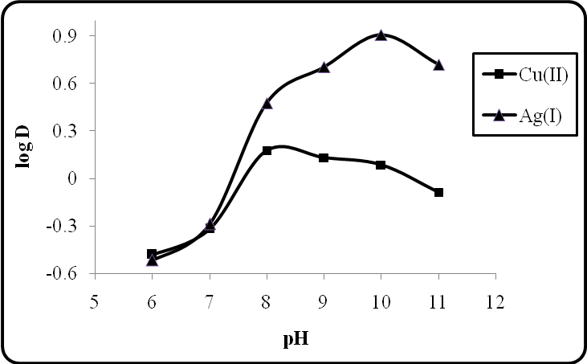

Figure (1): Effect of pH on the extraction method

3.2. Effect of Shaking Time:-

According to the Kinetic of complexation reaction the results in Table (2) and Figure (2) for extraction of (3.1×10⁻⁵ M) for Cu⁺² and (3.7×10⁻⁵M) for Ag⁺ by (1×10⁻⁴M) for ligand in chloroform at different time demonstrate the optimum shaking time for complexation reaction (20 min.) for Cu⁺² to complete complexation with (3-MeBAI) and (10min.) for Ag⁺, at this optimum shaking time obtain the maximum values effect for distribution ratio (D).

Table (2): Effect of shaking time

Shaking  time min. | 5 | 10 | 15 | 20 | 25 | 30
Cu⁺² | 2.30 | 2.89 | 3.58 | 4.55 | 4.00 | 3.76
Ag⁺ | 3.16 | 8.09 | 5.67 | 4.88 | 4.00 | -

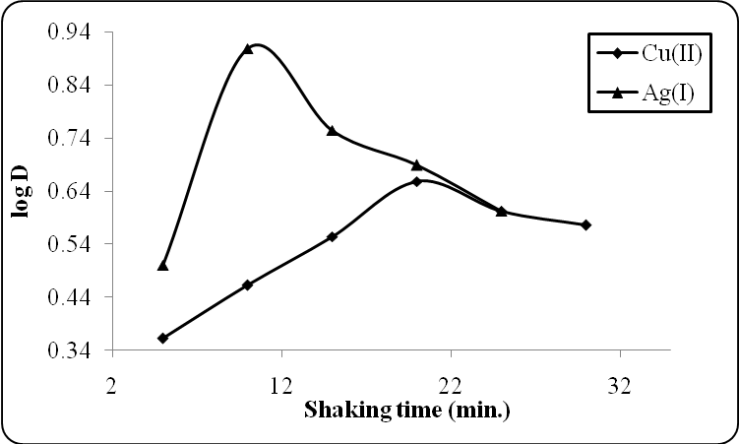
Figure (2): Effect of shaking time

3.3. Effect of Metal Ion Concentration:-

From the equation of thermodynamic equilibria below:
It’s clear the concentration of metal cation M^{n+} effect on the thermodynamic equilibria of complexation reaction. The results in Table (3) and Figure (3) appear the optimum concentration of metal cation M^{n+} give higher distribution ratio (D) for Cu⁺² was (10µg) (1.5×10⁻⁵M) but for Ag⁺ (40µg) (3.7×10⁻⁵M) . The charge density of Cu⁺² larger than Ag⁺ this effect to give equilibria for complexation reaction with reagent (3-MeBAI) at low concentration for Cu⁺² , but we are need more concentration for Ag⁺ to reach to the equilibrium to give good complexation.

Table (2):-Effect of metal ion concentration on the extraction method

 | D
µgM^{+n} | 5 | 10 | 15 | 20 | 30 | 40 | 50 | 60
Cu⁺² | 2.125 | 3.760 | 1.860 | 1.564 | 1.540 | 1.500 | 1.500 | -
Ag⁺ | - | 0.19 | 0.580 | 1.000 | 5.250 | 8.040 | 3.030 | 1.000

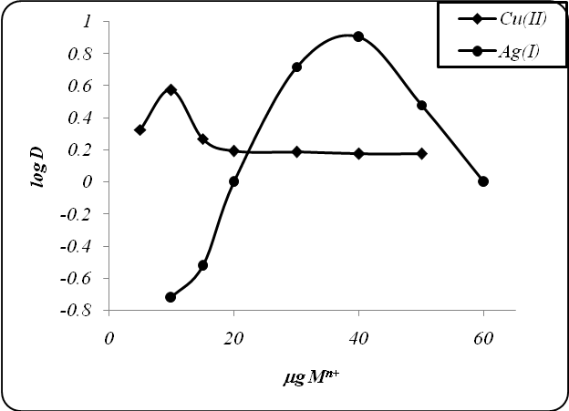

Figure (3): Effect of metal ion concentration

3.4. Effect of Organic Solvents:-
Solvent extraction method give attention about the organic solvent and it’s effect on the ion pair complex extracted and it’s stability (Mahmod, et al., 1984). Extraction procedure for (3.1×10⁻⁵M) Cu⁺² and (3.7×10⁻⁵M) Ag⁺ with (3-MeBAI) in (10ml) aqueous phase at (pH =6 ) by (10ml) of (1×10⁻⁴M) ligand solution dissolved in different organic solvents give results in Table (4). This results demonstrate no linear relation between distribution ratio (D) and appear carbon tetra chloride is more suitable for extraction Cu⁺² but for Ag⁺ the favorable organic solvent was dichloromethane and bromobenzene as well as this results reflect the probability of participation of organic solvent in the ion pair association complex may be throw produce contact ion pair (Tight ion pair) or solvent separated ion pair (loose ion pair).

Table (4): Organic solvents effected on the extraction of metal ions

Organic solvents | ε | D
Organic solvents | ε | Cu⁺² | Ag⁺
Dichloromethane | 9.08 | 0.612 | 24.000
Chloroform | 5.708 | 3.100 | 8.090
Bromo benzene | 5.4 | 1.500 | 24.000
Benzene | 2.804 | 1.270 | 7.300
Toluene | 2.438 | 0.000 | 0.000
Carbon tetrachloride | 2.38 | 3.540 | 4.550

The Free energy of transition (-ΔG_{t}) with association constant K_{A} and extraction constant K_{ex} with Free energy of extraction (-ΔG_{ex}) which is calculated with relations below give sure about participation of organic solvent in ion pair complexes may be form contact ion pair or loose ion pair, despite (-ΔG_{t}) increase with decrease of dielectric constant of organic solvent but CCl₄ give higher distribution ratio and K_{A}, K_{ex}, ΔG_{ex} for Cu⁺² but for Ag⁺ the larger value for distribution ratio appear with dichloromethane and bromobenzene and higher values for K_{A}, K_{ex}, ΔG_{ex} .
Table (5): (ΔG_{ex} , K_{A}, K_{ex}, ΔG_{t} values)

ΔG_{ex}  Jmol⁻¹  ×10⁴ |  | K_{ex}  ×10¹⁰ |  | K_{A}  Lmol⁻¹  ×10⁻⁵ |  | -ΔG_{t}  KJmol⁻¹ |  | ε | Organic solvents
Ag⁺ | Cu⁺² | Ag⁺ | Cu⁺² | Ag⁺ | Cu⁺² | Ag⁺ | Cu⁺² | ε | Organic solvents
6.210 | 4.989 | 7.550 | 0.056 | 3.550 | 0.580 | 0.039 | 0.243 | 9.08 | Dichloromethane
5.900 | 5.129 | 2.190 | 0.098 | 3.290 | 1.130 | 0.565 | 0.409 | 5.708 | Chloroform
6.210 | 4.879 | 7.560 | 0.036 | 3.550 | 0.440 | 0.069 | 0.432 | 5.4 | Bromo benzene
5.870 | 4.769 | 1.930 | 0.023 | 3.260 | 0.818 | 0.137 | 0.860 | 2.804 | Benzene
0.000 | 0.000 | 0.000 | 0.000 | 0.000 | 0.000 | 0.158 | 0.994 | 2.438 | Toluene
5.720 | 5.272 | 1.040 | 0.174 | 3.030 | 1.190 | 0.162 | 1.019 | 2.38 | Carbon tetrachloride

ΔG_{ex}= -RTln (K_{ex})

3.5.The Structure of ion pair complex extracted
3.5.1. Slope Analysis Method
The results in Table (6) and Figure (4) demonstrate the structure of ion pair complex was sandwich form (1:2) for Cu⁺² [Cu(L₂)]²⁺anion and for Ag⁺ (1:1) [AgL]⁺anion, and this results appear that the organic solvent not effect on the structure of ion pair association complex but the participation of organic solvent in ion pair complex and may be increase the stability of ion pair complex.

Table (6): slope analysis method

[L] | D in CHCl₃ |  |  |  | D in CCl₄ |  |  |  | D in D.C.M
[L] | Cu⁺² | slope | Ag⁺ | Slope | Cu⁺² | Slope | Ag⁺ | Slope | Cu⁺² | slope | Ag⁺ | Slope
5x10⁻⁴ | 4.900 | 1.64 | 4.260 | 1.43 | 0.658 | 2.2 | 15.000 | 0.86 | 2.3 | 1.55 | 8.090 | 1.38
3x10⁻⁴ | 4.300 | 1.64 | 3.760 | 1.43 | 0.785 | 2.2 | 11.300 | 0.86 | 5.01 | 1.55 | 6.140 | 1.38
1x10⁻⁴ | 2.900 | 1.64 | 8.090 | 1.43 | 3.520 | 2.2 | 4.260 | 0.86 | 0.612 | 1.55 | 24.000 | 1.38
8x10⁻⁵ | 1.000 | 1.64 | 6.690 | 1.43 | 1.500 | 2.2 | 3.390 | 0.86 | 0.510 | 1.55 | 8.090 | 1.38
5x10⁻⁵ | 0.900 | 1.64 | 2.030 | 1.43 | 0.724 | 2.2 | 2.250 | 0.86 | 0.282 | 1.55 | 4.690 | 1.38
4x10⁻⁵ | 0.600 | 1.64 | 1.702 | 1.43 | 0.581 | 2.2 | 2.156 | 0.86 | 0.282 | 1.55 | 4.400 | 1.38
3x10⁻⁵ | 0.500 | 1.64 | 1.580 | 1.43 | 0.250 | 2.2 | 1.500 | 0.86 | 0.140 | 1.55 | 3.310 | 1.38
2x10⁻⁵ | 0.400 | 1.64 | 1.000 | 1.43 | 0.120 | 2.2 | 0.631 | 0.86 | 0.132 | 1.55 | 1.986 | 1.38
1x10⁻⁵ | 0.300 | 1.64 | 0.298 | 1.43 | 0.116 | 2.2 | 0.510 | 0.86 | 0.112 | 1.55 | 0.540 | 1.38

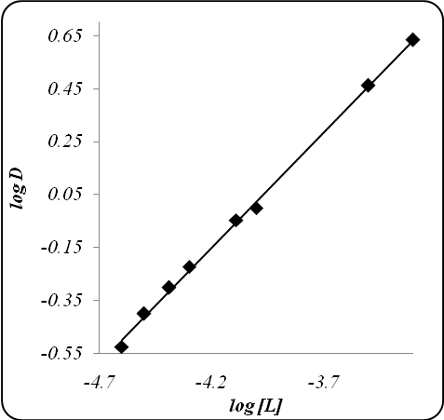

Figure(4): Slope analysis for Cu⁺² in CHCl₃ all other Figures like that.

3.5.2. Mole Ratio Method:-

The results in Table (7) and Figure (5) demonstrate the structure of ion pair complex for Cu⁺² was sandwich structure (1:2) [Cu(L)₂]⁺²anion and for Ag⁺ was (1:1) [Ag(L)]⁺ anion without any effect of organic solvent on the structure of complex.

Table (7): Mole ratio method

[L] | C_{L}/C_{M} | C_{L}/C_{M} | A CHCl₃ |  | A CCl₄ |  | A D.C.M
[L] | Cu⁺² | Ag⁺ | Cu⁺² | Ag⁺ | Cu⁺² | Ag⁺ | Cu⁺² | Ag⁺
5x10⁻⁴ | 32.59 | 13.5 | 0.38 | 1.38 | 0.9 | 1.36 | 1.14 | 1.65
3x10⁻⁴ | 19.29 | 8.1 | 0.72 | 1.14 | 0.7 | 1.14 | 0.88 | 1.5
1x10⁻⁴ | 6.25 | 2.7 | 1.12 | 0.94 | 0.56 | 0.66 | 0.6 | 1.42
8x10⁻⁵ | 5.22 | 2.16 | 1.6 | 1.21 | 0.55 | 1.48 | 0.86 | 1.38
5x10⁻⁵ | 3.3 | 1.38 | 1.72 | 0.39 | 0.65 | 0.83 | 0.54 | 1.67
4x10⁻⁵ | 2.55 | 1.08 | 1.44 | 0.26 | 0.59 | 0.76 | 0.46 | 0.98
3x10⁻⁵ | 1.9 | 0.81 | 1.12 | 0.15 | 0.39 | 0.43 | 0.34 | 0.8
2x10⁻⁵ | 1.27 | 0.54 | 0.69 | 0.03 | 0.45 | 0.41 | 0.23 | 0.65
1x10⁻⁵ | 0.65 | 0.27 | 0.3 | 0.015 | 0.23 | 0.01 | 0.11 | 0.14
5x10⁻⁶ | 0.32 | 0.19 | 0.38 | 0.008 | 0.08 | 0.008 | 0.09 | 0.07

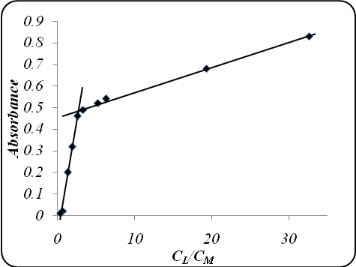

Figure(5): Mole ratio method for Cu⁺² in CHCl₃ all other Figures like that.

3.5.3. Continuous Variation Method:-
The results in Table (8) and Figure (6) pointed the structure of ion pair complex extracted was sandwich structure (1:2) for Cu⁺² as [Cu(3-MeBAI)₂]⁺²anion and (1:1) for Ag⁺ as [Ag(3-MeBAI)]⁺ anion.

Table (8): continuous variation method

V_{M} ml | 1 | 2 | 3 | 4 | 5 | 6 | 7 | 8 | 9
V_{L} ml | 9 | 8 | 7 | 6 | 5 | 4 | 3 | 2 | 1
Absorbance (A)
Cu⁺² | 0.38 | 0.72 | 1.12 | 1.6 | 1.72 | 1.44 | 1.12 | 0.69 | 0.3
Ag⁺ | 0.8 | 0.89 | 0.94 | 1.05 | 1.09 | 1.00 | 0.9 | 0.75 | 0.6

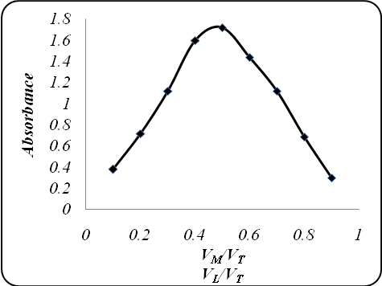

Figure (6): Continuous variation method

3.6. Temperature Effect
The results at Tables (9,10) for extraction of Cu⁺² and Ag⁺ at different temperature appear endothermic reaction for both cation with ligand and the ligand was more suitable for Ag⁺ than Cu⁺² and the values of enthalpy ΔH_{ex} demonstrate and proof the sandwich structure of ion pair complex with Cu⁺² (1:2) [Cu(L)₂]⁺²anion and (1:1) for Ag⁺ as [Ag(L)]⁺ anion in addition these results reflect that the temperature complexes (Arifien et al., 2003).

Table (9): Effect of temperature
T °C | T K | 1/T K ×10⁻³ | D
T °C | T K | 1/T K ×10⁻³ | Cu⁺² | Ag⁺
5 | 278 | 3.6 | 0.298 | 4.000
10 | 283 | 3.5 | 0.928 | 5.250
20 | 293 | 3.4 | 1.040 | 7.080
30 | 303 | 3.3 | 1.770 | 8.900
40 | 313 | 3.2 | 3.545 | 12.500

Table (10): Effect of temperature
Cation | ΔH_{ex}  KJmol⁻¹ | ΔG_{ex}  KJmol⁻¹ | ΔS_{ex}  KJmol⁻¹
Cu⁺² | 5.524 | -5.542 | 194.700
Ag⁺ | 1.904 | -5.630 | 240.767

Reference
Aeifien, A.E. Amarallh, A.H. Awadallah R.M. and Sirry; S.M. (2003). “Temperature and synergistic effect for extraction of Co(II)” http://www.acad journal .com/2003/partz/p2internet.
Ali, A.M. (1999), "Synthesis different azo compounds and study its complexes with several ions" , Ph.D. Thesis, University of Baghdad.
Atkin, P.W. (1990), “Physical chemistry” 4th ed. Oxford university press.
Fan, X. Zhang G.F. and Zhu C.(1998), “ Effect of different organic solvents on extraction and stability constant of complexes” ,Analyst, 123,109-112.
Ferreira, S.L.C. Queiroz, A.S. Assis, J.C.R. Korn M. and Costa A.; (1997), "Determination of Iron in alkaline salts by ICP-AES using 1-(2-thiozolyl azo)-p-cresol (TAC) preconcentration and separation” , J.Braz. Chem. Soc., 8(6),621-624.
Jalhoom M.G. (1988); “ Etraction of pertechnitrate TcO₄⁻from basic aqueous media by use different Crown ether” J.Iraqi.Chem.Soc.B., No.2,74-83.
Jawad, S.K. (1989) ," Studies about extraction of perhenate ReO₄⁻ by use crown ethers" ,Msc, Thesis, University of Baghdad Ibn-Al-Haitham.
Lenarcik, B. Glowackib J. and Rzepka M. (1979), “ Complexation and spectrophotometric determinastion of some transition metal ions by derivetives of 1-alkyl imidazole”Separation Science and Technology, 14(8), 734-771.
Lenarcik, B. Glowackib J. and Rzepka M. (1979), “Synthesis new 1-alkyl imidazole derivative and its complexes with different transition metal ions” Separation Science and Technology, 14(1), 37-54.
Lenarcik, B. Ranckyte T. and Kicrzkowska A.; (2003), “Spectrophotometric determination of some transition metal ions by 1-octyl-2-methyl imidazole derivative”, ARS,Separation-Zloty putok, Poland, 18,154-158.
Lenarcik, B. Ranckyte, T. (2002), “ The Comparison of the extraction process of Zn(II) , Ni(II) complexes with 1-octyl imidazole and 1-octyl-2-methyl imidazole” Preceedings, ARS, Separator, 189.
Mahmod, M.R. Hamman A.M. and Ibrahim S.A. (1984); ”Acid- base properties and spectral study for many imidazole derivatives”, 2.Phys.Chemic, Leipzing/ 265, 303-312.
Nabeel A. Fakhri, Sarmad B. Dakran, H.A. Saleh and A.H. Al-Kadhumii, (1989), “ Synthesis 1-[2-Benzoimidazole azo]-2- hydroxyl-3-naphthoic acid and spectrophotometric determination of Copper(II)” ,The journal of the college of education, Salahaddin Univ.,19-29.
Reddy, B.K. Kumar, J.R. Reddy, K.J. Sarma L.S. and Reedy A.V. (2003), "Arapid and sensitive extraction spectrophotometric determination of Copper (II) in pharmacentical and environmental samples using Benzildithiosemicarbazone" Anal. Sci, 19, 1234-1239.

