Residual Compressive Strength of Iraqi-Gypsum Subjected to Elevated Temperature Exposure

Muhammed S. Muhammed
Civil Engineering, University of AL-Qadissyia
Abstract
The effect of elevated temperate exposure on the compressive strength of ordinary gypsum and plaster of Paris has been studied in this research. The gypsum test specimens were subjected to six temperature levels of 100, 200, 300, 500, 700 and 900 ºC with three different exposure periods of 0.25, 0.5 and 1 hour. Results of 111 specimens for two types of gypsum with two cooling conditions having compressive strength ranging from 15 to 0 MPa were presented. These results showed that, the compressive strength of the specimens at temperature up to 100 ºC exhibited a slight increase as compared with reference values. But all gypsum specimens suffered a significant decreases in compressive strength when exposed to 500 ºC and above. After a period of 0.50 hour, the exposure period was seen to have a slight effect on the residual strength of ordinary gypsum except at 900 ºC. The results also show that no residual strength was observed at 500 and 900 ºC for the plaster of Paris and ordinary gypsum specimens respectively. On the other hand, water cooling was adversely affects on strength as compared with air cooling.
Keywords : Compressive strength, elevated temperature, gypsum, water cooling
الخلاصة
يتضمن هذا البحث دراسة تأثير درجات الحرارة العالية على مقاومة انضغاط الجص الاعتيادي والبورق. عرضت النماذج المفحوصة إلى ست درجات حرارة (100، 200، 300، 500، 700 و 900 م⁰) ولثلاث فترات زمنية (0.25، 0.5، 1 ساعة). وتم اعتماد نتائج 111 نموذج ذات مقاومة انضغاط تراوحت بين 15 إلى 0 نت/مم². أظهرت هذه النتائج بان مقاومة الانضغاط للنماذج أبدت زيادة طفيفة عند تعرضها إلى 100م⁰. لكن كان هناك تدهور واضح لمقاومة الانضغاط عند تعرض النماذج إلى درجات حرارة 500 م⁰ فما فوق. بعد فترة 0.5 ساعة من التعرض، فان الاستمرار في تسليط درجات الحرارة له تأثير طفيف على انخفاض مقاومة الجص عدا النماذج التي تعرضت إلى 900 م⁰. كما أظهرت النتائج أيضا بان مقاومة الانضغاط تصبح معدومة عند تعرض النماذج إلى 500 و 900 م⁰ لكل من البورك والجص على التوالي. من جهة أخرى فان التبريد المفاجئ للنماذج قد اثر سلبا على المقاومة إذا ما قورنت بالنماذج التي تم تبريدها في الهواء.
Introduction
Gypsum is a good construction material used for various building purposes because of its low cost and its availability with good and suitable types. The products of gypsum are suitable for the environment and usage such as light weight, thermal and sound isolation, fire resistance and other uses.
In Iraq, the major application of gypsum is as a binder, finishing materials, precast units, gypsum boards, partitions and sound isolations in various buildings. Many walls and internal roofs were finished by ordinary gypsum plaster, then coated by plaster of Paris layer to get smooth surface. Also, gypsum is a useful material used for jointing the brick units as a mortar in masonry walls.
In the structural design of buildings, in addition to the normal gravity and lateral loads, it is, in many cases, necessary to design the buildings to safely resist exposure to fire (Shettey 1988). It is also necessary to protect the building members such as beams, columns, slabs and walls by plaster materials (cement mortar and gypsum mortar) as finishing to decrease the structural deterioration for certain period of fire exposure. Such deterioration can be decreased if good finishing materials were used in the building. This attributed to the fact that, fire initially causes damage to member surface and then affects the core of the structural member.
There are many ways of exposing buildings to fire. One of the most common types of exposure is by accidental fire. Normally such fires are of short duration but at high intensity with the temperature reached up to 1000 ºC. Another type of heat exposure may be found in places exposed to sustained elevated temperatures ranging from 100-1000 ºC.
According to the available literature, few investigations were carried out on gypsum material. Several recent and past studies were conducted on using some types of additives to improve and control the setting time, hydration, strength development, water resisting property and volume change characteristics of gypsum (Faiyadh et al 1987, Al-Taee 1988, Al-Aubaidi 2004, Al-Qaisi 2004, Fraih et al 2005). Another research presented good performance in tensile strength when studied the theoretical and experimental behavior of fiber reinforced gypsum plate (Al-Ramadhani 1994). The effect of addition some chemical admixtures to gypsum was also studied to product suitable composition matrix for application on external brick walls exposed to weathering conditions (Al-Sudani 2001).
A new study on plaster of Paris materials showed that the addition of gypsum to concrete mix, produce matrix of structural concrete-gypsum planks to create a smooth, monolithic floor surface that delivers superior strength, sound control and fire resistance. This product set quickly, allowing foot traffic within two hours and continued construction activities the next day (Deely 2006).
In this study there is an attempt to investigate the influence of elevated temperature and exposure periods on the compressive strength of ordinary gypsum and plaster of Paris. However, still limited amount of published literature is available about gypsum material.

Experimental Program
Two Types of locally produced gypsum (ordinary gypsum and Al-Ahliyah plaster of Paris) were used in this work. The physical properties of these materials are shown in Table (1). For these two types, the (water/gypsum) ratios used were 0.43 and 0.56 respectively. The test procedure given by (ASTM C473-73) was adopted for measuring the setting time of gypsum mixtures using the vicat apparatus.
After mixing, the paste was cast into 50 mm molds corresponding to (ASTM C472-73). The specimens were demolded after the setting took place and they were exposed to laboratory environment under polyethylene cover up to the age of 14 days. The compressive strength was measured on gypsum specimens before and after heat exposure.
Table (1): Physical properties of ordinary gypsum and plaster of Paris.
Materials | Physical properties | Test results | Limits of Iraqi specification No.28/1988
Local gypsum | Initial setting time (Min.) | 4.5 | 8 - 25
Local gypsum | Fineness (%) remaining on sieve No.16 | 5 | ≤ 8
Local gypsum | Compressive strength (N/mm²) | 6.87 | Not less than 3
Plaster of Paris | Initial setting time (Min.) | 7.5 | 8 - 25
Plaster of Paris | Fineness (%) passing on sieve No.16 | 100 | 100
Plaster of Paris | Compressive strength (N/mm²) | 15.2 | Not less than 5

Conditions of Exposure
Electrically heated oven designed for temperature up to 1200 ºC was used. The dimensions of heating chamber are 20×20×30 cm. The temperature were selected to be 100, 200, 300, 500, 700 and 900 ºC and the period of exposure were 0.25, 0.50 and 1.00 hour. When the target temperature was reached, the specimens were kept at that temperature for the required periods. Some of the specimens were quick cooled (water cooling) after removed from the oven. The other specimens were kept beside the oven to cool down at a laboratory temperature as shown in Pictures (1 and 2).

Compressive Strength of ordinary gypsum
The test results of compressive strength for all ordinary gypsum specimens (50 mm) exposed to different temperatures and periods are given in Table (2) and shown graphically in Figures (1, 2 and 3).
Initially, as the temperature increased to 100 ºC, the specimens showed a slight increasing in compressive strength of an average of 6 percent as compared with reference specimens. This increase in compressive strength may be attributed to the following reasons: 1) The slight increase in the temperature causes additional increasing in the rate of hydration of gypsum paste. 2) The increase in compressive strength may be due to increase the reactivity of unhydrated gypsum particles of the specimens.
Table (2): Compressive strength test results for ordinary gypsum.
Compressive strength (MPa) at exposure periods of |  |  | Exposure Temperature, ºC
hour1.00 | hour0.50 | hour0.25 | Exposure Temperature, ºC
6.87 | 6.87 | 6.87 | 27
7.22 | 7.37 | 7.34 | 100
3.66 | 4.34 | 5.92 | 200
2.80 | 3.75 | 5.43 | 300
2.11 | 2.34 | 3.28 | 500
1.40 | 1.69 | 2.34 | 700
0 | 1.40 | 2.19 | 900

For comparison, the results of compressive strength are expressed as a percentage of reference values (residual strength). This variation in the residual strength with respect to temperature and period of exposure is plotted in Figure (2). At temperature of 200 ºC, it can be observed that the specimens show decreasing in compressive strength as the temperature increases for all periods of exposure. In temperature range from (200-900) ºC, the results are surmised as follows:
- At a period of 0.25 hour, the percentages of residual strengths were (86-31) % for a control specimens.
- More reduction in strength occurs at the 0.50 hour of exposure. The strength of specimens at this period was about (63-20) % for reference value.
- At a period of 1.00 hour, the reduction in compressive strength of specimens was slightly higher than of 0.50 hour. However, the residual compressive strength varied from (53 to zero) %.
This reduction may be due to dehydration process which occurred through the gypsum matrix according to the following series:
130-170 ºC
250-400 ºC
CaSO_{4.} 2 H2O (gypsum) CaSO_{4.} 1/2 H2O (Hemihydrate)
1000-1200 ºC
400-900 ºC
CaSO₄ (Anhydrate-Soluble) CaSO₄ (Anhydrate-Unsoluble) Cao (Lime)

Also, higher temperature causes weakening of bonds between the gypsum particles and gradually losing all the specimens properties.
Figure (1): Relationship between the compressive strength of ordinary gypsum and exposure temperatures for different periods
Temperature, ºC

0.25 0.50 1.00
Figure (2): Effect of exposure periods and temperatures on the residual compressive strength of ordinary gypsum.

Generally, the exposure period was seen to have a slight effect on the residual strength after 0.50 hour. Figure (3) showed that, the large amount of loss in compressive strength occurs within the first 0.50 hour. After this period, small reduction in strength was observed except at 900 ºC.
Figure (3): Relationship between the compressive strength of ordinary gypsum and exposure periods for different temperatures.

Furthermore, the tests show that the hair-surface cracks took place on the specimens at 500 ºC and above as shown in Picture (3). The number, depth and length of these cracks were increased and seen clearly especially at the 1.00 hour as shown in Picture (4).
On the other hand, greater deterioration in compressive strength was occurred when the specimens subjected to quick cooled (water cooled) than when slowly cooled (air cooled). This can be observed from Figure (1) and Picture (5). This cooling condition may cause thermal shock which giving large thermal gradient within gypsum specimens and therefore a greater reduction in strength may occur.

Compressive Strength of plaster of Paris
The influence of elevated temperature on the deterioration of plaster of Paris compressive strength at different period of exposure is shown in Table (3), Figures (4, 5 and 6) and Picture (6).
At 100 ºC, the compressive strength of specimens show trends somewhat similar to that observed in ordinary gypsum specimens. At 200 ºC and 300 ºC, the percentages of residual compressive strength were (101-50)% and (87-26)% respectively for a period of (0.25 -1.00) hour. As can be seen clearly from Figures (4 and 6), both higher temperature and period of exposure were significantly affect the strength of specimens when subjected to 500 ºC. At this temperature, the residual compressive strength after exposure to 0.25 hour is about 44%. But at period of 0.50 hour, no residual strength was observed and all specimens where damaged. Additionally, the cracks were seen clearly in the specimens as shown in Picture (6).
Compressive strength (MPa) |  |  | Exposure Temperature, ºC
hour1.00 | hour0.50 | hour0.25 | Exposure Temperature, ºC
15.20 | 15.20 | 15.20 | 0
16.40 | 15.60 | 15.10 | 100
7.60 | 12.40 | 15.90 | 200
4.00 | 6.40 | 13.20 | 300
0.00 | 0.00 | 6.80 | 500

Table (3): Compressive strength test results for plaster of Paris.

Figure (4) : Relationship between the compressive strength of plaster of Paris and exposure temperatures for different periods .

Figure (5): Effect of exposure periods and temperatures on the residual compressive strength of plaster of Paris.
0.25 0.50 1.00

Figure (6): Relationship between the compressive strength of plaster of Paris and exposure periods for different temperatures.

Conclusions
- Increasing the temperature to 100 ºC leads to slight increase in compressive strength of ordinary gypsum and plaster of Paris by about 6% as compared with reference value.
- At 200 ºC and above, the compressive strength of all specimens decreases with increasing both temperature and period of exposure.
- More reduction in compressive strength of ordinary gypsum occurs between (500-900) ºC and no residual strength was observed at a period of 1.00 hour in 900 ºC. However, surface cracks were took place on the specimens at 500 ºC and above. These cracks were increased at 900 ºC.
- Large amount of deterioration in compressive strength of ordinary gypsum occurs within the first 0.50 hour. After this stage, the exposure period have a slight influence on the residual strength except at 900 ºC.
- The compressive strength of plaster of Paris specimens was significantly affected when the specimens subjected to temperature between (300-500) ºC. At 500 ºC of 0.50 hour of exposure, all specimens were damaged and the cracks was observed clearly.

References
الرمضاني، خيرية عبد الله، " المنتجات الجبسية والسيراميك ومواد الرخام الخفيف" 1994، ندوة البناء في مواجهة الحصار وآفاق المستقبل.
الطائي، محمد حيدر، ايار 1988،" تحسين خواص جص القطاع الخاص المنتج من الجبس الثانوي وسط وجنوب القطر"، مجلة بحوث البناء، المجلد 7، العدد 1 .
العبيدي، لمى سعدي، 2004، " تحسين خواص الجص باستخدام المواد المضافة"، اطروحة ماجستير، الجامعة التكنولوجية.
القيسي، وليد عبد الرزاق، 2004 " تاثير بعض المضافات الكيميائية على زمن التجمد للجص الفني العراقي"، مجلة الهندسة والتكنولوجيا، المجلد 23، العدد 1.
المواصفة القياسية العراقية/ م ق ع، رقم 28 لسنة 1988، " الفحوصات الفيزيائية للجص لإغراض البناء"، الجهاز المركزي للتقييس والسيطرة النوعية.
فريح، قيس جواد، القيسي، وليد عبد الرزاق والعبيدي، لمى سعدي، 2005، " تحسين زمن التجمد للجص الفني العراقي باستخدام مضافات طبيعية"، مجلة الهندسة والتكنولوجيا، المجلد 24، العدد 9.
Al-Sudani, Mahmood Aziz, 2001, "The Use of Gypsum Materials as a substitutes in Building and Finishing Work", M.Sc. Thesis, Building and Construction Department, University of Tecnology
ASTM Designation C473-73, 1989, "Physical Testing of Gypsum Plaster and Gypsum Concrete", Annual Book of ASTM Standard, Philadelphia, Vol.04-02.
Deely, B, 2006 "Gypsum Concrete Floor Underlayments Are Stronger Than Ever", AIA/ Architectural Record, www.usg.com
Faiyadh, F.I., Mahmood, D.B.A. and Khalaf, F.M., 1987, "Proposals in Improvement the Pure Iraqi-Gypsum properties", Journal of Building Research, Vol.6, No.2 .
Shettey, M.S., 1988, "Concrete Technology", Third Edition, pp.361.

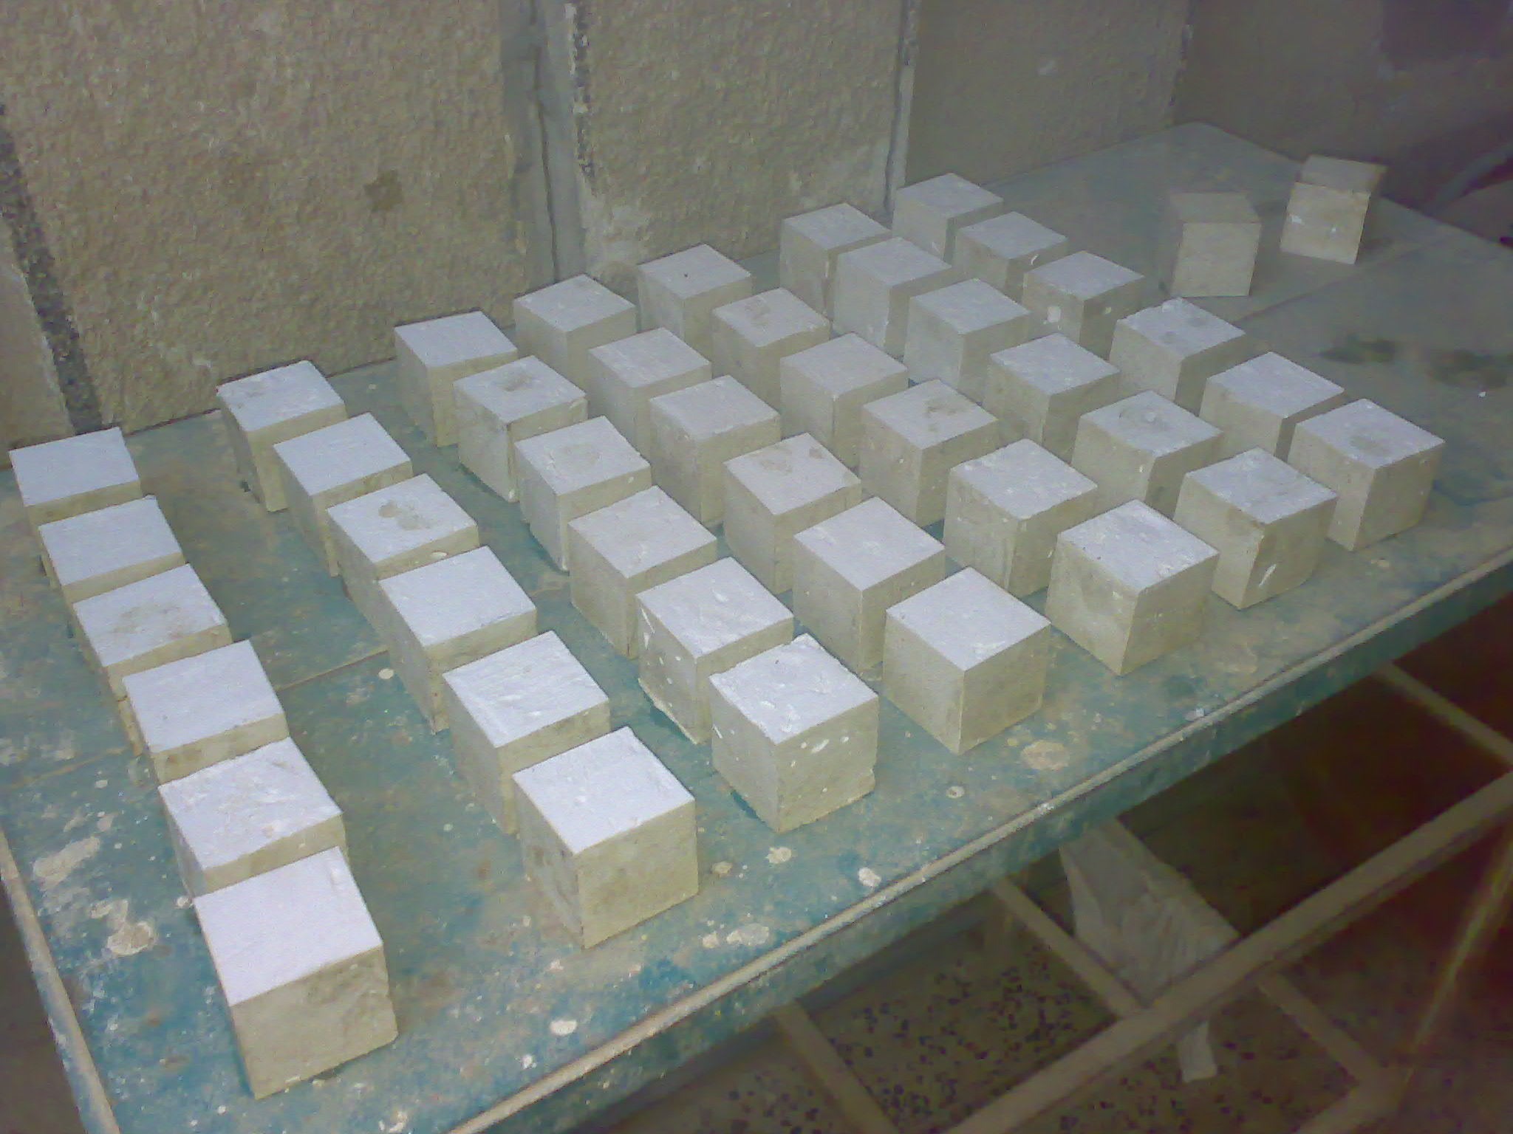
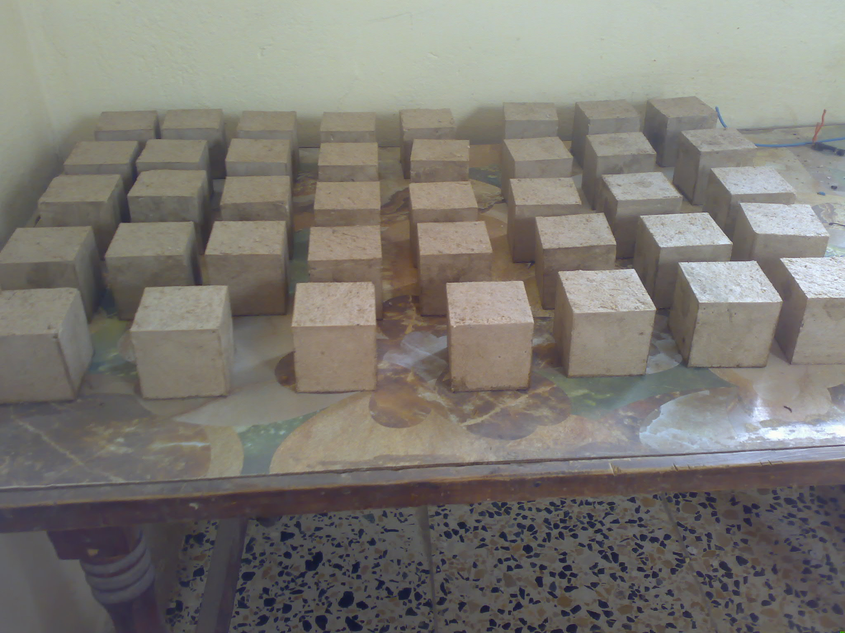
.
Picture (2): Plaster of Paris specimens before heating.
Picture (1): Ordinary gypsum specimens before heating.

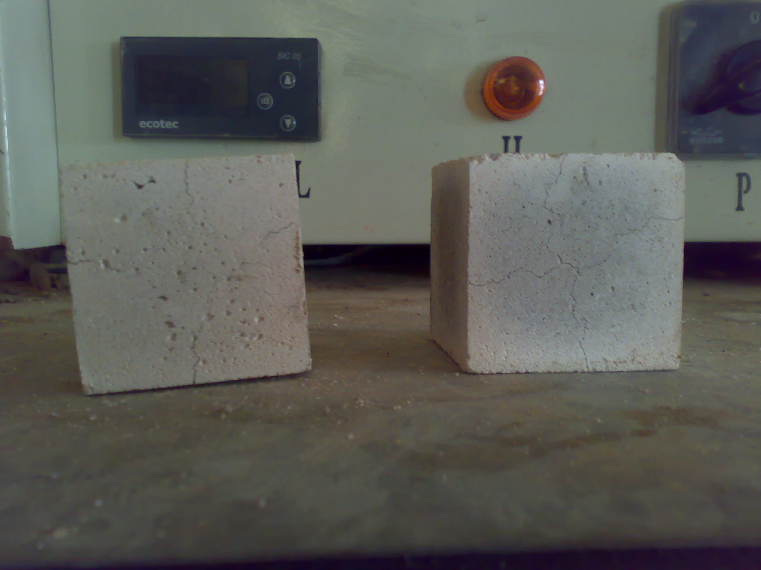
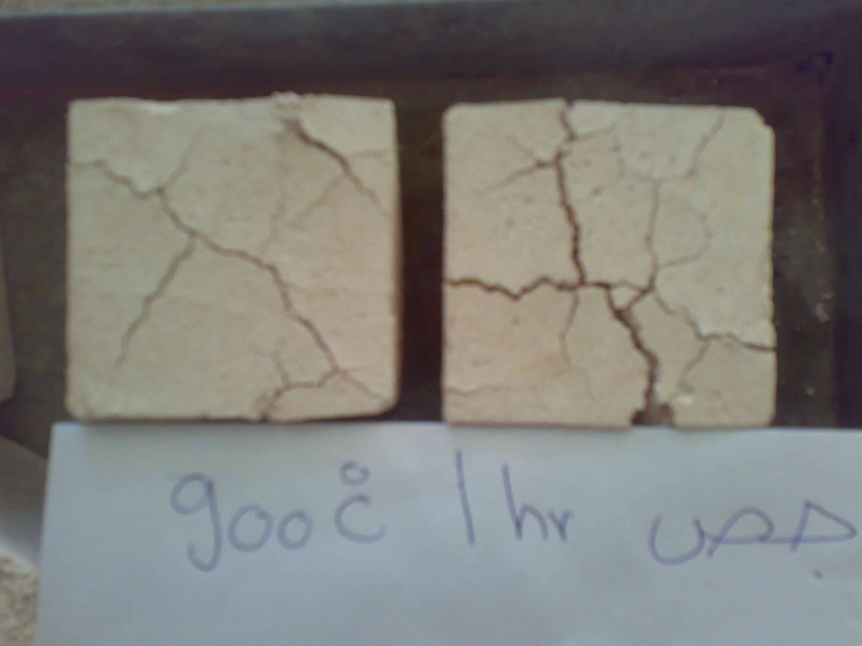
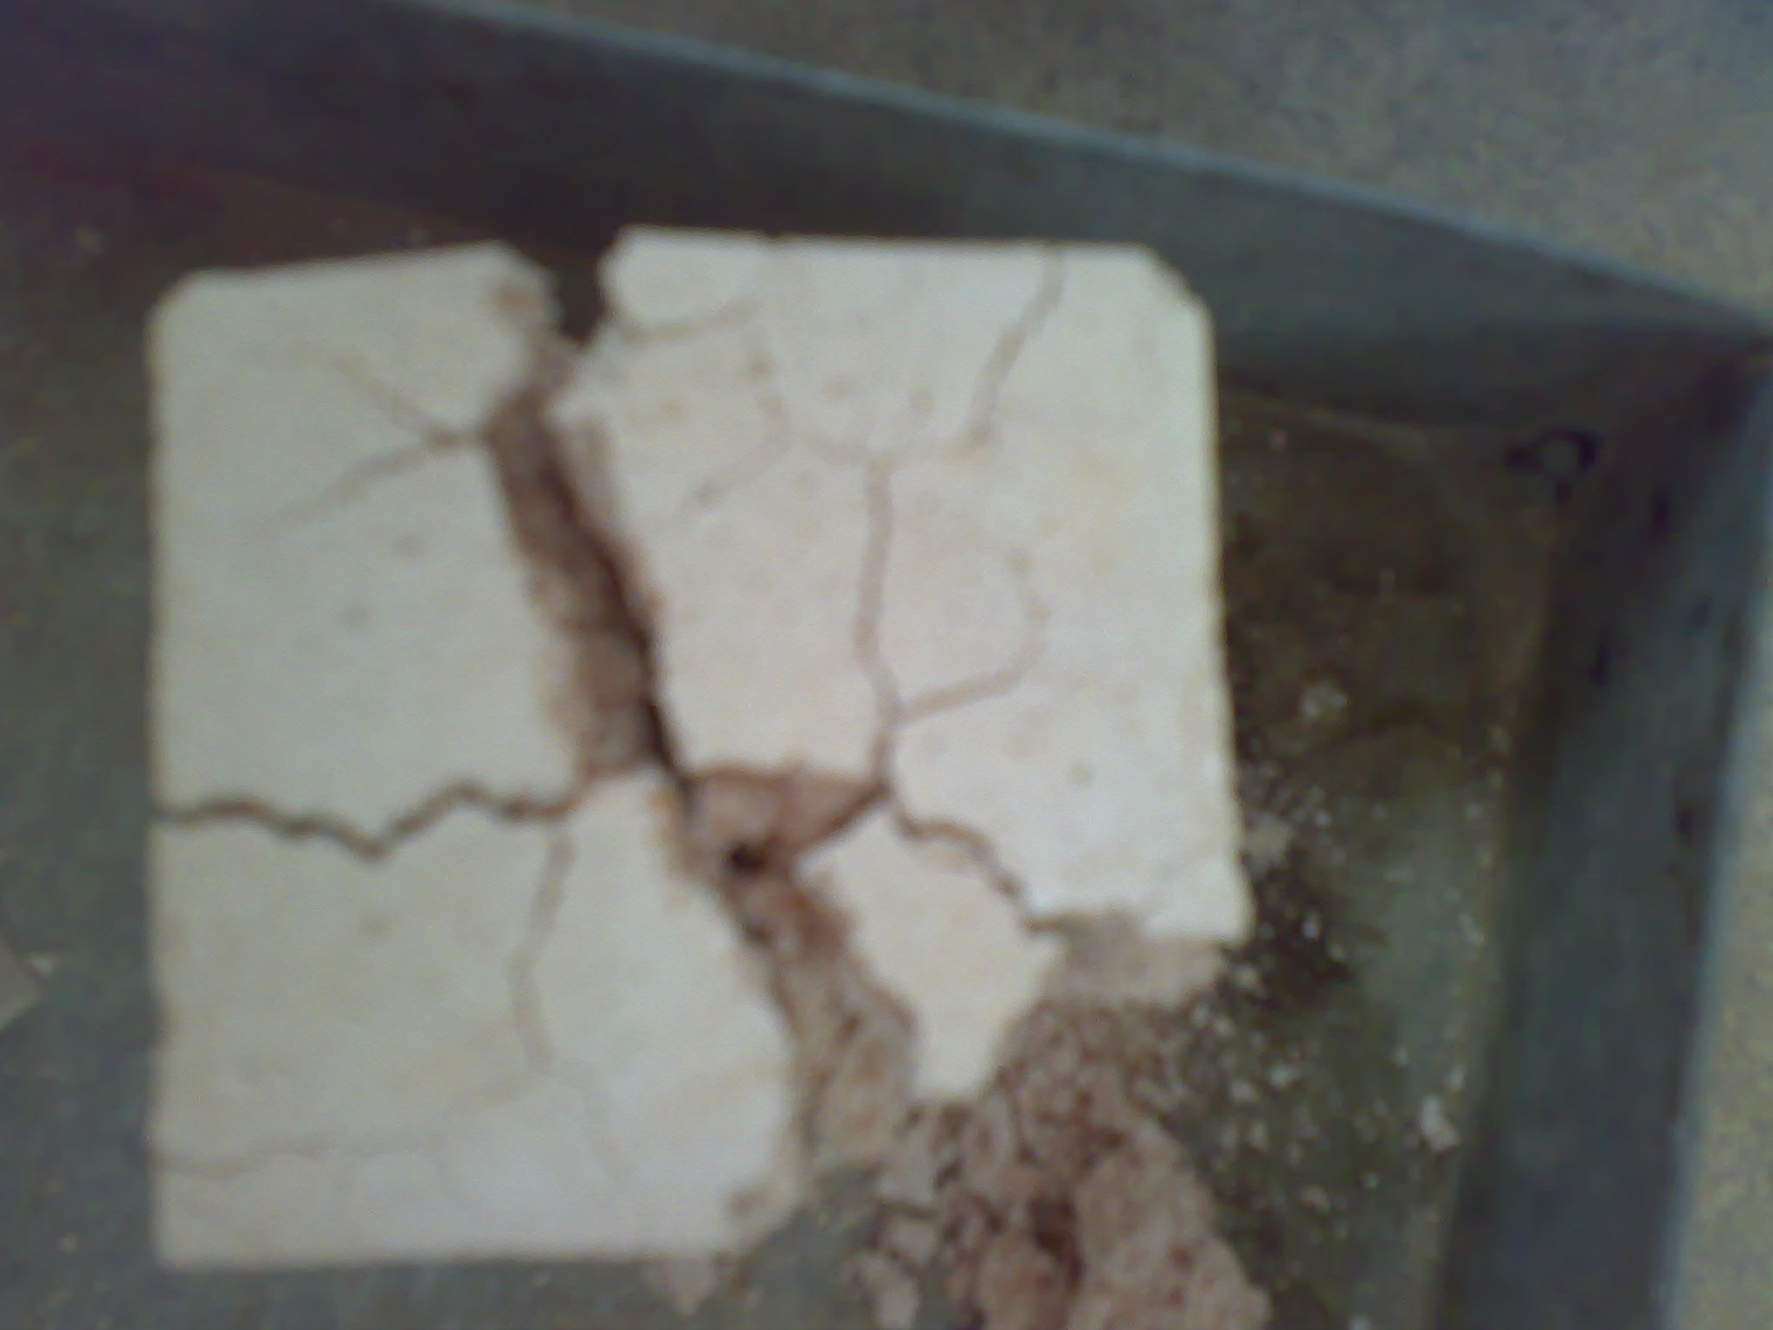
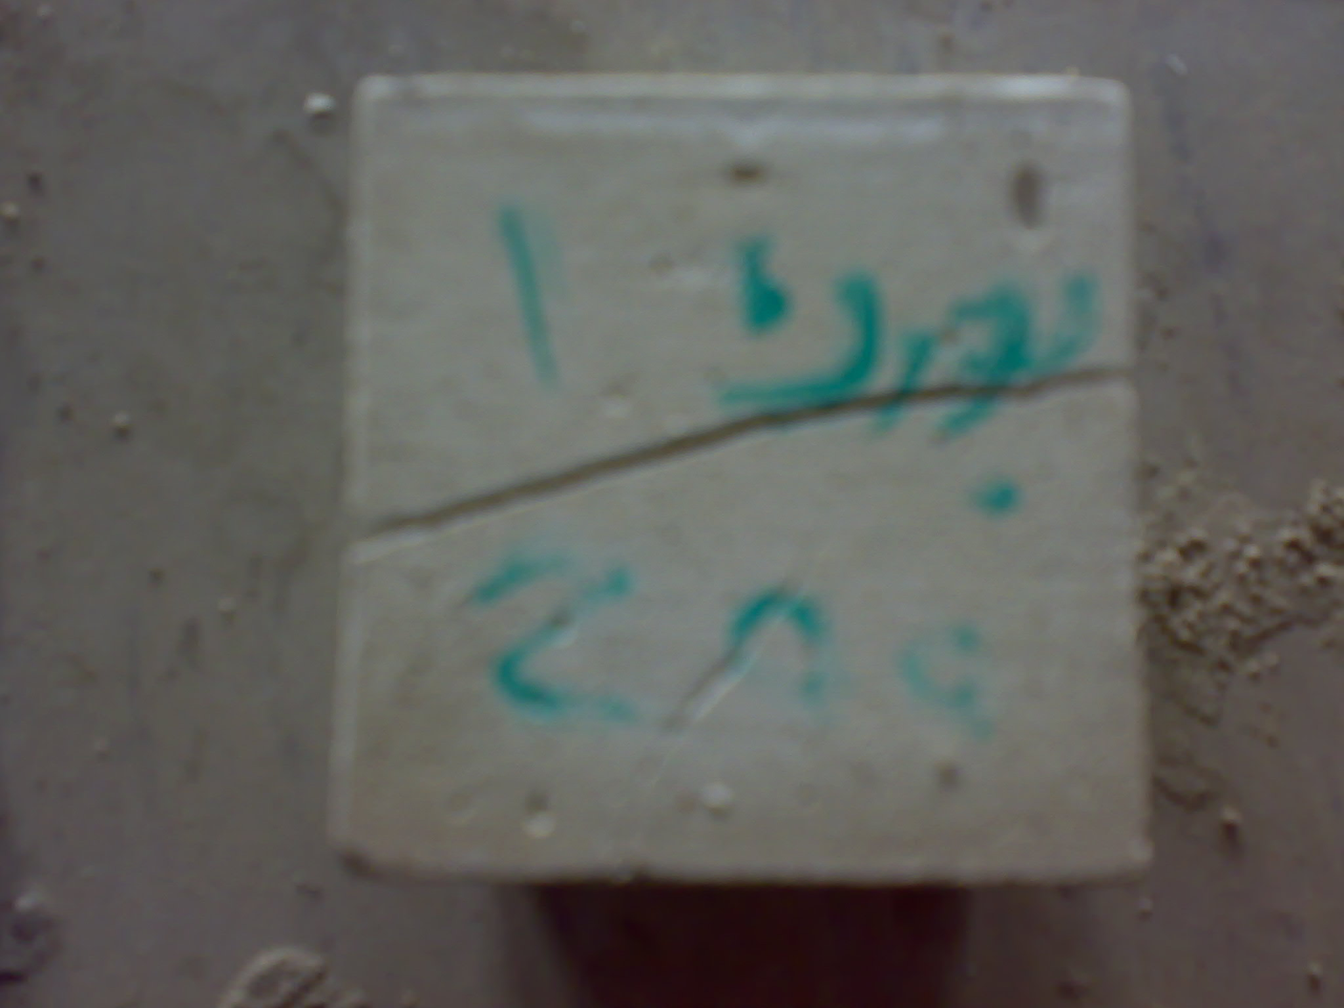
Picture (3): Surface-Cracks of ordinary gypsum specimens.
Picture (4): Cracks of ordinary gypsum specimens at failure.
Picture (6): Cracks of plaster of Paris specimens at failure.
Picture (5): Failure of ordinary gypsum specimens at water cooling.

