Nonlinear Analysis And Optimal Design Of Reinforced Concrete Plates And Shells

Abdul Ridah Saleh, Nameer A. Alwash
Ali Abdul Hussein Mohammed
Department of Civil Engineering, College of Engineering, Babylon University.

1.Abstract
This research deals with the optimal design of reinforced concrete plate and shell structures based on nonlinear finite element method. The eight-node degenerated curved shell element is used in which five degrees of freedom are specified at each nodal point. A layered model is considered in the modeling of the reinforced concrete behaviour and a perfect bond between the concrete and reinforcement has been assumed. The compressive behaviour of the concrete has been modeled by employing two approaches both elastic-strain hardening and elastic- perfectly plastic plasticity approach. The yield condition is formulated in terms of the first stress and second deviatoric stress invariants. The motion of the subsequent loading surface is controlled by the hardening rule that is extrapolated from the uniaxial stress-strain relationship given by a parabolic function. The behaviour of cracked concrete has been modeled using a smeared fixed crack approach, coupled with a tensile criterion to predict crack initiation. Gradual bond deterioration with progressive cracking is simulated by means of a tension stiffening model. A reduced shear modulus is employed in the cracked zone. The behaviour of steel reinforcement is idealized by elastic-perfectly plastic relation with linear strain hardening for tensile and compressive stresses. The nonlinear equations of equilibrium have been solved using an incremental-iterative technique operating under load control. Modified Newton-Raphson method has been employed.. A nonlinear geometrical model based on the total Lagrangian approach and taking into account the von Karman assumptions. For the structural optimization problem, which is dealt with as a constraint nonlinear optimization, the so-called Modified Hooke and Jeeves method, (1) is employed by considering the total cost of the structure as the objective function and the dimensions as the design variables with geometrical constraints. For the analysis of reinforced concrete plates and shells, the results show good agreement with experimental results and the difference at the range of (3%-16.8%) for the ultimate load. The results of optimization for reinforced concrete plates show that the optimal cost occurs when using of minimum thickness of slab. The optimal cost for reinforced concrete cylindrical shell occurs when the thickness and curvature of the shell increases and shell angle decreases.

الخلاصة
هذا البحث معنيّ بالتصميم المرن-اللدن الأمثل للألواح و القشريات الخرسانيه المسلحة وبالاعتماد على التحليل المرن-اللدن اللاخطي هندسيا، باستخدام طريقة العناصر المحددة. تم استخدام العنصر المتطبق القشري ذي العقد الثمانيه مع تحديد خمس درجات للحرية في كل عقدة متعلقة بالازاحات الثلاث ودورا نين للمتجه العمودي في كل عقدة.لقد تم استخدام نموذج الطبقات في سلوك الخرسانة المسلحة مع فرض ترابط كلي بين حديد التسليح والخرسانة.تم تمثيل سلوك الخرسانة تحت تأثير اجهادات الانضغاط كمادة مرنة مع انفعالات لدنة متصلدة او مادة مرنة تامة اللدونة بعد الخضوع. تم التعبير عن شروط الخضوع بدلالة المتغيرين الأوليين للاجهاد. تم السيطرة على حركة الأسطح المتعاقبة بقاعدة التصلب التي تستقرأ من علاقة الاجهاد-الانفعال المحوري والممثل عنها بدالة قطع مكافئ.إن تهشم الخرسانة هي ظاهرة مسيطر عليها بالانفعال ومنظمة بسطح سحق يشبه سطح الخضوع. استعمل أسلوب الشق الثابت لتمثيل سلوك الخرسانة المتشققة مصاحب بشرط الشد للتنبؤ بحدوث الشق. كما اخذ بنظر الاعتبار تخفيض معامل القص في منطقة الشق. تناقص الترابط التدريجي باستمرار التشقق تم تمثيله من خلال نموذج صلابة شد الخرسانة. لقد مثل سلوك حديد التسليح تحت تأثير قوى الشد والانضغاط كمادة مرنة تامة اللدونة او مادة مرنة مع تصلب انفعال خطي.تم استخدام التقنية المعروفة بالتزايدية – التعاودية والتي تعمل تحت أحمال متزايدة لحل معادلات التوازن الغير خطية. أما طريقة الحل التي استخدمت لمعالجة هذه التقنية هي طريقة محورة لطريقة (نيوتن - رافسون). في هذه الطريقة (نيوتن - رافسون) المحورة تعدل مصفوفة الصلابة في الإعادة الثانية لكل زيادة حمل. كما تم استخدام تقارب كل من الإزاحة والقوة في هذا البحث. تم استعمال طرق متعددة لأجراء التكاملات العددية مثل التكامل الكامل والاختياري والناقص للتطبيقات المستخدمة في هذا البحث. لقد تم الآخذ بنظر الاعتبار في النموذج الرياضي المستخدم في هذا البحث التغير غير الخطي في الشكل مستنداً على أسلوب (لاكرانج) الكلي آخذا بنظر الاعتبار فرضيات (فون كارمن).في حالة الأمثلية الإنشائية و التي هي أمثلية مقيدة لا خطية، فقد تم استخدام طريقة هوك و جيفس (Hooke and Jeeves) المعدلة وباعتبار حجم المنشأ كدالة الهدف وأبعاده كمتغيرات التصميم مع قيود هندسية. العديد من الأمثلة المتعلقة بالسقوف و القشريّات الخرسانية المسلحه، والتي قد تمّ تحليلها سابقا من قبل باحثين آخرين، تمّ تحليلها باستخدام طريقة العناصر المحددة الحالية والنتائج أظهرت تقارب جيد و خاصة مع نتائج التجارب العملية ومع وجود فرق بحدود (3%-16.8%) من الحمل الأقصى. التصميم الأمثل للسقوف و القشريات الخرسانيه المسلحة قد تمّ تناوله. لقد أظهرت النتائج بان اقل كلفة للسقف نستطيع الحصول عليها عند استخدام اقل سمك. أما في حالة القشريات الخرسانيه المسلحة فان زيادة السمك و درجة التقوس تعطي اقل كلفة.
2.1 Concrete Model
In the present study, a plasticity based model is used for simulairs the nonlinear behaviour of reinforced concrete members under static loads. An elasto-plastic work hardening model has been used to simulate the behaviour of concrete in compression with limited ductility, which is terminated at the onset of crushing. The model will be described in terms of the yield criterion, the hardening rule, the flow rule, and the crushing condition.
In tension, the response is assumed to be elastic until cracking occurs. The onset of cracking is controlled by a maximum principal stress criterion. The behaviour of cracked concrete has been modeled using a smeared fixed crack approach, coupled with a tensile criterion to predict crack initiation. Gradual bond deterioration with progressive cracking is simulated by means of a tension stiffening model. A reduced shear modulus is employed in the crack zone.

2.2 Steel Reinforcement Modeling
The steel reinforcement is smeared into equivalent steel layers with uniaxial properties. An elasto-plastic behavior with possible strain hardening assumed and elastic unloading and reloading in the plastic range are allowed.

3. Stiffness Matrix Formulation
3. 1 Degenerated Shell Element Formulations
Ahmad and Zienkiewicz(2) appeared to open a possible and promising avenue by giving fundamental idea of formulation of degenerated elements. The suggested process by Ahmed uses a full quadratic three-dimensional (20-noded) isoparametric for deriving (or degenerating) the formulation necessary to give the basic assumption of degenerated shell element. This approach employs a reference surface translations and rotations (mid-surface), which represent a replacement of the independent top and bottom node displacements in three dimension brick element and variation of displacements across the thickness is prescribed only linear. This is a great improvement of the element in the formulation to overcome some difficulties, which arise in satisfying the necessary continuity of slopes at interfaces and the inability of such formulation to account for shear deformation. The strain energy corresponding to the stresses perpendicular to the middle surface is ignored but those surfaces normal to mid-surface before deformation remain straight but not necessarily normal to mid-surface after deformation as shown in Fig. (1).

node
f
ξ

j_{bot}
j_{top}
j_{mid}
node j
η
ζ
X, (u)
Y, (v)
Z, (w)
x_{i,} (u_{i})

(b) (a)

Global Coordinate System

Nodal Coordinate System

Fig. (1) Coordinate systems( Nodal and Global Coordinate System)

Some difficulties appeared, due to degeneration processes. The thickness of the element was reduced, but also a great improvement of the model was achieved by the application of the so-called reduced integration technique. Since then the element has become applicable to thin as well as thick shells.
3. 1.1 Geometry of the Element
The general formulation of the coordinates defines the geometry of the shell element which represents the rotations between the curvilinear coordinates
$ξ\text{ , }η\text{ , }ζ$ and global coordinates (X, Y, Z).

$X_{i}=\sum_{f=1}^{n}{N_{f}(ξ,η)}\frac{1+ζ}{2}{\left[X_{\text{if}}\right]}_{\text{top}}+\sum_{f=1}^{n}{N_{f}(ξ,η)}\frac{1−ζ}{2}{\left[X_{\text{if}}\right]}_{\text{bot}}$
or … ……(1)$\left\{\begin{matrix}X \\ Y \\ Z\end{matrix}\right\}=\sum_{f=1}^{n}{N_{f}(ξ,η)}{\left\{\begin{matrix}X \\ Y \\ Z\end{matrix}\right\}}_{\text{mid}}+\sum_{f=1}^{n}{N_{f}(ξ,η)}\frac{ζh_{f}}{2}\left[\begin{matrix}{\overline{V}}_{3f}^{x} \\ {\overline{V}}_{3f}^{y} \\ {\overline{V}}_{3f}^{z}\end{matrix}\right]$
where,
n is the number of nodes per element,
$h_{f}$ is the shell thickness at node f, i.e. the respective “normal” length,
$X_{\text{if}}$ is the Cartesian coordinate of nodal point f, and
$N_{f}(ξ,η)$ is the two dimensional interpolation functions corresponding to the surface. ($ζ$=constant) at nodal point f. (see Table (1.1)).
${\overline{V}}_{3f}^{i}$ is the component of the unit normal vector to the middle surface.
The elements considered are the 8-node serendipity element.
Table (1.1) Shape Functions And Their Derivatives
Shape element function for 8-node Serendipity
 | Function corner nodes (1,3,5,7) | Edge nodes (2,6) | Edge nodes (4,8)
$$N_{k}$$ | $$\frac{1}{4}\left(1+ξ_{ο}\right)\left(1+η_{ο}\right)\left(ξ_{ο}+η_{ο}−1\right)$$ | $$\frac{1}{2}\left(1−ξ^{2}\right)\left(1+η_{ο}\right)$$ | $$\frac{1}{2}\left(1−η^{2}\right)\left(1+ξ_{ο}\right)$$
$$N_{k},ξ$$ | $$\frac{ξ_{k}}{4}\left(1+η_{ο}\right)\left(2ξ_{ο}+η_{ο}\right)$$ | $$−ξ(1+η_{ο})$$ | $$\frac{ξ_{k}}{2}\left(1−η^{2}\right)$$
$$N_{k},η$$ | $$\frac{η_{k}}{4}\left(1+ξ_{ο}\right)\left(2η_{ο}+ξ_{ο}\right)$$ | $$\frac{η_{k}}{2}\left(1−ξ^{2}\right)$$ | $$−η(1+ξ_{ο})$$

3.1.2 Displacement Field`
Five degrees of freedom at each node of shell element specify the displacement field, as the strain in the directions to` the mid-surface is assumed to be negligible. The displacement throughout the element can be defined by the three displacements (u,v,w ) of its mid-point and two rotations of the nodal vector V3f about orthogonal directions normal to it.
$\left\{\begin{matrix}u \\ v \\ w\end{matrix}\right\}=\left[\begin{matrix}N_{f} & 0 & 0 & N_{f}\frac{ζ{\text{ h}}_{f}}{2}V_{1f}^{x} & −N_{f}\frac{ζ{\text{ h}}_{f}}{2}V_{2f}^{x} & \\ 0 & N_{f} & 0 & N_{f}\frac{ζ{\text{ h}}_{f}}{2}V_{1f}^{y} & −N_{f}\frac{ζ{\text{ h}}_{f}}{2}V_{2f}^{y} & \\ 0 & 0 & N_{f} & N_{f}\frac{ζ{\text{ h}}_{f}}{2}V_{1f}^{z} & −N_{f}\frac{ζ{\text{ h}}_{f}}{2}V_{2f}^{z} & \end{matrix}\right]\left[\begin{matrix}u_{f} \\ v_{f} \\ w_{f} \\ α_{\text{1f}} \\ α_{\text{2f}}\end{matrix}\right]$ …….(2)
Where ,N_{f} is the shape function matrix of the degenerated shell element.
3.1.3 Definition of Stresses
For the shell assumption of zero local stress in the direction normal to the shell or slab mid-surface in $Z^{'}$-direction ($σ_{z}^{'}=0$) enables the stresses vector to be reduced to the following five stress components (Ahmad and Zienkiewic 1970).
$σ=\left[\begin{matrix}σ_{x^{'}} \\ σ_{y^{'}} \\ τ_{x^{'}y^{'}} \\ τ_{x^{'}z^{'}} \\ τ_{y^{'}z^{'}}\end{matrix}\right]=\left[D\right]\left(\left\{ε\right\}−\left\{ε_{ο}\right\}\right)$ ………(3)

where,
$\left\{ε_{ο}\right\}$ is the initial strain vector and may also represent the expansion due to thermal load,
$\left\{ε\right\}$ is the strain vector and details of its formulation are explained in the next section, and
[D] is the elasticity matrix given by,
$\left[D\right]=\frac{E}{1−ν^{2}}\left[\begin{matrix}1 & ν & 0 & 0 & 0 \\ ν & 1 & 0 & 0 & 0 \\ 0 & 0 & G & 0 & 0 \\ 0 & 0 & 0 & K_{1}G & 0 \\ 0 & 0 & 0 & 0 & K_{2}G\end{matrix}\right]$ .…..(4)

3.1.4 Definition of Strains
The normal strain in the $Z^{'}$-direction ($ε_{z}^{'}$) is neglected. Therefore the general vector of Green strains will be reduced to the following five components.( Hinton and Owen1984)

$\left\{ε\right\}=\left[\begin{matrix}ε_{x^{'}} \\ ε_{y^{'}} \\ γ_{x^{'}y^{'}} \\ γ_{x^{'}z^{'}} \\ γ_{y^{'}z^{'}}\end{matrix}\right]=\left[\begin{matrix}\frac{∂u^{'}}{∂x^{'}} \\ \frac{∂v^{'}}{∂y^{'}} \\ \frac{∂u^{'}}{∂y^{'}}+\frac{∂v^{'}}{∂x^{'}} \\ \frac{∂u^{'}}{∂z^{'}}+\frac{∂w^{'}}{∂x^{'}} \\ \frac{∂v^{'}}{∂z^{'}}+\frac{∂w^{'}}{∂y^{'}}\end{matrix}\right]$ .......(5)
or:
$\left\{ε\right\}=\left[B\right]\left\{δ\right\}$ .…..(6)
Where B is The strain-displacement matrix.
and: $\left\{δ\right\}$is the displacement vector
$\left\{δ\right\}={\left[u,v,w,α_{1},α_{2}\right]}^{T}$ ...….(7)

3.1.5 The Element Stiffness Matrix
The stiffness matrix of degenerated shell element is computed at the mid-section of each layer. The Jacobian matrix through the shell thickness must be taken into account. It is more appropriate to use an integration process, which may split the volume integral into integrals over the area of the shell mid-surface and through the thickness (h). Therefore, the process consists of the calculation of strain matrix [B_{j}] at the mid-surface of each layer. Consequently it is used in the calculation of the stiffness matrix [K] using the mid-ordinate rule. Thus, the stiffness matrix is computed by summing up the contribution of each layer at the Gauss points and may be written as follows (Owen and Hinton1980):
$\left[K\right]=\int_{V}{{\left[B\right]}^{T }\left[D\right] \left[B\right] \text{dV}}=\int_{S}{\int{\left({\left[B\right]}^{T}\left[D\right] \left[B\right] \text{dz}\right)} \text{dS}}$ (8)
$\left[K\right]=\int{\int{\left[\int{{\left[B\right]}^{T} \left[D\right] \left[B\right] \left|J\left(ξ, η, ζ\right) \right|dζ}\right]dξ dη}}$ (9)
Then, [k] can be written as summing up the contribution of each layer at the Gauss points,
$\left[K\right]=\int{\int{\left[\sum_{j=1}^{n}{{\left[B_{j}\right]}^{T} \left[D_{j}\right] \left[B_{j}\right] \left|J\left(ξ, η, ζ_{j}\right) \right|\frac{2 Δ h_{j}}{h}}\right]dξ dη}}$ (10)
where;
[k] = is the stiffness matrix.
[D]= is the elasticity matrix modified to account for tensile cracking, nonlinear behavior in compression and material matrix of steel layer.
[B_{j}]= is the strain matrix calculated at the mid section of each layer.
|J(ξ, η, ζ_{j})|= is the determinant of the Jacobian matrix for layer (j).
Δh_{j}= is the thickness of the jth layer.
n= is the total number of layers.
4. Numerical Integration and Nonlinear Solution
The Numerical rules adopted in this study.
1. Full integration rule
2. Reduced integration
3. Selective integration rule

The basic solution techniques of the above nonlinear of system equations are the iterative, incremental and combined incremental-iterative approaches.
5. Nonlinear Geometric Analysis
In the present work, a specific and appropriate formulation for the nonlinear analysis of reinforced plates and shells has been employed. In this formulation, large deflections and moderate rotations are taken into account with the simplified Von-Karman assumptions.
By applying Von – Karman assumptions, the strain vector component may be expressed in terms of local derivatives of the displacements for the degenerate shell element and can be written as:
$\left[\begin{matrix}ε_{x^{'}} \\ ε_{y^{'}} \\ γ_{x^{'}y^{'}} \\ γ_{x^{'}z^{'}} \\ γ_{y^{'}z^{'}}\end{matrix}\right]=\left[\begin{matrix}\frac{∂u^{'}}{∂x^{'}}+\frac{1}{2}{\left(\frac{∂w^{'}}{∂x^{'}}\right)}^{2} \\ \frac{∂v^{'}}{∂y^{'}}+\frac{1}{2}{\left(\frac{∂w^{'}}{∂y^{'}}\right)}^{2} \\ \frac{∂u^{'}}{∂y^{'}}+\frac{∂v^{'}}{∂x^{'}}+\frac{∂w^{'}}{∂x^{'}}\text{.}\frac{∂w^{'}}{∂y^{'}} \\ \frac{∂u^{'}}{∂z^{'}}+\frac{∂w^{'}}{∂x^{'}} \\ \frac{∂v^{'}}{∂z^{'}}+\frac{∂w^{'}}{∂y^{'}}\end{matrix}\right]$ ……(11)
Separating the strain components into a linear part {ε_{o}} and a nonlinear part {ε_{L}} which can be expressed as,
{ε} = {ε₀} + {ε_{L}} …… (12)
where,

$\left\{ε_{o}\right\}=\left[\begin{matrix}\frac{∂u^{'}}{∂x^{'}} \\ \frac{∂v^{'}}{∂y^{'}} \\ \frac{∂u^{'}}{∂y^{'}}+\frac{∂v^{'}}{∂x^{'}} \\ \frac{∂u^{'}}{∂z^{'}}+\frac{∂w^{'}}{∂x^{'}} \\ \frac{∂v^{'}}{∂z^{'}}+\frac{∂w^{'}}{∂y^{'}}\end{matrix}\right] , \left\{ε_{L}\right\}=\left[\begin{matrix}\frac{1}{2}{\left(\frac{∂w^{'}}{∂x^{'}}\right)}^{2} \\ \frac{1}{2}{\left(\frac{∂w^{'}}{∂y^{'}}\right)}^{2} \\ \frac{∂w^{'}}{∂x^{'}} \frac{∂w^{'}}{∂y^{'}} \\ 0 \\ 0\end{matrix}\right]$ ……..(13)
and
d {ε} = d {ε_{o}} + d {ε_{L}} …..(14)
The strain displacement matrix [B] may be separated into two parts,
[B] = [B_{o}] + [B_{L}] …….(15)
where;
[B_{o}] is the linear part,
[B_{L}] is the nonlinear part.
The tangential stiffness matrix for the current configuration [k] can be derived from the variation of internal force vector with respect to a displacement variation {a}.
$\left[\bar{K}\right]=\int_{V}{{\left[B\right]}^{T}\left[D\right] \left[B\right] \text{dV}}$ ………(16)
The geometric stiffness matrix [K]₆ must be defined explicitly in order to determine the tangential stiffness [K].
${\left[K\right]}_{σ}=\int_{V}{{\left[G\right]}^{T}} \left[σ\right] \left[G\right] \text{dV}$ ……..(17)
Finally the total stiffness matrix can be written as

$\left[K\right]$=$\left[\bar{K}\right]$+${\left[K\right]}_{σ}$

6. The Employed of Computer Program
The computer program has been used for nonlinear analysis of reinforced concrete plates and shells structures (Hinton and Owen1984). In this program a layered approach is adopted with material and geometric nonlinear effects may also be considered. The reinforcement is represented by a smeared layer of equivalent thickness. The nonlinear solution technique includes standard and modified Newton-Raphson and the initial stiffness methods may optionally be performed.
The program is coded in FORTRAN-90 Language. I used PC Pentium4 MHz Intel MMX compatible computer with 256 megabyte Ram.
7. Optimization
Reinforced concrete structural problem has numerous solutions. The purpose of optimization is to find the best possible solution among the many alternative solutions satisfying the prechosen criteria. The objective function is often the minimum weight especially for steel structures, or minimum cost taking into account function, safety and serviceability .The objective function is the minimum amount of reinforcement for reinforced concrete plates and shells since reinforcement cost, nowadays, represents the major portion in the total cont of construction.
Since the minimization of the objective function depends on the section resistance, which is an implicit function of the independent design variables and cannot be expressed directly as a function of these variables, it cannot be derived with respect to the independent design variables. Hence the gradient method of non –linear optimization such as Hooke and Jeeves is simpler than ( SUMT Method ) ( sequential unconstrained minimization technique ) therefore can be used in this study. So the modified direct search method of Hooke and Jeeves (Bunday 1984) will be used which uses the function values only. The search consists of a sequence of exploration steps about a base point which if successful are followed by pattern moves. The modification was made on this method to take account of constraints.

8. Application and Discussions
8.1 One-Way Reinforced Concrete Slab
A one-way slab supported at two edges was tested experimentally by (McNiece and Jofriet1971).The geometrical details, reinforcement layout, loading are shown in Fig. (2). Utilizing symmetry of loading and geometry, only a quarter of the slab is modeled by the finite elements method. Two mesh of four and nine eight-node shell elements are used for this quarter structure are shown in Fig. (3). The steel reinforcement is represented by a layer with a thickness equals to 0.356 mm. Material properties of concrete and steel are given in Table ( 2).

Table (2) Material Properties for (McNiece.and Jofriet) Slab considered in the analysis
Material properties and parameters |  | Value
Concrete | Young’s Modulus, E_{c}, MPa  Compressive Strength, f_{c}′, MPa  Tensile Strength, f_{t}, MPa  Poisson’s Ratio, ν  Uniaxial crushing strain ε_{cu .} | 31000  35.0  3.0  0.15  0.0035
Steel | Young’s Modulus, E_{s}, MPa  Yield Strength, f_{y}, MPa | 210000  345
Tension-Stiffening  Parameters | α_{m}  ε_{m} | 0.50  0.002

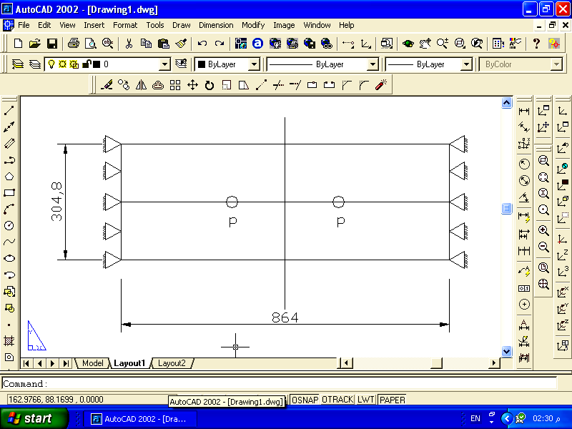
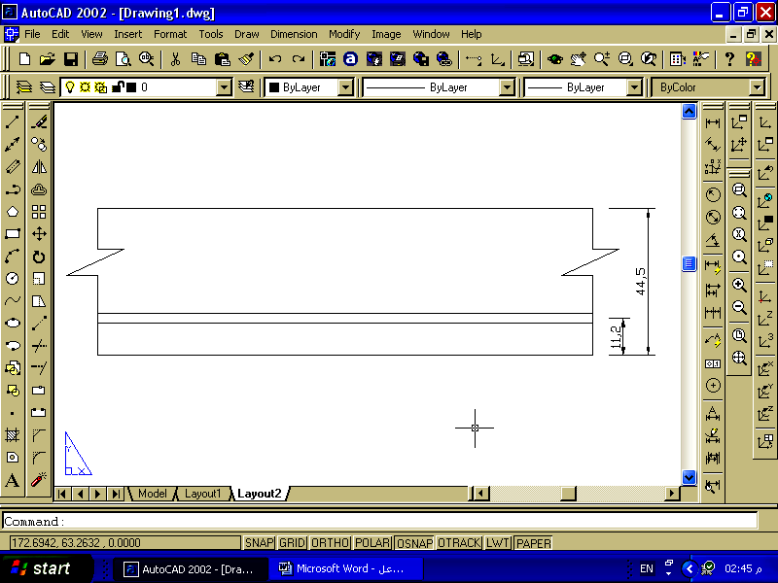
(a) Slab geometry and loading arrangement
$$ρ_{s}=0\text{.}\text{008}$$
(b) Reinforcement details

All dimensions in mm

Fig. ( 2).Slab geometry and reinforcement details for One-Way reinforced concrete

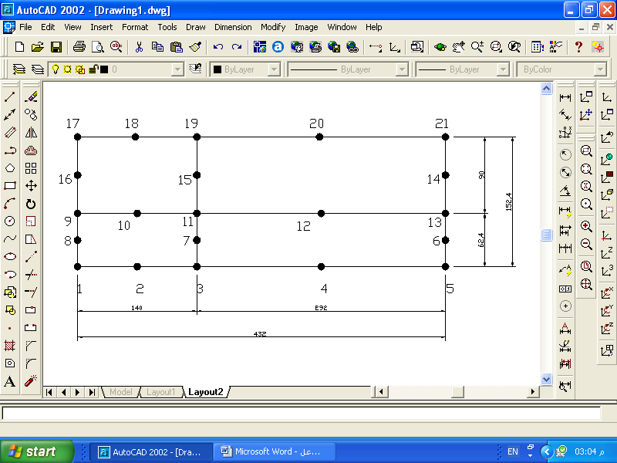
Y, C.L

V=0
W=0
θ_{y}=0

u=0
θ_{x}=0
X, C.L

v=0
θ_{y}=0

Load P
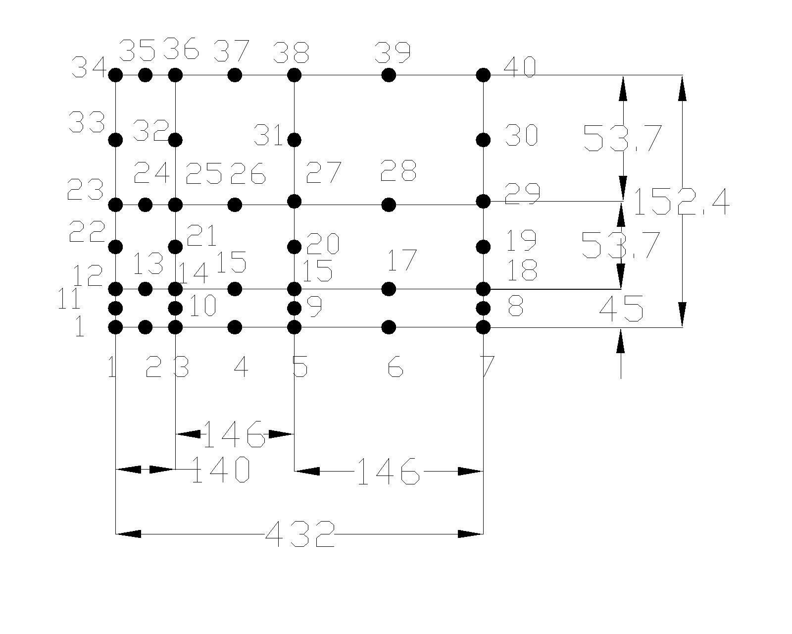
(a) Mesh No.1 (4-elements)
Y, C.L

V=0
W=0
θ_{y}=0
u=0
θ_{x}=0

X, C.L
All dimensions in mm
v=0
θ_{y}=0

(b) Mesh No.2 (9-elements)

Fig.(3). Finite element mesh for One –way reinforced concrete slab

Very small difference in load deflection behaviour for the two mesh at shown in Fig(4)
The load-deflection curve at midspan of the slab is shown in Fig. (5), Good agreement with experimental results are obtained through most loading level.
Crushed gauss points were initiated at a load of 0.97 of ultimate load. The presence of these crushed points at the top layer began when the compressive strain of the gauss point increased the ultimate crushing strain. The consideration of geometrical nonlinearity in the finite element analysis has been found to be the major parameter in the analysis of reinforced concrete plate structures, which exhibit relatively large deformations before failure as shown in Fig (5).

Fig. (4). Comparison of load-deflection curves for One-way slab

Fig. (5).Load-deflection curves at midspan of one- way
Simply supported slab

8.2 Reinforced Concrete Cylindrical Shell
The reinforced concrete cylindrical shell, simply supported in the circumferential direction at the curved edges was tested experimentally under pressure load by Van Riel et.al. (1957) and theoretical by (Arnesen, and Bergan 1980).Several investigators proved their theoretical work by comparing their analytical results with that of Van Riel shell. Geometric details, reinforcement layout and finite element idealization are shown in Fig.(6). Taking the symmetry of loading and geometry, only a quarter of the shell-beam system is modeled by the finite element method. A mesh of nine eight-node shell elements is used for this quarter structure is shown in Fig.(6).
The steel reinforcement for the shell is represented by four layers with a thickness equals to 0.04 mm each. While, the reinforcement for the beam is represented by a layer with thickness equals to 5.6 mm.. Material properties of concrete ant steel are given in Table (3).
Table (3): Concrete and steel material properties for the shell.
Material properties and parameters |  | Value
Concrete | Young’s Modulus, E_{c}, MPa  Compressive Strength, f_{c}′, MPa  Tensile Strength, f_{t}, MPa  Poisson’s Ratio, ν  Uniaxial crushing strain ε_{cu} | 30000.  30.0  4.91  0.15  0.0035
Steel | Young’s Modulus, E_{s}, MPa  Yield Strength, f_{y}, MPa | 210000  295
Tension-Stiffening  Parameters | α_{m}  ε_{m} | 0.50  0.002

Crushed gauss points were initiated at a load of 0.978 of ultimate load. The presence of these crushed points at the top layer began when the compressive strain of the gauss point increased the ultimate crushing strain. When the gauss points are considered crushed, zero stresses and stiffness are assigned to them.
A number of previous theoretical results are plotted in Fig. (7), (Arnesen, and Bergan 1980) employed a triangular shell element with numerical integration through thickness. They used end chronic theory for the concrete and a trilinear stress-strain law for the steel. Nonlinear geometry was included using an updated Lagrange approach. Cyclic loading was also considered. Crushed gauss points were initiated at a load of 0.91 of ultimate load. (Chan 1982), analyzed reinforced concrete shell finite element with edge beams using a layered curved shell finite element. He also used a filament line reinforced concrete beam element to model the edge beams. Each filament was assumed to be in a uniaxial stress state, i.e., cracks in the beam filaments were formed perpendicular to the axis of the beam. Hence tensional cracking could not be modelled with such an assumption. The beam elements were connected to shell elements at discrete points by means of rigid links to model eccentric beams. Concrete was modelled as a nonlinear orthotropic hypo elastic material with biaxial state of stress in shell and uniaxial state of stress in beams. Steel was considered in uniaxal state of stress with a bilinear stress-strain model. Crushed gauss points were initiated at a load of 0.84 of ultimate load together with the results of the present analysis for comparison purposes. The present model seems to provide good representation of deformation path.

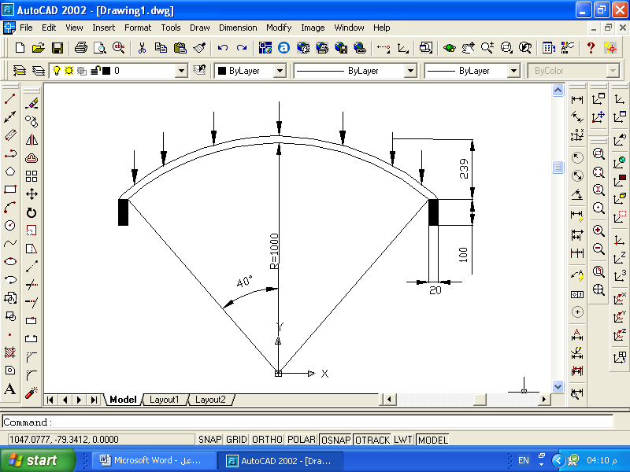
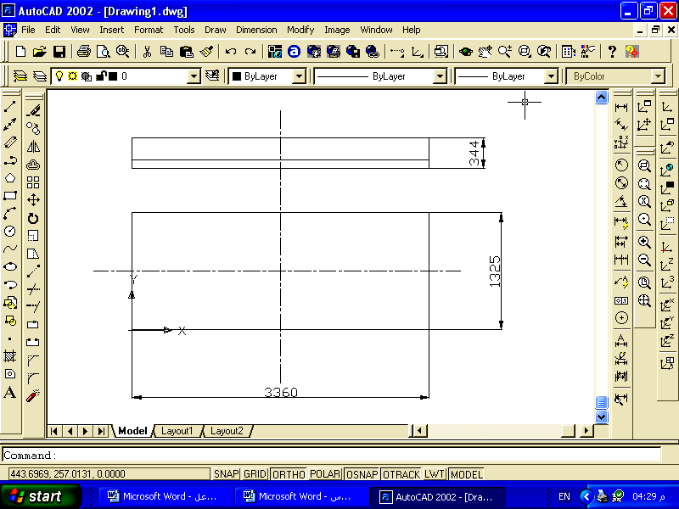
Top view
side view
Cross section

All dimension in mm

(a) Shell geometry and loading

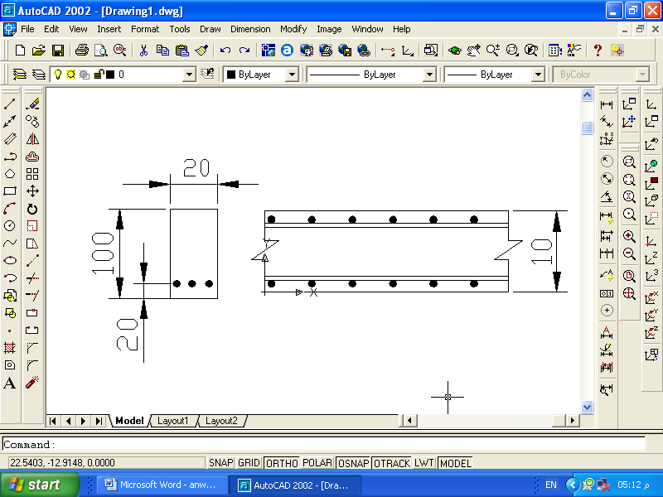

For edge beam
For shell
All dimensions in mm

(b) Steel arrangement

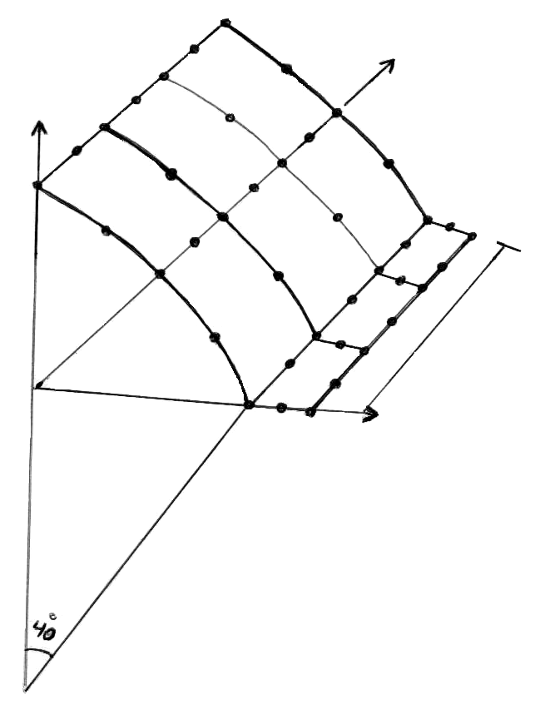
1
2
3
4
5
6
7
11
10
9
8
12
19
13
14
15
16
17
18
22
21
20
23
25
26
27
28
29
33
32
31
30
24
34
35
36
37
38
39
40
1680mm
239mm
662.5mm
R=1000mm
20mm
V = 0
Θ_{y}=0

u = 0
θ_{x}=0
V = 0
u = 0
w = 0
θ_{y}=0

Y,C.L
Z.C.L

X,C.L

ْ 40
All dimensions in mm

(c) Finite element mesh
Fig. (6). Reinforced concrete shell

Fig. (7) Load-deflection curves at midspan of edge beam

9. Optimal Design Application
9.1 One-Way Reinforced Concrete Slab
The optimal design of One –way reinforced concrete slab is investigated. The slab is exposed to concentrated load of 2.0 kN. Nine elements and six equal concrete and one steel layers through the thickness discredited a quarter of the slab. The design variable is thickness t. The initial values used are t=0.0445 and the step length is 0.01. $\text{.}\text{0432}≤t≤0\text{.}\text{2055}$ The material properties and
The non – linear cost objective function (Z) involving the cost of steel reinforcement, concrete and formwork is used in the optimization problem of this study.
where :
Cost of steel = Cs((4/3).As.b.(l/5)+(1/3).As.b.(l-(2.l/5))+Asmin.b.t ).ws
Cost of concrete = Cc ( b.t.l)
Cost of formwork = C_{f} (b.l+ 2.l.t + 2.b.t )
where :
Cs = unit price of steel reinforcement involving material and labour cost
As = area
l = slab length
b = slab width
t = slab thickness
ws = unit weight of steel
Cc = unit price of concrete involving material and labour cost
C_{f} = unit price of formwork
Assume
Cs=800 unites/ton, Cc=400 unites/m³, C_{f}=10unites/m².

Fig.(8) .Variation of Total Cost with No. of Analysis

It can be seen from Fig(8)that the total cost is reduced when the thickness is reduced .The minimum thickness gives the minimum cost.
9.2 Reinforced Concrete Cylindrical Shell
The optimal design of reinforced concrete cylindrical shell is investigated. The shell is exposed to uniform distributed load including self weight. Nine elements and eight equal concrete and five steel layers through the thickness discredited a quarter of the shell. The design variable is thickness t and shell angle. The Initial values used are t=0.005 and the step length is 0.005. The Constraints are.
0.005≤t≤0.02 and 35 º ≤β≤ 45 º.
The non – linear cost objective function (Z) involving the cost of steel reinforcement, concrete and formwork is used in the optimization problem of this study.
where :
Cost of steel = Cs.As1.2.β.R.l+As2.2.β.R.l+As3.2.β.R.l+As4.2.β.R.l).ws
Cost of concrete = Cc(β.R.t.l.2)
Cost of formwork =C_{f} (β.R.l.2+β.R.t.2+t.l.2)
where :
Cs = unit price of steel reinforcement involving material and labour cost
As = area of tension reinforcement
L = shell length
b = shell width
t = shell thickness
ws = unit weight of steel
Cc = unit price of concrete involving material and labour cost
C_{f} = unit price of formwork
Assume
Cs=800 unites/ton, Cc=400 unites/m³, C_{f}=10 unites/m².

Fig. (9) :Variation of Total Cost with No. of Analysis

It can be seen from Fig(9) that the total cost is reduced when the thickness, curvature of the shell increases and the shell angle decreases.

10. Conclusions
Based on the numerical results obtained from the finite element tests, which have been carried out throughout the present research work, the following conclusions can be drawn:
1.The finite element results obtained for different types of reinforced concrete members show that the computational model adopted in this study is versatile and suitable for prediction of the load-deflection behaviour and collapse load of reinforced concrete plates and shells with maximum difference in calculation of load is about 16.8% when compared with experimental results. The numerical tests carried out in the different cases studied reveal that the predicted load-deflection curves and collapse loads are in good agreement with the experimental results.
2. Quadratic degenerated Serendipity shell elements with five degrees of freedom per node proved to be efficient for structural discretization. They can adequately simulate the actual geometry of plate and shell structures.
3.The numerical tests carried out on reinforced concrete plate and shell structures show that the inclusion of the geometric nonlinearity together with the material nonlinearity in the finite element model can significantly improve the correlation of the predicted load-deflection behaviour and collapse load with experimental results at all stages of loading by increasing the predicted deformation before failure.
4.The nonlinear constrained optimization problem is solved by using the modified Hooke and Jeeves method. It has been shown that this method is efficient, easy to be programmed and can be used in general nonlinear constrained optimization.

5. In the case of reinforced concrete plates, the optimal cost will be obtained when the minimum thickness (ln/20 for one way reinforced concrete slab.
6. In the case of reinforced concrete cylindrical shell, the optimal cost will occur when the thickness increases and shell angle decreases.
11. References
Ahmad, S., Trons, B.M. and Zienkiewicz, O.C., “Analysis of Thick and Thin Shell Structures by Curved Finite Elements”, J of Num. Meth. Eng., Vol. 2, No.3, 1970, pp. 419-451.
Arnesen, A., Sorensen, S.I. and Bergan, P.G. “Nonlinear Analysis of Reinforced Concrete”, Computers and Structures, Vol.12, PP.571-579(1980).
Bunday, B.D. “Basic Optimization Methods”, Edward Arnold Ltd.
Chen, W, “Plasticity in Reinforced Concrete”, McGraw-Hill, New York, 1982.
Hinton, E. and Owen, D.R.J., “Finite Element Software for Plates and Shells”, Pineridge Press, Swansea, 1984.
McNiece, G.M.and Jofriet, J.C. “Finite Element Analysis of Reinforced Concrete Slab”, Journal of Structural Division, Proceeding of American Society of Civil Engineers, Vol.97, No.ST3, March(1971).
Owen, D.R.J. and Hinton, E, “Finite Elements in Plasticity-Theory and Practice”, Pineridge Press, Swansea, U.K., 1980.

