Design of New Optical Butler Matrix Beamforming Network for Phased Array Antenna

Saad Saffah Hassoon
University of Babylon, Collage of Engineering, Electrical Engineering Dept.

Abstract
The recent dramatic advances in high-speed photonic components have opened up significant applications of hybrid light-wave, microwave and millimeter wave systems. This paper explores the use of the interface between photonics and microwave and millimeter wave for designing efficient beamforming networks for phased array antennas.
A single-beam optical beamforming system is proposed and analyzed. The system is studied and their result is presented at two different levels: the first one is the system architecture and the second is the optical control devices for controlling the beamforming networks. The proposed system use Butler matrix scheme to achieve beamforming.
Mathematical analysis is presented to clarify the operation of the proposed system. Some results are presented to assess the performance of the proposed scheme.

Key words: Phased Array Antenna, Butler Matrix, Beamforming Network, Optical.
الخلاصة
فَتح التقدّم الأخير والمثير في المكوّناتِ الضوئية photonic عالية السرعة تطبيقاتَ هامّةَ للأنظمة الهجينةِ مِنْ الموجات الضوئية مايكروية وملليمترية. يستكشفُ هذا البحث إستعمالَ التداخل بين هذه الموجات لتَصميم شبكات توجيه (beamforming) كفوءة تستخدم مع مصفوفة الهوائيات الطورية.
تم اقتراح وتحليل منظومة توجيه ضوئية احادية الشعاع. كما وإنّ المنظومة قد دُرست ونَتائِجَ التمثيل الرياضي لها قد عرضت اعتماداً على مستويين مختلفينِ: اولهما معمارية المنظومة والثاني أدواتِ السيطرةِ الضوئيةِ المستخدمة للسَيْطَرَة على شبكة التوجيه. في المنظومة المقترحة تم إستعمال مصفوفة بتلر (Butler Matrix) للحصول على التوجيه.
استخدم التحليل الرياضي للمنظومة المقترحة لتَوضيح عملها. كما ان بَعْض النَتائِجِ التي قد عرضت قد وضحت تَقييما لأداءِ المخططاتِ المُقتَرَحةِ.
1. Introduction
Recently, there has been much interest in the development of photonic technology for steering millimeter-wave phased array antennas (PAAs) [Piqueras et. al. 2005]. Guided lightwave is used as a carrier for distributing and delaying the millimeter-wave signals that drive and phase-up the antenna radiating elements [Bass and Van Stryland 2002].
Array beamforming (beam steering) techniques are used to yield multiple, simultaneously available main beams. The main beams can be made to have high gain and low sidelobes or controlled-beam width. In beam scanning, a single main beam of an array is steered and the direction can be varied either continuously or in small discrete steps [Stulemeijer 2002, Saad 2007].
The form of the beam, far from a PAA, is determined by the Fourier transform of the near field at the antenna elements [Godara 1997]. The amplitude and timing information for each antenna element needs, therefore to be controlled in order to have complete freedom over the far field beam pattern.
Optics, thus, opens the way for practical True-Time-Delay (TTD) beamformers, thereby adding functionality to the PAA. A TTD beamformer has the advantage that the bandwidth of the antenna is extremely large. TTD beamformers are hindered by the large size and weight of electrical time delay lines. Another form of beamforming networks uses Butler matrix to control the direction of the main lobe of a PAA [Koubeissi et. al. 2005]. Butler matrix is a beamformer circuit consisting of interconnected hybrid couplers and phase shifters. A Butler matrix is such that a signal into an input port results in currents of equal amplitude on all output ports with a given phase shift [Hansen 2001]. In particular, an element antenna array requires an order matrix (is the number of input or output ports). When an input port of the matrix is excited, a radiation pattern with one single directive beam is generated by the antenna array [Saad 2007].
The well known Butler matrix is an arrangement of 3dB hybrids and fixed phase shifters which is applied to multiple-beam array antennas. Power introduced into any one of its input ports is divided equally among the output ports, but with various phase delays, such that when the output ports are connected to a linear array of antenna elements, a tilted beam is radiated [Hansen 2001]. The optical version of this type of beamforming network is expected to offer enhanced steering performance characteristics [Saad 2007].
2. Proposed Optical Butler Matrix Beamformers
A novel version of optical beamforming architectures based on optical Butler matrix (OBM) is proposed in this paper. The new version uses internal switching to control the direction of radiation of the main-lobe of the phased array antenna (PAA) through Butler beamforming matrix.
2.1 Internal OBM-Based Beamformer
2.1.1 Architecture
The proposed model of Butler beamforming matrix is the internal OBM (I-OBM) which is shown in Fig. 1. The signal generated by the heterodyning of the RF and optical signals will be separated with a wavelength demultiplexer to N parts depending on the number of array elements (N). Note that the optical carrier must be generated from a tunable laser source that could generate multiple wavelengths depending on the number of array elements. Then the separated optical signals will pass through OBM.
In order to choose the beam direction, a switching state generator used to control the matrix paths, as depicted in Fig. 1. The switching network shown in Fig. 1 will select one of the available beam of the M beams (M=N/2×n) (where N=2^{n}). The selection done by generating the suitable state to control the 2×2 3-dB coupler switches. Depending on the generated states, the optical carrier impinges a progressive phase shift.
Tunable Laser Source

Splitter
(Demux)
1×4

Butler Matrix
4×4

MZM
RF signal
States
Generator
Optical Source
Generator

Fig. 1. Simplified transmitter proposed I-OBM scheme for a 4×4 matrix.

For the reception mode, the proposed system set-up is very similar. Now, N local oscillator signals are obtained at the beamformer output (as depicted in Fig. 2) with proper phase difference in order to carry out the down-conversion of the signals received from the antenna array. Similarly the basic beamformer architecture could be upgraded to obtain steerable beams.
Tunable Laser Source

Splitter
(Demux)
1×4

Optical Butler Matrix
4×4

States
Generator
MZM
RF signal
Demod
Optical Source
Generator

Fig. 2. Simplified receiver proposed I-OBM scheme for a 4×4 matrix.
The proposed beamformer architecture for an I-OBM which is depicted in Fig. 3 for a single-beam array antenna.
The optical source must provide a number of optical carriers depending on the number of array elements. This optical carrier modulated with the desired Radio Frequency (RF) at photodetector output. When the beamformer operates in transmitting mode, the splitter will separate the optical carriers to inter Butler matrix in each port of its input ports. Then each carrier signal will take its time delay depending on the path length and phase shift of the dispersive area.
Butler Matrix
f_{RCX}
f_{TRX}
Demod
SEL
SEL
SEL
SEL
f_{IF}
Optical Source
Generator

Splitter
(Demux)
1×4

States
Generator

Fig. 3. Transmitting and receiving modes beamformer for a single-beam 1×4 array antenna.

At the output ports of Butler matrix different carrier signals with different time delay will pass through the photodetectors to supply each element of the array with different phase shift. All that cases depend on the state generated which is used to control the 3-dB switches of Butler matrix. Each state will give different beam direction [Saad 2007].
As an example if the states generator generate two different states [ 1 0 0 1 ], [ 0 1 0 0 ] the signals path will be as shown in Fig. 4.
Butler Matrix
4×4
1 0 0 1

Butler Matrix
4×4
0 1 0 0

A
B

C
D
D'
B'

A'
C'
A
B

C
D
C'
D'

B'
A'

Fig. 4. Two different states [ 1 0 0 1 ] and [ 0 1 0 0 ] to control the beam by I-OBM.

2.2.2 Model Description
The proposed model for Butler network is a novel one with switches have a 90º or 180º phase shift in the cross state. The phase shift depends on the type of the switch (90º hybrid switch or 180º hybrid switch). Each input port has its own input field i.e. there are N input field [E₁, E₂, …, E_{N}].
The hybrid switch has two inputs and two outputs as shown in Fig. 5. If the input field, E_{in}, passes through the switch and transmitted through the upper or lower line with direct state (s=1), the signal will not get any delay. But if the input field transmitted through the switch in the cross state (s=0), i.e. from the upper/lower input port to the lower/upper output port, the signal will take 90º or 180º phase shift.

s_{i}

Fig. 5. 2×2 3-dB Hybrid switch.

The output field of the 2×2 switch is:
E_{out} = T₂·E_{in} (1)

where
E_{out} $={\left[\begin{matrix}E_{\text{out}1} & E_{\text{out}2}\end{matrix}\right]}^{T}$ and E_{in} $={\left[\begin{matrix}E_{\text{in}1} & E_{\text{in}2}\end{matrix}\right]}^{T}$

a- 90º hybrid switch | b- 180º hybrid switch
$$T_{2}=\left[\begin{matrix}s & (1−s)e^{j\frac{π}{2}} \\ (1−s)e^{j\frac{π}{2}} & s\end{matrix}\right]$$ | $$T_{2}=\left[\begin{matrix}s & (1−s)e^{jπ} \\ (1−s)e^{jπ} & s\end{matrix}\right]$$
↓↓ | ↓↓
$$T_{2}=\left[\begin{matrix}s & j(1−s) \\ j(1−s) & s\end{matrix}\right]$$ | $$T_{2}=\left[\begin{matrix}s & −(1−s) \\ −(1−s) & s\end{matrix}\right]$$

The simple case of Butler network is a 4×4 network which has 4 inputs and 4 outputs as shown in Fig. 6. Butler network controlled electrically by the states s_{i} where i=1, 2,…,PS₉₀ or PS₁₈₀. Where PS₉₀ and PS₁₈₀ are the number and position of the phase shifter that are depend on the type of hybrids used in the network. The numbers of fixed phase shifters are, respectively
$${\text{PS}}_{\text{90}}=\frac{N}{2}\left(n−1\right)$$
$${\text{PS}}_{\text{180}}=\sum_{k=1}^{n−1}{\left(\frac{N}{2}−2^{\left(k−1\right)}\right)}$$

where N=2^{n}, n= 1, 2, 3, …
In the 4×4 network there are four state lines s₁, s₂, s₃ and s₄ and the transfer matrix of the network using the 90º hybrid switch is [Saad 2007]

E_{out} = T_{4×4}·E_{in} (2)
where
E_{out} $={\left[\begin{matrix}E_{\text{out}1} & E_{\text{out}2} & E_{\text{out}3} & E_{\text{out}4}\end{matrix}\right]}^{T}$
E_{in} $={\left[\begin{matrix}E_{\text{in}1} & E_{\text{in}2} & E_{\text{in}3} & E_{\text{in}4}\end{matrix}\right]}^{T}$
Further,
$T_{4×4}=\left[\begin{matrix}T_{{\left(4×4\right)}_{{}_{\text{11}}}}T_{\text{21}} & ⋮ & T_{{\left(4×4\right)}_{\text{12}}}T_{\text{22}} \\ 2×2 & ⋮ & 2×2 \\ ⋯ & ⋯ & ⋯ \\ T_{{\left(4×4\right)}_{\text{21}}}T_{\text{21}} & ⋮ & T_{{\left(4×4\right)}_{\text{22}}}T_{\text{22}} \\ 2×2 & ⋮ & 2×2\end{matrix}\right]$ (3)

or
$T_{4×4}=\left[\begin{matrix}s_{1}s_{3}e^{{jφ}_{1}} & j(1−s_{1})s_{3}e^{{jφ}_{1}} & {\text{js}}_{2}(1−s_{3}) & −(1−s_{2})(1−s_{3}) \\ j(1−s_{1})s_{4} & s_{1}s_{4} & −(1−s_{2})(1−s_{4})e^{{jφ}_{2}} & {\text{js}}_{2}(1−s_{4})e^{{jφ}_{2}} \\ {\text{js}}_{1}(1−s_{3})e^{{jφ}_{1}} & −(1−s_{1})(1−s_{3})e^{{jφ}_{1}} & s_{2}s_{3} & j(1−s_{2})s_{3} \\ −(1−s_{1})(1−s_{4}) & {\text{js}}_{1}(1−s_{4}) & j(1−s_{2})s_{4}e^{{jφ}_{2}} & s_{2}s_{4}e^{{jφ}_{2}}\end{matrix}\right]$
where
$$T_{2i}=\left[\begin{matrix}s_{i} & j(1−s_{i}) \\ j(1−s_{i}) & s_{i}\end{matrix}\right]$$

and

$T_{{\left(4×4\right)}_{\text{11}}}=\left[\begin{matrix}s_{3}e^{{jφ}_{1}} & 0 \\ 0 & s_{4}\end{matrix}\right]$, $T_{{\left(4×4\right)}_{\text{12}}}=\left[\begin{matrix}j(1−s_{3}) & 0 \\ 0 & j(1−s_{4})e^{{jφ}_{2}}\end{matrix}\right]$

$T_{{\left(4×4\right)}_{\text{21}}}=\left[\begin{matrix}j\left(1−s_{3}\right)e^{{jφ}_{1}} & 0 \\ 0 & j(1−s_{4})\end{matrix}\right]$, $T_{{\left(4×4\right)}_{\text{22}}}=\left[\begin{matrix}s_{3} & 0 \\ 0 & s_{4}e^{jφ2}\end{matrix}\right]$

In Fig. 6, i represents the output stage, j represents the input stage, for example T₁₂ represent the transfer matrix that gives the relationship between the output stage No.1 (i.e. E_{out1} and E_{out2}) and the input stage No.2 (i.e. switch No.2). In this case the signal that comes from the upper port of switch No.2 passes to switch no.3 without toke any delay and then through switch no.3 through the cross state (s₃=0) to the upper port to give E_{out1} with amplitude multiplied by j(1-s₃). The lower signal of switch No.2 passes through a delay line with phase shift φ₂ to switch No.4 and then with cross state (s₄=0) to the upper output port to give E_{out2} with amplitude multiplied by j(1-s₄)e ^{jφ2}.
s₁
s₂
s₃
s₄

E_{in1}
E_{in2}

E_{in3}
E_{in4}
E_{out1}
E_{out2}

E_{out3}
E_{out4}
φ₁
φ₂
Tx/Rx ports
Antenna
Ports
1
1
2
2
i
j

Fig. 6: A 4×4 Butler matrix beamforming network.

In the 8×8 network, there are twelve state lines s₁, s₂, … , s₁₂ (N/2× n= 8/2× 3=12) and the transfer matrix of the network is

E_{out} = T_{8×8}·E_{in} (4)

where
E_{out} $={\left[\begin{matrix}E_{\text{out}1} & E_{\text{out}2} & E_{\text{out}3} & \begin{matrix}⋯ & ⋯ & E_{\text{out}8}\end{matrix}\end{matrix}\right]}^{T}$
E_{in} $={\left[\begin{matrix}E_{\text{in}1} & E_{\text{in}2} & E_{\text{in}3} & \begin{matrix}⋯ & ⋯ & E_{\text{in}8}\end{matrix}\end{matrix}\right]}^{T}$

Further,
$T_{8×8}=\left[\begin{matrix}T_{{\left(8×8\right)}_{\text{11}}}T_{(4×4)_{1}} & ⋮ & T_{{\left(8×8\right)}_{\text{12}}}T_{(4×4)_{2}} \\ 4×4 & ⋮ & 4×4 \\ ⋯ & ⋯ & ⋯ \\ T_{{\left(8×8\right)}_{\text{21}}}T_{(4×4)_{1}} & ⋮ & T_{{\left(8×8\right)}_{\text{22}}}T_{(4×4)_{2}} \\ 4×4 & ⋮ & 4×4\end{matrix}\right]$ (5)
which could be rewritten as
$\begin{aligned}T_{8×8}=[\begin{matrix}s_{1}s_{3}s_{9}e^{j\left(φ_{1}+φ_{3}\right)} & j\left(1−s_{1}\right)s_{3}s_{9}e^{j\left(φ_{1}+φ_{3}\right)} & {\text{js}}_{2}\left(1−s_{3}\right)s_{9}e^{{jφ}_{3}} \\ j\left(1−s_{1}\right)s_{4}s_{\text{10}}e^{{jφ}_{3}} & s_{1}s_{4}s_{\text{10}}e^{{jφ}_{3}} & −\left(1−s_{2}\right)\left(1−s_{4}\right)s_{\text{10}}e^{j\left(φ_{2}+φ_{3}\right)} \\ {\text{js}}_{1}\left(1−s_{3}\right)s_{\text{11}}e^{{jφ}_{1}} & −\left(1−s_{1}\right)\left(1−s_{3}\right)s_{\text{11}}e^{{jφ}_{1}} & s_{2}s_{3}s_{\text{11}} \\ −\left(1−s_{1}\right)\left(1−s_{4}\right)s_{\text{12}} & {\text{js}}_{1}\left(1−s_{4}\right)s_{\text{12}} & j\left(1−s_{2}\right)s_{4}s_{\text{12}}e^{{jφ}_{2}} \\ {\text{js}}_{1}s_{3}\left(1−s_{9}\right)e^{j\left(φ_{1}+φ_{3}\right)} & −\left(1−s_{1}\right)s_{3}\left(1−s_{9}\right)e^{j\left(φ_{1}+φ_{3}\right)} & −s_{2}\left(1−s_{3}\right)\left(1−s_{9}\right)e^{{jφ}_{3}} \\ −\left(1−s_{1}\right)s_{4}\left(1−s_{\text{10}}\right)e^{{jφ}_{3}} & {\text{js}}_{1}s_{4}\left(1−s_{\text{10}}\right)e^{{jφ}_{3}} & −j\left(1−s_{2}\right)\left(1−s_{4}\right)\left(1−s_{\text{10}}\right)e^{j\left(φ_{2}+φ_{3}\right)} \\ −s_{1}\left(1−s_{3}\right)\left(1−s_{\text{11}}\right)e^{{jφ}_{1}} & −j\left(1−s_{1}\right)\left(1−s_{3}\right)\left(1−s_{\text{11}}\right)e^{{jφ}_{1}} & {\text{js}}_{2}s_{3}\left(1−s_{\text{11}}\right) \\ −j\left(1−s_{1}\right)\left(1−s_{4}\right)\left(1−s_{\text{12}}\right) & −s_{1}\left(1−s_{4}\right)\left(1−s_{\text{12}}\right) & −\left(1−s_{2}\right)s_{4}\left(1−s_{\text{12}}\right)e^{{jφ}_{2}}\end{matrix}\begin{matrix}−\left(1−s_{2}\right)\left(1−s_{3}\right)s_{9}e^{{jφ}_{3}} \\ {\text{js}}_{2}\left(1−s_{4}\right)s_{\text{10}}e^{j\left(φ_{2}+φ_{3}\right)} \\ j\left(1−s_{2}\right)s_{3}s_{\text{11}} \\ s_{2}s_{4}s_{\text{12}}e^{{jφ}_{2}} \\ −j\left(1−s_{2}\right)\left(1−s_{3}\right)\left(1−s_{9}\right)e^{{jφ}_{3}} \\ −s_{2}\left(1−s_{4}\right)\left(1−s_{\text{10}}\right)e^{j\left(φ_{2}+φ_{3}\right)} \\ −\left(1−s_{2}\right)s_{3}\left(1−s_{\text{11}}\right) \\ {\text{js}}_{2}s_{4}\left(1−s_{\text{12}}\right)e^{{jφ}_{2}}\end{matrix} \\ \\ \begin{matrix}{\text{js}}_{5}s_{7}\left(1−s_{9}\right)e^{{jφ}_{2}} & −\left(1−s_{5}\right)s_{7}\left(1−s_{9}\right)e^{{jφ}_{2}} & −s_{6}\left(1−s_{7}\right)\left(1−s_{9}\right) & −j\left(1−s_{6}\right)\left(1−s_{7}\right)\left(1−s_{9}\right) \\ −\left(1−s_{5}\right)s_{8}\left(1−s_{\text{10}}\right) & {\text{js}}_{5}s_{8}\left(1−s_{\text{10}}\right) & −j\left(1−s_{6}\right)\left(1−s_{8}\right)\left(1−s_{\text{10}}\right)e^{{jφ}_{1}} & −s_{6}\left(1−s_{8}\right)\left(1−s_{\text{10}}\right)e^{{jφ}_{1}} \\ −s_{5}\left(1−s_{7}\right)\left(1−s_{\text{11}}\right)e^{j\left(φ_{2}+φ_{3}\right)} & −j\left(1−s_{5}\right)\left(1−s_{7}\right)\left(1−s_{\text{11}}\right)e^{j\left(φ_{2}+φ_{3}\right)} & {\text{js}}_{6}s_{7}\left(1−s_{\text{11}}\right)e^{{jφ}_{3}} & −\left(1−s_{6}\right)s_{7}\left(1−s_{\text{11}}\right)e^{{jφ}_{3}} \\ \begin{aligned}−j\left(1−s_{5}\right)\left(1−s_{8}\right)\left(1−s_{\text{12}}\right)e^{{jφ}_{3}} \\ s_{5}s_{7}s_{9}e^{{jφ}_{2}} \\ j\left(1−s_{5}\right)s_{8}s_{\text{10}} \\ {\text{js}}_{5}\left(1−s_{7}\right)s_{\text{11}}e^{j\left(φ_{2}+φ_{3}\right)} \\ −\left(1−s_{5}\right)\left(1−s_{8}\right)s_{\text{12}}e^{{jφ}_{3}}\end{aligned} & \begin{aligned}−s_{5}\left(1−s_{8}\right)\left(1−s_{\text{12}}\right)e^{{jφ}_{3}} \\ j\left(1−s_{5}\right)s_{7}s_{9}e^{{jφ}_{2}} \\ s_{5}s_{8}s_{\text{10}} \\ −\left(1−s_{5}\right)\left(1−s_{7}\right)s_{\text{11}}e^{j\left(φ_{2}+φ_{3}\right)} \\ {\text{js}}_{5}\left(1−s_{8}\right)s_{\text{12}}e^{{jφ}_{3}}\end{aligned} & \begin{aligned}−\left(1−s_{6}\right)s_{8}\left(1−s_{\text{12}}\right)e^{j\left(φ_{1}+φ_{3}\right)} \\ {\text{js}}_{6}\left(1−s_{7}\right)s_{9} \\ −\left(1−s_{6}\right)\left(1−s_{8}\right)s_{\text{10}}e^{{jφ}_{1}} \\ s_{6}s_{7}s_{\text{11}}e^{{jφ}_{3}} \\ j\left(1−s_{6}\right)s_{8}s_{\text{12}}e^{j\left(φ_{1}+φ_{3}\right)}\end{aligned} & \begin{aligned}{\text{js}}_{6}s_{8}\left(1−s_{\text{12}}\right)e^{j\left(φ_{1}+φ_{3}\right)} \\ −\left(1−s_{6}\right)\left(1−s_{7}\right)s_{9} \\ {\text{js}}_{6}\left(1−s_{8}\right)s_{\text{10}}e^{{jφ}_{1}} \\ j\left(1−s_{6}\right)s_{7}s_{\text{11}}e^{{jφ}_{3}} \\ s_{6}s_{8}s_{\text{12}}e^{j\left(φ_{1}+φ_{3}\right)}\end{aligned}\end{matrix}] (5)\end{aligned}$
where
$T_{{\left(8×8\right)}_{\text{11}}}=\left[\begin{matrix}s_{9}e^{{jφ}_{3}} & 0 & 0 & 0 \\ 0 & s_{\text{10}}e^{{jφ}_{3}} & 0 & 0 \\ 0 & 0 & s_{\text{11}} & 0 \\ 0 & 0 & 0 & s_{\text{12}}\end{matrix}\right]$
$$T_{{\left(8×8\right)}_{\text{12}}}=\left[\begin{matrix}j\left(1−s_{9}\right) & 0 & 0 & 0 \\ 0 & j\left(1−s_{\text{10}}\right) & 0 & 0 \\ 0 & 0 & j\left(1−s_{\text{11}}\right)e^{{jφ}_{3}} & 0 \\ 0 & 0 & 0 & j\left(1−s_{\text{12}}\right)e^{{jφ}_{3}}\end{matrix}\right]$$
$T_{{\left(8×8\right)}_{\text{21}}}=\left[\begin{matrix}j\left(1−s_{9}\right)e^{{jφ}_{3}} & 0 & 0 & 0 \\ 0 & j\left(1−s_{\text{10}}\right)e^{{jφ}_{3}} & 0 & 0 \\ 0 & 0 & j\left(1−s_{\text{11}}\right) & 0 \\ 0 & 0 & 0 & j\left(1−s_{\text{12}}\right)\end{matrix}\right]$
$$T_{{\left(8×8\right)}_{\text{22}}}=\left[\begin{matrix}s_{9} & 0 & 0 & 0 \\ 0 & s_{\text{10}} & 0 & 0 \\ 0 & 0 & s_{\text{11}}e^{{jφ}_{3}} & 0 \\ 0 & 0 & 0 & s_{\text{12}}e^{{jφ}_{3}}\end{matrix}\right]$$
and
$$T_{(4×4)_{1}}=\left[\begin{matrix}s_{1}s_{3}e^{{jφ}_{1}} & j(1−s_{1})s_{3}e^{{jφ}_{1}} & {\text{js}}_{2}(1−s_{3}) & −(1−s_{2})(1−s_{3}) \\ j(1−s_{1})s_{4} & s_{1}s_{4} & −(1−s_{2})(1−s_{4})e^{{jφ}_{2}} & {\text{js}}_{2}(1−s_{4})e^{{jφ}_{2}} \\ {\text{js}}_{1}(1−s_{3})e^{{jφ}_{1}} & −(1−s_{1})(1−s_{3})e^{{jφ}_{1}} & s_{2}s_{3} & j(1−s_{2})s_{3} \\ −(1−s_{1})(1−s_{4}) & {\text{js}}_{1}(1−s_{4}) & j(1−s_{2})s_{4}e^{{jφ}_{2}} & s_{2}s_{4}e^{{jφ}_{2}}\end{matrix}\right]$$

$$T_{(4×4)_{2}}=\left[\begin{matrix}s_{5}s_{7}e^{{jφ}_{2}} & j(1−s_{5})s_{7}e^{{jφ}_{2}} & {\text{js}}_{6}(1−s_{7}) & −(1−s_{6})(1−s_{7}) \\ j(1−s_{5})s_{8} & s_{5}s_{8} & −(1−s_{6})(1−s_{8})e^{{jφ}_{1}} & {\text{js}}_{6}(1−s_{8})e^{{jφ}_{1}} \\ {\text{js}}_{5}(1−s_{7})e^{{jφ}_{2}} & −(1−s_{5})(1−s_{7})e^{{jφ}_{2}} & s_{6}s_{7} & j(1−s_{6})s_{7} \\ −(1−s_{5})(1−s_{8}) & {\text{js}}_{5}(1−s_{8}) & j(1−s_{6})s_{8}e^{{jφ}_{1}} & s_{6}s_{8}e^{{jφ}_{1}}\end{matrix}\right]$$

3. Simulation Results
The proposed model of a 4×4 Butler matrix (I-OBM) which gave the results shown in Table 1. Each state gives the amplitude and angle that will be multiplied by the desired input to be the output to each array element.

Table 1. A 4× 4 I-OBM result
States |  | E_{o1} | E_{o2} | E_{o3} | E_{o4}
[1111] | A* | j | j | -0.707+j0.707 | -0.707-j0.707
[1111] | θ∗∗ | 90º | 90º | 135º | -135º
[0111] | A | -0.707-j0.707 | -0.707+j0.707 | -0.707+j0.707 | -0.707-j0.707
[0111] | θ | -135 | 135 | 135 | -135
[1011] | A | j | j | -j | -j
[1011] | θ | 90 | 90 | -90 | -90
[0011] | A | -0.707-j0.707 | -0.707+j0.707 | -j | -j
[0011] | θ | -135 | 135 | -90 | -90
[1101] | A | -0.707-j0.707 | j | -1 | -0.707-j0.707
[1101] | θ | -135 | 90 | 180 | -135
[0101] | A | -0.707-j0.707 | -0.707+j0.707 | 0.707-j0.707 | -0.707-j0.707
[0101] | θ | -135 | 135 | -45 | -135
[1001] | A | 1 | j | -1 | -j
[1001] | θ | 0 | 90 | 180 | -90
[0001] | A | 1 | -0.707+j0.707 | 0.707-j0.707 | -j
[0001] | θ | 0 | 135 | -45 | -90
[1110] | A | j | 0.707-j0.707 | -0.707+j0.707 | -1
[1110] | θ | 90 | -45 | 135 | 180
[0110] | A | -0.707-j0.707 | 0.707-j0.707 | -0.707+j0.707 | -0.707-j0.707
[0110] | θ | -135 | -45 | 135 | -135
[1010] | A | j | 1 | -j | -1
[1010] | θ | 90 | 0 | -90 | 180
[0010] | A | -0.707-j0.707 | 0.707-j0.707 | 0.707-j0.707 | -0.707-j0.707
[0010] | θ | -135 | -45 | -45 | -135
[1100] | A | -0.707-j0.707 | 0.707-j0.707 | -1 | -1
[1100] | θ | -135 | -45 | 180 | 180
[0100] | A | -0.707-j0.707 | 0.707-j0.707 | 0.707-j0.707 | -0.707-j0.707
[0100] | θ | -135 | -45 | -45 | -135
[1000] | A | 1 | 1 | -1 | -1
[1000] | θ | 0 | 0 | 180 | 180
[0000] | A | 1 | 1 | 0.707-j0.707 | -0.707-j0.707
[0000] | θ | 0 | 0 | -45 | -135

* A represent the amplitude multiplied by E_{i} (the input signal)
** θ represent the angle of port E_{oi} (the output at port i)

The results of the algorithm shows in the flowchart of Fig. 7, which tabulates in Table 1 are drawn in polar plot and illustrated in the Fig. 8.

Start

Enter all parameters

Create the RF signal

Determine the transfer matrix of each 2×2 switch

Determine the transfer matrix of each 4×4 matrix

Determine the transfer matrix of the overall 4×4 matrix

Is
the matrix is
4×4 or 8×8
?

4×4

8×8
Determine the transfer matrix of each 8×8 matrix

Calculate the output signal

Determine the transfer matrix of the over all 8×8 matrix

Calculate the output signal

Compute the output power

End

Fig. 7: flowchart of the program that simulates the proposed Butler matrix beamforming network model.

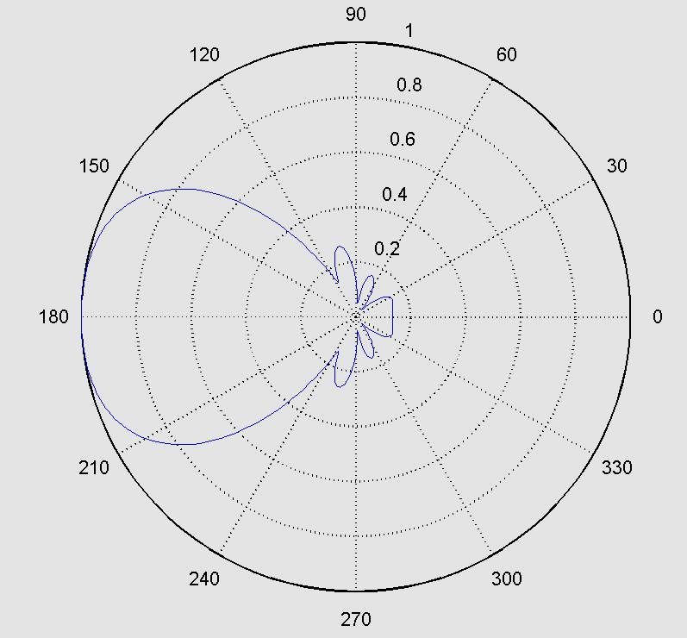 | 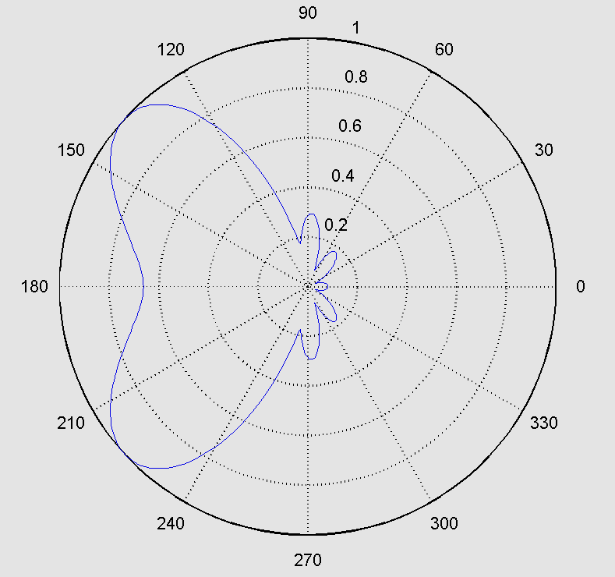
(a) | (b)
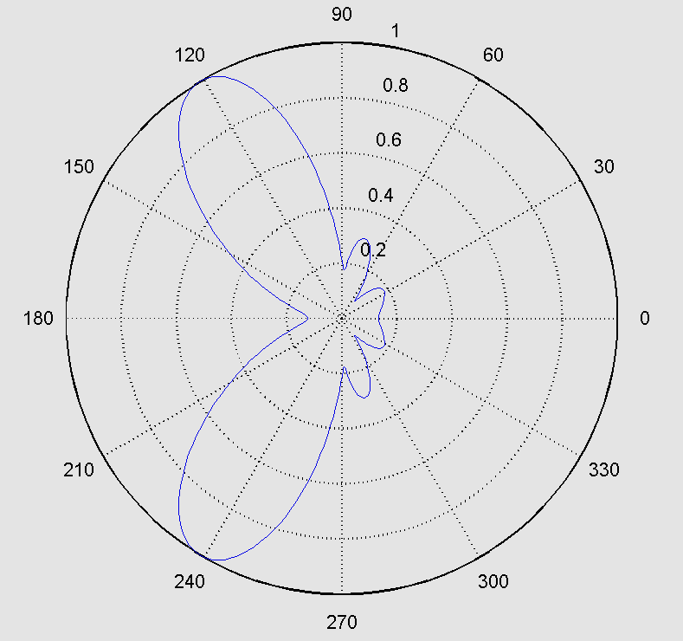 | 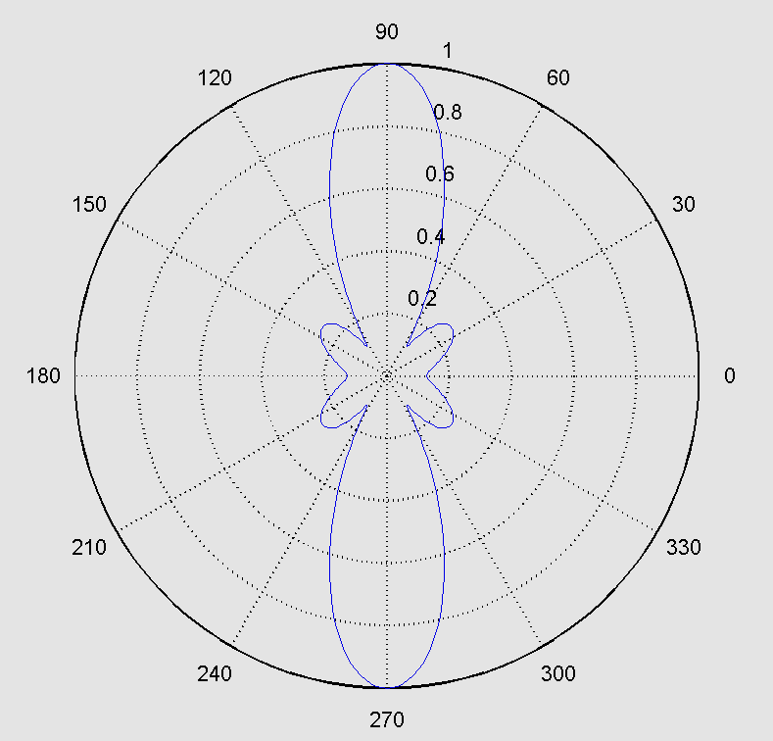
(c) | (d)
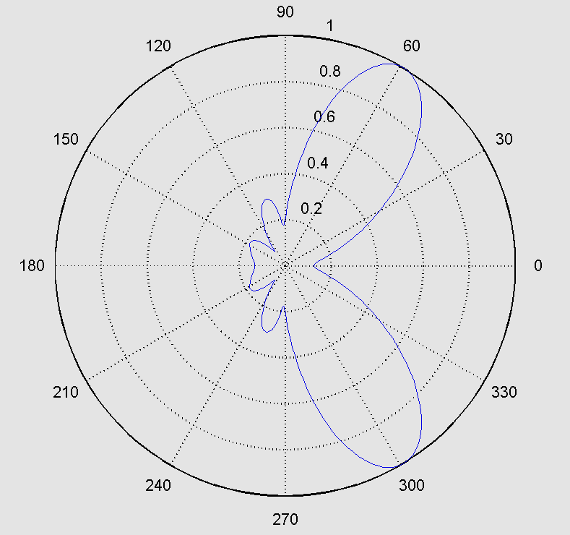 | 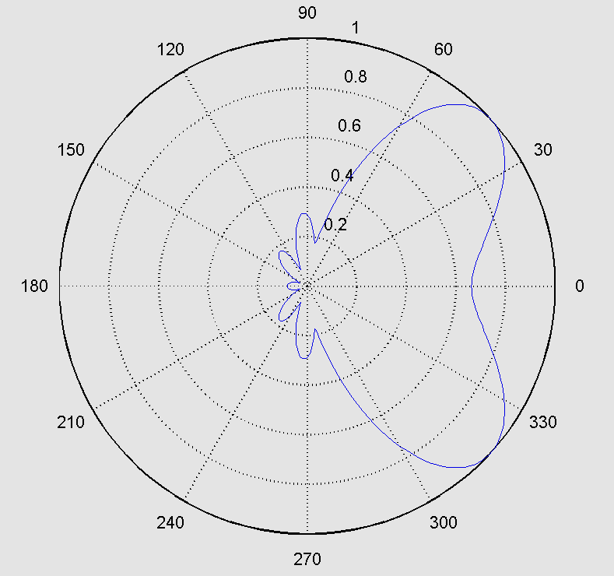
(e) | (f)
Fig. 8: The power pattern and the beam direction of the array antenna for some states of Butler matrix switches
(a) (s₁=1, s₂=1, s₃=1, s₄=1), (b) (s₁=0, s₂=0, s₃=1, s₄=1), (c) (s₁=0, s₂=1, s₃=0, s₄=1)
(d) (s₁=1, s₂=1, s₃=1, s₄=0), (e) (s₁=0, s₂=0, s₃=1, s₄=0), (f) (s₁=0, s₂=1, s₃=0, s₄=0)

Another example of Butler matrix is with 8×8 input/output ports. The proposed model will have 2¹² states so it is difficult to draw all these results. Some of the simulated results are shown in the Fig. 9.

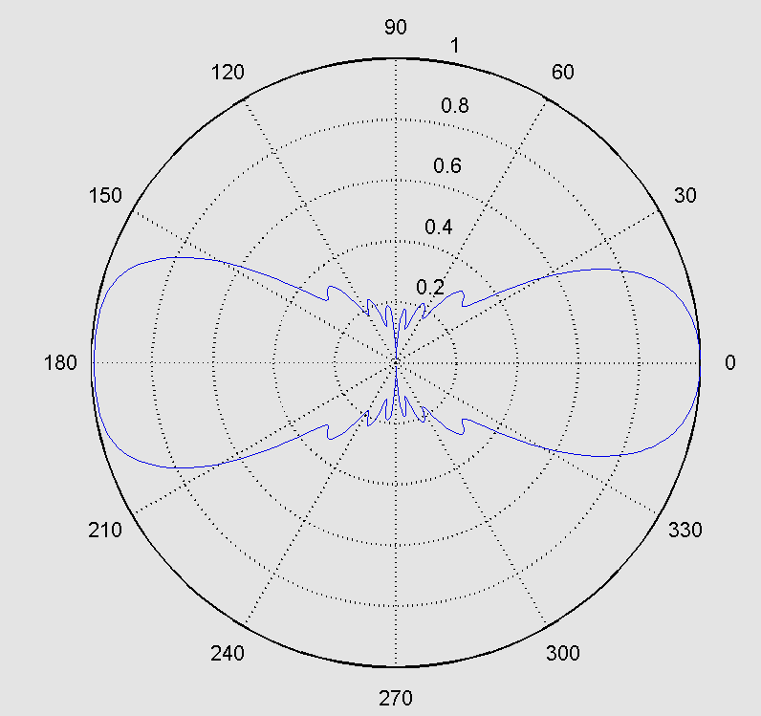 | 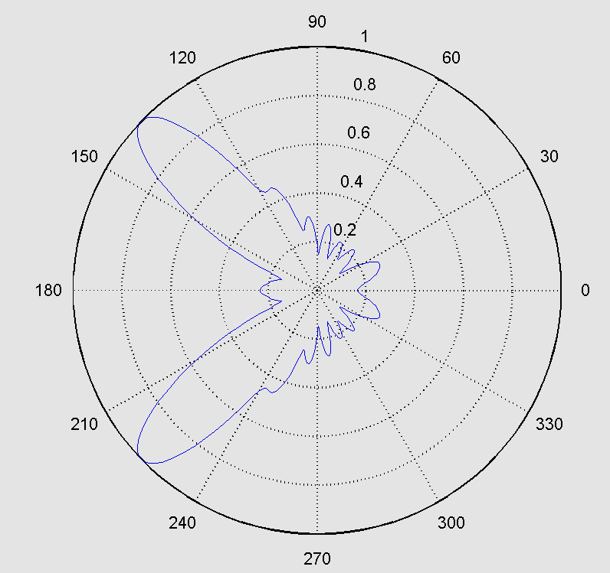
(a) (b)
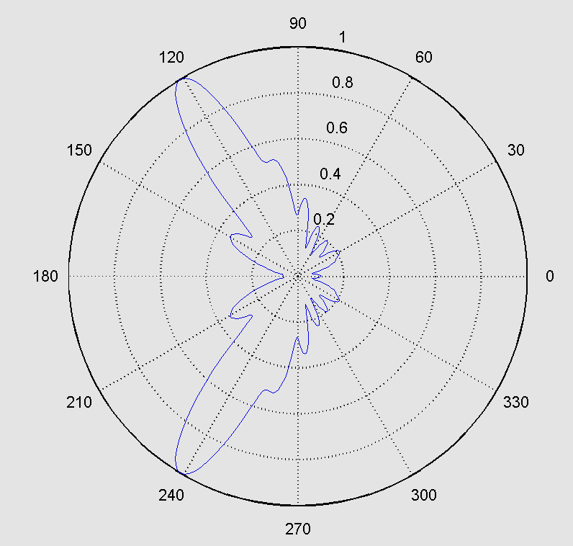 | 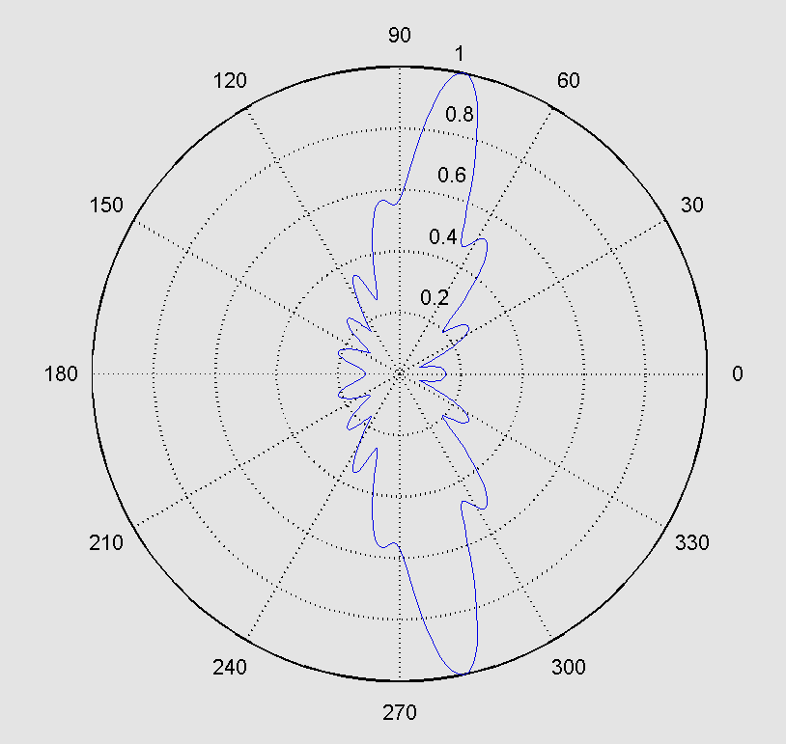
(c) | (d)
Fig. 9: The power pattern and the beam direction of the array antenna when the state of Butler matrix switches are
[ 1 1 1 1 1 1 1 1 1 1 1 1 ]
[ 1 1 1 1 0 1 1 1 1 0 1 1 ]
[ 0 1 1 0 1 1 0 1 1 0 1 1 ]
[ 1 1 1 0 1 1 1 0 1 1 1 0 ]

4. Conclusion
In this paper, a novel beamforming architecture has been proposed and studied due to their potential to fulfill the requirements when a single highly directive beam switched antenna is employed.
The use of optical beamforming networks based on the optical Butler matrix (OBM) has been considered for the 40GHz frequency band. Single-beam option has been considered and detailed architectures have been proposed for a 4 elements array. The proposed beamformer are valid for transmitting and receiving modes.
In the N×N OBM, the number of cases are $2^{{\text{PS}}_{\text{90}}}$ which is 2⁴ (16 cases) in the 4×4 OBM with differential steering angle of (180/16) degree, while the 8×8 OBM have 2¹² (4096 cases) with differential steering angle of (180/4096) degree.
5. References
Bass M., and Van Stryland E. W. 2002, “Fiber Optics Handbook: Fiber, Devices, and Systems for Optical Communications”, the McGraw-Hill Companies, Inc.
Godara L. 1997, "Application of Antenna Arrays to Mobile Communications, Part II: Beam-Forming and Direction of Arrival Considerations", Proceedings of the IEEE, Vol. 85, No. 8, PP. 1195-1245, August.
Hansen R. C. 2001, “Phased Array Antennas”, John Wiley & Sons, Inc.
Koubeissi M., Decroze C., Monediere T. and Jecko B. 2005, “Switched-beam antenna based on novel design of Butler matrices with broadside beam”, Electronics Letters, Vol. 41 No. 20, 29th September.
Piqueras M. A., Vidal B., Herrera J., Polo V., Corral J. L. and Marti J. 2005, “Photonic switched beamformer implementation for broadband wireless access in transmission and reception modes at 42.7 GHz”, Optics Communications, Vol. 249, PP. 441-449.
Saad S. H. 2007, “Optical Beamforming Networks for Linear Phased Array Antennas”, Ph.D. Thesis, University of Basrah.
Stulemeijer J. 2002, "Integrated Optics for Microwave Phased-Array Antennas", Ph.D. Thesis, Delft University of Technology, Netherlands.

