Corrosion Inhibition of Carbon Steel by Sodium Benzoate in 3% by weight NaCl Solution
Hameed Hussein Alwan
Babylon University, College of Engineering
Abstract
In this study, the inhibitor effect of Sodium Benzoate on carbon steel corrosion in a solution for NaCl was investigated. The experiment was carried in solution contain 3%by weight of sodium chloride at room temperature and pH = 7 (neutral solution) as well as the investigations repeated under different temperature (30, 40, and 50 ○ C) on the other hand the effect of pH was investigated by repeat the experiment with different pH (3, 5, 7, and 9), it is found the effect of inhibitor was decrease with increasing temperature and it was increase with increase the solution pH.
Sodium Benzoate has been shown to be an effective inhibitor of the corrosion of carbon steel in a moderately hard mains-water and very dilute (e.g.) sodium chloride solutions. As well as study shows that Sodium Benzoate is less efficient, it is a safe inhibitor since it does not lead to localized corrosion when its concentration is just below the minimum for protection.
الخلاصة
تم في هذا البحث دراسة تأثير إضافة بنزوات الصوديوم كمثبط لتأكل الحديد الكربوني في محلول كلوريد الصوديوم , حيث تم إجراء الفحوصات في محلول متعادل ( ذو رقم هيدروجيني يساوي 7)و بتركيز 3% وزنا من كلوريد الصوديوم في درجة حرارة الغرفة و قد أعيدت التجارب و لكن بدرجات حرارة مختلفة ( 30 , 40 , 50 درجة مئوية ) و قد تم دراسة تأثير تغيير الدالة الحامضية و ذلك باستخدام محاليل ذات قيم دالة حامضية مختلفة ( 3, 5, 7, 9 ) .و قد تم التوصل إلى إن معدل التآكل يزداد مع زيادة درجة الحرارة بالرغم من وجود المثبط و يقل مع زيادة الدالة الحامضية للمحلول و بوجود المثبط
أظهرت النتائج فعالية بنزوات الصوديوم كمثبط لتأكل الحديد الكربوني في المحاليل المتوسطة و المخففة لكلوريد الصوديوم علاوة على ذلك فان بنزوات الصوديوم يعتبر من المواد التي يمكن استخدامها بأمان كمادة مثبطة للتآكل لان بنزوات الصوديوم لاتؤدي إلى حدوث الأكل الموضعي و الذي يحدث عادة عندما تضاف المثبطات بتركيز اقل من الحد الأدنى المطلوب للحماية.
Introduction
Carbon steel, the most widely used engineering material, accounts for approximately 85%, of the annual steel production worldwide. Despite its relatively limited corrosion resistance, carbon steel is used in large tonnages in marine applications, nuclear power and fossil fuel power plants, transportation, chemical processing, petroleum production and refining, pipelines, mining, construction and metal-processing equipment. The cost of metallic corrosion to the total economy must be measured in hundreds of millions of dollars (or euros) per year. Because carbon steels represent the largest single class of alloys in use, both in terms of tonnage and total cost, it is easy to understand that the corrosion of carbon steels is a problem of enormous practical importance. This is the reason for the existence of entire industries devoted to providing protective systems for irons and steel. One possible exception to this statement would be weathering steels, in small additions of copper, chromium, nickel and phosphorus produce significant reduction in corrosion rate in certain environments (Mars Fontana,1987).
NaCl which is plentiful in seawater, brackish water, and many chemical processes waters, by increase NaCl concentration in water, the increasing in corrosion rate is due to enhanced solution conductivity, and with increased NaCl concentration lead to higher dissolved salt and this lead to decrease the solubility of dissolved Oxygen and corrosion rate steadily decrease beyond the maximum at about 3wt % NaCl (Jones, 1996). Oxygen reacts with any ferrous iron ions and converts them to ferric iron. Ferrous iron ions Fe⁺², are soluble in water, bur ferric iron forms an insoluble hydroxide, thus when Oxygen is present in water pitting corrosion may take place .
The Chloride and sulfate ions may cause pitting of metallic by reacting with the metals in solution and causing them stay soluble, thus preventing the formation of protective metallic oxide films (Singely , 1985)
A useful method for achieving in prevent or reduce corrosion is addition of species to the solution in contact with surface in order to inhibit the corrosion reaction and reduce corrosion rate. These species must does their job with out any environment problem, thus attention is now focused on the development of substances non toxic as well as environmentally friendly. The inhibiting action of such compounds as a first stage to the adsorption of additives to the metal/solution interface (Oguzie and et al 2007).
Corrosion inhibitors are selected on the basis of solubility or dispersibility in the fluids which are to be inhibited. For instance, in a hydrocarbon system, a corrosion inhibitor soluble in hydrocarbon is used. Two phase systems composed of both hydrocarbons and water, utilize oil soluble water-dispersible inhibitors. Some inhibitors produce films on the anode and hence stifle the corrosion reaction (iron in chromate or nitrite solutions). Several authors consider the presence of a thick barrier of corrosion products, relatively protective, on the metallic surface as passivation. Inhibitors may enhance the formation of passive films on top of the substrate, such as benzotriazole on copper or benzoate on iron, or they may form monomolecular adsorption layers and prevent the dissolution of the substrate and the reduction of oxygen by changing the potential drop across the interface and/or the reaction mechanism (Sastri, 2007).
Organic Inhibitors similar to Polyphosphate inasmuch must chemisorbed on metal surface to be effective. Since chemisorptions processes are specific to the substrate metal, organic inhibiting vary in effectiveness for different alloy systems. Chemisorptions of an organic compound is facilitated by presence of polar groups in the molecules structure which can readily attached to metal surface. The effectiveness of organic inhibiting molecules may be improved by large size; asymmetry, great molecules weight and high electron density .Molecule structure that include the Benzene ring are especially prevalent (Jones ,1996).
Sodium benzoate (C₆H₅COONa) are further examples of non oxidizing compounds that effectively passivate iron in the near neutral range, apparently through facilitating the adsorption of dissolved oxygen. As little as 5×10⁻⁴ M sodium benzoate (0.007%) effectively inhibits steel in aerated distilled water, but inhibition is not observed in deaerated water. The steady-state corrosion rate of iron in aerated 0.01 M (0.14%) sodium benzoate, pH 6.8, is only 0.001 gmd, whereas in deaerated solution the rate is 0.073 gmd. Inhibition occurs only above about pH 5.5; below this value the hydrogen evolution reaction, for which benzoate ions have no inhibiting effect, presumably becomes dominant, and the passive film of oxygen is destroyed(Uhlig, 2008) . The detailed mechanism of the protective action of sodium benzoate is not yet established , but electrode-potential and film-stripping experiments provide evidence for view that anodic inhibition produces and maintains a continuous film ,as well as it has been suggested that Sodium Benzoate reduces fouling by reducing the tendency of rust and scale to dislodge from corroded surface .
Experimental work
In this study Carbon steel was used .The chemical composition of the metal is given in table 1.
C% | Si% | Mn% | P% | S% | Cr% | Mo% | Ni% | Cu% | V% | Fe%
0.1649 | 0.2559 | 0.5027 | 0.0020 | 0.0068 | 0.0251 | 0.0000 | 0.0088 | 0.1505 | 0.0033 | Rem.
Table 1: the chemical composition of carbon steel used in the study

The corrosive media was 3% by weight Sodium Chloride solution at different pH (5,7,9,and 11) with different temperature (25,30,40, and 50 ○ C) by using a heating water bath with temperature control, the solution was prepare by using Analar NaCl and distilled water while pH of solution was adjusted to the desired value by using HCl and NaOH
Electrochemical polarization test was carried out by using three-electrode cell. The specimen was exposed to the solution after it was prepared by polished on a fine grade of ambry paper up to 800 level and followed by washing with distilled water and finally dried. The electrochemical cell consists to carbon steel as working electrode (WE), a saturated calomel electrode (RE) and graphite as auxiliary electrode (AE), the specimen (WE) was immersed in test solution 500 ml. The circuit was manually composed and the values of current as well as potential were recorded depending on the variable resistance value employed. Figure 1 show the circuit apparatus.

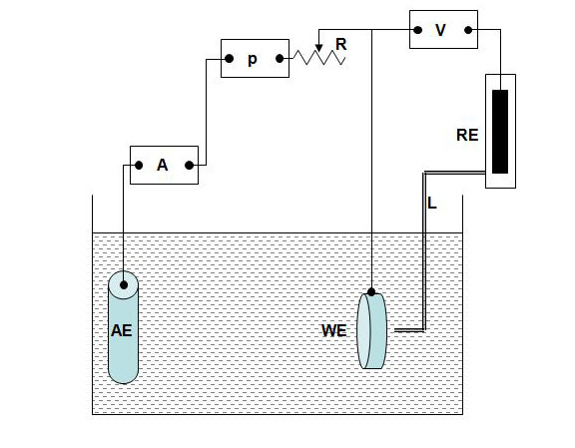
A: Ammeter
AE: Auxiliary electrode
L: luggin capillary
R: resistance
RE: reference electrode
P: power supply
V: voltmeter
WE: working electrode

Fig 1 (a): apparatus of the three electrode cell used in this work.
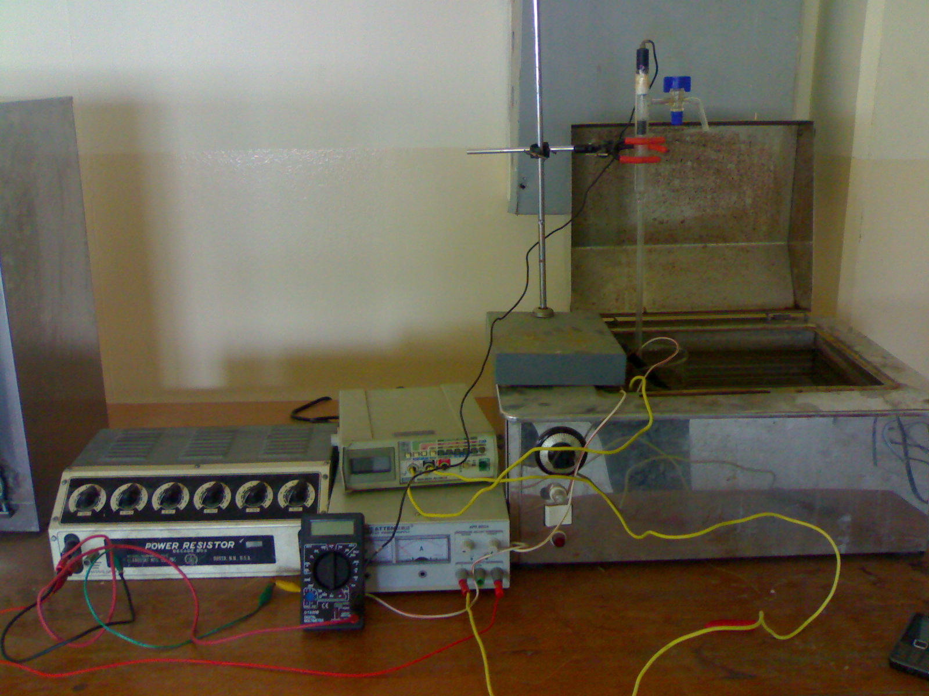
Fig 1 (b): show the arrangement for the devices are used in investigation (Electrochemical Department Lab.)
Results and Discussion
To find the effect of inhibitor on corrosion of carbon steel, Sodium Benzoate was added to solution at concentration 100 ppm and start investigation run by used three-electrode cell, the corrosion currents were obtained with their corresponding corrosion potentials by extrapolation of Tafel slopes of polarization curve which got by investigation. The inhibitor efficiency ($η\text{\%}$) is represented in the below form :
$$η\text{\%}=\frac{i_{∘}−i}{i_{∘}}×\text{100}$$
Where i◦ and i are the uninhibition and inhibition corrosion currents respectively.
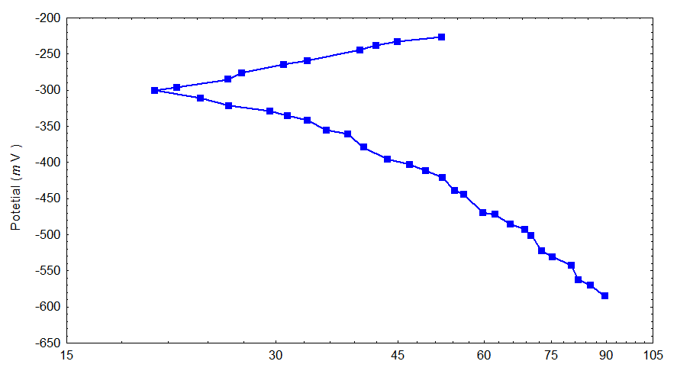
Current Density log i (μ A/ cm ²)
Figure 2: polarization curve for carbon steel in 3% by weight NaCl solution at 25 ◦C and pH=7 without inhibitor.
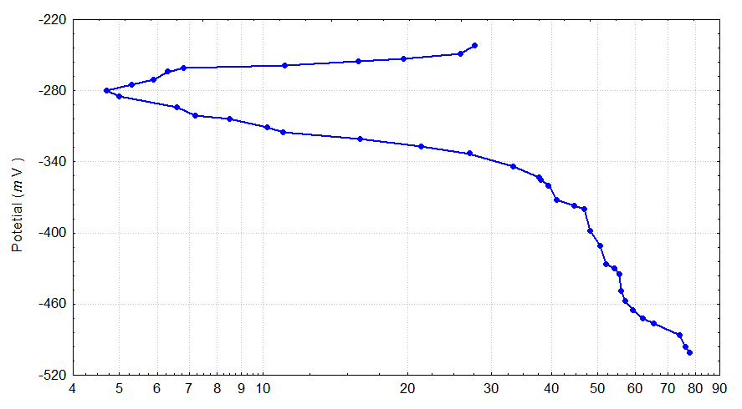
Current Density log i (μ A/ cm ²)
Figure 3: polarization curve for carbon steel in 3% by weight NaCl solution at 25 ◦C and pH=7 after add 100 ppm Sodium Benzoate
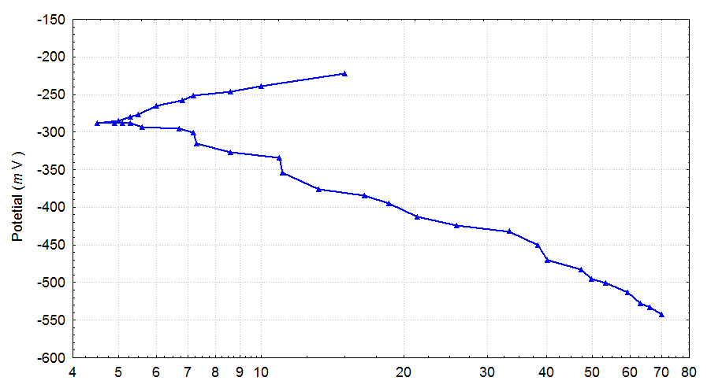
Current Density log i (μ A/ cm ²)

Figure 4: polarization curve for carbon steel in 3% by weight NaCl solution at 30 ◦C and pH=7 after add 100 ppm Sodium Benzoate
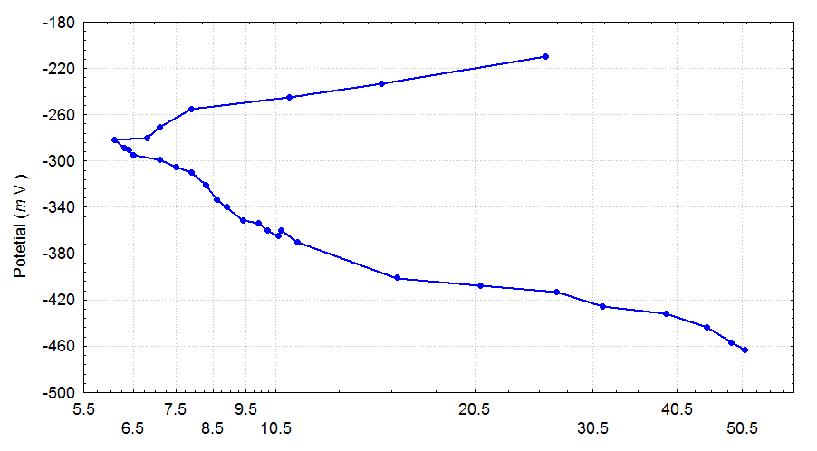
Current Density log i (μ A/ cm ²)
Figure 5: polarization curve for carbon steel in 3% by weight NaCl solution at 40 ◦C and pH=7 after add 100 ppm Sodium Benzoate
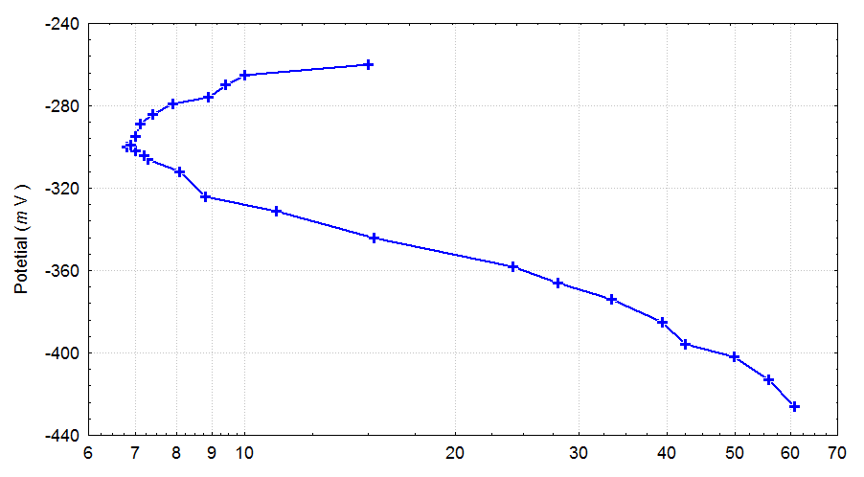
Current Density log i (μ A/ cm ²)
Figure 6: polarization curve for carbon steel in 3% by weight NaCl solution at 50 ◦C and pH=7 after add 100 ppm Sodium Benzoate
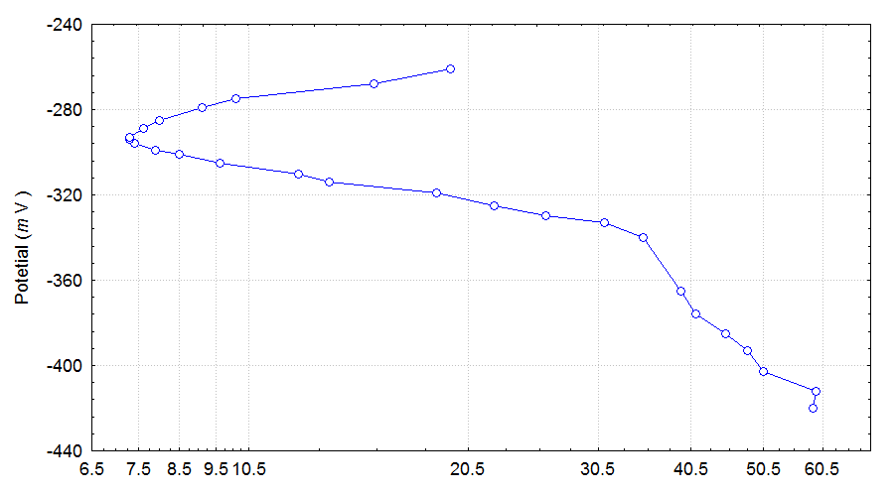
Figure 7: polarization curve for carbon steel in 3% by weight NaCl solution at 25 ◦C and pH=3 after add 100 ppm Sodium Benzoate

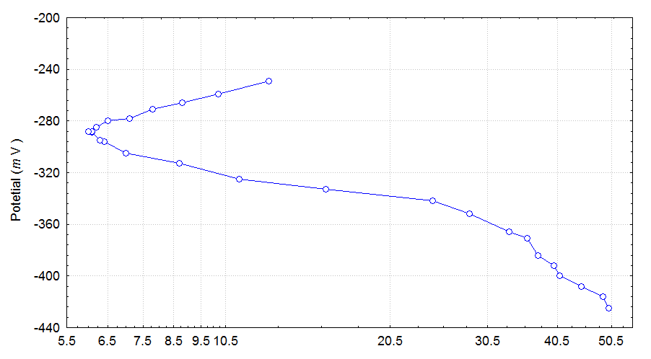
Figure 8: polarization curve for carbon steel in 3% by weight NaCl solution at 25 ◦C and pH=5 after add 100 ppm Sodium Benzoate
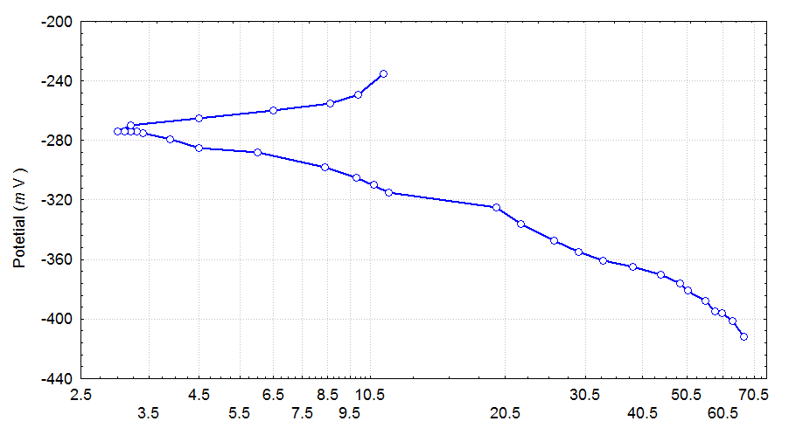
Figure 9: polarization curve for carbon steel in 3% by weight NaCl solution at 25 ◦C and pH=9 after add 100 ppm Sodium Benzoate.

Table 2 summarized all data that got from the investigation runs during this work and as below:
 | Condition | Corrosion potential (mV_{SCE}) | Corrosion rate ( μ A/cm²) | Inhibitor efficiency ($η\text{\%}$)
No add | Temp=25 ◦C  pH=7 | -300 | 20.2 | 0
Add 100ppm | Temp=25 ◦C  pH=7 | -282 | 3.0 | 0.85
Add 100ppm | Temp=30 ◦C  pH=7 | -255 | 3.5 | 0.83
Add 100ppm | Temp=40 ◦C  pH=7 | -267 | 5.1 | 0.75
Add 100ppm | Temp=50 ◦C  pH=7 | -273 | 6.4 | 0.86
Add 100ppm | Temp=25 ◦C  pH=3 | -261 | 5.3 | 0.74
Add 100ppm | Temp=25 ◦C  pH=5 | -277 | 4.1 | 0.80
Add 100ppm | Temp=25 ◦C  pH=9 | -280 | 2.5 | 0.88

It found that the addition of inhibitor decrease the corrosion current (corrosion rate ) with respect to uninhibited case, and it increase with increase temperature in spite of inhibitor presence , while the corrosion rate was decrease in case of decreasing the acidity ( increasing in pH) because this is makes a water potentially is less corrosive .
Conclusion
The inhibitor effect decreased by increasing temperature .Inhibitor efficiency decreased in acidic medium while it is increased in basic one. Sodium benzoate has found considerable application as a corrosion inhibitor, As a liquid phase inhibitor, low concentrations of sodium benzoate have been reportedly been used for corrosion control at a pH as low as 5, but the most effective inhibition appears to be in the pH range of above 7.
References
Jones. Denny A,(1996), Principles and Prevention of Corrosion, 2nd Edition , Prentice Hall , New Jersey, pp 365-366 & pp 508.
Mars Fontana, G. (1987), Corrosion Engineering ,3rd Edition , McGraw-Hill Book Company, New York
Oguzie. E. E, and Wang. F.H. ,(2007),Journal of Colloid and Interface Science, 310, pp 90.
Sastri. V.S. ,(2007), Corrosion Prevention and Protection Practical Solution,2nd Edition, John Wiley & Sons, Ltd, New Jersey, pp .
Singely J.E. and Beaudet B.A. , (1985). Corrosion Prevention and Control in Water Treated and Supply Systems, (1985), Noyes Publication , New Jersy , USA, pp16
Tosun Ayse, and Ergun Mubeccel ,( 2006) , Protection of Corrosion of Carbon Steel by Inhibition in Chloride containing Solution , GU Journal of Science , 19(3) pp 149-154
Ulig H.H. and Winston. R,(2008),Corrosion and Corrosion Control, 4th Edition, John Wiley & Sons, INC., Publication, New Jersey pp 306.
Zaki Ahmad, (2006), Principle of Corrosion Engineering and Corrosion Engineering, Elsevier Science & Technology Books pp .

