Color Edge Detection with the Least Square Numerical Method
Amer K. Hussain
Collage of Science for Woman/Babylon University
Abstract
The edge detection considers the important technical in the digital image processing, many edge detection operator already exist to edge detection in digital color image. In this study we detection the edge for many real color image that represented the type of digital image by using anew operator that is into least square approximation method that one of the type of the numerical method. We using this method to creation algorithm that depends on the local scan of the image in four major directions (the horizontal direction, the vertical directions and the major diagonal direction, and the second diagonal direction), and we using the stander detection edge Sobel operator to comparison between the result, and this work depends on the using the best threshold to detection the edge of the real images.
From the results obtained in this work, that the new method can to detection on the edge in digital color image with high efficiency compare with standard methods used to edge detection. Also the result obtained that the suggested operator that using is very useful to detect the edge in the digital color image.
الخلاصة
تعد عملية كشف الحافة من التقنيات المهمة في معالجة الصورة الرقمية. وقد استعملت عدة مؤثرات للكشف الحافي لكشف الحافات في الصور الرقمية الملونة وقد تم في هذا البحث إيجاد الحافات لعدد من الصور الحقيقية الملونة كأحد أنواع الصور الرقمية وذلك من خلال استخدام مؤثر جديد والذي يعتمد على طريقة التربيعات الصغرى الخطية كإحدى الطرق العددية . حيث استخدمت هذه الطريقة لتكوين خوارزمية تعتمد على مسح الصورة في أربعة اتجاهات أساسية هي الاتجاه الأفقي والعمودي والاتجاهين القطري والرئيسي والثانوي وقد استعملنا مؤثر سوبل القياسي للكشف الحافي للمقارنة بين النتائج و يعتمد العمل على استخدام أفضل شرط العتبة لتحديد الحافات في الصور الحقيقة المستعملة .
تم في دراستنا هذه استخدام ثلاث أنواع من الصور الرقمية الملونة ذات التدرج اللوني المختلف.
نجد من خلال النتائج التي تم الحصول عليها إن الطريقة الجديدة قادرة على كشف الحافات في الصور الرقمية الملونة وبكفائه عالية مقارنة بالطرق القياسية للكشف الحافي . وأوضحت النتائج إن المؤثر المقترح المستخدم مناسب جدا للكشف عن الحافات في الصور الرقمية الملونة .
1- Introduction
Edge detection in color images is an important process in low-level image processing (Audo, 2000). The purpose of a general image understanding system is to recognize objects in a complex scene or document. That, the edge detection is one of the first steps in such a system. (Gonzalez et. al, 1992 , Slawo et. al, 1999)
The color image provides more information than gray value images, means detailed edge information is expected from color edge detection. (Andréa's, 1995)
Edge detection algorithms usually detected sharp transitions of intensity and color within an image. These transitions are characteristic of object edges. Once edges of an object are detected other processing such as region segmentation, text finding, and object recognition can take place. (Slawo Wesoikowski et. al, 1999, Slawomir 1999)
2. Color Edge Detection
For color images, the notion of an edge is much more complex than in grayscale images. In color images, the intensity and the saturation of a color all play apart in determining object boundaries. (Slawomir, 1999, Umbough, 1998)
The physical boundary produces an edge that needs to be captured using a measure that combines the different color characteristics. The use of color in edge detection increases the amount of information needed for processing which complicates the definition of the problem. In color images, a distance measure needs to be use to define the color gradient, that, it is very easy to extend the Roberts, Prewitts, and Sobels operators.( Janakiraman,2008) Most edge detection schemes are base on finding maxima in the first derivative of the image function. The difficulty in extending derivative approaches to color images arises from the fact that the image function is vector-valued. Whenever the gradients of the image components are compute, the problem is how to combine them into one result.
3. Stander Detector Operators
The standard edge detector operators are these used from many searchers in the lasts years. In detector operators, the image process based on the gradient processes (Janakiraman T. N., 2008).
The fundamental types of gradient operators used are Roberts, Prewitts, and Sobel operators. Roberts's operator determines only the edge points without any information's about the edge orientations. (Van de Weijer J. et. al, 2003)
The Sobel operator is the classical standard edge detector (Baker et.al, 1998), it is described in figure (2).The horizontal and vertical differences between the pixels closest to the central pixel.

-1 | -2 | -1
0 | 0 | 0
1 | 2 | 1

1 | 0 | -1
2 | 0 | -2
1 | 0 | -1

Figure (2) Sobel operator 3x3 masks
The gradient of a continues function f(x, y) at (x, y) can be defined as (Yong; Gerbrands; Van Vliet, 1998):
G[f(x,y)]=[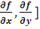…………………..(1)
Pointing toward the direction of largest increase on the function.
Any Cartesian x-y coordinate system can be chosen since it is easy to verify that the gradient (Gonzalez et.al, 1992).
Mag G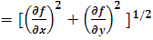 …………….(2)
Because of the digital image can be described as discrete function, we have using the differences instead of the differential. Thus, the approximation of the equation may be taken in the:
G ..(3)
To obtain the gradient image g(x, y), we use the relation:
g(x,y) =G[f(x,y)] ………………..(4)
The solution of this problem can be obtained by using the following threshold condition:
g(x,y)= 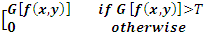……….(5)
Where T is nonnegative threshold.
5. Present Work
In present study, we suggested a method of edge detection are depends on the algorithm of least square carve fitting. We take a sliding mask (like 3x3) and take some steps to detection an edge point in this mask if it's found.
In the first step, we rearrange the pixels of this mask in a pair [x, y(x)], where (x) represents the location (index) of the color levels values y(x), {x=1, 2, 3… n}, n is the total number of pixels in the mask.
The relation then modify in the form of a straight-line relation given in the equation (Richard Burden; Douglas Faires, 2001).
Y(x) = a + b x …………………. (6)
Where a, b are constant can be obtained in the following:
- Compute the summation
,
, ………..… (7)
- From the least square approximation method ,we calculate a and b :
b=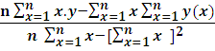 …………….. (8)
a=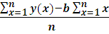 …………….. (9)
The best of derived data can be obtained from equation (6) depends on the values of (a) and (b).
The algorithm used in this work depends on the local scan of the image in four major directions as see in algorithm (1). For digital image of (3x3), the image function can be writing in the form:
$f(x,y)=\left[\begin{matrix}(x−1,y−1) & (x−1,y) & (x−1,y+1) \\ (x,y−1) & (x,y) & (x,y+1) \\ (x+1,y−1) & (x+1,y) & (x+1,y+1)\end{matrix}\right]$…… (10)
The four major direction of the matrix can be representing in the figure (3).

1 | 2 | 3 |  |  | 1 |  |  | 1 |  |  |  |  |  | 1
 |  |  |  |  | 2 |  |  |  | 2 |  |  |  | 2
 |  |  |  |  | 3 |  |  |  |  | 3 |  | 3
(a) |  |  |  | (b) |  |  |  | (c) |  |  |  | (d)
Figure (3) the four direction of mask (3x3)
Where (a) and (b) represents the horizontal and vertical directions, respectively, (c) and (d) are the two diagonal directions.
The pixel at (x , y) has neighbor in horizontal direction as (x,y-1) , (x,y+1) and in the vertical direction as (x-1,y) , (x+1.y) , and the neighbors in the major diagonal direction as (x-1,y-1) , (x+1,y+1) while in the second diagonal direction (x-1,y+1),(x+1,y-1).
From the above step, we determine the pixels of all directions of the image.

Assume that the x-axis represent the local and y-axis represent the color levels Y(x), where (x=1, 2, 3, 4… n) and (n) is the total number of points in this direction.
From the pair [x, y(x)], can calculate the values of (a, b) from equation (8) and (9). Then we can find the equation of the best line of data for the image y(x) due to equation (6). In the next step, we compute the error between y(x) and Y(x) using the relation:
$\text{Er}=\frac{1}{n}\sum_{x=1}^{n}{\left|y(x)−Y(x)\right|}$……………. (11)
If the value of the error compute in equation (11) is small, that means the determining region in this direction is a homogenous region.

Start algorithm

i. Load the image.
ii- Input size of sliding mask (3x3).
iii- Input the value of threshold (th).
iv- Apply the sliding mask on the image plane, then extract the values from mask by using four major directions the horizontal direction, the vertical directions and the major diagonal direction, and the second diagonal direction, Avery one independent on the other.
- v. Analyses every pixel value from the extracted pixels values to the (r, g, b,) band.
- vi. Then re-ascending the resulted red band (r) data in increasing manner and present in
a vector$y(x)$, where (x=1, 2, 3…n), where n is the number of extracted values, initially used Red band (i.e. y(x) =r).
vii. Estimate ($a$ and$b$) of the best fitting line for the sorted data in
vector y(x), by using eqs. (8) and (9), then can be apply the equation of the best fitting line Y(x) by eq. (6).
- viii. Estimate the absolute error ($E_{r}$) between the data y(x) and the
approximated curve Y(x), by eq. (11).
viiii. Repeat the steps (v, vi, vii and viii) for (g band) and (b band) in order to find
seven errors values.
x. Compare the seven errors value that comes from the steps above and take the greet errors have been computation ($m_{g}$).
xi. Experimented the point (x, y) if can represented an edge point or not, by using the condition below:
If $m_{g}$ > th. , then the elements (x, y) represented an edge point edg(x, y), otherwise the elements belong to the homogenous regain edg(x, y) =0.
xii. The result matrix it was the edge matrix.

End Algorithm

Algorithm (1) shows the linear fitting algorithm to detect edges for the color image by using four major directions sliding mask on the image plane.

6. Results and Discussion
In this study, three different color images are used, they can describe as:
1- Lina image: it is real image of (512 x512) pixels and color distribution (24 bits/pixel).this image is of a distinguish different color levels.
2- Geometric image: it also real image of (512 x512) pixels and (256) color distribution. It has distinguished color levels and
3- House image: this real image of (256 x256) pixels and (256) color distribution. The description of this image compare with two above, it has color levels between lina and the geometrical images. Figure (4) show the three images.
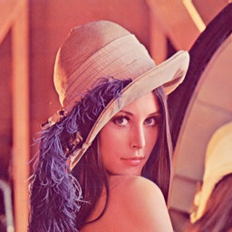
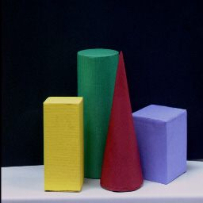
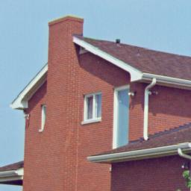

(c) (b) (a)
Figure (4) show the three images where
(a) Lina image. (b) Geometrical image. (c) House image.

The new method used in this study is the linear fitting algorithm to detect edges for the color image by using four major directions sliding mask on the image plane.
The stander Sobel operator have been used in this work to compare the results obtained from the applicated this operator on the images above with the results obtained from the applicated the new suggested operator on the same images .
This result shown in figure (5)

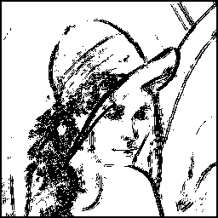
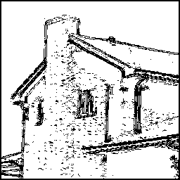
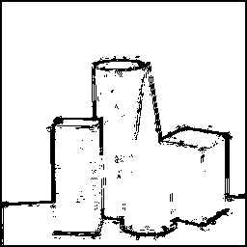

(c) (b) (a)
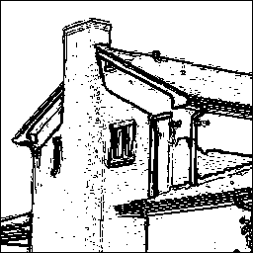
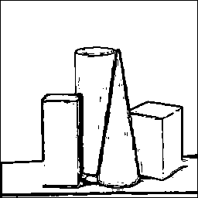
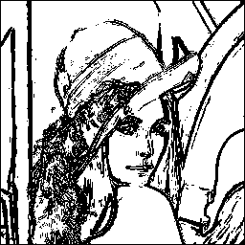

(f) (e) (d)

Figure (5) show the result where
(a) ,(b), (c) Results of the edge detection for three images by using Sobel operator. (d) ,(e), (f) Results of the edge detection for the same three images by using suggested operator.

As we see from the results above, the new suggested operator used in this study that can able to detect the edge of color images compared with stander Sobel operator .Also the linear fitting algorithm to detect edges for the color image by using four major directions sliding mask on the image plane is a best method to edge image detection.
References
Andréa's Koschan, "A comparative study on color Edge Detection ", Accv, Singapore, vol.III, pp.578, 1995.
Audo S.," Consistent Gradient Operators," IEEE Trans, Pattern AnalysisMachine Intelligence, Vol.22, pp.252-265, 2000.
Audo S.," Image Field Categorization and Edge comer detection from Gradient Covariance ", vol.22, pp 179-190, 2000.
Baker S., Nayar S.K. and Murase H.," Parametric Feature Detection ",Int'1 J.computer Vision ,vol.27, pp 27-50,1998.
Gonzalez R.C. and Wintz P., "Digital Image Processing", Addision-Wesley, 1992.
Janakiraman T. N., and Chandra Mouli P. V. S. S. R., " Color Image Edge Detection using Pseudo-Complement and Matrix Operations", Proceedings of World Academy of Science, Engineering and Technology Volume 32, ISSN 2070-3740, 2008.
Richard Burden L.; Douglas Faires J.," Numerical Analysis ", Cambridge University Press, 2001.
Slawo Wesoikowski and Ed Jemigan,"Color Edge detection in RGB Using Jointly Euclidean Distance and Vector Angle" Trois - Rivieres, Vision interface, Canada, 1999.
Slawomir Borgumil,"Color Similarity Measures,"PhD Theses, Waterloo, Ontario, Canada, 1999.
Umbough S.E., "Computer Vision and Image Processing a practical Approach Using CVIP Tools". Prentice-Hall, 1998.
Van de Weijer J.; Gevers Th. and Geusebroek J.M., " Color Edge Detection by Photometric Quasi-Invariants", Proceedings of the Ninth IEEE International Conference on Computer Vision (ICCV 2003) 2-Volume Set,2003.
Yong I.T.; Gerbrands J.J.; and Van Vliet J., "Fundamentals of Image Processing", Printed in the Netherlands at the Delft University of Technology, 1998.

