Experimental Studies on The Fire Endurance of Reinforced Concrete Beams
Mohammed Mansour Kadhum  Babylon University  College of Engineering | Nada Mahdi Fawzi  Baghdad University  College of Engineering | Khalid Safa'a Hashim  Babylon University  College of Engineering

Abstract
In this study, some mechanical properties and deflection behavior of rectangular reinforced concrete beams under the effect of fire flame exposure is presented. The properties investigated were compressive strength and load-deflection behavior of rectangular reinforced concrete beams under the effect of fire flame exposure. The concrete specimens and beams were subjected to fire flame temperatures ranging from (25-800) °C at different ages of 30, 60 and 90 days, three temperature levels of 400, 600 and 800 °C where chosen for exposure duration of 2.0 hours.
The test results showed that the residual compressive strength ranged between (67-76 %) at 400 °C, (58-66 %) at 600 °C and (28-51 %) at 800 °C.
It was noticed that the load-deflection relation to specimens exposed to fire flame are flat , representing softer load deflection behavior than that of the control beams. Also, it was found that the shrinkage values increase with temperature increase.
الخلاصة
في هذا البحث تم دراسة تأثير لهب النار المباشر على بعض الخواص الميكانيكية وسلوكية العلاقة بين الحمل والانحراف.تم تعريض النماذج الخرسانية للنار بدرجات حرارة تراوحت بين ( 25-800 ) درجة مئوية وبأعمار مختلفة تراوحت ( 30 , 60 , 90 ) يوما مع ثلاث مستويات للحرارة ( 400 , 600 , 800 ) درجة مئوية ولمدة ساعتين.
لوحظ من النتائج أن مقاومة الانضغاط المتبقية كانت قد تراوحت بين ( 67-76 % ) في درجة 400 درجة مئوية و ( 58-66 % ) في درجة حرارة 600 درجة مئوية و ( 28-51 % ) في درجة 800 درجة مئوية. أما بالنسبة للعلاقة بين الحمل المسلط والانحراف في العتبات الخرسانية المسلحة فأن الحمل الأقصى اقل من قيمتها قبل التعرض إلى لهب النار.
Introduction
Concrete is universally used as a construction material which can be molded into any shape that man desires can be provided at a reasonable cost a material that can be designed to ensure high compressive strength Kadhum (2003).
In the structural design of building, in addition to the normal gravity and lateral loads, it is in many cases necessary to design the structure to safely resist exposure to fire. However it is usually necessary to guard against structural collapse for a given period of time Shetty ( 1998 ).
The main goals of this study are :
1-studying the fire effect on the mechanical properties of concrete, such as a compressive strength , drying shrinkage before and after exposure to fire flame .
2- investigation the fire endurance of reinforced concrete beams .
3 -studying the fire flame effect on the immediate deflection of reinforced concrete beams and comparing the results with control beams .
4-studying the fire effect on the cracking tendency and pattern in reinforced concrete beams before and after exposure to fire flame .
5 -studying the fire flame effect on the shrinkage cracking of the specimens before and after exposure to fire flame .

- Fire Effect on the Mechanical Properties of Concrete
Elizzi etal. in (1987) investigated the influence of different temperature on the compressive strength and density of concrete. They used (100*100*100 mm) cubes heated for a short duration (one hour) to temperature ranging from (20-100) °C and the ages of concrete at heating were ( 14 , 28 , 90 days ). The test results showed that the compressive strength decreased 10 % from the original strength up to 400°C and at 600°C the strength reduction was 50% from the original. They noticed that there was a large strength reduction when heated to temperatures above 400°C. They also mentioned that the small reduction in density up to 300°C was a result to the loss of the free water from concrete specimens. At temperature above 300°C, large reduction in density took place because of loss of the reduction water in concrete.
Habeeb in (2000) investigated the effect of high temperature on the mechanical properties of high strength concrete (HSC). The specimens were subjected to elevated temperature ranging between (100-800) °C. Five temperature levels of (100, 300, 500, 600 and 800 °C) were chosen with three different exposure duration of 1, 2 and 4 hours without any imposed loads during heating . the specimens were heated and cooled under the same regime and tested either one day or one month after heating. Compressive strength of 100 mm cubes and flexural strength (100*100*500mm) prisms were measured . Ultrasonic pulse velocity ( U.P.V) and dynamic modulus of elasticity (Ed) were tested also. He observed that ( HSC) was more sensitive to high temperature exposure than normal strength concrete ( NSC ) . He found that the residual compressive strength ranged between ( 90 -100 % ) at 100 °C, ( 70-103 %) at 300 °C, (55- 87 % ) at 500 °C and ( 22-66 % ) between (600 -800) °C.
He also found that ultrasonic pulse velocity (U.P.V) and dynamic modulus of elasticity (Ed) were more sensitive to elevated temperatures than the compressive strength he also noticed that exposure time after on hour has a significant effect on residual compressive strength of concrete .
- Shrinkage of Concrete Before and After Burning
Neville (1995) reported that the given workability, which approximately means a concrete water content, shrinkage is unaffected by an increase in the cement content, or may even decrease, because the water /cement ratio is reduced and the concrete is therefore, better able to resist shrinkage.
Habeeb in (2000) found from the test results, that the additional shrinkages values due to heating are between (400-800) °C micro strains, and there is no significant increase in shrinkage values due to the increase of exposure time from 1.0 to 4.0 hours. shrinkage values were not more than 10 % of that at 1.0 hour exposure.
- Fire Effect on Reinforced Concrete
The behavior of reinforced concrete structure exposed to fire depends on the thermal properties of steel and concrete, strength and stiffness properties of the concrete and steel at elevated temperatures, and on the ability of the structure to redistribute internal forces during the course of the fire Purk- Kiss (1984).
Asa´ad in (1987) studied the behavior of structural reinforced concrete specimens subjected to elevated temperature. Four type of reinforced concrete samples were used. Singly and doubly reinforced concrete beams having the dimension of (100*100*1100 mm) were used. The double reinforced with both tension and compression steel, while the singly reinforced beams with tension steel only. Continuous beams (100*150*1300mm) and structure frame with outer dimensions of (900*150*1300 mm) and structure frame with outer dimensions of (900*750mm) were used. The frame had a cross-section of (100*150mm) for the beam and (100*100mm) for the column. The specimens were subjected to temperatures of (150, 300, 600, 750 and 900 °C ) at the ages of 30 and 90 days and tested the flexure after cooling. The research found that both flexural strength and stiffness decreased with the temperature increase. He also noticed that the use of top reinforcement had limited this decrease. Moreover, he observed that the increase in temperature led an increase in magnitude of moment redistribution in continues beams .
Experimental Work
- Introduction
The experimental work was carried out to decide upon the temperature range and duration of burning. It was decided to limit to maximum exposure to fire flame to about 400 °C, 600 °C and 800 °C with two different exposure durations of 1.0 and 2.0 hours which covered the range of situation in the majority of elevated temperature test.
- Materials and Mixture Properties
In this investigation, the cement used Ordinary Portland Cement (O.P.C) product at kufa factory. This cement complied with the Iraqi specification No.5 (1984). The physical properties and chemical composition are presented in table (1). The gravel used was brought from Al-Nibaii area with a maximum size 19 mm and the fine aggregate Al-Akhaider well graded natural silica sand was used. Deformed steel bars of 10 mm diameter were used for longitudinal reinforcement and plain bars of 6mm were used for stirrups.
The concrete mix was designed according to British mix design method BS 5328 : part 2 :1991, the concrete proportions of the concrete mix are summarized in table (2).

Table (1) : a – physical properties of cement
Physical properties | Test results | IQS :1984 limits  No.5
Fineness, Blaine, cm²/gm  setting time , vicat´s method  Initial hrs : min  Final hrs : min  Compressive strength of 70.7 mm cube , MPa  3 days  7 days | 3190  1 : 35  3 : 50  23.5  28 | ≥ 2300  ≥ 1 : 0  ≤ 10 : 0  ≥ 15  ≥ 23

B – Chemical Properties of the Cement
Oxide | % | IQS :1984 limits  No.5
CaO  SiO2  Fe2O3  Al2O3  MgO  SO3  Free lime  L.O.I  I.R | 60.50  20.36  3.25  6.30  4.14  2.32  0.72  1.62  0.66 | ≤ 5  ≤ 2.8  ≤ 4.0  ≤ 1.5

Table (2): Mix Properties
 |  | Weight proportion | Mix properties kg / m³
Slump mm | w/c ratio | Cement : sand : gravel | Water | Cement | Sand | Gravel
60 | 0.45 | 1.0 : 1.2 : 2.7 | 195 | 435 | 525 | 1215

Volume Change of Concrete
- Test Specimens
For the volume changes tests, prisms, specimens of ( 100*100*500mm) were used in this work, multi position gauge was used for measurement. an extensometer while more type, with an accuracy of (0.002mm /division ) was used to measure strain in the panels prisms .
- Test Procedure
Shrinkage tests were performed according to ASTM C 157 : 93 setting gauge plugs : the gauge length was selected to be 200 mm, the stainless steel in the figure (1). Specimens were cured in water at age of 28 days. The specimens were exposed to drying in laboratory for another 28 days ( i.e. 28 days curing in water + 28 days air dried in laboratory ) .

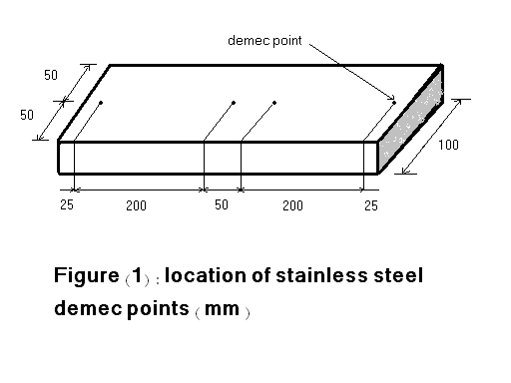

- Drying Shrinkage
The drying shrinkage was monitored for the concrete after the 28 days in water and the measurements were done from 28 days to 60 days age at ages of 29, 32, 37, 45 and 60 days.
- Shrinkage after Burning
Shrinkage of specimens were monitored after exposure to fire flame and cooling the laboratory to room temperature. Shrinkage was measured after the specimens were cooled to room temperature, at ages of ( 1, 3, 7, 15 and 30 days ) after burning.
- Burning and Cooling
The concrete specimens and the reinforced concrete beams were burnt with direct fire flame from a net work of methane burners inside the frame. The dimension of this burner net are (1500*1500mm) (length * width ) respectively as shown in plate (1). The bars of flame were intended to simulate the heating condition in a actual fire. When the target was reached, the temperature continuously measured by digital thermometers, one of them was positioned in the bottom surface of the beams in the contact with the flame, while the other was positioned at the unexposed upper surface of the beam, and by thermocouple that was inserted in the near center of each beam to measure the temperature at the mid-depth (75 mm from the exposed or unexposed surface ).
The measurement devices are shown in plate (2). After burning the concrete specimens and the reinforced concrete beams were quenched immediately in water for 2.0hours and then stored in laboratory environment about 20 hours also before testing.

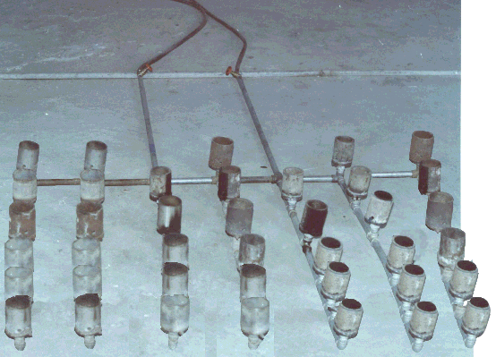
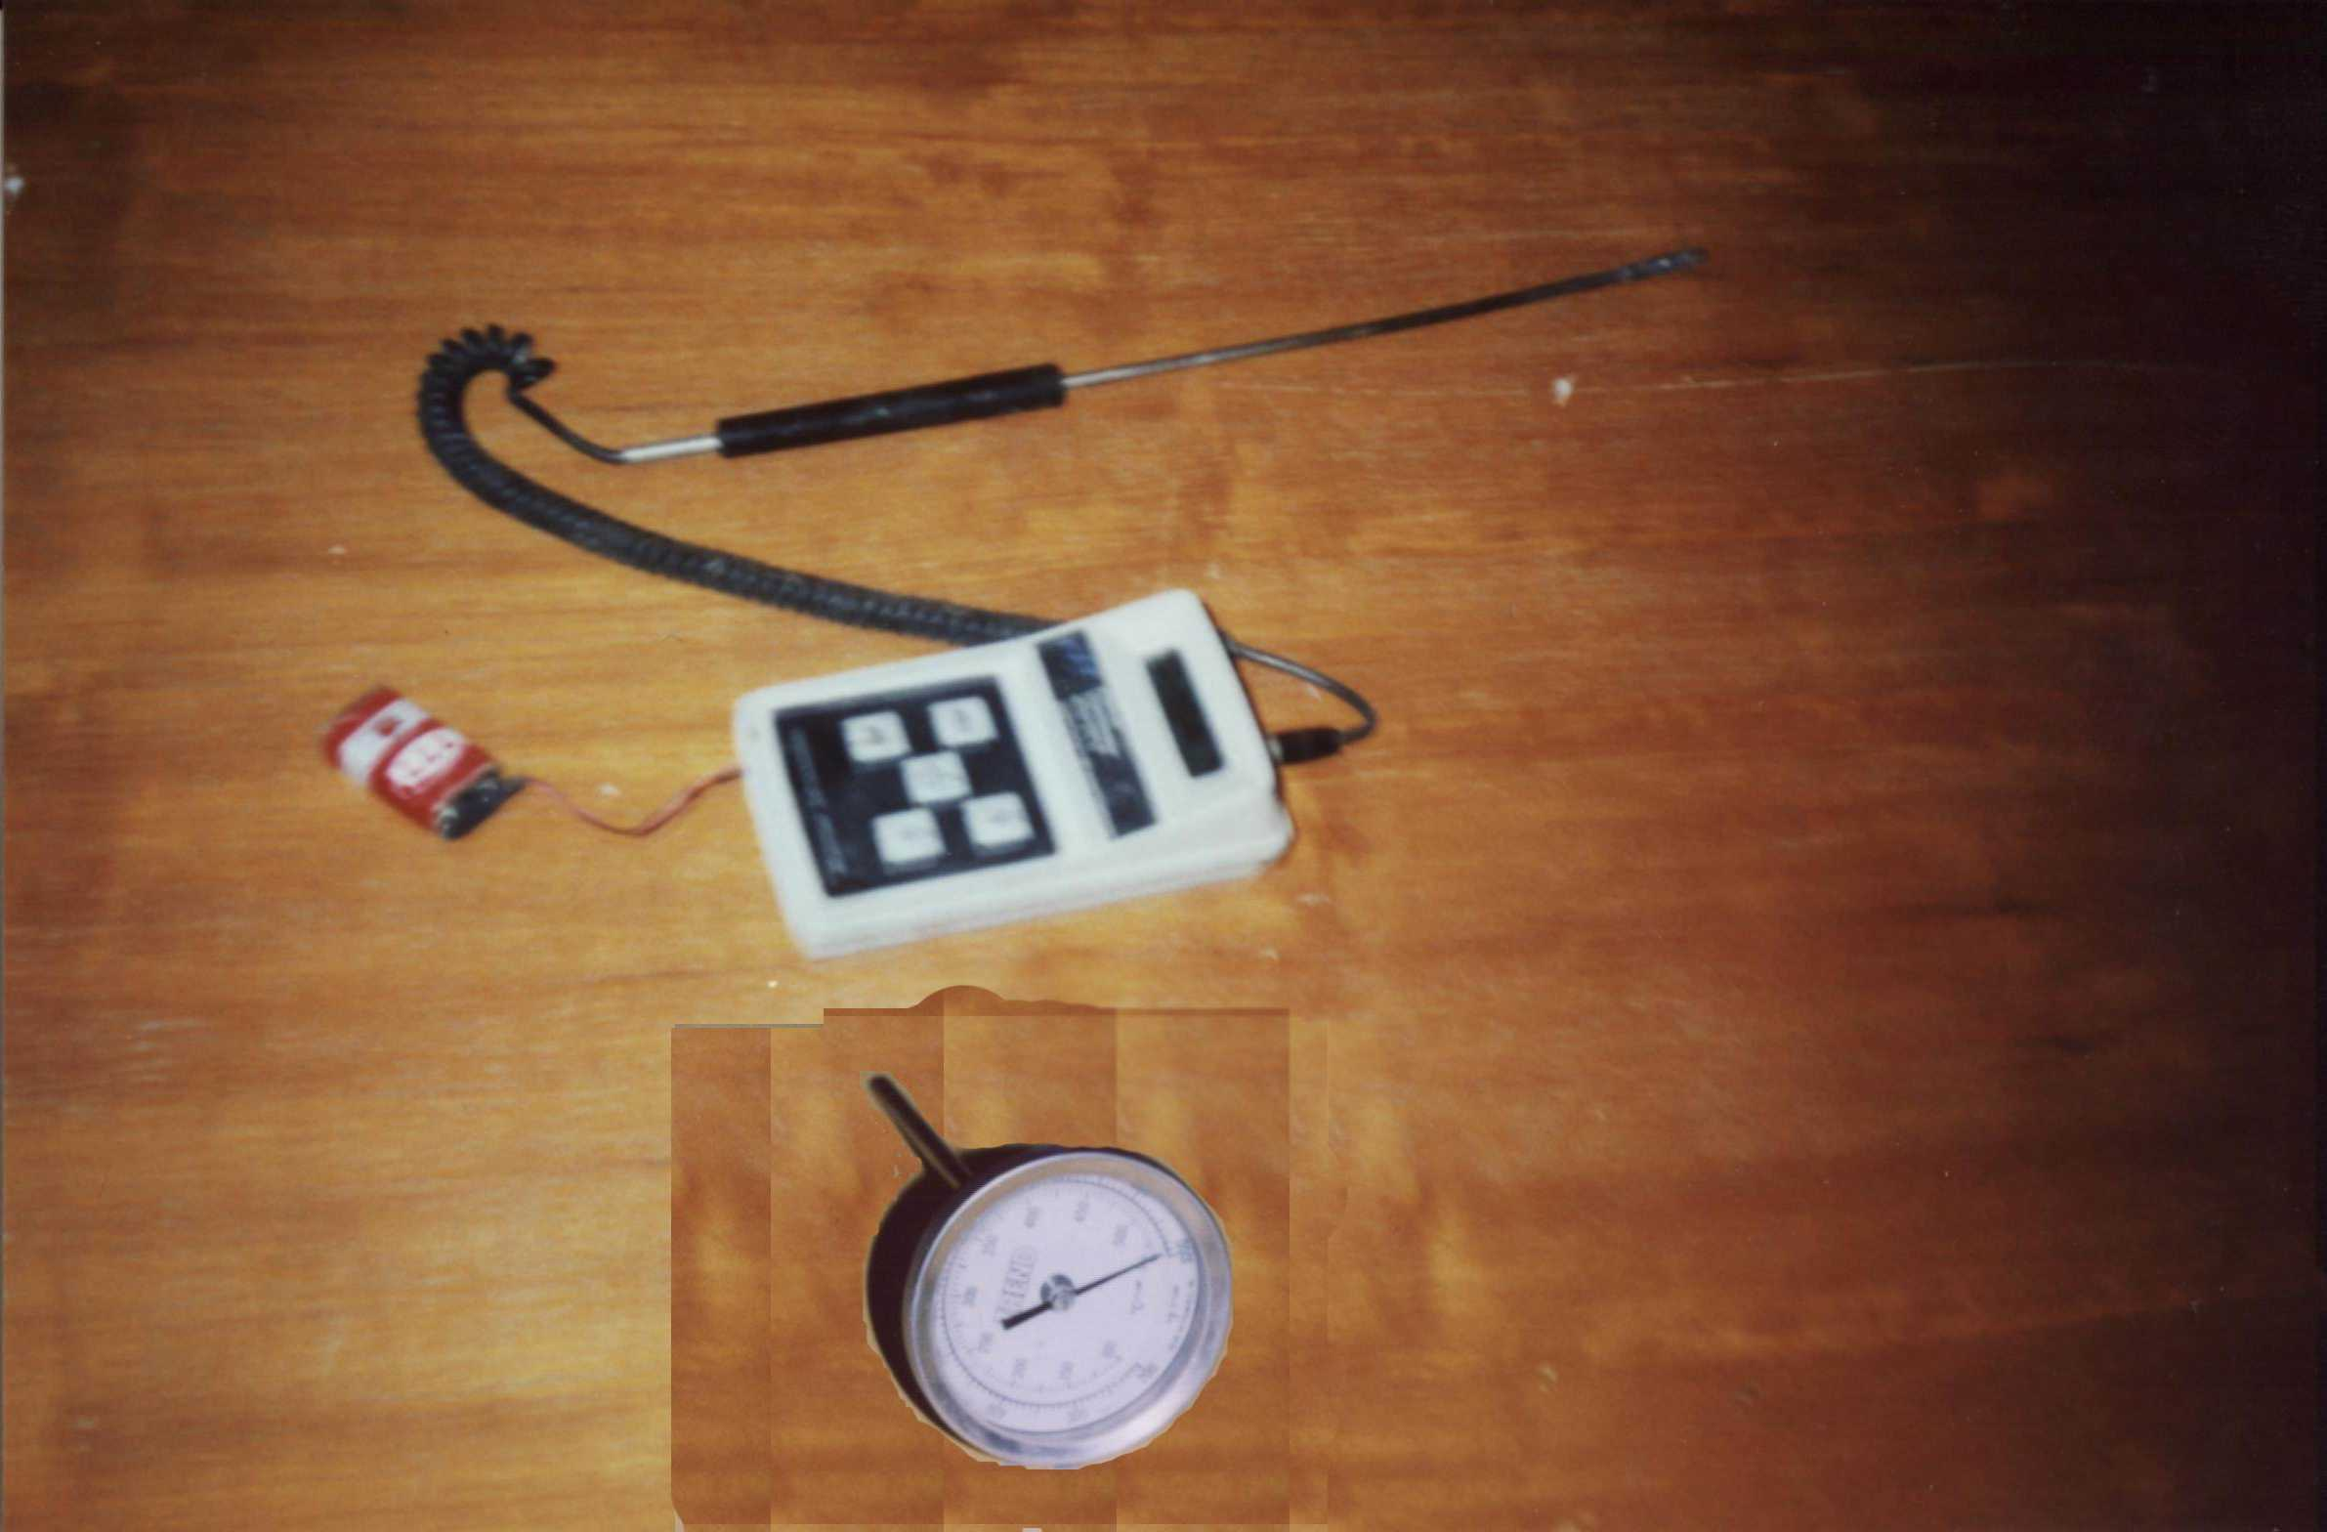
Plate(1) : The work of net methane burners. burners
Plate(2) : Temperature measurements devices .

- Beams Specimens Preparation and Details
The total number of beams cast was sixteen samples. Four beams were retained as reference Beams for 30 days of age, twelve were exposed to fire flame with different temperature, different periods of exposed. The beams were covered with polyethylene sheet in the laboratory for about 24 hours, and then demolded for curing in water for 28 days.
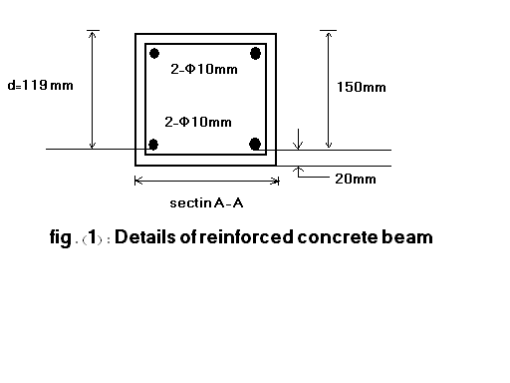
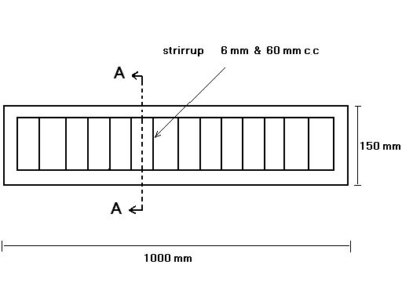
The beams were simply supported. All beams were 1000 mm length, 150 mm height and 100 mm width as shown in figure (2) .
2

Result and Discussion
-Compressive Strength
Table ( 2) show the effect of the exposure to fire flame on compressive strength, while figures (3 and 4) show the relation between compressive strengths and fire flame temperature. It is clear from these figures that the residual compressive strength after exposure to fire flame the reduction at 30 days age was more than the reduction at 60 and 90 days. It can be seen from these table and figures that the compressive strength behaved as the following:
At 400 °C, the residual compressive strength compared to the original strength before exposure to fire flame were ( 67 – 76 % ). These results are similar to that obtained by Al-Ausi and Faiydh ( 1985), Umran (2002) and Chih-hung (2005) was ( 60 – 71 % ) and (67 – 82 % ) respectively .
At 600 °C, the residual compressive strength compared to the original strength before exposure to fire flame was ranged from ( 58 – 66 % ) these results confirmed that of Habeeb ( 2000 ) and Karim ( 2005 ) .
At 800 °C, it was found that the residual compressive strength after exposure to fire flame ranged from ( 28 – 51 % ) these results agreed with that obtained by Habeeb (2000).
Table (3): Test values of compressive strength of concrete specimens before and after exposure to fire flame.
Age at exposure (days) | Period of exposure (hours) | Compressive strength (MPa) |  |  |  | Rtios  F_{ca} / F_{cb}
Age at exposure (days) | Period of exposure (hours) | Temperature (°C)
Age at exposure (days) | Period of exposure (hours) | 25(1) | 400(2) | 600(3) | 800(4) | (2/1) | (3/1) | (4/1)
30 | 1.0 | 41.80 | 30.06 | 23.20 | 18.70 | 0.72 | 0.55 | 0.45
30 | 2.0 | 41.80 | 26.40 | 21.82 | 16.12 | 0.63 | 0.52 | 0.38
60 | 1.0 | 44.65 | 31.76 | 27.60 | 21.30 | 0.71 | 0.62 | 0.49
60 | 2.0 | 44.65 | 28.20 | 25.0 | 19.80 | 0.63 | 0.56 | 0.44
90 | 1.0 | 46.82 | 32.64 | 28.0 | 22.24 | 0.69 | 0.59 | 0.48
90 | 2.0 | 46.82 | 29.0 | 26.65 | 20.43 | 0.62 | 0.57 | 0.44

F_{ca}= compressive strength (cube) after exposure to fire flame.
F_{cb}= compressive strength (cube) before exposure to fire flame.
Figure (3): The effect of fire flame on the compressive strength at 1.0 hour period of exposure.

Figure (4): The effect of fire flame on the compressive strength at 2.0 hour period of exposure.

- Modulus of Elasticity of Concrete
Test results of the modulus of elasticity are summarized in Table (3). Figures (5and 6) illustrates the relationship between the residual modulus of elasticity and fire flame temperatures. From these results, it can be seen that the reduction values of concrete modulus of elasticity were more significant than that of the compressive at identical fire flame temperatures.
At 400°C, there was a significant reduction in the concrete modulus of elasticity due to effect of fire flame. The residual value of modulus of elasticity was ranged from (64-70%).
At 600°C, the f residual value of modulus of elasticity was (28- 31%).
At 800°C, the residual value of modulus of elasticity was (18-22%). The reduction in modulus of elasticity of concrete can be attributed to the increase in the amount of cracks formation due to exposure to fire and the physico - chemical transformation in concrete constituenents during burning will yield strength loss . These results conformed that of Umran (2002) and Karim (2005).
Table (4): Test values of modulus of elasticity of concrete before and after exposure to fire flame .
Age at exposure (days) | Period of exposure (hours) | Modulus of Elasticity of Concrete (GPa) |  |  |  | Rtios  mca / mcb
Age at exposure (days) | Period of exposure (hours) | Temperature (°C)
Age at exposure (days) | Period of exposure (hours) | 25(1) | 400(2) | 600(3) | 800(4) | (2/1) | (3/1) | (4/1)
30 | 1.0 | 34.5 | 23.0 | 10.7 | 7.6 | 0.67 | 0.31 | 0.22
30 | 2.0 | 34.5 | 20.4 | 10.2 | 6.9 | 0.50 | 0.29 | 0.20
60 | 1.0 | 37.0 | 25.7 | 11.3 | 7.8 | 0.69 | 0.30 | 0.21
60 | 2.0 | 37.0 | 23.6 | 10.3 | 7.0 | 0.64 | 0.28 | 0.18
90 | 1.0 | 39.8 | 28.0 | 11.9 | 8.0 | 0.70 | 0.30 | 0.20
90 | 2.0 | 39.8 | 25.8 | 11.1 | 7.6 | 0.65 | 0.28 | 0.19
M_{ca}= modulus of elasticity of concrete after exposure to fire flame.
M_{cb}= modulus of elasticity of concrete before exposure to fire flame.
Figure (5): The effect of fire flame on the modulus of elasticity of concrete at 1.0 hour period of exposure.

Figure (6): The effect of fire flame on the modulus of elasticity of concrete at 2.0 hour period of exposure.

-Shrinkage Before and After Exposure to Fire Flame
The values of shrinkage before and after exposure to fire flame are shown in
table (4) and plotted in figures (7, 8 and 9) against age. It can be seen from these figures that the shrinkage increase with temperature.
There is no significant increase in shrinkage values due to the increase of exposure time from 1.0 to 2.0 hours, shrinkage values were not more than 17 % of that at 2.0 hours exposure .
Table (5): Test values of shrinkage before and after exposure to fire flame (prisms 100*100*500mm)
Temperature ( °C) | Period exposure(hour) | Age ( days ) | Strain in (millionths)
25 before burning | ____ | 0 | 0
25 before burning | ____ | 1 | 145
25 before burning | ____ | 3 | 275
25 before burning | ____ | 7 | 320
25 before burning | ____ | 15 | 405
25 before burning | ____ | 30 | 485
25 before burning | ____ | 45 | 560
25 before burning | ____ | 60 | 590
400 after burning | 1.0 | 61 | 160
400 after burning | 1.0 | 63 | 275
400 after burning | 1.0 | 67 | 335
400 after burning | 1.0 | 75 | 345
400 after burning | 1.0 | 90 | 345
400 after burning | 2.0 | 61 | 165
400 after burning | 2.0 | 63 | 280
400 after burning | 2.0 | 67 | 345
400 after burning | 2.0 | 75 | 360
400 after burning | 2.0 | 90 | 360
600 after burning | 1.0 | 61 | 170
600 after burning | 1.0 | 63 | 290
600 after burning | 1.0 | 67 | 380
600 after burning | 1.0 | 75 | 435
600 after burning | 1.0 | 90 | 435
600 after burning | 2.0 | 61 | 175
600 after burning | 2.0 | 63 | 295
600 after burning | 2.0 | 67 | 405
600 after burning | 2.0 | 75 | 440
600 after burning | 2.0 | 90 | 440
800 after burning | 1.0 | 61 | 180
800 after burning | 1.0 | 63 | 305
800 after burning | 1.0 | 67 | 410
800 after burning | 1.0 | 75 | 445
800 after burning | 1.0 | 90 | 445
800 after burning | 2.0 | 61 | 185
800 after burning | 2.0 | 63 | 310
800 after burning | 2.0 | 67 | 415
800 after burning | 2.0 | 75 | 445
800 after burning | 2.0 | 90 | 445

Figure (7): relation between strain and age of concrete before exposure to fire flame.
Figure (8): The effect of fire flame on the strain of concrete at 1.0 hour period of exposure.

Figure (9): The effect of fire flame on the strain of concrete at 2.0 hour period of exposure.

- Deflection Before and After Burning
Single load was applied at mid span because of the limitation of the machine available. The deflection were recorded at each stage of loading at mid span of beam, the load at the first visible crack and at failure were recorded .
The best results were summarized in Table (5) and the relation between the load and deflection were illustrated in figures (10 and 11). After the beam were Subjected to fire flam, two types of cracks developed, the first was thermal cracks appearing in a honeycomb fashion all over the surface, They originated from top or bottoms edges and terminated near the mid-depth of the beam. The crack width was (1.25 mm). The patterns of fine crack were consistent with the release of moisture being greater in the outer lagers than in the interior resulting in differential shrinkage. The second crack were flexural tensile cracks due to loading developed in the mid-span region .
Table (6) : the measured values of service load deflection at mid span of the beam .

Temperature °C | Period of exposure (hour) | Service load  ( Kn ) | Experimental deflection ( mm )
25 | ___ | 35.80 | 2.20
400 | 1.0 | 29.05 | 1.74
400 | 2.0 | 25.84 | 1.52
600 | 1.0 | 24.22 | 1.30
600 | 2.0 | 22.27 | 1.01
800 | 1.0 | 22.12 | 0.92
800 | 2.0 | 17.84 | 0.69

Figure (10): Load-deflection behavior or reinforced concrete beam before and exposure to fire flame at 1.0 hour.
Figure (11): Load-deflection behavior or reinforced concrete beam before and exposure to fire flame at 2.0 hour.

-Effect of Fire Flame on the Steel Reinforcement Bars
The effect of fire temperature on the properties of steel reinforcement bars is summarized in Table (6). At temperature of (400°C), both burning and subsequent cooling did not affect the mechanical properties of the steel reinforcement bars, but this effect was observed at burning temperature of 600°C and 800°C.
The percentages of residual yield tensile stress and ultimate tensile stress were (90.6%, 78.8% and 89.8% ,81.4%) at temperature (600 and 800°C) respectively. The modulus of elasticity was not affected by burning and cooling at all levels of temperature. Similar behavior was also recorded by other investigators Harmathy and Stanzak (1980) and Umran (2002).

Table (7): Effect of fire temperature on the properties of steel bars .
Exposure  Temperature.  (°C) | Yield  Tensile  Stress  N/mm² | Residual  Yield Tensile  Stress  % | Ultimate  Tensile  Stress  N/mm² | Residual  Ultimate  Tensile  Stress  % | Modulus  of  Elasticity  Es (Gpa) | Residual  Es  %
25 | 345 | 100 | 480 | 100 | 205 | 100
400 | 345 | 100 | 480 | 100 | 205 | 100
600 | 315 | 90.6 | 438 | 89.8 | 205 | 100
800 | 260 | 78.8 | 414 | 81.4 | 205 | 100

-Surface Condition and Fire Endurance of Tested Beam
The aim of design for fire safety should be to limit damage due to fire. The unexposed surface of each tested beam was observed throughout 1.0 and 2.0 hour fire test.
Figure (12) shows the temperature-time curves for the exposed mid-depth and unexposed surface for beam. At the beginning the beams are at room temperature, measured to be 25 ºC.
The experimental results clearly indicated that the temperature near the surface to fire is higher and decreases to words the top of the beam thickness similar behavior was observed by other investigators, Hidayat (1994) , Dhahir (1991) and Ehm .

Figure (12): beam temperature as a function of time at various depths (beam thickness: 10cm) .

-Conclusions
Based the results obtained from testing in this work, the following conclusions can be with drown :
1 – The residual compressive strength ranged between ( 62 – 72 % ) at 400 °C, ( 52 – 62 % ) at 600 °C and ( 38 – 49 % ) at 800 °C .
2 – Large proportion of drop in compressive strength occurs at the first 1.0 hour period of exposure
3 – Based on the results obtained, it was found that the shrinkage values increase with temperature increase .
4 – The temperature distribution through the thickness of beam that was found in this investigation is similar for all the beams which have the same thickness and exposed period to fire flame .
5 – After the beams were subjected to fire flame, two types of cracks developed. The first was thermal cracks, which appeared in honey comb fashion all over the surface. The second cracks originated at mid-span region due to bending from the applied load and called flexural cracks .
6 – It was noticed that the load deflection relations to specimens exposed to fire flame are flat, representing softer load-deflection behavior that of the control beams. This can be attributed to the early cracks and lower modulus of elasticity.
7 - At temperature of (400 °C) , both burning and subsequent cooling did not affect the mechanical properties of steel reinforcement; the effect was observed at 600 and 800 °C . The residual yield tensile stress and residual ultimate stress was (90.6%, 78.8% and 89.8%, 81.4%) respectively.
8 - Modulus of elasticity of concrete is the most affected by fire flame temperature rather than compressive strength.

References
Al- Ausi, M.A. and Faiyadh, F.I., (1985), "Effect of Method of cooling on concrete compressive strength exposed to high temperature". Engineering and Technology, Vol. 1, 1985 (in Arabic).
Asa´ad , B. muhammed ( 1987 ) , “ Response of Reinforce Concrete Subjected to Fire “, M.Sc. thesis ,university of technology , Baghdad , Iraq.
British standards institution (1991) “,Method for Specifying Concrete Mixes “,
BS 5328 : part 2.
Chih-hung, C., and Chung-chia, Y., (2005), "Artificial Neural networks in prediction of concrete strength production due to high tempreture", ACI Materials Journal PP 93-101.
Dhahir , K.N ,(1999), “Fire Endurance of Concrete Joist Floors “, M.Sc .thesis college of engineering , department of civil engineering ,University of al – Nahrain , October , pp88 .
Ehm , H., and von Postel ,R ., (2000) “ Tests of Continues Reinforced Beams and Slabs Under Fire “ , proceedings , symposium of fire resistance of prestressed concrete , English translation , SLA translation center , John Crerar library , Chicgao.
Elizzi , M . A . S . Al – Maddad , A . M . H , Yousif , S . H . and Ali , A . K . (1987), “ Influence of Different Temperature on Compressive Strength and Density of Concrete “ , journal of building research vol. ,November , pp.1-3 (in Arabic ).
Habeeb , G.M., (2000) “Residual Mechanical Properties of High Strength Concrete Subjected to Elevated Temperature “ ,Ph.D thesis , college of engineering , department of civil engineering , Al – mustansiryah university , Baghdad , Iraq , November, 164 pp .
Harmathy,T.Z., and Stanzak, W.W., (1980) “Elevated Temperature and Prestressing Steels ” National Research Council of Canada, Division of Building Research , Paper No.424 Ottawa.
Iraqi organization of standards , IQS 5:1984 , for Portland Cement .
Kadhum, M.M., (2003) “ Shrinkage Cracking of Reinforced Concrete Slabs Exposed to Fire “ , MSc . Thesis College of Engineering, Department of Civil Engineering , University of Babylon , July.
Karim , M.M, (2005) “ Investigation of The Behavior and Properties of Reinforced Slabs Exposed to Fire Flame “, M.Sc thesis , college of engineering , department of civil engineering , university of Babylon , December ,pp 126.
Neville , A.M., (1995) , “ Properties of Concrete “ ,fourth and final edition , wiley , Newyourk and Longman , London.
Purk–kiss, J. A.,( 1984 ) ,Steel Fiber Reinforced Concrete at Elevated Temperature “ the international journal of cement composite and light weight concrete “ , vol 1.6 no. 3 august, pp 179 – 184 .
Umran, M.K., (2002) "Fire Flame Exposure Effect on Some Mechanical Properties of Concrete", MSc. Thesis, college of Engineering, Babylon Univesity, October, 2002, PP 103.

