Evaluation of Inhibitors Blends Used in Iraqi Markets for Automobile Cooling System

Wathiq Nasser Hussein Shaker Saleh Bahar
Nadir Mohammed Abdul Rida Hameed Hussein Alwan
Babylon University , College of Engineering
Electrochemical Engineering Department

Abstract
Detection the behavior of some metals ( carbon steel and copper) that are widely used in automobiles cooling system in tap water and a cooling mixture for radiators was held. The purpose of this work is to check the performance of two types of mixtures that available in Iraqi markets, viz the Kuwait mixture and the Germany one and what are known as blue water by an electrochemical technique. The experiments were held at two values of temperatures of 17 and 80 ˚C-where these values of temperature almost represent the cases of idle and operating engine. The obtained results showed that the two types of mixtures have given good inhibition efficiency for the case of steel especially in presence of Germany mixture.
الخلاصة
تم اجراء فحص سلوك بعض المعادن ( الفولاذ الكاربوني و النحاس) والتي تستخدم بكثرة في المركبات باستخدام مياه الشبكات و محاليل التبريد المستخدمة في مشعات (الراديترات) السيارات. ان الغرض من هذه الورقة هو تقييم اداء نوعين من محاليل التبريد والمتوفرة في الاسواق العراقية وهما المنتج الكويتي الصنع والاخر هو الماني او مايسمى شيوعا في العراق بالماء الازرق. اجريت التجارب تحت قيمتين لدرجات الحرارة وهما 17 و 80 درجة مئوية –حيث ان تلك القيمتين تمثلان تقريبا درجتي حرارة ماء التبريد في المحرك. اظهرت النتائج لكلا النوعين بان كفاءة التثبيط جيدة بالنسبة الى الحديد خصوصا بوجود الخليط الالماني.
Introduction
The purpose of an engine cooling system is to remove excess heat produced by engine operation and control metal temperature within safe limits. When metal temperatures are not controlled by a adequate cooling, the consequences are lubrication failure and serious engine damage ]ASTM, 1989[.
The protection of cooling systems of internal-combustion engines (diesel, automobiles) is beset with major difficulties, for the following reasons: the systems contain a number of electrochemically unlike metals and alloys (steel, zinc, brass, solder, cast iron, aluminum); numerous slit openings and dead areas exist, operation is at high temperature and erosion effects and cavitations are frequent. There is no difficulty in protecting steel or cast iron against corrosion, however if aluminum which can be used only in a narrow range of pH, is present, then the alkaline reagents which protect ferrous metals so effectively can not be used [Rozenfeld 1981].
Metals and alloys that come into contact with water are susceptible to corrosion because of thermodynamic instability in the cooling system. The common way for corrosion protection is to use durable material. But this way is impossible owing to economic causes in the complex and wide process such as, the cooling system. The most common way is to use inhibitor to reduce corrosion in this condition [Tosun et al, 2006]. There are many formulations for the inhibitors used in cooling system in the literature [Nathan, 1973], as well as proprietary mixtures. Inhibitors can interfere with the anodic or cathodic reaction and can form a protective barrier on the metal surface against corrosive agents or can work by combination of these actions [Wang et al, 2001]. The inhibitor functionality is either anodic, cathodic or mixed depending on the displacement of the open circuit potential [Shrier, 2000] and its efficiency is calculated from [Bouklah et al, 2006]:

$η=\frac{i−i^{}}{i}∗\text{100}\text{\%}$ …………….1
where,
$η$is the efficiency of an inhibitor.
i is the current density without inhibitor in appropriate units.
i* is the current density with inhibitor in appropriate units.

The aim of the present work is to check the performance of the inhibitor blends used in Iraq market in the radiators of cars by using electrochemical technique ( Evans plot). Two types of common blends were used; one is from Kuwait made while the other is Germany made (with unknown composition).
Experimental Work
Two metals, carbon steel and copper with a rectangular shape of 12 cm² for each one were used. Their compositions are shown below:

Table 1; Carbon steel composition

C | Mn | Si | Ni | S | Cr | Fe
0.184 | 0.1434 | 0.1495 | 0.0581 | 0.0233 | 0..0202 | Balance

Table 2; Copper composition

Cu | Cd | P | Zn | Pb | S | Oxygen
99.8 | 0.003 | 0.0015 | 0.0005 | 0.001 | 0.0015 | Balance

For the polarization measurements, three electrode system were used, the working electrode, the graphite electrode as an auxiliary one and the saturated calomel as a reference. The circuit was manually composed and the values of current as well as potential were recorded. Figure 1 show the circuit apparatus.

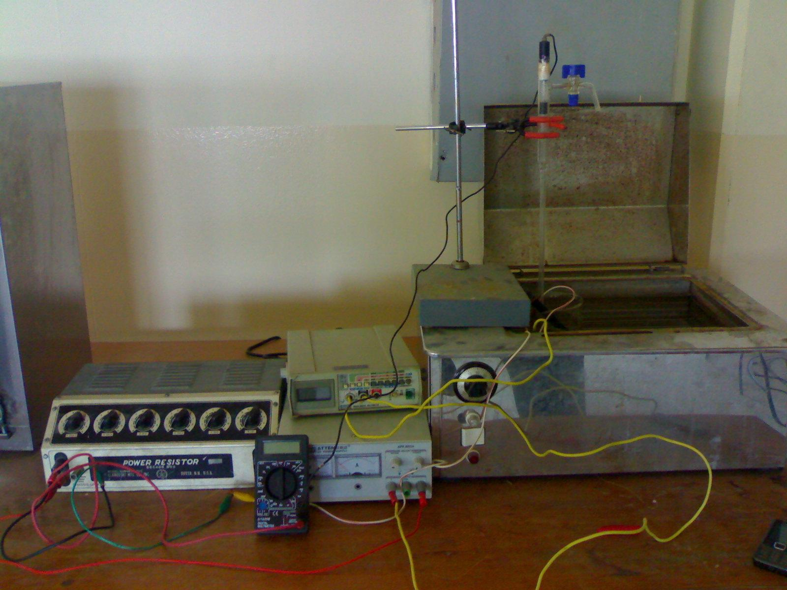

Figure 1: The polarization circuit
The temperature of the solutions was kept constant at either 17 or 80˚C using the water bath (HAAK W13) supplied with a thermostat to keep the temperature constant within $∓2^{o}C$ until the solution reached the preset temperature.
Two classes of solutions were used; tap water as a coolant for engine and the two types of inhibitor blends, i.e., the Kuwait one and the Germany and they were bought from the Iraqi markets. For each type, the polarization curves were constructed for each metal and at the respective temperature.
Results and Discussion
1-Uninhibited case
Figures 2 through 5 show the polarization curves in tap water at various temperature for steel and copper respectively.
Figure 2: Polarization Curves for Carbon Steel in Tap Water at 17˚C

Figure 3; Polarization Curves for Copper in Tap Water at 17˚C

-2
-1.5
-1
-0.5
0
0.5
0.00001
0.001
0.1
10
Current Density
,
mA
/
cm
2
Potential, V

Figure 4; Polarization Curves for carbon steel in tap water at 80˚C

-2
-1.5
-1
-0.5
0
0.5
1
0.00001
0.001
0.1
10
Current Density
,
mA
/
cm
2
Potential, V

Figure 5; Polarization Curves for copper in tap water at 80˚C

The corrosion current values for all conditions are shown in table 3.
In all these figures, the activation polarization is seen for both metals. From the above figures, it is clear that the corrosion current in case of carbon steel is higher than that of copper (table 3, figures 6 and 7) . The possible reactions are;
A: for carbon steel
In water which is neutral as well as the two types of mixtures (where pH≈7.5), the possible cathodic reactions are;
$O_{2}+4H^{+}+4e=2H_{2}O$ …………1
or;
2$O_{2}+4H^{+}+4e=4{\text{OH}}^{−}$ ………….2

B: for copper
The same reactions (1 and 2) are possible.

Table 3: values abstracted from above figures showing i_{corr} and corrosion potential for carbon steel and copper in water, Kuwait mixture and Germany one
Metal | Temperature  (˚C) | Medium | Corrosion Current, mA/cm² |  |  | Corrosion Potential, V | %Change with respect to that of water at 17 ˚C
Copper | 17 | Water | 0.0324 |  |  | -0.1 | ……………………
Copper | 17 | Kuwait Mixture | 0.0286 |  |  | -0.130 | 11.72
Copper | 17 | Germany Mixture | 0.0105 |  |  | -0.142 | 67.5
Copper | 80 | Water | 0.0864 |  |  | 0.095 | 0.0037*
Copper | 80 | Kuwait Mixture | 0.0716 |  |  | -0.14 | 17.9
Copper | 80 | Germany Mixture | 0.0621 |  |  | -0.162 | 28.12
Carbon Steel | 17 | Water | 0.437 |  |  | -0.558 | …………..
Carbon Steel | 17 | Kuwait Mixture | 0.283 |  |  | -0.707 | 35.24
Carbon Steel | 17 | German Mixture | 0.0891 |  |  | -0.368 | 79.6
Carbon Steel | 80 | Water | 0.8208 |  |  | -0.726 | 0.467*
Carbon Steel | 80 | Kuwait Mixture | 0.0837 |  |  | -0.268 | 89.7
Carbon Steel | 80 | German Mixture |  | 0.0603 | -0.415 |  | 92.6

*Represents the value of increasing in corrosion current

From the above figures as well as that of table 3, some conclusions were obtained:
- Corrosion current is increased for both metals as the temperature increased, this is an expected case since the corrosion rate is varied with temperature-in case of activation polarization-as;
i=ke^{-E/RT} ………………………….3
where
k is constant
E is the activation energy
the rest have their usual meanings.

Figures 6 and 7 demonstrate such effect.

Figure 6: corrosion current vs. Temperature for the three types of mediums used in cooling engine(for copper)

Figure 7: corrosion current vs. Temperature for the three types of mediums used in cooling engine (for carbon steel)

- No case of passive layer was detected for the two metals at both values of temperature, since in copper the anodic dissolution is:
2Cu+H₂O=Cu₂O+2H⁺+2e ………………4
Therefore, the cupric oxide film that is formed is not protective.
While for the steel;
Fe=Fe⁺²+2e (anodic) ……………...5
2$O_{2}+4H^{+}+4e=4{\text{OH}}^{−}$(cathodic)……....6
Total reaction
2Fe+2O₂+4H⁺=2Fe(OH)₂ ……………....7
It is obvious that the hydroxide of ferric does not reduce corrosion.

2-Inhibited Case
Figures 8-15 and table 3 demonstrate the behavior of the carbon steel and copper using Germany mixture and Kuwait one.
Through these figures, no detection about concentration polarization; that is the controlling means of reaction is activation, also no detection of passivity, that is no feasibility for pitting.

Figure 8; Polarization Curves for carbon steel in Kuwait mixture at 17˚C

Figure 9; Polarization Curves for carbon steel in Kuwait mixture at 80˚C

Figure 10; Polarization Curves for copper in Kuwait mixture at 17˚C

Figure 11; Polarization Curves for copper in Kuwait mixture at 80˚C

Figure 12; Polarization Curves for carbon steel in Germany mixture at 17˚C

Figure 13; Polarization Curves for carbon steel in Germany mixture at 80˚C

Figure 14; Polarization Curves for copper in Germany mixture at 17˚C

Figure 15; Polarization Curves for copper in Germany mixture at 80˚C

In general, good inhibition efficiencies were obtained by using the two mixtures especially with Germany one, but it can be seen that the retarding of corrosion is higher in case for steel than for copper, this could be attributed to the changing of the specified inhibitor action by changing metal with which it contacts, hence some inhibitors doing well with certain metals but doing bad with other and this conclusion is ascertained by others [Niki Katsumi et al.1975]. The possible reasons for this diversity is due to outer orbitals of the metal atom (saturated or not), to the surface morphology, formation of inhibitor material especially that types containing S , N or O atoms in their structure as well as kinetic factor.
Since in this study no feasibility of studying the effect of inhibitor concentration variation on corrosion current because the mixture as bought was used, i.e., it was prepared by the manufacturer, therefore, the action mechanism of these mixtures could not be detected, instead we assume that the inhibitor was adsorbed on the surface of the specified metal and according to this the relevant variables were outlined.
We will assume that Langmuir model for adsorption is applicable, that is;
$\frac{Θ}{1−Θ}=\text{AC}\text{exp}(−{{ΔG}_{\text{ads}}}/{\text{RT}})$……………….8
where
Θ is the coverage
A is constant
C is the concentration of the inhibitor
ΔG is the free energy of adsorbtion

Since C is constant, therefore it is included with A as a constant.
By plotting Θ/1- Θ against 1/T for steel and copper, ΔG_{ads} for the two mixtures on the two metals as shown in figures 17 and 18 below

Figure 17: Langmuir model for steel in presence of Kuwait and German mixture

Figure 18: Langmuir model for copper in presence of Kuwait and German mixture

The following table –table 4- shows the abstracted values of free energy for both metals.

Table 4: values of free energy of adsorption ΔG_{ads} for the two types of metals used under the two types inhibitor mixtures
Type of metal | Type of inhibitor mixture | ΔG value, kJ/mol
Carbon steel | Kuwait | 8.164
Carbon steel | Germany | 6.142
Copper | Kuwait | 0.086
Copper | Germany | -1.689

From table 4 above it can be seen that the adsorption of both types-in general-of inhibitors is endothermic, i.e., ΔG is positive and the adsorption is non-spontaneous. As the temperature increases the inhibition efficiency is increased-in general- as shown in figure 19.
Figure 19:Eeffect of temperature on inhibition efficiency

The increase in inhibition efficiency of these inhibitors with the rise of temperatures advocated the chemisorption nature of the mechanism.
Since the increased of efficiency with temperature rise-except of copper with Germany mixture-, therefore the stability of such inhibitor going to do well. In our opinion it could be attributed to the stretching of the adsorbed molecule without impairing its functionality, since the total current under inhibition condition takes the form;
i=iΘ+i(1-Θ) ………………….9
the first term for the right side represents the filmed current( if the film is electronic conductive), while the second one is the current on bare sites. So as Θ increases the current decreases.
Since for the case of Germany mixture the inhibition efficiency is increased for the case of steel with temperature increase while it decreases for the case of copper, this could not be attributed to decomposition of the inhibitor on copper surface, rather it could be attributed to the bonding or sticking with the surface that is every inhibitor has a tendency to a metal while for other is not. This also reflects the diversity of the same inhibitor action on different surfaces (as stated above).

Conclusions
Good inhibition efficiencies were obtained by using blends of engine cooling system, especially for the Germany blend which it is doing well with steel, therefore it can be used safely, while for Kuwait one, no such good efficiencies were detected. Based on our data both inhibitors can be used for steels while they are poor inhibitors for copper, also there was no detection for pitting corrosion for both metal under both inhibitors mixtures.

References
ASTM Manual Series, (1989). Published by American Society for Testing and Materials.
Bouklah, M. and Hammmouti,B., (2006). Portugaliae Electrochimica Acta, 24, 457-468.
Nathan, C.C., (1975). Corrosion Inhibitors, Nace, Texas.
Niki Katsumi, Delnick, Frank M. and Hackerman Norman, J. Electrochem. (1975). Soc., Vol. 122, No.7.
Rozenfeld, I. L.,(1981). Corrosion Inhibitors, Mc-Graw Hill, New York.
Shrier, L.L.,(2000). Corrosion, Butterworths,Vol.1, 3rd ed.
Tosun Ayse and Ergun Mubeccel, G.U. (2006). Journal of Science, 19(3), 149-154.
Wang, B.B., T.Hong, H.Shi, C.Kang and W.P. Joseph, (2001). Paper No.01023, Corrosion.

