Effect of Temperature on Electronic Structure of Silicon Using a Large Unit Cell within Intermediate Neglect of Differential Overlap (INDO)

Mohammad G. Merdan
College of Science, Babylon University, Hilla, Iraq
Abstract
A large unit cell (LUC) formalism of eight atoms within intermediate neglect of differential overlap (CNDO) is used to study some properties of Silicon crystal and to investigate the effect of temperature on these properties due to the changes in coulomb energies. Cohesive energy, direct band gap, valance band width, conduction band width and hybridized orbitals of the crystal are obtained from the band structure calculations. X-ray scattering factor are also calculated. The energy gap and valance band decrease with increase of temperature, this cause increasing in conduction band width. All the aforementioned properties are obtained by selecting empirical parameter sets for LUC-INDO model.
الخلاصة
خلية وحدة كبيرة ( (LUC بثمان ذرات ضمن الإهمال المتوسط للتداخل التفاضلي (INDO) استعملت لدراسة بعض خصائص السليكون ذو الشبيكة المكعبة بالتركيب الماسي ولدراسة تأثير الحرارة على هذه الخصائص. طاقة الترابط و فجوة الطاقة المباشرة و عرض حزمتي التكافؤ والتوصيل وتهجين المدارات وعامل تشكيل الاشعه السينيه تم الحصول عليها من حسابات التركيب ألحزمي. جميع الخواص المذكورة أعلاه قد تم الحصول عليها باختيار مجموعة مُعلمات تجريبية لأنموذج وحدة الخلية الكبيرة للإهمال المتوسط للتداخل التفاضلي. ، فجوة الطاقة المباشرة و عرض حزمة التكافؤ تتناقص مع زيادة درجة الحرارة بينما يتزايد عرض حزمة التوصيل.
1. Introduction
Silicon has the atomic number 14 [Kittle, 1996], in the ground state it is crystallized in diamond structure (eight atoms per unit cell) [Blakemore, 1974; Myers, 1990]. It’s electronic structure 3s²3p². the atoms is bounded by covalent bond. Silicon is very important in the industry so, many methods can be used to study it. Semiconductors are widely used and have important applications in the industry and technology specially in instruction of the electronic devices, thus there are many studies of the electronic structure and physical properties of the semiconductors. The exact solution of Schrödinger equation for a complicated system, which is consisted of many electrons atoms, is impossible because of a huge number of mathematical processes. For solving such equations, many approximations in the theory are needed. In the present work, a theoretical model, which is called the large unit cell-intermediate neglected of differential overlap (LUC-INDO) method is used to calculate the effect of temperature on some properties of silicon. The purpose of the large number of approximations in the theory is to maintain the ability of computers for solving such equations [Blakemore, 1974].

- Method of Calculation
A quantum-chemical semi-empirical INDO method developed especially for crystals [Pople and Beveridge, 1970] is used in the present work. A large unit cell (LUC) formalism of eight atoms within intermediate neglect of differential overlap (INDO) is a method can be used for many body systems. In the large unit cell method, we shall need to reduce the zone of the wave vector (k) to simplify the calculations. In this method Bloch orbital is approximated by a linear combination of one-electron molecular orbitals X_{u} in the cells [Bransden and Johchain, 1983; Chen, 2005].
$ψ_{α}(k,r)=N_{L}^{{−1}/2}\sum_{u}^{\text{cells}}{\sum_{p}^{\text{basis}}{\text{exp}}}(\text{ik}\text{.}R_{u})C_{pα}(k)φ_{p}(r−R_{u})$ (1)
where N_{L} is the number of LUCs in the crystal, C_{p}(k) denotes the combination coefficients of the hybridized orbitals, $φ$ is the atomic wave function, k is the wave vector, and $R_{u}$ denotes the lattice translation vector.
The Hartree-Fock equations [Atkins and Friedman, 1997; Bransden and Johchain, 1983] for the microcrystal can be written as,
$\sum_{p}{(F_{\text{pq}}(k)−∈_{α}(k)S_{\text{pq}}(k))}C_{pα}(k)=0$ (2)
where the summation index p goes over all the atomic states of the LUC, F_{pq}(k) represents the Fock Hamiltonian and S_{pq}(k) is the overlap integral

Equation (2) can be solved by using self consistent field method. An initial guess of the wave function is predicted using the basis set and adopting Slater-type orbitals [Pople and Beveridge, 1970]. The initial guess of the wave function is important since an optimum guess reduces the number of iterations performed to obtain the converged electronic energy. In this work, we choose the large unit cell of eight atoms. The number of Bravais lattices in this cube is 27 lattices. The interaction of the atoms in the central Bravais with the surrounding atoms up to the fourth neighbors is included.

3.Results and discussion
The empirical parameters included in the LUC-INDO method are the orbital exponent $ζ$, the bonding parameter $β^{0}$, $\frac{1}{2}(I_{s}+A_{s})$, and $\frac{1}{2}(I_{p}+A_{p})$. The symbols I and A refer to the ionization potential and the electron affinity respectively. Fitting of empirical parameters can be made and we found that the Empirical parameters which given by the investigator Mussafer [Mussafer, 2003] gave good result as comparison with experimental results. So with these parameters the effect of temperature on the band structure has been investigated.

Table 1 Empirical parameters used in the present work for Si.

Parameter | Value
$$ζ(a\text{.}u^{−1})$$ | 1.9965
 | -5.3345
$$\frac{1}{2}(I_{s}+A_{s}) (\text{eV})$$ | -9.452
$$\frac{1}{2}(I_{p}+A_{p}) (\text{eV})$$ | -5.632

3.1 lattice parameters determination
The total energy of the crystal in ground state is a sum of attractive and repulsion energies. The distances between particles are changed due to the change in lattice constant. These variation can be happened by varying pressure and temperature. So, temperature cause variation in coulomb energies because its effect on lattice parameter, as results Band structure and some properties of the crystal are varied. The lattice constant can be calculated as [Xie et al., 1982]
$a=a_{0}(1+α_{L}T)$ (3)

where a is the lattice constant of the crystal at temperature (T) and a₀ is the equilibrium lattice constant at temperature (T₀). $α_{L}$ is the linear thermal expansion coefficient of the crystal. By using the calculated values of the linear thermal expansion coefficient of silicon [Swenson, 1983; Touloukian & Kirby, 1977], the lattice parameter as a function of temperature can be determined as shown in Fig 1.

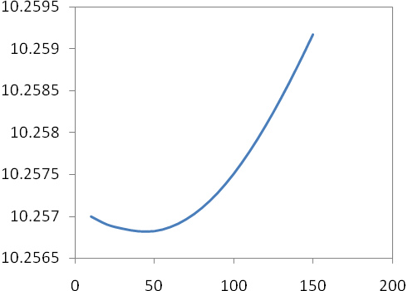
Lattice constant (a.u)
Temperature (k)

Fig (1) The lattice constant of Si as a function of temperature.

3.2 The Cohesive Energy
The cohesive is calculated from the total energy of the large unit cell. Since the large unit cell is composed of 8 atoms, the cohesive energy is given by
where $E^{T}$, E_{free} is the total energy and the free atoms sp shell energy [C. Allen ] respectively. Its value is equal to (103.129 eV) for Si [Adbul Sattar, 1997]. The cohesive energy as a function of temperature can be shown in Fig (2).
$$E_{\text{coh}}={E^{T}}/8−E_{\text{free}}−E_{0}$$ | (4)
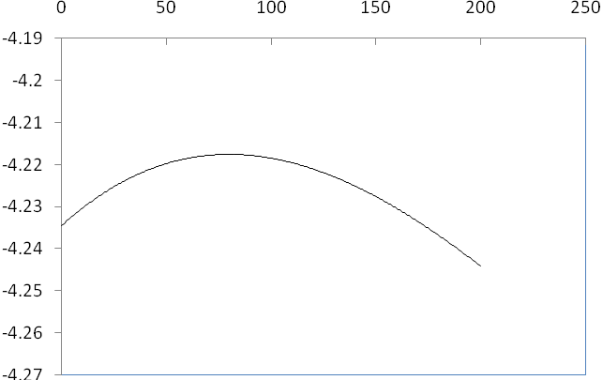
Cohesive Energy (eV)

Temperature (k)

Fig (2). Cohesive energy of Si as a function of temperature.

3.3 Band structure
The band structure and the electronic properties of Si crystal are calculated.
It should be mentioned that the study of the effect of temperature is approach because we calculate the effect of temperature only on the internal energy of the crystal. This calculations do not include the vibration contribution to the free energy. So, our calculations represent the effect of temperature on the coulomb energies of the crystal. and the variation of the others properties is calculated with the change of internal energy of the crystal. At high temperature we show that the conduction band width increase with the increase of temperature but the valance band width and the direct band gap decreased with the increase of temperature as shown in Figs (3,4,5), this work is consistent with K. P. O’Donnell and X. Chen work. They found that the energy gap decrease with temperature and cause increasing in conduction band [O’Donnell and Chen, 1991].

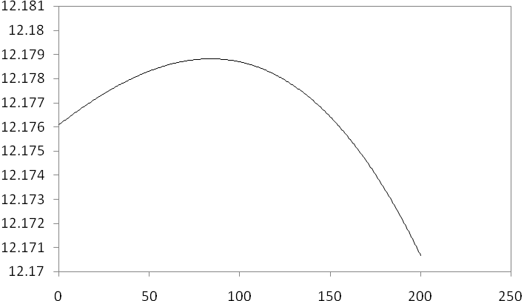
bbbjjbjjbjj
Valance band width
Temperature (k)
Fig (3) Effect of temperature on valance band width
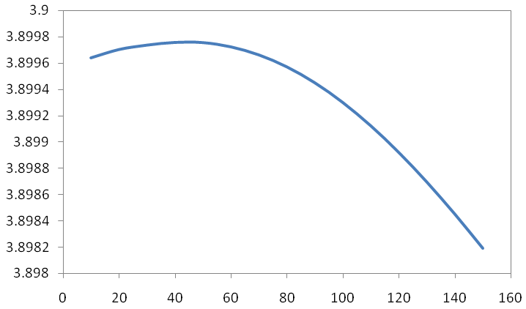
Direct Band Gap
Temperature (k)
Fig (4) Effect of temperature on band gap width

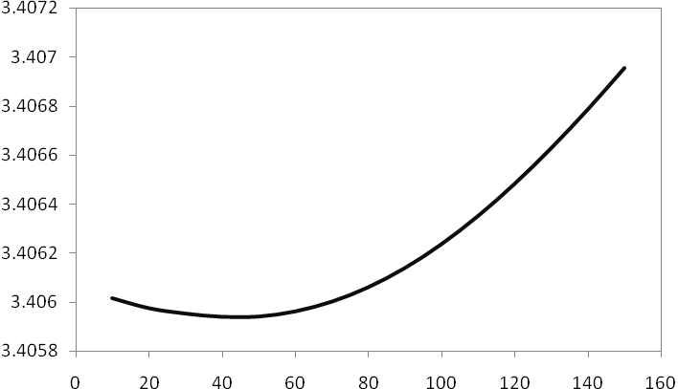
Conduction Band Width
Temperature (k)
Fig (5) Effect of temperature on Conduction Band Width

3.4 Hybridization state
At high temperature, the s state occupation increases; therefore, the p state occupation decreases as shown in Fig (6). The increase of temperature causes an increase of the probability of electron transition from p-orbital to s-orbital, this phenomenon is known and leads to phase transition due to the change of electronic distribution such as s-d transition in alkali metals [Takemura, and Syassen, 1983].

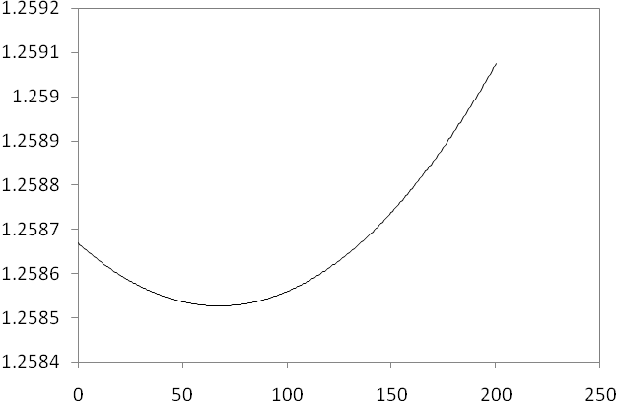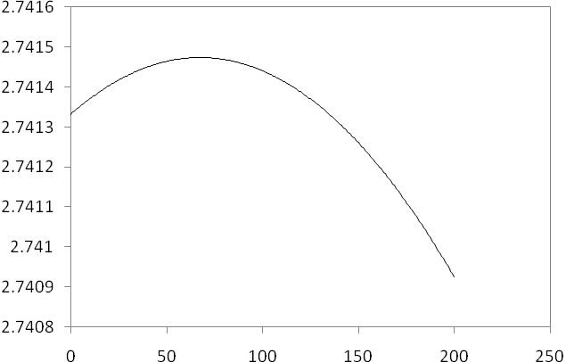
Hybridization of s-orbit
Hybridization of p-orbit

Temperature (k) Temperature (k)
(a) (b)

Figure (6). The effect of temperature on the hybridization of (a) s- state and (b) p- state.

3.5 X-Ray Scattering Factors
The x-ray diffraction determines the electronic charge density experimentally. In our work we can reverse the operation. Having the electronic charge density the scattering factor (atomic form factor) can be determined. The atomic form factor is defined as [Kittle, 1996]
$$f_{j}=\int{ρ_{c}(r)\text{exp}(−\text{iG}\text{.}r)\text{dv}}$$ | (5)
The present work shows that the x-ray scattering factors increase with the increase of temperature as shown in (7)
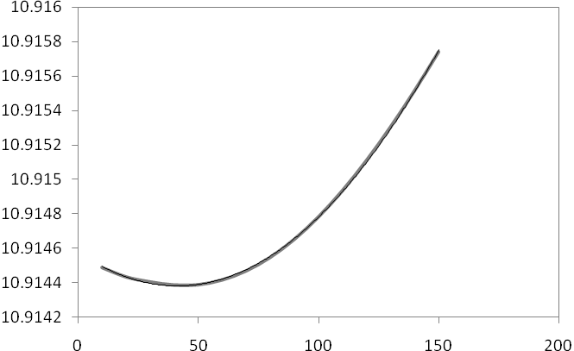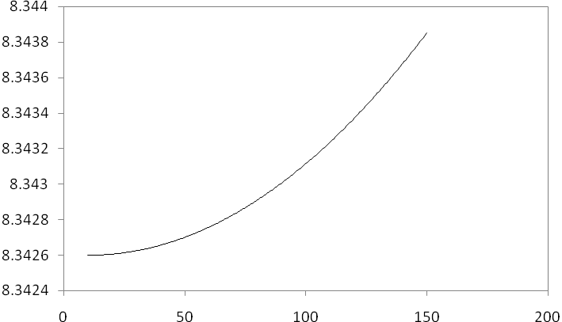
x-ray scattering factors of (220)
x-ray scattering factors of (111)

Temperature (k) Temperature (k)
(c) (d)

x-ray scattering factors of (311)

Temperature (k)
(e)
Figure (7). The effect of temperature on x-ray scattering factors of (c) (111) level, (d) (220) level and (e) (311) level.

4. Conclusions
The effect of temperature on electronic structure of silicon is investigated . The LUC-INDO method was used. empirical parameters included in the LUC-INDO method have large effect on the properties, thus we chose the proper parameters which give good result for properties. The effect of temperature is not completely effect in this study. we investigated about the effect of temperature in the change of lattice parameter, the vibration contribution of atoms is not included. cohesive energy change with temperature. The band gap and valance band are decreased with high temperature and the conduction band increase. The increase of temperature causes an increase of the probability of electron transition from p-orbital to s-orbital. The x-ray scattering factors increase with the increase temperature. we show from the calculations the lattice constant decrease with temperature until minimum value and then back to increase with temperature this is the fact of silicon. this change can be shown in all calculation of electronic structure and properties.

References
Adbul Sattar, M.A.(1997). "Self-Consistent field calculations of covalent semiconductors, Ph. D. thesis, University of Baghdad.
Allen , C. (1976). Astrophysical Quantities, Athlone press.
Atkins P.W. and Friedman, R.S. (1997). "Molecular Quantum mechanics", Oxford University Press,.
Blakemore, J.S. (1974). "Solid state physics", Cambridge University Press.
Bransden B.H. and Johchain, C.J. (1983). "Physics of atom and molecules", Longman.
Bueclte, F. (1982). "Principle of physics", McGraw-Hill.
Chen, P. (2005). "Qualitative MO Theory and its application to organic reactions, thermal rearrangements pericyclic reactions", ETH Zurich.
Harker A. and Larkins, F. (1979). J. Phys. C, vo. 12 P. 2487.
Kittle, C. (1996). "Introduction to solid state physics", John Wiely & Sons.
Mussafer, M. (2003). “ Effect of pressure on the properties of Silicon crystal using semiempirical method, MSc. thesis, University of Babylon, (2003).
Myers, H.P. (1990). "Introductory solid state physics", Taylor & Francis.
O’Donnell K. P. and Chen, X. (1991). Appl. Phys. Lett. 58 (25) P 2924, 24 June .
Pople and Beveridge, D. (1970). Approximate MO Theories, McGraw-Hill, New York.
Swenson, C.A. (1983). J. Phys. Chem. Ref. Data, vo. 12(2), P. 179).
Takemura, K., and Syassen, K., 1983,"High-pressure phase transitions in potassium and phase relations among heavy alkali metals", Phys. Rev. B vo.28, PP. 1193-1196.
Touloukian, Y.S. ; Kirby, R.K. ; Taylor R.E. & Lee, T.Y.R. (1977). Thermophysical Properties of Matter, vo.13, 1977
Xie; J. ; Chen; S.P. Tse, J.S.; de Gironcoli S. and Baroni, S. (1999). Phys. Rev. B, vo. 60 P.9444.

