Effect of Fire Flame Exposure on some Properties of Fiber Reinforced High Strength Concrete
Muna Mohammed Karim
Babylon University, College of Engineering, Department of Civil Engineering

Abstract
The increased use of high strength concrete (HSC) in buildings has resulted in concern regarding the behavior of such concrete in fire. In the present work, an attempt is made to study the effect of fire flame exposure on compressive strength and splitting tensile strength of plain and fiber reinforced high strength concrete. High strength concretes were prepared in two series, with and without steel fiber reinforcement. Plain and steel fiber reinforced high strength concrete (PHSC) and (FRHSC) were subjected to the same fire temperatures and same burning time to reveal the effect of steel fiber on concrete strength at different heat levels as well as fire duration. The concrete specimens for (PHSC) and (FRHSC) were subjected to fire flame temperature ranging between (300- 600 °C) at different ages 30 and 60 days. Three temperature levels (300, 500 and 600 °C) where chosen with two exposure periods of 1.0 and 1.5 hours. The test specimens were cubes (100 mm) and cylinders (100*200 mm). After burning, the concrete specimens were allowed to cool in air. The results obtained from this study indicated that damage of concrete caused by exposure to fire depends on the temperatures range and the duration of exposure to fire. Also, the results showed that (PHSC) higher rates of strength loss than (FRHSC).
الخلاصة
أدى ازدياد استخدام الخرسانة عالية المقاومة في الأبنية إلى الاهتمام فيما يتعلق بسلوك هذا النوع من الخرسانة في الحريق. يشمل البحث الحالي محاولة لدراسة تأثير لهب النار على مقاومة الانضغاط ومقاومة شد الانشطار للخرسانة عالية المقاومة و المسلحة بالألياف الحديدية .أعدت فئتين من الخرسانة عالية المقاومة مسلحة بالألياف الحديدية وخالية من الألياف .عرضت الخرسانة عالية المقاومة المسلحة بالألياف الحديدية والخالية من الألياف إلى نفس درجات النار ونفس وقت الحرق لمعرفة تأثير الألياف الحديدية على مقاومة الخرسانة عند مستويات مختلفة من الحرارة بالإضافة إلى فترة الحرق.تم تعريض النماذج الخرسانية إلى درجات حرارة تتراوح بين (300 – 600 )درجة مئوية وبأعمار مختلفة هي (30 ، 60) يوما . تم تعريض النماذج إلى ثلاث درجات حرارة ثلاثة هي (300، 500، 600) درجة مئوية لفترتين تعرض هي (1, 1.5) ساعة . كانت نماذج الفحص مكعبات (100 مم) واسطوانات (100 * 200 مم). بعد التعرض تركت النماذج لتبرد في الهواء . أظهرت النتائج التي تم الحصول عليها من هذه الدراسة بان ضرر الخرسانة بسب التعرض للنار يعتمد على مدى درجات الحرارة وفترة التعرض للنار. كذلك أظهرت النتائج إن اكبر معدلات للفقدان في المقاومة كان في الخرسانة العالية المقاومة الخالية من الألياف الحديدية.
Introduction
With the development of concrete technology, high strength concrete (HSC) has been commonly utilized in many concrete structures around the world. High strength concrete offers more strength and durability compared to normal strength concrete. In economical point of view, cost studies have shown that (HSC) can carry the same compression load as normal strength concrete (NSC) at less cost. In architectural point of view, with its capacity of bearing higher load, HSC allows smaller size column to be used in high-rise construction leaving more space to be occupied.
Although high strength concrete has been shown to have a number of advantages when used in concrete structures, it suffers from one major weakness: higher brittleness. When exposed to high temperatures, (HSC) exhibits more serious degradation than normal concretes do, such as spalling and cracking (Poon et al, 2003).
The fiber reinforced concrete is a composite material essentially consisting of concrete reinforced by random placement of short, discontinuous and discrete fine fibers of specific geometry (Swamy et al, 1974). Fibers have extensively been used to improve the ductility of concrete. Recently, it has been found that a number of fibers can improve residual properties of concrete after exposure to elevated temperatures (Kalifa et al, 2001).
Literature Review
Some studies had found that (HSC) in some cases fail in a catastrophic manner during exposure to fire characterized by explosive spalling of the concrete surface. Some researchers hypothesized that the vulnerability of (HSC) to explosive spalling is partly due to its lower permeability, which limits the ability of water vapor to escape from the pores resulting in significant build-up of pore pressure within cement matrix. As heating increases, the pore pressure also increases until the internal stresses become so large as to result in explosive spalling (Phan, 1996).
(Fanella and Naaman, 1985) and (Ramakrishnan, 1987) revealed the inclusion of fiber polymers to enhance of the structural properties of a given material, such as concrete. These properties include; compressive strength, fracture toughness, flexural strength, tensile strength, impact strength, resistance to fatigue, and fire resisting. The fiber acts as crack arresters, resisting the development of crack and transferring a brittle matrix into strong composite with better ductility (Ramakrishnan, 1987).
The effect of transient high temperature on strength and load –deformation behavior of HSC was investigated (Castillo and Durrani, 1990). The concrete strength varied between (31 to 89 MPa ) and the temperature exposure was in the range of 23 to 800 °C . Exposure to temperature in the range of 100 to 300 °C was found to decrease the compressive strength of (HSC) by 15 to 20 percent. At temperature in the range of 400 to 800 °C the compressive strength decrease to about to 30 percent of its strength at room temperature.
(Habeeb, 2000) studied the effect of high temperatures (up to 800 °C) on some mechanical properties of high strength concrete (HSC). Three design strengths were investigated (40, 60 and 80 MPa). The investigated properties were compressive strength, flexural strength and volume changes. Ultrasonic pulse velocity (U.P.V) and dynamic modulus of elasticity (Ed) were tested also. The specimens were heated slowly to five temperature levels (100, 300, 500, 600 and 800 °C), and to three exposure periods 1, 2 and 4 hours without any imposed loads during heating. The specimens were then cooled slowly and tested either one day or one month after heating. He concluded that the (HSC) is more sensitive to high temperatures than (NSC).The residual compressive strength ranged between (90 – 106%) at 100 °C, (72-103%) at 300 °C, (55 – 87%) at 500 °C and (22-66%) between (600-800 °C). He also concluded that exposure time beyond one hour had a significant effect on the residual compressive strength of concrete; however, the effect was diminished as the level of temperature increased. Moreover, the compressive strength at age of one month after heating, suffered an additional loss than at age of one day after heating. The flexural strength was found to be more sensitive to high temperature exposure than compressive strength, the residual flexural strength was in the range of (92 – 98%), (52-98%) and (29- 47%) at 100° C, 300ْ C and 500°C respectively and (2-30%) at (600 –800 °C), as well as, at 800 °C spalling occurred in specimens during cooling which resulted in concrete softening. The author also noticed that the (U.P.V) and (Ed) were more sensitive to elevated temperatures exposure than compressive strength.
(Mahasneh, 2005) studied the effect of high temperatures on some properties of Polymeric Fiber Reinforced Concrete (PFRC). The investigated properties were compressive strength, splitting tensile strength and pullout strength. The specimens were heated to various temperatures (Furnace temperature), starting from room temperature up to 1000°C. The test results indicated that (PFRC) strength is controlled by the composite action of both fiber and concrete. This Polymeric fiber shows an increase in the ductility, fire resistance and enhancement of the composite material properties. Also This study provides a good understanding of the behavior of fiber polymers on composite concrete properties and the effect of polymeric reinforced polymer on unprotected concrete.
(Kadhum, 2006) carried out on experimental program to study the effect of fire flame on compressive strength of steel fiber reinforced normal concrete. The steel fibers properties (25* 0.25mm) were used and one volume fraction (0.75%). The ultimate tensile strength of the fibers was found to be 1100 MPa, Two mixes were used; mix1 contained 0.75% of crimped fibers, mix2 no fiber. Concrete cubes (150*150*150mm)were used. The specimens were exposed to three temperatures levels( 300, 500, and 700 °C) without any imposed load. The specimens were burnt by direct fire flame from a net of methane burners inside a brick stove with three exposure periods of (0.5, 1.0 and 2.0 hours). The test results showed that the compressive strength decrease with increasing of the temperature. The author also found that the residual compressive strength of steel fibers reinforcement concrete after exposure to fire is higher than residual compressive strength of plain concrete. Experimental Work
Program of Work
This research was designed to study the effect of fire exposure on compressive strength and splitting tensile strength of high strength concrete with and without steel fibers reinforcement.
The test specimens used were (100*100*100 mm) cubes and (100 * 200 mm) cylinders. The compressive strength test was conducted according to (B.S 1881: Part 116: 1983) and the splitting tensile strength was determined according to procedure outlined in (ASTM C- 496) specification.
Materials and mixes
Cement:
The cement used in this study was Alqaseem Ordinary Portland Cement (OPC) manufactured in Saudia Arabia. The chemical composition and physical properties of cement complied with the Iraqi specification (IQS No.5 1984).
Aggregate
The fine aggregate used was Al-Ekhaider natural sand zone 2 with fineness modulus of 2.9. The grading, physical and chemical properties of fine aggregate conform to Iraqi specification (IQS No. 45 /1984).

Crushed gravel obtained from AL-Nebai source was used as coarse aggregate. The maximum coarse aggregate size was chosen to be 14 mm.
Superplasticizer:
High range water reducing agent ( HRWR) called Glenium 51( Sulfonated melamine – formaldehyde ) was used in this work. This superplasticizer is conformed to (ASTM C-494) classified as type F, it has acceleration effect on the HSC .The dosage for Glenium 51 was 0.8 liters per 100 Kg of cement . The typical properties are shown in Table (1).

Table (1) : Typical Properties of Super plasticizer

Form Viscous liquid
Colour Light brown
Relative density 1.1 @ 20ºC
pH 6.6
Viscosity 128 cps @20ºC
Transport Not classified as dangerous
Labelling No hazard label required
Dosage 0.5 to 0.8 liters per 100 Kg of cement
Water:
Tap water was used for mixing and curing of concrete through out the investigation.
Fibers
Crimped steel fibers were used in this investigation and the properties of these fibers are presented in Table (2).
Table (2): Properties of steel fibers
Density  kg/m³ | Tensile strength(MPa) | Length (mm) | Diameter (mm) | Steel Fiber Addition (%) | Aspect ratio
7840 | 1100 | 25 | 0.3 | 1.5 | 75

Mix Design and Proportions
One target design strength of 80 MPa. The proportions of the concrete mix are summarized in Table (3). The high strength concrete was made under controlled laboratory conditions.
Table (3): Mix Proportions
Weight proportion  Cement : Sand : Gravel | W/C  Ratio | Mix proportion kg/m3  Cement :Sand :Gravel: Water | Superplasti-cizer  (liter/100 kg cement) | Slump  mm
1.0 : 1.2 : 1.8 | 0.3 | 550 : 660 : 990 : 165 | 0.8 | 150

Concrete Mixing and Casting
The concrete was mixed using an electrical drum type mixer with a maximum capacity 0.1m³. The interior surface of the mixer was cleaned and moistened before placing the materials. Materials were put in the pan of the mixer, firstly coarse and fine aggregates were mixed together with amount of mixing water (1/4 mixing water without superplacticizer) for 1 minute. Meanwhile the superplacticizer was mixed with the remaining water (3/4 of mixing water). Half of cement and half of mixing water (with superplacticizer) were added as mixing proceeded for 4 minutes to make a homogeneous mix. Finally, the remaining (cement and water) were added to the mix as mixing proceeds for 2 minutes. 1.5% of steel fibers content was used; the steel fibers were fed continuously to the mixer for a period of 2 to 6 minute.
After mixing, the concrete was poured into the moulds and compacted using a vibrating table till no air bubbles emerged from the surface of the concrete. Then, the specimens were leveled by hand trawling and covered with polyethylene sheet.
Burning and Cooling
The concrete specimens were burnt by direct fire flame as shown in Plate (1) from a net of methane burners with dimensions of (800 * 800mm) as shown in Plate (2). The bare flame was intended to simulate the heating conditions in an actual fire. When the target temperature was reached, the digital thermometer continuously recorded the temperature. After burning, the concrete specimens were allowed to cool for 4 hours and stored in the laboratory environment about 20 hours.

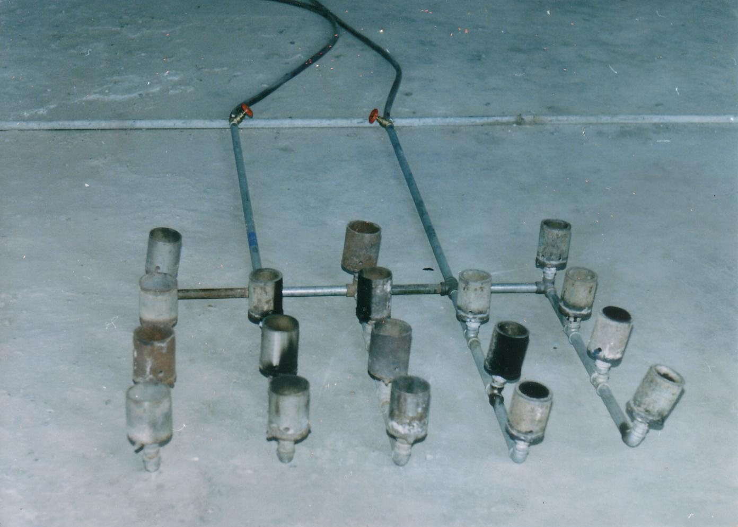
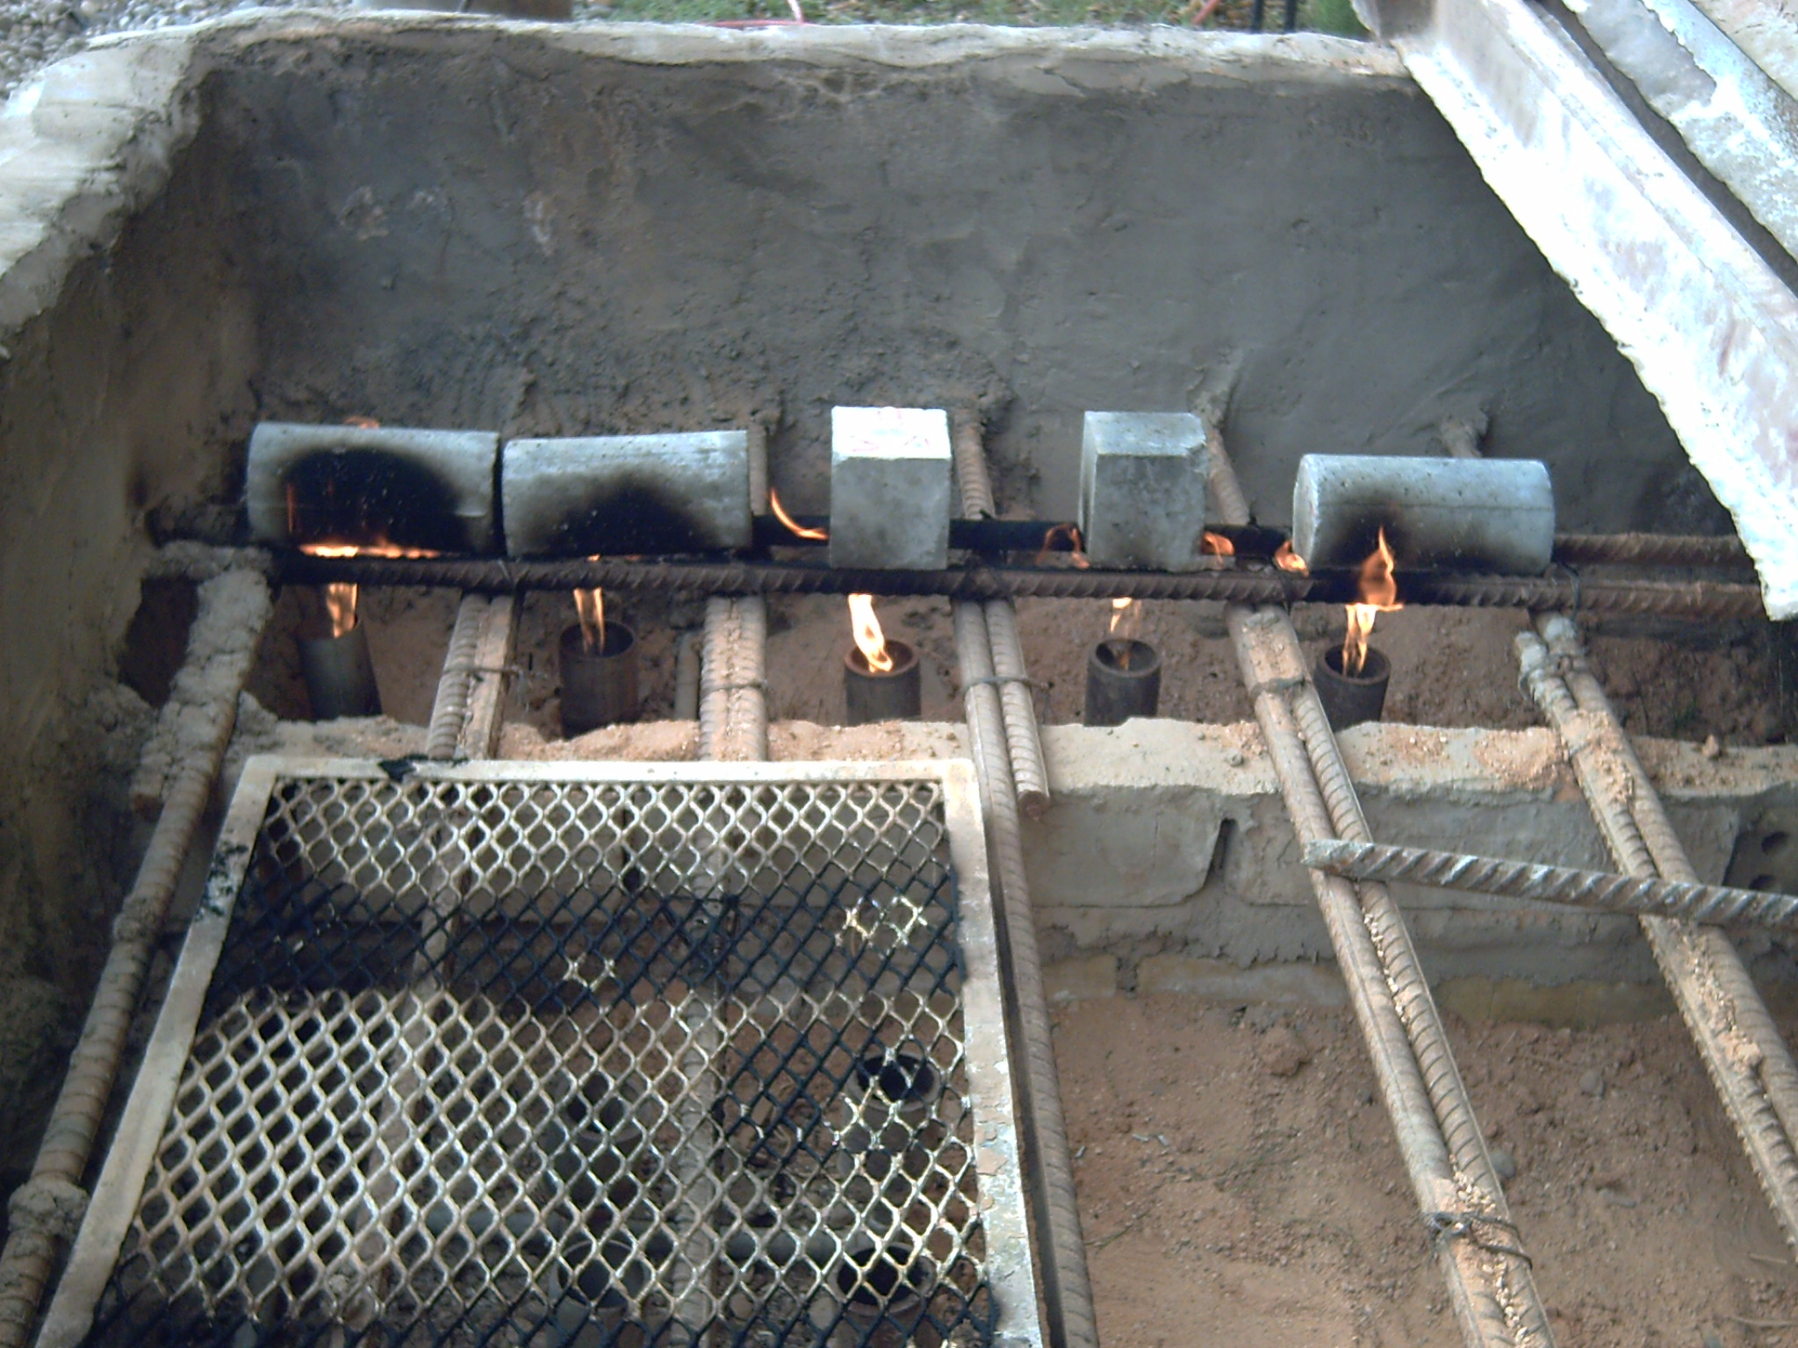

Plate (2): The Network of Burners

Plate (1): Burning of Concrete specimens
Results and Discussion
1-The Density
Table (4) shows the effect of the exposure to fire flame on the density of plain (PHSC) and steel fibers reinforced concrete (FRHSC), while Figures (1) and (2) show the relations between fire temperature and density.
It can be seen from Table (4) and Figures that the density behaved as the following:
- At 300 °C fire flame temperature and for all ages and all periods of exposure, the reduction in density was ranged between (6.2 – 8.6 %) and (4.3 - 7%) for (PHSC) and (FRHSC) if compared with initial density before exposure to fire.
- At 500 °C, a further reduction took place, which was ranged between ( 8- 9.6 % ) and ( 6.6- 8.4% ) for (PHSC) and (FRHSC) respectively.
- At 600 °C, the reduction in density was (8 -11.5 %) and (7.5 -9.2 %) for (PHSC) and (FRHSC) respectively. The loss in density of plain concrete (PHSC) was more than that in density of steel fiber reinforced concrete (FRHSC) at all fire temperature levels, these results confirmed that of (Kadhum, 2006). High temperature induces loss in density, by vaporization of the free water, loss of combined and adsorbed water.

Table (4): Test values of density of plain and fibers reinforced high strength concrete specimens before and after exposure to fire flame.

Age at  Exposure (days) | Period of  Exposure  (hours) | Density (kg/m³) |  |  |  | Ratios  (pa/pb) |  |  | Steel Fiber  Content
Age at  Exposure (days) | Period of  Exposure  (hours) | Temperature °C |  |  |  |  |  |  | Steel Fiber  Content
Age at  Exposure (days) | Period of  Exposure  (hours) | 25  (a) | 300  (b) | 500  (c) | 600  (d) | b/a | c/a | d/a | Steel Fiber  Content
30 | 1.0 | 2440⁽¹⁾  2490⁽²⁾ | 2260 | 2221 | 2196 | 0.926 | 0.91 | 0.90 | No Fibers
30 | 1.0 | 2440⁽¹⁾  2490⁽²⁾ | 2348 | 2330 | 2291 | 0.943 | 0.925 | 0.92 | 1.5% Steel Fibers  Content
30 | 1.5 | 2440⁽¹⁾  2490⁽²⁾ | 2228 | 2206 | 2160 | 0.914 | 0.904 | 0.885 | No Fibers
30 | 1.5 | 2440⁽¹⁾  2490⁽²⁾ | 2316 | 2281 | 2261 | 0.93 | 0.916 | 0.908 | 1.5% Steel Fibers  Content
60 | 1.0 | 2436⁽¹⁾  2484⁽²⁾ | 2285 | 2241 | 2224 | 0.938 | 0.92 | 0.912 | No Fibers
60 | 1.0 | 2436⁽¹⁾  2484⁽²⁾ | 2377 | 2361 | 2324 | 0.957 | 0.934 | 0.925 | 1.5% Steel Fibers  Content
60 | 1.5 | 2436⁽¹⁾  2484⁽²⁾ | 2256 | 2217 | 2186 | 0.926 | 0.91 | 0.89 | No Fibers
60 | 1.5 | 2436⁽¹⁾  2484⁽²⁾ | 2335 | 2300 | 2280 | 0.94 | 0.926 | 0.918 | 1.5% Steel Fibers  Content
pa:- The density of (PHSC) and (FRHSC) after exposure to fire flame.
pb:- The density of (PHSC) and (FRHSC) before exposure to fire flame.
(1):- The density of (PHSC) at 25 °C.
(2):- The density of (FRHSC) at 25 °C.
(Kg/m³)
Figure (1): The effect of fire temperatures on the density of plain and
Steel fiber reinforced concrete at 1.0 hour period of exposure.

(Kg/m³)

Figure (2): The effect of fire temperatures on the density of plain and
Steel fiber reinforced concrete at 1.5 hour period of exposure.

2- Compressive Strength
Concrete cubes (100*100*100mm) were tested at ages 30 and 60 days. The compressive strength results are summarized in Table ( 5 ). Comparing with the use of steel fibers which resulted in an increase in the compressive strength before exposure to fire, the increase of compressive strength was about (6.8 and 7.7 % ) at ages of 30 and 60 days respectively. Figures (3) and (4) show the relation between compressive strengths and fire flame temperatures for both plain and composite concrete (PHSC and FRHSC). The percentage of residual compressive strengths were (36 - 78 %) for PHSC and (49 - 89 %) for FRHSC for all periods of exposure. The loss in strength can be attributed to fact that more dense microstructure of high strength concrete, which favors steam – pressure build ups, followed by high tensile stresses (Habeeb, 2000). It is clear from the obtained results that the exposure time of 1.5 hours has significant effect on the residual strength of concrete for all levels of fire temperatures. Also it can be observed that the effect of fire flame at 30 days was more than at 60 days age, this may be due to the complete hydration of the cement at later age.
From above Figures it can be seen that the (PHSC) series concretes showed the highest losses in strength after exposure to fire. It can be seen from results that the use of steel fibers slightly reduced the rate of degradation of compressive strength, these results confirmed with that obtained by other investigators, (Kadhum, 2006) and (Mahasneh, 2005).
Compare the two cases (with and without steel fibers), it is clear that at a 300 °C, the increase in compressive strength was about (21.4 and 23.0%) and (19.8 and 22.2%) at ages of 30 and 60 days and exposure period 1.0 and 1.5 respectively. At temperature of 500 °C, the effect of fibers is clear in increasing the compressive strength of (31.7 and 33.0%) and (29.8 and 31.6%) at ages of 30 and 60 days and exposure period 1.0 and 1.5 respectively. At temperature of 600°C and exposure period 1.0, 1.5 hour and at age of 30 and 60 days, the effect of fibers is clear in increasing the compressive strength of (49.7 and 51%) and (47.3 and 49.1%) respectively compare with that for non- fibred concrete. From the results, it can be concluded that the concrete with steel fiber resist fire more than that without fiber at a temperature of 600°C. This can figure out that this kind of fiber (steel) is good on the temperature of 600°C.

Table (5) : Test values of compressive strength of plain and fibers reinforced
high strength concrete specimens before and after exposure to fire
flame.
Age at  Exposure (days) | Period of  Exposure  (hours) | Compressive Strength (MPa) |  |  |  | Ratios  ( fca /fcb) |  |  | Steel Fiber  Content
Age at  Exposure (days) | Period of  Exposure  (hours) | Temperature °C |  |  |  |  |  |  | Steel Fiber  Content
Age at  Exposure (days) | Period of  Exposure  (hours) | 25  (a) | 300  (b) | 500  (c) | 600  (d) | b/a | c/a | d/a | Steel Fiber  Content
30 | 1.0 | 81 ⁽¹⁾  86.5⁽²⁾ | 59.3 | 48.6 | 32.4 | 0.73 | 0.60 | 0.40 | No Fibers
30 | 1.0 | 81 ⁽¹⁾  86.5⁽²⁾ | 72.2 | 64.0 | 48.5 | 0.84 | 0.74 | 0.56 | 1.5% Steel Fibers  Content
30 | 1.5 | 81 ⁽¹⁾  86.5⁽²⁾ | 52.8 | 44.3 | 29.2 | 0.65 | 0.55 | 0.36 | No Fibers
30 | 1.5 | 81 ⁽¹⁾  86.5⁽²⁾ | 63.3 | 57.5 | 43.0 | 0.73 | 0.66 | 0.49 | 1.5% Steel Fibers  Content
60 | 1.0 | 84.5⁽¹⁾  91⁽²⁾ | 65.1 | 53.4 | 38.8 | 0.78 | 0.64 | 0.46 | No Fibers
60 | 1.0 | 84.5⁽¹⁾  91⁽²⁾ | 80.1 | 71.0 | 58.6 | 0.89 | 0.78 | 0.64 | 1.5% Steel Fibers  Content
60 | 1.5 | 84.5⁽¹⁾  91⁽²⁾ | 57.4 | 50.2 | 33.8 | 0.68 | 0.59 | 0.4 | No Fibers
60 | 1.5 | 84.5⁽¹⁾  91⁽²⁾ | 70.2 | 66.1 | 50.4 | 0.77 | 0.72 | 0.56 | 1.5% Steel Fiber  Content

fca:- The compressive strength of (PHSC) and (FRHSC) after exposure to fire flame.
fcb:- The compressive strength of ( PHSC) and (FRHSC) before exposure to fire
flame.
(1):- The compressive strength of (PHSC) at 25 °C.
(2):- The compressive strength of (FRHSC) at 25 °C.

Figure(3): The effect of fire flame on the compressive strength of plain and steel fibers reinforced concrete at 1.0 hour period of exposure.

Figure(4): The effect of fire flame on the compressive strength of plain and steel fibers reinforced concrete at 1.5 hour period of exposure.

4-Splitting Tensile strength
The splitting tensile strength test results of the concrete specimens (cylinder 100×200 mm) were tested at age ( 30 and 60 days ), the results of two series are given in Table (6). Figures (5) and (6) present the relation between the splitting tensile strength and fire flame temperatures for concrete cylinder with and without the addition of fiber reinforcement. The percentage of residual splitting tensile strengths were (34 - 68 %) for (PHSC) and (43 - 81 %) for (FRHSC) for all periods of exposure.
It is clear from the test results that the splitting tensile strength is more sensitive to elevated temperatures than the compressive strength. It can be observed that concrete deteriorates at a faster rate when tested in tension rather than in compression. This observation conforms the results obtained by other investigators (AL-Ausi and Faiyadh, 1985). This indicates that severe microcraking insue due to fire.
The reduction in splitting tensile strength can be attributed to the formation of tensile stresses during the contraction of hardened cement paste upon cooling, which, when superimposed onto the already existing tensile stresses formed during heating, would cause further reduction in splitting strength(Venecanin, 1977).
It is clear that use of steel fibers which resulted in an increase the splitting tensile strength at a room temperature, the increase in the splitting tensile strength was about (25 and 26.9 %) at ages of 30 and 60 days respectively. At temperature of 300 °C the effect of steel fiber is clear in increasing the tensile strength of (48.6 and 52.3%) and (45.8 and 50%) in compare with the value without fiber at ages of 30 and 60 days and exposure period 1.0 and 1.5 respectively. At temperature of 500 °C, the increase in splitting tensile strength was about ( 51.5 and 54.7 % ) and (46.4 and 50.3%) at ages of 30 and 60 days and exposure period 1.0 and 1.5 respectively. At a temperature of 600°C the effect of fiber is clear in increasing the tensile strength of (61.3 and 64.1%) and (58.5 and 59.4% ) at ages of 30 and 60 days and exposure period 1.0 and 1.5 respectively. It can be seen that the addition of steel fibers to concrete would increase the residual splitting tensile strength of burned concrete.

Table (6): Test values of splitting tensile strength of plain and fibers reinforced
high strength concrete specimens before and after exposure to fire
flame.

Age at  Exposure (days) | Period of  Exposure  (hours) | Splitting Tensile Strength (MPa) |  |  |  | Ratios  ( fsa /fsb) |  |  | Steel Fiber  Content
Age at  Exposure (days) | Period of  Exposure  (hours) | Temperature °C |  |  |  |  |  |  | Steel Fiber  Content
Age at  Exposure (days) | Period of  Exposure  (hours) | 25  (a) | 300  (b) | 500  (c) | 600  (d) | b/a | c/a | d/a | Steel Fiber  Content
30 | 1.0 | 5.8⁽¹⁾  7.25⁽²⁾ | 3.7 | 3.3 | 2.17 | 0.63 | 0.56 | 0.37 | No Fibers
30 | 1.0 | 5.8⁽¹⁾  7.25⁽²⁾ | 5.5 | 5.0 | 3.5 | 0.76 | 0.69 | 0.48 | 1.5% Steel Fibers
30 | 1.5 | 5.8⁽¹⁾  7.25⁽²⁾ | 3.43 | 2.8 | 2.0 | 0.59 | 0.48 | 0.34 | No Fibers
30 | 1.5 | 5.8⁽¹⁾  7.25⁽²⁾ | 5.0 | 4.1 | 3.17 | 0.69 | 0.56 | 0.43 | 1.5% Steel Fibers
60 | 1.0 | 6.2⁽¹⁾  7.87⁽²⁾ | 4.2 | 3.6 | 2.62 | 0.68 | 0.58 | 0.42 | No Fibers
60 | 1.0 | 6.2⁽¹⁾  7.87⁽²⁾ | 6.4 | 5.57 | 4.3 | 0.81 | 0.70 | 0.54 | 1.5% Steel Fibers
60 | 1.5 | 6.2⁽¹⁾  7.87⁽²⁾ | 3.7 | 3.26 | 2.34 | 0.59 | 0.52 | 0.37 | No Fibers
60 | 1.5 | 6.2⁽¹⁾  7.87⁽²⁾ | 5.55 | 4.9 | 3.73 | 0.70 | 0.62 | 0.47 | 1.5% Steel Fiber

fsa:- The splitting tensile strength of( PHSC) and (FRHSC) after exposure to fire
flame.
fsb:- The splitting tensile strength of (PHSC) and (FRHSC) before exposure to fire
flame.
(1):- The splitting tensile strength of (PHSC) at 25 °C.
(2):- The splitting tensile strength of (FRHSC) at 25 °C.

Figure(5): The effect of fire flame on the splitting tensile strength of plain and steel fibers reinforced concrete at 1.0 hour period of exposure.

Figure(6): The effect of fire flame on the splitting tensile strength of plain and steel fibers reinforced concrete at 1.5 hour period of exposure.

Conclusions
Based on the tests of present study, the following conclusions can be drown :
- The density, compressive strength and splitting tensile strength of high strength concrete decrease with increasing the fire temperature for plain and steel fiber reinforced concrete.
- The density loss of concrete specimens increases with increasing fire temperature. The reduction in density was ( 6.2 – 8.6 %), ( 8- 9.6 % ) and (8 -11.5 % ) for plain concrete and ( 4.3 - 7% ), ( 6.6- 8.4% ) and (7.5 -9.2 % ) for steel fiber reinforced concrete at fire temperatures of 300 °C, 500 °C and 600 °C respectively. The decrease in the density with increasing in fire temperatures can be attributed to the fact that exposure to fire causes vaporization of the free water, loss of combined and adsorbed water.
- The compressive strength of concrete decreases with fire exposure at all ranges of temperatures. The percentage of residual compressive strengths were (36 - 78%) for plain concrete and (49 - 89%) for fiber reinforced concrete.
- The splitting tensile strength was more sensitive than the compressive strength. The percentage of residual splitting tensile strengths were ( 34 -68%) for plain concrete and (43 -81%) for fiber reinforced concrete for all periods of exposure.
- The addition of steel fibers to concrete would increase the residual compressive and splitting strength of burned concrete.
References
ACI Committee 363, 1997 “State –of –the Art Report on high –strength concrete ˮ Journal of American Concrete Institute.
AL-Ausi, M. A. and Faiyadh, F. I., 1985“Effect of Method of Cooling on The Concrete Compressive Strength Exposed to High Temperature”, Engineering and Technology, Vol.1, (in Arabic).
ASTM C (496 - 86), 1989 “Standard Test Method for Splitting Tensile Strength of Cylindrical Concrete Specimens”, American Society for Testing and Materials, Annual Book of ASTM Standards, V. 04. 02, PP. 32-34.
ASTM C 494/C 494M – 1999a, “Standard Specification for Chemical Admixtures for Concrete”, Vol. 04.02, pp.1-9.
BS.1881, part 116, 1989, “Method for Determination of Compressive Strength of Concrete Cubes”, British Standards Institution, 3pp.
Castillo, C .and Durrani, A,J. 1990 “Effect of Transient High Temperature on High – Strength Concrete” ACI Material Journal Vol. 87, No.1, pp .47-53.
Fanella, D.A. and A.E. Naaman, A.E., 1985. “Stress-strain properties of fiber reinforced mortar in compression”. ACI. J., Vol.82: 475-83.
Habeeb, G. M., 2000, “Residual Mechanical Properties of High Strength Concrete Subjected to Elevated Temperature” ,Ph. D. Thesis, Collage of Engineering, Department of Civil Engineering, Al- Mustansiria University ,Baghdad, Iraq, November, 164 pp.
Iraqi Organization of Standards, 1984, IOS 5: for Portland cement.
Iraqi Organization of Standards, 1984, IOS 45: for Aggregate.
Kadhum, M., Mansour., 2006, “ Effect of Fire Flame Exposure on the Compressive Strength of Fiber Reinforced Concrete”, Journal of Babylon University, Series E, Engineering Science, Vol.11, No.5, pp.1005-1020.
Kalifa, P, Ghene, P G. and Ch. Galle, Ch., 2001 “High –Temperature Behavior of HPC with Polypropylene Fibers from Spalling to Microstructure”, Cern. Concr. Res. 31,, PP.1487- 1499.
Mahasneh, Z. Bassam, 2005, “The Effect of Addition of Fiber Reinforcement on Fire Resistance Composite Concrete Material” Journal of Applied Sciences, Vol. 5, No.2, pp. 373-379.
Phan, L.T. 1996. “Fire performance of high-strength concrete”. A report of the state-of-the-art. National Institute of Standard and Technology, Gaithersburg, Md,
Poon, C.S., Azher, S., Anson, M and Wong, Y.L., 2003 “Performance of Metakaolin Concrete at High Temperatures”. Cern. Concr. Compos. 25, pp.83-89.
Ramakrishnan, V., 1987 “Materials and properties of fiber reinforced concrete”. In: Proceedings of International Symposium on Fiber Reinforced Concrete, Madras. India, SERC, pp.2.23- 2.3.
Swamy, R.N., Mangat, P.S. and. Rao, C.V.S.K. 1974, “The Mechanism of Fiber reinforcement of Cement Matrices. SP44, American Concrete Institute, Dertroit, pp.1-28.

