Analysis of Reinforced Concrete Beams with Openings and Strengthened by (CFRP) laminates.

Ammar Y. Ali Ayoub A. Ibrahim Rana F. Yousif
University of Babylon, College of Engineering , Civil Engineering Department

Abstract
Tension capacity of reinforced concrete is always less than compression capacity for this reason if need to make openings at the flexure region of reinforced concrete beams must know the safe (length /depth) ratio of opening and also strengthening the flexure region of this beam . In several occasions existing RC beams have been found to be deficient in tension and is need of Conventional strengthening methods such as by external post tensioning member, member enlargement along with internal transverse steel, and by bonded steel plates . The cost once, requiring extensive equipment, time and significant labor. Conversely, the relatively new alternative strengthening technique using advanced composite materials, known as fiber reinforced polymer (FRP) offers significant advantages such as simplicity of installation, lower construction time and improved durability. The overall objective of this study was to investigate reinforced concrete beams with different shape of openings and constant area at flexural region and strengthening by externally fixed (CFRP) prepared strips.
الخلاصة
إن قابلية تحمل الشد للخرسانة اقل من قابلية تحمله للانضغاط . لذا عند ضرورة عمل فتحة في منطقة إجهاد الانحناء للعتب يجب معرفة شكل ألفتحه (الطول/الارتفاع) الأكثر ملائمة أو أمانا للعتب و تقوية منطقة عزم الانحناء لها . في الاستخدامات المتعددة للعتب الخرساني وجد بان معظم الأجزاء الخراسانية بحاجة إلى تقوية وتدعيم بطرق تقليدية متبعة في هذا المجال كالتسليح الخارجي المسبق الشد لهذه الأجزاء الخراسانية أو زيادة حجم الأجزاء الخرسانية مع إضافة حديد تسليح أو تثبيت صفائح معدنية باللصق على سطح الخرسانة , هذه الطرق وجد أنها مكلفة وتحتاج إلى وقت طويل ومعدات والى خبرة عالية وكذلك تكون معرضة للعوامل الجوية التي تؤثر مع الوقت على كفاءته .
البديل الجديد نسبيا هو اللدائن الصناعية المقوات بألياف الكربون أو تكون هذه الألياف من الزجاج أو الحديد أو بعض المنتجات الصناعية . حيث تكون سهلة الاستعمال , لا تتأثر بالعوامل الجوية وبذلك يكون لها ديمومة أعلى ,خفيفة الوزن وبذلك تقلل من الزمن اللازم للعمل .
الغرض الرئيسي لهذا البحث هو معرفة تأثير شكل الفتحات (مع ثبوت مساحتها ) في منطقة عزم الانحناء على أداء العتب و تدعيم تلك المنطقة بواسطة اللدائن المقوات بالألياف CFRP)).

1-Introduction
Concrete is a construction material with a high compressive strength and a poor tensile strength. A concrete structure without any form of reinforcement will crack and fail when subjected to a relatively small load . The failure occurs in most cases suddenly and in a brittle manner . To increase the strength and ductility it needs to be reinforced. This is mostly done by reinforcing with steel bars which are placed in the structure before concrete is cast . The reinforcement then interacts with the hardened concrete so that the concrete and the steel together carry the load on the structure . Since a concrete structure usually has a long life the demands on the structure will normally change over time . In some multistory buildings, it is often desirable to have the lower floors free of columns, therefore; these beams may be designed as beams spanning across the column free space. Almost, these structures may include elements in the form of beams provided with openings for electrical cables, mechanical ducts and water and sewerage pipes so that the structure needs to be strengthened before using .
2-Objective
The main aim of the present work is to clarify the possibilities and drawbacks of using composite materials for the purpose of strengthening or retrofitting concrete structures. This general goal is divided into the following aims.
Firstly, to investigate the effect of the shape and dimensions of opening on the behavior .
Secondly, Examine the effectiveness of CFRP reinforcement in enhancing the flexural capacity of RC beams with opening at the flexural region.
3- General
There have been techniques for strengthening almost as long as structures have existed. Fiber reinforced polymer, FRP composites consist of high strength fibers embedded in a polymer resin. The fibers are the main load–carrying element and have a wide range of strength and stiffnesses with a linear stress-strain relationship up to failure. FRP composites have significantly higher strength-to-weight ratio than metals and other construction materials.
Alagusundaramorthy et al., (2002) tested two control beams and twelve concrete beams strengthened with externally bonded CFRP sheet or fabric on the tension face . Results of the testing showed that the flexural strength was increased up 40% for beams strengthened with two layers of CFRP fabric , 49% for beams strengthened with two 1.42 mm thick CFRP sheets, 58% for beams strengthened with two anchored 4.78mm CFRP sheets.
Carolin Anders, (2003) tested 4m span beams, in strengthening application CFRPS were used as additional tensile reinforcement. A testing program including 18 rectangular reinforced concrete beams was carried out by Pham and AL-Mahaidi (2004) to investigate the failure mechanisms and the influence of several parameters on these debounded modes . Testing showed that Shear crack debond failure was due to the opening of one of those inclined cracks .
Michael et al., (2005) described the effects of traffic loads applied during and after strengthening on the performance of a reinforced concrete (RC) bridge strengthened with (FRP) reinforcement. Failure of all strengthened specimens initiated with FRP debonding in the maximum moment region .
Izzet,A. F. , (2008) study the shear performance and failure modes of RC beams strengthened with externally fixed carbon FRP (CFRP) prepared strips and shown that end anchorage is very important to transmitting the stresses from the concrete to the CFRP. The main variables were shear span-to depth ratio (a/d), the amount and distribution of CFRP. The major aim of this work included determining the efficiency of CFRP in resisting shear.
4-Experimental Preparations
4-1 Description of Tested beams
Tests beam have been carried out to create an understanding the effects of opening at the flexure region on beams behavior and effect CFRP provided at this opening. All beams have been tested to failure. The beams were grouped into two main series named as NS &S. Series NS focused on not strengthening beams and the second series S investigated the strengthening with CFRP beams as shown in Table 1. The variables investigated in this work included length -depth ratio of opening . The reinforcement of beams including two bars of diameter 10mm at bottom and 6mm diameter at top , with shear reinforced 8 bars of 6mm diameter, as shown in Fig. 1 .
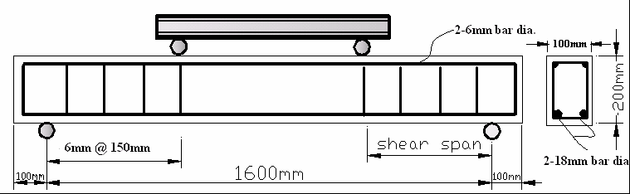
Figure (1) Details of the beams Reinforcement Details
2-6mm bar
50mm
50mm
Φ6
900mm
Φ6mm@40mm
150mm
2-10mm bar dia.
L
h

Table (1) Details of Beams
NO. | Specimen designation | The Opening (mm) | (length/depth)  Ratio of opening
1 | NS1 | ------- | -------
2 | NS2 | (75*60) | 1.25
3 | NS3 | (90*50) | 1.8
4 | NS4 | (100*45) | 2.22
5 | NS5 | (150*30) | 5
6 | NS6 | (300*15) | 20
7 | S1 | (90*50) | 1.8
8 | S2 | (150*30) | 5
9 | S3 | (300*15) | 20
(#) NS non strengthened
(##) S Strengthened with CFRP
4-2 Materials Properties
The properties of steel and concrete used in this investigation are presented in this section. Standard tests according to the American Society for Testing and Materials (ASTM) were carried out to determine the properties of hardened concrete and steel. The details of the constituent and design of concrete mix used is also presented
4-2-1Concrete Mix Constituent
The constituent materials of the concrete used throughout this investigation are described below:
Cement :
Ordinary Portland cement complying with ASTM C150-02 was used.
Coarse aggregate
The coarse aggregate used was natural aggregate with 4.74-19mm nominal size of aggregate. Sampling was carried out in accordance with ASTM C75-00.
The grading curve obtained from the results of sieve analysis of the aggregate

lies within the range defined by ASTM C136-01.

Fine aggregate
The results of the sieve analysis which was carried out lies within the range defined by ASTM C136-01.
4-2-2 Concrete mix design
Several mixes were originally considered. The final mix used is 1:1.8:3with water cement ratio 0.46 and the slump was 100mm, the concrete strength was 25MPa at 28 days.
4-2-3 Properties of Steel :
Steel bars
The longitudinal steel reinforcement bars were deformed, hot-rolled, high-yield strength with 10mm diameter. The stirrups were made from smooth steel bars with 6mm diameter.. Three specimens from each bar diameter were tested to determine their tensile properties according to ASTM 370-05a.
The results are shown in Table 2 . The bars have been tested in the material laboratory of the Civil Engineering Department at Babylon University .

Table 2: Properties of steel bars:
Bar diameter (mm) | Modulus of elasticity  (GPa) | Yield stress  (MPa) | Strain at yield stress (microstrain) | Ultimate stress  (MPa)
6*  10 | 197  198 | 450  490 | 2280  2420 | 550  590
(*) 6.1mm smooth steel bar
4-3 Composite Strengthening System
The strengthening system used in this research study comprised of epoxy, fiber sheets.
4-3-1 Epoxy: The properties of the resins in tension are listed in Table 3. The values were obtained from the manufacturer (Sika /Switzerland Co.). One types of epoxy were used: Sikadour30 was used to fix CFRP to the concrete surface .

Table 3: Resins properties (from manufacturers)
Epoxy type | Tensile bond strength (MPa) | Strain at yield  (mm/mm) | Elastic moduls (MPa) | Shear strength  (MPa)
Sikadour 30 | 21.3 | 1% | 4482 | 15

4-3-1 Carbon fiber sheets: The carbon fibers used in this program were in the form of dry unidirectional flexible sheets. The sheets had a paper backing and were supplied in a roll of 600mm width. The carbon fibers were manufactured by Fosrock Company.
According to the manufacturer's information the design thickness is 0.16mm. Tensile strength test had been made according to ASTM D3039M-00 and the result is shown in Table 4.
Table 4 : Properties of CFRP :
CFRP strip | Modulus of elasticity  (GPa) | Yield stress  (MPa) | Ultimate stress  (MPa) | Strain at ultimate stress (microstrain)
40mm width 0.16mm thick | 180 | --- | 1650 | 10000

4-3-3 Fixing procedure: The CFRP were prepared by manual lay-up . The components of the strengthening system are illustrated in Fig (2). Prior to fixing the CFRP, the edges of the beams were rounded (radius of approximately 15mm) at the position of wrapping .
They were used to attaching the CFRP sheets bonded to the concrete by epoxy (Sikadour 30).

Figure (2) Strengthening Schemes for Beams Specimens.

5- Experimental Results
5-1 Beam Specimens without CFRP laminates
The specimen NS1 failed in shear. The closest crack to the support (in the shear span at the right hand side of the beam) propagated directly towards the nearest loading point (diagonal shear crack), and failure occurred at a total applied load of 90kN. Fig 3 shows the crack pattern of specimen NS1 at ultimate load.
In control beam NS2 and NS3, some of flexural cracks at the middle zone of the shear span changed their direction and propagated toward the opening (flexure-shear crack). But it is failed with local failure at region above opening , at a total applied load of 68 kN and 72kN respectively. Fig 4 shows the failure of specimen NS3.
In specimen NS5, the first some closest crack to the support (in the shear span at the left hand side of the beam) propagated directly towards the nearest loading point, (diagonal shear crack). which were widening and propagating until failure occurred because the compression and reached the loading point at a total applied load of 75.35kN. Fig 5 shows the crack pattern of specimen NS5 at ultimate load.
In the control beam specimen NS6, just few cracks were observed close to the middle of the shear span. When the applied load reached approximately 40kN, then with little increase of the applied load the single diagonal crack rapidly propagated and became wider. Then collapse happened by splitting the beam into two pieces along the main diagonal crack at a load of 75.5kN, Fig 6 shows the crack pattern of specimen NS6 at ultimate load.
Subgroup (NS) consisted control beam specimens, (NS1) beam don’t have opening, but the other beam have openings with different (length / depth) ratio.
The beam (NS2) with (L/h)equal to (1.25)compare with (NS1), the deflection for (NS2) greater than it for (NS1) because the opening causing reduction in stiffness of beams and reduce the load failure by about 32 % .
The deflection at same applied load of (NS3) is less than of (NS2) but greater than of (NS1). This gives index if (L/h) ratio increase from (1.25) for (NS2) to (1.8) for (NS3) the deflection decreasing by(80%) also the load failure increasing by about 6%, that because the moment of inertia for the section is increase while the (L/h) is increase, see Figure (7) .
Figure (8) shows that before (30KN) the beam (NS4) with (L/h)equal to (2.22) had similar behavior to that of the reference beam (NS5) with (L/h) equal to (5), With increasing load the flexure–shear crack were formed and increased causing reduction in the stiffness of beam (NS4) (because the moment of inertia of the crack section). But this crack reach to the opening and stopped them increased, for that the length of crack for beam (NS5) is greater than it for beam (NS4) that causing reduction in the stiffness of beam (NS5) at load greater than (30KN) and failed at load less than beam (NS4) by about 6.17% .When the (L/h) ratio increase from (2.22) for(NS4) to (5) for (NS5) the deflection decrease about (16%). The deflection of beams (NS4) and (NS5) at the beginning load is greater than it for beam (NS1) but the inverse is happened at load greater than (32KN) that refer when the (L/h) increase for (2.22) the beam became behavior as two beams and the load divided into two beams (upper beam and lower beam) beside to the high length of crack that reduce the stiffness of solid beam.
Test (NS6) with (L/h) is (20) we notes behavior of beam (NS6) converges of beam (NS1), also the deflection less than it for (NS4) and (NS5) at the same applied load less than (40KN) because the moment of inertia of the section of beam (NS6) is greater than for the other beams. But after crack formation the deflection of beam (NS6) became greater than it for (NS4) and (NS5), that because the length of crack for beam (NS6) is greater than it for beam (NS4) and (NS5) that causing reduction in the stiffness of beam (NS6) at load greater than (40KN) and reduce the load failure by about 0.2 % of(NS4) and by about 6% of (NS5), that shown in Figure (9).

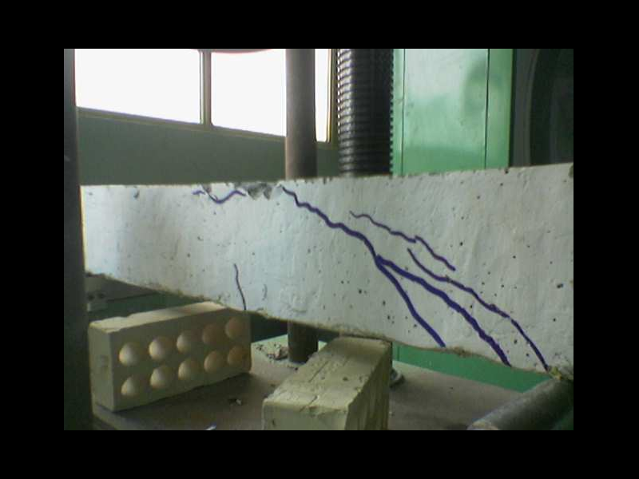
Figure 3: the crack of Beam specimen NS1 as a beam without opening

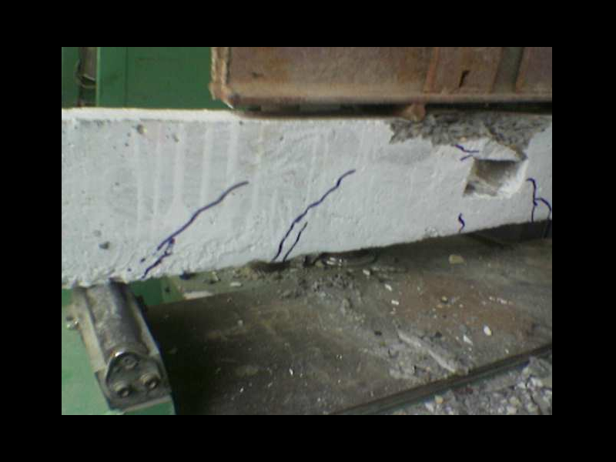
Figure 4: the crack of Beam specimen NS3 as a beam with (length/depth=1.8)

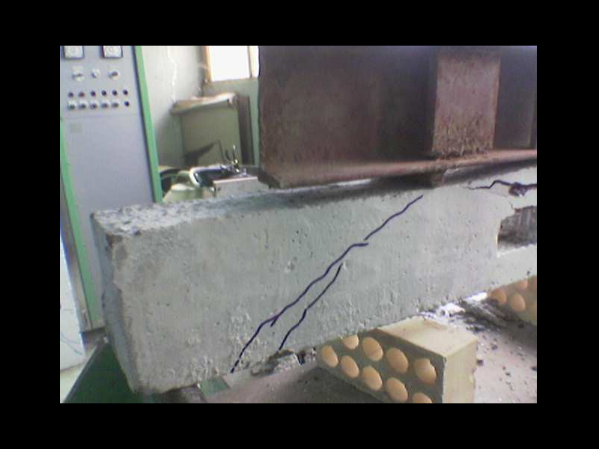

Figure 5: Beam specimen NS5 as a beam with (length/depth=5)

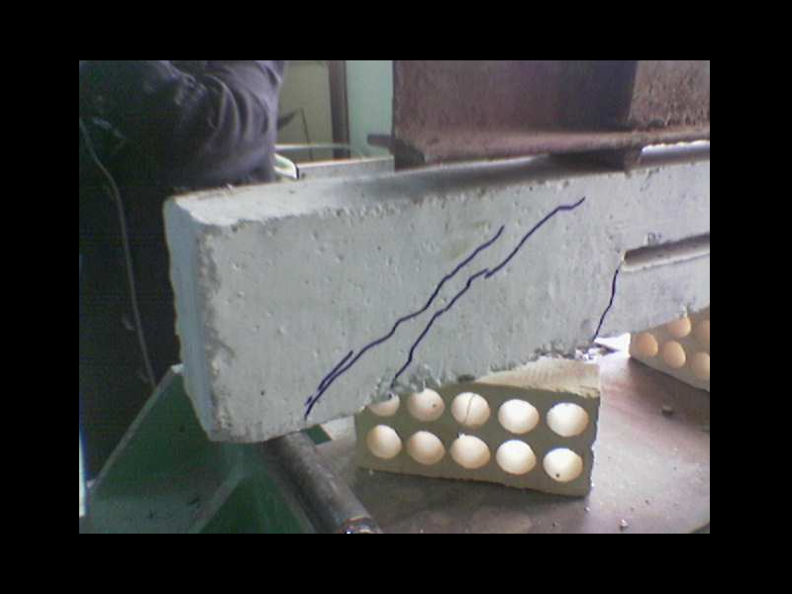
Figure 6: Beam specimen NS6 as a beam with (length/depth=20)

Figure 7: Experimental load-deflection relationship for specimens
beams (NS1,NS2 and NS3).
Figure 8: Experimental load-deflection relationship for specimens
beams (NS1, NS4 and NS5).
Figure 9: Experimental load-deflection relationship for specimens
beams (NS1,NS4,NS5 and NS6).
5-2 Control Beam Specimens :
In beam specimen S1,S2 and S3, as the applied load increased the deformation of the specimen obviously increased. This broke the bonding between the CFRP strips and the concrete cover (thin layer of epoxy type Sikadour330) and the sound of the separation (destroying the epoxy layer) was very obvious. At about 30kN,35KN and 32kN respectively for S1,S2 and S3 diagonal shear cracks formed, they continued growing and propagating until failure occurred immediately after separation of the CFRP. The failure was sudden and explosive after the separation of the CFRP laminate. There were some attached particles of cement on the separated CFRP strips.
Subgroup (S) consisted control beam specimens, (S1,S2 and S3) is the beams with (L/h)ratio 1.8 , 5 and 20 respectively and flexure region strengthen by CFRP reinforcement as pattern shown in Figure (6).
From the Figure (10,11 and 12) find that the deflection of beams strengthen by CFRP reinforcement is less than it for the beams without CFRP reinforcement , but the load of failure for strength beams is very small if compare with don’t strengthen beams, that because CFRPs debonded from the concrete surface and the failure (separation) happened in the concrete, because of the differences in the stiffness of the three materials (concrete, epoxy and CFRP).The concrete is the weakest material compared to the epoxy and the CFRP strip and the epoxy is the lesser in thickness (rigidity).
The difference in behavior between the beams with and without carbon fiber (S1 and NS3) respectively, both with L/h=1.8.
The reduction in the slope (stiffness) of the beam NS3 may be because of forming the cracks and started to grow with increasing applied load but the beam S1 where the failure happened explosively, and then beam NS3 continued in carrying load for about 140% of the loading capacity of beam S1 that because the CFRP resisted the applied flexure force at first and decaling it for the concrete suddenly . Similar behavior was observed by comparing the beams S1 with S2 and S3 and comparing NS3 with NS5 and NS6, as shown in Figs. 13,14,15. Experimental load failure, central deflection and type of failure shown at Table (5).
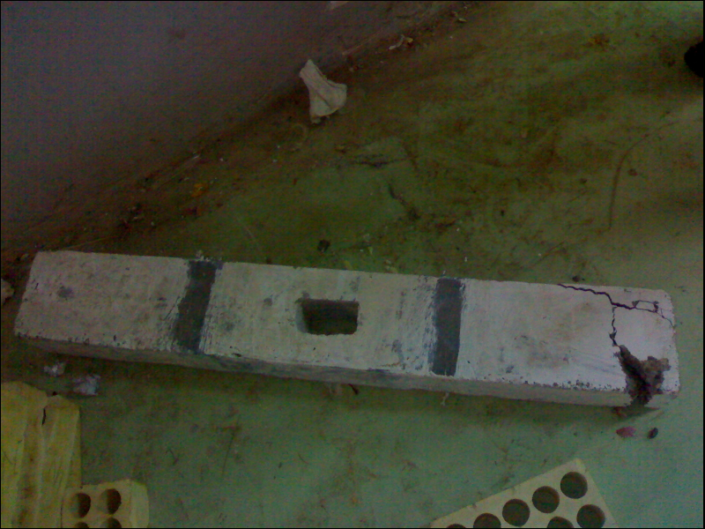
Figure 10: Beam strengthen with CFRP specimen S1 as a beam with (length/depth=1.8)
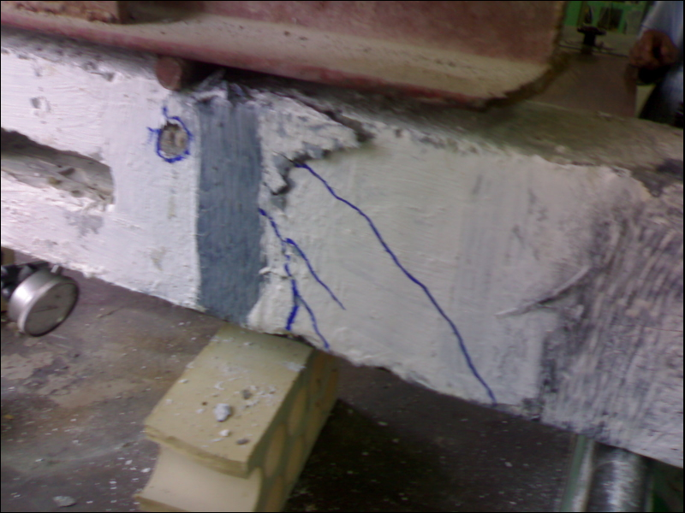
Figure 11: Beam strengthen with CFRP specimen S2 as a beam with (length/depth=5)
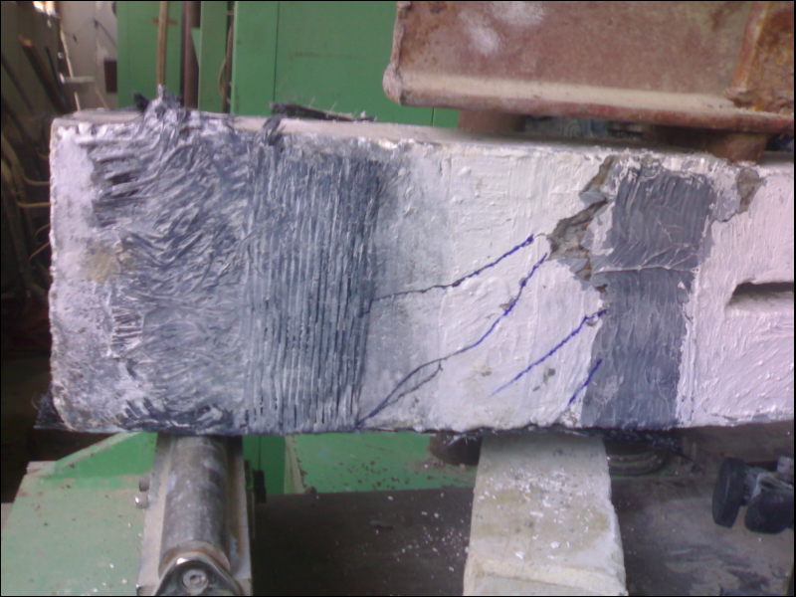
Figure 12: Beam strengthen with CFRP specimen S3 as a beam with (length/depth=20)

Figure 13: Experimental load-deflection relationship for specimens
beams (NS3and S1).
Figure 14: Experimental load-deflection relationship for specimens
beams (NS5 and S2).
Figure 15: Experimental load-deflection relationship for specimens
beams (NS6 and S3).

Table (5) experimental load failure, central deflection and type of failure.
NO. | Specimen designation | (length/depth)  Ratio of opening | Load Failure  (KN) | central deflection  (mm) | type of failure
1 | NS1 | ------- | 90 | 6.8 | Diagonal Shear failure
2 | NS2 | 1.25 | 68 | 8.8 | Shear-compression failure
3 | NS3 | 1.8 | 72 | 5.9 | Shear-compression failure
4 | NS4 | 2.22 | 80 | 4.7 | Flexural failure
5 | NS5 | 5 | 75.35 | 4.24 | Shear-compression failure
6 | NS6 | 20 | 75.5 | 4.57 | Diagonal Shear failure
7 | S1 | 1.8 | 55 | .62 | The failure at right support
8 | S2 | 5 | 64 | .87 | Diagonal Shear failure with CFRP rupture
9 | S3 | 20 | 55 | .63 | Diagonal Shear failure with CFRP rupture

6-Nonlinear Finite Element Analysis for Structures :
Most phenomena in solid mechanics are nonlinear. However in many applications it is convenient and practical to use linear formulation for problems to obtain engineering solutions. On the other hand, some problems definitely require nonlinear analysis if realistic results are to be obtained such as post-yielding and large deflection behavior of structures. Depending on the sources of nonlinearities, the present study deals with material nonlinearity in analyzing the tested beams. This is because for RC members, similar to this work, geometric nonlinearity effects are insignificant .

Table 6: Element types for working model
Material type | ANSYS element
Concrete  Reinforcement  CFRP strips | SOLID65  LINKE8  SHELL41

6-1 General :
The finite element method has become a powerful tool for the numerical solution of a wide range of engineering problems. In this research the formulation of the finite element method used for analyzing the tested beams is introduced. The finite element model will be using the experimental load-deflection results of the concrete beams. The use of ANSYS-8 to create the finite element model is adopted. All the necessary steps to create the calibrated model are explained in details and the steps taken to generate the analytical load-deflection response of the member are discussed.
6-2 Solid 65 Input Data :
The element is defined by eight nodes and the isotropic material properties. The element has one solid material and up to three rebar materials. MAT. command is used to input the concrete material properties while link8 is used to represent the main reinforcement so, the volume ratio which is defined as the rebar volume divided by the total element volume is equal to zero.

6-3 Link8 Element :
A link 8 element was used to model steel reinforcement and the connector bolts. This is a 3D spar element and it has two nodes with three degrees of freedom; translations in the nodal x, y and z directions. This element is also capable of plastic deformation.
6-4 Link 8 Input Data
The element is defined by two nodes, the cross-sectional area, an initial strain, and the
material properties. Real Constant
AREA - Cross-sectional area
ISTRN – Initial strain
6-5 Strength limit state: Table 7 shows the failure load and its central deflection for each beam. This can be made by changing the tolerance till finding this value of load. The failure of the modeled beam was indicated by the state that the beam no longer can support additional load as indicated by the convergence failure of ANSYS program in failing to find a solution. The deflection of the finite element model was within 13% for the beams of the experimental results at which the beams failed.

Table 7: The experimental and ANSYS deflection values of the beams at the experimental failure load.
Beam specimen | Failure load  (kN) | Central deflection (mm) |  | Exp./ANSYS  %
Beam specimen | Failure load  (kN) | Experimental | ANSYS
NS1  NS2  NS3  NS4  NS5  NS6 | 90  68  72  80  75.35  75.5 | 6.8  8.8  5.9  4.7  4.24  4.57 | 6.7  8  6  5.3  4  4.8 | 101  110  98  89  106  95
 |  |  |  | Average=99.8

Figure 16: Theoretical and experimental load-deflection relationship for specimens NS1.

Figure 17: Theoretical and experimental load-deflection relationship for specimens NS2

Figure 18: Theoretical and experimental load-deflection relationship for specimens NS3
Figure 19: Theoretical and experimental load-deflection relationship for specimens NS4
Figure 20: Theoretical and experimental load-deflection relationship for specimens NS5
Figure 21 : Theoretical and experimental load-deflection relationship for specimens NS6

7- Conclusions
- Results obtained from the present study show that when the (L/h) of opening at flexural region increased the stiffness of beams increase also until the beams working as two beams.
- For beams with (L/h) less than (1.8) the deflection of it is greater than the deflection of beams without opening , but for (L/h) greater than (2.22) the beams became working as two beams and the deflection of it is at high load less than the deflection of solid beam.
- When (L/h) ratio increase from (1.25) to (1.8) the deflection decreasing by (64%) and this stiffness is less than of solid beam, but if (L/h) increasing from (2.22) to (5) the deflection decrease about (6%) and the deflection of this cases at large load become greater than the deflection of solid beam.
- The ultimate load decrease when opening at the flexural region of beams .
- The comparison between the numerical and the available experimental results has shown a good agreement with a difference of about (13%) respect to ultimate load.
- The flexural strengthening of R.C. beams with CFRP is effective with increment in deflection of about (310,300 and 360)% for beams with (L/h) 1.8, 5 and 20 respectively, but it is reduce the ultimate load of about (35,16 and 15)% respectively.
- recommend to keep the CFRP working till the beam reaches its failure, because in most of the previous researches the CFRPs debonded from the concrete surface and the failure (separation) happened in the concrete, because of the differences in the stiffness of the three materials (concrete, epoxy and CFRP).The concrete is the weakest material compared to the epoxy and the CFRP strip and the epoxy is the lesser in thickness (rigidity).
- The end anchor system proved with epoxy its effectiveness in carrying the applied force whether the CFRP were bonded or not to the beam.
- In spite of the fact that CFRP is a brittle material (inductile) and this property is not preferable in flexural behavior, but in shear behavior this brittleness is useful. This is because the redistribution of the stresses between the concrete and the shear reinforcement is limited and the shear failure is a brittle failure in any case (i.e. the shear failure is brittle whether the shear reinforcement does or does not carry the applied shear force. On the other hand, tests have shown that the CFRP elongation is a major factor that could affect shear crack propagation).
References
- Anthony, J. (2004) "Flexural behavior of reinforced and prestressed concrete beams using finite element analysis" MSc thesis, Department of Civil and Environmental Engineering, Marquette University, May.
- Alagusundaramoorthy et al., Harilk, I.E. and Choo,c.c. "Flexural behavior of R/C beams strengthened with CFRP sheets or fabric", Technical Report, University of Kentucky, Agust,22002,p.p.35.
- AL-Shmmary H. M. T., (2006) "Nonlinear finite element analysis of reinforced concrete beams flexural of reinforced concrete beams flexural strengthened with carbon fiber reinforced polymer plates" MSc thesis, Department of Civil Engineering, University of Babylon.
- ASTM Designation A370-05a "Standard specification for testing method and definitions for mechanical testing of steel products", 2000 Annual Book of ASTM Standards, American Society for Testing and Material, Philadelphia, Pennsylvania,section1,Vol.1.01,pp248-287.
- Carolin, A. (1999) "Improvement of the load-bearing capacity of existing bridges: A review of literatures". Technical report 1999:19 Lulea: University of Technology. Lulea 31pp.
- Izzet,A. F. , (2008) " Retrofit of Shear Critical R.C. Beams with Carbon Fiber Reinforced Polymer Sheets " MSc thesis, Department of Building and Construction Engineering, University of Technology, March.
- Michael, W.R., Robert, W.B., Barnes, A.S. and Hwan-Woo,L., "Fiber-reinforced polymer strengthening of concrete bridge that remain open to traffic ", Technical Paper ,ACI Structure Journal , Vol. 102 ,No.6, November – December,2005 ,p.p.823.
- Mansure,M.A. and Tan,K.H.,(1999) "Concrete beams with opening analysis and design" by CRC press LLC.
- Salles Neto, M., Melo, G. S., Nagato, Y., (2001) "T-beams strengthened in shear with carbon sheet laminates (CFRP)" Fiber-Reinforced Plastics for Reinforced Concrete Structures: Proceedings of the Fifth International Conference on Fiber-Reinforced Plastics for Reinforced Concrete Structures, Edited by C. J. Burgoyne, Cambridge, UK, Vol.1, July, pp 239-248.

