Multicast Particle Swarm Optimizer Router based QoS in Communication Networks
Ali Kadhum Idrees
Department of Computer Science, College of Sciences for Women, University of Babylon

Abstract:
In this paper, a Multicast Particle Swarm Optimization Router (MPSOR) based Quality of Service (QoS) in Communication Networks is proposed. Each MPSO system in the MPSOR will uses an efficient objective function that reflect one or more of the QoS parameters to evaluate the multicast Tree between one source node and multiple destination nodes according to Class of Service (CoS). We first classify the applications into classes according to its sensitivity to one or more QoS parameters. Our proposed multicast PSO router finds the multicast Tree with minimum cost subject to specific QoS parameter(s) and for the specific application that belong to appropriate CoS in computer networks. The multicast PSO router system is distributed at each node in communication network and it makes its decision based on a database of alternate routes between each pairs of nodes in the network dynamically. The simulation results explain that the proposed multicast PSO systems in the MPSOR exhibits a good quality of solution and a good rate of convergence to optimal solution for each CoS that lead to high speed response in computer networks.
Keywords: Multicasting, Particle Swarms Optimizer (PSO), QoS, Communication Networks, and Combinatorial Optimization.
الخلاصة
اقترح في هذا البحث موجه محسن اسراب الجسيمات المتعدد محطات الاستقبال المستند على جودة الخدمة في شبكات الاتصالات. كل نظام محسن اسراب جسيمات في الموجه المتعدد محطات الاستقبال سوف يستخدم دالة هدف كفوءة والتي تعكس واحد او اكثر من معاملات جودة الخدمة لتقييم الشجرة متعددة الاستقبال بين عقدة المصدر وعدة عقد هدف.في البداية صنفنا التطبيقات في فئات طبقاً لحساسيتها لمعامل او اكثر من معاملات جودة الخدمة. يجد موجهنا محسن اسراب الجسيمات المتعدد محطات الاستقبال الشجرة المتعددة محطات الاستقبال الاقل كلفة الخاضعة لمعامل (او معاملات) جودة خدمة محدد ولغرض تطبيق محدد الذي ينتمي الى فئة خدمة مُعيّن في شبكات الحواسيب. تم توزيع نظام الموجه محسن اسراب الجسيمات المتعدد محطات الاستقبال في كل عقدة في شبكة الاتصالات والذي يصنع قراره بالاستناد على قاعدة بيانات من المسارات البديلة بين كل زوج من العقد في الشبكة ديناميكياً. تبين نتائج المحاكاة ان انظمة محسن اسراب الجسيمات المتعدد محطات الاستقبال في الموجه تعرض جودة حل جيدة ونسبة تقارب جيدة للحل المثالي ولكل فئة خدمة والذي يقود الى استجابة عالية السرعة في شبكات الحاسبات.
- Introduction
The migration to integrated networks for voice, data, and multimedia applications introduces new challenges in supporting predictable communication performance. Multimedia applications require the communication to meet stringent requirements on delay, delay-jitter, cost, and/or other quality-of-service (QoS) metrics (Yuan, 2002). QoS is the ability of a network element (e.g. an application, host or router) to have some level of assurance that its traffic and service requirements can be satisfied. QoS manages bandwidth according to application demands and network management settings (Marchese, 2007). An efficient QoS multicast algorithm should construct a multicast routing tree, by which the data can be transmitted from the source to all the destinations with guaranteed QoS (Wang et. al. , 2006). Constructing a function that reflect all QoS parameters for multicast routing and use it for all types of applications will not guarantee that each QoS parameter in the constructed function will be respected. Many proposed intelligent algorithms are used to solve the QoS multicast routing with using one, two, or three QoS parameters, but there is no global one is used for all types of applications in the Internet. The hardware implementations of neural network (NN) and Genetic algorithm (GA) are extremely fast. Furthermore, they are not sensitive to network size (Ahn et. al., 2001; Tufte and Haddow, 1999). The quality of solution returned by NNs is constrained by inherent characteristics. GAs are flexible in this regard. The quality of solution can be adjusted as a function of population. In addition, NN hardware is limited in size, it cannot accommodate networks of arbitrary size because of its physical limitation. GA hardware, on the other hand, scales well to networks that may not even fit within the memory. It is realized by employing parallel GA over several nodes. Therefore, GAs (especially hardware implementation) are clearly quite promising in this regard (Ahn and Ramakrishna, 2002). The GA is one of evolutionary algorithms (EA), which is a population-based stochastic optimization algorithm. A particle swarm optimizer (PSO) is a population-based stochastic optimization algorithm modeled after the simulation of the social behavior of bird flocks (Kennedy and Eberhart, 2001). PSO is similar to EAs in the sense that both approaches are population-based and each individual has a fitness function. Furthermore, the adjustments of the individuals in PSO are relatively similar to the arithmetic crossover operator used in EAs (Coello and Lechuga, 2002). However, PSO is influenced by the simulation of social behavior rather than the survival of the fittest (Shi and Eberhart, 2001). Another major difference is that, in PSO, each individual benefits from its history whereas no such mechanism exists in EAs (Coello and Lechuga, 2002). PSO is powerful, easy to understand, easy to implement, and computationally efficient (Kennedy and Eberhart, 2001). The PSO has been successfully applied to solve a wide range of optimization problems that solved by the GA with less computational cost (Hassan et. al., 2005). The hardware implementations of the PSO will makes each of the multicast PSO systems based QoS inside the router gives faster response that leads to enhance the performance of computer networks.
In this paper, we propose a Multicast Particle Swarm Optimization (PSO) Router based QoS in Communication Networks. We first classify the applications into classes according to its sensitivity to one or more QoS parameters. A multicast PSO algorithm based QoS is suggested to each class of service. The multicast PSO router finds the multicast tree with minimum cost from one source to multiple destinations subject to specific QoS parameter(s) and for the specific application that belong to appropriate class of service (CoS) in computer networks. The multicast PSO router system is distributed at each node in communication network and it makes its decision based on a database of alternate routes between each pairs of nodes in the network dynamically. The simulation results explain that the proposed multicast PSO router exhibits a good quality of solution and a good rate of convergence to optimal solution for each CoS that lead to high speed response in computer networks.
The remainder of the paper is organized as follows: in section 2, we review Related Works. Section 3 gives The QoS specification and Class of Service in Communication Networks, Particle Swarm Optimization, and Alternative Routes Computation. Section 4 describes the Proposed MPSOR based QoS. Simulation Results are illustrated in section 5. Conclusions and future work are drawn in section 6.
2. Related Works
Many proposed intelligent algorithms with different techniques have been introduced to solve the QoS multicast routing with using one or more QoS parameters. The first class used the neural networks for solving the QoS multicasting, Zhang and Liu (2001) proposed a Chaotic Neural Network for solving the QoS Multicast Routing Problem and then Yin et. al. (2005) uses the same Chaotic Neural Network with improved energy function for solve the same Problem. However, the two approaches have several limitations. These include the complexity of the hardware with increasing number of the network nodes; at the same time, the reliability of the solution decreases. Secondly, they are less adaptable to topological changes in the network graph including the cost of the arcs (Araujo, 2001). The proposed two neural networks don’t support all applications (the classes in the CoS) in the Internets.
Another class of methods uses the evolutionary algorithms is the most attractive alternative ways to go for. Zhang et al. (2008), Zhengying et al. (2001), Haghighat(2004) ,and Chen (2005) tackled multicast routing while looking at delay and bandwidth constraints. Roy and Das (2004) investigated multicast QoS routing to mobile phones for multimedia applications using a genetic algorithm. Simulation showed that the algorithm worked even with imprecise information. Wang et. al. (2003), Bao et al. (2006), Sun and Li (2004), and Yuan and Yan (2004) were researched multicast routing with QoS requirements using genetic algorithms. Li et. al. (2003), Tsai et. al.(2004), and Cui et. al. (2003) also investigated QoS multicast routing with genetic algorithms under various circumstances. Xu and Chen (2006) proposed an effective algorithm for solving the multicast problem with one QoS constraints. Wang et al. (2006) proposed three algorithms to construct multicast trees, which not only utilize network resources with optimal cost but also satisfy the QoS requirements of multimedia applications. These algorithms are based on three intelligent computational methods – GA, SA, and TS, respectively. There is no paper from the above class of methods used the concept of Class of Service (CoS) in its method to support all traffic flows in the Internet.
The third class of methods uses the hybrid intelligent approaches to solving the QoS multicast routing problem. Vijayalakshmi and Radhakrishnan (2008a) proposed hybrid genetic algorithm to find the multicast tree with minimum cost subject to delay, degree, and bandwidth constraints. They are also proposed an artificial immune based GA for the construction of minimum multicast tree with delay, bandwidth and degree constraints (Vijayalakshmi and Radhakrishnan, 2008b). Pan et. al. (2004) researched multicast routing with QoS requirements using hybrid system genetic algorithm and neural network. Chen and Dong (2003) presented a fuzzy genetic algorithm for QoS multicast routing and simulation experiments demonstrate that the algorithm is efficient. QoS multicast routing problem in WDM networks is investigated by Xing et. al. (2009), and an improved algorithm Multi-granularity Evolution based Quantum Genetic Algorithm (MEQGA) is proposed to address it. Zhang et. al. (2009) presents a new genetic simulated annealing algorithm for QoS multicast routing. Genetic algorithm and simulated annealing algorithm are combined to improve the computing performance in this method. Xing et al. (2009) investigates least-cost QoS multicast routing problem in IP/DWDM optical networks, and proposes an improved evolutionary algorithm (AEQEA) Based on quantum-inspired evolutionary algorithm (QEA) with quantum rotation gate strategy. Despite those hybrid approaches improves the performance of the system but it don’t support the concept of CoS in the communication networks.
The fourth class of methods used the swarm intelligent methods for solving the QoS problem, Pinto and Barán (2005), Wang et al. (2009), Wang and Zhang (2005), Li and Tian (2008), Gong et al. (2007a), and Gong et al. (2007b) tackled the QoS multicast routing by using Ant colony algorithms under two or more of QoS constraints, but their works don't support the all types of traffic in the network (i.e., CoS). LIU et al. (2006) proposes PSO algorithm to solve the QoS multicast routing. The QoS multicast routing problem was transformed into a quasi-continuous problem by constructing a new integer coding and the constrained conditions in the problem were solved by the method of penalty function. SUN et al. (2006) proposes quantum PSO algorithm for solving the QoS multicast routing by converting it into an integer programming problem and then solve it by QPSO. Wang et al (2007) used the PSO to solve the bandwidth-delay constrained least cost multicast routing problem. Jin et al. (2008) proposed a novel probability convergence based particle swarm optimization algorithm for the multiple constrained QoS multicast routing. This algorithm is inspired from the probability convergence attributes. The main contents of this paper includes: (1) A novel particle sorting rule of swarm are designed. (2)A novel probability convergence mechanism is developed in the position updating phase. (3) A new anti-congestion tactic is introduced. Li et al. (2007) presented a hybrid intelligent QoS multicast routing algorithm based on PSO and GA and take into account the QoS parameters (such as bandwidth, delay, delay jitter, and error rate). The above papers don’t support the concept of CoS in the communication networks. However, we have designed a new system that supports all CoS in the communication networks, which is different from those multicasting methods, to support all applications in the Internet.
3. Preliminaries
3.1. The QoS specification and Class of Service in Communication Networks:
One of the most important steps in requesting QoS in communication networks is to specify what these requirements are and to quantify them accurately (QoS specifications) (Alkahtani et al., 2003). A stream of packets from a source to a destination is called a flow. In a connection-oriented network, all the packets belonging to a flow follow the same route; in a connectionless network, they may follow different routes. The needs of each flow can be characterized by four primary parameters (Tanenbaum, 2003; Forouzan, 2007): reliability, delay, jitter (delay variation), and bandwidth. We can add the security as another important and primary parameter for certain traffics such as money transactions in e-commerce, confidential or extremely-private applications (Alkahtani et al., 2003). Together these determine the QoS (Quality of Service) the flow requires. Several common applications and the stringency of their QoS requirements are listed in Table 1(Tanenbaum, 2003; Alkahtani et al., 2003).
Table 1: Examples of common applications and the sensitivity of their QoS requirements.
Applications |  | Sensitivity
 |  | Reliability | Delay | Jitter | Bandwidth | Security
Data traffic | E-Mail | High | Low | Low | Low | Low
Data traffic | Confidential E-Mail | High | Low | Low | Low | High
Data traffic | File Transfer | High | Low | Low | Medium | Low
Data traffic | Money Transactions | High | Low | Low | Low | High
Real-time traffic | Audio on demand | Low | Low | High | Medium | Low
Real-time traffic | Video on demand | Low | Low | High | High | Low
Real-time traffic | Telephony | Low | High | High | Low | Low
Real-time traffic | Videoconferencing | Low | High | High | High | Low
Real-time traffic | Confidential  Videoconferencing | Low | High | High | High | High
From the above table 1 we suggest to classify the applications according to its Sensitivity to QoS parameter(s) into groups called Class of Service (CoS) as in table 2.
Table 2: The groups of Applications in the CoS
CoS | The Groups of Applications | Sensitive to the following QoS parameter(s)
1 | Confidential E-Mail ; Money Transactions | Reliability; Security
2 | E-Mail | Reliability
3 | File Transfer | Reliability; Bandwidth
4 | Audio on demand; Video on demand | Jitter; Bandwidth
5 | Telephony | Delay; Jitter
6 | Videoconferencing | Delay; Jitter; Bandwidth
7 | Confidential Videoconferencing | Delay; Jitter; Bandwidth; Security
According to above table 2 the multicast PSO router based QoS will contain seven Multicast PSO algorithms, one for each class of service CoS that take into account the sensitivity of its applications to the certain QoS parameter(s).
3.2. Particle Swarm Optimization:
Particle swarm optimization (PSO) is a stochastic optimization approach, modeled on the social behavior of bird flocks. PSO is a population-based search procedure where the individuals, referred to as particles, are grouped into a swarm that developed by Kennedy and Eberhart (Kennedy and Eberhart, 2001; Engelbrecht, 2007). Each particle in the swarm represents a candidate solution to the optimization problem. In a PSO system, each particle is “flown” through the multidimensional search space, adjusting its position in search space according to its own experience and that of neighboring particles. A particle therefore makes use of the best position encountered by itself and the best position of its neighbors to position itself toward an optimum solution. The effect is that particles “fly” toward an optimum, while still searching a wide area around the current best solution. The performance of each particle (i.e. the “closeness” of a particle to the global minimum) is measured according to a predefined fitness Function which is related to the problem being solved. PSO has some advantages over other similar optimization techniques such as GA, namely the following. 1) PSO is easier to implement and there are fewer parameters to adjust(Kang et al.,2008; Valle et al., 2008).2) In PSO, every particle remembers its own previous best value as well as the neighborhood best; therefore, it has a more effective memory capability than the GA (Valle et al., 2008). 3) PSO is more efficient in maintaining the diversity of the swarm (Engelbrecht, 2006; Valle et al., 2008) (more similar to the ideal social interaction in a community), since all the particles use the information related to the most successful particle in order to improve themselves, whereas in GA, the worse solutions are discarded and only the good ones are saved; therefore, in GA the population evolves around a subset of the best individuals.

3.3. Alternative Routes Computation:
We must first determine the all alternative routes between each Source-Destination (SD) pairs in computer network. We used the algorithm that proposed in (Idrees, 2010) for generating all paths between each two nodes in the grid network. We can also use the algorithms suggested by (Feng, 2001). The cost, delay, delay Jitter, packet loss rate, security rate and bandwidth between each two nodes can be generated randomly. This algorithm will be executed at each router in the network and only during the network configuration or changing the network topology to generate all routes between each two nodes in the network. The generated routes will be saved in a database of alternative routes for each CoS to be used later by the MPSO systems in the MPSOR.

3.4. Mathematical model of QoS multicast routing:
The network can be modeled as an undirected connected graph G = (V, E), with node set V representing routers or switches, edge set E representing communication links between network nodes and n = be the number of nodes in G. An edge e E which connects v₁ and v₂ will be denoted by (v₁, v₂). Each edge is associated with edge cost C(e), Bandwidth B(e), Delay D(e), Delay Jitter DJ(e), Reliability R(e), and Security S(e) where e E. Delay includes transmission, propagation and queuing delay over that edge, edge cost could be a measure of buffer space or monetary cost, the bandwidth is the minimum available residual bandwidth at any link along the path, Delay Jitter is the variation in delay for packets belonging to the same flow, Reliability is the Packet loss rate in transmission that consists of calculating and obtaining the minimum end-to-end packet loss rate, and Security is the more secure route to transmit the data across it . The multicast tree T(s, D) is a tree rooted at s and routes information to all members in D, where s V is the source node, D = {d₁, d₂, d₃, . . .,d_{k}} is the set of sinks in multicast tree, and k is the number of destination nodes. P(s, d_{i}) is the unique path in a tree T(s, D) from the source node s to any destination node d_{i}, d_{i} D. For arbitrary d_{i} D, the tree cost , delay , delay jitter , available bandwidth , packet loss ratio , and Security rate of the path P(s, d_{i}) from the source node s to the destination node d_{i} are expressed as follows:
……………………………………….………………………..…..……..... (1)
……………..…………………………….…………………………….….…(2)
……………………………………….………………….….….....(3)
………………….……………….…………..……... (4)
………………………………………..………………….…….....(5)
……………………………………………………….(6)
According to the above expressions, the QoS multicast routing problem for each CoS in communication network is defined as in the table 3.

Table (3): The mathematical formulation of the QoS multicast routing for each CoS in table 2.
CoS | The Mathematical Formulation | CoS | The Mathematical Formulation
1 | Min  Subject to  ……………..(7) …………………………….…………………………….……….(6) | 5 | Min  Subject to  ……………..(11) …………………………….…………………………….……….(6)
2 | Min  Subject to  ……………..... (8) …………………………….…………………………….……….(6) | 6 | Min  Subject to  ……………..(12) …………………………….…………………………….……….(6)
3 | Min  Subject to  ………………....(9) …………………………….…………………………….……….(6) | 7 | Min  Subject to  ……………..(13) …………………………….…………………………….……….(6)
4 | Min  Subject to  ………………...(10) …………………………….…………………………….……….(6) | 7
4. The Proposed MPSOR based QoS:
The proposed Multicast Particle Swarm Optimization Router (MPSOR) based QoS consists of seven Multicast PSO based QoS algorithms, one for each CoS as well as seven Multicast routing tables, one for each CoS that are include the alternative routes for each pair in communication network as shown in figure (1).

Network Protocol Manager
Multicast Routing Tables
MPSO1 For CoS1
MPSO2 For CoS2
MPSO3 For CoS3
MPSO4 For CoS4
MPSO5 For CoS5
MPSO6 For CoS6
MPSO7 For CoS7

Figure (1): The Proposed MPSOR based QoS.
MPSOR is distributed at each node in computer network. Each MPSO algorithm in the above MPSOR is activated with the associated CoS (group of applications) to produce the minimum cost multicast tree from one source to a set of destinations with satisfying the QoS constraints. Each MPSO algorithm makes its decision based on a multicast routing table of alternative routes between each pair of nodes in the network. In order to enable Each MPSO algorithm to make an optimal QoS multicast routing decision, it is important to make this decision based on correct and updated information about the topology and states of the links and nodes of the network. The network protocol manager will makes this updating to the multicast routing tables at each router periodically. The primary function of the network protocol manager is to interact with the communication network and the MPSO systems with its multicast routing tables. Each of the seven MPSO systems in the proposed MPSOR will use the flow chart in figure (2) to make their decisions based on Multicast routing table corresponding to their QoS constraints and CoS.

Start
Set parameters c1, c2, w, …, etc.
Iteration ← 0

Evaluate swarm using corresponding QoS fitness function
Update the local bests and global best
Update the particle velocities
Update the particle positions
Repair Particle Positions
Mutate Particles
Swarm Initialization
Iteration ← Iteration + 1

Is Termination Criterion met?
Report Global best Position
End
Yes
No

Figure (2): The Proposed flow chart for each of seven MPSO systems in the Proposed MPSOR based QoS.
The seven MPSO systems in the Proposed MPSOR based QoS uses the above flow chart but with different fitness functions according to the CoS. We can explain the detail of the above flow chart as follow:
- Setting Parameters: setting a suitable value for the inertia weight w usually provides balance between global and local exploration abilities and consequently results in a reduction of the number of iterations required to locate the optimum solution. Also set suitable values for each cognitive parameter c1 and a social parameter c2 that direct the particle towards good positions. Set values for each source address sr, multicast group size Dgroup, the set of receivers Dset, the probability of mutation Pm, swarm size (particle population size) Popsize, maximum iterations MaxItr, delay constraint , delay jitter constraint , packet loss constraint , bandwidth constraint , and security constraint .
- The swarm initialization: In the initialization process, a set of particles is created at random. Each particle k in the swarm includes Particle position , Particle velocity , local best , fitness of local best Fitlbest of the particle k, and the fitness value of the particle k, where 1 ≤ k ≤ Popsize and 2 ≤ i ≤ Dgroup. The particle k’s position can be represented as the vector and each value in the vector represents the serial number of the route in the set of the alternative routes between the source node and the target node Dset_{i}. This route will be QoS constrained path (according to the CoS) and will be selected randomly from the multicast routing table of the alternative routes between each pairs of nodes in the network. Each particle position in the swarm represents the serial numbers of the routes from source node to the other destination nodes in the networks. Every velocity vector V of every particle k is initiated within the range to reduce the likelihood of particles that leaving the space of search, where that represents the number of alternative routes from source node sr to the destination node . Also initialize the global and local fitness to the worst possible.
- The swarm evaluation: each particle in the swarm will be evaluated by using fitness function, where each of the seven MPSO systems in the Proposed MPSOR based QoS will use different fitness functions according to the CoS. A good particle will get a large fitness values, the relative bad particle will get a smaller fitness value. We can show the fitness functions that used by each of the seven proposed MPSO systems as follow:
The system | The Corresponding QoS Fitness Function
MPSO1 For CoS1 | ……………………………………………………(14)
MPSO2 For CoS2 | ………………………………………………………………………..…….…....(15)
MPSO3 For CoS3 | …….……………………………………...(16)
MPSO4 For CoS4 | ……………………………………………….…..(17)
MPSO5 For CoS5 | ………………………………………………..…..(18)
MPSO6 For CoS6 | ….………..………...(19)
MPSO7 For CoS7 | …..(20)
………………….(21)
………………….(22)
Where,, is the fitness value of the particle k. In the above functions, A, B, C, and D are positive coefficients. and are penalty functions and () is a penalty factor.
- Update the local bests and global best:
We can update the local bests and their fitness and the global best and its fitness as in the following algorithm
Algorithm Update
Inputs: the particles with its fitness values, where i= 1, …, Popsize.
Outputs: the updated local bests with its fitness ; as well as the global best with its fitness
For i← 1 to Popsize
endif
endfor
Retrieve the maximum fitness in the swarm, Maxfit with its index, ind from the swarm 1, ..., Popsize
endif
End of Algorithm
- Update the particle velocities: each particle i in the swarm will update its velocity by using the following equation of the original PSO algorithm.
……. (23)
Where is the velocity of the particle i at j^{th} dimention, is the local best positions of the particle i , is the positions of particle i in swarm at j^{th} dimention, is the global best positions in swarm, and j = 0… Dgroup-1, is the inertial weight, is the acceleration constant for particles moving to , is the acceleration constant for particles moving to , and are two random numbers among 0 to 1.
- Update the particle positions: Each particle i in the swarm will update its position by using the following equation of the original PSO algorithm.
…………………………..…. (24)
- Repair Particle Positions: after updating the velocity and the position of the particle, we need to repair the particle position X because it may contains serial number of a route that is not in the set of the alternative routes serial numbers between the source node and the target node Dset_{i}. This will be performed by comparing each serial number in vector X from 0… Dgroup-1, if the serial number of the route out of the range of its alternative routes serial numbers, we exchange this serial number with randomly selected serial number from the range, otherwise if there is no serial number in the particle position out of the rang it don’t repaired. The following algorithm explains the repairing approach.
Algorithm RepairParticle
Input: the index of the particle id, and the particle position vector Xr.
Output: the repaired particle X.
For j 0 To Dgroup - 1
If ( -1 ) Then
endif
endfor
End of Algorithm
Where is the number of alternative routes from the source node to the destination node .
- Mutate Particles: we designed a special PSO mutation operator to help our proposed MPSO algorithms to change the partial structure of some particles in order to get new types of solution. Our proposed MPSO algorithms in the MPSOR cannot fall into the local convergence easily because the mutation operator can explore the new solution. The following algorithm shows the MPSO mutation.
Algorithm MutateParticle
Input: the index of the particle id, the particle position vector Xr
Output: the mutated particle X.
Do While (
Select the serial number of the minimum cost route from Sr to the that satisfy the QoS constraint(s)
Endif
EndWhile
End of Algorithm
Where is the number of destination nodes in the Target nodes set , is the probability of mutation, and are the input particle position vector and the output particle position vector respectively.
- Termination Criterion: the algorithm will be converged to optimal solution when the difference between the new average of fitness values of swarm and old average of fitness values less than a certain threshold for a five times respectively, or the total number of iterations exceed the maximum number of iterations.
- Report Global best Position: after the convergence to the optimal solution (minimum cost multicast tree that satisfy the QoS constraints for appropriate CoS), the Global best position will contains the serial numbers of optimal routes that satisfy the QoS parameters according to the CoS from the Sr node to each destination node in the destination node set Dset.
5. Simulation Results:
In this section, the proposed Multicast Particle Swarm Optimization Router (MPSOR) based QoS that consists of seven of Multicast PSO based QoS systems; one for each CoS is simulated on a network consists of 9-Routers to test its performance. The network example that used in this paper is illustrated in figure (2), the all edges are labeled with (cost, delay, bandwidth, delay Jitter, Packet Loss Rate, Security Rate). We set = 8, = 6, = 0.7, = 2, and = 0.8. Also we set P_{m}=1/Dgroup and penalty factor . The (cost, delay, bandwidth, delay Jitter, Packet Loss Rate, Security Rate) on edge (i, j) is the same as with (j, i).
(1.4, 2, 2, 1, 0.4, 0.7)
(0.7, 1, 3, 0.5, 0.2, 0.8)
(1.6, 1, 4, 0.5, 0.1, 0.7)
(1.1, 3, 3, 2, 0.3, 0.8)
(0.5, 3, 5, 2, 0.1, 0.9)
(0.9, 1, 4, 0.5, 0.1, 0.4)
(1.2, 1, 2, 0.5, 0.3, 0.8)
(0.6, 3, 2, 3, 0.2, 0.6)
(0.2, 1, 2, 0.5, 0.3, 0.9)
(1.3, 4, 3, 3, 0.2, 0.8)
(0.3, 2, 3, 1, 0.3, 0.9)
(0.8, 2, 3, 1, 0.5, 0.7)
1
4
5
2
1
4
7
8
5
0
3
6

Figure (3): 9-Routers computer network example.
By using one of the algorithms in section 3.3, we can obtain for each SD pair in the network in figure (3) on the all possible routes and then stored in a database of multicast routing tables to be used later by each of the seven MPSO systems according to CoS for selecting the optimal multicast routes that satisfy the QoS parameters for sending the packet from the source router to the destination routers set. These experimental simulations are achieved by using Visual Basic 2008 professional edition on Dell laptop 1525 with processor T8300 2.4 GHz Core 2 due and RAM 2GB on Windows Vista Ultimate. By the simulation, many experiments will be made to explain the performance of the proposed MPSOR for QoS multicast routing.
Our performance metric measures include the Average number of Iteration of each of the seven MPSO systems (AVGITR), the Optimality of the Multicast Tree (OMT) that satisfies the QoS constraints according to CoS, Multicast tree cost, convergence rate, and the execution time. The AVGITR and the OMT are calculated by using the following relations:
………………………….……....(25)
* 100 ………………………………..…(26)
Where : the maximum number of iteration that needed by MPSO to converge to optimal solution in the i^{th} run. : The number of convergence of MPSO to optimal multicast routes that satisfy the QoS constraints according to the CoS after running it 100 times.
5.1. The impact of the number of particles on the AVGITR and OMT:
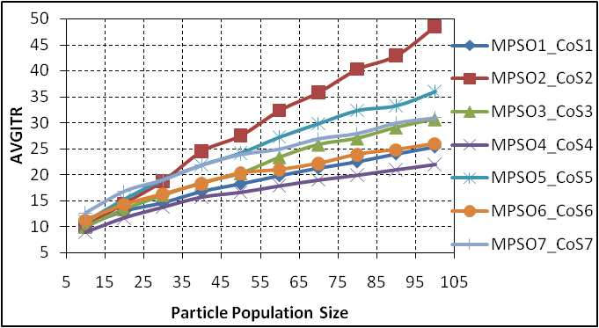
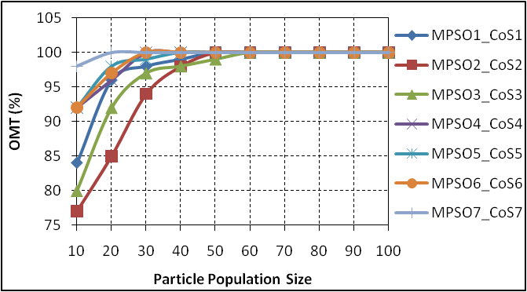
In this experiment, we study the impact of the number of particles on the AVGITR and the OMT for each MPSO in MPSOR. We set the Dgroup to 4. Figures 4 and 5, shows the effect of the number of particles on the AVGITR and the OMT for each MPSO in MPSOR respectively.
Figure (4): The impact of the number of particles on the AVGITR for each MPSO system in the MPSOR.
Figure (5): The impact of the number of particles on the OMT for each MPSO system in the MPSOR.

From simulation results, we see when the particle population size increase, this leads to increase each of the AVGITR and the OMT. We must make a good balance between the AVGITR and the OMT by taking the particle population size that give optimal solution with minimum AVGITR.
5.2. The impact of Multicast Group Size on the AVGITR:
In this experiment, we study the effect of the number of the destination nodes in the multicast group on the AVGITR of each the seven MPSO systems in MPSOR. We set the particle population size for each of MPSO1,…, MPSO7 in MPSOR to 50, 50, 60, 30, 40, 30, and 20 respectively. The source node and the destination set nodes will be selected randomly according to the network in the fig. 3. Figure 6 shows the effect of the multicast group size on the AVGITR for each of the seven MPSO systems in MPSOR.
From simulation results, we see that each of the MPSO systems in the MPSOR give optimal multicast tree that satisfy the QoS constraints according to CoS with acceptable AVGITR for each, as well as the increasing in the multicast group size may not leads to increase the AVGITR, this show the powerful performance of each of MPSO systems in MPSOR.
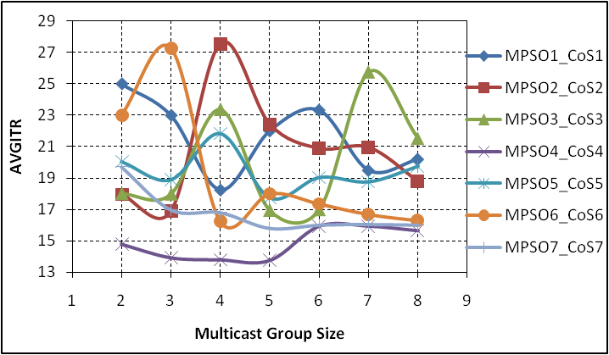

Figure (6): The impact of the multicast group size on the AVGITR for each of the seven MPSO systems in MPSOR
5.3. The impact of Multicast Group Size on the Multicast Tree Cost:
In this experiment, we study the effect of the number of the destination nodes in the multicast group on the Multicast Tree Cost of each the seven MPSO systems in MPSOR. We set the particle population size for each of MPSO systems in MPSOR as in experiment in section 5.2. Fig. 7 shows the Multicast Tree Cost versus the Multicast Group Size.
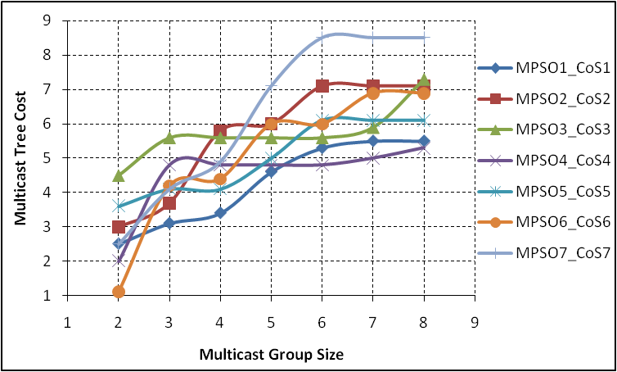

Figure (7): The Multicast Tree Cost versus the Multicast Group Size for each of the seven MPSO systems in MPSOR
From simulation results, we see that each of the MPSO systems in the MPSOR give optimal multicast tree that satisfy the QoS constraints according to CoS with minimum cost for each, but my MPSO systems in the MPSOR can achieves better optimal tree cost in both small and large multicast group size.
5.4. The impact of Multicast Group Size on the required Execution Time:
In this experiment, we study the effect of the number of the destination nodes in the multicast group on the execution time of each the seven MPSO systems in MPSOR. We set the particle population size for each of MPSO systems in MPSOR as in experiment in section 5.2. Fig. 8 shows the impact of the Multicast Group Size on the execution time for each of MPSO systems in MPSOR.

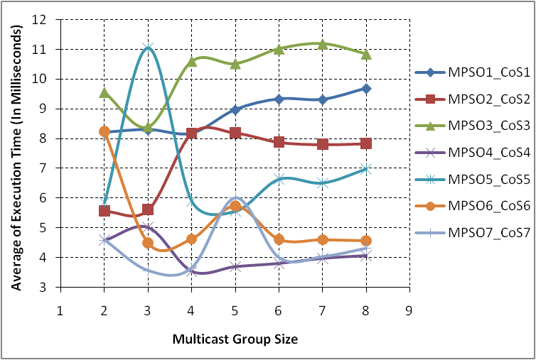

Figure (8): The impact of the Multicast Group Size on the execution time for each of MPSO systems in MPSOR
From the simulation results, we see whenever increasing the multicast group size this leads to increase or decrease the execution time that needed by each of MPSO systems in MPSOR to give optimal solution that satisfy the QoS constraints and according to the CoS. The increase in the group size that not make increase in the execution time this give additional advantage to the performance of the proposed MPSO systems in MPSOR because its high speed convergence to find the minimum cost Multicast tree that satisfy the QoS constraints and according to the appropriate CoS.

6. Conclusions and Future Work:
The simulation results show that the proposed MPSO systems in MPSOR for QoS multicast routing based CoS can quickly converge to optimal decision that satisfy the QoS constraints and according to CoS based on alternative routes in multicast routing tables that was created during the first stage of the network configuration. By using this architecture for MPSOR QoS multicasting, it can also adapt to the dynamically changing network environment such as congestion or router failure. The MPSOR will operate the appropriate MPSO system to give the QoS multicast tree according to the CoS that will determined by Multicast network manager. Whenever increase the Particle population size leads to increase the OMT and the AVGITR. The proposed mutation operator and the repair function that used in the proposed MPSO systems in MPSOR based QoS multicasting contribute in high speed convergence to optimal QoS multicast tree from source node to the destination node set in multicast group. The increase in the multicast group size cause increasing or decrease the AVGITR of each MPSO system in MPSOR but in acceptance rate that show the efficiency of the proposed MPSO systems in MPSOR that don’t effected by the increase in the group. The proposed MPSO systems in MPSOR can achieve better optimal tree cost that satisfies the QoS constraints according to the CoS in both small and large multicast group size. Our proposed MPSO systems in MPSOR based QoS multicasting takes less execution time to converge to optimal solution since it uses the alternative routes which was created during the first stage of our proposed system. Our future study is to combine the proposed MPSO systems in MPSOR with other functions such as admission control and packet scheduling and classification in the design of the QoS multicast router and evaluate the performance of the router and focus on other networks such as wireless and mobile networks.

References
Ahn, C. W., Ramakrishna, R. S., Kang, C. G., and Choi, I. C.(2001). Shortest path routing algorithm using Hopfield neural network, Electronic letters, Vol. 37,No. 19 ,pp. 1176-1178.
Ahn, C. W. and Ramakrishna, R. S.(2002). A genetic algorithm for shortest path routing problem and the sizing of populations, IEEE Transactions on Evolutionary Computation, Vol. 6, No. 6, pp. 566-579.
Alkahtani, A. M. S., Woodward, M. E. and Al-Begain, K.(2003). An Overview of Quality of Service (QoS) and QoS Routing in Communication Networks. 4th PGNET2003 Symposium, Liverpool, UK, pp. 236-242, 16-17/6/2003.
Araujo, F., Ribeiro, B., and Rodrigues, L.(2001). A neural network for shortest path computation, IEEE Transactions on Neural Networks, vol. 12, no. 5, pp. 1067–1073.
Bao, G., Yuan, Z., Zheng, Q., and Chen, X.(2006). A novel genetic algorithm to optimize QoS multicast routing, in: Lecture Notes in Control and Information Sciences, Vol. 344, pp. 150–157.
Chen, H. and Sun, B. (2005). Multicast Routing Optimization Algorithm with Bandwidth and Delay Constraints Based on GA, Journal of Communication and Computer, Vol. 2, No. 5, pp. 63-67.
Chen,P. and Dong, T.(2003). A fuzzy genetic algorithm for QoS multicast routing, Computer Communications, Vol. 26, Issue 6, pp. 506–512.
Coello, C. C. and Lechuga, M.(2002). MOPSO: A Proposal for Multiple Objective Particle Swarm Optimization. In Congress on Evolutionary Computation, Piscataway, New Jersey, USA, vol. 2, pp. 1051-1056, IEEE Service Center, 2002.
Cui, X. Lin, C., and Wei, Y. (2003).A Multiobjective Model for QoS Multicast Routing Based on Genetic Algorithm, in; Proceedings of the 2003 International Conference on Computer Networks and Mobile Computing, pp. 49, 2003.
Engelbrecht, A. P. (2007). Computational Intelligence: An Introduction, Second Edition, John Wiley & Sons Ltd.
Engelbrecht, A. P. (2006). Particle swarm optimization: Where does it belong?, in Proc. IEEE Swarm Intell. Symp., May 2006, pp. 48–54.
Feng, G. (2001). Neural network and algorithmic methods for Solving Routing Problems in High-Speed Networks, Ph.D. Thesis, University of Miami, USA.
Forouzan, B. A. (2007). Data Communications and Networking, 4th edition, McGraw-Hill Companies, Inc.
Gong, B., Li, L., Wang, X., and Jiang, T. (2007a). A Novel QoS Multicast Routing Algorithm Based on Ant Algorithm, International Conference on Wireless Communications, Networking and Mobile Computing, WiCom 2007, 21-25 Sept, pp. 2025-2028.
Gong, B., Li, L., and Wang, X.(2007b). Multicast Routing Based on Ant Algorithm with Multiple Constraints, International Conference on Wireless Communications, Networking and Mobile Computing, WiCom 2007, 21-25 Sept, pp. 1945 – 1948.
Haghighat, A.T., Faez, K., Dehghan, M., Mowlaei, A., and Ghahremani, Y. (2004). GA-based heuristic algorithms for bandwidth-delay-constrained least-cost multicast routing, Computer Communications, Vol. 27, No. 1, pp. 111–127.
Hassan, R., Cohanim, B., DeWeck, O. L. and Venter, G.(2005).A comparison of particle swarm optimization and the genetic algorithm, in Proceedings of the 1st AIAA Multidisciplinary Design Optimization Specialist Conference, Austin, Tex, USA, April 2005.
Idrees, A. K. (2010). Neural network for QoS multicast routing in computer networks, Accepted for publishing in Journal of Babylon University, Vol. 18, No. 3, 2010.
Jin, X., Bai, L., Ji, Y., and Sun, Y.(2008). Probability Convergence based Particle Swarm Optimization for Multiple Constrained QoS Multicast Routing, Fourth International
Conference on Semantics, Knowledge and Grid, pp. 412-415.
Kang, H., Lee, B., and Kim, K.(2008). Path Planning Algorithm Using the Particle Swarm Optimization and the Improved Dijkstra Algorithm, 2008 IEEE Pacific-Asia Workshop on Computational Intelligence and Industrial Application, pp. 1002-1004.
Kennedy, J. and Eberhart, R.(2001). Swarm Intelligence, Morgan Kaufmann.
Li, C., Cao, C., Li, Y., and Yu, Y.(2007).Hybrid of genetic algorithm and particle swarm optimization for multicast QoS routing, IEEE international conference on control and automation, ICCA 2007, May 30 2007-June 1 2007, pp. 2355-2359.
Li, K. and Tian, J.(2008). Application of Improved Ant Colony Algorithm to the QoS Multicast Routing, 2008 International Workshop on Education Technology and Training & 2008 International Workshop on Geoscience and Remote Sensing, pp. 780-784.
Li, L. and Li, C.(2003). Genetic Algorithm-Based QoS Multicast Routing for Uncertainty in Network Parameters, in; Lecture Notes in Computer Science, vol. 2642, Jan 2003, pp. 430-441.
LIU, J., SUN, J., and XU, W. (2006). QoS multicast routing based on particle swarm optimization, proceedings of 7th international conference on Intelligent Data Engineering and Automated Learning, Burgos, Spain, September 20-23, IDEAL 2006, , vol. 4224, pp. 936-943.
Marchese, M. (2007). QoS OVER HETEROGENEOUS NETWORKS, John Wiley & Sons Ltd.
Pan, D., Du, M., Wang, Y., and Yuan, Y.(2004). A Hybrid Neural Network and Genetic Algorithm Approach for Multicast QoS Routing, in; Lecture Notes in Computer Science, vol. 3174, Jul 2004, pp. 269-274.
Pinto, D. and Barán, B. (2005). Solving Multiobjective Multicast Routing Problem with a new Ant Colony Optimization approach, Proceedings of the 3rd international IFIP/ACM Latin American conference on Networking, Cali, Columbia, pp. 11 – 19.
Roy, A. and Das, S.K.(2004). QM2RP: a QoS-based mobile multicast routing protocol using multi-objective genetic algorithm, Wireless Networks, vol. 10, no. 3, pp. 271-286.
Shi, Y. and Eberhart, R.(2001). Fuzzy Adaptive Particle Swarm Optimization. In Proceedings Congress on Evolutionary Computation, Seoul, S. Korea, vol 1, pp. 101-106.
Sun, J., LIU, J., and XU, W.(2006). QPSO-based QoS multicast routing algorithm, Lecture notes in computer science, Springer, Berlin/ Heidelberg, ISSN 978-3-540-47331-2, Vol. 4247/2006, pp. 261-268.
Sun, Q. and Li, L.(2004) Optimizing on multiple constrained QoS multicast routing
algorithms based on GA, J. Syst. Eng. Electron., Vol. 15, No. 4, pp. 677–683.
Tanenbaum, A. S. (2003). Computer Networks, 4th edition, Prentice Hall PTR.
Tsai, C.F., Tsai, C.W., and Chen, C.P. (2004). A novel algorithm for multimedia multicast routing in a large scale networks, Journal of Systems and Software, Vol. 72, No. 3, pp. 431–441.
Tufte, G. and Haddow, P.C. (1999). Prototyping a GA pipeline for complete hardware evolution, In proceeding 1st NASA/DoD workshop on evolvable hardware, Pasadena, California, July 19-July 21, pp. 76-84.
Valle,Y., Venayagamoorthy, G. K., Mohagheghi, S., Hernandez,J. and Harley, R. G. (2008). Particle Swarm Optimization: Basic Concepts, Variants and Applications in Power Systems, IEEE TRANSACTIONS ON EVOLUTIONARY COMPUTATION, vol. 12, no. 2, pp. 171-195.
Vijayalakshmi, K. and Radhakrishnan, S. (2008a).Dynamic Routing to Multiple Destinations in IP Networks using Hybrid Genetic Algorithm (DRHGA), International Journal of Computer Science Vol. 4, No. 1, pp. 43-52.
Vijayalakshmi, K. and Radhakrishnan, S. (2008b). Artificial immune based hybrid GA for QoS based multicast routing in large scale networks (AISMR), Computer Communications, Vol. 31, No. 17, pp. 3984–3994.
Wang, X., Cao, J., Cheng, H. , Huang, M.(2006).QoS multicast routing for multimedia group communications using intelligent computational methods, Computer Communications, vol. 29, issue 12, pp. 2217-2229.
Wang, X., Cheng, H., Cao, J., Wang, Z., and Huang, M.(2003). QoS-Driven Multicast Tree Generation Using Genetic Algorithm, In; Lecture Notes in Computer Science, vol. 2834, Sep 2003, pp. 404-413.
Wang, x., Zou, R., and Huang, M. (2009). An ABC Supported QoS Multicast Routing Scheme Based on Ant Algorithm, 2009 International Conference on Communications and Mobile Computing, January 06-January 08,vol. 3, pp. 222-226.
Wang, Z., Sun, X., Zhang, D. (2007).A PSO-based multicast routing algorithm, proceedings of Third international conference on natural computation (ICNC 2007), Vol. 4, pp. 664-667.
Wang, Z. and Zhang, D. (2005).A Qos Multicast Routing Algorithm Based on Ant Colony Algorithm, Proceedings International Conference on Wireless Communications, Networking and Mobile Computing, vol. 2, pp. 1007-1009.
Xing, H., Ji , Y., Bai, L., Liu, X., Qu, Z., and Wang, X. (2009). An adaptive-evolution-based quantum-inspired evolutionary algorithm for QoS multicasting in IP/DWDM networks, Computer Communications, Vol. 32 , Issue 6, pp. 1086-1094.
Xing,H., Liu,X., Jin,X., Bai,L., and Ji, Y.(2009). A multi-granularity evolution based Quantum Genetic Algorithm for QoS multicast routing problem in WDM networks, Computer Communications, Vol. 32, issue 2, pp. 386–393.
Xu, Z. and Chen, L. (2006). An effective algorithm for delay-constrained dynamic multicasting, Knowledge Based Syst., Vol. 19, No. 3, pp. 172–179.
Yin,Y., Sun, L. and Ruan, X. (2005). The Implementation of A Routing Algorithm Based on Chaotic Neural Network in Multicast Routing Problems, International Journal of Information Technology, Vol. 11, No.9, pp. 82-90.
Yuan, X. (2002). Heuristic Algorithms for Multiconstrained Quality-of-Service Routing, IEEE/ACM TRANSACTIONS ON NETWORKING, VOL. 10, NO. 2, pp. 244-256.
Yuan, Y. and Yan, L.(2004). QoS-based dynamic multicast routing design using genetic algorithms, Chinese Journal of Electronics, Vol. 13, No. 4, pp. 575–578.
Zhang, L., Cai, L., Li, M., and Wang, F.(2009). A method for least-cost QoS multicast routing based on genetic simulated annealing algorithm, Computer Communications Vol. 32, No. 1, pp. 105–110.
Zhang, O. Wang, Z., and Zhang, D. (2008). Qos Multicast Routing Optimization Based on Memetic Algorithm, International Conference on Management of e-Commerce and e-Government, October 17-October 19, p. 441-444.
Zhang, S., Liu, Z.(2001). A New Multicast Routing Algorithm Based on Chaotic Neural Networks, Chinese Journal of Computers, Vol. 24, No. 12, pp. 1256-1261.
Zhengying, W., Bingxin, S., and Erdun, Z.(2001). Bandwidth-delay-constrained least-cost multicast routing based on heuristic genetic algorithm, Computer Communications, vol. 24, no. 7-8, pp. 685-692.

