Mathematical Models for Prediction of Some Mechanical Properties of Concrete Exposed to Burning

Mohammad Mansour Kadhum | Saif Salah Alkizwini | Ali Abd-A'meer Alwash
Babylon University, College of Engineering, Department Of Civil Engineering

Abstract
In this study, some mechanical properties of high strength concrete under the effect of fire flame exposure is presented. The concrete specimens were subjected to fire flame temperatures ranging from ( 20-850 °C) at different ages of 30 , 60 and 90 days. Three temperature levels of 400°C , 600°C and 850°C were chosen of exposure duration of 2.0 hours. After burning, the concrete specimens were quenched in a water tank to provide the maximum shock due to sudden cooling. The test results showed that the density, compressive strength, tensile and flexural strength decreases when the fire flame temperatures were increased. mathematical models were proposed to predict the compressive strength, splitting tensile strength and flexural strength of concrete after exposure to fire flame. These models made by statistical program called (DATA FIT 9.0.59, 2009).
الخلاصة
في هذا البحث تم دراسة تأثير الحرق بلهب النار على بعض الخصائص الميكانيكية للخرسانة ذات المقاومة العالية. عرضت النماذج الخرسانة إلى درجات حرارة تتراوح بين (20– 850) درجة مئوية وبأعمار مختلفة هي (30, 60, 90) يوما حيث تم تعريض النماذج إلى ثلاث درجات حرارية ( 400 , 600 , 850 ) درجة مئوية ولمدة ساعتين. بعد التعرض بردت النماذج بالماء لوحظ من النتائج أن مقاومة الخرسانة للانضغاط والشد والانثناء تتناقص بزيادة درجة الحرارة. تم استخدام برنامج إحصائي (Data Fit) لتخمين خصائص الخرسانة المعرضة للحرق.
Introduction
In the structural design of buildings, in addition to the normal gravity and lateral loads, it is in many cases necessary to design the structure to safely resist exposure to fire. However it is usually necessary to guard against structural collapse for a given period of time Shetty ( 1988) .
Several investigations have shown that the deterioration in the compressive strength of concrete under high temperature exposure. There are indeed rare researches about temperature gradient and exposure time of the concrete indirect contact with the fire flames. In this study there is an attempt to investigate the effect of temperature gradient and exposure of high strength concrete to fire flames on compressive strength, tensile strength and flexural strength of high strength concrete .
- Fire Effect on The Mechanical Properties of Concrete
Maltora (1956), Davis (1967), Abrams (1971), Faiyadh (1989), Khoury (1992 ) and Noumowe et al ( 1994 ) had reported the effects of high temperature exposure on the properties of concrete. Several mechanisms have been identified for the deterioration of concrete due to high temperature. These include decomposition of the calcium hydroxide with time and water , expansion of lime on re-hydration, destruction of gel structure, phase transformation in some types of aggregate, and development of micro-cracks due to thermal incompatibility between cement paste matrix and aggregate phase .
High strength concrete, in comparison with medium strength concrete, is more brittle; contains less water; and the solid particles are more compact. Hence, the effects of high temperature on high strength concrete will be different to those with the medium strength concrete. Sri Ravindarajah (1998) studied the effect of temperature up to 800°C and method of cooling on the compressive and tensile strength of high-strength concrete .
Habeeb in (2000) studied the effect of high temperatures ( up to 800 °C) on some mechanical properties of high strength concrete ( HSC ). Three design strength investigated 40, 60 and 80 MPa. The investigated properties were compressive strength, flexural strength and volume changes. Ultrasonic pulse velocity ( U.P.V ) and dynamic modulus of Elasticity ( Ed ) were tested also. The specimens were heated slowly to five temperatures levels (100, 300, 500, 600 and 800 °C), and to three exposure periods 1.0,2.0 and 4.0 hours without any imposed loads during heating. The specimens were then cooled slowly and tested either one day or one month after heating. He concluded that the ( HSC ) is more sensitive to high temperatures than(NSC). The residual compressive strength ranged between (90-106 %) at 100 °C, ( 72-103 % ) at 300°C, ( 55-87 %) at 500°C and ( 22-66 %) between (600-80°0C). He concluded that exposure time beyond one hour had a significant effect on the residual compressive strength of concrete; however, the effect was diminished as the level of temperature increased. Moreover, the compressive strength at age of one month after heating, suffered an additional less than at age of one day after heating.The flexural strength was found to be more sensitive to high temperature exposure than compressive strength the residual flexural strength was in the range of ( 92- 98 % ) , ( 52-98 %) and (29-47 %) at 100 °C,300 °C, and 500 °C respectively and ( 2- 30% ) at (600-800) °C. The author also noticed that the (U.P.V) and (Ed) were more sensitive to elevated temperature to exposure than compressive strength .
Umran (2002) investigated the fire exposure effect on some mechanical properties of concrete. The specimens were subjected to fire flame ranging between ( 25-700 ) °C. Three temperature levels of (400,500, and 700) °C were chosen with four different exposure duration of 0.5, 1.0, 1.5, and 2.0 hours without any imposed loads during heating. The specimens were heated and cooled under the same regime and tested after exposure to fire flame at ages ( 30, 60, and 90 days). Compressive strength of 150mm cubes and flexural strength of (100*100*400mm) prisms were measured. Ultrasonic pulse velocity (U.P.V) and dynamic modulus of elasticity (Ed) were tested also he found that the residual compressive strength ranged between(70-85%) at 400 °C, (59-78%) at 500 °C and (43-62% ) at 700°C. The flexural strength was found to be more sensitive to fire flame exposure than the compressive strength. The residual flexural strength was in the range of (67-78%) at 400 °C, (40-67 %) at 500 °C and (20-45 %) at 700 °C. He also found that the ultrasonic pulse velocity (U.P.V) and dynamic modulus of elasticity (Ed) were more sensitive to fire flame than compressive strength. He also noticed that exposure time after one hour has a significant effect on residual compressive strength of concrete.
Husem (2006) examined the variation in compressive and flexural strengths of ordinary and high-performance concretes exposed to high temperatures of 200, 400, 600, 800 and 1000°C and then cooled in air or water. The compressive and flexural strengths of these concrete specimens were compared with each other and with unheated specimens. On the other hand, strength loss curves of these concrete specimens were compared with the strength loss curves given in the codes. In this study, ordinary concrete with an average compressive strength of 34MPa and high-performance concrete with an average compressive strength of 71MPa were produced. From the results obtained, he concluded that (a) for ordinary and high-performance concrete exposed to high temperature, the flexural and compressive strengths decrease with the increase in temperature. Such decrease is greater when the specimens were cooled in water. (b) the compressive strength of high-performance concrete cooled in air and water decreases up to 200°C and increases between 200 and 400°C. The compressive strength gain was 13% for the specimens cooled in air and 5% for those cooled in water. The compressive strength of ordinary concrete decreases continuously. (c) the compression test was not done on ordinary concrete at temperatures above 600°C, because the concrete specimens disintegrated. For high-performance concrete, the compression test was not done at temperatures above 800°C. (d) the concrete may completely lose its strength as a result of the immediate expansions that take place during the expansion of mineral admixture used in the production of high-performance concretes at high temperature. (e) it was observed that some high-performance concrete specimens spalled explosively at temperatures between 400 and 500°C, which is attributed to expansion of silica fume used in the production of such concretes. Explosive spalling was not observed for ordinary concrete specimens. (f) experimental studies indicated that ordinary and high-performance concretes produced using limestone aggregate underwent high percentages of strength loss in the specimens cooled in water after high temperature exposure. (g) The CEN Eurocode and the CEB design curves for the properties of fire-exposed concrete are not applicable to high strength concrete. The Finnish Code is more suitable especially up to 400°C. These codes are not applicable to ordinary and high-performance concrete cooled in water.
Experimental Work
- Introduction
The experimental work was carried out to decide upon the temperature range and duration of burning. It was decided to limit the maximum exposure to fire to about 400 °C, 600 °C and 850 °C with a duration of exposure to fire flame of 2.0 hours which cover the range of situation in the majority of elevated temperature test.
- Material and Mixture properties
In this investigation, the cement used Ordinary Portland Cement (O.P.C) produced at Kufa factory. This cement complied with the Iraqi specification No.5 (1984). The physical properties and chemical compositions are presented in Table(1). Crushed basalt (specific gravity of 2.65) having the maximum aggregate size of 10mm and river sand (specific gravity of 2.62 ) were used as a coarse and fine aggregate content was 30% , by weight .
Three mixes were investigated mix 1 consisted 535Kg/m³of cement. In mix 2, 20% fly ash and 80% cement (O.P.C) ( fly ash was replaced from cement). Mix 3 contained 90% (O.P.C) and 10% silica fume (silica fume was replaced from cement). For all three mixes the water to cement ratio was kept at 0.30, by weight. A constant dosage of super plasticizers (1.0 % by weight of cement) was used in all concrete mixture to obtain workable concrete mixtures.

Table (1) : a- Physical properties of the cement
Physical properties | Test results | IOS: 1984 limits
Fineness ,Blaine ,cm²/gm  setting time, vicat´s method  initial hrs : min.  final hrs : min.  compressive strength of70.7mm cube ,MPA  3 days  7 days | 3180  1:40  3:60  24  29 | ≥ 2300  ≥ 1:0  ≤ 10:00  ≥ 15  ≥ 23

b- Chemical composition of the cement
Oxide | % | IOS : 1984 limits
CaO  SiO₂  Fe₂O₃  Al₂O₃  MgO  SO₃  Free lime  L.O.I  I.R. | 60.76  20.20  3.30  6.20  4.24  2.34  0.72  1.63  0.61 | ≤ 0.5  ≤ 2.8  ≤ 4.0  ≤ 1.5
Compound composition | % | IOS : 1984 limits
C₃S  C₂S  C₃A  C₄AF  L.S.F | 37.50  30.85  10.65  8.42  0.82 | 0.66-1.02

- Concrete Mixing and Casting
The concrete mixture were produced in a horizontal pan-type mixer of 0.1 m³ capacity. The interior surface of mixer was cleaned and moistened before it was used. Freshly mixed concrete was tested for its density and used to cast a number of test specimens ( standard cubes , cylinder and prism ) in steel moulds. A table vibrator was used to achieve full compaction for the moulded test specimens. The specimens used for compressive strength (100*100*100) mm cube and for tensile strength (100 mm diameter by 200 mm long) cylinder. The specimens used for flexural strength ( 100*100*400) mm prisms .
- Burning and Cooling
The concrete specimens were burn with direct fire flame from a net of methane burners inside a brick store with dimensions of (800 *800 * 1000 mm) (length*width*height respectively) as shown in plate (1). The bare flame was intended simulate the heating condition in actual fire. The measurement devices are shown in plate (2). After burning, the concrete specimens were quenched in a water tank to provide the maximum thermal shock due to sudden cooling .

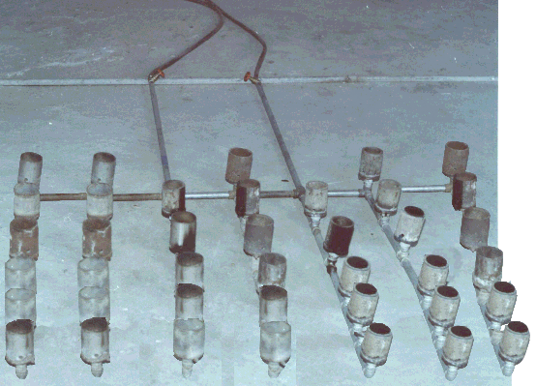
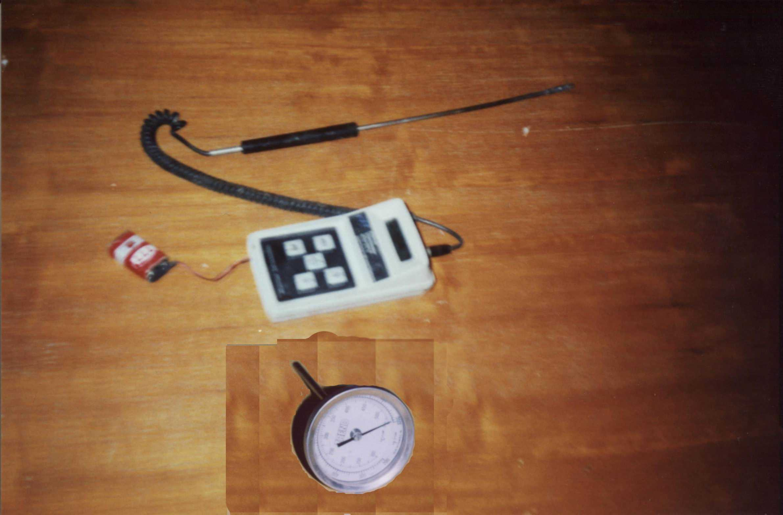
Plate (1): The work of net methane burners.

ate(2) : Temperature measurements devices .

Results and Discussion
-The Density
Table (2) show the effect of the exposure to fire flame on the density of high strength concrete, while figures ( 1 to 3 ) shows the relations between the fire flame temperature and density of high strength concrete. It can be seen from these table and figures that the density behaved as the following :
- At (400,600 and 850°C) fire flame temperature exposure and for all ages and for mix 1, the reduction in density was ranged between (1.8- 2.8 %) , (3.6-5.5%) and (6.8-9.2%) respectively if compared with initial density before exposure to fire flame .
- At (400, 600 and 850°C ) fire flame temperature exposure and for all ages and for mix 2, the reduction in density less than reduction in mix 1 was ranged between (1.4-2.0 %),(2.8-4.2 %) and (5.6-8.6 %) respectively .
- In mix 3, the reduction in density less than reduction in mix (1 and 2) was (1.0-1.5%) ,(2.0-3.1%) and (4.2-6.8%) at (400, 600 and 850°C) respectively for the same fire flame temperature. These results confirmed that of Sri Ravindrarajah (1993) and Karim (2005) .

Table (2): Test values of density of high-strength concrete for all mixes before and after exposure to fire flame .
Age at exposure (days) | Mix  NO . | Density ( Kg/m³ ) |  |  |  | Ratios  ρa / ρb
Age at exposure (days) | Mix  NO . | Temperature °C
Age at exposure (days) | Mix  NO . | 25 ₍₁₎ | 400 ₍₂₎ | 600 ₍₃₎ | 850 ₍₄₎ | 2/1 | 3/1 | 4/1
30 | Mix 1 | 2420 | 2235 | 2167 | 2112 | 0.92 | 0.89 | 0.87
30 | Mix 2 | 2380 | 2212 | 2134 | 2092 | 0.93 | 0.90 | 0.88
30 | Mix 3 | 2640 | 2495 | 2347 | 2297 | 0.95 | 0.89 | 0.87
60 | Mix 1 | 2415 | 2237 | 2169 | 2115 | 0.92 | 0.90 | 0.88
60 | Mix 2 | 2370 | 2216 | 2137 | 2095 | 0.94 | 0.90 | 0.88
60 | Mix 3 | 2632 | 2499 | 2349 | 2299 | 0.95 | 0.89 | 0.89
90 | Mix 1 | 2411 | 2241 | 2172 | 2117 | 0.93 | 0.90 | 0.88
90 | Mix 2 | 2365 | 2219 | 2139 | 2097 | 0.94 | 0.90 | 0.89
90 | Mix 3 | 2625 | 2502 | 2351 | 2301 | 0.95 | 0.90 | 0.88
ρa = Density of concrete after exposure to fire flame.
ρb = Density of concrete before exposure to fire flame.
Fig.(1) The effect of fire exposure on the density of high-strength concrete at age 30 days and 2.0 hours period of exposure.
Fig.(2) The effect of fire exposure on the density of high-strength concrete at age 60 days and 2.0 hours period of exposure.

Fig.(3) The effect of fire exposure on the density of high-strength concrete at age 90 days and 2.0 hours period of exposure.

Effect of Temperature on Compressive Strength
Concrete cubes (100*100*100mm) were tested at ages 30,60 and 90 days. The compressive strength results are summarized in Table (3), while the Figure(4, 5 and 6) shows the relation between the compressive strength and fire flame temperature for different ages. The compressive strength of the high strength concrete dropped significantly as the maximum temperature was increased. The residual strength varied from (71-89%) of the corresponding initial strength when the concrete was exposed to the fire flame was 400°C followed by sudden cooling in water. As the temperature was increased to 600 °C, the residual strength was ranged from (46-81%) of the initial strength. At 850°C fire flame temperature exposure the residual strength ranged from (29-45%) .
The results showed that the binder material type has noticeable influence on the residual strength. The concrete mixture containing silica fume performed poorly compared to other binder materials. Although the silica fume addition increased the initial strength of concrete, considerable compressive strength loss when exposed to fire flame temperature is noticed. These result agreed with that obtained by other investigations, Habeeb (2000) and Umran (2002). It is observed that the color of the concrete specimens changed to pink and increased in intensity. This may be due to hydration condition of iron oxide component and other material constituents of the fine and coarse aggregates, Habeeb (2000). The surface cracks increased in number length and depth due to temperature rise.

Table (3): Test values of compressive strength of high strength concrete for all mixes before and after exposure to fire flame .
Age at exposure (days) | Mix No. | Compressive strength (MPa) |  |  |  | Ratios  fca / fcb
Age at exposure (days) | Mix No. | Temperature °C
Age at exposure (days) | Mix No. | 25₍₁₎ | 400₍₂₎ | 600₍₃₎ | 850₍₄₎ | 2/1 | 3/1 | 4/1
30 | Mix 1 | 42.4 | 30.1 | 19.5 | 12.3 | 0.71 | 0.46 | 0.29
30 | Mix 2 | 52.5 | 43.6 | 34.2 | 19.9 | 0.83 | 0.65 | 0.38
30 | Mix 3 | 57.0 | 49.0 | 43.3 | 23.4 | 0.86 | 0.76 | 0.41
60 | Mix 1 | 44.0 | 32.0 | 20.7 | 12.3 | 0.73 | 0.47 | 0.28
60 | Mix 2 | 55.2 | 49.1 | 38.0 | 21.5 | 0.89 | 0.69 | 0.39
60 | Mix 3 | 59.8 | 52.6 | 47.2 | 25.7 | 0.88 | 0.79 | 0.43
90 | Mix 1 | 45.3 | 33.0 | 22.2 | 13.6 | 0.73 | 0.49 | 0.30
90 | Mix 2 | 57.0 | 50.7 | 39.9 | 24.0 | 0.89 | 0.70 | 0.42
90 | Mix 3 | 61.2 | 54.4 | 49.6 | 27.6 | 0.89 | 0.81 | 0.45

fca = Compressive strength after exposure to fire flame .
fcb = Compressive strength before exposure to fire flame .

Fig.(6) The effect of fire exposure on the compressive strength of high-strength concrete at age 90 days and 2.0 hours period of exposure.

Fig.(4) The effect of fire exposure on the compressive strength of high-strength concrete at age 30 days and 2.0 hours period of exposure.

Fig.(5) The effect of fire exposure on the compressive strength of high-strength concrete at age 60 days and 2.0 hours period of exposure.

Effect of Temperature on Tensile and Flexural Strengths
Figure (7,8 and 9) show the residual tensile for high-strength concrete as a function of the maximum temperature. Similar to the compressive strength, the tensile strength showed significant losses with the increase in the exposed temperature. Once again, the binder material types played a noticeable role in influencing the strength losses. The results shown in figures (7,8 and 9) indicated that the mix 3 having silica fume suffered significant loss in strength at the temperature of 600°C. The tensile strength for high strength concrete mixes was reduced by 78% to 84% when they were burn to 850°C. These result are summarized in table (4).
The flexural strength for all three concrete mixes are presented in Table (5) , while Figure ( 10,11 and 12 ) show the effect of fire flame exposure of flexural strength. Similar to compressive and tensile strengths of concrete, the flexural strength decreased with temperature. Once again the binder material type had influenced the extent of strength loss.

Fig.(7) The effect of fire exposure on the tensile strength of high-strength concrete at age 30 days and 2.0 hours period of exposure.

Fig.(8) The effect of fire exposure on the tensile strength of high-strength concrete at age 60 days and 2.0 hours period of exposure.

Fig.(9) The effect of fire exposure on the tensile strength of high-strength concrete at age 90 days and 2.0 hours period of exposure.

Table (4): Test value of tensile strength f high strength concrete for all mixes before
and after exposure to fire flame.
Age at exposure (days) | Mix No. | Tensile strength (MPa) |  |  |  | Ratios  Tsa/Tsb
Age at exposure (days) | Mix No. | Temperature °C
Age at exposure (days) | Mix No. | 25₍₁₎ | 400₍₂₎ | 600₍₃₎ | 850₍₄₎ | 2/1 | 3/1 | 4/1
30 | Mix 1 | 6.25 | 5.86 | 5.22 | 4.82 | 0.90 | 0.80 | 0.74
30 | Mix 2 | 4.35 | 3.94 | 3.45 | 2.96 | 0.90 | 0.79 | 0.68
30 | Mix 3 | 6.78 | 6.30 | 5.90 | 5.37 | 0.93 | 0.87 | 0.79
60 | Mix 1 | 6.60 | 5.91 | 5.40 | 5.10 | 0.89 | 0.82 | 0.77
60 | Mix 2 | 4.72 | 4.22 | 3.88 | 3.23 | 0.89 | 0.82 | 0.68
60 | Mix 3 | 7.20 | 6.52 | 6.12 | 5.80 | 0.90 | 0.85 | 0.80
90 | Mix 1 | 6.68 | 6.10 | 5.52 | 5.21 | 0.91 | 0.83 | 0.80
90 | Mix 2 | 4.95 | 4.30 | 4.20 | 3.40 | 0.87 | 0.87 | 0.69
90 | Mix 3 | 7.30 | 6.82 | 6.42 | 6.00 | 0.93 | 0.88 | 0.82
Tsa = Tensile strength after exposure to fire flame.
Tsb = Tensile strength before exposure to fire flame.

Table (5): Test values of flexural strength of high-strength concrete for all mixes
before and after exposure to fire flame.
Age at exposure (days) | Mix No. | Flexural strength(MPa) |  |  |  | Ratios  Fsa/Fsb
Age at exposure (days) | Mix No. | Temperature °C
Age at exposure (days) | Mix No. | 25₍₁₎ | 400₍₂₎ | 600₍₃₎ | 850₍₄₎ | 2/1 | 3/1 | 4/1
30 | Mix 1 | 9.22 | 8.39 | 7.86 | 7.45 | 0.90 | 0.85 | 0.80
30 | Mix 2 | 6.64 | 5.80 | 5.12 | 4.76 | 0.87 | 0.77 | 0.71
30 | Mix 3 | 8.30 | 7.42 | 6.95 | 6.30 | 0.89 | 0.84 | 0.80
60 | Mix 1 | 9.40 | 8.50 | 7.94 | 7.65 | 0.90 | 0.84 | 0.81
60 | Mix 2 | 6.88 | 6.02 | 5.50 | 4.90 | 0.88 | 0.80 | 0.71
60 | Mix 3 | 8.92 | 7.80 | 7.20 | 6.50 | 0.87 | 0.80 | 0.73
90 | Mix 1 | 9.72 | 8.72 | 8.25 | 7.75 | 0.89 | 0.85 | 0.80
90 | Mix 2 | 7.01 | 6.48 | 5.82 | 5.12 | 0.92 | 0.83 | 0.73
90 | Mix 3 | 9.12 | 7.95 | 7.40 | 6.81 | 0.87 | 0.81 | 0.75
Fsa = Flexural strength after exposure to fire flame .
Fsb = Flexural strength before exposure to fire flame .

Fig.(12) The effect of fire exposure on the flexural strength of high-strength concrete at age 90 days and 2.0 hours period of exposure.

Fig.(11) The effect of fire exposure on the flexural strength of high-strength concrete at age 60 days and 2.0 hours period of exposure.

Fig.(10) The effect of fire exposure on the flexural strength of high-strength concrete at age 30 days and 2.0 hours period of exposure.

Effect of Exposure Fire Flame on The Colour of Concrete
Since the thermal conductivity reduces with the increase in temperature water quenching of the heated concrete samples has not produced uniform cooling. At the temperature of 400°C, there was no apparent visual discoloration occurred in the concrete. The concrete specimens subjected to 600°C and above suffered noticeable color change. The inner section of the concrete bluish in colour. The dark colored area boundary was very distinct and showed no transition zone. Outside this, concrete had maintained its color however, when the fire flame temperature was increased to 850°C the inner color was changed to bluish dark grey.

Mathematical Models for Prediction of Mechanical properties of Concrete After Exposure to Fire Flame
By using the data which was obtained from this study, mathematical models were proposed to predict the compressive strength, splitting tensile strength and flexural strength of concrete after exposure to fire flame. These models made by statistical program called (DATA FIT 9.0.59, 2009) (http://www.oakdaleengr.com). and depends on compressive strength, splitting tensile strength and flexural strength of concrete before and after burning, age and temperature of fire flame.
The first step in the development of the statistical analysis was the selection of the variables include in model prediction. The independent dependent variables were selected as shown in Table (6).
Table (6): Dependent and independent variables.
Dependent Variables | Independent Variables
f_{cua} | f_{cub} , Age, T, ρ
f_{sa} | f_{sb} , Age, T, f_{cu}
f_{ra} | f_{rb} , Age, T, f_{cu}

5.9.1 Models for Prediction of Compressive Strength (f_{cua})
Three models were examined to predict of (f_{cua}) after burning as follows:
- The first models :
Where:
f_{cua} = Compressive strength of the specimens after exposure to fire flame temperature (MPa).
f_{cub} = Compressive strength of the specimens before exposure to fire flame temperature (MPa).
Age = The age of the specimens at the time of exposure (days).
T = Temperature of fire flame (ºC).
$ρ$ = Density of concrete before and after exposure to fire flame (kg/m³).
a, b, c, d, e = Regression coefficients of independent variables.
- The second model :
- The third model:

5.9.2 Models for Prediction of Splitting Tensile Strength (f_{sa})
Three models were examined to predict of (f_{sa}) after burning as follows:
- The first model:

Where:
f_{sa} = Splitting tensile strength of the specimens after exposure to fire flame temperature (MPa).
f_{sb} = Splitting tensile strength of the specimens before exposure to fire flame temperature (MPa).
Age = The age of the specimens at the time of exposure (days).
T = Temperature of fire flame (ºC).
f_{cu} = Compressive strength of the specimens before and after exposure to fire flame temperature (MPa).
a, b, c, d, e = Regression coefficients of independent variables.
- The second model :
- The third model :
5.9.3 Models for Prediction of Flexural Strength (f_{ra})
To find the regression for prediction of (f_{ra}) after burning three models were as follows:

- The first model :
Where:
f_{ra} = Modulus of rupture of the specimens after exposure to fire flame temperature (MPa).
f_{rb} =Modulus of rupture of the specimens before exposure to fire flame temperature (MPa).
Age = The age of the specimens at the time of exposure (days).
T = Temperature of fire flame (ºC).
f_{cu} = Compressive strength of the specimens before and after exposure to fire flame temperature (MPa).
a, b, c, d, e = Regression coefficients of independent variables.
- The second model :
- The third model :

Table (7) gives the regression coefficients of the prediction models above for the prediction of the compressive strength, splitting tensile strength and flexural strength of concrete after exposure to fire flame.
From the same table, the correlation coefficient increases and the standard error decreases with increasing the number of factors used in the proposed model.

Table (7): Regression coefficients for mechanical properties of concrete after burning.
- f_{cua}
Coefficient | Model 1 | Model 2 | Model 3
a | 0.032513 | 1.20969 | 1.21525
b | -0.000364 | -0.004753 | -0.005179
c | -0.000957 | -0.039192 | -0.039796
d | -0.000242 | -0.003225 | -0.004703
e | 2.88643 | ------ | 3.423845
Variance Explained (R²) | 0.8547 | 0.9281 | 0.9283
Standard Error | 5.9184 | 4.1971 | 4.1595

- f_{sa}
Coefficient | Model 1 | Model 2 | Model 3
a | 0.193225 | 0.980034 | 0.98577
b | -0.000210 | -0.000974 | -0.00097
c | -0.000299 | -0.001541 | -0.001541
d | 0.000260 | 0.004840 | 0.00560
e | 0.620608 | ------- | -0.08118
Variance Explained (R²) | 0.9810 | 0.9822 | 0.9858
Standard Error | 0.36753 | 0.2476 | 0.1432

3.f_{ra}
Coefficient | Model 1 | Model 2 | Model 3
a | 0.13438 | 1.00638 | 0.925041
b | -0.000147 | -0.000272 | 0.000430
c | -0.000347 | -0.002419 | -0.002841
d | -0.000515 | 4.83152 | -0.009862
e | 1.035120 | ------ | 1.213533
Variance Explained (R²) | 0.9821 | 0.9821 | 0.9890
Standard Error | 0.1906 | 0.1788 | 0.1495

The increase of correlation coefficient and decrease in standard error from model (1) to model (3), proves the right choice of the variables and their effect on compressive strength, splitting tensile strength and flexural strength of concrete after burning. Also it can be seen from Figures (13) to (15) the difference between experimental data and calculated data of mechanical properties of concrete before and after burning in model (3).
From Table (7), it can be seen that model (3) represents the best model fits to the experimental data due to the higher coefficient of determination (R²). Therefore, the following models could be used to estimate the compressive strength, splitting tensile strength and flexural strength of concrete after exposure to fire flame.
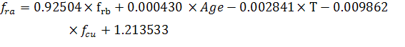
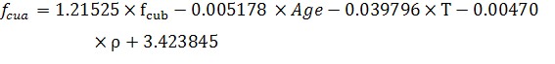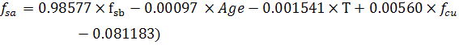

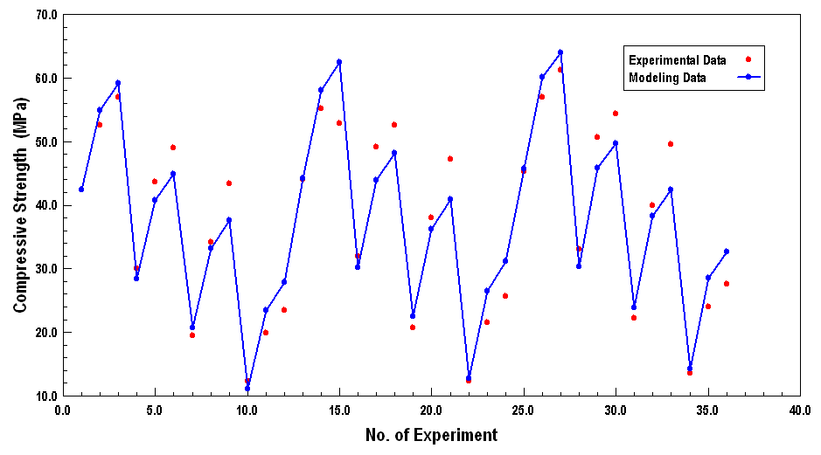
Figure 13: The difference between observed compressive strength and calculated
compressive strength after burning in model (3).

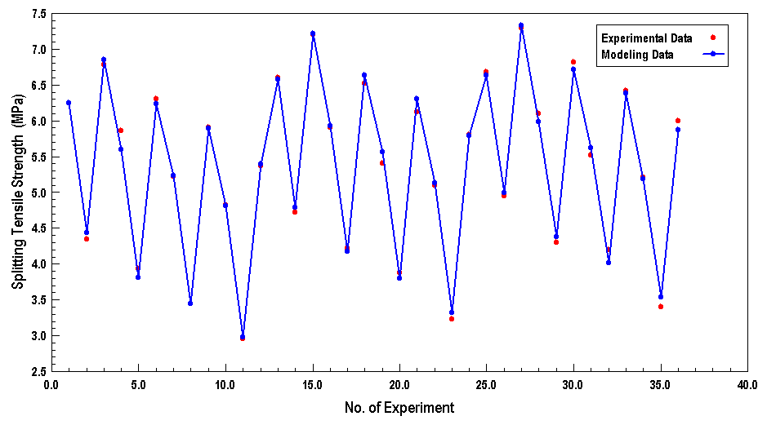
Figure 14: The difference between observed splitting tensile strength and calculated
splitting tensile strength after burning in model (3).

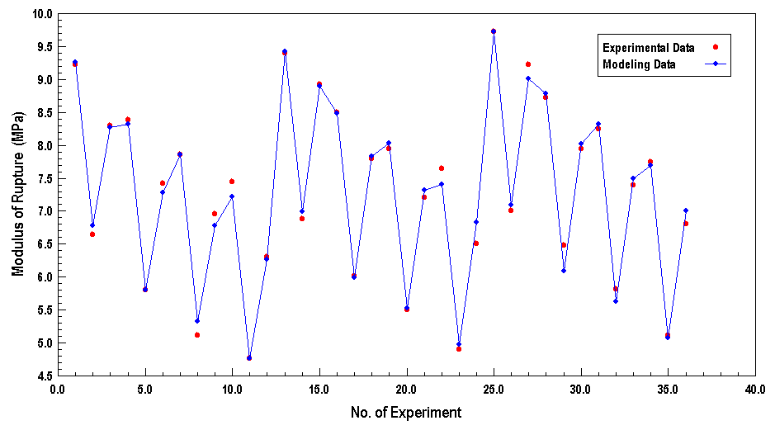
Figure 15: The difference between observed modulus of rupture and calculated modulus of
rupture after burning in model (3).

Conclusions
Based on the results of this experimental the following conclusion can be made :
- The density, compressive, tensile and flexural strength of high strength concrete decrease with increasing fire flame temperature for all mixes and for all ages .
- It was found that the loss in density of mix 3 less than that in density of mixes 1 and 2.
- Concrete with silica fume suffered the most under increased exposure to fire flame temperature below 850 °C.
- High-strength concrete has shown 74% drop in its strengths once exposed to 850°C irrespective of the type of binder materials used.
- The reduction in tensile strength for high-strength concrete mixes was (78-84 %) when they were burned to 850°C.
- Based on experimental results, an equation to estimate the compressive strength, splitting tensile strength and flexural strength of concrete after burning was suggested as follows:

These equations gave a good agreement with the tested values in the experimental work.

Reference
Shetty, M.S., (1988) , “Concrete technology“ theory and practice” , third edition , 1988 pp.361.
Malhotra ,H.L. (1956) “ The effect of high-temperature on compressive strength “ , magazine of concrete research , 8(3) pp.85 – 94 .
Davis ,H.s (1967) ,” Effect if high temperature exposure on concrete “ material research and standards ,pp.452 – 459 .
Abrams , M.S (1971), ”Compressive strength of concrete at temperature to 1660f “ , ACI special publication Sp25 , USA , pp.33 – 58 .
FAiyadh ,F.I. and Al-Alusi ,M.A. (1989 ) , “Effect of elevated temperature on splitting tensile strength of fibre concrete “, the international journal of cement composite and light weight concrete , 11(3) pp.175 – 178 .
Khoury ,G.A. (1992) ,”Compressive strength of concrete at high temperatures, a measurement “ magazine of concrete research , 44(161) , pp.291 – 309 .
Noumowe ,A.N. Clasters , P., Debicki ,G. and Boluin , M. ( 1994) , “High temperature effect on high performance concrete (70-600°C) strength and porosity “, ACI special publication SP145 , pp . 154 – 172 .
Sri RAVIN Drarajah , R. and Stathopoulos , F. (1998) , “Residual compressive strength and tensile strength for high – strength concrete exposed to high temperature up to 800 °C “ , proc .Int . conf . on high performance high strength concrete , Perth , Australia ,pp 663 – 645 .
Habeeb ,G.M. (2000), “Residual mechanical properties of high strength concreted subjected to elevated temperature “ , Ph .D. Thesis college of engineering , department of civil engineering , Al–Mustansiria University Baghdad , Iraq , November , 2000 , 164pp.
Umran ,M.K. , (2002) , “Fire flame exposure effect on some mechanical properties of concrete “ , M.Sc Thesis , College of engineering , University of Babylon October , 2002 , 103 pp.
Karim, M.M. , (2005) ,” Investigation of the behavior and properties of reinforced concrete slabes exposed to fire flame“ , M.Sc thesis , college of engineering , university of Babylon , December , 2005 ,126 pp.
Sri Ravin Drarajah , R. and mercer , C.M. ( 1993) , “ properties of high – strength concrete containing cement Supplementary materials “ , proc . FIP congress ,Kyoto , Japan.
Husem, M. (2006) “The Effect of High Temperature on Compressive and Flexural Strengths of Ordinary and High-Performance Concrete” Fire Safety Journal 41:155-163.

