Influence of Cu and B on the Machineability of (Al-Fe) alloy
Haydar A.Hussain Saad Hameed Najem Aseel Hadi Hamza
University of Babylon ,College of Engineering, Dept. of Material's Eng.

Abstract
The present investigation is aimed to study how the machineability of an (Al-Fe) alloy will be affected by adding together Boron and Copper. Machineability was defined regarding a tool life based on the flank wear of a twist drill made of high speed steel. Two percentages of copper and of boron were added together. The alloy had been prepared by casting with rapid cooling. The results showed that copper and boron have a noticeable effect on the machineability of (Al-Fe) alloy regarding the tool life, and the tool life depends on the weight percentage of the added elements, so as a smaller percentage of boron gives a tool a shorter life. A reliable model had been developed for tool life. The model took into account the effect of cutting speed, feed rate, the percentage of adding elements and the hardness of the produced alloys. This model may be utilized to enhance the efficiency of machining (Al-Fe) alloys to which elements may be added and the present method of modeling represents a suitable methodology to study the effect of additives on the machineability of the alloys.
الخلاصة
البحث الحالي يتوجه لدراسة كيف تتأثر قابلية تشغيل سبائك نظام ألمنيوم- حديد بإضافة النحاس والبورون معا إليها. تم احتساب قابلية التشغيل على أساس عمر أداة القطع باعتماد معيار بلى الخلوص لمثقب ثنائي مصنع من فولاذ السرعات العالية. تمت إضافة نسبتين من النحاس ونسبتين من البورون وقد حضرت نماذج السبائك بطريقة السباكة واعتماد التبريد السريع. أوضحت النتائج بان للنحاس والبورون تأثير ملحوظ على قابلية تشغيل سبيكة ألمنيوم- حديد وبان عمر الأداة يعتمد على النسبة الوزنية للعناصر المضافة حيث أن النسب القليلة من البورون تعطي الأداة عمرا اقصر. تم في البحث صياغة موديل رياضي يعبر عن عمر أداة القطع من خلال سرعة القطع ، معدل التغذية، نسب العناصر المضافة وكذلك صلادة السبيكة المحضرة. من الممكن اعتماد هذا الموديل وطريقة صياغته في تحسين كفاءة تشغيل سبائك نظام ألمنيوم- حديد أو السبائك الأخرى المضاف إليها عناصر سبك.
Introduction
The improvement in mechanical properties had been noticed in aluminum alloys containing a high volume fraction of dispersed intermetallic elements based on iron, nikle, chromium, vanadium and some other transition-metal elements. These transition metal can form with aluminum micro-dispersed elements in aluminum matrices ( α- Al matrices) as a result of rapid solidification (Yaneva et al., 2004 and Prima et al., 2004). Development of Al- alloys containing three or four alloying elements are continued. One of the most popular these alloys is (Al-Fe) alloy containing additives of Cr, Mo, Si, Ce, Zr, Cu, and other elements. Most of such work are aimed to study the influence of the additives or the influence of the manufacturing processes on the mechanical and physical properties of the alloy (Bunk, 1991; Martin Palm, et al.,2005; Jameel, 2008).
The present investigation is aimed to study the influence of different percentages of Boron and Copper on the machineability of an (Al-Fe) alloy. The alloy is to be prepared by casting with rapid cooling. Machineability is to be defined regarding a tool life based on the flank wear of the cutting tool.
Experimental Details
Experimental part includes processes regarding the samples preparation of the investigated alloys by melting and casting in metallic die, also includes the tests for hardness and machineability.
- Melting and casting process:
The constituents of the alloys were melted in a gas furnaces by using ceramic ladle. The prepared alloy are listed in table (1). The ladle was preheated and a part of the required amount of aluminum was melted, then powder of iron coated by an aluminum foil was added. The melt was mixed by a ceramic rod for enough time. The powders of the other alloying elements (copper and then boron) were added by the same method as that for the iron. Finally the remaining part of aluminum was added. The melt was poured rapidly in a steel die having a cylindrical cave of 5cm diameter and a height of 20cm, the die was cooled by a mixture of water and ice.
The weight percentage of iron for all the prepared samples was considered as 10% as this percent represents the mean value used in the well known (Al-Fe) alloys (Martin Palm et al.,2005). The weight percentages of Cu and B were chosen randomly to study their effects.
- Hardness test:
Samples from the alloys (as cast) were prepared for this test. The test was done using a hardness tester type (Microhardness Tester, China, HV-1000).
- Machineability test:
The machineability of the prepared alloys was investigated basing on a tool life determined according to the dimension of flank wear in the cutting tool. Drilling operation was used for all experiments as this operation is the most one used in manufacturing parts from the investigated such alloys. Twist drill (5mm diameter, 118⁰ point angle, 6⁰ rake angle, 12⁰ relief angle) made of high speed steel with a chemical composition of (18.5%W, 1.4%V, 1%Mo, 4.4%Cr, 0.5%Co, 0.83%C, and Fe) was used for all experiments. The investigation were achieved by using the following:
- optical microscope (rmm-7t(2003))-india to measure the dimension of the flank wear by a micrometer with an accuracy of 1μm.
- Lathe machine (Harison/England) with a power of 2.2KW and speed of (40-2500 rpm) and feed rate of (0.03-1 mm/rev.).
- Digital watch (Nokia type)
- Cylindrical workpeices from the prepared alloys with a diameter of 4.8mm and a height of 18cm.
Three cutting speed (260, 370, 540rpm) were considered and each speed was running with three feed rates ( 0.03, 0.04, 0.05mm/rev.). The cutting operation had been done according to the cutting conditions, and the dimension of the flank wear was measured during the operation for periods of time mentioned in table (2). According to experience a dimension of (16μm) for the flank wear was considered as a criteria to determine the tool life.
Mathematical model for the tool life:
Tool life is affected by the cutting variables, and for a particular machining process, a generalized and modified Taylor's tool life equation taking into account the effect of cutting velocity, feed rate and depth of cut is given by the following model (Ranganath, 1994, and Feng C.-X., et al., 2006 ):

V T ^{n} f ^{x} t ^{y} ═ const. …………………. (1)

Where: V is the cutting velocity (m/min); T is the tool life (min); t is the depth of cut; n, x, and y are exponents.
The presented investigation introduces a new factor (K) which reflects the effect of : the additives, the percentage of the added boron relative to that of copper, and the change in the hardness of the matrix alloy (Al-Fe alloy). This factor (K) can be formulated as:

K= ( %B / %Cu)*(Hardness of the alloy/Hardness of the matrix alloy) ………(2)

So, for a constant depth of cut, the mathematical model for the tool life will take the form :

V T ^{n} f ^{x} K^{y} ═ const. …………………. (3)

Results and discussion
1- The results of the hardness tests are listed in table (1) and that of the flank wear and tool life are demonstrated in table (2) and fig.1 through fig.3.
It is clear that the hardness of the basic alloy (alloy C) increased by 22% due to adding 6%wt of Cu and 4%wt of B (alloy A) and by 26% due to adding 8%wt of Cu and 2%wt of B (alloy B). This increase in hardness may belong to precise intermetallic dispersoids formed in Al-matrix by the added alloying elements. These dispersoides have different compositions and sizes and this will be reflected on the hardness and other mechanical properties of the alloys and as a consequence different values for the dimensions of the flank wear and for the tool life resulted in operating the alloys although a unique cutting conditions were used. The more interesting results are the values of the flank wear and that of the tool life when operating alloy C. These values are the worst in comparison with that resulting by operating the other alloys (A and B) although this alloy has the lowest hardness. This may be due to the fact that the chips produced by machining alloy C were longer and more wide, i.e. the friction between the chips and the tool were greater and so the flank wear of the tool.
Fig.4 shows samples of chips produced by machining the investigated alloys under machining conditions mentioned in the figure, however the chips produced under other cutting conditions (considered in this investigation) are similar to what are shown in fig.4.The effect of the adding elements on the size of the chips can be well noticed. This may belong to their effects on the hardness and toughness of the alloys.
2- Basing on the resulted values of the tool life under the considered cutting conditions and calculated values of factor (K) according to Eq.2 as stated in table (3) and by using the least squares method the mathematical model of the tool life can be provided as follows:

T = 351.09 V^{-1.3972} f ^{-1.917} K ^{0.274} ………………..……….(4)

The mathematical model given by Eq.(4) was tested by the analyses of regression with a coefficient of determination equals to 0.867. Fig.5 shows that the predicted values of the tool life are a close match of its experimental values. It is well noticed from the predicted model (Eq.4) that any increase in cutting speed or feed rate will give a shorter tool life and this is a well known phenomena in machining operations, but the effect of (K) factor represents a compromise between the percentage of the added boron which reduces the hardness of the prepared alloy and the hardness its self.
Conclusions
1- Adding copper and boron to (Al-Fe) alloy has a noticeable effect on their machineability regarding the tool life.
2- The tool life depends on the weight percentage of the added elements, however a smaller percentage of boron gives a tool a shorter life.
3- A reliable model had been developed for tool life, which takes into account the effect of cutting speed, feed rate, the amount of adding elements and the hardness of the produced alloys. This model may be utilized to enhance the efficiency of machining (Al-Fe) alloys to which copper and boron were added.
4- Although the model developed can be used to predict the tool life only within the boundaries considered in this investigation, the present method of modeling represents a suitable methodology to study the effect of additives on the machineability of the alloys.

References
Bunk W. G., Mater. Sci. Eng. A, 134, 1087-1097, (1991).
Feng C.-X., Yu Z., and Andrew K., 2006, Selection and validation of predictive regression and neutral network models based on designed experiments, IIE Transactions, 38, 13-23.
Jameel H. G. Al-Ammar, 2008, Investigation the possibility of development the preparation of aluminium alloy 8009 by improving the manufacturing process, alloying elements and surface treatments, Phd theses, University of Babylon, College of engineering, Materials Engineering Dept.
Martin Palm, Andre Schneider, Frank Stein and Gerhard Sauthoff, 2005, Strenghening of Iron Aluminide Alloys for High-temperature Application, Mater.Res.Soc.Symp.proc.Vol 842, Materials Research Society.
Prima F., Tomut M., Stone I., Cantor B., Janickovic D., Vlasak G. and Svec P. , Mater. Sci. Eng. A, 375-377, 772-775,(2004).
Ranganath Bj, 1994, Metal Cutting and Tool Design, Vikas Publishing House PVT Ltd, New Delhi.
Yaneva S., Kalkanli A. and Petrov K. , Mater. Sci. Eng. A, 373, 90-98,(2004).

Table (1): Chemical composition and hardness of the prepared samples.
Alloy code | Weight percentage of elements (%) |  |  |  | HV  hardness  (kg/mm²)
Alloy code | Al | Fe | Cu | B | HV  hardness  (kg/mm²)
A | Balance | 10 | 6 | 4 | 77.8
B | Balance | 10 | 8 | 2 | 80.5
C | Balance | 10 | ------ | ------- | 63.8

Alloy  code | Cutting  speed  (rpm) | Feed  rate(mm/rev) | Nose wear dimension ( μm) |  |  |  |  |  |  |  |  |  | Tool  life  (sec)
Alloy  code | Cutting  speed  (rpm) | Feed  rate(mm/rev) | Cutting time (sec.) |  |  |  |  |  |  |  |  |  | Tool  life  (sec)
Alloy  code | Cutting  speed  (rpm) | Feed  rate(mm/rev) | 15 | 30 | 45 | 60 | 75 | 90 | 105 | 120 | 150 | 180 | Tool  life  (sec)
A | 260 | 0.03 | 2 | 5 | 7 | 9 | 11 | 13 | 14 | 16 | ---- | ---- | 120
A | 260 | 0.04 | 5 | 8 | 11 | 13 | 15 | 17 | 18 | 20 | ---- | ---- | 82
A | 260 | 0.05 | 7 | 12 | 16 | 18 | 20 | 22 | 24 | ---- | ---- | ---- | 45
A | 370 | 0.03 | 3 | 8 | 9 | 15 | 16 | 19 | 22 | 24 | ---- | ---- | 75
A | 370 | 0.04 | 9 | 16 | 21 | 25 | 29 | 32 | 35 | 38 | ---- | ---- | 30
A | 370 | 0.05 | 11 | 20 | 25 | 29 | 34 | 37 | 40 | ---- | ---- | ---- | 22
A | 540 | 0.03 | 7 | 11 | 15 | 18 | 22 | 24 | 27 | 30 | ---- | ---- | 48
A | 540 | 0.04 | 11 | 19 | 26 | 31 | 36 | 41 | 45 | 49 | ---- | ---- | 24
A | 540 | 0.05 | 15 | 24 | 31 | 38 | 43 | 48 | 54 | ---- | ---- | ---- | 17
B | 260 | 0.03 | 4 | 7 | 10 | 12 | 14 | 16 | 20 | 22 | ---- | ---- | 90
B | 260 | 0.04 | 6 | 11 | 14 | 16 | 19 | 21 | 23 | 25 | ---- | ---- | 60
B | 260 | 0.05 | 8 | 15 | 18 | 24 | 28 | 30 | 32 | ---- | ---- | ---- | 33
B | 370 | 0.03 | 6 | 10 | 16 | 19 | 24 | 26 | 27 | 29 | ---- | ---- | 45
B | 370 | 0.04 | 9 | 16 | 22 | 26 | 30 | 34 | 38 | 42 | ---- | ---- | 30
B | 370 | 0.05 | 13 | 23 | 29 | 34 | 39 | 42 | 46 | ---- | ---- | ---- | 20
B | 540 | 0.03 | 9 | 16 | 21 | 26 | 31 | 36 | 38 | 41 | ---- | ---- | 30
B | 540 | 0.04 | 11 | 20 | 27 | 34 | 40 | 45 | 50 | 54 | ---- | ---- | 22
B | 540 | 0.05 | 19 | 31 | 38 | 46 | 52 | 58 | 63 | ---- | ---- | ---- | 13
C | 260 | 0.03 | ---- | 7 | ---- | 14 | ---- | 20 | ---- | 23 | 26 | 29 | 70
C | 260 | 0.04 | 7 | 12 | 17 | 22 | 25 | 28 | 30 | 32 | ---- | ---- | 44
C | 260 | 0.05 | 11 | 21 | 26 | 30 | 33 | 37 | 40 | ---- | ---- | ---- | 22
C | 370 | 0.03 | ---- | 11 | ---- | 22 | ---- | 29 | ---- | 31 | 33 | 36 | 48
C | 370 | 0.04 | 10 | 18 | 25 | 30 | 34 | 38 | 41 | 43 | ---- | ---- | 26
C | 370 | 0.05 | 19 | 30 | 38 | 43 | 48 | 51 | 54 | ---- | ---- | ---- | 13
C | 540 | 0.03 | ---- | 18 | ---- | 26 | ---- | 37 | ---- | 43 | 44 | 46 | 26
C | 540 | 0.04 | 17 | 25 | 33 | 39 | 45 | 49 | 52 | 55 | ---- | ---- | 14
C | 540 | 0.05 | 26 | 38 | 48 | 57 | 61 | 66 | 70 | ---- | ---- | ---- | 8
Table (2): Experimental conditions and the resulted tool life.
Alloy  code | Cutting  speed  (rpm) | Feed  rate(mm/rev) | Flank wear dimension ( μm) |  |  |  |  |  |  |  |  |  | Tool  life  (sec)
Alloy  code | Cutting  speed  (rpm) | Feed  rate(mm/rev) | Cutting time (sec.) |  |  |  |  |  |  |  |  |  | Tool  life  (sec)
Alloy  code | Cutting  speed  (rpm) | Feed  rate(mm/rev) | 15 | 30 | 45 | 60 | 75 | 90 | 105 | 120 | 150 | 180 | Tool  life  (sec)
A | 260 | 0.03 | 2 | 5 | 7 | 9 | 11 | 13 | 14 | 16 | ---- | ---- | 120
A | 260 | 0.04 | 5 | 8 | 11 | 13 | 15 | 17 | 18 | 20 | ---- | ---- | 82
A | 260 | 0.05 | 7 | 12 | 16 | 18 | 20 | 22 | 24 | ---- | ---- | ---- | 45
A | 370 | 0.03 | 3 | 8 | 9 | 15 | 16 | 19 | 22 | 24 | ---- | ---- | 75
A | 370 | 0.04 | 9 | 16 | 21 | 25 | 29 | 32 | 35 | 38 | ---- | ---- | 30
A | 370 | 0.05 | 11 | 20 | 25 | 29 | 34 | 37 | 40 | ---- | ---- | ---- | 22
A | 540 | 0.03 | 7 | 11 | 15 | 18 | 22 | 24 | 27 | 30 | ---- | ---- | 48
A | 540 | 0.04 | 11 | 19 | 26 | 31 | 36 | 41 | 45 | 49 | ---- | ---- | 24
A | 540 | 0.05 | 15 | 24 | 31 | 38 | 43 | 48 | 54 | ---- | ---- | ---- | 17
B | 260 | 0.03 | 4 | 7 | 10 | 12 | 14 | 16 | 20 | 22 | ---- | ---- | 90
B | 260 | 0.04 | 6 | 11 | 14 | 16 | 19 | 21 | 23 | 25 | ---- | ---- | 60
B | 260 | 0.05 | 8 | 15 | 18 | 24 | 28 | 30 | 32 | ---- | ---- | ---- | 33
B | 370 | 0.03 | 6 | 10 | 16 | 19 | 24 | 26 | 27 | 29 | ---- | ---- | 45
B | 370 | 0.04 | 9 | 16 | 22 | 26 | 30 | 34 | 38 | 42 | ---- | ---- | 30
B | 370 | 0.05 | 13 | 23 | 29 | 34 | 39 | 42 | 46 | ---- | ---- | ---- | 20
B | 540 | 0.03 | 9 | 16 | 21 | 26 | 31 | 36 | 38 | 41 | ---- | ---- | 30
B | 540 | 0.04 | 11 | 20 | 27 | 34 | 40 | 45 | 50 | 54 | ---- | ---- | 22
B | 540 | 0.05 | 19 | 31 | 38 | 46 | 52 | 58 | 63 | ---- | ---- | ---- | 13
C | 260 | 0.03 | ---- | 7 | ---- | 14 | ---- | 20 | ---- | 23 | 26 | 29 | 70
C | 260 | 0.04 | 7 | 12 | 17 | 22 | 25 | 28 | 30 | 32 | ---- | ---- | 44
C | 260 | 0.05 | 11 | 21 | 26 | 30 | 33 | 37 | 40 | ---- | ---- | ---- | 22
C | 370 | 0.03 | ---- | 11 | ---- | 22 | ---- | 29 | ---- | 31 | 33 | 36 | 48
C | 370 | 0.04 | 10 | 18 | 25 | 30 | 34 | 38 | 41 | 43 | ---- | ---- | 26
C | 370 | 0.05 | 19 | 30 | 38 | 43 | 48 | 51 | 54 | ---- | ---- | ---- | 13
C | 540 | 0.03 | ---- | 18 | ---- | 26 | ---- | 37 | ---- | 43 | 44 | 46 | 26
C | 540 | 0.04 | 17 | 25 | 33 | 39 | 45 | 49 | 52 | 55 | ---- | ---- | 14
C | 540 | 0.05 | 26 | 38 | 48 | 57 | 61 | 66 | 70 | ---- | ---- | ---- | 8

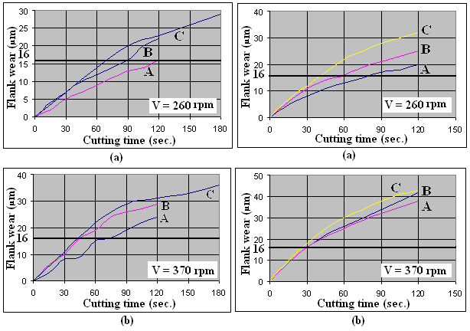
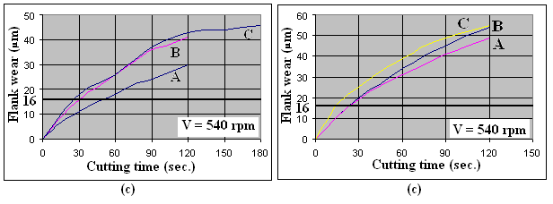
Fig.1: Variation of flank wear with the cutting Fig.2: Variation of flank wear with the cutting
time at f = 0.03 mm/rev. time at f = 0.04 mm/rev.

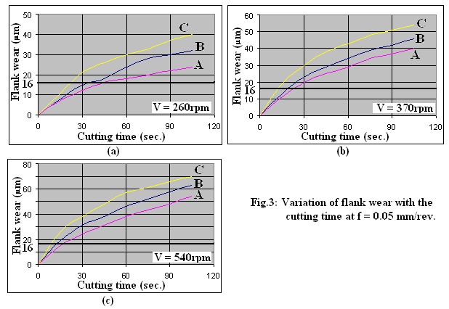

Machining  condition | Alloy code
Machining  condition | A | B | C
V = 540  (rpm)  f = 0.05 (rev/min) |  |  | 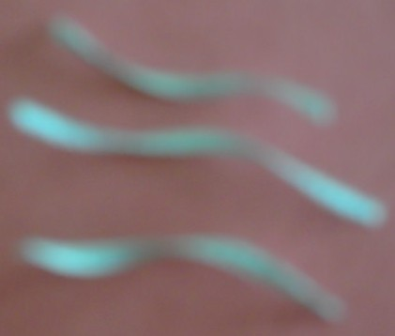
V = 370  (rpm)  f = 0.04 (rev/min) |  |  | 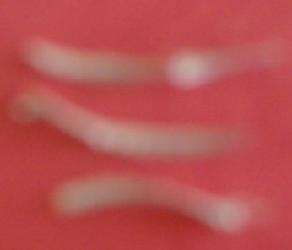

Fig.4 : Comparison of chips for alloys A, B, and C

Table 3 : Experimental design for measured tool life and its predicted values.

Alloy code | Exp.  No. | Cutting speed (rpm) | Feed rate  (mm/rev.) | Experimental  tool life (sec) | K-Factor | Predicted  tool life(sec)
A | 1 | 260 | 0.03 | 120 | 0.812 | 116.7
A | 2 | 370 | 0.03 | 75 | 0.812 | 71.2
A | 3 | 540 | 0.03 | 48 | 0.812 | 42
A | 4 | 260 | 0.04 | 82 | 0.812 | 67.2
A | 5 | 370 | 0.04 | 30 | 0.812 | 41
A | 6 | 540 | 0.04 | 24 | 0.812 | 24.1
A | 7 | 260 | 0.05 | 45 | 0.812 | 43.8
A | 8 | 370 | 0.05 | 22 | 0.812 | 26.7
A | 9 | 540 | 0.05 | 17 | 0.812 | 15.8
B | 10 | 260 | 0.03 | 90 | 0.315 | 89.9
B | 11 | 370 | 0.03 | 45 | 0.315 | 55
B | 12 | 540 | 0.03 | 30 | 0.315 | 32.3
B | 13 | 260 | 0.04 | 60 | 0.315 | 51.8
B | 14 | 370 | 0.04 | 30 | 0.315 | 31.6
B | 15 | 540 | 0.04 | 22 | 0.315 | 18.7
B | 16 | 260 | 0.05 | 33 | 0.315 | 33.8
B | 17 | 370 | 0.05 | 20 | 0.315 | 20.6
B | 18 | 540 | 0.05 | 13 | 0.315 | 12.2

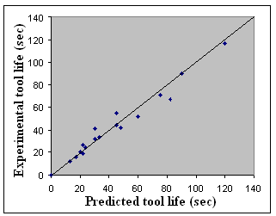

Fig.5 : Scatter plot of the experimental tool life and
its predicted values.

