General Operating Problems and Their Solutions of Natural Gas Sweetening Process (Amine System)

Rifat M.Dakhil, Sata K.Ajjam
Technical College in Basrah, College of Eng., Babylon Univ.

Abstract.
The paper presents general operating problems and some important trouble shootings which are concerning and involved with the operation and performance of the different equipment of the gas sweetening plant by using amine system. The trouble shooting deal and diagnosis of the problems encountered during plant operation with the main equipment like high & low pressure, level and differential pressure in the absorber and stripper as well as the high and low temperature of the lean solution besides the reflux pump shut down and low & high level alarm failure. Experimental work was done, it was seen that the optimum concentration of MDEA is 50 %, the optimum mole of steam to acid gas ratio is 1.5, and it was recommended to maintain the pH value for lean amine at a range of 7.1-8.0 by improving the stripping process
Keywords: Gas sweetening, Amine system, Trouble shooting
الخلاصة:-
تعرض هذه الدراسة المشاكل العملية وأهم طرق المعالجة والتي تهتم بعمليات وسلوك مختلف الأجهزة والمعدات الخاصة بمعامل تحلية الغاز الطبيعي باستخدام المحاليل الأمينية. معالجة المشاكل يعتمد على التشخيص والتحليل للمشكلة وتوقع حدوثها أثناء التشغيل لمختلف العمليات والأجهزة مثل أجهزة قياس الضغط العالي والواطئ قبل وبعد جهازي الامتصاص والنزع وكذلك أجهزة قياس درجات الحرارة العالية والواطئة للمحلول الأميني الفقير(الخالي من الغازات الحمضية) بالإضافة للإطفاء لمضخة الراجع بسبب إنذار المستوى العالي والواطئ.
عمليا تم دراسة تراكيز مختلفة للمحلول ألأميني (MDEA) ووجد إن أفضل تركيز هو 50%, وكذلك فأن أفضل نسبة مول بخار إلى الغاز الحمضي هو 1,5 وكذلك يفضل الحفاظ على قيمة الدالة الحمضية للمحلول الأميني الفقير بمعدل 7,1-8,0 من خلال تحسين عملية النزع.

Symbols
MDEA : Methyl-Diethanol Amine . DPI : Differential Pressure Gauge Faulty.
MEA : Mono-ethanol Amine. LCV : Level Control Valve.
DEA : Di-ethanol Amine TCV : Temperature Control Valve.
DGA : Di-glycol Amine TC : Temperature Controller.
GPSA : Gas Processors Suppliers Association. LG : Level Gauge.
PCV : Pressure Control Valve. LLA : Low Level Alarm.
HCV : Hand Control Valve. Mmscf : Million Standard Cubic Feet.
PI : Pressure Indicator.
BDV : Blow Down Valve.
PSV : Pressure Safety Valve.
DP : Differential Pressure.

1-Introduction
Many natural gases are produced from wells containing hydrogen sulphide, sulphur compounds and carbon dioxide. Perry and Chilton, et al, 1999 these gases are treated prior to sale or entry to a process plant. A gas which has high concentration of sulphur compounds is called 'Sour' gas. (Also called 'Acid' gas). The H₂S and CO₂ are known as acid gases, and are corrosive, if water or oxygen are present.The hydrogen sulphide H₂S must be removed from the Natural Gas before it can be used, due to the fact that it is highly corrosive and deadly toxic. The MDEA solution selectively removes the H₂S , however, some of the CO₂ and sulphur compounds during the sweetening process also absorbed, CO₂ concentration in the first gas plant is below the allowable concentration for the pipe line specification (less than 5%).
1-1 Amine Sweetening Process
There are a number of absorption gas treating processes, but the most common is the amine process in which acid gases react chemically. The 'rich' amine solution is heated under low pressure to regenerate the liquid by driving off the acid gases. Several different amine solutions can be used.
- Methyl-Diethanol Amine (MDEA)
- Mono-ethanol Amine (MEA)
- Di-ethanol Amine (DEA)
- Di-glycol Amine (DGA)
- Alkanol Amine + Sulfinol
Bullin, and Polasek, 1982, Cornelissen,1982, Savage and Funk, 1981, Daviet, Sundermann, Donnelly, Bullin, 1984, MacKenzie, Prambil, Daniels, and Bullin,et al, 1987, the sweetening process is similar for each of the amine solutions listed.
These amine mixtures have been called a variety of names including formulated amines and MDEA based amines. Historically, MDEA has been recognized primarily for its ability to selectively absorb H₂S from a gas while leaving large amounts of CO₂ in the gas. The selective absorption characteristics of MDEA have been widely reported in the above literature.
Polasek, Iglesias-Silva,et al, 2006, MDEA_s selective absorption ability is due to its relatively slow reaction rate with CO₂. Until the last few years, MDEA has not been associated with cases where the removal of large amounts of CO₂ is desired.
The type of solution used in the process will depend upon the type and quantity of acid gas contained in the sour gas stream and the volume of sour gas to be treated.
From Sahl Operating Manual, 1983, Sirte Oil Company, the process flow diagram for Amine sweetening system show the process details carried upon the Sour gases in the plant, see the simplified below diagram and fig(4) for Sahl Plant.

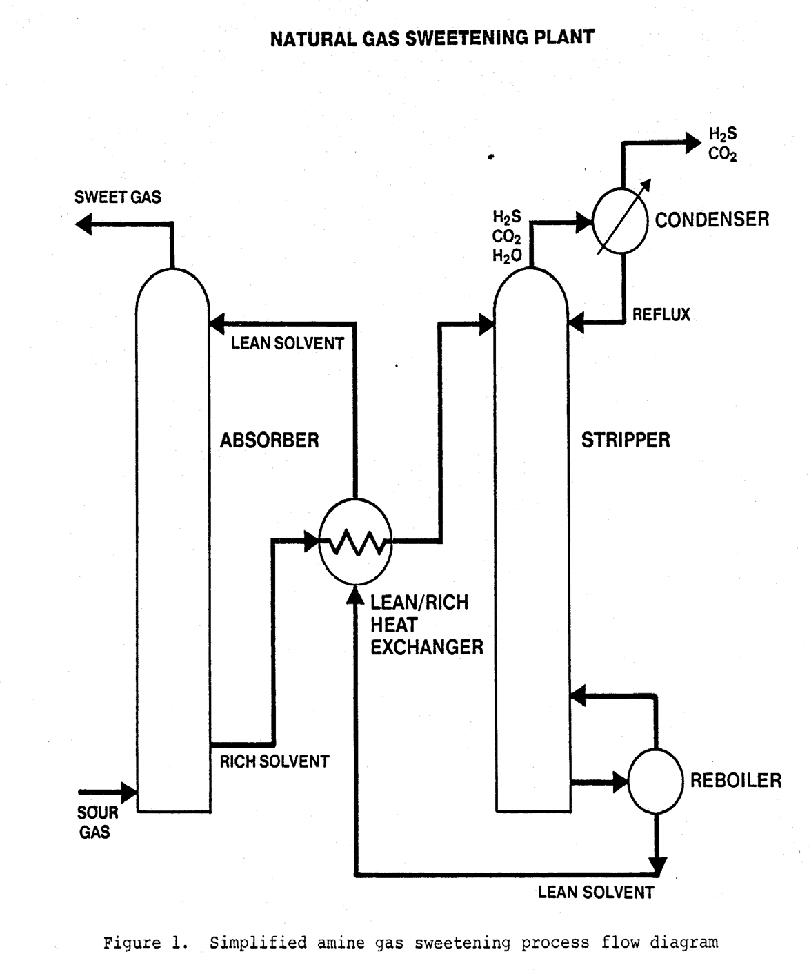

GPSA(Gas Processors Suppliers Association),et al, 2004, the general operating problems in the amine system are centered around the following five major areas:-
1. Amine loss from the system
2. Amine foaming problem
3. Corrosion problem
4. Concentration of residual gas in lean amine solution
5. Winterization.

1. Amine loss from the system
A certain amount of MDEA will be continuously lost from the amine sweetening system due to the vapour pressure of the amine.
The largest amine losses are usually through the amine absorber as carry over with the treated gas. Some amine is also lost through the amine stripper, amine flash tank, pumps packing etc. The losses vary for different plants, but usually are between 0.05 to 0.5 gallons per Mmscf of treated gas. These losses can be much higher depending upon several factors such as sour gas flow rate, reboiler temperature, high differential temperature between amine solution and the sour gas in the amine absorber, bad mist eliminator on the absorber top, bad filtration system and foaming.
Here are some guidance to help in minimising the amine solution losses from the system:
- Maintain the top temperature of the amine absorber as low as possible.
- Maintain proper amine solution concentration.
- Ensure good clean amine solution - good filtration, proper reboiler control to avoid chemical breakdown of amine and avoid all amine contamination.
-Regularly check all operating parameters & process variables to maintain steady running of the amine unit.

2. Amine foaming

Foaming is a common problem that results in a decrease of treating capacity of the plant and amine losses. It is usually detected by a sharp rise in the pressure drop across the amine absorber.
Amine foaming can occur from the reaction of the amine solution with organic acids or because of the presence of hydrocarbon contaminants, ferric sulphide, or other sludge. Several anti-foaming agents have been developed to combat this and some products which are primarily corrosion inhibitors have shown good anti-foaming properties. Where foaming is caused by hydrocarbon contamination, it may be eliminated by maintaining the temperature of the absorber above the hydrocarbon condensation temperature.

Foaming can be prevented in the following ways:
- Do not overload the inlet separator in your plant.
- Avoid condensation of liquid hydrocarbons in the amine absorber by keeping the temperature in the absorber above the hydrocarbon dew point.
- Keep field corrosion inhibitors, soap based lubricants and lube oil out of the amine system.

-Degradation of amine can cause foaming, so avoid it by preventing oxidation and
by proper reboiler control.
-Maintain the charcoal filter in good working condition, because this is the
filter which absorbs the liquid contaminants.
-If these remedies fail, try a de-foaming agent and evaluate the results.
-Always keep in mind that the de-foamers are only a temporarily answer for
the foaming problem, and the best cure for the problem is to avoid the main
causes.
3. Corrosion problem
Corrosion problem is commonly encountered in the amine system and generally occurs in the amine regenerator, heat exchanger, amine stripper and amine pumps etc. Most corrosion occurs in areas where the acid gases are actually released from the solution i.e. in the reboiler, stripper tower and its overhead systems. The cause of corrosion is traced to gaseous H₂S & CO₂ which comes out of the amine solution while the rich amine solution is receiving heat in the heat exchanger prior to the regenerator. These acid gases combine with water to form acids, which will attack the metal surfaces in contact with the amine solution.
Corrosion problems can be minimized by the following practices:

-Keep the amine solution clean. Do not over load the inlet separator, which prevents solids entering in the system. Other solids that contribute to corrosion are removed by amine filters. so, its very important to maintain a good amine filtration system.
-The presence of air will cause the amine to degrade into heat stable salts, so there should be a gas blanket on all the amine storage tanks to exclude air.
-Maintain acid-gas loading within the proper ranges.
-Corrosion problems become severe at high temperatures with the rich amine solutions, so keep the amine solution concentration up to the recommended value.
-Amine reboiler temperature should be kept at the recommended range to avoid any amine decomposition or any extra water losses which will affect the amine solution concentration.
-Maintain a regular corrosion testing programmed for an early detection of any corrosion problems in the system.
4. Concentration of residual gas in lean amine solution
The Concentration of residual gas in the lean amine solution should be controlled at a specified level for the plant. This is the gas which remains in the MDEA solution at all times.
-The amount of residual acid gas in the solution depends upon the heat used in the stripper reboiler. Increasing the heat reduces the residual acid gas and vice versa.
-If the concentration of residual gas is low then more acid gas can be absorbed by the lean amine solution in the absorber. This will also, allow a reduction in the circulation rate of the amine solution.
-If the inlet sour gas rate changes, the amine solution flow rate and the reboiler heat should be changed in same proportion to match the sour gas changes.
Note: The rich amine solution fed to the amine stripper contains acid gas from two sources:
a).Acid gas absorbed in the absorber.
b).Residual acid gas from the amine stripper.
Therefore, the sum of the two is the total acid gas content of the rich amine solution.
5. Winterization
Cold weather operation requires special attention for plants using MEA, DEA or Sulfinol. The freezing point of these solutions is about the same as that of the water. Consequently, lines or vessels in which there is no continuous flow should be given a special consideration during cold weather. If the plant and / or the amine unit is shut down for an extended period during freezing weather, the amine solution should be completely drained from the system.
The freezing point of MDEA and DGA is about ( -40 °F ) at the recommended amine concentration which is about 50% by weight for MDEA.
Therefore, the amine system at the hot areas gas plant does need special attention
during the cold weather other than not allowing excessive cooling. As a conclusion, this problem is an occasional one, but it is rather important and must be considered while working in the amine system.

1-2 Trouble Shooting Guide
From Sahl Operating Manual, 1983 and Personal communications with Sahl Plants supervisors, 2002, the following trouble shooting guide is presented to assist with the diagnosis of the problems encountered during plant operation.

PROBLEM | CAUSE | REMEDY
1. High pressure in absorber | Malfunction of PCV Downstream block valve  HCV-241 obstructed/closed  Pressure gauge failure | Check the downstream PCV Check for opening of block  valve  Calibrate defective PI-240 or PI-241 pressure gauge, if required install new gauge
2. Low pressure in absorber | Malfunction of PCV Pressure gauge failure  Opening of BDV-240 to flare system  Vent valve left open  PSV-240/241 open | Check the PCV downstream  Calibrate defective  PI-244/241. pressure gauge, if required install new  Check air supply (valve open with air failure).  Check power feeding to its solenoid valves.  Check vent valve  Check setting of PSV correct if required
3. High DP in absorber | Foaming  Differential pressure gauge faulty (DPI-240) | Determine cause of foaming. Inject de-foamer until foaming stops  Check the isolating valves  - close if open.  Have DP gauge checked out

PROBLEM | CAUSE | REMEDY
4. Low DP in the absorber | Very low gas flow rate  Gas leaks through trays and down-comers  Differential pressure gauge failure DPI-240 | Check correct opening of isolating valves of the gas piping system  Check amine solution flow. Increase flowrate if it is too low  Check vent valves closed. Calibrate DP gauge.
5. High liquid level in absorber | Faulty LCV operation,  .  Possible high pressure in Flash  Tank.  Liquid outlet line blocked | Check LCV - If faulty contact  Inst. Dept.  Meanwhile use bypass to control level.  Check Flash Tank pressure - If high investigate why and correct the fault.  If LCV and Flash Tank are OK, and High Level remains, probable blockage in the line - Further checks are required.
6. Low liquid level in the absorber | LCV-240 sticking in open position  High gas rate causing hold-up on absorber trays or failure of glycol circulation - pump or filter problem.  Low pressure at amine charge pump discharge | Use the bypass and have the  Inst. Dept. check the LCV  Check for abnormal gas rate and glycol filters and pump operation.  Check pump for correct operation (no cavitation) If necessary, change over pumps & re-check.

1-2 TROUBLE SHOOTING GUIDE

PROBLEM | CAUSE | REMEDY
7. High temperature of lean amine solution | Cooler TCV (to variable pitch fan) failure or fan motor failure  Lean amine air cooler tube bundle internal or external fouling  High ambient temp. | Call inst./elect. technician.  Check pressure drop  across the tube bundle and visually check tubes & fins externally  No action can be taken.
8. Low temperature of lean amine solution | Temperature controller TC-  360 failure  Lean amine air cooler auto- variable fan failure  Low ambient temperature | Check and correct set point if required  Check TCV-360 for correct operation - call Instrument Technician if required.  Stop the fixed pitch fan.  Use cooler bypass if necessary.
9. High pressure in stripper  Low pressure in stripper | Reflux drum controller  PC-410 failure.  Pressure relief valves PSV-  260/261/270/410 open. | Check PCV set point and operation - Call Instrument Technician if necessary. Use PCV bypass meanwhile.  Check for open S/V or bypass valve.
10. High D.P. across the stripper. | Foaming.  Excessive vapour flow or circulation rate too high causing flooding of the trays  Faulty DP gauge | Determine cause of foaming and take remedial action.  Inject defoamer until system is normalised.  Check reboiler temp. - decrease if too high.  Check stripper pressure - if too low - adjust PCV.  Check amine flow rate. Inst. Dept to check gauge

1-2 TROUBLE SHOOTING GUIDE

PROBLEM | CAUSE | REMEDY
11. Low DP across the stripper. | Vapour blow-through in trays and/or downcomers.  Faulty DP gauge | Check reflux drum level and liquid flow to stripper and increase flow if possible to re- establish liquid levels on trays.  Have DP gauge checked
12. Low liquid level in stripper. | LG bottom leg blocked or  LLA malfunction  LCV malfunction.  Failure of reflux flow | Blowdown the LG / Have LLA  checked out.  Check LCV operation - call Inst. dept. if necessary. Close down on LCV block valve to raise stripper level.  Check reflux system operation.
13. High stripper temperature. | Low pressure in the reflux accumulator. | Refer to paragraph on low pressure in stripper.
14. Reflux pump shutdown. | Low level of reflux drum.  Selector on "O" position. | Check the minimum flow block valve is open or flow orifice is not plugged.  Select the running pump.
15. High and low level alarm failure. | Block valve closed.  Drain valves of alarm left open.  Switch failure. | Check & open valves. Check and close the valve.  Call instrument Technician.

2- Experimental Results and Discussion:-
Three main factors in the sweetening process were adapted experimentally as follow:
- The pick-up rate
The quantity of acid gas removed by each gallon of amine solution is referred to as’ The Pick-up Rate’. The Pick-up rate can be determine from the difference of the acid gas concentration in the rich and lean Amine solution(i.e. before and after the absorption tower).
Study the relation between the amine concentration and gas pick-up rates for MDEA (Methyl di-ethanol amine) as shown in table No. 1.
Conc. of lean solution | Pick-up rate  ft³ acid gas / gal. solution
40 Wt. % | 4.9
45 Wt. % | 5.4
50 Wt. % | 6.3
55 Wt. % | 6.5
60 Wt. % | 6.7

Table 1. relation between the concentrations & pick-up rates for MDEA

From the above table-1 and fig-1, it can be seen that the optimum concentration of MDEA is 50 % , with a result of pick-up rate 6.3 ft³ of acid gas per gallon of solution. Also, the pick-up rate shown above is for plants operating above 500 psig pressure. The pick-up rates may drop as much as 50% if the pressure in the absorber is below 250 psig.
A higher concentration of the amine in the solution would be more effective in acid gas removal but the increase in pick-up rate decrease slightly and, it may be more corrosive and will require more heat for its regeneration. In addition, a higher concentration requires a higher temperature in the stripper reboiler, which may cause the amine to decompose and form undesirable compounds.
- Effect of overhead ratio(steam to acid gas) on the amount of stripped acid gas by amine solution.
The percentage of amine sulphide & carbonate that convert to acid gas and amine depends upon the amount of heat and stripping steam applied to stripper tower. To achieve an appropriate amine solution MDEA to stripe the acid gas to an amount considered to be economically and technically acceptable. A different overhead ratios of moles of steam per moles of acid gas has been adapted during the plant start-up as shown in table -2.
Mole of steam / mole of acid gas | Mole of acid gas / mole of amine solution
0.5 | 0.005
1.0 | 0.009
1.5 | 0.015
2.0 | 0.017
2.5 | 0.018

Table-2 The relation between the ratio of mole steam to mole of acid gas verses the ratio
of mole of acid gas to mole of amine solution.

From the above table-2 and fig-2, it can be seen that the optimum mole of steam to acid gas ratio is 1.5 which is led to 0.015 mole of stripped gas by mole of amine solution. A higher ratio of steam to acid gas would be more effective in stripping of acid gas by mole of amine solution but that slightly increase would not acceptable economically and technically.
3- Amine pH Control :
It is important to control the amine pH within a certain specified value to get optimum acid gas removal and protect the equipment from corrosion. Too high a pH (more than the specified values) will tend to increase the amine foaming , hence more amine losses as well as less intimate contact between the gas stream and the absorbent agent (amine) .
The recommended pH values for amine are given in the table below :
Amine(MDEA) Type Required pH values
Lean 7.0 - 7.5
Rich 5.5 (minimum)
pH for lean amine solution | pH for rich amine solution | Delta pH | Dates for samples taken
7.2 | 5.7 | 1.5 | 1/2002
7.3 | 6.2 | 1.1 | 2/2002
7.1 | 5.4 | 1.7 | 3/2002
8.0 | 6.3 | 1.7 | 4/2002
7.8 | 5.3 | 2.5 | 5/2002
7.6 | 5.1 | 2.5 | 6/2002
7.5 | 5.6 | 1.9 | 7/2002

Table-3 pH Samples at different dates showing the difference between the rich and lean
amine solution pH values.
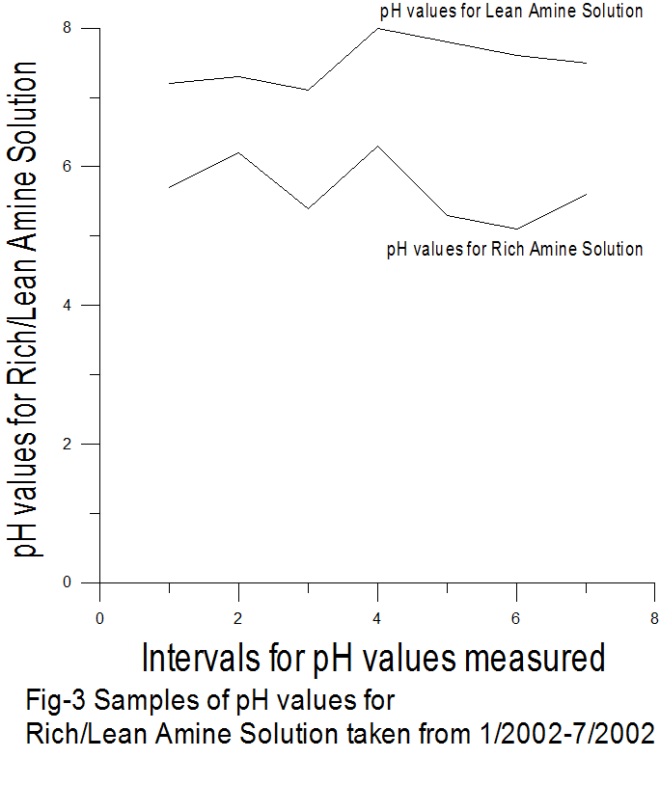

From the above table-3 and fig-3, it can be seen that the pH values decreases within the range of 7.1-8.0 for lean amine solution to 5.1-6.3 for rich amine due to acid gas removal by the lean amine solution, that problem can be shoot by improved the stripping process as shown in fig-2.
Delta pH variation before and after absorption almost the same.
Conclusions
It was highly recommended that the different operating problems accompanied with the gas sweetening process specified in order to establish the possible solutions of these problems and keep the units running well with a highly efficient performance. To establish a trouble shooting guide seems to be very important to be adapted as a training course for the process engineers and plant operators in order to understand the effect of the different process variables and their fluctuations effect on the process and to take the correct decision in case of any malfunction with the process. This study help the process engineers and operators for keeping their gas sweetening plant in a safe and good working conditions.
Experimentally it can be seen that the optimum concentration of MDEA is 50 % , with a result of pick-up rate 6.3 ft³ of acid gas per gallon of solution, the optimum mole of steam to acid gas ratio is 1.5 which is led to 0.015 mole of stripped gas by mole of amine solution, and the pH values decreases within the range of 7.1-8.0 for lean amine solution to 5.1-6.3 for rich amine .
References
Bullin, J. A., and Polasek, J. C., 1982, "Selective Absorption Using Amines," Proc. of 61st Annual Gas Processors Convention.
Cornelissen, A.E., 1982,"Simulation of Absorption of H₂S and CO₂ Into Aqueous Alkanolamines," Shell Laboratory p. 301-315.
Daviet, G.R., Sundermann, R.; Donnelly, S.T. ; Bullin, J.A. 1984, March,"Dome_s North Caroline Plant Conversion to MDEA,"Proceedings of GasProcessors Association Convention, NeOrleans, LA, p. 69.
GPSA, 2004 (Gas Processors Suppliers Association ), ENGINEERING DATA BOOK.
MacKenzie, D.H., Prambil, F.C., Daniels, C.A. and Bullin, J.A., 1987, March, "Design &Operation of a Selective Sweetening Plant Using MDEA," Energy Progress, (vol. 7, No. 1).
Perry and Chilton, 1999, Chemical Engineering Handbook,sec.14, 6th edt.
Polasek, J.C. ; Iglesias-Silva, G. A. 2006, "Using Mixed Amine Solutions for Gas Sweetening" Bryan Research and Engineering Inc. Technical Paper.
Sahl Operating Manual, 1983, Sirte Oil Company. Esso Standard Libya Ltd.Personal communications, 2002, with Sahl Plants supervisors.
Savage, D. W., and E. W. Funk, 1981, April 5-9 "Selective Absorption of H₂S and CO₂ into Aqueous Solutions of Methyldiethanolamine," AIChE meeting, Houston, Texas.

