Enhance concrete performance using natural materials as partial replacement of cement

Ikram Faraoun Al-Mulla
MSc. Material, Civil engineering dept. University of Baghdad

Abstract
In the last decades, the use of residue in civil construction, especially in addition to concrete has been studied by many researches related to, besides to reduce the environmental polluter’s factors. This may lead several improvements of the concrete properties. In recent years increasing attention towards utilizing less energy intensive materials, such as fly ash, rice husk ash, condensed silica fume and slag, in combination with cement to achieve energy saving.
This research evaluates how adding rice husk ash (RHA) to concrete may influence its physical and mechanical properties. RHA of 8% and 10% were replaced partially as cement. Also, the research studies the effect of adding Iraqi slag (SS) (steel slag) as partial replacement of cement. Slag is a by-product from pig-iron production process, which causes environmental problem remains as disposals when not used. In this research cubic samples of (100x100x100) mm were tested to evaluate compressive strength, cylindrical samples of (100 diameter x200 high) mm were used for testing splitting tensile strength, and prism samples of (100x100x400) mm were tested for flexural strength. All samples were tested after 28 days curing. Three mixes were prepared, the first mix with partial replacement (8%, 10%) of RHA as cement which gave enhancement in compressive strength of 46MPa while it was 33 MPa for ordinary concrete and 22 MPa for slag concrete ,the second mix with partial replacement ((40%) of SS) of cement SS gave enhancement in splitting tensile strength by 4.7 MPa while it was 2.6 MPa for ordinary concrete mix and 5 MPa for RHA mix and the third was plain concrete (to compare with) without replacement all tests were made after 28 days of curing.
الخلاصة:
خلال العقود المنصرمة كان استخدام المخلفات في الانشاءات المدنية ،خصوصا اضافتها للخرسانة، موضع دراسة من قبل عدة بحوث في هذا المجال، بالاضافة الى تقليل عوامل التلوث البيئيي ،هذا قد يؤدي الى تحسين خواص الخرسانة.. في السنوات الاخيرة زاد الاهتمام نحو استغلال المواد التي تحتاج طاقة انتاجية اقل مثل الرماد المتطاير، رماد قشور الرز، رغوة السليكا المكثفة والخبث حيث تعمل مع السمنت لتحقيق التوفير بالطاقة. هذا البحث يدرس اضافة رماد قشور الرز للخرسانة وتاثيره على خواصها الفيزيائية والميكانيكية. حيث تمت اضافته بنسبة 8%و10% كاحلال جزئي عن السمنت، ايضا يدرس البحث اضافة الخبث بنسبة احلال 40% عن السمنت حيث ان هذا الخبث هو ناتج عرضي عن عمليات تصنيع الحديد والذي يسبب مشاكل بيئية عند بقاءه كراسب غير مستعمل.
تم في هذا البحث عمل نماذج خرسانية مكعبة بابعاد 100 ملم لفحص مقاومة الانضغاط وعمل نماذج اسطوانية 100ملم قطر و200ملم ارتفاع لاجراء فحص مقاومة الشد بالانفلاق وعمل نماذج خرسانية من مواشير بابعاد100x100x400 ملم لفحص مقاومة الانثناء وكل النماذج فحصت بعمر 28 يوم. تم عمل ثلاث خلطات الاولى فيها احلال جزئي لرماد قشور الرز بنسبة 8%و10% عن السمنت والتي اعطت تحسن في الخواص فمثلا كانت مقاومة الانضغاط46.89 MPa بينما للخرسانة الاعتيادية كانت 33MPaوالحاوية خبث اعطت 22 MPa والثانية احلال 40% من الخبث بدلا عن السمنت حيث اعطت مقاومة للانشطار قدرها 4.7 MPa بينما الخرسانة العادية اعطت مقاومة 2.6 MPa والخلطة الحاوية خبث اعطت مقاومة 5 MPa والثالثة خلطة مرجعية لاغراض المقارنة معها وتكون خالية من اي اضافة او احلال وتمت كل الفحوص بعمر 28 يوم.
Introduction
Rice husk is an agro-waste material which is produced in about millions of tons. Approximately, 20Kg of rice husk are obtained for 100Kg of rice[Al-Rahamy 2002]. Rice husks contain organic substances and 20%of inorganic material. RHA is obtained by the combustion of rice husk. The most important property of RHA that determines pozzolanic activity is the amorphous phase content. RHA is a highly reactive pozzolanic material suitable for use in lime-pozzolana mixes and for Portland cement replacement. RHA contains a high amount of silicon dioxide, and its reactivity related to lime depends on a combination of two factors, namely the non-crystalline silica content and its specific surface.
Researches on producing rice husk ash (RHA) that can be incorporated to concrete and mortars are not recent. [Mehta, 1992] investigated the effect of byprocessing on the pozzolanic reactivity of RHA. Since then, a lot of studies has been developed to improve the mechanical and durability properties of concrete. Since then, a lot of researches have been developed to improve the mechanical and durability properties of concrete ([Paya, et al, 2000], [Al-Rahamy, 2002]).The potential reactivity of aggregate was investigated by [Afrani & Rogers, 1994]. The results show that adding percentage over 12% of RHA, the expansion is reduced in acceptable levels [Hogan, 1985]. Mechanical properties (compressive strength, splitting tensile strength and flexural strength) were tested. The samples were tested after 28 days of curing.
Steel slag (SS) has been used for many years as a supplementary cementitious material in Portland cement concrete, either as a mineral admixture or as a component of blended cement. The use of SS as a partial Portland cement replacement takes advantage of the energy invested in the slag making process and its corresponding benefits with respect to the enhanced cementitious properties of the slag. Grinding slag for cement replacement requires only about 25 percent of the energy needed to manufacture Portland cement. Moisture in steel slag, which occurs in the granulation process or in pelletized slag, should be removed by drying prior to the use of SS as either an additive to Portland cement or a mineral admixture to Portland cement concrete. Processing for use as a supplementary cementitious material requires grinding of the slag, typically using the same or similar plant and equipment as for Portland cement production. The SS is added to concrete in two methods: first as replacement of part of cement (40%), this was studied in this research, second as admixture without replacement by weight of cement. In the first method when increasing slag replacement the workability increased, but there was a reduction in strength and initial surface absorption. In the second method when slag increased there was a reduction in workability and increase in strength [Al-Mulla, 1992].
Engineering properties:
- Iraqi steel slag(SS) [ACI,1990][Hooton,1981]
Some of the engineering properties of SS that are of particular interest when slag is used as a supplementary cementitious material in Portland cement concrete include the hydraulic reactivity of the slag and its fineness.
-Hydraulic Reactivity: Depending on the quenching process, the structure of pelletized slag can range from crystalline (slow quench) to vitreous (rapid quench). Rapid quenching is important if cementitious properties are to be achieved. The chemical composition of SS use in Portland cement concrete must also conform to sulfur and sulfate content limitations outlined in AASHTO M302.
-Fineness: Granulated slag is a glassy granular material, and its particle distribution, shape, and grain size vary, depending on the chemical composition and method of production, from popcorn like friable particles to dense, sand-size grains. Pelletized slag, in contrast to air-cooled and expanded slag, has a relatively smooth texture and rounded shape. Grinding reduces the particle size to cement fineness for use as hydraulic cement, which is typically less than 3500 cm²/g. Some of the properties of concrete mixes containing SS that are of particular interest when it is used as partial cement replacement include strength development, workability, heat of hydration, resistance to alkali-aggregate reactivity, resistance to sulfate attack, and salt scaling.
-Strength Development: Concrete containing SS develops strength at a somewhat slower rate than concrete containing only Portland cement, but ultimately can develop equivalent strength. This can be a concern where early strength development is important (staged construction where the first structure must develop strength before the second structure can be placed). Low temperatures (cold weather) generally have a more adverse impact on strength development with concrete containing SS than concrete containing only Portland cement.
-Workability: Concrete containing SS as a partial cement replacement has longer-lasting workability and low slump loss during hot weather construction.
-Heat of Hydration: Concrete containing SS exhibits a lower heat of hydration than conventional Portland cement concrete.
-Alkali-Aggregate Reactivity: The use of SS as a partial replacement for Portland cement can reduce available alkalis and can reduce the reaction between certain siliceous components of concrete aggregates and the alkalis in the concrete
-Sulfate Resistance: Use of SS as a partial cement replacement gives concrete moderate resistance to sulfate attack
-Salt Scaling: Concrete containing high concentrations of SS may be susceptible to salt scaling (the loss of surface layers of cement mortar during repeated freeze-thaw cycles). Due to this problem, some agencies limit the amount of slag in a Portland cement concrete mix to 25 percent of the total cement weight
The same equipment and procedures used for conventional Portland cement concrete may be used to batch, mix, transport, place, and finish concrete containing SS.
Curing
The slower strength development of concrete containing SS may require that the moisture be retained in the concrete for a longer period of time than what is normally required for conventional concrete. Scheduling of pavement construction should allow adequate time for the specified strength gain prior to the placement of traffic loads, the onset of freeze-thaw cycles, and the application of deicing salts.
Quality Control
The same quality control procedures used for conventional Portland cement concrete can be used for concrete containing SS.
Unresolved Issues
The primary issue associated with the use of slag cement is the reported loss of durability (salt scaling resistance) for exposed Portland cement concrete containing more than about 25 percent slag cement. During the mix design stage, a salt scaling resistance test (ASTM C672) should be undertaken to assess the potential durability problems that may be encountered with the levels of SS being used .
- Rice husk ash(RHA)
The successful utilization of a waste material depends on its use being economically competitive with the alternative natural material. The stability and durability of products made of concrete using waste material over the expected life span is of utmost importance, particularly in relation to building and structural applications. Rice husk ash has been found suitable for masonary mortar, foundation concrete and mass concrete work [swamy, 1983]. The use of rice husk ash, which is a mineral admixture produced from natural sources, enhances the concrete performance because this material is considered as high activity pozzolanic material containing high content of amorphous silica. The soundness of rice husk ash permits filling the pores between cement particles and the use of rice husk ash reduces the evolution rate of the hydration heat. RHA is possible to be used in concrete as a corrosion deterrent material [Al-Heaty, 2000].
Rice husk was burnt approximately 48 hours under uncontrolled combustion process. The burning temperature was within the range 600 to 850Cº. The ash obtained was ground in ball mill and its appearance color was grey.
Experimental Work
A mix design of 30 MPa after 28 days curing was used (as plain concrete) in this research with two parameters: the first was to place
(8%, 10%) of rice husk ash as partial replacement of cement. The second was to place (40%) of slag as partial replacement of cement. The mix proportion was (1: 1.2: 1.6) by weight and the water cement ratio w\c= 0.42 the cement content was 350 Kg/m³ and its fineness was 2600 cm²/gm. Three types of specimens were used: (100x100x100) mm cubes for determining compressive strength, (100x100x400) mm prisms for determining flexural strength and (100 diameter x200 height) mm for determining splitting tensile strength. Each test was made after 28 days of curing.
In centralized rice milling huge quantities of rice husk are generated. Each ton of paddy produces about 200 Kg of husk [Swamy, 1983]. In this research RHA is used after it was burned by special kilns of 560 C for 5 hours [Al-Heaty,2000]. The resulting material is of grey color with amorphous silica content exceeding 93%. Table (2) shows the chemical properties of RHA. Figure (1) explains the X-Ray test, which shows that the material is amorphous silica. It was crushed in porcelinite mills, Figure (2), for about 12 hours. The surface area of crushed RHA was 2700 cm² /gm by blain method.
The physical and chemical characteristics were determined .In addition; X-ray diffraction was used to verify the presence of crystalline silica in RHA. According to the chemical characteristics, the RHA has high levels of silicon dioxide, approximately 93%, and the specific gravity is 2.16. Figure 1 shows x-ray diffract grams for the RHA sample. The results showed a very distinct peak corresponding to crystalline silica. The reason for this behavior is the long time combustion process and the high temperature of burning. The average particle size distribution was 13.34∝m. Thus the RHA is finer than cement and should be expected to work not only a pozzolanic role, but also a micro filler effect.
Steel slag were brought as a big mass from iron and cast factories, and it has been broken by large hammer to coarse aggregate size then it was crushed in a crusher to fine aggregate size , finally a steel ball mill was used to have specific surface area ( fineness) (2900 cm²/gm), equal or higher than cement fineness.Table (1) shows the chemical composition of the SS. The SS was used as partial replacement (40%) by weight of cement.

Table (1) Chemical composition of the SS
Oxides | Percentage %
SiO₂ | 18.83
CaO | 38.4
MgO | 9.14
SO₃ | 0.122
Fe₂O₃ | 24.27
AL₂O₃ | 4.5
Slag density gm/cm³ | 3.57

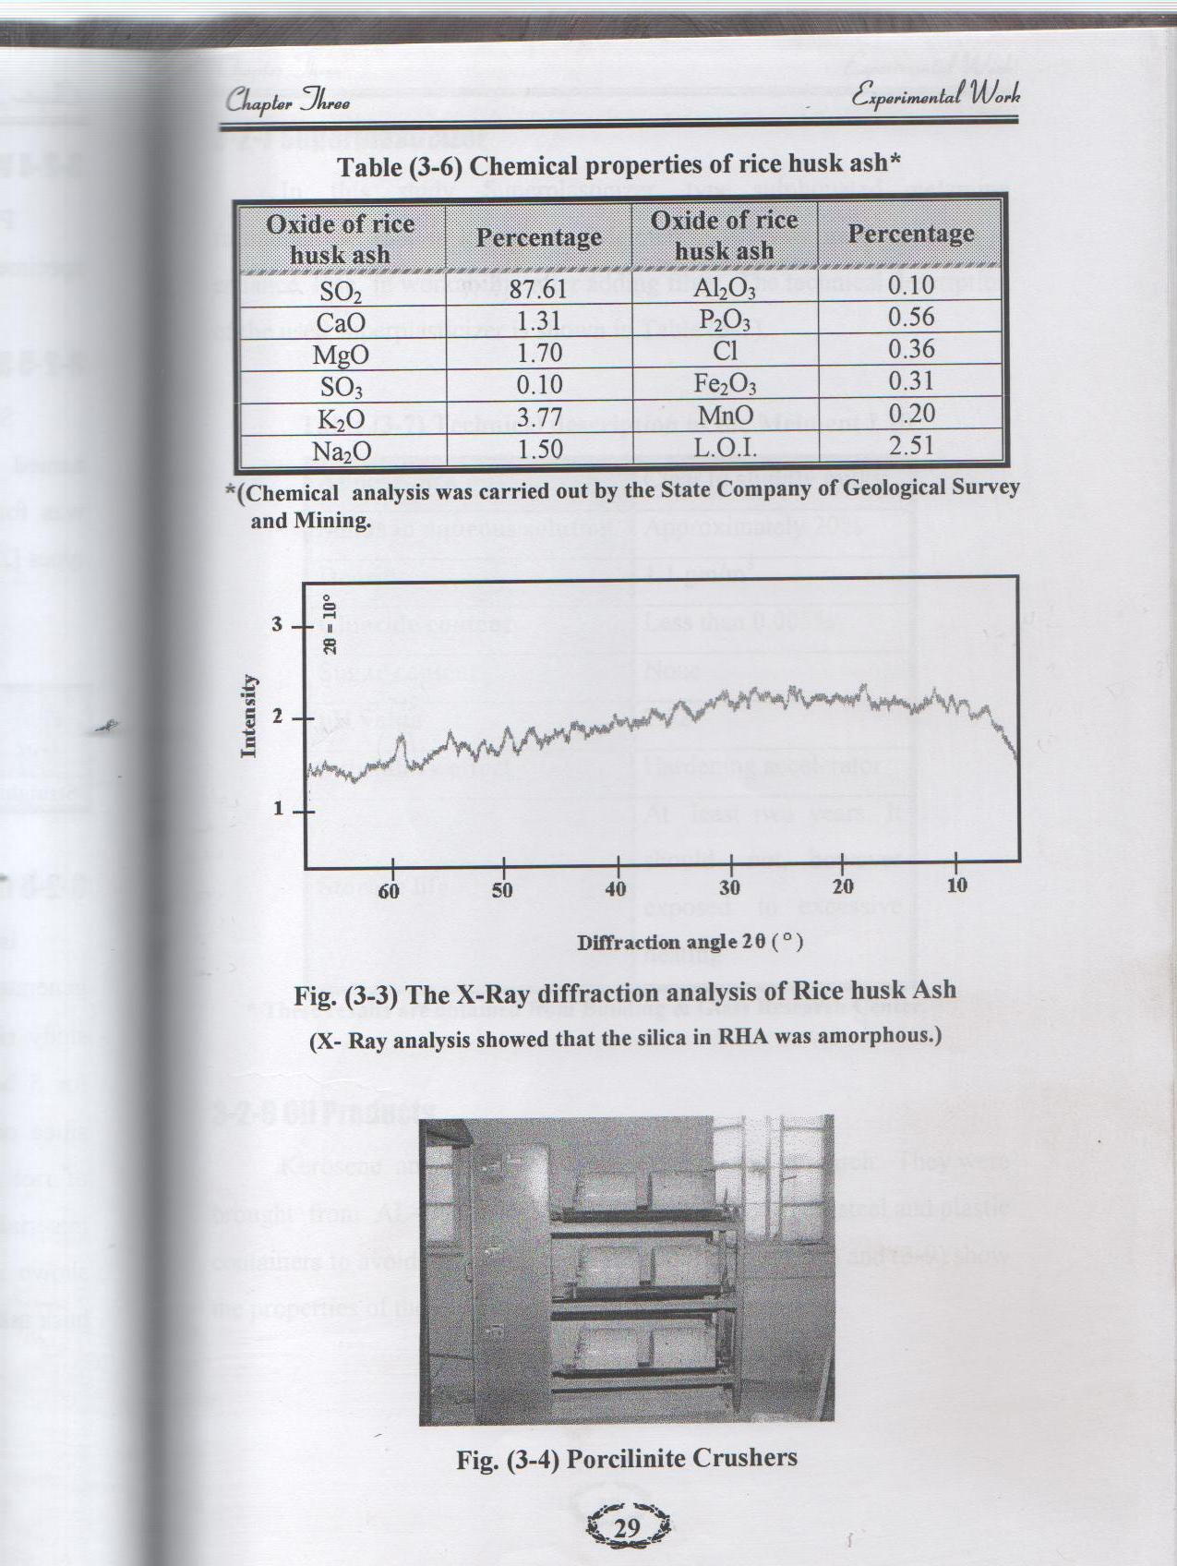
Figure (1) X-Ray diffraction for rice husk ash

Figure (2) Porcilinite crusher
Table (2) Chemical properties of RHA
Oxides of RHA | Percentage | Oxides of RHA | percentage
SiO₂ | 93 | AL₂O₃ | 0.1
CaO | 1.31 | P₂O₃ | 0.56
MgO | 1.7 | CL | 0.36
SO₃ | 0.1 | Fe₂O₃ | 0.31
K₂O | 3.77 | MnO | 0.2
Na₂O | 1.5 | L.O.I | 2.51

Test Results:
- Compressive strength:
This test was performed on standard cubical specimens of 100mm, the specimens were cured for 28 days and tested by testing machine of 2000 kN capacity, commercially known as (ELE-digital Elec2000). Table (3) shows the results of the test for the three mixes.
- Splitting tensile strength:
In this test, a concrete cylinder of 100mmx200mm is placed with its axis horizontal between platens of ELE-Machine. In practice narrow strips of plywood interposed between the cylinder and platens, these narrow strips are 3mm thick and 25mm wide. Table (3) shows the results of this test.

- Flexural strength:
Flexural test was carried out on a standard 100x100x400 mm prisms (simply supported) with clear span of 300 mm under two points loading . Test results were explained in Table (3).

Table (3) Tests results after 28 days curing
mix | Compressive strength MPa | Splitting tensile strength MPa | Flexural strength MPa
plain | 33.5 | 2.66 | 5.86
8% RHA | 46.89 | 5.93 | 7.4
10% RHA | 40.4 | 5.82 | 6.88
40% SS | 22.7 | 4.7 | 3.71

Discussion and Conclusions:
1-The addition of RHA causes an increment in the compressive strength due to the capacity of the pozolanic materils, of fixing calcium hydroxide, generated during the reactions of hydration of cement. The replacement of RHA increased the compressive strength. The concrete mixes have 8% RHA give higher compressive strength (46.89 MPa) than those with 10% RHA (40.4 MPa), this behavior may be due to the fact that 8% may be optimum proportion to be compatible with other concrete constituents. The 10% RHA absorbs more water from the mix, hence weakening the concrete, due to insufficient compatibility.
2- The use of SS reduces the compressive strength (22 MPa) because of the reduction in the activity factor of the slag.
3- The results of splitting tensile strength show that there is no interference of replacing RHA partially to cement. Concrete mixes with 8%RHA give better behavior (5.9 MPa) compared to concrete mix with 10% RHA (5.8 MPa), due to higher water demand of 10% RHA.
4- The results in splitting tensile strength of the mix have 40% SS as a replacement of cement (4.7 MPa) show a reduction compared to RHA concrete.
5- The concrete mix with 8% RHA give higher flexural (7.4 MPa) than those with 10%RHA (6.88 MPa) due to higher water demand of 10% RHA.
6- The SS concrete mix show a reduction in flexural strength (3.7 MPa)compared to plain concrete (5.8 MPa) and to 8%RHA mix (7.4 MPa).
7- Relation between the ratios of adding RHA to cement may be adopted throughout this research, which conforms that these ratios (more than 7% of RHA) may enhance concrete properties.

References
ACI. "Ground Granulated Blast-Furnace Slag as a Cementitious Constituent in Concrete," ACI Manual of Concrete Practice, 1990, Part 1, Materials and General Properties of Concrete, American Concrete Institute, ACI 226.1R, 1990.
Afrani,I.andC. Rogers," The effects of different cementing materials and curing on concrete scaling.", Cement Concrete and Aggregates, December, 1994.
Al-Heaty ,A,K.”Controlling slump loss problems in ready mix high resistance concrete exposed to sever solutions”, MSc. Thesis, University of Technology,2000.
AL-Mulla, J.A,"Effect of using Iraqi slag in concrete industry", MSc. Thesis, University of Baghdad, pp.90, 1992.
AL-Rahamy, A.S,"Properties and Durability of Admixture Fiber concrete exposed to oil products.", MSc.Thesis, University of Technology, pp.106,2002.
Hogan,F.J,"The effect of blast furnace slag cement on aggregate reactivity.",Cement Concrete and Aggregate,Vol.7, No.2,1985.
Hooton,R.D.,” Pelletized slag cement, hydraulic potential and Autoclave Reactivity” Ph, D.Thesis, Hamilton, Ontario, Canada, pp.251,1981.
METHA, P. K., Rice husk ash–a unique suplementary cementing material, V.M. Malhotra (Ed), Proceedings of the International Symposium on Advances in Concrete Tecnology. CANMET/ACI, Athens, Greece, May, 1992, pp. 407-430.
PAYÁ, J. et al. Studies on cristalline rice husk ashes and activation of their pozzolanic properties. In WOLLEY, G.R.; GOUMANS, J.J.J. M.; WAINWRIGHT, P. J.. Waste materials in construction wascon 2000. Amsterdam: Pergamon, 2000. P.493-503. (Waste Management Series, 1).
Swamy,R.N," New concrete material.", Concrete technology and design, Vol.1, 1983,pp.146-150.

