Influence of Stiffener Shape on the Buckling Loads of Aluminum Stiffened Plate.

Salwan O. Wheed
Babylon University, College of Engineering,
Abstract
Buckling study represents one of the most important studies for structures subjected to in plane loads so that it provides the researcher by an excellent informations specially at critical design levels. These informations are buckling modes, buckling types, and critical buckling loads which should be taken into the consideration at design process. In this research, a stiffened plate formed form 5083 aluminum alloy for two cases of stiffening. In the first case, the stiffeners were a flat plate and the second the stiffeners were changed into what corresponding in quadrilateral, triangular, and circular type. Also, effect of the changing in the stiffeners shape and stiffening locations under same boundary conditions on the buckling modes and buckling loads was also studied. From the results, it was noted that the changing in the stiffeners shape (keeping the same thickness and length of the stiffeners) doesn’t lead to increase the buckling load only, but to convert the structural behaviors from mode to other. Location of stiffening play an important rule in assessment the stiffness of the structure. The mathematical modeling was achieved using ANSYS finite element program. At last, a numerical program includes all above features written in APDL (Ansys Parametric Design Language) was achieved and added to the ANSYS milieu as a new feature.

الخلاصة
تعتبر دراسة الانبعاج من الدراسات المهمة جدا للأجزاء التركيبية بحيث تجهز معلومات ممتازة للباحث عند التصميم خاصة حول أنماط الانبعاج, أنواع الانبعاج, والحمل الحرج للانبعاج والتي يجب أن تأخذ بنظر الاعتبار عند تصميم أي تركيب. في هذا البحث, تم تحليل الانبعاج لصفيحة مقواة مصنوعة من سبيكة الألمنيوم 5083 في حالتين, الأولى يكون شكل المقوي فيها هو ألصفيحه المستوية والثانية تم تغيير شكل المقوي إلى ما يقابله من الشكل المربع, المثلث, والدائري. تمت دراسة تأثير تغيير شكل المقوي وموقعه تحت نفس الشروط الحدية على أنماط التشوه والأحمال الحرجة. وجد إن تغيير شكل المقوي (بالحفاظ على نفس السمك والطول ) لا يؤدي إلى زيادة الحمل الحرج فقط وإنما يغير تصرف التركيب من نمط إلى أخر. يلعب موقع التقوية دور مهم جدا في ضمان مقاومة التركيب. تم التمثيل الرياضي للمسألة باستخدام طريقة العناصر المحددة والمتمثلة بالبرنامج التحليلي (ANSYS). أخيرا, تمت كتابة برنامج باستخدام. أل APDL (Ansys Parametric Design Language) تضمن جميع الخصائص المذكورة وقد أضيف لبيئة أل ANSYS كخاصية جديدة.
1.Introduction
The use of high strength aluminum alloys in shipbuilding provides many benefits but also presents many challenges. The benefits of using aluminum versus steel include lighter weight, which helps increase cargo capacity and/or reduce power requirements, excellent corrosion resistance and low maintenance. Challenges include reduced stiffness causing greater sensitivity to deformation, buckling, and plastic collapse and different welding practices. The benefits difficulties are now well recognized, particularly for the design and construction of war ships, littoral surface crafts, and littoral combat ships as well as fast passenger ships. The size of such ships is increasing, causing various related design challenges compared to vessels with shorter length. In addition to aluminum alloys being less stiff than mild steel, no refined ultimate limit state (ULS) design methods involving local and overall ULS assessment exist unlike steel structures where the necessary information is plentiful. The use of ULS design method in addition to more conventional structural design standards will be able to help design and build very large ocean-going aluminum high speed vessel structures (Paik, Jeom Kee, 2007).
One of the critical failure events of a ship structure is the occurrence of overall buckling of deck or bottom structure under longitudinal bending. So, the deck and the bottom plates are reinforced by a number of longitudinal stiffeners to increase their strength and rigidity. For a rational design avoiding such a failure, it is very important to know the buckling behavior of such stiffened plates under thrust loading. Plenty of research works have been performed both theoretically and experimentally on the buckling strength of isolated plates as well as stiffened plates subjected to thrust. The results are put to practical uses establishing design rules or deriving design formulae. However, in most of the previous research studies, plates and stiffeners are separately considered. In general, stiffened plates are so designed that local panel buckling first takes place between stiffeners. In the actual ship structures, however, interactions between plates and stiffeners can not be ignored. The interactions depend on the sectional geometry of a stiffener ( this is the point of concentration in this paper). When stiffeners with high flexural-torsional rigidity are provided, the buckling strength of panels between stiffeners is expected to increase. The stiffeners in ship structures can be grouped into three types, which are flat bars, angle-bars and flat plate stiffener.
In the late 1980s, at the Admiralty Research Establishment (ARE), UK carried out the buckling testing on a total of five aluminum stiffened plate structures. This was one of the earliest test programs to use ship shaped aluminum stiffened plate structures using full scale prototype models of all construction with multiple frame bays. All material of the test structures was equivalent to 5083 aluminum alloy. Hopperstad et al. (1998, 1999), Tanaka & Matsuoka (1997), Matsuoka et al. (1999), Zh et al. (2000), Zha & Moan (2001, 2003) and Aalberg et al. (2001) were studied overall buckling and interaction between plate and stiffeners but without concentrations on effect of geometry of stiffeners. The material of most test structures was 5083 aluminum alloy for plating and 6082 aluminum alloy for stiffeners.
Gabor M. Voros, in 2007, studied buckling characteristics of stiffened plates subjected to dead loads using finite element method. Lastly, Umur Yuceoglu, et al, (2008) studied the dynamic stability of stiffened plate by changing in the location of stiffener from the center of the plate
Even in light of the existing excellent research results on stiffened plate and stability analysis of stiffened structure. The concentration was on the interaction between the plate and stiffener without take into the consideration the stiffeners and their effects on the structural response under load conditions. Therefore, a significant motive for initiating the present research project was to contribute to deep study on effects of the changing in the stiffener shape and geometry (keeping same weight and length of the stiffener) on the buckling loads induced for a different types of stiffener stiffening.
2.1 Finite Element Discritization
In recent years, finite element is present as progressive mean to analyze the structure. The finite element method is the most powerful numerical technique, which offers an approximate solution to most realistic types of structures. The use of the computational tools have become common in design, and the need for explicit design formulas have therefore decreased. More direct and accurate calculations may be performed in order to achieve safe and optimal design. Ansys 5.4 is used to analyze a stiffened plate. In the present study, a 4–nodded isoparametric quadrilateral element as shown in Fig (1) is used for discretization of the plate and the stiffeners, respectively.
2.2 Element Parameters.
A quadratic element of quadrilateral shape as shown in Fig(1) consists of four nodes, all of which are located on the element boundary have been used to define the stiffened plate and stiffeners finite element model. The elements is widely used for plates and shells structure applications for bending, membrane, and load conditions. The element has six degrees of freedom at each node: translation in the nodal x, y, and z directions and rotations about the nodal x, y, z axes. Stress stiffening and large deformation are also included.

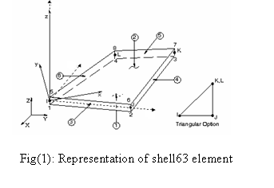
Uz
Uy
Ux

Ux

2.3 Mesh Generation and Boundary Conditions.
One of the most important steps in finite element analysis is how the model or structure is desicritzized into sub domain called elements. The processes called mesh generation. Number of elements have a significant effect in accuracy and time of processes. Therefore, some convergence studies should be induced to obtain the required numbers of element for covering the mesh processes. After these studies, it was noted that there are 25 and 30 elements for plate length and width, respectively.
Height of the stiffener is divided into seven segments, each one of them was meshed by two elements only in order to explain the dramatic changes in these regions. Therefore, fourteen elements along height of the stiffener were used for all case of stiffening and unstiffening in the stiffeners.
Figure(2) shows the proposed finite element model (stiffened plate without stiffening). ANSYS finite element package is used as a mathematical tool in the analysis of this model.
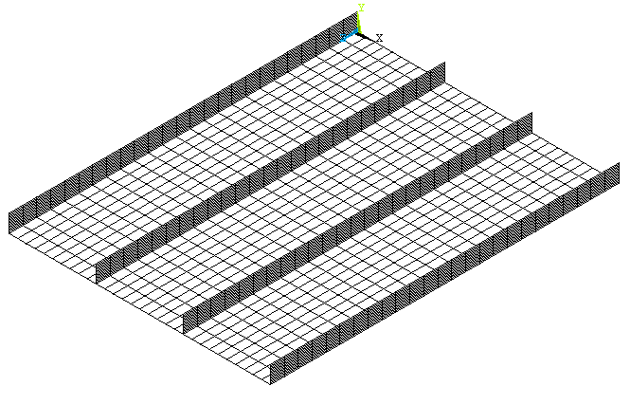
Fig(2): Finite elements modeling and boundary conditions.
a
Edge (n):All degree of freedom
equal zero
Edge (w):only uy
equal zero
Edge (e):only uy
equal zero
Edge (s):only ux and uy
equal zero

As showed obviously that each node of the elements have six degrees of freedom, then the boundary condition are related to them. The boundary conditions at each edge of the stiffened plate were also showed in Figure(2). The edges of the plate are assumed to be free to move in plane, but forced to remain straight. This restriction is imposed due to the effect of the neighboring plates that support the plate in a large structure. The boundary conditions was used as mentioned in Bukulum. Catia (2002).
2.4 Strain Displacement Relation.
The strain-displacement relationship can be written with its dependence explicitly expressed as, Singiresu S. Rao (2004).

(1)
Where is strain matrix, $\left[B\right]$ is strain- displacement matrix, and $\begin{matrix}\left\{q^{e}\right\}\end{matrix}$ is nodal displacement. All elements of strain–displacement matrix are derived in terms of the shape function derivatives and the Jacobian matrix.
2.5 Element Stiffness Matrix.
In general, the basic concept of the finite elements method is to discrete the continuum into a definite numbers of small elements connected together at their common nodes. Depending on the strain-displacement matrix,$\left[B\right]$, the element stiffness matrix can be written as; Singiresu S. Rao ( 2004),

$[k]^{e}=\int_{V}{[B]^{T}[E][B]\text{dV}}$ (2)

in which,
[K]^{e}: is the element stiffness matrix,
[E]: stress- strain matrix.
3.Buckling Analysis
Linear buckling analysis in Ansys finite-elements software is performed in two steps. The first step is a static solution in order to obtain the initial conditions as an initial values to start the iterative solutions and to calculate the prebuckling stress of the structure. The second step involves solving the iterative eigenvalue problem given in form of Equation (3). This equation takes into consideration the prebuckling stress effect matrix [S] calculated in the first step.
(3)
where $\left[k\right]=$stiffness matrix
$\left[s\right]=$Stress stiffness matrix
= ith eigenvalue (used to multiply the loads which generated [S])
=ith eigenvector of displacements.

Equation (3) represents eigenvalue and eigenvector problem so that eigenvalue is the critical buckling load and eigenvector is the corresponding mode shapes. Therefore, there are a numbers of equations equal to the numbers of degrees of freedom in the whole structure. (numbers of elements multiplies by numbers of degrees of freedom in one element). Due to the presence of a large numbers of degrees of freedom in the structure, there are a large numbers of corresponding mode shapes and the researcher can be concentrate on the more important of the mode shapes. The system of equations are solved using iterative procedure. The Block Lanczos algorithm is used to solve and extract the eigenvalue and corresponding eigenvectors resulting from equation (3). Block Lanczos is described in details by Bathe (1982), Lewis, et al (1994), and Raju Kumar and Rogers (1991). The buckling analysis was done to obtain the failure of buckled behavior for five modes under similar conditions. The critical buckling load of the model presents the more important index in the buckling analysis.
4.Geometrical Modeling
In general, the model is a stiffened plate with four stiffeners as shown in Fig(2). Two of them are on the edges and the other are equally space between them. The plate dimensions are 1.2m in length, 0.9m in width, and 3mm in thickness. Stiffeners of 3mm in thickness and 60mm in height. The idea is to make a stiffening in the stiffener itself by three types. They are: quadrilateral, circular, and triangular, respectively depending on the shape of stiffened stiffener itself. Figures(3, 4, and 5) represent quadrilateral, triangular, and circular stiffening types, respectively. There are three main type of stiffening indices; Quadstiff for quadrilateral, Tristiff for triangular, and Circlstiff for circular. Each one of them also have contain five submodels they are (Quadstiff1, Quadstiff2, Quadstiff3, Quadstiff4, and Quadstiff5), (Tristiff1, Tristiff2, Tristiff3, Tristiff4, and Tristiff5), and (Circlstiff1, Circlstiff2, Circlstiff3, Circlstiff4, and Circlstiff5) for quadrilateral, triangular, and circular stiffening, respectively. Nostiff means there aren't stiffening through the stiffeners (flat plate stiffeners).

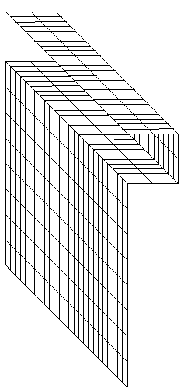
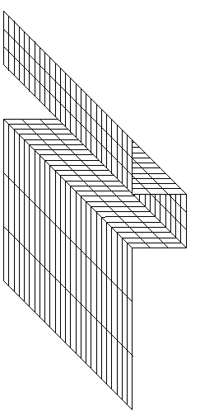
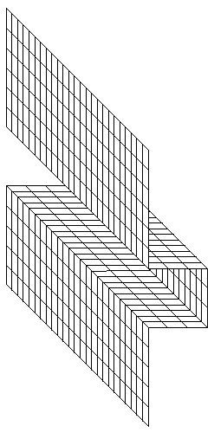
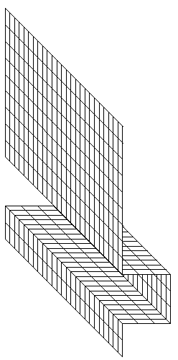
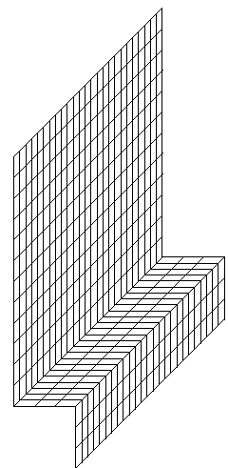
Q2
a) Quadstiff1 b) Quadstiff2 c) Quadstiff3 d) Quadstiff4 e) Quadstiff5

Fig.(3): Presents Quadrilateral submodels
Q1
Q3
q

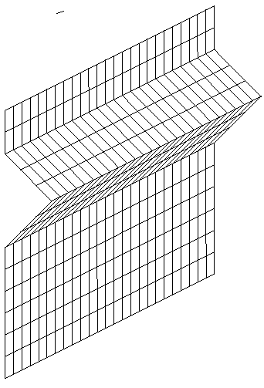
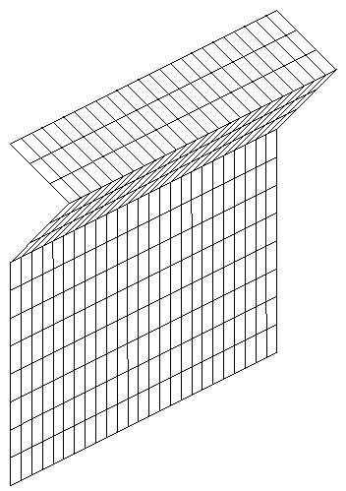
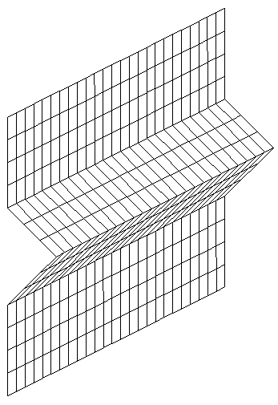
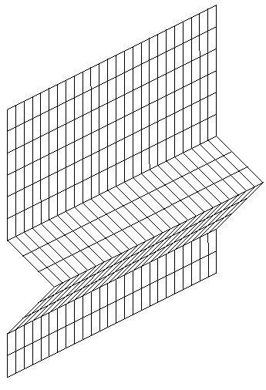
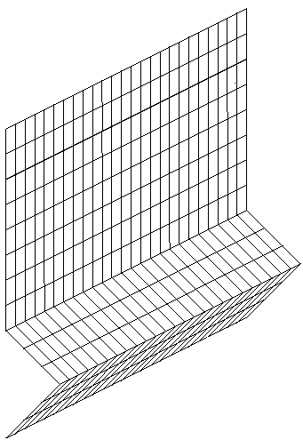
a) Tristiff1 b) Tristiff2 c) Tristiff3 d) Tristiff4 e) Tristiff5

Fig.(4): Presents triangular submodels.

T2
T1

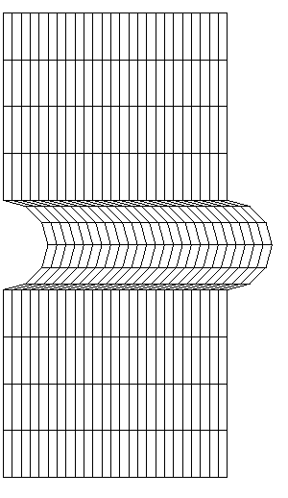
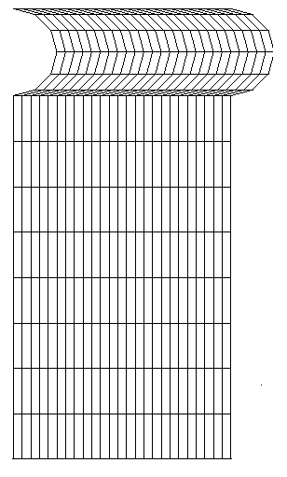
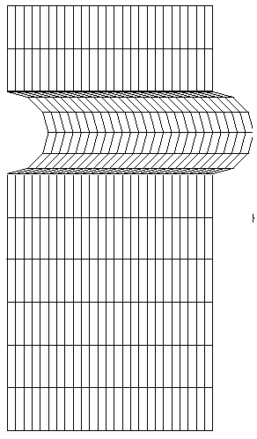
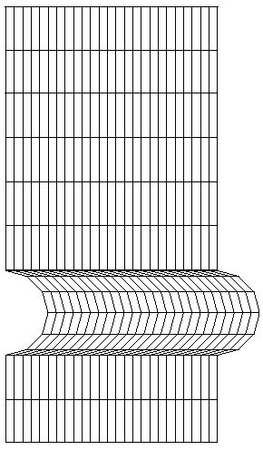
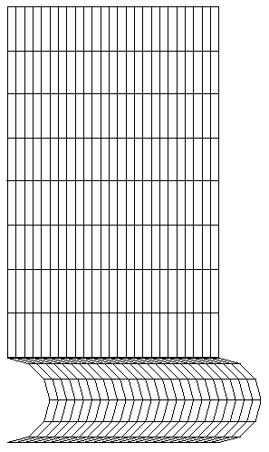
a) Circlstiff1 b) Circlstiff2 c) Circlstiff3 d) Circlstiff4 e) Circlstiff5

Fig.(5): Presents circular submodels.

The stiffeners are divided into five sections. When the stiffening occurs at the upper section, the submodel index is Quadstiff1, Tristiff1, and Circlstiff1. Numbers in the indices of the submodels represent the locations of the stiffening. As example, Quadstiff5 represents quadrilateral stiffening type at section number 5 (lower section). Its important to refer that the surface area of the stiffener remain constant for the three types of stiffening as compared with Nostiff in order to make the comparisons between the results.

5. Results and Discussion
Due to the large numbers of models and sub models, the concentration will be on the most important results which the researcher believed to give an excellent explanations about the nature of the structural behaviors in each case study before and after stiffening additions.
5.1 Critical buckling loads
Magnitude of compressive load at which the structure becomes unstable is called the “critical buckling load”. Buckling load represents an important parameters and may be the governor in the buckling analysis. Table (1) shows buckling loads for different types of models and submodels of stiffened plates for five modes.

Firstly, its important to refer that values of buckling loads in case of unstiffened plate (Nostiff) for all five modes are smaller than that corresponding in the other models and submodels of stiffened stiffeners. So that the maximum value of the buckling loads in that correspond to the fifth mode of unstiffened stiffeners case is (3.456kN) is smaller than a minimum buckling load in circlstiff5 (represents the worst type of stiffening) (3.86kN). The previous comparison gives good explanation about the importance and effectiveness of the changing in the stiffeners shape or geometry in increasing the stiffness and thereby buckling load.
Buckling analysis was induced for five modes and the buckling load are obtained at each buckling mode. There is no doubt that the values of the buckling loads are increases with the increasing of mode number due to the complexity in the deformations which corresponds to greater stiffness and hence greater buckling load.
From the results also tabulated in Table (1), it was noted that values of buckling loads for each type of stiffening (quadrilateral, triangular, and circular) are differ one each other; which means that buckling loads are different depending on the stiffening type. On the other hand, buckling loads are also differ for the same type of stiffening depending on the changing in the stiffening location (or stiffening section) for all types. Quadrilateral stiffening gives the best results (maximum buckling loads) and greater than that corresponding to triangular and circular types for all modes as showed in Table (1). Now, what's are the important reasons which made the quadrilateral stiffening types stronger than (higher buckling loads) that corresponding to triangular and circular.
are three areas; numbered as Q1, Q2, and Q3 (for all quadrilateral submodels), respectively as shown in Figure(3a). Two of these areas, A1 and A3 are parallel to x-z plane; thereby, increase the stiffness of the stiffeners against ux and uz (displacement in x and z directions, respectively). Therefore, the increasing in the stiffness means an increasing in the buckling loads which required to buckle the stiffeners out of its plane. While Q2 offers little contributions in the stiffness but play an important rule in support Q1 and Q3 (indirect contribution in the stiffness).
The difference in the triangular stiffening is that there are only two areas T1 and T2, aren’t parallel to x-z plane (out of plane of stiffeners) but inclined by 45 degrees with x-axis. Inclination of these areas means that a part only (not all) of those areas will contribute in increase the stiffness of the stiffeners against buckling in x-direction because the projected areas of T1 and T2 that corresponding to Q1 and Q3 in quadrilateral types are smaller. A little contributions due to the curvature profile of the circular types which made the effective area is smaller.
Secondly, the dimensions of the different types of the stiffening; q, t, and r (represent the distance from the points of load application to stiffeners plane (y-z axes) for quad, tri, and circle, respectively are showed in Appendix A. These dimensions have a great effects on the buckling loads because what is called (in this paper) by Reverse Effect. Reverse effect means that the applied loads on the edges of the plate and stiffeners play really a great role in reduces deformations and displacement in x-direction (ux) by moments which results from effect of the applied loads at a distance q, t, and r for quadrilateral, triangular, and circular stiffening, respectively.
Distances q₀,q_{1,} and q₂ for quadrilateral; t₀, t_{1,} and t₂ for triangular; c_{0,} c_{1,} and c₂ for circular are illustrated in Appendix (A). The presence of these dimensions is simply means that applied forces tend to create a reverse moment to reduce the value of displacement in x-direction (ux). Maximum reverse moment occurs at quadrilateral type because the contribution of force there and dimensions in quadrilateral is greater than that corresponding in triangular and circular, respectively, as showed in Appendix (A). Thereby, maximum reverse effect in the first type. Its important to refer that the reverse effect is another guide added to the first one to verify the results that obtained.
One of the more important parameters by which the structure or stiffeners is said to be buckle are the deflections. Specially, in x-directions (which represents out of plane of the stiffeners ); therefore the concentrations will be on deformation in x direction.
Figures (6) and (7) show displacement in x-direction (ux) of unstiffened stiffener (No stiffened). The first is a body contour and the second is graphical along path parallel to y-axis. Its clear that the maximum displacements in x-direction (ux) for all modes occur at the free ends of the stiffeners ( locations of minimum normal and bending stiffness, respectively). This result is agreed with Paik, Jeom Kee, et al. From Fig(7), its clear that maximum values of (ux) displacement occurs approximately at a distance (60-100%) of stiffeners height (near the free ends). Therefore, the controlling on this regions of maximum displacements (minimum stiffness) by addition a stiffening there leads to increase the stiffness there, thereby, required buckling loads.
Therefore; when the stiffening in stiffeners is directly designed to be exactly in same locations at which the maximum displacement (minimum stiffness) is occur, the structure offers more stronger than that corresponding for other locations (or stiffener sections). Again, a distance of minimum stiffness and maximum displacement occurs at section number one and two (sections of maximum dramatic changes and maximum value of ∆(ux)/∆(h/H); therefore, one can easily notice that why the maximum buckling loads in Table (1) occur at Quadstiff2, Tristiff2, and Circlstiff2, respectively.

5.2 Deflections
Again, due to the large numbers of results obtained under considerations and due to importance of displacement in x-direction (ux), the concentration will be on these displacements. Also the results were offered only for the models of maximum buckling loads; they are: Quadstiff2, Tristiff2, and Circlstiff2 for quadrilateral, triangular, and circular stiffening, respectively.
Figures (8, 9, and 10) present ux for Quadstiff2, Tristiff2 , and Circlstiff2, respectively. Firstly, one can notice that there is a great different in the structural response for all modes between these submodels and Nostiff case. The common between all types of stiffening is that the maximum displacement in x-direction (ux) occurs at the upper of the stiffeners for all modes which is basically due to the maximum distance from the root of the stiffeners. But, the difference is locations of the maximum displacement (ux) along the stiffeners direction (z- axis). There are a clear difference in types of deformations or the structural behavior from model to other.
It is important to note that the deformations in the quadrilateral type of the stiffening is less than in nature that corresponding in triangular and circular types in first and second modes. For the third and the fourth modes, the deformations are similar in quadrilateral and Triangular types due to the closeness in their stiffness and buckling loads as showed from Table(1) but circular type is different. The deformation induced in the plate is greater regards to the circular than triangular and quadrilateral stiffening type, respectively.

The deformations in circular stiffeners are closed in its nature and behavior from that corresponding of no stiffening type (Nostiff) and this leads to the same conclusion of minimum stiffness ( a closeness in the their stiffness). On the other hand, its noted that the changing in the stiffeners shape (keeping the same thickness and length of the stiffeners) doesn’t lead to increase the buckling load only, but to convert the structural behaviors for each modes as showed in figures related with stiffened stiffeners (models and submodels) and unstiffened stiffeners. Also its noted that the connection between the stiffeners and the plate does not displace vertically, this result noticed also by Paik, Jeom Kee, et al.

Conclusions:
At end of the research, its severe important to mention some conclusions excluded from the results showed previously. Therefore, some conclusions can be drawn from results Stiffening type, configuration, location, and dimensions play an important roles in assessment the stiffness of the stiffened structure. So that the location of stiffening is so important during the design as shown in Quadstiff2 and Tristiff2, and Circlstiff2 at section number two of maximum buckling loads.
Table(1): presents models and submodels under study and their corresponding
buckling loads for five modes.

Model index | Buckling loads at different modes in (kN)
Model index | 1st mode | 2nd mode | 3rd mode | 4th mode | 5th mode
Quadstiff1 | 4.61 | 4.709 | 5.135 | 5.15 | 5.252
Quadstiff2 | 4.663 | 4.75 | 5.182 | 5.238 | 5.306
Quadstiff3 | 4.471 | 4.583 | 4.983 | 5.062 | 5.226
Quadstiff4 | 4.431 | 4.568 | 4.793 | 5.06 | 5.121
Quadstiff5 | 4.317 | 4.37 | 4.633 | 4.98 | 5.09
 | 1st mode | 2nd mode | 3rd mode | 4th mode | 5th mode
Tristiff1 | 4.55 | 4.642 | 5.037 | 5.13 | 5.178
Tristiff2 | 4.633 | 4.722 | 5.147 | 5.253 | 5.26
Tristiff3 | 4.612 | 4.71 | 5.12 | 5.15 | 5.17
Tristiff4 | 4.55 | 4.613 | 4.958 | 5.025 | 5.1
Tristiff5 | 4.318 | 4.43 | 4.77 | 4.98 | 5.03
 | 1st mode | 2nd mode | 3rd mode | 4th mode | 5th mode
Circlstiff1 | 3.93 | 4.03 | 4.37 | 4.653 | 4.663
Circlstiff2 | 3.98 | 4.175 | 4.475 | 4.754 | 4.9
Circlstiff3 | 3.9 | 3.92 | 4.301 | 4.53 | 4.607
Circlstiff4 | 3.88 | 3.90 | 4.257 | 4.454 | 4.562
Circlstiff5 | 3.86 | 3.84 | 4.23 | 4.349 | 4.52
Nostiff | 2.826 | 3.055 | 3.245 | 3.29 | 3.456

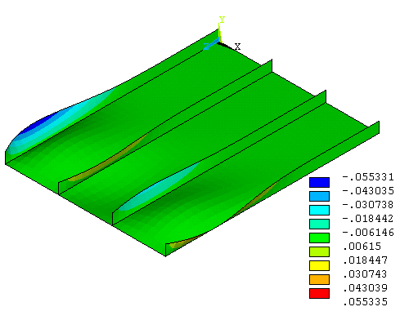
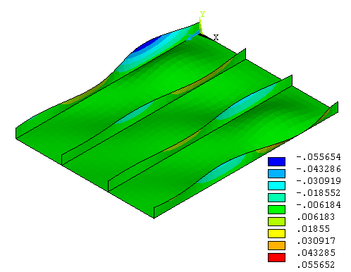
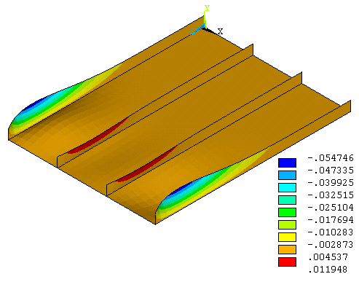
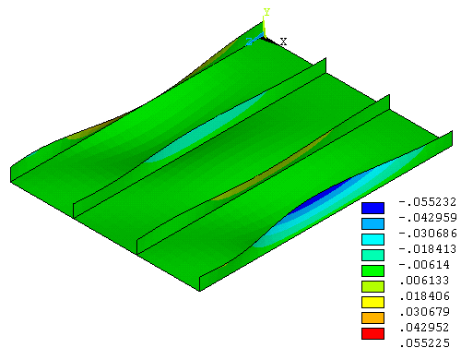
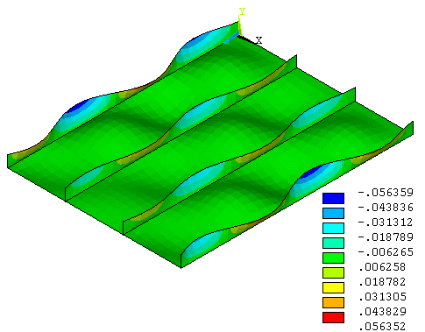
a) First modes
c) Third mode
b) Second mode
d) Fourth mode
e) Fifth mode
Fig(6a): presents displacement in x-direction (ux) for five modes
of unstiffened stiffener (No stiffening).

Fig(6b): presents displacement in x-direction (ux) for three modes
of unstiffened stiffener (No stiffening). h/H is dimensionless ratio along height of stiffener
h/H
Ux (m)

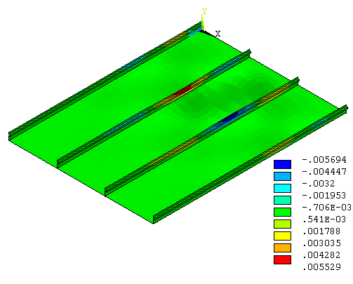
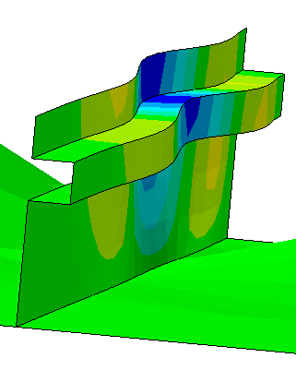
Fig(7a):Buckled shape of the 1st mode for Quadstiff2 stiffener
and whole geometry.

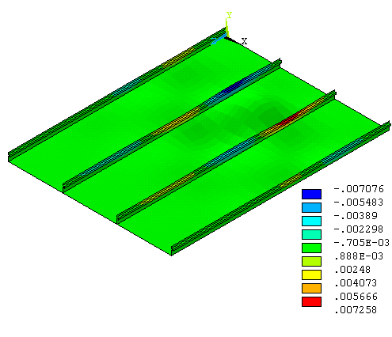
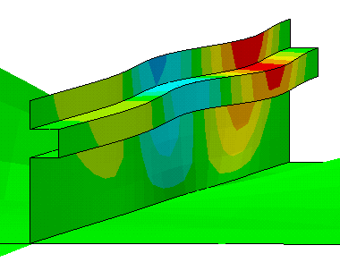
Fig(7b):Buckled shape of the 2nd mode for Quadstiff2 stiffener
and whole geometry.

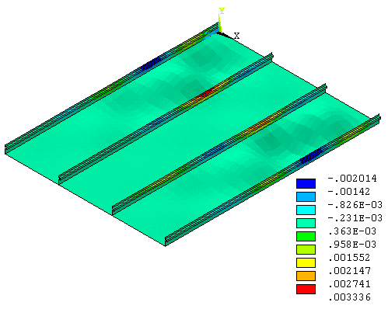
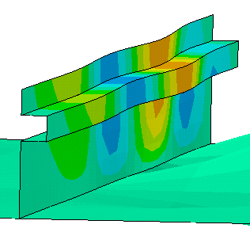
Fig(7c):Buckled shape of the 3rd mode for Quadstiff2 stiffener
and whole geometry.

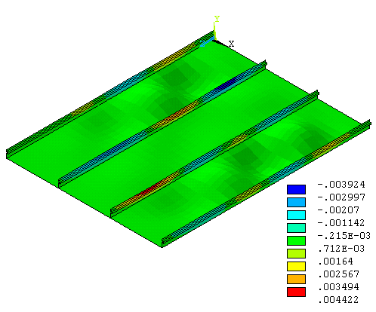
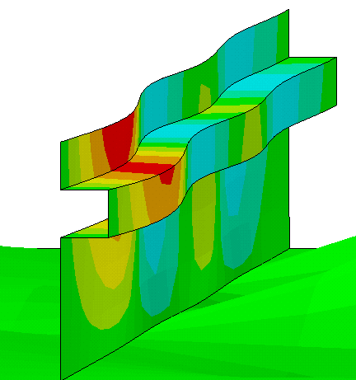
Fig(7d):Buckled shape of the 4th mode for Quadstiff2 stiffener and whole geometry.

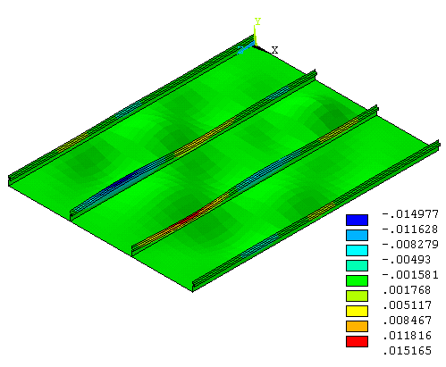
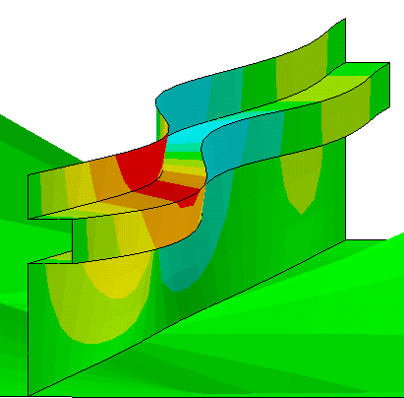
Fig(7e):Buckled shape of the 5th mode for Quadstiff2 stiffener
and whole geometry.

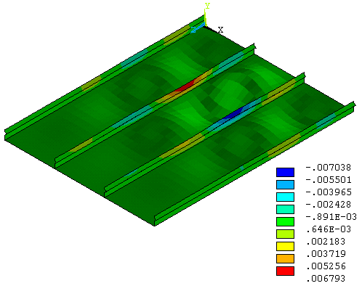
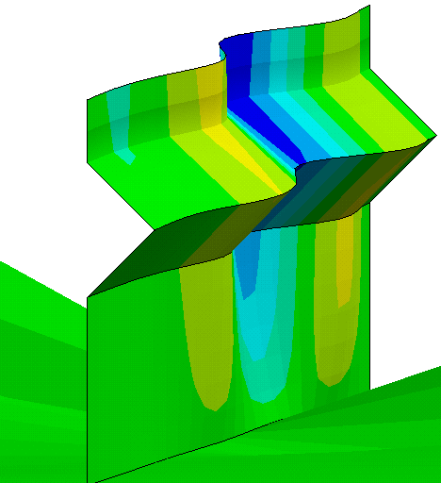
Fig(8a):Buckled shape of the 1st mode for Tristiff2 stiffener
and whole geometry.

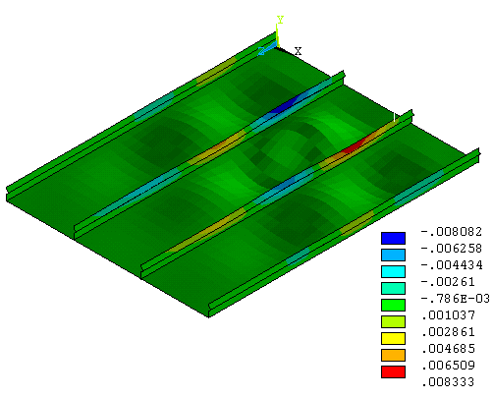
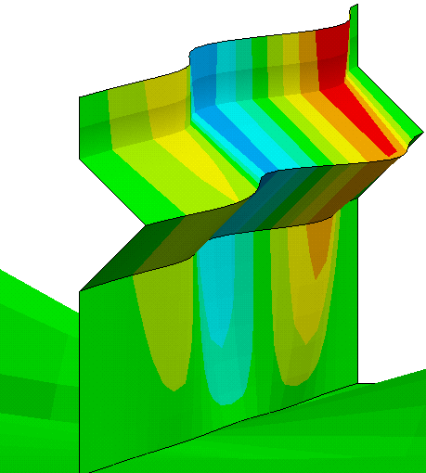
Fig(8b):Buckled shape of the 2nd mode for Tristiff2 stiffener and whole geometry.

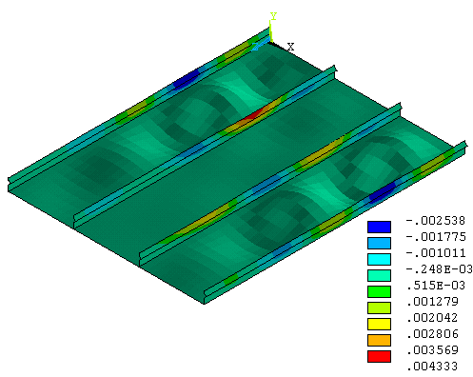
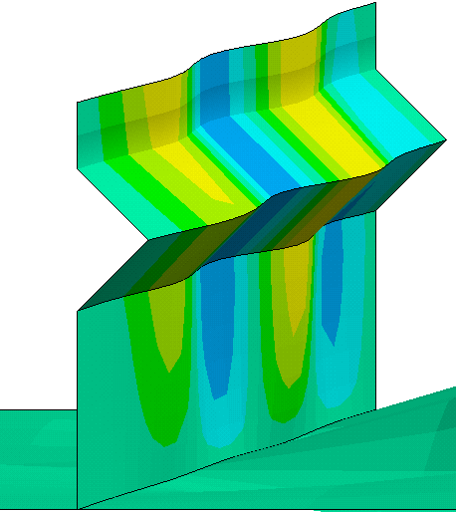
Fig(8c):Buckled shape of the 3rd mode for Tristiff2 stiffener and whole geometry.

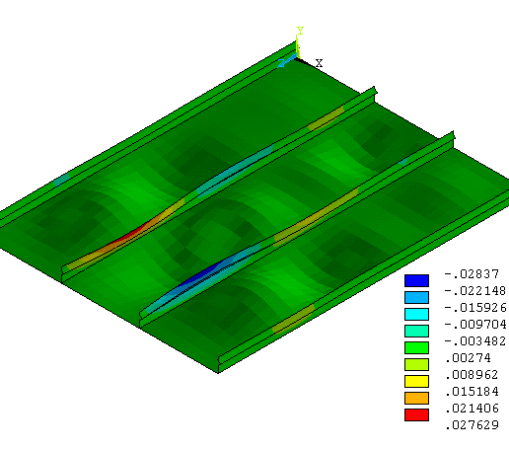
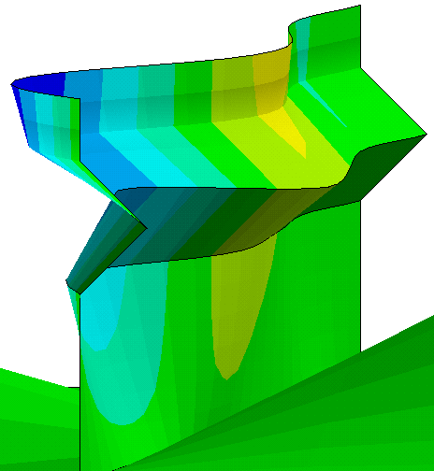
Fig(8d):Buckled shape of the 4th mode for Tristiff2 stiffener and whole geometry.

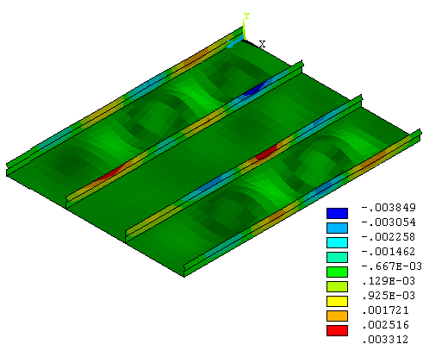
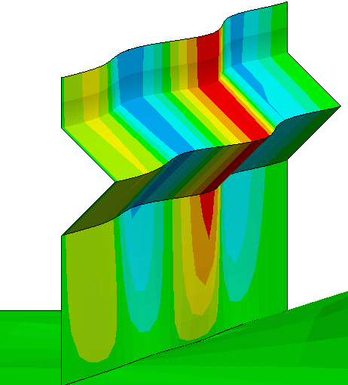
Fig(8e):Buckled shape of the 5th mode for Tristiff2 stiffener and whole geometry.

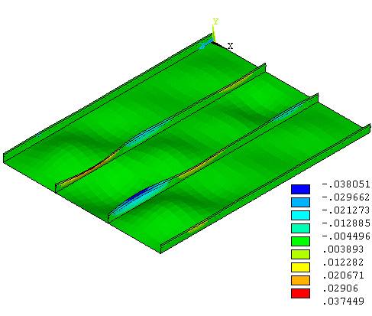
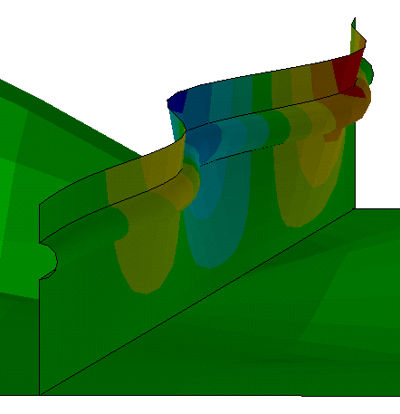
Fig(9a):Buckled shape of the 1st mode for Circlstiff2 stiffener and whole geometry.

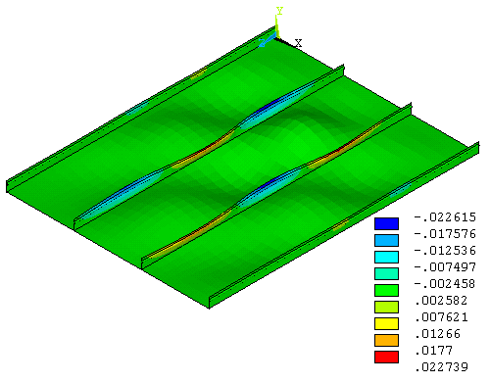
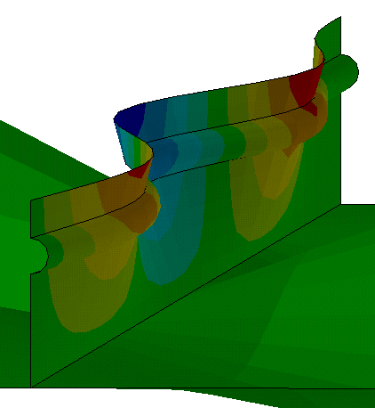
Fig(9b):Buckled shape of the 2nd mode for Tristiff2 stiffener and whole geometry.

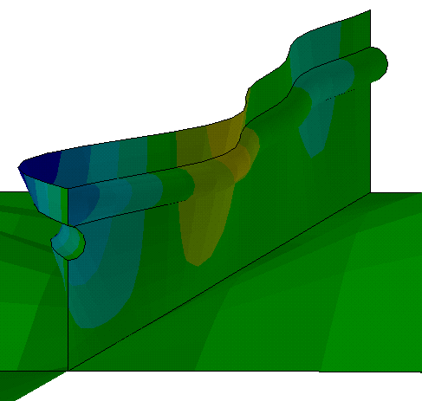
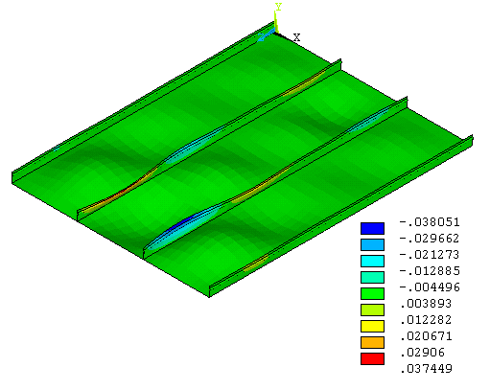
Fig(9c):Buckled shape of the 3rd mode for Tristiff2 stiffener and whole geometry.

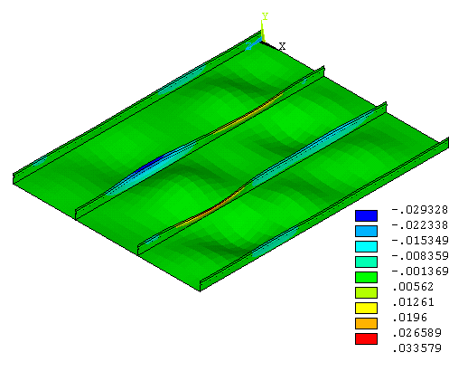
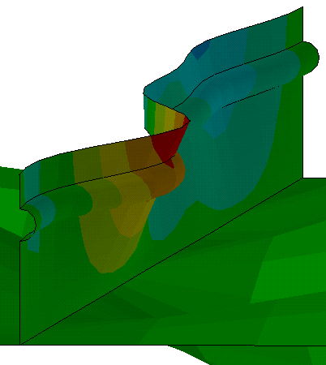
Fig(9d):Buckled shape of the 4th mode for Tristiff2 stiffener and whole geometry.

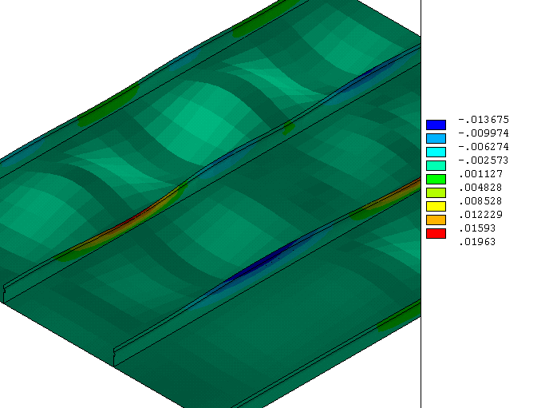
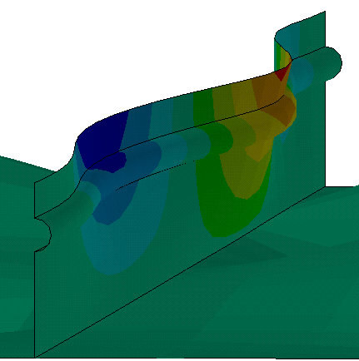
Fig(9e):Buckled shape of the F^{th} mode for Tristiff2 stiffener and whole geometry.

Appendix (A):
Appendix (A) gives some details about the dimensions of the stiffening geometry. Fig(A1) represents these dimensions at each type of stiffening.

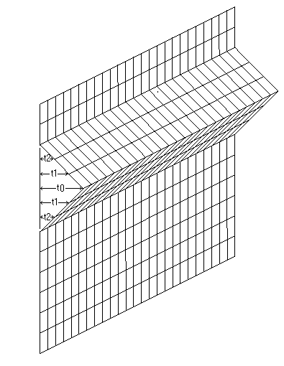
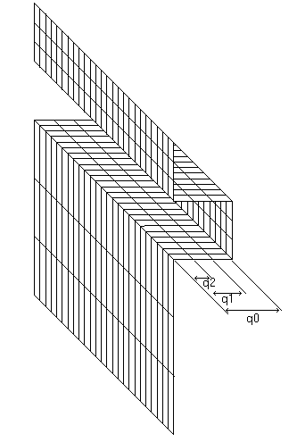
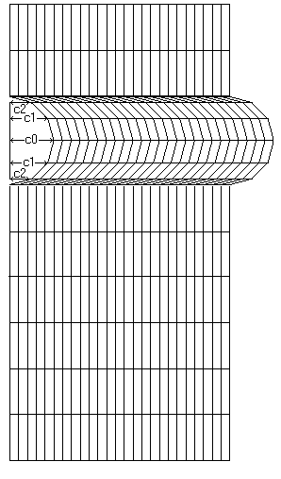
(a)
(a)
(b)
Fig(A1):presents dimensions of stiffeners.

Simply, the reverse moment about a specific plane can be obtain (from classical strength of material theory) by a force multiply by the distance from its locations to the specified plane. Therefore, the reverse moment can be describe as,
$M_{r}=\sum_{i=0}^{n}{\text{fi}}∗d_{i}$,
where i =0 to 2 for all types of stiffening and d_{i} is the distance between force and the plane. This means that the reverse moment for quadrilateral is

$$M_{r}=f_{0}∗q_{0}+f_{1}∗q_{1}+f_{2}∗q_{2}$$
For triangular is,
$$M_{r}=f_{0}∗t_{0}+t_{1}∗q_{1}+t_{2}∗q_{2}$$
And for circular is,
$$M_{r}=f_{0}∗c_{0}+f_{1}∗c_{1}+f_{2}∗c_{2}$$
Using simple mathematical processes to obtain the values of the moment showed obviously in above equation and for same magnitude of force on all types of stiffening. Dimensions of stiffening geometry are showed in Table (A1).
Table (A1): presents dimensions of stiffening geometry.
Dimensions of stiffening geometry (m)QuadrilateralTriangularCircular

The moments are (6*q₀*f), (3*t₀*f), and ((1+(3)^{1/2})*c₀*f) for quadrilateral, triangular, and circular stiffening type. One can notice that value of moment is maximum in quadrilateral and less in triangular and circular.

References
Aalberg, A., Langseth, M. and Larsen, P.K., " Stiffened Aluminum Panels Subjected to Axial Compression. Thin-Walled Structures, Vol.39, pp.861-885, 2001.
ANSYS^{R}, Engineering Analysis System Theoretical Manual, “Http:\\ www. Ansys. Com”, Ansys Version 5.4, 1998.
Bathe, K. J., "Finite Element Procedures in Engineering Analysis", Prentice- Hall, Englewood Cliffs (1982).
Bycolem Youshita, "Nonlinear buckling analysis and ultimate strength prediction of stiffened steel and aluminum panels", paper, the second international conference on advance in structural engineering and mechanics, Busan, Korea, August 21-23, 2002.
Gabor M. Voros, " Buckling and vibration of stiffened plates", International Review of Mechanical Engineering (I.RE.M.E.), Vol. 1, n. 1, 2007.
Hopperstad, O.S., Langseth, M. and Hanssen, L ,"Ultimate Compressive Strength of Plate Elements in Aluminum: Correlation of Finite Element Analyses and Tests. Thin-Walled Structures, Vol. 29, pp.31-46, 1998.
Hopperstad, O.S., Langseth, M. and Tryland, T, "Ultimate Strength of Aluminum Alloy Outstands in Compression: Experiments and Simplified Analyses. Thin-Walled Structures, Vol. 34, pp. 279-294. 1999.
Jone, R. G., Lewis. G, J., and Simon. H. D., " A Shifting Block Lanczos Algorithm for Solving Spare Symmetric Generalized Eigenproblems", standard matrix analysis applications, vol. 15, pp.228-272 (1994).
Matsuoka, K., Tanaka, Y. and Fujita, Y, "Buckling Strength of Lightened Aluminum Hull Structures. Proceedings of INALCO’98, International Conference on Aluminum Structural Design, Cambridge, UK, April 15-17, (1998).
Paik, Jeom Kee, et al." Mechanical Collapse Testing on Aluminum Stiffened Plate Structures for Marine Applications". 10th International Symposium on Practical Design of Ships and Other Floating Structures Houston, Texas, United States of America,© 2007 American Bureau of Shipping.
Rajakumar, C. and Rogers, C, R., " The Lanczos Algorithm Applied to Unsymmetrical Generalized Eigenvalue Problems, International Journal for Numerical Method in Engineering, vol. 32, pp. 1009-1026 (1991).
Singiresu S. Rao, " The Finite Element Method in Engineering", Fourth Edition, Elsevier Science & Technology Books, December 2004.
Tanaka, Y. and Matsuoka, K, "Buckling Strength of Lightened Aluminum Hull Structures. Proceedings of the 7th International Offshore and Polar Engineering Conference, Vol.4, Honolulu, pp.790-797, 1997.
Umur Yuceoglu, Özen GÜvendik, Nihat Gemalmayan, and Orkun Sunar, "Effects of Central and Non-Central Plate Stiffener on Free Vibrations Response of Integrally-Stiffened and/or Stepped-Thickness Plates or Panels”. 49th AIAA/ASME/ASCE/AHS/ASC, Structural Dynamics and Materials Conference, 7 - 10 April, 2008.
Zha, Y. and Moan, T, "Experimental and Numerical Collapse Prediction of Flat Bar Stiffeners in Aluminum Panels. Journal of Structural Engineering, Vol.129, No.2, pp.160-168, 2003.
Zha, Y. and Moan, T, "Ultimate strength of Stiffened Aluminum Panels with Predominantly Torsional Failure Modes. Thin-Walled Structures, Vol.39, No.8, pp.631-648, 2001.
Zha, Y., Moan, T. and Hanken, E. "Experimental and Numerical Studies of Torsional Buckling of Stiffener in Aluminum Panels. Proceedings of the 8th International Offshore and Polar Engineering Conference", Seattle, pp.249-255, 2000.

