Imperforate Anus
A prospective study to 60 cases repaired by posterior sagittal ano rectoplasty (PSARP) in the Maternity and Children Teaching Hospital /Al-Qadisiya .

Mohammed J. Aboud
The Maternity and Child Teaching Hospital,Al-Qadisiya
Abstract
A prospective study of 60 cases of congenital gastro-intestinal obstruction were collected from the pediatric surgical words of The Maternity and Child Teaching Hospital, Al-Qadisiya-Al- Diwaniya ,in the period from the 1st of July 2004 to the end of June 2008 . 49 males ( 81.6% ) and 11 ( 18.3%) females, of mean age 16.5 months were evaluated. Early postoperative, stenosis of neoanus developed in 6 patients (10%) , 5 (8.3%) with mucosal prolapse, 3 (5%) patients developed recurrence of fistula (3 boys had a rectourethral fistula were repaired with the redo PSARP and urethroplasty) The most frequent bowel function post of complications were soiling 11 (18.3%), constipation 9 (15%), and fecal incontinence 4 (6.6%). Total continence was present in 36 (60%) of the patients after PSARP. Patients referred to the pediatric surgery unit were diagnosed and treated according to the stage their management had reached. Patients with a colostomy and a high lesion were managed by a PSARP and those with failed previous surgery were managed with a redo anorectoplasty .
الخلاصة
تمت دراسة ستون حالة انعدام فتحة الشرج, أدخلت الى وحدة جراحة الأطفال في مستشفى النسائية والأطفال التعليمي في محافظة القادسية للفترة الأول من تموز 2004 م الى نهاية حزيران 2008 م. اجريت لها عملية تصنيع فتحة الشرج وسحب المستقيم بطريقة القطع الخلفي للحوض وتجميل الشرج والمستقيم (طريقة بينا ودي فراي) , 49 (81.6%) ذكور و11 (18.3%) اناث وكانت معدل أعمارهم حين إجراء هذا التداخل الجراحي 16.6 شهر . تمت متابعة المرضى بعد اجراء توسيع فتحة الشرج الأولي بعد 10-14 يوم من العملية ووثقت جميع المضاعفات المبكرة والمتأخرة (المعوية ومضاعفات المجاري البولية) وتم تحليل ودراسة نتائجها. وجد أن 27 (45%) مريض كانوا يعانون من تشوهات خلقية اخرى مصاحبة لتشوه الشرج . شكل هطول الغشاء المخاطي للمجمع , تضيق فتحة الشرج , ناسور الاحليل وتلوث فتحة الشرج من المضاعفات المهمة والتي كان من الضروري إعادة التداخل الجراحي لعلاج بعض هذه المضاعفات .
Introduction
Perhaps the first cases of neonatal intestinal obstruction recognized and documented were those of imperforate anus and other anorectal anomalies. These have always aroused feeling of horror. This is well expressed on a stone slab from the library of King Assurpanipal of Nineveh (Swenson's, 1990) .
When a women bears a child whose anus is closed, then the whole land will suffer from the want of the food.
An anorectal malformation is a birth defect that affects the development of the anus, the urinary system and/or the sexual structures. This malformation can also be associated with defects of the spine, esophagus, trachea, kidneys, heart or limbs. They occur in 1 out of 4000 newborns.
Amuset successfully freed the bowel, in cases of high imperforate anus, and sutured it to the skin in 1835. A colostomy was suggested by Litter in 1710, but was not successfully performed in an infant until 1793 (Al-Rawi, 2002).
Posterior sagittal anorectoplasty PSARP is the newest and most-widely-used technique for correction of anorectal malformations (ARMs). The PSARP, popularized by de Vries and Peña and has become the preferred technique for surgical management of anorectal malformations (ARMs) (deVries, 1982). The PSARP involves incision from coccyx to perineal body, to widely expose the external sphincter, the levators, the rectum, and distal fistula to facilitate surgical repair. Dividing the sphincter posteriorly can affect the pudendal nerve and its terminal branches to the sphincter in these patients, who already may be having widespread lumbar and sacral lesions(Yuan et al., 2002). The general adoption of Pena's PSARP for high and intermediate lesions has increased the accuracy of the classification and simplified the correction of high and intermediate lesions. Despite excellent exposure of the anatomy and exact placement of the distal rectum within the muscle complex, continence often is less than ideal(Pena, 1988; Pena et al., 1998). In the present investigation, the functional outcomes of PSARP and the complications have been studied.
Patients and Methods
A prospective study include 60 cases of congenital gastro-intestinal obstruction at the pediatric surgical words of The Maternity and Child Teaching Hospital, Al-Qadisiya-Al-Diwaniya ,in the period from the 1st of July 2004 to the end of June 2008. 49 males (81.6%) and 11 (18.3%) females, of mean age 16.5 months . It should be mentioned that for the purpose of our survey high and intermediate type of imperforate anus were grouped together (wingspread classification) figure (1) (Stephens et al, 1988). Only cases needing operative (posterior sagittal anorectoplasty) treatment were considered. All cases of cloaca , deaths or transferred to other departments were excluded from the study. All recorded cases were evaluated by a full history and clinical examination, laboratory assessment, radiological examination, ultrasound study, echocardiogram and other studies as appropriate to confirm and gives a better evaluation and diagnosis of the pathology or other associated anomalies. Appropriate management of each cases was done. All of the patients with high-type anomalies, underwent a divided loop high sigmoid colostomy via a curved incision in the left lower quadrant with tapering of the distal stoma. Children with intermediate or high malformations were preferably given colostomy and a colostogram was performed to determine the nature and location of any fistula where present, prior to repair. All the patients had bowel washout via the stoma ,their dehydration and electrolyte imbalance was corrected , prophylactic broad-spectrum antibiotics were given preoperatively and blood was prepared prior to surgery .
While performing a thorough evaluation to rule out the associated urogenital, cardiovascular, skeletal, and vertebral anomalies, For objective evaluation of the sacrum, the SR was calculated in all of the patients The transverse lines are drawn across the uppermost portion of iliac crests, line A, posterior inferior iliac spines(PIIS), line B, and the lowermost radiologically visible point of sacrum , line C (SR = the ratio of distance BC : AB ).In 100 normal children at the author's institution the ratio of the distance BC:AB was 0.7-0.8. children with anorectal malformation suffer from different degrees of sacral hypodevelopment with the ratio varying between 0 and 0.18. In author's experience ratio less than 0.4 usually signifies a poor functional prognosis (Lewis et al., 1995). And then under optimal conditions the patients underwent PSARP. Figure (2) shows the SR of a pelvis in an anteroposterior (AP) film. The area of maximal sphincter contraction was identified preoperatively and under light anesthesia , by stimulation with pin prick or digital stimulation. During the operation, the muscle fibers were identified visually and by low current diathermy, as there was no muscle stimulator available. Identified muscle groups are marked with sutures on either side of the posterior sagittal incision.
Postoperative dilatation was commenced 10-14 days postoperatively, provided wound healing had occurred and continued daily, until the colostomy is closed. The patient is only discharged after the anus can accept the maternal little finger. Thereafter, it is continued in the outpatient basis by the mothers. During the clinic, the mothers are asked about the daily bowel habit, including the presence of soiling and straining. The complications of the procedure, as well as the anatomic and functional outcome in term of bowel motion as obtained from the mothers at follow up clinics, were noted.
All records of the cases were reviewed and the early and late postoperative complications (urologic and gastrointestinal) were assessed during the follow-up visits. The three parameters of bowel function used in this study were: 1- voluntary bowel movements (VBMs), 2- soiling, and 3- constipation. Also, the relationship between SR and functional complications was evaluated .The duration of follow-up was from 1 month to 3 years.
Of the total children were underwent PSARP, 8 (13.3%) children had a redo procedure, 2 of whom had a second operation , which were needed because of the failure of postoperative management after their first PSARP. One of these was for failure to carry out the postoperative dilatations and 2 were due to poorly controlled constipation in the postoperative period. The indication for redo PSARP included stenosis, rectourethral fistula, megarectum and malposition of the anorectum in relationship to the muscle complex and levator muscle. Of the 8 patients who had redo surgery, 3 boys had a rectourethral fistula were repaired with the redo PSARP and urethroplasty.

Figure- 2 - Classification of anorectal malformations 1984 (Wingspread classification).

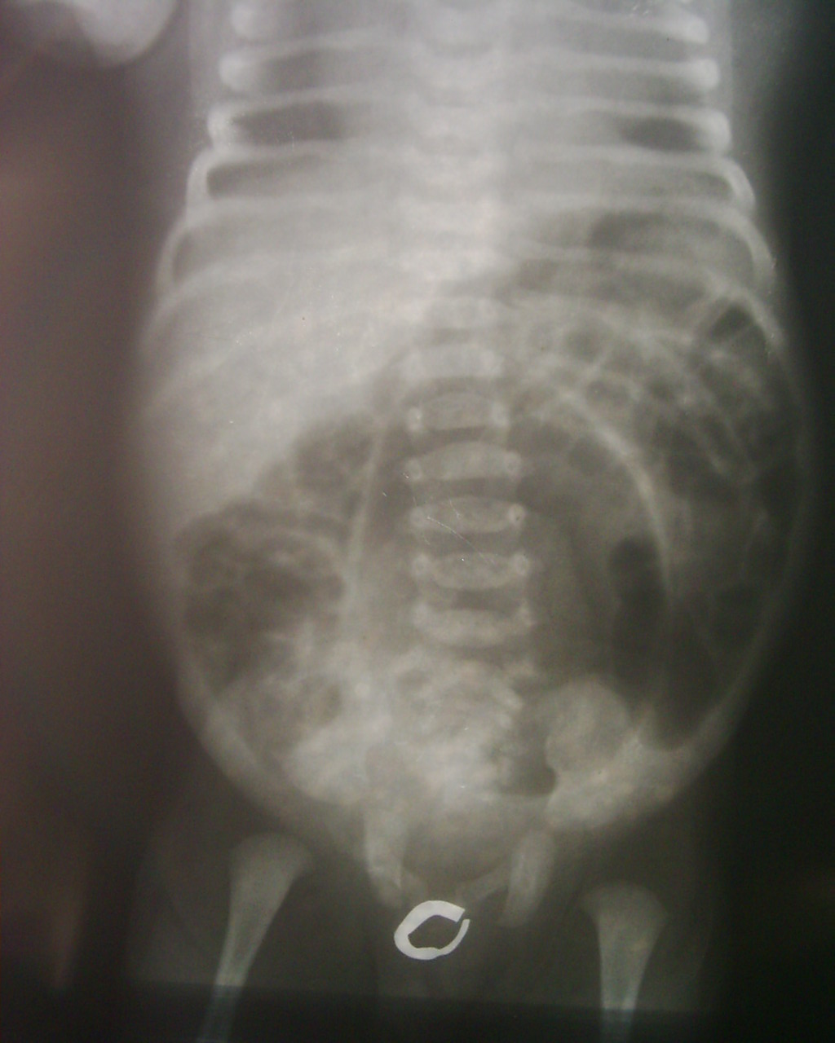

A ------------------------------------------------------------- ---- Iliac crest.
B------------------------------------------------------------- -- - PIIS.
C ------------------------------------------------ -----------------Tip of sacrum.

Figure -2- Sacral ratio in the AP view. The transverse lines are drawn across the uppermost portion of iliac crests, line A, posterior inferior iliac spines(PIIS), line B, and the lowermost radiologically visible point of sacrum , line C (SR = the ratio of distance BC : AB ).

Results
Sixty children had the posterior sagittal anorectoplasty (PSARP) for high and intermediate anorectal malformations, during the study period. There were 49 males and 11 females (male: female ration 4.4: 1.3). The mean age at presentation was 16.5 month . The types of anorectal malformations at presentation, are as shown in table (1). Four of the patients with high type malformation had flat perineum, suggesting a possibility of incontinence, postoperatively. Gross associated malformations were seen in 27(45%) patients, and are as shown in table (2). Three of the patients had suspected VATER'S association .
The most frequent associated anomalies were, in order of frequency, urogenital, cardiovascular, skeletal, and gastrointestinal defects. During PSARP no injury to the ureters, vas deferens, with one case the urethra was injured and the patient now on tube cystostomy. Early postoperatively, stenosis of neoanus developed in 6 patients (10%) which were treated by dilatation in 4 cases, cutback appeared in another one, and redo PSARP in other patient. Four patients developed wound infection, 5 mucosal prolapse, One had wound dehiscence .Among postoperative urologic complications, 3 patients developed recurrence of fistula (3 boys had a rectourethral fistula were repaired with the redo PSARP and urethroplasty), neurovesical disorder complications like urinary incontinence and dribbling developed in 2 pateint (3.3%), one who had dribbling had vertebral anomaly the other had no such anomaly, no any form of other complications like urethral stricture. Three patients (5%) had aganglionic bowel, confirmed by histopathologic reports. They underwent sphincter dilatation and anorectal myectomy and 2 of them whom did not respond to this procedure, were treated by pullthrough (Swenson) procedure. Both of these cases of Hirschsprung,s disease have normal bowel habit now. The most frequent bowel function complications were soiling 11 (18.3%), constipation 9 (15%), and fecal incontinence 4 (6.6%). Total continence was present in 36 (60%) of the patients after PSARP, table (3) show the complications of PSARP in our study. Follow up following neo-anal reconstruction has been poor, as only 47 patients had regular follow up ranging from 1 month to 36 months .
Table -1- The types of anomalies and there distribution
High anomalies  -no fistula  -rectal atresia  -recto-vesical  -recto-prostatic  -recto-vagina | Male  13  2  3  18  - | Female  5  1  -  -  1 | Total ( % )  18 (30%)  3 (5%)  3 (5%)  18 (18%)  1 (1.6%)
Intermediate anomalies  -recto-bulbar  -vestibular fistula  -anal agenesis  -recto-scrotal | 10  -  1  2 | -  4  -  - | 10 (16.6%)  4 (6.6%)  1 (1.6%)  2 (3.3%)
Total | 49 | 11 | 60
Table -2- Associated malformations seen in 27 patients.
 | Associated anomalies | No. | %) )from the total cases
1 | Genitourinary | 12 | 20
2 | Cardio-vascular | 6 | 10
3 | Musculoskeletal | 3 | 5
4 | Gastro-intestinal | 2 | 3.3
5 | Neurological | 2 | 3.3
6 | Respiratory | 1 | 1.6
7 | Others | 1 | 1.6
 | Total | 27
Table - 3 - Show the complications of PSARP in our study.
Complication | No. | (%)from the total cases
Stenosis of new anus | 6 | 10
Mucosal prolapse | 5 | 8.3
Soiling | 11 | 18.3
Constipation | 9 | 15
Fecal incontinence | 4 | 6.6
Recurrent urethral fistula | 3 | 5
Urethral injury | 1 | 1.6
Neurovesical dusfunction | 2 | 3.3
Wound infection | 4 | 6.6
Wound dehiscence | 1 | 1.6

Discussion
The complication rate in our unit is 44%, which is high, though comparable to 26% quoted by (Nakayama et al 1986) 30.8% by (Sowande et al 2006). This excludes superficial wound infections that healed spontaneously. Most complications following the PSARP are said to be preventable, with attention to operative techniques. There was no major wound infection or dehiscence, most probably because of the presence of proximal colostomy. Rectal prolapse occurred in 5 patients, but only one required excision of the prolapse, this patient had suspected VACTERS association. The overall incidence of significant rectal prolapse following PSARP is low, the incidence of mucosal prolapse has been reported to be 23%, (Ahmed, 2005). Patients with higher anorectal malformations, poorer muscle quality and vertebral anomalies, had a greater risk of developing postoperative rectal prolapse (Belizon et al., 2005). The presence of tethered cord and quality of the sacrum were not predictive of postoperative prolapse. Constipation seems to be a factor in the development of prolapse(Pena, 1988). We recorded 6 cases of Anal stenosis, which were managed successfully by repeated anal dilatation. Anal stenosis usually follows non compliance with dilatation regimen, post PSARP. one of 39 patient by (Sowande et al, 2006) (12.7%) by (Ahmad ,2005) and (30%) by (Nixon,1977). It is our practice to instruct the mother to continue with digital anal dilatation at home, because it is impossible to give all the patients Hegar's dilator to take home. In one case the urethra was injured and the patient now on tube cystostomy . Intra-operative complications like urethral injuries in boys are infrequent, but can occur. Hong et al found that 129 of 1003 children had urologic injuries following reconstruction of anorectal malformations. 26 of these children had urethral injuries(Hong et al., 2002). In our study no ureteric or vas injury were occur .In one study, the incidence of ureteric or vas injury was (0.18%) and urinary incontinence(Kiely and Pena, 1998). Three boys had a rectourethral fistula white were repaired with the redo PSARP and urethroplasty .The presence of a rectourethral fistula is an absolute indication for reoperation .We recorded 2 cases (3.3%) of neurovesical dusfunction in other study(9.3%)(Pena, 2000). In many series, using a variety of continence scoring system, continence following PSARP ranges from 35 to 78%(Rintala et al., 1995; Mulder et al., 1995; Bliss et al., 1996; Martins et al., 1997; Bukarica et al., 2004). Continence is however dependent on a variety of factors, including type of anomaly, absence or presence of the sacrum and the sex of the patient (Mulder et al., 1995). The results of clinical evaluation in postoperative patients with anorectal malformations vary depending on the operative methods used by various investigators. In most series continence rates are reported between 8% to 75% and improve with time (Pena, 1988; Langemeijer, 1991). In our series, the functional outcome is difficult to determine, because of poor clinical follow up and poor communication. Also manometric and other modalities of assessing sphincteric functions, are not available. Our experience based on maternal reports in 47 of the children who had attained the age of 2-3.6 years at the time of their surgery or at follow up, suggests that the functional outcome in terms of continence would be good. Moreover, 4 of our patients we have operated upon, has reported back with intractable faecal incontinence. Many other studies have suggested that the functional outcome after the PSARP is better, than in patients with the sacro-perineal or the abdomino-sacro-perineal pull-through, although the outcome is also influence by the presence of associated anomalies, especially sacral agenesis, which adversely affects the outcome. The normal SR is considered to be 0.77. The patients who developed soiling and fecal incontinence had SR of 0.69±0.04 and 0.67 ± 0.02, respectively . There was no significant difference between SR of the patients with postoperative constipation and those patients who did not develop this problem. SR is indicative of sacral bone and nerve development. The SR value of our patients was lower than the normal value. This ratio was even significantly lower in the cases with concomitant urinary system anomalies, those with postoperative soiling, and fecal incontinence(Pena, 1988). Three of our patients had such anomalies. The bowel function of each patient was evaluated independent of any medical treatment, such as the use of suppositories, laxatives, or enemas. VBMs are defined as the act of feeling the urge to use the toilet for a bowel movement and the capacity to verbalize it and to hold it until the patient reaches the bathroom. Soiling is defined as the involuntary leakage of small amounts of stool, which produces smearing of the underwear. Constipation is the incapacity to empty the rectum spontaneously (without help) everyday. Patients who had VBMs and never soiled, were considered totally continent.(Pena, 1998). The incidence of soiling and constipation in our study group was lower than the other studies, which have reported values of (57%) and( 43.1%), respectively in (Kiely et al., 1998) study and (44.9%) and (36.6%) respectively in (Ahmad ,2005). However, fecal incontinence was lower than the results of other studies (26%) and (26.5%) in (Kiely et al., 1998), and in Ahmad Khaleghnejad-Tabari studies respectively (Ahmed, 2005).
Conclusion
The PSARP is a useful procedure for the correction of ARM , even in the absence of muscle stimulators. The immediate anatomical outcome is satisfactory but functional results are difficult to access, because lack of facilities
References
AL-Rawi Abdullah (2002). Neonatal and infant surgery during sanction, J. Fac. Med .’’Baghdad’’ ,vol. 44,No. 1
Ahmad Khaleghnejad-Tabari .(20052) The results of posterior sagittal anorectoplasty in imperforate anus Arch Iranian Med; 8 (4): 272 . 276 .
Belizon A, Levitt M, Shoshany G, Rodriguez G, Pena A. (2005) Rectal prolapse following posterior sagittal anorectoplasty for anorectal malformations. J Pediatr Surg , 40:192-6.
Bliss DP Jr, Tapper D, Anderson JM, Schaller RT Jr, Hatch EI, Morgan A, et al . (1996). Does posterior sagittal anorectoplasty in patients with high imperforate anus provide superior fecal continence? J Pediatr Surg ;31:26-30.
Bukarica S, Marinkovic S, Pekovic-Zrnic V, Dobanovacki D, Borisev V, Likic J. (2004). Clinical evaluation of fecal continence after posterior sagittal anorectoplasty in anorectal abnormalities. Med Pregl ;57:284-8.
Chen CJ. (1999). The treatment of imperforate anus: experience with 108 patients. J Pediatr Surg;34:1728-1732.
deVries PA, Pena A. (1982). Posterior sagittal anorectoplasty. J Pediatr Surg;17:638-643.
Hong AR, Acuna MF, Pena A, Chaves L, Rodriguez G. Urological injuries associated with repair of anorectal malformations in male patients. J Pediatr Surg 2002;37:339-44.
Kiely EM, Peňa A. Anorectal malformations. In: O.Neill JA, Rowe MI, Grosfeld JL, et al, eds. Pediatric Surgery. 5th ed. St. Louis: Mosby; 1998: 1425 . 1448.
Langemeijer RATM, Molenaar JC: (1991). Continence after posterior sagittal anorectoplasty. J Pediatr Surg, 26:587-590.
Lewis Spitz , Arnold G. Coran ,Rob and Smith operative surgery, pediatric surgery 1995.
Martins JL, Lederman HM, Pinus J. (1997). Clinical and radiological postoperative evaluation of posterior sagittal anorectoplasty in patients with upper and intermediate anorectal malformations. Sao Paulo Med J ;115:1566-9.
Mulder W, de Jong E, Wauters I, Kinders M, Heij HA, Vos A. (1995). Posterior sagittal anorectoplasty: Functional results of primary and secondary operations in comparison to the pull-through method in anorectal malformations. Eur J Pediatr Surg ;5:170-3.
Nakayama DK, Templeton JM Jr, Ziegler MM, O'Neill JA, Walker AB. (1986). Complications of posterior sagittal anorectoplasty. J Pediatr Surg ;21:488-92.
Pena A, deVries PA. (1982). Posterior sagittal anorectoplasty: important technical considerations and new applications. J Pediatr Surg;17:796-811.
Pena A, Guardino K, Tovilla JM, Levitt MA, Rodriguez G, Torres R: (1998) Bowel management for fecal incontinence in patients with anorectal malformations. J Pediatr Surg, 33:133-137.
Peňa A. (1998). Anorectal malformations: experience with the posterior sagittal approach. In: Stringer MD, Oldham KT, Mouriquand PDE, et al, eds. Pediatric Surgery and Urology. Philadelphia: Saunders; 376 . 385.
Peňa A. (2000). Imperforate anus and cloacal malformations. In: Ashcraft KW, Holder TM, eds. Pediatric Surgery. 2nd ed. Philadelphia: Saunders; 473 . 492.
Pena A: (1988). Posterior sagittal anorectoplasty: results in the management of 332 cases of anorectal malformations. Pediatr Surg Int, 3:94-104.
Sowande OA, Adejuyigbe O, Alatise OI, Usang UE. (2006). Early results of the posterior saggital anorectoplasty in the treatment of anorectal malformations in Nigerian children. J Indian Assoc Pediatr Surg ;11:85-8.
Stephens FD, Smith ED, Paoul NW. (1988). Anorectal malformations in children: update 1988 March of Dimes Birth Defect Foundation Original series, vol. 24 (4). New York7 Alan R. Liss Inc.
Swenson's Pediatric surgery 5th edition 1990 ‘’Appleton and Lange’’ .
Yuan Z, Bai Y, Zhang Z, Ji S, Li Z, Wang W: (2002). Neural Electrophysiological Studies on the External Anal Sphincter in Children With Anorectal Malformation. J Pediatr Surg 35:1052-57.

