A Comparative Study Between PID Controller And Fuzzy Logic Controller For Speed Control
of D.C Motors

Ali A. Al Razzaq Al – Tahir
Electrical Engineering Dept. Babylon University

Abstract:
This study presents two efficient methods for speed control of a separately excited D.C motor using fuzzy logic control (FLC) and PID control. Design of a fuzzy logic controller requires many design decisions, for example regarding rule base, defuzzification, and data pre- and during processing. This paper identifies and describes the design choices related to a single-loop fuzzy logic control, based on an international standard and contains also, a design approach, which uses a proportional, integral and derivative PID controller for a separately excited D.C motor has 30 h.p, and 2600 r.p.m is simulated by aids of diagrams. Two controllers, which are PID and FLC are investigated with the help of MATLAB / SIMULINK package volume 7.6 program simulations. Using fuzzy logic controller for D.C drive operation was successful. Electrical phenomena of thyristor bridge and D.C motor are satisfied very well. The FLC is more difficult in design comparing with PID controller, but it has an advance to be more suitable to satisfy non-linear quality criterion in all operational range. In PID controller the armature voltage is varying between (230 - 265) V, while in FLC is varying between (145 - 265) V.
الخلاصة

تُقدّمُ هذه الدراسةِ طريقتين فعالةَ للسيطرة على سرعةِ محرك تيار مستمر منفصل الأثارة باستخدام دائرة سيطرةَ منطقيةِ ضبابية ودائرة سيطرةِ أشتقاقية تكامليِة نسبية. يَتطلّبُ جهاز السيطرة ذو المنطق الضبابي قراراتَ تصميمِ متعددة، كمثال على ذلك ما يتعلق بقاعدة الأساس وأتخاذ القرار وكذلك بيانات التناقل قبل وخلال عملية معالجة المعلومات. أن هذه الدراسةِ توضح وتَصِفُ اختيارات التصميمَ المتَعلقة بسيطرةِ منطقيةِ ضبابية ذات حلقة مفردة مبنية وفق المواصفات القياسية الدولية وتحتوي هذه الدراسةِ أيضا على طريقة تصميم باستخدام سيطرة أشتقاقية تكامليِة نسبية كنقطة بداية أولية. تمت محاكاة عمل محرك تيار مستمر منفصل الإثارة ذي قدرة 30 قدرة حصانيه وسرعة مقدارها (2600) دورة بالدقيقة بالإضافة إلى المخططات التوضيحية. تم فحص خصائص كل من السيطرةَ الضبابية والسيطرةِ الاشتقاقية التكامليِة النسبية بمساعدة آلية المحاكاة ضمن برنامج محاكاةVol.7.6 MATLAB / SIMULINK . تم استخدام دائرة سيطرةَ منطقيةِ ضبابية للسيطرة على عمل محرك تيار مستمر بنجاح والظواهر الكهربائية لقنطرة كاملة السيطرة على محرك مستمر نفذت بطريقة جيدة. إنّ جهازَ السيطرة الضبابيِ يعتبر أكثر صعوبةً في التَصميم مُقَارَنَة بجهازِ سيطرة أشتقاقية تكامليِة نسبية ِ، لكنه يتفوق من حيث الأكثر ملائمة للمعيارِ اللاخطّيِ ذي الجودة العالية في كُلّ مديات التشغيل. أن فولتية المنتج في دائرة سيطرةِ أشتقاقية تكامليِة نسبية تتراوح بين (230 – 265) فولت بينما في دائرة سيطرةَ منطقيةِ ضبابية تتراوح بين (145 – 265) فولت.
Keywords: Control System, Separately Excited D.C Motor, Fuzzy Logic Controller, PID Controller, MATLAB / SIMULINK.
1- Introduction
Everyone recognizes the vital role played by electrical motors in the development of industrial systems. There are five major types of D.C motors in general use, which are the separately excited D.C motor, the shunt D.C motor, the permanent – magnet D. motor, the series D.C motor and the compound D.C motor. The D.C machine is the first practical device to convert electrical power into mechanical power, and vice versa. Inherently straightforward operating characteristics, flexible performance and efficiency encouraged the use of D.C motors in many types of industrial drive application. Most multi-purpose production machines benefit from adjustable speed control, since frequently their speeds must change to optimize the machine process or adapt it to various tasks for improved product quality, production speed ^{[Krishan, 1992]}. However, modern electronic control technology, that generates the necessary variable voltage is able not only to render the D.C motor satisfactory for modern drive applications, but also greatly to extend its application and enable advantage to be taken of its low capital and maintenance costs. New motors appearing, fully dependents of the power electronics are changing the applications and possibilities of speed control systems. All D.C drives use power semiconductor devices to convert and control electrical power. The devices operate in the switching mode either ON–OFF states, which cause the losses to be reduced, energy conversion efficiency to be improved. The power converter built up with the power semiconductor devices modifies the electric power from the mains to another voltage relationship able to supply the electric motor as control loop decides. A.C/D.C converters serve to obtain variable D.C voltages from a constant A.C voltage and one application is to use the D.C source to drive a D.C motor in variable speed modes [Fedor, 2003].
While it is relatively easy to design a proportional, integral plus differential controller, the inclusion of fuzzy rules creates many extra design problems, and although many introductory textbooks explain fuzzy control, there are few general guidelines for setting the parameters of a simple fuzzy controller. The approach here is based on a three step design procedure, which builds on PID control start with a PID controller; insert an equivalent, linear fuzzy controller and make it gradually non-linear [Cirstea and Khor,2002].
Guidelines related to the different components of the fuzzy controller will be introduced shortly. In the next three sections three simple realizations of fuzzy controllers are described: a table-based controller, an input-output mapping and a Takagi-Surgeon type controller. A short section summarizes the main design choices in a simple fuzzy controller by introducing a check list. The terminology is based on an international standard which is underway [Mrozek, 1999].Fuzzy logic controllers are used to control consumer products, such as washing machines, video cameras, and rice cookers, as well as industrial processes, such as cement kilns, underground trains, and robots. Just as fuzzy logic can be described simply as computing with words rather than numbers; fuzzy control can be described simply as control with sentences rather than equations. FLC can include empirical rules, especially useful in operator controlled plants. Tuning FLC may seem at first to be a daunting task. There are many parameters that can be adjusted. These include the rules, membership functions and any other gains within the control system.[Pavol, 2005].This paper present speed control system simulation blocks, especially that related with a separately excited D.C motor considerations, which can be applied practically in one of the factories returned to southern cement company in Iraq, especially in department of materials mills or cement mills in order to mix the fundamental materials of cement, homogenously to give very good quality and high production annually, if the speed of industrial D.C motors are controlled by PID or FLC controllers.
2- Mathematical Formulation For A Separately Excited D.C Motor
A rotational mechanical load in which any one of a wide range of operating speed may be required is often called in infinitely variable speed drive or more modestly a variable speed drive or adjustable speed drive. Suitable operating characteristics to provide a given range of load torques and rotated speeds might be provided by a pneumatic or hydraulic drive as well as by several forms of electrical variable speed drive ^{[Katsuhiko, 2000]}.

The output power developed by an electric motor is proportional to the product of the shaft torque and the shaft rotational speed. The value of the developed torque usually varies automatically to satisfy the demand of the load torque plus any torque associated with frication and winding. Increase of the shaft power due increase of load torque is usually supplied by automatic increase of the supply current demanded by the motor. Any significant change in motor speed, however, must be obtained in a controlled manner by making some adjustment to the motor or its electrical supply. The common form of electric motor used in adjustable speed drive is the separately excited motor especially when the application requires a wide range of changing loads or application high power requirements are medium to large. A direct current D.C motor has two basic components, the field windings (invariably mounted on the frame or stator) and the armature winding (invariably mounted on the rotor)[Mats,2002]. A symbolic representation for a separately- excited D.C motor is shown in Fig. (1).
Fig. (1): Equivalent Circuit Representation for a Separately - Excited D.C Motor.

M
_{a}V
+
-
R_{a}
E _{back}
+
-
+
-
R_{f}
L_{f}
I_{f}
Load
α _{n}
ω_{r}
T_{L}
B_{m}
ω_{r}
Variable Voltage
Controller

V_{f}
L_{a}

The resistance of the field winding is R_{f} and its inductance is L_{f}, whereas the resistance of the armature is R_{a} and its inductance is L_{a}. The speed variation of the motor can be represented by equations representing its terminal properties of electrical input and mechanical output. The injection of direct current through the motor field winding, establishes an excitation current, which sets up a field of flux in the motor air gap. In terms of instantaneous variables [Liu, 2000]:
$V_{f}=i_{f}\text{.}R_{f}+L_{f}\frac{{\text{di}}_{f}}{\text{dt}}$ (1)
If the motor operates on the linear part of the magnetization characteristic of its mutual flux path, then linear relationship between the study state field flux Φ_{f} and the study state value I_{f} of the field current is:
And $Φ_{f}=F(i_{f})$ (2)
But, at study state conditions there no time variation of the field current and, no e.m.f. induced in the field winding due to armature circuit effects so that, at the study state condition:
$V_{f}=R_{f}\text{.}I_{f}=\frac{R_{f}}{K_{f}}Φ_{f}$ (3)
When the armature conductors carry current, forces are exerted on them due to the interaction of this current with the steady air gap flux Φ, which consists of the field current component Φ_{f}. The resulting instantaneous electromechanical torque T (t) developed by D.C motor is given by:
$T_{e}(t)=K_{T}Φ\text{.}i_{a}$ (4)
In term of steady state condition, a time average value of the torque is given by:
$T_{e}=K_{T}\text{.}Φ\text{.}I_{a}$ (5)
Rotation of the armature conductors in the flux field causes an electro motive force. to be induced in the armature circuit of such polarity as to oppose the flow of armature current. This induced e.m.f. is usually known as the reverse e.m.f. or back e.m.f., which in terms of instantaneous variables is given as:
$E=K_{E}\text{.}Φ\text{.}ω$ (6)
Where ω is the instantaneous speed. Taking time average values, for steady state operation, results in:
$E=K_{E}\text{.}Φ\text{.}ω$ (7)
In the international system units, the torque and voltage constants K_{T} and K_{E} are equal and have the dimensions of Newton meters per Weber ampere and volt second per Weber radian. The internal power developed by the D.C motor is given as:
$P_{\text{Initial}}=T_{L}\text{.}ω=\frac{K_{T}}{K_{E}}E_{\text{back}}\text{.}I_{a}=E_{\text{back}}\text{.}I_{a}$ (8)
For a separately excited D.C motor, the armature instantaneous voltage equation is given as: $V_{a}=i_{a}\text{.}R+L_{a}\frac{{\text{di}}_{a}}{\text{dt}}+E_{\text{back}}$ (9)
For steady state operation, the inductive effects are usually negligibly for small value.
This is justifiable since the D.C motor used has either inter-poles or compensating winding to minimize the effects of armature reaction, so the armature voltage equation is reduced to:
$V_{a}=I_{a}\text{.}R_{a}+E_{\text{back}}$ (10)
The difference between the magnitudes of E _{back} and V_{a} is usually only few percent. The electromechanical torque developed by the drive has to supply the torque demand of the externally applied load T_{L}, overcome the friction, windage effects (T_{F&W} ) and accelerate the inertial mass of the rotor during speed increases. If the polar moment of the inertia of the load and drive machine is J and the friction consists of a coulomb friction torque T_{f} plus a viscous friction term B then the dynamic mechanical part is implemented by the following equation for an adjustable speed drive is given as [Stephen, 2005]:

$T_{e}=J\frac{\text{dω}}{\text{dt}}+T_{f}+B_{m}\text{.}ω+T_{L}$ (11)
The average output armature voltage can be calculated from the output of bridge converter is:
(12 - a) $\text{Va }=\frac{1}{2\text{π /6}}\int_{\text{π/6}+α}^{\text{π /6}+α+\text{π/ 3}}{\sqrt{3}}{\text{*V}}_{\text{max}}\text{sin}(\text{ωt}−\text{π /6})dωt=\frac{3\sqrt{\text{3 }}\text{.}V_{m_{\text{ax}}}}{π}\text{cos }α{\text{- 2*V}}_{\text{Thyristor }}$
In addition, V_{a} = $E_{\text{back}}$ + R_{a} . I_{a} (12 - b)
Thus, $\frac{3\sqrt{\text{3 * }}V_{m}}{π}\text{cosαa }$= $[(\frac{T_{L}}{K\text{.}I_{f}})R_{a}+K\text{.}I_{f}\text{.}ω]$ (13 )
So, the triggering angle is $α={\text{cos}}^{−1}\left\{\frac{π}{3\sqrt{3}\text{.}V_{\text{max}}}[(\frac{T_{L}}{K\text{.}I_{f}})R_{a}+K\text{.}I_{f}\text{.}ω]\right\}$ in degree (14)

The usual method of changing the speed of a separately excited direct current motor is called armature voltage control which adjusts the speed of a shaft to a set speed that remains relatively constant regardless of changes in required load. When this method is used, the speed of separately excited D.C motor can be controlled by varying V_{a} and holding V_{f} constant at its rated value. Then when the voltage applied to the armature is raised, the armature current increases first. As the armature current increases, the torque developed by motor increases and hence speed of the motor increase. The drop across the armature resistance tends to be small and hence the motor speed rises almost proportionately with the voltage applied to the armature. But there is a limit to the voltage that can be applied to the armature and that limit is the rated voltage of the armature voltage. The speed of the motor corresponding to the rated armature voltage and the rated field voltage is its rated speed. Thus the speed of a motor can be varied below its rated speed by controlling the armature voltage. The torque that the motor can deliver depends on the armature current and the field current. If the motor is operated continuously, the maximum armature current should not be higher than its rated value. When the armature current and the field voltage are at their rated level, the motor generates the rated torque. Hence the maximum torque the motor can deliver continuously over a long period of time is its rated torque when its speed is varied from a low value to its rated speed [Michael, P., 2007].
The speed control of the separately excited D.C motor can be done using two control loop inner and outer connected in cascade. The general arrangement for variable speed drive using servo system as shown in Fig. (2).

Speed Feedback
A.C Power
Supply
Power Electronics
Converter
A.C / D.C
Current Feedback
Firing Circuit
Input Command
Intelligent
System PID
and Fuzzy
Fig. (2): Variable Speed Control for Separately Excited D.C Motor Using Servo System.

D.C
Motor
Tacho Meter
DCCT
ω_{r}
Load

The speed reference the desired operating speed is compared to the speed feedback signal from the motor. Any error between the reference and feedback is amplified in this outer control loop and applied as a reference to the current regulator. Motor current will provide torque which will in turn change the motor voltage and speed to satisfy this outer loop, driving its error to zero. Stability adjustments change the gain of this control loop to match the desired dynamic response of the motor and load. This inner current control loop receives a reference from the speed outer loop. This reference is compared to current feedback from the motor. Any error is amplified and used to change the thyristors' firing angle. This causes a change in current flow in the motor to satisfy the current loop, driving its error to zero. The inner current loop provides smooth drive performance and current limit capability, thus an important function of a current controller is to limit the maximum possible current in a fault situation. Separately excited D.C motor is mainly suitable for two types of loads: those that require constant torque for speed variations up to full – load speed and those whose power requirements are constant for speed variations above nominal speed. The power versus speed and torque versus speed characteristics for a separately excited D.C motor are shown in Figs. (3-a) and (3-b), respectively. These diagrams also identify the method of a motor speed control. The armature voltage control is used for loads that require constant torque for speed variations up to full – load, while the field current ( I_{f} ) control is used for constant power requirements for speed variations above the full – load speed. Both methods of speed control aim to supply the requirements of the mechanical load while not exceeding the nominal capability or rating of the machine. The armature voltage control is used to supply D.C motor can be verified by two methods, which are PID controller and fussy logic controller .
Armature voltage control
Field current control
ω _{FL}
ω, rad / sec.
T, N.m
Armature voltage control
Field current control
ω _{FL}
ω, rad / sec.
P, watt
Fig. (3 –a): Power – Speed Characteristics
of the D.C Motor.
Fig. (3 –b): Torque – Speed Characteristics
of the D.C Motor.

2-1 Proportional Integral Differential (PID) Controller:
Many industrial controllers employ a proportional, integral plus differential PID regulator arrangement that can be tailored to optimize a particular control system. The PID controller can be used in most control loops in an electrical drive. There are reasons to take a closer look at this controller. It is available both in analogue and digital forms. The control action in a PID controller combines proportional, integral and derivative control modes as shown in Fig. (4).
Proportional
Integral
Differential
+
e (t) Error signal
u (t)
Fig. (4): Proportional, Integral plus Differential Arrangement Controller.

Summing
Process

The proportional, integral, differential PID controller output equation is given as:
$u(t)=K_{p}\text{.}e(t)+K_{i}\int{e(t)\text{.}\text{dt}+K_{d}}\frac{\text{de}(t)}{\text{dt}}$ (15)
The control signal is proportional to the error signal and the proportional gain K_{p}. A proportional controller will have the effect of reducing the rise time and will reduce, but never eliminate. If an integrator is added, the control signal is proportional to the integral of error and the integral gain K_{i}. Integral control will have the effect of reduced the error, in principle, to zero value. The in principle must be added, because there are always limits on accuracy in any system. Derivative control is used to anticipate the future behavior of the error signal by using corrective actions based on the rate of change in the error signal. The control signal is proportional to the derivative of the error and K_{d} is the derivative gain. Derivative control will have the effect of increasing the stability of the system, reducing the overshoot, and improving the transient response. Derivative control action can never be used a lone because this control action is effective only during transient periods. The PID controller makes a control loop respond faster with less overshoot and most popular method of control by a great margin. The combined action has the advantages of each of the three individual control actions [Kaho, 2006].

2 - 2 Fuzzy Logic Controller (FLC):
In recent years, fuzzy control has emerged as a practical alternative to classical control schemes when one is interested in controlling certain time varying, non-linear, and ill-defined processes. There have in fact been several successful commercial and industrial applications of fuzzy control. Fuzzy controllers are used to control consumer products, such as washing machines, video cameras, and rice cookers, as well as industrial processes, such as cement kilns, underground trains, and robots. Fuzzy control is a control method based on fuzzy logic. Fuzzy logic can be described simply as computing with words rather than numbers; fuzzy control can be described simply as control with sentences rather than equations. A fuzzy controller can include empirical rules, and that is especially useful in operator controlled plants ^{[Shepherd, 1998]}. Fuzzy logic controller (FLC) is capable of improving its performance in the control of a nonlinear system whose dynamics are unknown or uncertain. Fuzzy controller is able to improve its performance without having to identify a model of the plant. Fuzzy control is similar to the classic closed-loop control approaches but differs in that it substitutes imprecise, symbolic notions for precise numeric measures. The fuzzy controller takes input values from the real world. These crisp input values are mapped to the linguistic values through the membership functions in the fuzzification step. A set of rules that emulates the decision making process of the human expert controlling the system is then applied using certain inference mechanisms to determine the output. Finally, the output is mapped into crisp control actions required in practical applications in the de-fuzzification step ^{[Yehliang, 2005]}. In a fuzzy controller the data passes through a pre-processing block, a controller, and a post-processing block. Pre-processing consists of a linear or non-linear scaling. linguistic variables are central to fuzzy logic manipulations. They are non-precise variables that often convey a surprising amount of information. Usually, linguistic variables hold values that are uniformly distributed (µ) between 0 and 1, depending on the relevance of a context dependent linguistic term [Sivanandam and Deepa, 2007].
The collection of rules is called a rules base and the rules are in the familiar if-then format, and formally the if-side is called the condition and the then-side is called the conclusion. The computer is able to execute the rules and compute a control signal depending on the measured inputs error and change in error. Therefore the rules reflect the strategy that the control signal should be a combination of the reference error and the change in error. Fuzzy inference is the process of formulating the mapping from a given input to an output using fuzzy logic. The mapping then provides a basis from which decisions can be made. The process of fuzzy inference involves membership functions, fuzzy logic operators, and if-then rules. There are two types of fuzzy inference systems that can be implemented in the fuzzy logic toolbox which are Mamdani-type and Sugeno-type. The basic structure of a F.L.C as illustrated in Fig. (5) below, consists of the following components [Ahmed, 2007]:-
1-Fuzzification, which converts controller inputs into information that the inference mechanism can easily uses to activate and apply rules.
2-Rule-Base, (a set of If-Then rules), which contains a fuzzy logic quantification of the expert’s linguistic description of how to achieve good control.
3-Inference Mechanism, (also called an “inference engine” or “fuzzy inference” module), which emulates the expert’s decision making in interpreting and applying knowledge about how best to control the system
4-Defuzzification Interface, which converts the conclusions of the inference mechanism into actual inputs for the process.
RULE 1
RULE 2
RULE 3
RULE N
α ₁
α ₂
α ₃
α _{n}
Rotated Speed, ω_{r}
Armature
Current, I_{a}
Desired
Firing Angle
Fuzzyfication
Inference Mechanism and Rule - Base
Defuzzyfication
Fig. (5): Illustrates Fuzzy Logic Algorithm [Vas, and Stronach, 1996 ] .
Process

3-Case Study Simulation And Results
Motor control means that speed has to be controlled with high accuracy and as in all control problems, disturbance signals are present, which is the reason that closed loop control is needed. The most common disturbance is load variations, but parameter variations are also common, and the closed loop control system is used to compensate for such variations. Closed loop control is important not only to control a certain quantity, but also to limit it. The control loops in an electrical drive are usually always connected in cascade. The inner most loops are thus the fastest and the outermost the slowest. The setting of suitable control parameters can thus be simplified if the inner loops are regarded as infinitely fast, or can be modeled with a simple model. For higher power drives up to M.W range, three phase supply with three phase rectifier is normally used. Electric drives for motor is used to draw electric energy from the mains and supply the electrical energy to the motor at whatever voltage and current to achieve the desired mechanical output. The power source is numerically simulated using MATLAB / SIMULINK Vol. -7.6 - [Math works, 2009].Three - phase semi or full converters are extensively used in adjustable speed D.C drives from 10 hp up to 150 h.p when two quadrants operation is required and the armature voltage for a separately excited D.C motor is given by [Mats, 2002].

Table (1) and Table (2) illustrate specifications and parameters of D.C machine and specifications of thyristor converter.

Table (1): Specifications and Parameters of D.C Machine
30 h.p, 240 V, 2600 r.p.m, 300 V Field, 82 N.m.Specifications of D.C Motor0. 985Ω, 0. 01244 HArmature Resistance and Inductance102. 3 Ω, 20. 82HField Resistance and Inductance0. 8355 HField Mutual Armature Inductance0. 1239 kg. m2Total Inertia0. 025219 N. m. sViscous friction coefficient
3. 164 N.mCoulomb Friction Torque
rad / sInitial Rotated Speed

Table (2): Specifications of Thyristor Converter

3Number of Bridge Arm
500 ΩSnubber Resistance
0. 1 μFSnubber Capacitance
ThyristorPower Electronic Device
1*10 ⁻ ³ ΩTurn ON Resistance
55 AmpThyristor Rated Current320 VThyristor Peak Inverse Voltage

Fig. (6) and Fig. (7) are shown bellow, which represent two methods for speed control of separately excited D.C motor. Table (3), which represents the results for triggering angle variation with torque changing. If the rectifier is fully - controlled, it can be operated to become negative D.C voltage, by making firing angle greater than ninety degree. Figs. (6) and (7) illustrate MATLAB simulation for speed control of separately excited D.C motor using PID and fuzzy logic controller methods.
Simulation results of the proposed motor scheme show good performance compared to the PID controller with fixed parameters. Craw bar thyristor used to protect D.C motor from over current problem (over current protection, (93. 25) A at steady state by making virtual short circuit as shown in Figs. (6) and (7) and free wheeling diode used to prevent negative armature voltage that is preventing the direction of rotation for D.C motor. The number of curves and the overlapping of curves are important criteria to be considered while defining membership functions.

The two inputs have three gausses membership functions and three singleton outputs membership functions (thus, the fuzzy logic controller is mamdani type) as shown in Table (4) .

Fig. (6): MATLAB Simultion for Speed Control of D.C Motor Using PID Controller.

Fig. (7): MATLAB Simulation for Speed Control of D.C Motor Using FLC.

The load torque can be represented by three levels, which are (20, 40 and 60) N.m with repeating sequence stair has (50) sec sample time through a multi - port switch. It is necessary to connect an automatic starter motor circuit for large size of D.C motors, usually greater than (10) hp. Fig. (8) shows electronic circuit with seven steps for D.C motor starter, A simplified firing circuit consists of a two comparators (741), uni-junction transistor (U.J.T) as a relaxation oscillator, pulse transformer (P.T) to isolate power circuit from control circuit, synchronization circuit (AND) gate, charging capacitor of (0.1) µF and a seven stages shift register with latching signal, type of (D) flip - flop would be required for a seven-pulses (after neglecting the propagation delay time for flip flops in nanosecond), for operating D.C motor starter, which operates by electromagnetic force (Vin) to a separately excited D.C motor with a seven - steps delay times and starting resistances are shown in Table (3). The power thyristors shown in Fig. (8) must be withstand the starting current of (243.038) A and peak inverse voltage of (240) V. It necessary to connect more than one thyristors in parallel for applications required current exceeds the rating of the largest thyristor rating. A Tipple five (555) timer TTL - compatible integrated circuit that can be used as triggering to provide a clock waveform, which it is basically a switching circuit that has two distinct output level (high and low) with synchronizing desired pulse at positive edge trigger and duration time of (5.72) msec.
Table (3): Illustrates the Values of Starting Resistance and Time for Each Step
Steps Step1 Step2 Step3 Step4Step5 Step6 Step7 Starting Resistance
Ω
1. 98

0. 929
0.436

0.205

0. 096
0. 045
0. 021 Operating Time
msecond2. 8598. 579 14. 29520. 01325. 73131. 44937. 167

D.C motor starters are used to protect the motors against damage from excessive starting currents. At starting conditions, the motor is not turning, and so E _{back} equal zero volt. A solution to the problem of excess current during starting is to insert a starting resistor in series with the armature to limit the current flow until E _{back} can build up to do the limiting. This resistor must not be in the circuit permanently, because it would result in excessive losses and would cause the motor s torque – speed characteristic to drop off excessively with an increase in load [Stedhone, 2005]. The allowed starting current of (243.038) A, which is yield from inrush current and large armature inductance at transient state condition. Number of steps is increase with size of motor increase, drastically such as (3,4,5,6, 7 and 10) steps used in this study depending on manufacturing capability for winding and insulation type The starting resistances can be calculated from the following geometric series.. The reason is D.C motor may have to develop more than the rated torque under transient conditions to achieve fast response [Math works,2009].
$\frac{R_{\text{starting}}}{R_{\text{Armature}}}=(\frac{I_{\text{Starting}}}{I_{\text{Operating}}})^{n−1}=K^{n−1}$ (16)

V_{0n}
OFF
1

D

0
1

D

0
1

D

0
1

D

0
1

D

0
1

D

0
Desired
Pulse
V_{in}
1

D

0
T₁
T₂
T₃
T₄
T₅
T₆
T₇
R₁
R₂
R₃
R₄
R₅
Fig. (8): Electronic Circuit with Seven Steps for D.C Motor Starter.
V_{cc} = 10 V

C= 0.1 µF

+
_
R₂=100Ω
P.T
R_{ex}
D
V_{GT}
I_{GT}
U.J.T
R_{G}
+
-
VanA
E _{back 0}
&
10
- 10

25 Ω
741Comparator
Desired Signal
Turn Ratio 1:1
200 kΩ
10 Ω
5..5MΩ
100 KΩ
1. 98
0. 929
0. 426
0. 253
0. 095
0. 045
0. 021
R₆
R₇
Clock

E back meashered
5. 5 M
R

Fig. (9-a) illustrates membership for output variables, Fig. (9-b) illustrates errors to interface part, Fig. (10-a) illustrates armature voltage variation using FLC, Fig. (10-b) illustrates armature voltage variation using PID and Fig. (10-c) illustrates rule viewer such that Error₁ physically corresponds to difference between reference and measured value for rotated speed, while Error₂ physically corresponds to difference between reference and measured value for armature current. The first rotated speed error is (12.5) % while for second armature current error is (8.16) % and optimal firing angle is (29.9) electrical degree. Table (4), shows IF – THEN Rule- Base algorithm of FLC for Error₁
and Error₂. The fuzzification part matches the input data with the conditions
of the rules to determine how the condition of each rule matches. The resulting fuzzy set
converted to a number that can be sent to the processor as a control signal. First error
corresponds to difference between reference and measured value of rotated speed while
second error corresponds to difference between reference and measured value
of armature current. Fig. (11) shows Matlab simulation for speed and
firing angle varies between (85 – 150) degree using PID controller. These figures also shows how the harmonic torque amplitude decreases with speed increase during the first two second, because the harmonic torque produced by interaction between the fundamental rotating flux with rotor current harmonic, which is reflect on firing angle.
Fig. (9 - b): Illustrates Two Errors Interred to Fuzzy Function and the Decision is Firing Angle value.
Fig. (9 -a): Illustrates Membership for Fuzzy Variable “Speed” in r.p.m

ωr

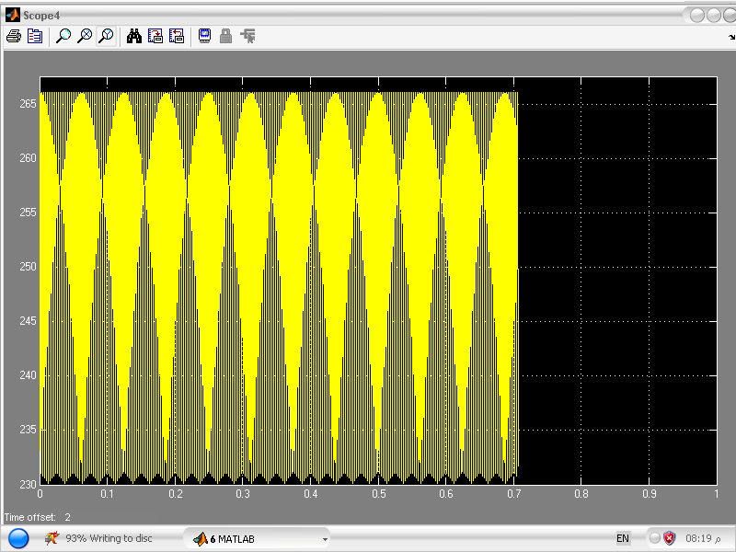
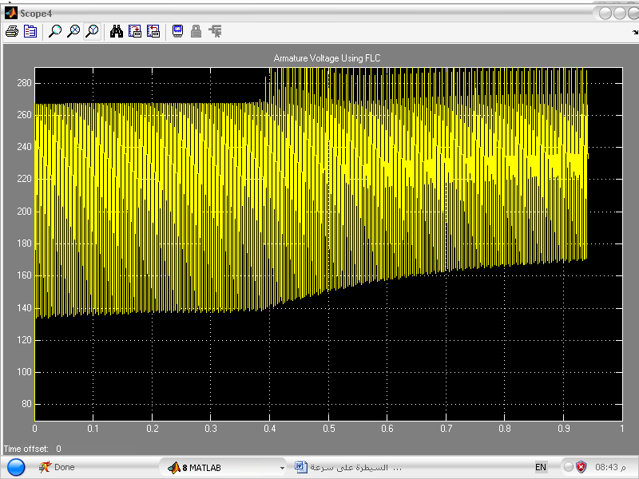
Fig. (10-b): Illustrates Armature Voltage Variation Using PID.

Fig. (10-a): Illustrates Armature Voltage Variation Using FLC.

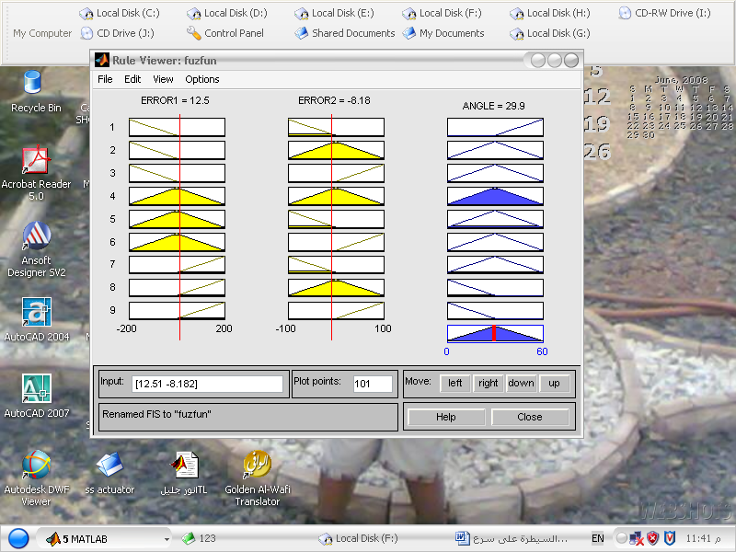
Fig. (10-c): Illustrates Rule Viewer.

POS1ZERO1NEG1MediumMediumLargeNEG2SmallMediumMediumZERO2SmallMediumMediumPOS2
E _{Ia}
E ω_{r}

Table (4): IF – THEN Rule Base of FLC Algorithm

Fig. (11): Matlab Simulation for Speed and Firing Angle Using FLC Controller.
Fig. (12): Matlab Simulation for Speed and Firing Angle Using PID

Conclusions
- MATLAB / SIMULINK Vol.7.6 used to obtain the optimal specifications, which are firing angle and fast decision with PID action & Fuzzy controller depending on the variations of rotating speed and armature current with variations of load torque.
- This study allows fast multiple analyses for a separately excited D.C motor using PID or FLC controllers, which can be especially useful for speed control to all other types of D.C motors, taking into account the principle of operation for each type.
- Fuzzy controller has more design parameters, based on empirical software rules, more suitable to satisfy non-linear criterion in all operation range compared with PID controller (satisfy linear criterion), which is based on a hardware components.
- In conventional PID controller design, mathematical model of the system must be derived then a mathematical model of a controller could be developed. But, in fuzzy logic controller design, no need for mathematical representation of the system because it depends basically on human experience, hence, its easier, to design the controller to such system.
- In fuzzy logic controller design for speed control of D.C motors by controlling on firing angle value of the bridge converter, also the fuzzy logic controller takes the difference between the reference rotated speed and the actual motor speed and then gives appropriate firing angle to reduce the first error between the reference and the actual rotated speed.
- In PID controller the armature voltage of a separately excited D.C motor is varying between (230 - 265) V, while in fuzzy logic controller is varying between (145 - 265) V, which means the range of voltage variation increased by (37 %) compared with PID controller.
- The power factor of the armature current drawn from the D.C supply is directly reflected to speed in the case of the armature fed D.C motor drive, so the half speed, that means armature voltage will be halved, hence the firing delay angle has sixty degree, the power factor of the fundamental component of the armature current being 50 % lagging.
- Craw - bar thyristor used to protect D.C motors from over current problem by making virtual short circuit as shown in Figs. (6) and (7), while Free Wheeling Diode (FWD) used to prevent negative applied armature voltage that is preventing the opposite direction of rotation for D.C motor.
- The running time duration by MATLAB simulation for engineering using computer Pentium 4 in two models of PID and FLC is approximately (2 - 4) minutes, which dependents mathematically on ordinary differential equations (ODE) to solve the scientific problems.

References
Ahmed R., 2007," Fuzzy Logic in Electric Drives", Lubbock Engineering, Howard University, Washington, D.C., USA.
Cirstea, M., Dinu, A. and Khor, J., 2002," Neural and Fuzzy Logic Control of Drives and
Power Systems", First Edition, Book, Newnes.
Fedor, P., 2003" Direct Current Drive Fuzzy Model", IJECE, Iranian Journal of Electrical and Computer Engineering, Vol.2, No.1, pp. 11-16.
Katsuhiko, O., 2000," Modern Control Engineering", University of Minnesota, Prentic - Hall International, Inc, Book.
Krishna, R.,1992," Criteria For The Comparison of Motor Drive Systems in Motion Control", Proceedings of International Conference on Intelligent Control and Instrumentation, Vol.1, No. 3,pp.127 – 133.
Kaho, C., 2006, “Design of a Fuzzy and PI controller to Guarantee Proportional Delay Differentiation on Communication Web Servers”, Hong Kong University.
Liu, C., Vu, K., Yu, Y. and Gallery, D., 2000,"Electrical Machines", The Electrical Engineering Handbook, CRC Press LLC.
Mellor, P.H., Roberts, D. and Turner, D.R. 1991" Lumped Parameter Thermal Model for Electric Machines Design", IEE Proc - B, Vol. 13, No. 5.
Mrozek, B., 1999," Design and Testing Control System for D.C Drive Using Simulink and Power System Block set", 2'nd National Conference Methods and Computer Systems, Vol. 3, No.3, pp.185 – 190, in Poland.
http://www.Math works.com, 2009, “MATLAB and Simulink Release 2008a Installation Guide for Windows", Release 14, June 18, Math Works, Inc.
Mats, A., 2002," Power Electronic Control", Lund University, Industrial Electrical Engineering, Book.
Michael, P., 2008," Computer Simulation of Power Electronics and Motor Drives", Lubbock, Texas Tech University, USA.
Pavol, F., 2005," A Simple Fuzzy Controller Structure", Faculty of Electrical Engineering and Information, Slovak Republic, Vol.5, No.4, pp. 25 – 40.
Shepherd, W., 1998, "Power Electronics and Motor Control", Cambridge University press, 1’st edition, Book.
Stephen, J., 2005," Electric Machinery Fundamentals", Hand Book, Fourth Edition, McGraw Hill, Higher Education, Australia.
Sivanandam,S. and Deepa, S., 2007," Introduction to Fuzzy Logic using MATLAB", Springer - Verlag Berlin Heidelberg .
Vas, P.and Stronach, A., 1996," Design and Application of Multiple Fuzzy Controllers for Servo Drives". Archive for Electro Technique 79, pp.1 –12.
Yehliang, H., 2005, "A Fuzzy Proportional-Derivative Controller for Engineering Optimization Problems Using an Optimality Criteria Approach", Engineering optimization, IEEE Trans. on Optimization, Vol. 37, No. 6, pp.45 – 55.

Nomenclature:

Symbols Definitions Units

B_{m} Viscous friction coefficient N.m.s
J Polar moment of the inertia kg.$m^{2}$
T_{L} Load torque N.m
T_{f} Coulomb friction torque N.m.
R_{a} Armature resistance Ω
L_{a} Armature inductance H
L_{f} Field inductance H
I_{a} Armature current Amp.
V_{a} Armature applied voltage Volt
V_{f} Field applied voltage Volt
E_{back} Back electromotive force Volt
K_{p} The proportional gain -
K_{i} The integral gain -
K_{d} The derivative of gain -
n Number of pins -
ω Angular velocity rad / sec.
α Firing angle of converter Degree

