Effect of Piers Shape on the Dynamic Structural Responses of Prestressed Concrete Bridge:
Part II

Ali Fadhil Naser
Building and Construction Technical Engineering/Al-Mussaib Technical
College/Al-Furat Al-Awsat Technical University
ali_hu73@yahoo.com
Abstract
Pier of bridge is usually used as a general term for any type of substructure located between horizontal spans and foundations. Piers give vertical supports for spans at intermediate points and perform two main functions. The objective of this study is to inspect the effect of piers shape on the dynamic structural performance by adopting theoretical dynamic analysis. The results of dynamic analysis of 25 bridges models show that the maximum value of natural frequency is equal to 5.64Hz in two circles piers bridge model. Therefore, this type of model has good stiffness and bearing capacity. The two square piers model, the one circle pier model, and the two circles piers model appear good stiffness because of the natural frequencies (5.30Hz, 5.52Hz, and 5.64Hz) are more than the maximum forced frequencies (4.52Hz, 5.45Hz, and 4.52Hz) respectively. According to the comparison between all models results, the two circles piers model has the higher stiffness because of this model has the maximum value of natural frequency (5.64Hz) and it is more than all forced vibration frequencies of all others models. Therefore, this study recommends that using the bridge model of two circles piers in the bridges construction that consists of three spans (30m+40m+30m) with section of box girder.
Key words: bridge, dynamic analysis, natural frequency, forced frequency, piers, box girder.
الخلاصة
دعامة الجسر هي احد أجزاء مكونات الجسر المهمة والتي يكون موقعها مابين منشأ الجسر العلوي وأساس الجسر وهي تعطي تثبيت عمودي لمكونات الجسر العليا كالعتبات والسطح الإسفلتي (التبليط) وتقوم بنقل الأحمال إلى الأسس. يمكن تصنيف الدعامات بالاعتماد على شكل الدعامة الهندسي إلى دعامات مربعه ودعامات مستطيله و دعامات دائرية ودعامات صلبة ممتلئة وممتدة على عرض الجسر. إن الغرض من هذا البحث هو دراسة تأثير شكل الدعامة الهندسي وعددها على الأداء الإنشائي الديناميكي للجسور الكونكريتية مسبقة الصب ذات العتبات الصندوقية بواسطة اعتماد التحليلي الديناميكي النظري. نتائج التحليل الديناميكي لخمسة وعشرون نموذج أظهرت إن أعلى قيمة للتردد الطبيعي للجسر بدون تأثير الحمل المروري تساوي(5.64Hz) لنموذج الدعامة الدائرية المزدوجة. لذلك هذا الموديل يمتلك صلابة عالية وقابلية تحمل جيده. نموذج الدعامات المربعة المزدوجة ونموذج الدعامة الدائرية المفردة و نموذج الدعامات الدائرية المزدوجة أظهرت صلابة عالية لان التردد الطبيعي (5.64Hz , 5.52Hz, 5.30Hz) أعلى من القيمة العليا للتردد الاهتزازي تحت تأثير حمل المرور (4.52Hz, 4.45Hz, 4.52Hz) على التوالي. المقارنة مابين نتائج جميع النماذج أظهرت أن نموذج الدعامات الدائرية المزدوجة يملك اعلي قيمة للتردد الطبيعي (5.64Hz) وهي اعلي من قيمة التردد الاهتزازي تحت تأثير حمل المرور لجميع النماذج. لذلك هذه الدراسة توصي باستخدام نموذج الدعامات الدائرية المزدوجة في إنشاء الجسور مسبقة الصب والتي تتكون من ثلاث فضاءات مع عتبات صندوقية الشكل الهندسي.
الكلمات المفتاحية: جسر, التحليل الديناميكي, التردد الطبيعي, التردد الاهتزازي, الدعامات, العتبة الصندوقية.
1. Introduction
A bridge is a structure which has length more than 6m. In general, it consists of two parts. The first part is known superstructure,which includes bearings,girders or beams,reinforced concrete deck, joints, pavement layers, security barriers, and drainage system. The second part is called substructure, which includes foundations, abutments, piers, piers caps.(Ali & Wang, 2011;Al-Rifaie & Kareem,1986; Demetrios & Jim, 2007).
Bridges are the key elements in any road network. The using of box girder is the main type in the bridge engineering fraternity because it has better stability, serviceability, economy, aesthetic appearance and structural efficiency. Structurally, it is a bridge in which the main beams comprise girders in the shape of a hollow box.
The box girder normally comprises either prestressed concrete, structural steel, or a composite of steel and reinforced concrete. The cross-section of box girder is typically rectangular or trapezoidal. The box girder bridges are commonly used for highway fly-over and for modern elevated structures of light rail transport. (Bhivgade, 2014)
Pier of bridge is usually used as a general term for any type of substructure located between horizontal spans and foundations. Piers give vertical supports for spans at intermediate points and perform two main functions. These functions are transferring superstructure vertical loads to the foundations and resisting horizontal forces acting on the bridge. There are many pier types that are used in bridge construction. The simplest may be pile bent piers where a reinforced concrete cap is placed on piling. The other pier type is a cap and column pier. Columns supported on individual footings support a common cap. There are some factors could be affect on the spacing of columns such as the type of superstructure, the superstructure beam spacing, and the size of the columns. (Wang , 2000; AASHTO LRFD, 2010 ).
Vibration of bridge structure under the passage of vehicles is an important consideration in the design of bridges. Dynamic response of bridges has assumed added significance with the advent of faster and heavier vehicles and the use of structural forms and materials that permits the bridge to be more slender. Interaction between the vehicle and the bridge is a complex dynamic phenomenon. (Humar & Kashif, 1993).
Natural frequency is the frequency at which a system tends to oscillate in the absence of any driving or damping force. Free vibrations of any elastic body is called natural vibration and happens at a frequency called natural frequency. Natural vibrations are different from forced vibration which happens at frequency of applied force (forced frequency. Theoretically, natural frequency can be determined by using the following equations).(Tse, 1978):

$f=\frac{1}{2π}\sqrt{\frac{k}{m}}$ (1)
The circular frequency=$ω=\sqrt{\frac{k}{m}}$ (2)
Where: f is natural frequency (Hz), $k=\frac{\text{EI}}{l}$=stiffness, E is modulus of elasticity (MPa), I is moment of inertia (m⁴), l is the length of span (m)

Many studies proved that the natural frequency increases with the increasing in the stiffness of structure and it decreases with the increasing in the mass and span length of structure. (Ali, 2013).
2. Bridge Modeling Description and Vehicles Load
The bridge model of this study is same model in the first part of paper that included the structural static analysis and effects of piers shape and skew angles. The properties of model materials, prestressed loads, vehicles live loads, cross section of box girder, and lengths of spans are same in the first model. (Ali, 2014). The type of bridge model is a continuous prestressed concrete box girder bridge.The bridge model contains three spans. The length of first span is 30m , the length of second span is 40m, and the length of third span is 30m. The box girder has width is equal to 8.5m with two lanes for forward traffic. According to piers shape and speed of vehicles, there are 25 bridge models are used in this analysis. SAP2000 Ver. 14.2 is used to analyze the bridge models. Figure (1) to figure (5) show the bridge models. Figure (6) shows the layout of prestressed tendons along the bridge structure. Five speeds are used in each model (20km/hr, 40km/hr, 60km/hr, 80km/hr, and 100km/hr).
3. Properties of Models
a. Concrete density=26kN/m³, Poisson ratio (μ) =0.2, concrete grade 40.
b. Live load: vehicle type is HSn-44L-1, according to AASHTO LRFD 2002 and 2007.
c. Load combinations: the load combinations consist of two combinations. The first combinations is COMB I= dead load + prestressed load. The second combination is COMB II= COMB I + live load (traffic load) + temperature load.
d. Prestressed tendons properties: the prestressing tendons made of 1×7 wires 15.24-1860-II-GB/T5224-1995. Tendon area is equal to 1656mm2. The standard strength and controlled tension force of steel strands is equal to 1395MPa and 2310kN, respectively.
e. Two lanes are selected to move the vehicles in the forward directions.

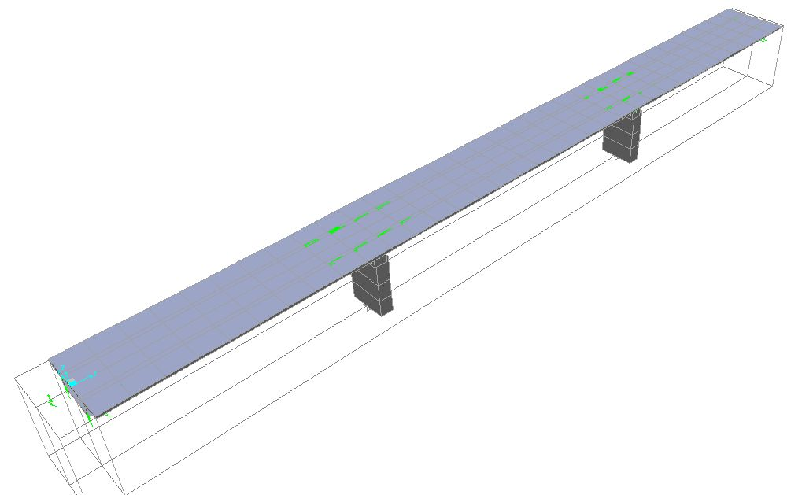
(a)

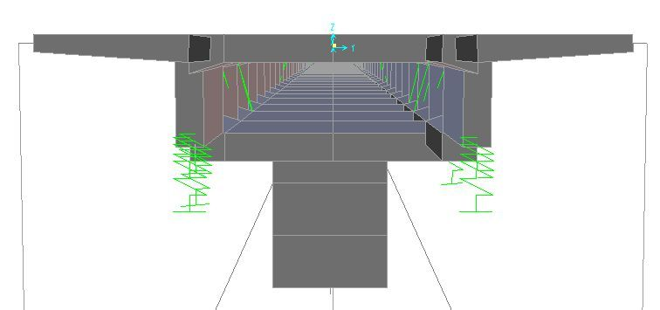
(b)
Fig (1) The model of solid piers structure: (a) Longitudinal section, (b) Cross- section

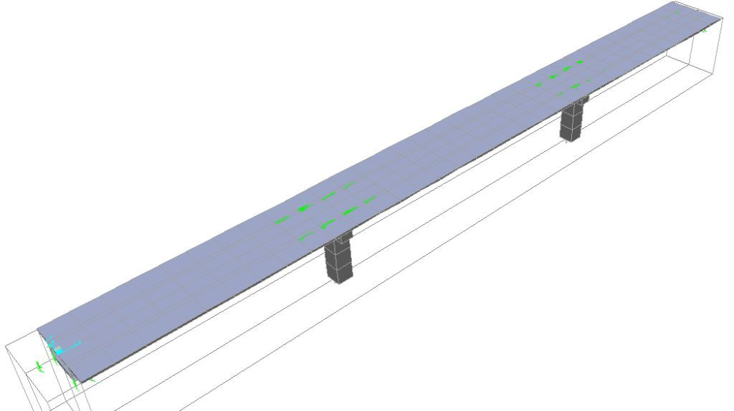

(a)

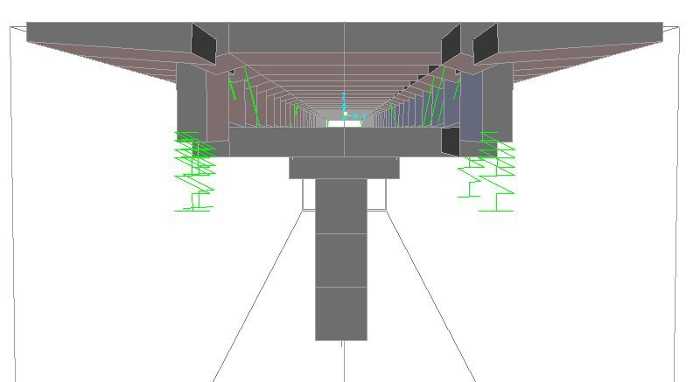

(b)

Fig (2) The model of one-rectangular piers structure: (a) Longitudinal section, (b) Cross- section

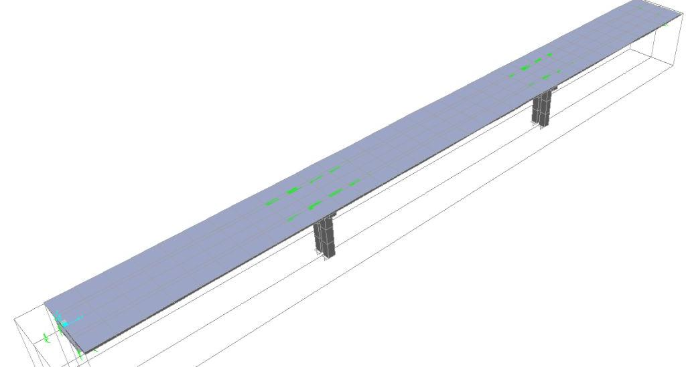
(a)

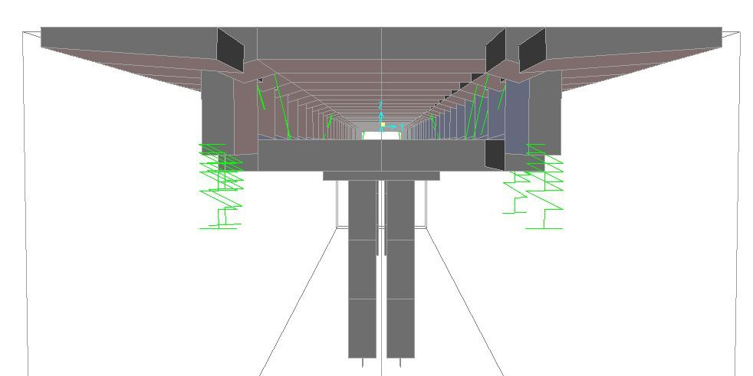
(b)
Fig (3) The model of two-rectangular piers structure: (a) Longitudinal section, (b) Cross- section
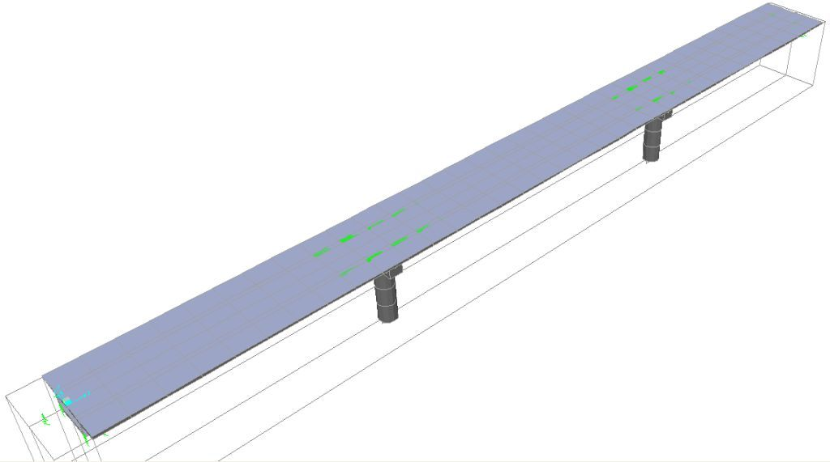
(a)

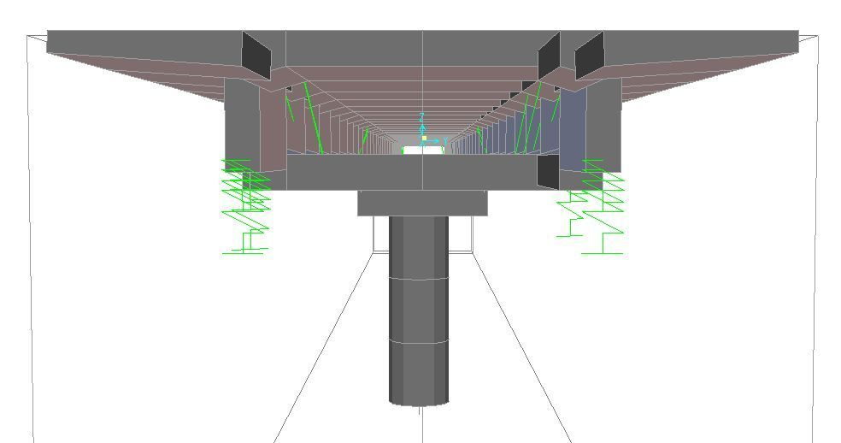
(d)
Fig (4) The model of one-circle piers structure: (a) Longitudinal section, (b) Cross- section

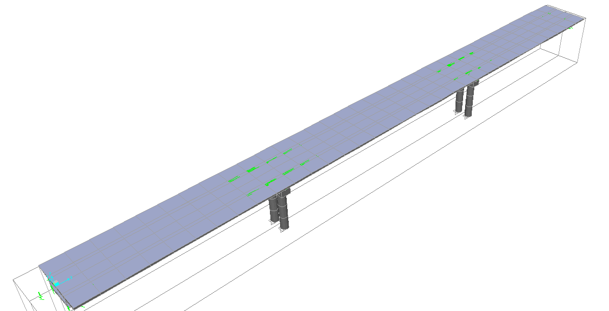
(a)

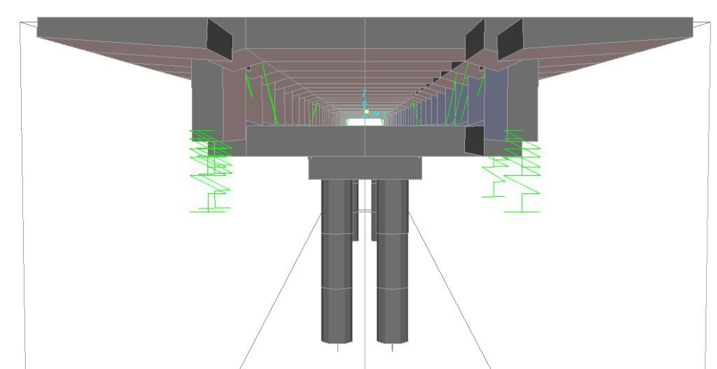
(b)
Fig (5) The model of two-circles piers structure: (a) Longitudinal section, (b) Cross- section

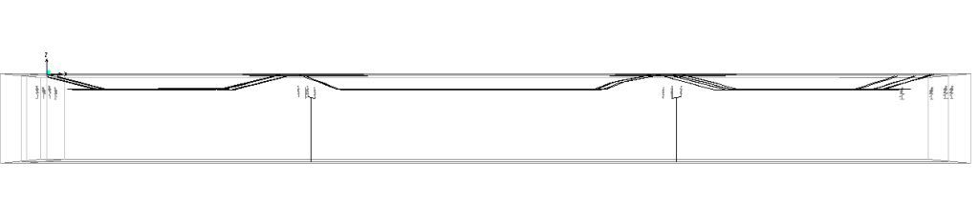
(a)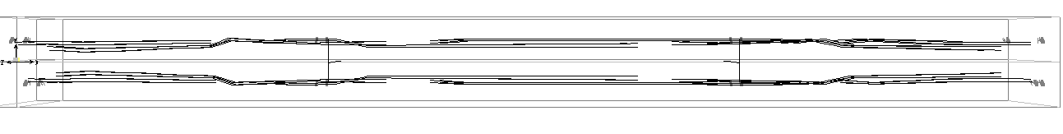
(b)
Fig (6) The layout of prestressed tendons along the bridge structure: (a) Elevation view, (b) Top view

4. Dynamic Analysis of Bridge Model
4.1 Natural Frequency
Natural frequency is important factor in the dynamic analysis of the bridges structures to evaluate the structural stiffness of the all bridge structure members after comparing the natural frequency with forced frequency. The method of dynamic analysis is Hilber-Hughes-Taylor. The type of analysis is linear and the type of time history is direct integration. Time history motion type is transient Natural frequency is measured when the bridge structure has not any traffic (there are not any types of vehicles on the bridge). Figure (7) shows the analysis of natural frequency for 25 bridges models (the relation between time and natural frequency for each mode). Figure (8) shows the selected natural frequency of each model. The results of dynamic analysis show that the maximum value of natural frequency is equal to 5.64Hz in two circles piers bridge model. Therefore, this type of model has good stiffness and bearing capacity comparing with others types of models in the analysis because of the natural frequency is the measuring of structure stiffness and when the structure has maximum natural frequency, the stiffness of structure is more.

(a)
(b)
(c)
(d)
(e)
Fig (7) The relation between time and natural frequency for each mode: (a) solid pier, (b) one square pier, (c) Two one squares piers, (d) one circle pier, (e) two circles piers

4.2 Forced Frequency
Forced vibration frequency is calculated when the tested long vehicles pass on bridge structure. Some theoretical and experimental studies of dynamic responses (natural and forced frequency) applied just for vertical direction (z-direction) of structures because they think the values of dynamic responses in others directions (x and y directions) are not important and have not significant effects on the stiffness of structures. The direction x represents the length of the bridge model and the y direction represents the transverse section of the bridge model (width of bridge). This study includes dynamic analysis in three dimensions (z-x-y) to check the amounts of dynamic responses values in the longitudinal and transverse sections. Figure (9) shows the relation between speed of vehicles and forced vibration frequency, and Table (1) lists the compared values of natural frequency and maximum forced frequency for each model in three directions.
According to the Figure (4) and Table (1), the maximum value of forced vibration frequency is appeared in the one circle pier model, which is equal to 5.45Hz in the z direction and in the x direction, the minimum value is equal to 1.44Hz within one circle pier model. For vertical direction (z), the minimum value is appeared in the one square pier model, which is equal to 3.80Hz.
To evaluate the stiffness of structures, natural and forced frequencies were compared. If the natural frequency more than forced frequency, the stiffness of structure is good and has enough bearing of capacity and vice versa. The results of analysis showed that the solid pier model and one square model give the lower stuffiness because the natural frequencies 3.05Hz and 3.13 Hz are less than the maximum forced frequencies 5.25Hz and 4.77Hz respectively. The two square piers model, one circle pier model, and the two circles piers model appear good stiffness because of the natural frequencies 5.30Hz, 5.52Hz, and 5.64Hz are more than the maximum forced frequencies 4.52Hz, 5.45Hz, and 4.52Hz respectively. According to the comparison between all models results, the two circles piers model has the higher stiffness because of this model has the maximum value of natural frequency (5.64Hz) and it is more than all forced vibration frequencies of all others models.

Fig (8) The selected natural frequency of each model
(a)
(b)
(c)
(d)
(e)
Fig (9) The relation between speed of tested long vehicle and forced frequency for each model: (a) solid pier, (b) one square pier, (c) Two one squares piers, (d) one circle pier, (e) two circles piers

Table (1) The maximum and minimum value of forced frequency with natural frequency
Types of model | Direction | Max. value of forced frequency (Hz) | Min. value of forced frequency (Hz) | Natural frequency (Hz)
Solid pier | Z | 4.94 | 4.32 | 3.05
Solid pier | X | 2.66 | 1.92 | 3.05
Solid pier | Y | 5.27 | 3.76 | 3.05
One square pier | Z | 4.77 | 3.80 | 3.13
One square pier | X | 2.82 | 1.98 | 3.13
One square pier | Y | 4.68 | 2.77 | 3.13
Two squares piers | Z | 4.52 | 3.98 | 5.30
Two squares piers | X | 3.04 | 2.01 | 5.30
Two squares piers | Y | 4.35 | 3.75 | 5.30
One circle pier | Z | 5.45 | 4.57 | 5.52
One circle pier | X | 2.62 | 1.44 | 5.52
One circle pier | Y | 4.30 | 3.38 | 5.52
Two circles pier | Z | 4.52 | 3.98 | 5.64
Two circles pier | X | 3 | 2 | 5.64
Two circles pier | Y | 4.3 | 3.75 | 5.64

5. Conclusion
The main conclusions of this paper are:
1. The type of bridge pier has significant effects on the stiffness of the bridge structure. Therefore, the dynamic analysis is required to apply for many types of bridge structure with different types of piers to select the suitable design.
2. The results of natural frequency analysis showed that the maximum value of natural frequency is equal to 5.64Hz in two circles piers bridge model. Therefore, this type of model has good stiffness and bearing capacity comparing with others types of models in the analysis.
3. Force vibration frequency analysis showed that the two square piers model, one circle pier model, and the two circles piers model appear good stiffness because of the natural frequencies 5.30Hz, 5.52Hz, and 5.64Hz are more than the maximum forced frequencies 4.52Hz, 5.45Hz, and 4.52Hz respectively. According to the comparison between all models results, the two circles piers model has the higher stiffness because of this model has the maximum value of natural frequency (5.64Hz) and it is more than all forced vibration frequencies of all others models.
References
Ali, F.N. and Wang Z. L,2011, Damage Inspection and Performance Evaluation of Jilin Highway Double-Curved Arch Concrete Bridge in China, Structural Engineering and Mechanics, An International Journal,93(4): pp:521-539, (IF= 0.863).
Ali, F. N., 2013, Damage Inspection and Structural Performance Evaluation of Prestressed Concrete Box Girder Bridges Before and after Strengthening: Theoretical and experimental Study, Ph. D Thesis Submitted to School of Transportation Science and Engineering, Harbin Institute of Technology, Harbin City, China.
Ali, F. N., 2014, Optimization of oblique Angle Design of Abutments and piers, and piers Shape of Continuous Prestressed Concrete Box Girder Bridges: Static Analysis part 1, International Journal of Engineering and Advanced Technology (IJEAT), Volume-3, Issue-4, pp: 113-121.
Computers & Structures,2009, Bridge Superstructure Design Concrete Box Girder Bridges and Precast Concrete Composite Girder Bridges AASHTO LRFD 2002 and 2007, Berkeley, California, USA.
Al-Rifaie, W. N. and Kareem A. S., 1986. Bridges, University of Technology, Baghdad, Iraq, first edition, pp:5-8.
American Association of State Highway and Transportation Officials (AASHTO LRFD Bridge Design), 2010, Abutments, Piers, and Walls, Design Specifications, Chapter 11.
Bhivgade, P.R., 2014, Analysis and Design of Prestressed Concrete Box Girder Bridge, Civil Engineering Portal, http://www.engineeringcivil.com/analysis-and-design-of-prestressed-concrete-box-girder-bridge.html.
Demetrios, E. and Jim J., 2007. Bridge Engineering: Design, Rehabilitation, and Maintenance of Modern Highway Bridges, Second Edition, Copyright 2007 by McGraw Companies.
Humar, J. L., and Kashif A. M., 1993, Dynamic Response of Bridges Under Traveling Loads, CAN. J. CIV. EN1 S. VOL. 20, pp: 278-298.
Tse, F. S., Morse, I. E., and Hinkle, R. T. 1978, Mechanical Vibrations: Theory and Applications, Allyn and Bacon, Inc., Boston, MA, USA.
Wang, J., 2000, Bridge Engineering Handbook: Piers and Columns, Chapter 27, © 2000 by CRC Press LLC.

