Effect of Natural Sand Percentages on Fatigue Life of Asphalt Concrete Mixture

Nahla Yassub Ahmed Hassan Mohammed Mahdi Mohiuddin
Babylon University / College of Engineering
nahlayassub@yahoo.com engineer_hassan1990@yahoo.com
Abstract
The design of a flexible pavement requires the knowledge of the material properties which are characterized by stiffness and fatigue resistance. The fatigue resistance relates the number of load cycles to failure with the strain level applied to the asphalt mixture. The main objective of this research is the evaluation of the fatigue life of asphalt mixtures by using two types of fine aggregate having different percentages. In this study, two types of fine aggregate were used natural sand (desert sand) and crushed sand. The crushed sand was replaced by natural sand (desert sand) with different percentages (0%, 25%, 75% and 100%) by the weight of the sand (passing sieve No.8 and retained on sieve No.200) and one type of binder (40/50) penetration from Al-Daurah refinery. The samples of beams were tested by four point bending beam fatigue test at the control strain mode (250, 500 and 750) microstrain while the loading frequency (5Hz) and testing temperature (20ºC) according to (AASHTO T321). The experimental work showed that fatigue life (Nf) and initial flexural stiffness increased when control strain decreased for asphalt mixtures. Acceptable fatigue life at 750 microstrain was obtained with asphalt concrete mixtures containing 100% crushed sand as well as asphalt concrete contained 25% natural sand. The asphalt concrete contained 100% and 75% of natural sand exhibited high fatigue life at low level of microstrain (250). The main conclusion of this study found that best proportion of natural sand to be added to an asphaltic concrete mixture is falling within the range (0% and 25%) by weight of fraction (passing No.8 and retained on No.200) sieve .
key words:Asphalt, pavement, aggregate, natural sand, crushed sand, hot mix asphalt, temperature, optimum asphalt content, fatigue life, stiffness .
الخلاصة
يتطلب تصميم التبليط المرن معرفة خصائص المواد التي تتميز بالصلابة و مقاومة الكلل. تتعلق مقاومة الكلل بعدد دورات الحمل إلى الفشل مع مستوى من الانفعالات المسلطة على الخلطات الإسفلتية. الهدف الرئيسي لهذا البحث هو تقييم سلوك الكلل للخلطات الإسفلتية باستخدام نوعين من الركام الناعم (الرمل الطبيعي،رمل الكسارة) بنسب مختلفة. يتم استبدال رمل الكسارة بالرمل الطبيعي (الرمل الصحراوي ) بنسب مختلفة (25,0، 75, 100) % كوزن من الرمل (المار من منخل رقم 8 والمتبقي على منخل رقم 200) ونوع واحد من الاسفلت ذو اختراق (40/50) من مصفى الدورة. تم فحص نماذج من العتبات عن طريق استخدام جهاز ذو أربع نقاط الانحناء لفحص الكلل وبمستوى انفعال (250، 500, 750) (microstrain) بينما كان تردد التحميل (5Hz) ودرجة الحرارة الفحص (20 درجه مئوية) وذلك وفقاً للمواصفة (AASHTO T321). اظهرت النتائج المختبرية ان عمر الكلل (Nf) ، والصلابة الابتدائية يرتفعان مع انخفاض الانفعال لجميع نسب الرمل الطبيعي. يتم الحصول على سلوك كلل مقبول في (750)(microstrain) للخلطات الإسفلتية التي تحتوي على الرمل المكسر وكذلك الخلطات الاسفلتية الحاوية على (25%) من الرمل الطبيعي, بينما اعطت الخلطات الإسفلتية التي تحتوي على (100%) من الرمل الطبيعي وكذلك الخلطات الاسفلتية التي تحتوي على (75%) عمر كلل عالي عند اختبارها في الانفعالات المنخفضة (microstrain250).الاستنتاج الرئيسي من هذه الدراسة هو اثبات ان أفضل النسب من الرمل الطبيعي التي يوصى بخلطها لإنتاج الخلطات الاسفلتية هي (0% و25%) كوزن من الرمل (المار من منخل رقم 8 والمتبقي على منخل رقم 200).
الكلمات المفتاحية: أسفلت, تبليط, ركام, رمل طبيعي, رمل كسارة, الخلطة الإسفلتية الحارة, الحرارة, المحتوى الإسفلتي الأمثل, عمر الكلل, الصلابة .
- Introduction
The fatigue resistance of asphalt mixtures is generally defined as the ability of these mixtures to resist repeated traffic loading under the prevailing environmental conditions without significant cracking or pronounced failure. The mechanism of pavement design procedures requires the characterization of laboratory material under the real loading (multiple axle loading, traffic speed, rest periods between traffic stresses, etc.) and environment conditions (temperature, aging, etc.). Fatigue cracking is the most common distress in road pavement. It is mainly due to the increase in the number of load repetition of vehicles particularly those with high axle loads, and to the environmental conditions. The construction practice and design shortcomings may also result in shortening of pavement’s life and increase maintenance cost. It is vital to find out ways to delay the asphalt pavement deterioration and increase its service life (Moghaddam et. al., 2011;Fernandes and Gouveia, 2003) investigated the effect of crushed fine aggregate. They found that the replacement of the rounded aggregate by crushed fine aggregates improved mixture properties such as stability, rutting and water resistance. The aggregate gradation (distribution of particle sizes) is one of the most important factors to resist pavement distress (Shen et. al., 2005). The effect of aggregate interlocking on the fatigue life is assessed by using control mixture and stone matrix asphalt. The results showed that, stone matrix asphalt mixture has lower fatigue life than control mixtures. This is referring to the lack of mechanical locking of the aggregate because stone matrix asphalt mixture is a gap graded asphalt mixture (Asi,2006;Yasreen et. al., 2011) noticed that the quarry sand incorporated bituminous mixtures give a better fatigue performance. This is may be due to the effect of sand properties such as angularity, surface texture, shear strength,particle size and distribution in addition to the content of alumina and hematite. The results obtained from beam fatigue test provide an insight view that physical, chemical and mechanical properties of fine aggregate could improve the mixture fatigue performance.
- Research objective
The main objective of the presented work to evaluate the fatigue life of asphalt mixtures that contains different proportions of natural and crushed sand .
- Materials and testing
In this study several tests were carried out to determine the following : physical properties of coarse aggregate, fine aggregate, filler and asphalt, Marshall Test and beam fatigue tests also were performed .
  - Materials
Coarse aggregate is the portion of the combined aggregate retained on the 4.75 mm (No.4) sieve used for asphalt concrete. The source of crushed aggregate from Al- Najaf quarry. This aggregate is widely used in the middle and south areas of Iraq for asphalt pavement . The particles tend to off white in color with angular surfaces. The fine aggregate is the portion of the combined aggregate passing the 4.75 mm (No.4) sieve shall consist of stone screenings and natural sand (SCRB R/9, 2003). The coarse and fine aggregates (crushed sand and natural sand) are sieved according to state corporation of roads and bridges specifications (SCRB R/9, 2003) for wearing coarse gradation. Plate (1) showed crushed sand and natural sand used in this study. Table (1) shows the test results of aggregate (coarse and fine) and the limitations of these tests while table (2) explains aggregate gradation with specification limit according (SCRB R/9, 2003). One type of asphalt cement was used with (40-50) penetration grade brought from Al-Daurah refinery. The physical properties and tests of the asphalt cement used are shown in table (3) .

Table (1): Physical properties of aggregate
Property | ASTM Designation | AASHTO Designation | Coarse aggregate | Fine aggregate |  | SCRB  Specification
 |  |  |  | Crushed | Desert | SCRB  Specification
Bulk specific gravity | C-127  C-128 | -------- | 2.52 | 2.68 | 2.66 | --------
Apparent specific gravity | C-127  C-128 | -------- | 2.65 | 2.7 | 2.68 | --------
% water absorption | C-127  C-128 | -------- | 0.89 | 0.6 | 0.63 | --------
%Abrasion (Los Angeles) | C-131 | -------- | 26% | -------- | -------- | 30% max.
%Fine aggregate  angularity (FAA) | C-1252 | -------- | -------- | 50.4 | 40.97 | --------
%Sand equivalent | -------- | T176-2008 | -------- | 51 | 89 | 45% min.
Table (2): Asphalt mixture grading
Sieve size |  | (% passing by weight of total aggregate+filler) | Specification limits for wearing coarse (SCRB)
Standard sieves (mm) | English sieves (in) | (% passing by weight of total aggregate+filler) | Specification limits for wearing coarse (SCRB)
19 | 3/4'' | 100 | 100
12.5 | 1/2'' | 95 | 90-100
9.5 | 3/8'' | 83 | 76-90
4.75 | No.4 | 59 | 44-74
2.36 | No.8 | 43 | 25-58
0.3 | No.50 | 13 | 5-21
.075 | No.200 | 7 | 4-10
Asphalt cement (% by weight of total mix) |  | ------------ | 4-6
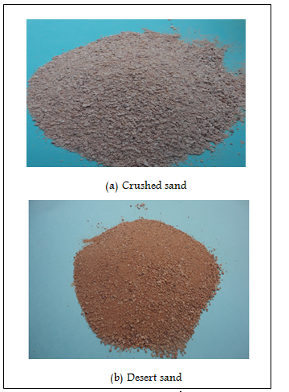
Plate (1): The types of sand used in the study

Table (3): Physical properties of asphalt cement
Property | ASTM Designation | Test result | SCRB specification
Penetration(25 0C,100 gm,5 sec)* | D-5 | 47 | (40-50)
Ductility (25 0C, 5 cm/min). (cm)* | D-113 | 107 | >100
Flash point(Cleveland open cup), ( 0C)* | D-92 | 280 | Min.232
Softening point, (0C)* | D-36 | 55 | ------------
%Solubility in trichloroethylene* | D-2042 | 99.5 | Min. 99%
Viscosity, 135 (oPC), (Cs)* | D-2171 | 540 | Min. 400
Specific gravity at 25 0C * | D-70 | 1.04 | ------------
Residue from thin-film oven test
- Retained penetration, % of original* | D-5 | 76 | Min. 55
- Ductility at 25 oC, 5 cm/min (cm)* | D-113 | >100 | Min. 25
  - Testing
    - Marshall Test
The optimum asphalt content is obtained by the standard Marshall test method (ASTM D-1559). The range of asphalt content (4 to 6)% by the weight of total mix with (0.5%) increment have been used. The optimum asphalt content for each asphalt mixtures contain natural sand and crushed sand, as shown in table (4) below:
Table (3-4): Optimum asphalt content
% natural sand | % optimum asphalt content
0  (all crushed sand) | 5.3
25 | 5.18
75 | 5.02
100 | 4.86
The optimum asphalt content percentages decrease with increasing the natural sand percentages. This can be explained by the surface area of fine aggregate in mixture becoming more with increasing the percent of natural sand.
    - Beam Fatigue Test
The fatigue beam specimens were prepared by using rectangular metal mold having the dimensions of (50 mm thickness x 63 mm width x 380 mm length) according to AASHTO T321. The required mixture batch was 3000 grams to fill mold of the fatigue beam. The asphalt mixture prepared with coarse aggregate, fine aggregate (desert and crushed sand) with different percentages. The compaction effort can was done by using a compressing machine to get 4% air voids. The test temperature was 20°C and all specimens were kept inside the chamber at this temperature for 2 hours before the test. Four Point Bending Beam device as shown in plate(2) was used to test fatigue samples .
Testing device properties are:
- Constant strain mode.
- Loading frequency 5 Hz .
- Strain level between 250 to 750 microstrain.
- haversine (sinusoidal) load is applied.
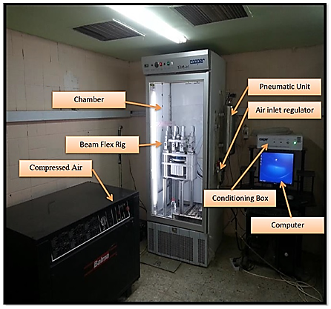
Plate (2): Four Point Bending Beam device and Testing Equipment
- Results and Discussion
Results obtained in this work are highly dependent upon the variability of tested mixes. This variability includes; type of fine aggregate (crushed sand or natural sand),strain level and the effect of natural sand on fatigue life, initial flexural stiffness.
Generally fatigue life increases when microstrain decreases for asphalt mixtures that contain crushed sand or natural sand. It can be observed that the asphalt mixtures contain (crushed sand and 25% natural sand) have a better fatigue life at high microstrain (750) but asphalt mixtures contain 75% natural sand and asphalt mixtures contain 100% natural sand are the best when microstrain is low (250) because of the effect of sand properties such as angularity, surface texture, shear strength, particle size and distribution as well as laboratory conditions as shown in figure (1) .
The initial stiffness is determined by plotting flexural stiffness against the number of repetitions to failure and the form of the exponential function is either best fitting of the data or by applying the 100th load cycle. Generally initial flexural stiffness decreases when microstrain increases from (250 to 750) microstrain for asphalt mixtures containing (natural sand and crushed sand). It is obvious from the analysis that high initial flexural stiffness can be obtained for asphalt concrete mixtures contain natural sand compared to asphalt concrete mixtures contain crushed sand because that natural sand provides flexibility for asphalt mixtures while crushed sand leads to increase repeated load as shown in figure (2).

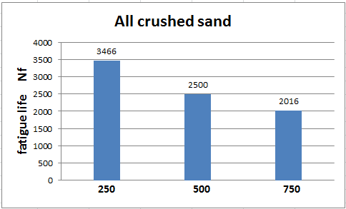
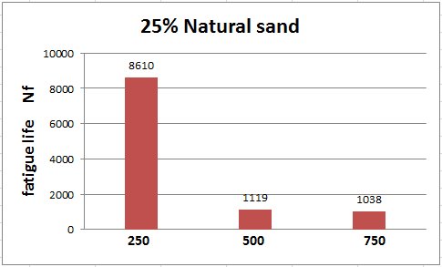
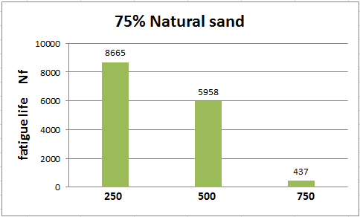
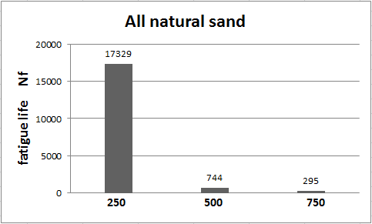
Figure (1): Effect of natural sand on fatigue life at (250, 500 and 750) microstrain

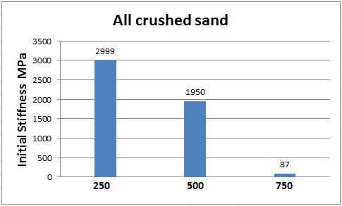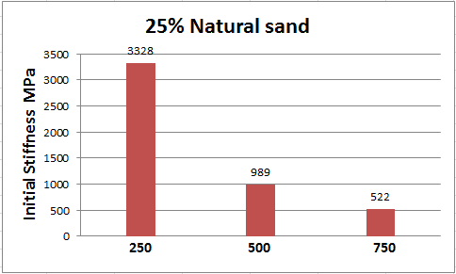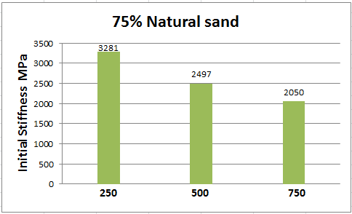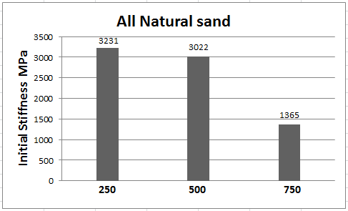

Figure (2):Effect of natural sand on initial stiffness at (250, 500 and 750) microstrain
Conclusion
It is concluded that:
- Fatigue life (Nf) and initial flexural stiffness will be increased when control strain is decreased .
- Acceptable fatigue behavior can be obtained for asphalt concrete mixtures that contain all crushed sand when tested in high microstrain (750) and the asphalt concrete contains natural sand is the best when microstrain is low (250) .
- The best proportions of natural sand to be used in an asphaltic concrete mixture is (0% and 25%) by weight of fraction (passing No.8 and retained on No.200) sieves.
- References
AASHTO T-321.2010,"Method for Determining the Fatigue Life of Compacted Hot-Mix Asphalt (HMA) Subjected to Repeated Flexural Bending," AASHTO Provisional Standards.
Asi ,2006,“Laboratory Comparison Study For the Use of Stone Matrix Asphalt in Hot Weather Climates”,Science Direct Journal of Construction and Building Materials, Vol. 20, pp. 982–989 .
ASTM C-128, 2002," Standard Test Method for Density, Relative Density (Specific Gravity), and Absorption of Fine Aggregate”, American Society of Testing and Materials.
ASTM D-113, 2002," Standard Test Method for Ductility of Bituminous Materials”, American Society of Testing and Materials.
ASTM D-1559 “Resistance to Plastic Flow of Bituminous Mixtures using Marshall Apparatus”, American Society for Testing and Materials .
ASTM D-5, 2002," Standard Test Method for Penetration of Bituminous Materials”, American Society of Testing and Materials.
Fernandes, and Gouveia ,2003, “Limitation of the Fine Aggregate Angularity (FAA) Test to Predict the Behavior of Asphalt Mixtures”,Department of Transportation, University of Sao Paulo, Brazil, pp. 1-9 .
Moghaddam, T.B.,Karim, M.R., and Abdelaziz, M., 2011,“A review on Fatigue and Rutting Performance of Asphalt Mixes.” Scientific Research and Essays, Vol.6, PP.670-682 .
Shen, F.M., Kuo, and C.J.Du ,2005,“Properties of Gap- Aggregate Gradation Asphalt Mixture and Permanent Deformation”, Science Direct Journal of Construction and Building Materials, Vol. 19, pp.147-153.
Yasreen,N.B.,Madzlan, and K. Ibrahim,2011,“The Effect of Fine Aggregate Properties on the Fatigue Behavior of the Conventional and Polymer Modified Bituminous Mixtures Using Two Types of Sand as Fine Aggregate” World Academy of Science, Engineering and Technology 58 2011 .

