Controlling The Surface Water of Shatt Al Arab River by using Sluice Gates

Ahmed Naseh Ahmed Hamdan
Dept. of Civil Eng., College of Eng., Univ. of Basrah, Basrah-Iraq
ahmed_n_ahmed2005@yahoo.com
Abstract
The purpose of this study is to find hydrodynamic simulations of river water by controlging gates in Shatt Al Arab river. This river is formed by the meeting of the Tigris and Euphrates rivers near the city of Qurna in the south of Iraq, and it pours into the Arabian Gulf. Hydrodynamic simulations give a proper understanding performance and optimize utilization of the gates controlging the water level. Three different sluice gates opening cases simulate the water surface level using HEC-RAS in Shatt Al Arab river. These cases where being studied within two situations of Tide (the highest high water level and the lowest low water level) within the downstream of Shatt Al Arab river. The study also deals with six cases of flow rates in upstream of Shatt Al Arab river. Hec-Ras model is produced by US Army for analyzing river system. This model could simulate steady and unsteady open channel flow.
Keywords: hydrodynamic simulation, HEC-RAS, Shatt Al Arab river
الخلاصة
الغرض من هذه الدراسة هو لإيجاد المحاكاة الهيدروديناميكية لمياه النهر بالسيطره على البوابات في نهر شط العرب. ويتكون هذا النهر من التقاء نهري دجلة والفرات بالقرب من مدينة القرنة في جنوب العراق، ويصب في الخليج العربي. المحاكاة الهيدروديناميكية تعطي الفهم الصحيح لكيفية الأداء والاستخدام الأمثل لبوابات التحكم في منسوب المياه. ثلاث حالات فتح للبوابات اخذت لمحاكاة مستوى سطح الماء باستخدام HEC-RAS في نهر شط العرب.وتجري دراسة هذه الحالات ضمن حالتين من المد والجزر (أعلى مستوى للمد العالي وأدنى انخفاض للمد الواطيء لمستوى الماء) في اسفل نهر شط العرب. تناولت الدراسة ست حالات من التصاريف في اعالي نهر شط العرب. تم إنتاج نموذج HEC-RAS من قبل الجيش الأمريكي لتحليل نظام النهر. هذا النموذج يستطيع محاكاة الجريان الثابت وغير الثابت لقناة مفتوحة.
الكلمات المفتاحية : التمثيل الهيدرودايناكيمي ، المحاكاة الهيدروديناميكية ، HEC - RAS ، نهر شط العرب

- Introduction
Shatt al-Arab river is one of the most important river systems in Iraq. It arises from the confluence of Tigris and Euphrates rivers in the town of Qurna (70 km) North of Basra 30.5º N. The length of Shatt Al Arab River is approximately 200 km. Shatt al Arab river widens over its course, expanding from a width of 250-300 m near the Euphrates-Tigris confluence to almost 700 m near the city of Basrah and about 2 Km as it approaches the river mouth, The southern part of the river constitutes the border between Iran and Iraq until it discharges into the Gulf. (Hamdan, 2008).
Several tributaries join Shatt al Arab river during its course, most importantly the Karkheh and the Karun Rivers. But now these tributaries have diverged their water into the inside of the Iranian borders and this causes a very high increase of salinity in Shatt Al-Arab River.( Al-Ansari, 2014).
The tide in Shatt Al Arab river estuary is mainly of a semi diurnal type (i.e. two unequal high and low tides a day), which has a period averaging about 12 hours, 25 minutes. The hydrological condition of the Shatt Al-Arab River basin is affected by several factors including conditions at the upper reaches of the Tigris and Euphrates rivers, the status of advancing flood tides from the Arabian Gulf, seepage of saline ground water into the basin, as well as the impact of climate conditions prevailing in the region on discharge rates and the payload of the river. (Moyel, 2014).
In recent years, Shatt Al Arab river suffers from a decrease of flow rates due to the policy of the countries of the source, where the decided water share for Shat Al Arab river is 50 m³/s that caused shortage problems of water for irrigation and drinking in Basrah governorate and this increases salinity. Now the river depends mainly on the Tigris river because the rest of the water fed by other rivers and streams (that are Al-soib river, Euphrates river, and Garmat Ali river) are closed by the Ministry of water resources in Iraq and Al-Karon river is closed by Iran. This lead to a decrease in discharge. Furthermore, the tidal power coming from the Arabian Gulf has more impact and increased salinity intrusion wedge into the river.
(AL- Mahmood, 2015).
In this study HEC-RAS application was applied on Shatt Al Arab river, for whole length of 200 km from the confluence of the Tigris and Euphrates rivers in the town of Qurna to Shatt Al Arab river estuary. It’s divided into (40) cross sections. The paper covers the case of normal depth of flow, and for different cases of discharge in the upstream of the river and different observed water stage data in the downstream of the river, (the observed period was from September 2009 to January 2015).
The aim of this study is to use a hydrodynamic modeling software developed by the "Hydrologic Engineering Center, U.S. Army Corps of Engineers”, to design a sluice gate. The suggested location of the gate is about 3 km upstream of Abu Floos port. It is used to control and store river water for irrigation and drinking purposes and to prevent saline sea water from being mixed with river fresh water. It also helps to know hydrodynamic simulations of the water control gates in Shatt Al Arab river. With the computational modeling, it was possible to simulate the height of water level of different scenarios of the gate openings to estimate the level of water upstream of the gate that insure arriving water to the branches of Shatt Al Arab river.
- HEC-RAS Model
The Hydrologic Engineering Center River Analysis System (HEC-RAS) model is a professional engineering software package which allows to perform one-dimensional steady flow and unsteady flow simulation. Fig. (1) shows the main menu of HEC-RAS model.

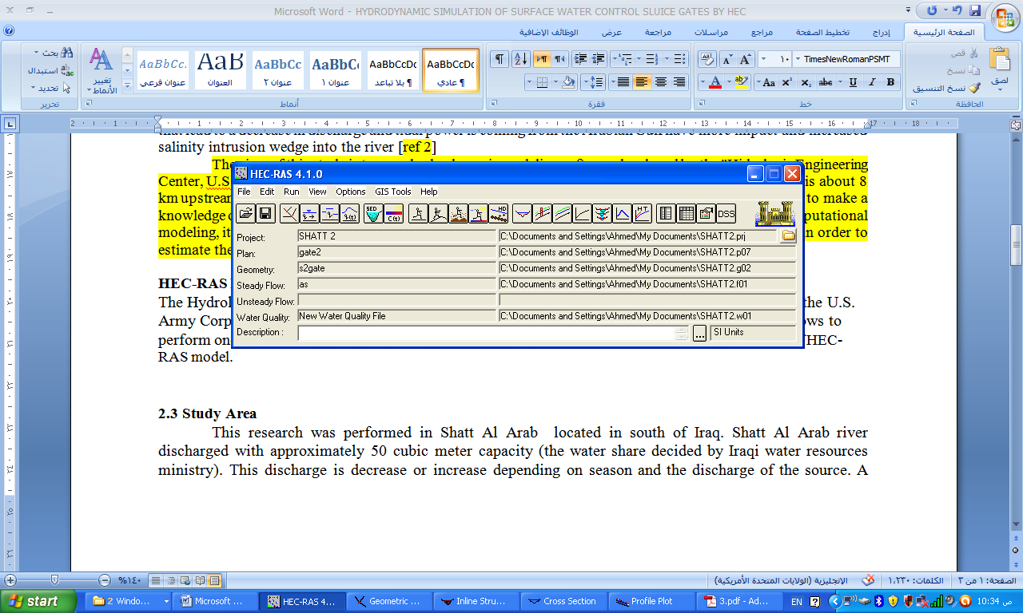
Fig.1: Main menu of HEC-RAS model

The flood modeling using HEC-RAS was performed in the following steps. The analysis of each step is presented in form of output in print screen mode.
2.1 Study Area
This research was performed in Shatt Al Arab river. Shatt Al Arab river discharged with approximately 50 m³/s capacity (the water share decided by Iraqi water resources ministry). This discharge is changed depending on the season and the discharge from the source. A design of three different sluice gates opening was taken. It simulates the water surface level using HEC-RAS. The location of the suggested sluice gate is decided to be approximately 3 km upstream of Abu Floos port (between Abu Floos river and Abu Al Khaseeb river), in the station of 122 Km upstream of Shatt Al Arab river estuary within Iraqi border and near the borders between Iraq and Iran. The suggested location is to insure the entrance of ships to Abu Floos port and to lead to the rise of river water level upstream of the gate, which is needed for irrigating the agricultural lands. A schematic diagram of Shatt Al Arab river is shown in Fig.(2).

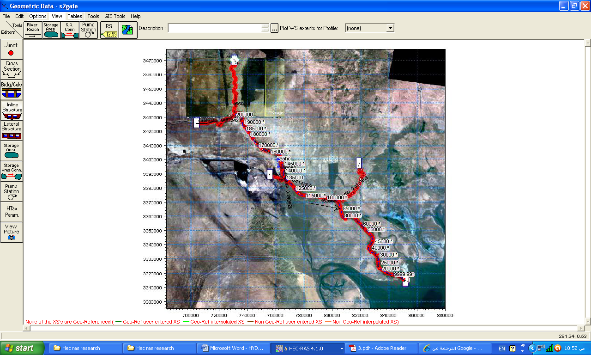
Garmat Ali river
Sluice gate
Euphrates
Tigres
Shatt Al Arab
Al-karon river
Fig. 2: Schematic diagram of the Shatt Al Arab river
  - Geometric Data
The next step is to enter the necessary geometric data which consist of cross-section data representing the geometric boundary of the stream. The required information for a cross-section consists of the river reach, the river station identifiers (station and elevation points) and main channel bank stations. The information required is displayed on the cross-section data editor as shown in Fig.(3).

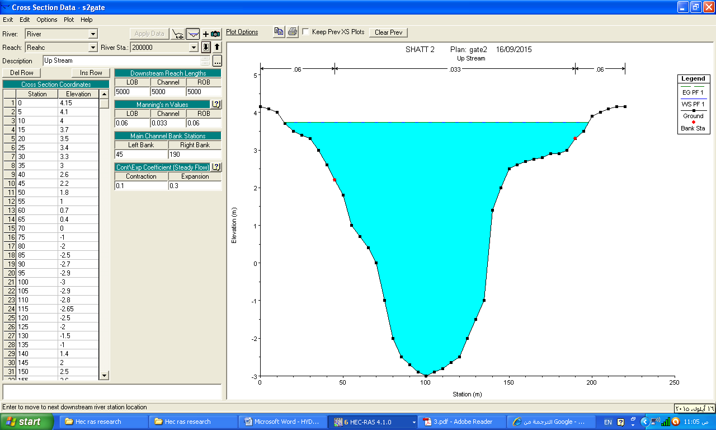
Fig.3: Cross-section data editor
2.3 Inline Structure Data
The suggested Shatt Al Arab river has total length of 600 m with uncontrolled spillway in left side saddle. Six sluice gates have maximum opening height of 4m. The necessary data for calculating the weir flow is weir width, weir coefficient and crest shape and it is used for schematic diagram. The gated spillway is added to the structure using the gate data editor. Moreover, physical description and required coefficient of gate is entered in HEC-RAS as shown in Figs. 4 and 5.
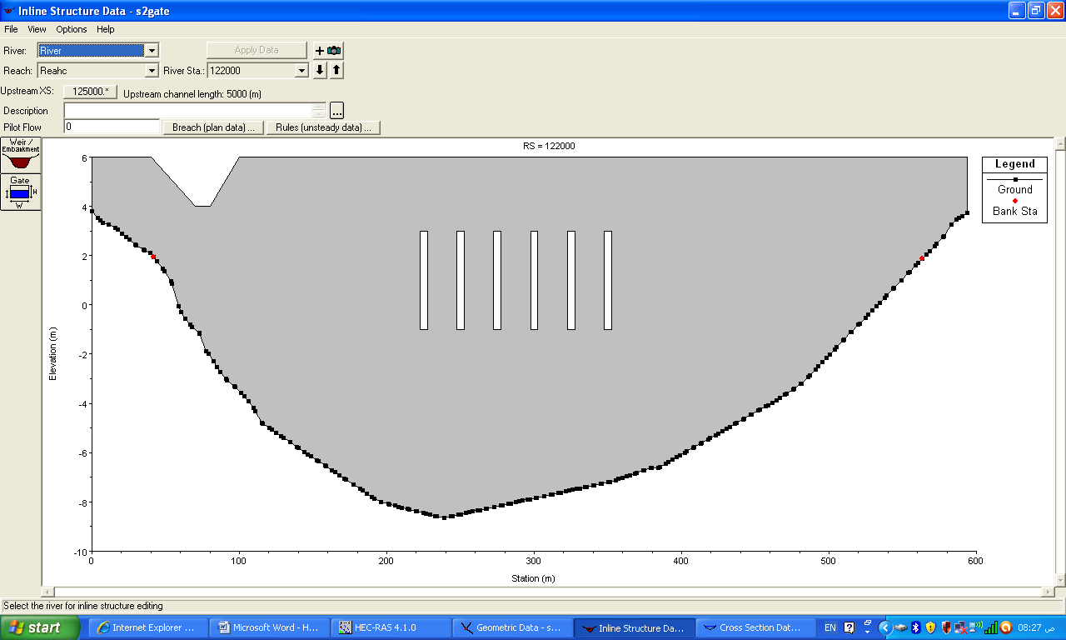
Fig.4: : Inline structure data

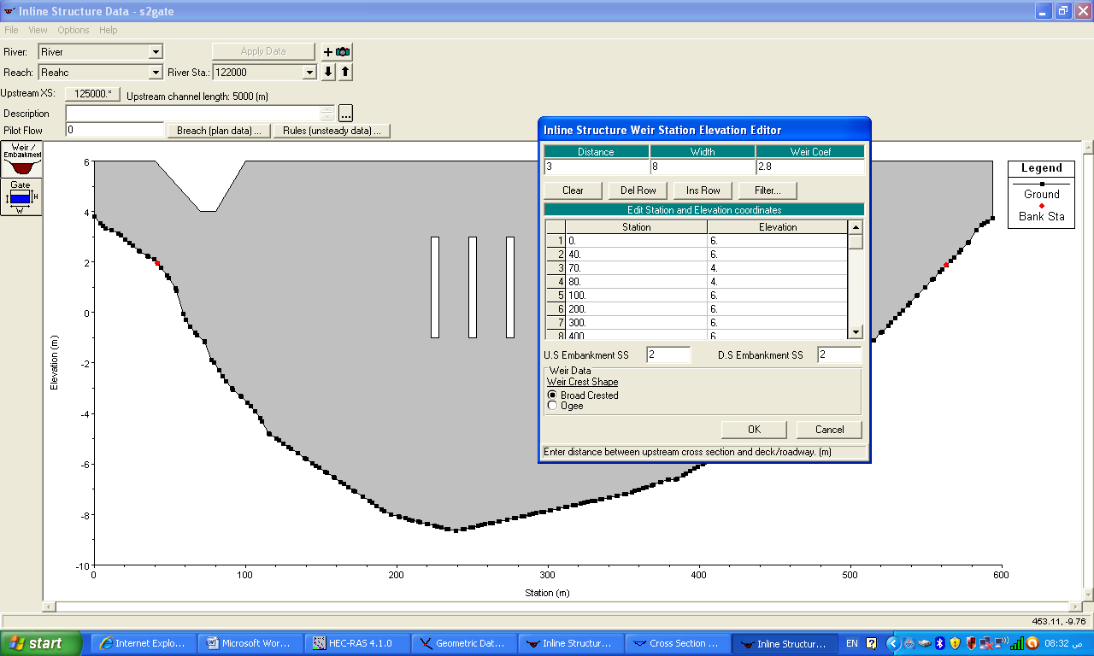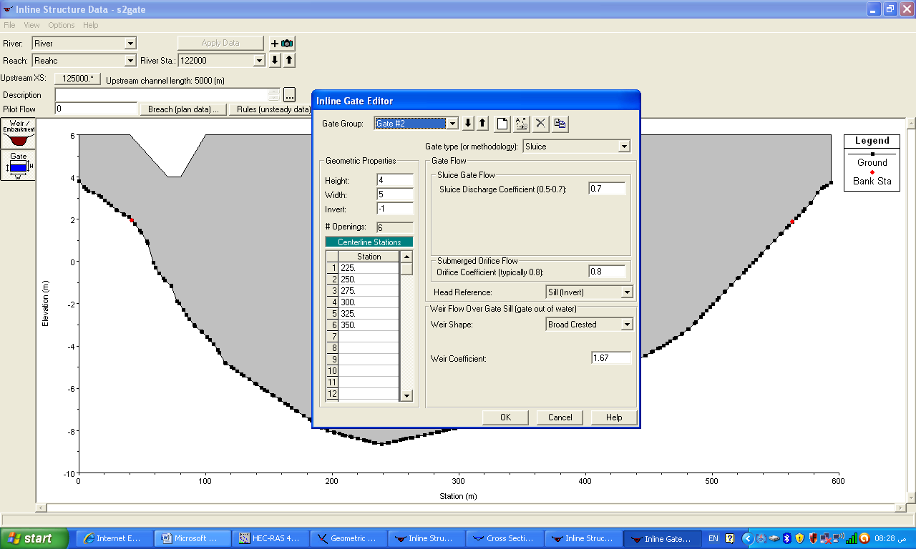

Fig.5: Gate and weir data

  - Entering Flow Data and the Boundary Conditions
The type of flow data entered depends upon the type of analysis to be performed in the project. In the present paper, the steady flow analysis is performed. In the upstream river discharge has been identified depending on the measurements of water resources directorate, daily field measurements in the Shatt Al Arab river (from the year of 2009 up to 2015). This shows that the water discharge upstream of the river is between 25 – 80 m³/s. Therefore six cases have been taken to show the effect of discharge on the water level profile which is (25, 50, 75, 100, 125, 150) m³/s. The high values of discharge are taken to insure gates working in worst flood conditions.
Boundary conditions are required to perform the calculations. In this study, the normal depth is used as a boundary condition and steady flow data and gate opening schedule are entered. As for six cases of flow rate is considered in the present modeling, all the gates are opened to their full extent, additional two cases of opening have also been taken (which are closed or 50 % opened) to study the effect of gate opening on water surface profile.
The flow data entered in HEC-RAS are shown in Fig. 6.

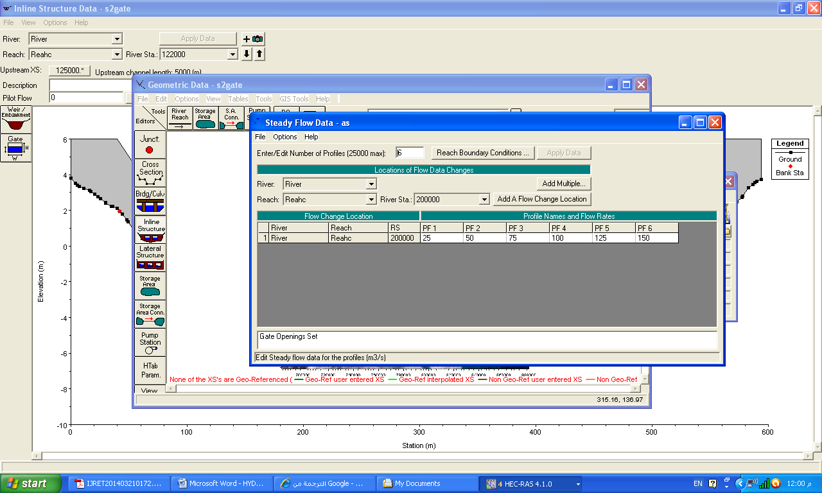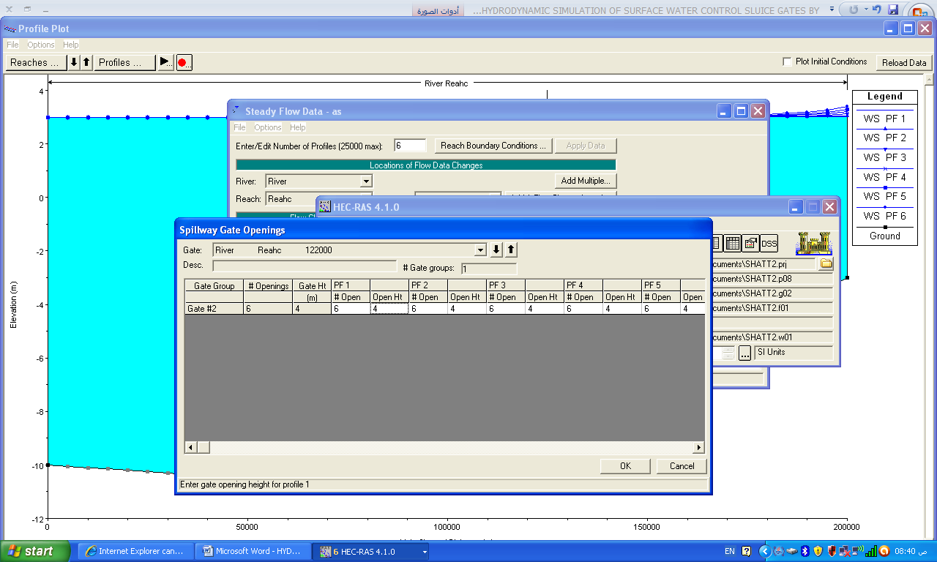

Fig .6: Steady flow data and spillway gate opening

- Results and Discussion
After selecting a suitable location for the sluice gate, the proportion of the opened gates to secure the appropriate water storage upstream of the sluice gate must be determine. In order to improve the networks, the designer must carefully calculate the elevation of the water in the downstream of the river. By depending on Total Tide software (by UK Hydrographic Office (UKHO) of Admiralty Way, Taunton, TA1 2DN, United Kingdom), the tide in Shatt al Arab river estuary can be identified. Two cases had been taken, the first is high water level and the second is low water level in Al Faw region (29º 58’N, 48º 29’E) which is the nearest to Shatt Al Arab river estuary. Total tide software shows that the highest high water doesn’t exceed 3 m and the lowest low water is not less than 0.7 m. Therefore the two cases are taken in this study (see Fig.7).

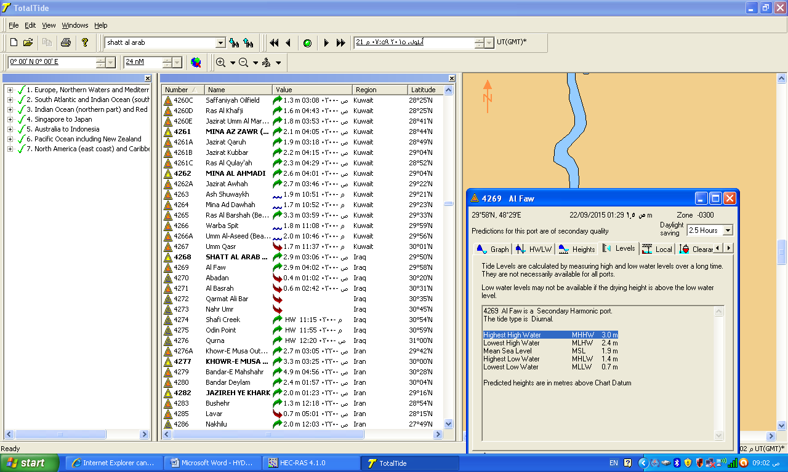
Fig.7: Total tide software

The study area in Shatt Al Arab river extends from km 00+00 in the river estuary to km 200 +00 in the river confluence. Shatt al Arab river widens over its course, expanding from a width of 250-300 m near the Euphrates-Tigris confluence to almost 700 m near the city of Basrah and about 2 km as it approaches the river mouth. The case study was adopted with the help of HEC-RAS application which is applied on Shatt Al Arab river for a length of (200 Km) divided into (40) cross sections, (see Fig. 8). To evaluate the effects of hydraulic structures along the river for the water surface elevation, flow modeling software HEC-RAS was performed on two cases of tide in the downstream and six cases of discharge in the upstream of the river as explained above.
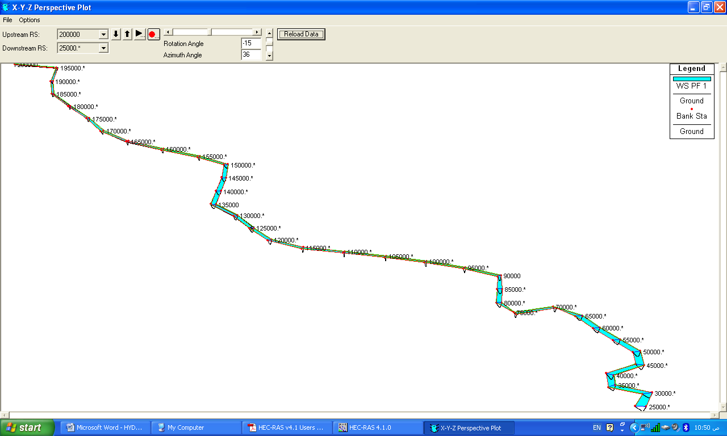
Sluice gate
Fig.8: Map of study area showing the locations of cross sections.

The typical value of Manning’s coefficient (n) for natural irrigation channels is (0.025) (Fenton, 2002) and for earth channels ranges from 0.022 to 0.033 (Gupta, 2007). Past experience of flow in Iraqi natural rivers indicates that the value of Manning's (n) may vary between 0.025 and 0.033 (BWRD, 1998) (Hamee, L.,H. et al. 2013). In this study the taken value of Manning’s is 0.03 which is within the range of Manning number and leads to converge the level of water between the measured and simulated values.
Figs.9, 11, and 13, represent the water level profiles for a discharge of (25, 50, 75, 100, 125 and 150) m³/s, considering a closed sluice gate, 50% opening and full opening respectively. The case of highest high water tide level in the estuary which is taken as 3 m. Figs. 10, 12 and 14 represent cross section of the gates that illustrate the levels of water for the above six cases of discharge.
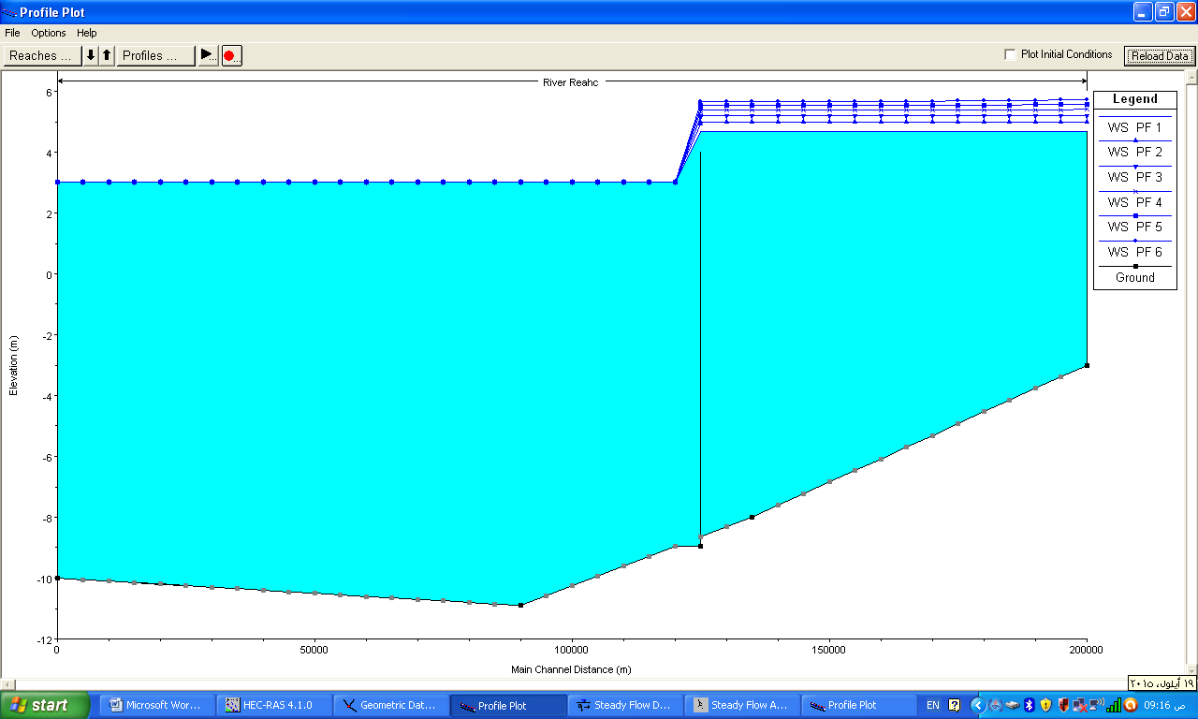 | 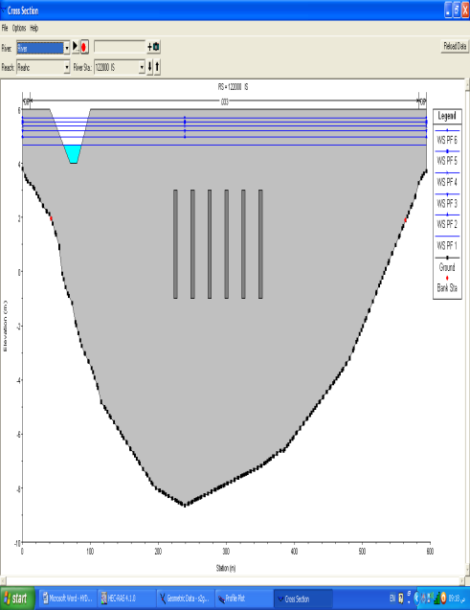
Fig.9: water level profiles for different discharge considering a closed sluice gates | Fig.10: Inline structure cross section
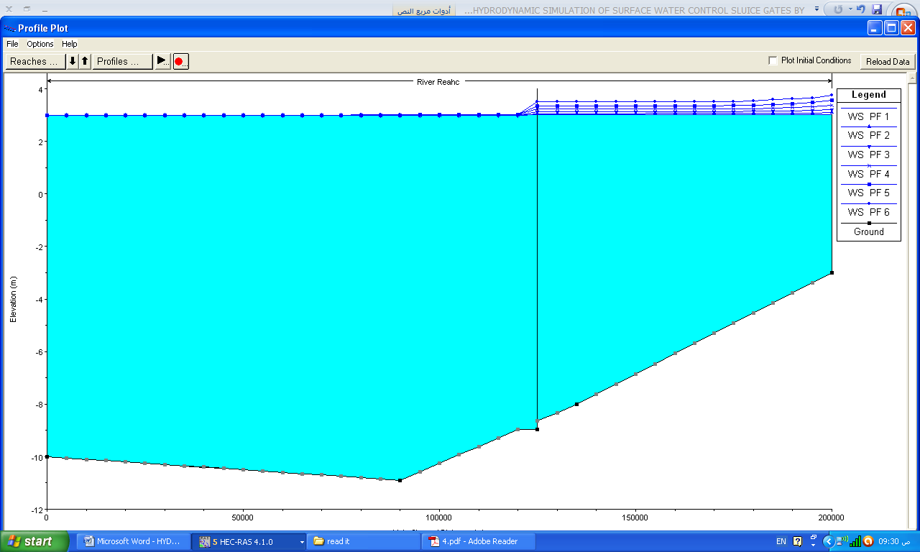Fig.11: water level profiles for different discharge considering 50% opening sluice gates | `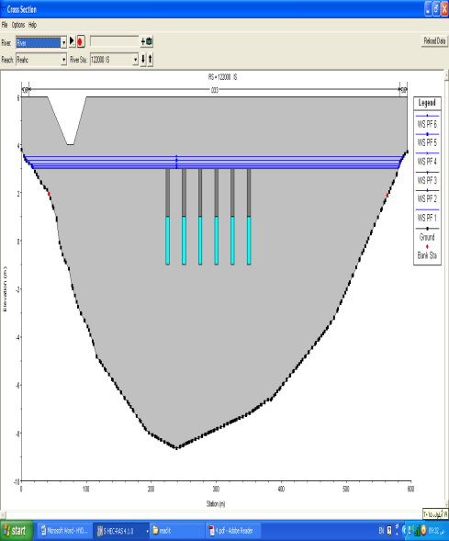  Fig.12: Inline structure cross section
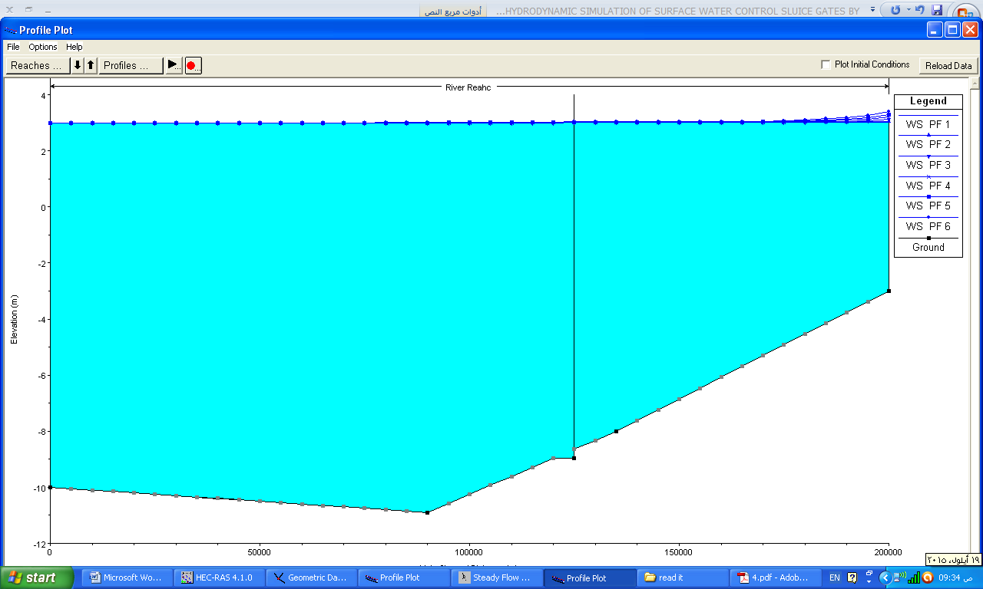 | 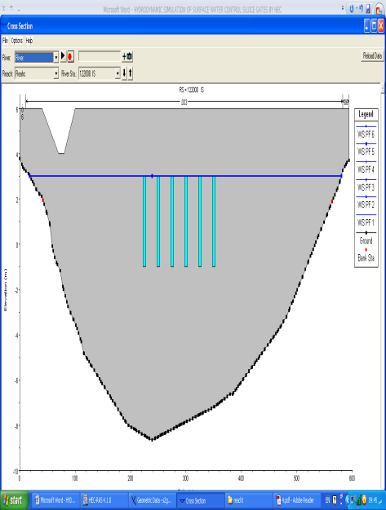
Fig.13:water level profiles for different discharge considering a full opening sluice gates | Fig.14: Inline structure cross section

Figs.15,17 and 19, represent the water level profiles for six cases of flow rates, considering a closed sluice gates, 50 % opened sluice gate, and full opened sluice gates respectively. The case of lowest low tide level in the estuary which is taken as 0.7 m. Figs. 16,18 and 20 represent cross section of the gates that illustrate the levels of water for the above six cases of discharge.
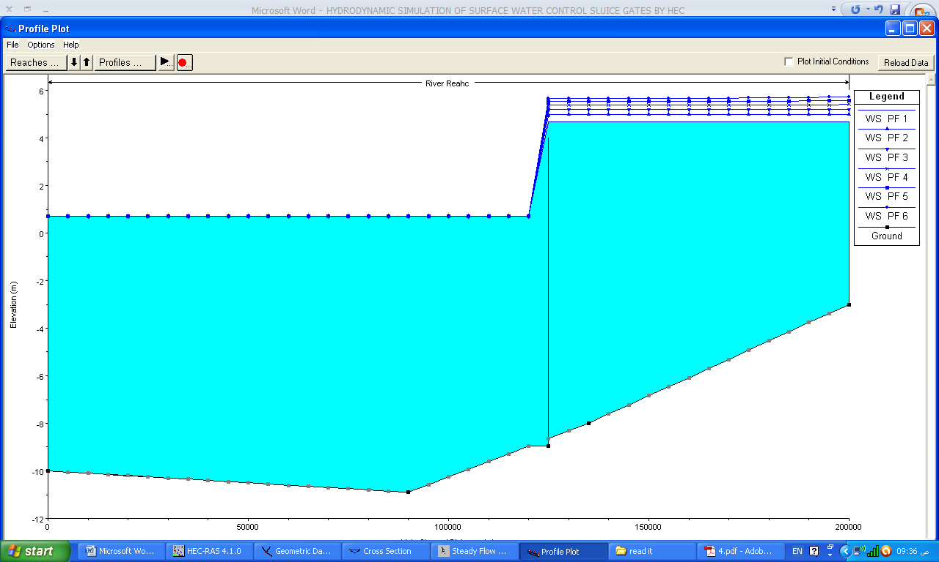 | 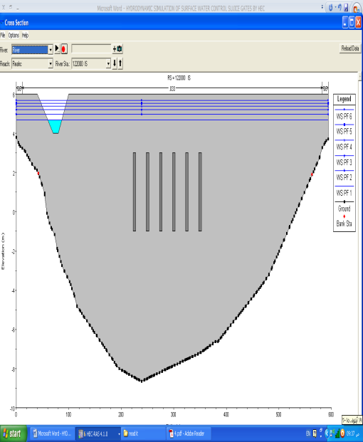
Fig.15: water level profiles for different discharge considering a closed sluice gates | Fig.16: Inline structure cross section
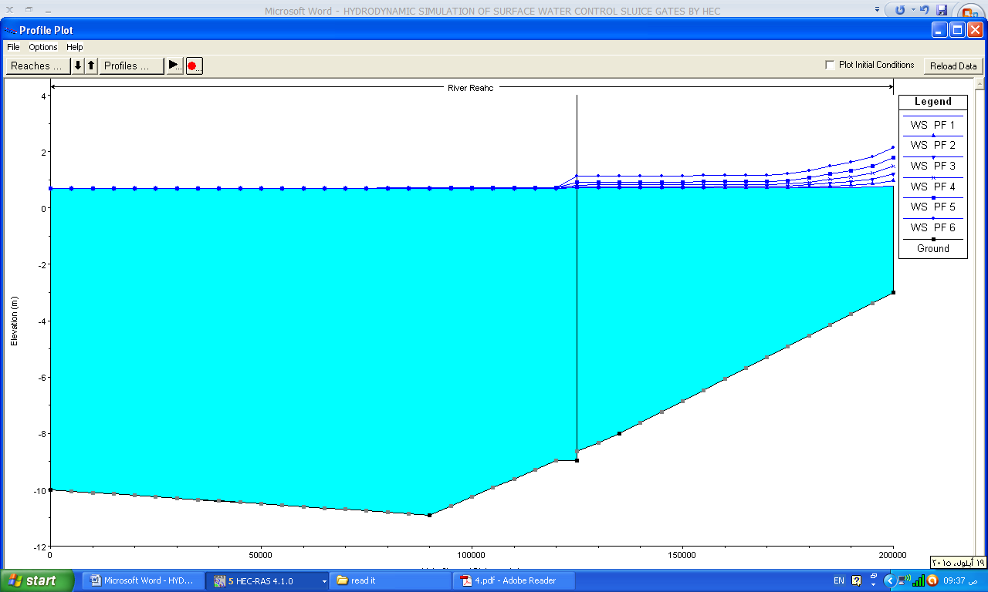 | 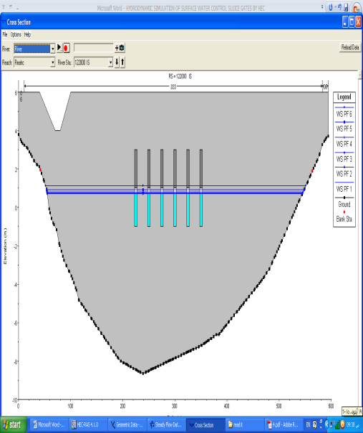
Fig.17: water level profiles for different discharge considering a 50% opened sluice gates | Fig.18: Inline structure cross section
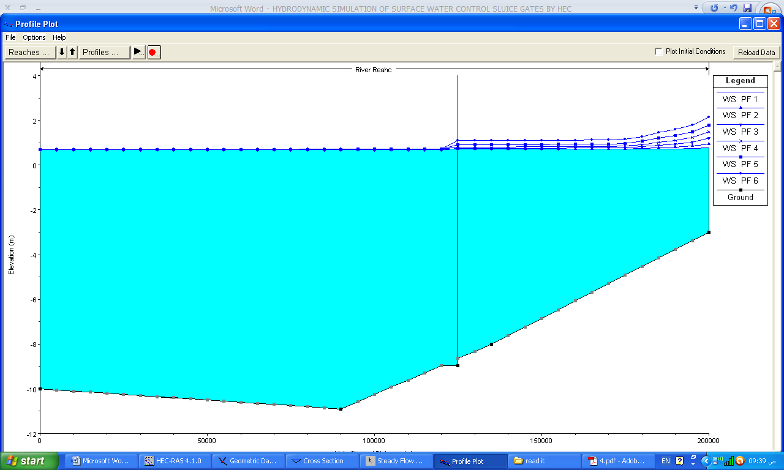 | 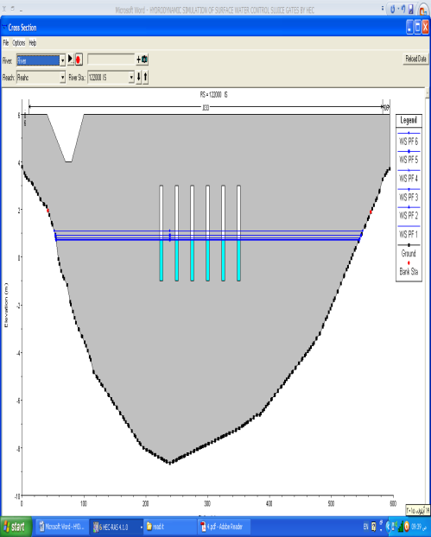
Fig.19: water level profiles for different discharge considering a full opened sluice gates | Fig.20: Inline structure cross section.
Installing the dam on Shatt Al Arab river helps to increase the water level to approximately 1 m when all gates were opened to their full extent as compared with the situation without a dam. Fig.21, is a comparison of water level for the river in two cases, that is with installing a dam and without the dam, for two cases of flow rates which are 25 and 150 m³/s.
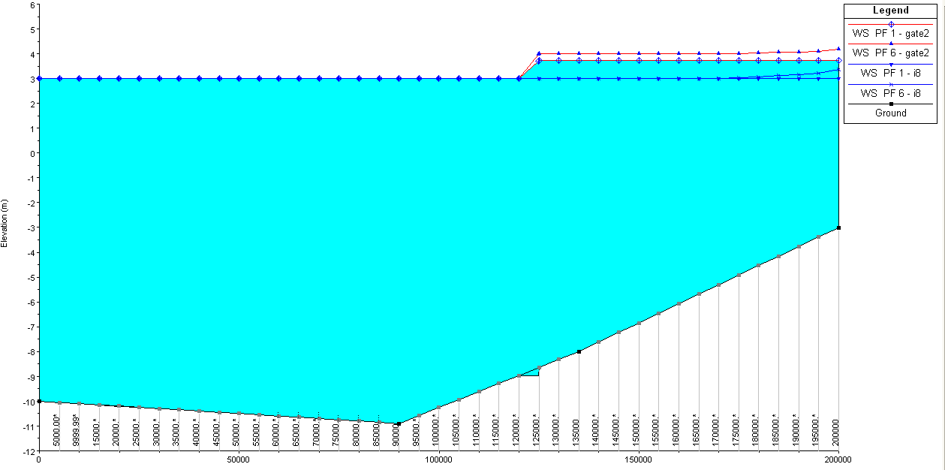

Fig.21: Comparison of two cases which is with installing the dam and without it
for two cases of flow rate (25 and 150 m³/s ).

4. Conclusions
- The HEC-RAS provides the water profile for the six cases of discharge. This profile will facilitate adopting the appropriate gates control to insure a reasonable level of water in the upstream of the river gate.
- Water surface modeling using HEC-RAS is an effective tool for hydraulic study and handling of river water management.
- Closing the sluice gates leads to the rise of water level to approximately 3 m, that leads to feeding the branches which irrigate the agricultural lands.
- Installing the dam leads to the rise of water level to 1 m when all gates are opened to their full extent as compared to the case of river without a dam.
- Installing the dam prevents saline wedge coming from the sea water from being mixed with river water.
- The suggested location of the gate allows the passage of ships to Abu Floos port and it also irrigates the agricultural lands in Abu Al Khaseeb and Basrah center up to Qurna region.
5. Suggestions
- Excavate an irrigation canal starting from this dam parallel to Shatt Al-Arab river and close to the road connecting Basrah city to Al- Fao city. All Shatt Al-Arab river tributaries downstream of the dam should be connected to this channel instead of Shatt Al Arab river. That results in reducing the effect of Arabian Gulf salinity.
- Installing a canal lock to convey the ships and boats to upstream of the dam.
6 .References
Al- Mahmood, H. 2009,"The monthly variations of discharge and effect that on a total dissolve suspended and salinity in Shatt al-Arab river (south of Iraq)", Journal of Iraq sciences, 50 (3): 355-368.
AL- Mahmood, H., Hassan,W., AL-Hello,A., Hammood, O., and Muhson, N. 2015,"Impact of low discharge and drought on the water quality of the Shatt al-Arab and Shatt al-Basra rivers (south of iraq)", Journal of international academic research for multidisciplinary, 3(1): 285-296.
Al-Ansari, N., Ali, A. and Knutsson, S.2014 ," Present Conditions and Future Challenges of Water Resources Problems in Iraq", Journal of Water Resource and Protection, 6: 1066-1098.
Aliakbari, M., Pilpayeh, A. and Raoof, M. 2012 ,"Study and simulation of hydraulic and structural changes result of changing of section from soil to concrete,"International Journal of Advanced Technology & Engineering Research (IJATER), 2(4): 231-234.
Hamdan, A. 2008," 2d sediment transport modelling to the Shatt al-Arab river estuary", Journal of Basrah Researches (Sciences), 34(4): 50-59.
Hamee, L.,H. and Ali, S., T. 2013," Estimating of Manning’s Roughness Coefficient for Hilla River through Calibration Using HEC-RAS Model", Jordan Journal of Civil Engineering, 7(1): 44-53.
Khassaf, S.,I., Maatooq,J., S. and Nasrallah, S., A.2009,"Mathematical Modeling of water surface at Unsteady Flow in Al-Msharah River", Kufa Journal of Engineering, 1(1): 118-136.
Moyel, M., S.2014,"Assessment of water quality of the Shatt Al-Arab River, using multivariate statistical technique", Mesopotamia Environmental Journal (MEJ), 1(1): 39-46.
Pilpayeh, A.,Shahbazi, A. N. and Abbasalilou, H., B.2014 ,"Hydrodynamic simulation of surface water control sluice gates by hec-ras model", 2nd International Conference-Water resources and wetlands.11-13 September,Tulcea (Romania).
US Army Corps of Engineers, 2010"HEC-RAS River Analysis System, Applications Guide Version 4.1", Hydrologic Engineering Center, January.
US Army Corps of Engineers, 2010,"HEC-RAS River Analysis System, User’s Manual Version 4.1", Hydrologic Engineering Center, January.
Xiong,Y.2011,"A Dam Break Analysis Using HEC-RAS", Journal of Water Resource and Protection, 3: 370-379.

