Buckling Optimization of Thick Stiffened Cylindrical Shell

Qasim Hassan Bader Israa Saad Alshukri
Department of Mechanical Engineering, College of Engineering , University of Babylon
drqasimbader@yahoo.com & mec.enga@yahoo.com
Abstract:
In this work the critical pressure due to buckling was calculated numerically by using ANSYS¹⁵ for both stiffened and un-stiffened cylinder for various locations and installing types , strengthening of the cylinder causes a more significant increase in buckling pressures than non reinforced cylinder . The optimum design of structure was done by using the ASYS¹⁵ program; in this step the number of design variables 21 DV^{s}. These variables are Independent variables that directly affect. The design variables represented the thickness of the cylinder and( height and width of 10 stiffeners). State variables (SV^{s}), these variables are dependent variables that change as a result of changing the DVs and are necessary to constrain the design. The objective function is the one variable in the optimization that needs to be minimized. In this case the state variable is critical pressure (CP) and the objective function is the total (volume) of the structure. The optimum weight of the structure with reasonable required conditions for multi types of structure was found. The result shows the best location of stiffener at internal side with circumferential direction. In this case the critical pressure can be increased about 18.6% and the total weight of the structure decreases to 15.8%.
Key words: Ring-stiffened cylindrical shell , Hydrostatic external pressure ,Optimization theory , Buckling theory .
الخلاصة
في هذا العمل يتم حساب الضغط الحرج الناتج عن الانبعاج باستعمال برنامج الانسزفي حالة وجود اوعدم وجود (stiffeners) ان اضافة حلقات التقوية يؤدي الى زيادة الضغط الحرج (optimum design).ايجاد الحل الامثل للاسطوانة بأستعمال برنامج الانسز في هذه المرحلةعدد متغيرات التصميم (21) متغير هذه المتغيرات هي متغيرات مستقلة ذات تاثير مباشر.هذه المتغيرات هي سمك الاسطوانة وارتفاع وسمك حلقات التقوية لعشرة حلقات تقوية . (state variables )هذه المتغيرات هي متغيرات تابعه وتتغير بتغير متغيرات التصميم . دالة الهدف ,هي واحده من المتغيرات للحصول على الحل الامثل والتي من الضروري تقليلها وفي هذه الحالة فأن (state variables)هو الضغط الحرج.كما تم ايجاد الوزن الامثل للتصميم عند الظروف المطلوبة ولاكثرمن تصميم .النتائج تبين بأن موقع الستفنر على السطح الداخلي وبصورة حلقية يعطي افضل قيمة للضغط الحرج بزياده مقدارها 18.6% ويقلل الوزن الكلي للاسطوانه بنسبة 15.8%.
الكلمات المفتاحية :الاسطوانات المقواة , الضغط الخارجي الهايدروستاتيكي , نظرية الحل الامثل ,نظرية الانبعاج
1-Introduction
The extensive use of stiffened shells in aerospace industries is mainly motivated by the high stiffness-to-weight and strength-to-weight ratios. In China’s newly developed launch vehicle, stiffened shell still plays a significant role in fuel storage and load-carrying aspects [Wang,2011]. For cylindrical shell structures, buckling is one of the main failure patterns. Several methods and programs are available for the analysis of stiffened panels and shells, ranging from simple closed form solutions to complicated discrete solutions. Several simple analysis methods, such as Smeared Stiffener Method (SSM) and simple analytical models were utilized to calculate the critical buckling load of stiffened shell for preliminary design [Kidane,2003]. However, these methods are based on linear assumption, thus they cannot account for the nonlinearity of buckling behavior. For practical designs, the collapse load needs to be calculated to represent the load-carrying capacity of stiffened shell. Finite Element Methods (FEM),including nonlinear explicit dynamic method and implicit approaches, such as Newton-Raphson method and modified Riks’ arc-length method, have been commonly employed to simulate the Buckling behavior of stiffened shells[Bushnell and Bushnell,1995]. Newton-Raphson method was utilized to perform the buckling analysis of stiffened shell by [Wu et. al., 2010]. However, the convergence of this analysis is difficult to guarantee, especially after skin buckling occurs. [Huang et. al.,2010]carried out the buckling analysis of stiffened shell under axial compression using explicit dynamic method. Compared to nonlinear implicit approaches, explicit dynamic method allows to investigate the deformed shape evolution of stiffened structure from pre-buckling to buckling field until collapse. In other words, the position where collapse occurs can be captured accurately by the explicit dynamic analysis. Many optimizations have been carried out for metallic and composite stiffened shells against buckling. [Leriche et. al., 1993] demonstrated the efficiency of the genetic algorithm in dealing with global optimization and discrete design variables for stiffened panels. A design strategy for optimum design of grid-stiffened shells subjected to global and local buckling constraints and strength constraints was developed based on genetic algorithm by [Jaunky et. al.,1998]. In the previous work, the variables involved in the optimizations were usually stiffener size, stiffener spacing, skin laminate sequence and angle, etc [Hao et. al.1995]. The layout optimizations of stiffened shells are rarely reported, which are capable of increasing the bending stiffness without the increase of structural weight.[Sadeghifar et. al.,2010] performed a multi objective optimization of stiffened shells for minimum weight and maximum axial buckling load.
2- Buckling theory
Buckling is a mathematical instability, leading to a failure mode. Theoretically, buckling is caused by a bifurcation in the solution to the equations of static equilibrium. At a certain stage under an increasing load, further load is able to be sustained in one of two states of equilibrium and un-deformed state or a laterally deformed state.
In practice, buckling is characterized by a sudden failure of a structural member subjected to high compressive stress, where the actual compressive stress at the point of failure is less than the ultimate compressive stresses that the material is capable of withstanding. For example, during earthquakes, reinforced concrete members may experience lateral deformation of the longitudinal reinforcing bars. This mode of failure is also described as failure due to elastic instability. When load is constantly being applied on a member, such as column, it will ultimately become large enough to cause the member to become unstable. Further load will cause significant and somewhat unpredictable deformations, possibly leading to complete loss of load-carrying capacity. The member is said to have buckled, to have deformed. There are two types of buckling analysis :-
A- Nonlinear buckling analysis

Nonlinear buckling analysis is usually the more accurate approach and is therefore recommended for design or evaluation of actual structures. This technique employs a nonlinear static analysis with gradually increasing loads to seek the load level at which your structure becomes unstable.as depicted in Figure (1.a) using the nonlinear technique, your model can include features such as initial imperfections, plastic behavior, gaps, and large-deflection response. In addition, using deflection-controlled loading, you can even track the post-buckled performance of your structure (which can be useful in cases where the structure buckles into a stable configuration, such as "snap-through" buckling of a shallow dome).
B- Eigen value buckling analysis:
Eigen value buckling analysis predicts the theoretical buckling strength (the bifurcation point) of an ideal linear elastic structure See Figure(1.b). For instance, an Eigen value buckling analysis of a cylinder will match the classical Euler solution. However, imperfections and nonlinearities prevent most real-world structures from achieving their theoretical elastic buckling strength. Thus, Eigen value buckling analysis often yields un conservative results, and should generally not be used in actual day-to-day engineering analyses.

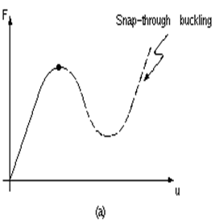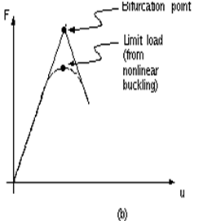
Fig .(1.a) Nonlinear load-deflection curve. Fig. (1.b)Linear(Eigen- value) buckling curve.

3-Buckling Results Of Stiffened and Un Stiffened Cylinder .
The critical pressure as a function to mode shape for both stiffened and un stiffened cylinder is done. The critical pressures is estimated by applying hydrostatic pressure of (1MPa) and solve the model by Eigen value buckling analysis to get the critical pressure versus mode number for each case. Figure (2) shows the results of critical pressure versus mode number for cylinder alone without any stiffener (CA), from this figure the results show the critical pressure for CA in the first mode is (25.87MPa) this value for FEM and theoretical according to (equ.1) this value is( 24.4MPa) for nodal diameter is 2, the percentage of error between FEM and theoretical is 6% .The value of critical pressure for CI shown in figure (3) is (36.56MPa) this value by FEM but for theoretical method this value is (35.5MPa) according to (eq.2) the percentage of error between FEM and theoretical is 3%.The value of critical pressure for CEL is (24.2MPa) shown in figure (6) this value by FEM but for theoretical method this value is (24.7MPa) according to (eq.3) [Nguyen,2002] the percentage of error between FEM and theoretical is 5.7%.
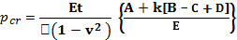${\text{Pcr}}^{=\frac{\text{Et}}{r(1−v^{2})}}\left\{\frac{A+k[B−C+D]}{E}\right\}$ (equ.1)
A=
B=
C=
D=2(2-v)$λ^{2}m^{2}+m^{4}$
E=$m^{2}(λ^{2}+m^{2})^{2}−m^{2}(3λ^{2}+m^{2})$
E = Modulus of Elasticity
r = Mean cylinder radius
t = thickness of cylinder
ν = Poisson’s ratio
m = nodal diameter
Buckling equation of stiffened cylindrical shell(circumferential stiffeners) ,
$P_{\text{cr}}=\frac{E(tr}{1−v^{2}}\left[\frac{(1−v^{2})}{(m^{2}−1)\left[\frac{m^{2}L^{2}}{m^{2}r^{r}}\right]}\right]+\left[\frac{E(tr)^{3}}{\text{12}(1−v^{2}}\right] \left[m^{2}−1+\frac{2m^{2}−1−v}{\frac{m^{2}L^{2}}{π^{2}r^{2}}−1}\right]$ (equ.2)
Buckling equation of stiffened cylindrical shell(longitudinal stiffeners)

p_{cr} = $\frac{1}{{Rπ}^{2}λ^{2}L^{2}}(D+\frac{B^{2}}{A}=\frac{1}{(\frac{R}{π})^{3π2λ4}}(\overset{−}{D+\frac{\overset{−2}{B}}{\overset{−}{A}}})$(equ.3)
To get an idea about the effect of stiffeners on the value of critical pressure as a function to mode number, the same analysis was done for all types of stiffened cylinder. Figure (3) shows the critical pressure versus mode number for stiffened cylinder with internal circumferential stiffener CI. Figure (4) shows the critical pressure versus mode number for external circumferential stiffener CE. Figure (5) shows the critical pressure versus mode number for internal longitudinal stiffener CIL. Figure (6) shows the critical pressure versus mode number for external longitudinal stiffener CEL. Table (1) will summarize the results of critical pressure as a function for mode shape for figure.(2) to figure.(6).
From the above buckling theory, strengthening of the ring causes a more significant increase and slightly buckling pressures than non-reinforced cylinder.With the added enhancement of the ring, the buckling pressure increases. Also the effect of ring stiffening was to increase the buckling resistances. There are good agreements between the numerical and experimental results. The number of stiffeners was varied around the circumference and along the length of the cylinder, and the stiffness values of these supports were varied. As a result of the analysis it was shown that there was a maximum level of improvement that can be obtained for a given number of stiffeners around the circumference of the shell. Furthermore increasing the number of stiffeners around the circumference of the shell in the middle of the shell length increases the critical buckling greatly.

Table (1) critical pressure of structure versus mode number

Mode shape | CA (MPa) | CI(MPa) | CE(MPa) | CIL(MPa) | CEL(MPa)
Mode 1 | 25.87 | 36.56 | 35.2 | 25.9 | 24.2
Mode 2 | 26.7 | 37.6 | 36 | 26.85 | 27.8
Mode 3 | 27.1 | 38.4 | 39 | 27.2 | 30.6
Mode 4 | 27.3 | 38.6 | 40.4 | 27.5 | 33.1

Table (2) critical pressure of CA.

Mode shape | CA(FEM)MPa | CA(Theoretical)MPa | Nodal Diameter (m)
Mode 1 | 25.87 | 24.4 | 2
Mode 2 | 26.7 | 25.9 | 2
Mode 3 | 27.1 | 26.7 | 4
Mode 4 | 27.3 | 26.5 | 4

Table (3) critical pressure of CI.

Mode shape | CA(FEM)MPa | CA(Theoretical)MPa | Nodal Diameter (m)
Mode 1 | 36.56 | 35.5 | 2
Mode 2 | 37.6 | 36.9 | 2
Mode 3 | 38.4 | 37.4 | 4
Mode 4 | 38.6 | 38.1 | 4

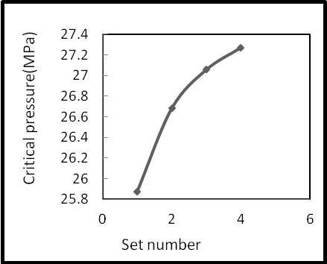
Fig.2 critical pressure for un-stiffened (CA).
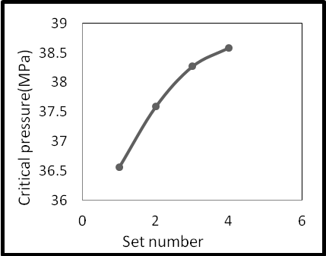
Fig.3 Critical pressure for internal stiffened cylinder (CI).
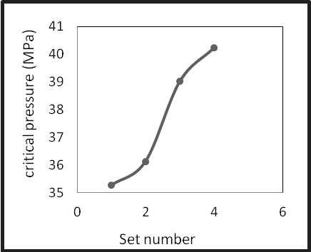
Fig.4 critical pressure for external stiffened (CE)
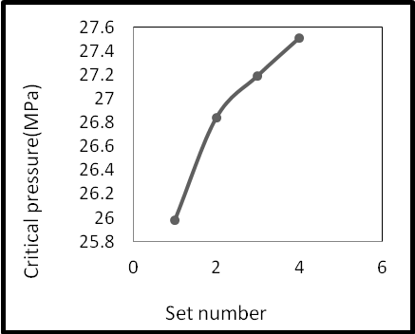
Fig.5 Critical pressure for internal longitudinal stiffened cylinder (CIL).
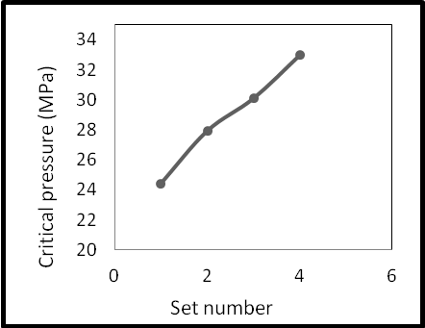
Fig.6 Critical pressure for internal longitudinal stiffened cylinder (CEL).

Generally when inspect the values of critical pressure in table (1), it is clear that the values of this pressure increased with existing the stiffeners. But when we wanted to make a comparison between the stiffened shell, it is clear that the circumferential stiffeners for both internal and external type (CI and CE) are best than longitudinal stiffeners (CIL and CEL). Also when comparing the result between internal stiffeners only, this is a function of mode shape and change according to mode number as shown in table (2).
4-Structural Optimization
Optimization may be defined as the process of maximizing or minimizing a desired objective function while satisfying the prevailing constraints. In every stage of design, construction and maintenance of engineering systems, engineers are bound to take certain technological and managerial decisions. The ultimate goal of all such decisions is either to minimize the effort required or maximize the desired benefit. Since either of these goals in any physical situation can be expressed as a function of certain design variables, optimization may also be defined as the process of finding the conditions that give the maximum or minimum value of a function that was detailed by [Krishna,2009] In engineering optimization can be used to solve any problem. Some typical applications from different engineering disciplines are:-
-Design of aircraft and aerospace structures for minimum weight.
-Vibration and noise optimization of automobile for ride quality, comfort and handling.
- Optimal design of electric networks.
- Analysis of statistical data and building empirical models from experimental results to obtain the most accurate representation of the Physical phenomenon.
The design variables in this work are (, ,) where →These variables are Independent variables that directly affect the design objective. State variables (SVs) are dependent variables that change as a result of changing the DVs. These variables are necessary to constrain the design. The objective variable is the one variable in the optimization that needs to be minimized. In this work the objective variable is the volume of cylinder. Two methods are used in this work for optimization, the first method is Monte-calo method and the other method is Sub-problem method. The optimization program has been written using ANSYS¹⁵ parametric design language (APDL) .
5- Structural optimization theory
Structural optimization has received increasing attention in civil, chemical and especially aeronautical engineering with the advent of high speed computers. The tools of structural optimization are no longer resituated to the classical differential calculus and variation calculus .Indeed, various numerical search techniques have been developed over the past three decades .This chapter, presents a review to the element of structural optimization, fundamentals of structural optimization and the concept of design method. [Belegundu,2005] described that the optimization may also be defined as the process of finding the conditions that give the maximum or minimum value of a function. Optimization is the act of obtaining the best result under given circumstances. Engineers have to take many technological and managerial decisions at several stages. The ultimate goal of all such decisions is either to minimize the effort required or to maximize the desired benefit. Since the effort required or the benefit desired in any practical situation can be expressed as a function of certain decision variables. It can be seen in fig.(7) that if a point ($χ$) corresponds to the minimum of function f($χ$), the same point also corresponds to the maximum value of the negative of the function, -f($χ$). Thus without loss of generality, optimization can be taken to mean minimization since the maximum of function can be found by seeking the minimum of the negative of the same function. There is no single method available for solving all optimization problems efficiently. [Rao,1996] showed a number of optimization methods developed for solving different types of optimization problems.

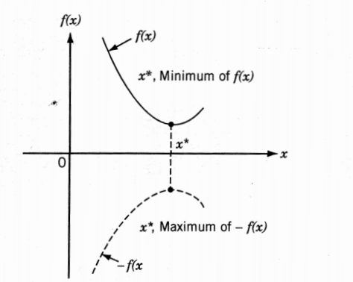
Fig.7 Maximum and minimum value of a function f(ᵡ).

6-Objective function
The conventional design procedures aim at finding an acceptable or adequate design which merely satisfies the functional and other requirements of the problem. In general, there will be more than one acceptable design, and the purpose of optimization is to choose the best one of the many acceptable designs available. Thus a criterion has to be chosen for comparing different alternative acceptable designs and for selecting the best one. The criterion with respect to which the design is optimized, when expressed as a function of the design variables is known as the criterion or merit or objective function the choice of objective function is governed by the nature of problem. The objective function for minimization is generally taken as weight in aircraft and aerospace structural design problems. In civil engineering structural designs, the objective is usually taken as the minimization of cost
7-Design variables
Selection of appropriate design variables is one of the most important decisions in creating a design model. Factors to be considered are:
1-Each design variable has appreciable influence on the objective and/or the constraint functions
2-Each design variable is directly related to physically significant quantity such as dimension of part. So that designer can modify the drawing or the hardware based on the responded design.
3-In the most method used, the total number of design variables may be limited only by the computational resources(i.e. memory size,secondary storage size,etc.) The optimization process is efficient for reduced number of design variables that are shown by [Qasim,2003].
In many practical problems, the design variables cannot be chosen arbitrarily rather, have to satisfy certain specified functional and other requirements. The restrictions that must be satisfied to produce an acceptable design are collectively called design constraints .Constraints that represent limitations on the behavior or performance of the system are termed behavior or functional constraints that were noticed by [Krishna,2009].
8-Finite Element Modeling and Data.
The element used for cylindrical shell:(SOLID72) has 6 degrees of freedom (UX,UY, UZ, ROTX, ROTY, ROTZ).And the element for stiffeners is (BEAM 188)this type of element also has six degrees of freedom, and the material is steel AISI tempered at 425᾽C, was selected in this work.
The cylindrical shell model.
Radius (r) = 0.25m.
Length (h) = 1.2m.
Thickness (t) = 0.015m.
Poisson’s ratio (p) = 0.3.
Young’s modulus (E) = 210MPa.
Width of stiffener = 0.02m.
Height of stiffener = 0.01m.
The same applied boundary condition given by [Ruud,2013] is also used in this work . The external pressure load is applied on the external surface of the cylindrical shell models
9-Optimization Result.
The final stage of this work is the optimization of cylinder based on buckling strength. This means that, if we can get the optimum design or change the design into better state than existing design. In this case the design variables (TH, WIS_{i}, HIS_{i}, WES_{i,} and HES_{i}) where i represents the total number of stiffeners,these variables are Independent variables and normally represent the dimensions of geometry that directly affect the design objective. The State variables (SVs) which represent dependent variables that change as a result of changing the DVs and normally represent the state of stress or the strength of structure. These variables are necessary to constrain the design. The objective function is the one variable in the optimization that needs to be minimized. In this thesis the state variable is critical buckling pressure and the objective function is the total volume of the cylinder. There are several different methods which can be used to solve the optimization problem numerically and to ensure that you are not finding a solution at a local minimum, it is advisable to use different solution methods.
A- Optimum design variables (DV^{s})
Figure (8) and figure (9) show shell thickness versus set number for both cylinder alone (CA) and also for cylinder with internal stiffener (CI) respectively. From these figures the thickness of cylinder without stiffener (CA) is changing from 0.015 m to 0.011 m which represents the best value that can be obtained.Also the shell thickness of cylinder with internal stiffener (CI) is changing from 0.015 m into 0.0119 m which represent the best value that can be obtained during the constraints required.

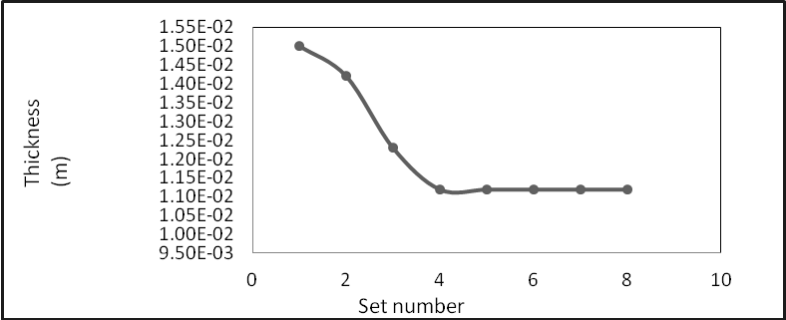
Fig. 8 cylinder thickness (CA) versus set number.
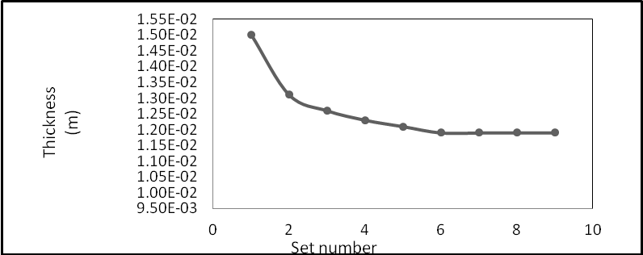
Fig. 9 cylinder thickness (CI) versus set number.

Also for the optimum design set for the stiffeners dimensions (height and width) of each stiffener, figure(10) shows the width of internal stiffener number one (WSI₁) versus the set number, the best value of this variable that can be obtained is changing from 0.02 m to 0.013 m.
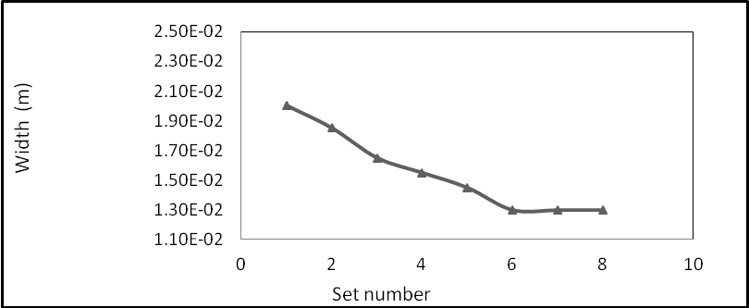
Fig. (10) width of stiffener for (CI) versus set number.

Figure.(11) shows the height of internal stiffener number one (HSI₁) versus set number, from this figure the value of this stiffeners is changing from 0.01 m to 0.008 m which represents the best set that can be obtained.

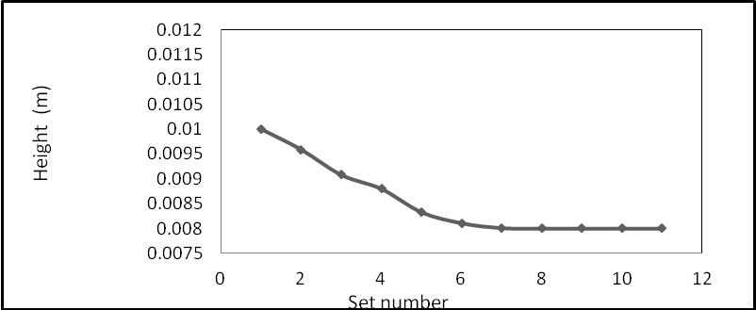
Fig.11 height of stiffener for (CI) versus set number.

The optimum design variables for cylinder with external stiffener (CE) was done by the same procedure, figure.(12) shows the thickness of cylinder versus the set number, from this figure the shell thickness changes from primary value of 0.015 m to 0.0106 m which represents the best design value which can be obtained.Also from figure.(13) shown the width of first external stiffener (WSE₁) versus the set number, from this figure the optimum value is 0.0123 m. Figure. (14) shown the height of first external stiffener (HSE₁) versus set number, from this figure the optimum value is 0.0082m. The optimum design variable for cylinder with internal stiffener (CIL) were done by the same procedure, figure.(15) shows the thickness of cylinder versus the set number, from this figure the shell thickness changes from primary value of 0.015 m to 0.0101 m which represents the best design value which can be obtained. Also figure.(16) shows the width of first external stiffener (WSE₁) versus the set number, from this figure the optimum value is 0.0169 m. Figure.(17) shows the height of first external stiffener (HSE₁) versus set number, from this figure the optimum value is 0.0083m.

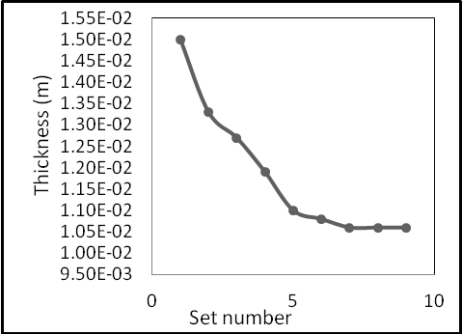
Fig.(12) cylinder thickness (CE) versus set number.
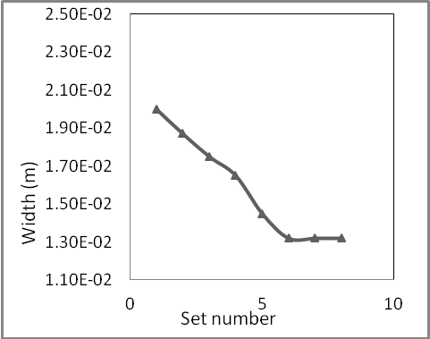 Fig. 13width of stiffener for (CE) versus set number.
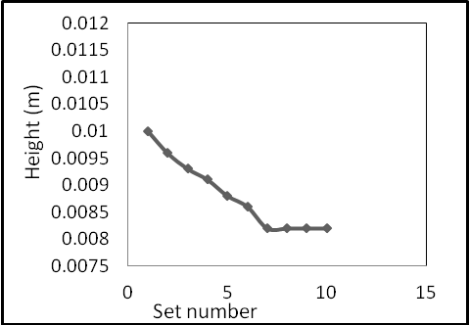
Fig.14 height of stiffener for (CE) versus set number.
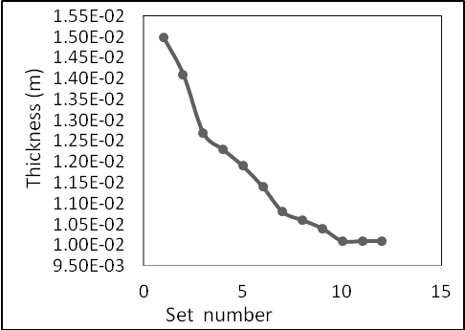
Fig.15 cylinder thickness (CIL) versus set number.
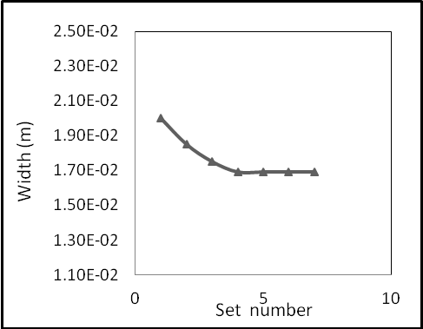
Fig. 16 width of stiffener for (CIL) versus set number.
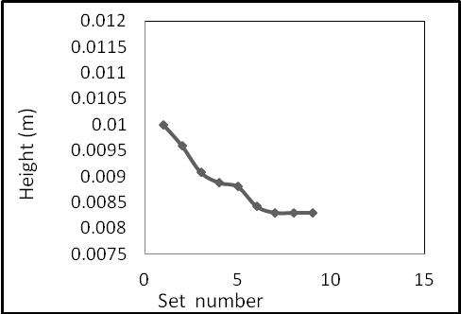
Fig. 17 height of stiffener for (CIL) versus set number.

The optimum design variables for cylinder with external stiffener (CEL) were done by the same procedure, figure.(18) shows the thickness of cylinder versus the set number, from this figure the shell thickness changes from primary value of 0.015 m to 0.0129 m which represents the best design value which can be obtained. Also figure.(19) shows the width of first external stiffener (WSE₁) versus the set number, from this figure the optimum value is 0.17 m.Figure.(20) shows the height of first external stiffener (HSE₁) versus set number, from this figure the optimum value is 0.0081 m.
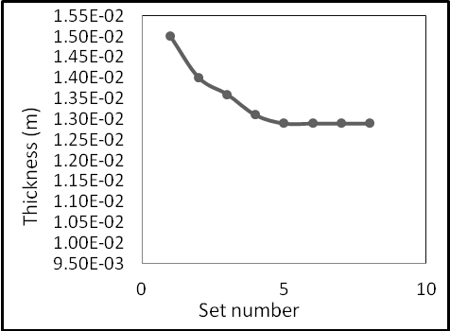
Fig. 18 cylinder thickness (CEL) versus set number.

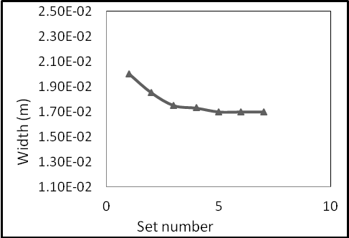Fig.19 width of stiffener (CEL) versus set number.
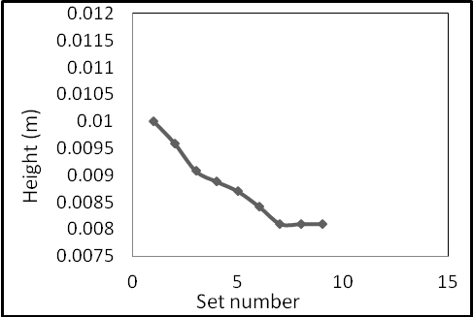
Fig.20 height of stiffener (CEL) versus set number.

B- Optimum state variable and objective .
The optimization based buckling strength is done with the state variable are the buckling strength of the structure and the objective function is the total weight or volume of the structure which required being minimum.The total volume of the structure versus optimization set number for cylinder without any stiffener (CA) is shown in figure.(21), the volume initially is 0.0273m³ and the optimum value obtained is 0.0253m³, the reduction in volume obtained about 7.3%.
Also the total volume versus optimization set number for cylinder with internal stiffener (CI) is shown in figure.(22), the volume initially is 0.0303 m³ and the optimum value obtained is 0.0255 m³, the reduction in volume obtained for this structure is 15.8%. Figure.(23) shows the total volume of the structure versus optimization set number for cylinder with external stiffener. The volume initially is 0.03055m³ and the optimum value obtained is 0.02654 m^{3.} The reduction in volume that obtained for this structure is 13.12% which represents the maximum reduction in volume can be obtained. Also the total volume versus optimization set number for cylinder with internal longitudinal stiffener (CIL) is shown in figure.(24), the volume initially is 0.02831 m³ and the optimum value obtained is 0.0272 m³, the reduction in volume obtained for this structure is 4.1 %. And the total volume versus optimization set number for cylinder with external longitudinal stiffener (CEL) is shown in figure.(25), the volume initially is 0.0283 m³ and the optimum value obtained is 0.027 m³, the reduction in volume obtained for this structure is 4.84%.

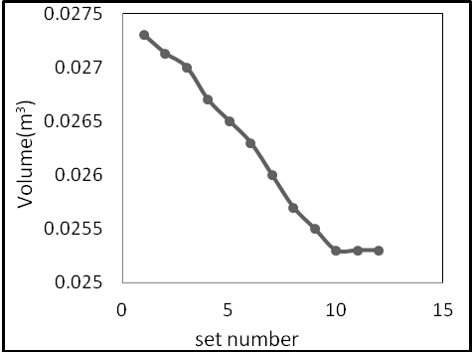
Fig. 21 total volume of (CA) versus set number.
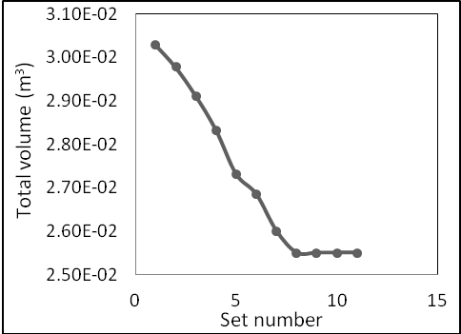
Fig. 22 total volume of (CI) versus set number.
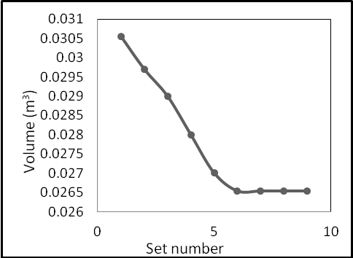
Fig. 23 total volume for (CE) versus set number.
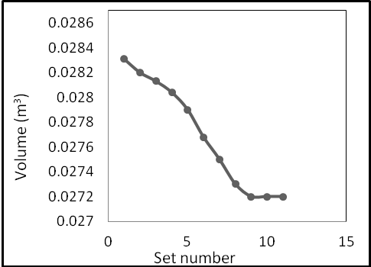
Fig. 24 total volume for (CIL) versus set number.

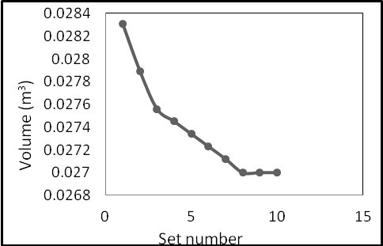
Fig.25 total volume for (CEL) versus set number.

The state variable versus optimization set number for both CA and CI structures is shown in figure.(26) and figure.(27) respectively. Generally the critical pressure which represents the strength of the structure is the state variable and required to be maximum as soon as possible.
The critical pressure for CA initially is 25.4 MPa and after optimization became 27.8 MPa with increasing percentage about 7.2%. The critical pressure for CI initially is 33.4 MPa and the optimum value is 39.6MPa with increasing percentage about 18.6%.The value of critical pressure for cylinder with external circumferential stiffener (CE) versus optimization set number is shown in figure. (28). from this figure the value changes from initially 35.3 MPa and reaches the optimum that can be obtained of 38.9 MPa which represents the increasing in this value about 9.3% , and this also represents the maximum increasing in critical pressure that can be obtained. So the critical pressure for CIL initially is 26.6 MPa and the optimum value is 28.9MPa with increasing percentage about 7.9%.The value of critical pressure for cylinder with external longitudinal stiffener (CEL) versus optimization set number is shown in fig. (30). from this figure the value changes from initially 26.54 MPa and reaches the optimum that can be obtained of 29.5 MPa which represents the increasing in this value about 11.1% , and this also represents the maximum increasing in critical pressure that can be obtained.

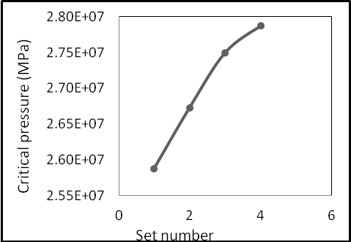
Fig. 26 critical pressure of (CA) versus set number.
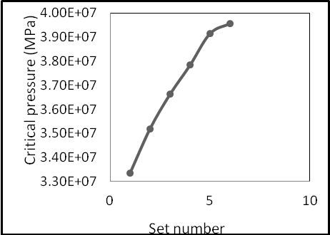
Fig. 27 critical pressure of (CI) versus set number.

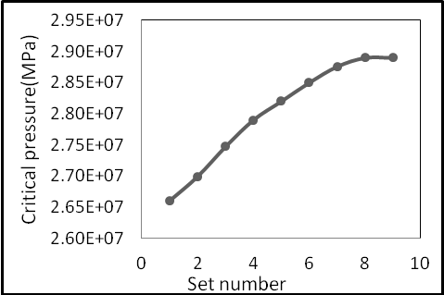
Fig.28 critical pressure for (CE) versus set number.
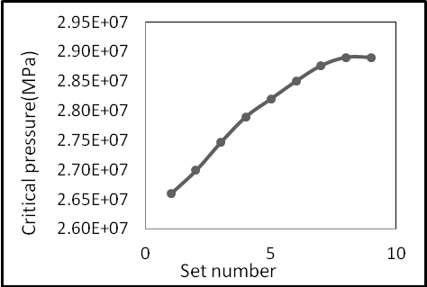
Fig.29 critical pressure for (CIL) versus set number

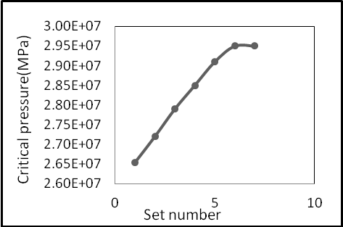
Fig.30 critical pressure for (CEL) versus set number
Conclusions:
From the buckling theory, strengthening of the ring causes a more significant increase and slightly buckling pressures than non reinforced cylinder. With the added enhancement of the ring, the buckling pressure increases. Also the effect of ring stiffening was to increase the buckling resistances. The number of stiffeners was varied around the circumference and along the length of the cylinder ,and the stiffness values of these supports were varied. As a result of the analysis it was shown that there was a maximum level of improvement that can be obtained for a given number of stiffeners around the circumference of the shell .Furthermore increasing the number of stiffeners around the circumference of the shell in the middle of the shell length increases the critical buckling greatly .It is clear that the circumferential stiffeners for both internal and external type (CI and CE) are better than longitudinal stiffeners (CIL and CEL). From the optimization case the best design of cylinder when adding internal stiffeners gives the higher decrease in volume which is about 15.8% compared with the other, and the optimum design gives us the best design of critical pressure to avoid the failure of cylinder.

Table 4 Optimization result summary for all structure types
Type | Initially Critical pressure | Optimum value of CP (MPa) | % increase in CP (MPa) | Initially Total volume (m³) | Optimum Total volume (m³) | %  decrease  in volume
CA | 25.9 | 27.9 | 7.2% | 0.0273 | 0.0253 | 7.3%
CI | 33.4 | 39.6 | 18.6% | 0.0303 | 0.0255 | 15.8%
CE | 35.3 | 38.9 | 9.3% | 0.03055 | 0.02654 | 13.12%
CIL | 26.589 | 28.9 | 7.9% | 0.02831 | 0.0272 | 4.1%
CEL | 26.54 | 29.5 | 11.1% | 0.028307 | 0.027 | 4.84%

References
Bushnell,D.,2005.Static collapse:A survey of methods and modes of behavior. Finite elements in analysis and design, 1985,1(2):165-205 .
Bushnell,D. and Bushnell,W.D.,1995. Optimum design of composite stiffened panels under combined loads. Computers and Structures, 55(5):819-856 .
Belegundu ,2005,"optimization concepts and applications in engineering.
Hao,P.,Wang, B. and Li,G.,1995. Surrogate-based optimum design for stiffened shells with adaptive sampling. AIAA Journal (Accepted) .
Huang,C,Zhang,X,Wang,B.,and Wang,B.,2010. Optimization of an axially compressed ring and stringer stiffened cylinder structure with explicit FEM method. CJK-OSM6, Kyoto, 2010 .
Jaunky,N, Knight, N. F., and Ambur, D. R., 1994. Optimal design of general stiffened composite circular cylinders for global buckling with strength constraints, 41(3): 243-252 .
Kidane, S.,Li,G.,Helms,J.,Pang,S.,S.,and Wolddsenbet,E.,2003.Buckling load analysis of grid stiffened composite cylinders. Composites Part B: Engineering, 34(1).
Krishna.V.,2007"Structural optimization using ANSYS classic and radial Basis function based response surface models." University of Texas at Arlington \.
Liao, B., H., Yan, Y., Yan, W., and Wu, H., 2010.Adaptive Approximation - based Optimization of Composite Advanced Grid-stiffened Cylinder. Chinese Journal of Aeronautics, 23(4): 423-429 .
Leriche,R., and Haftka, R.T., 1993.Optimization of laminate stacking sequence for buckling load maximization by genetic algorithm. AIAA Journal,1993,31(5):951-956.
Nguyen Thi Phuong ,2002," Buckling analysis of eccentrically stiffened functionally graded circular cylindrical thin shells under mechanical load" University of Transport Technology, 54
Wang, B., Hao,P., Du, K.F., and Li, G.,2011.Knockdown factor based on imperfection sensitivity analysis for stiffened shells.International Journal Aerospace and Lightweight Structure , 2(1): 315–333 .
Qasim, H.,B.,2003,"Optimization flexural design of linearly and non linearly elastic spinning rocket structure " University of Baghdad .
Ruud Selker ,2013," Local buckling collapse of marine pipelines " Delft University of Technology Faculty of Mechanical.
Sadeghifar, M., Bagheri, M., and Jafari, A. A., 2010. Multiobjective optimization of orthogonally stiffened cylindrical shells for minimum weight and maximum axial buckling load. Thin-Walled Structures, 48(12): 979-98

